3GPP TSG SA WG5 Meeting 137-e S5-213167

electronic meeting, online, 10 - 19 May 2021

Source: Huawei,China Telecom, China Mobile

Title: Add concrete IntentExpectation for radio network deployment and radio service deployment

Document for: Approval
Agenda Item: 6.4.10

1 Decision/action requested
The group is asked to discuss and approval.

2 References
[1] 3GPP draft TS 28.312: “Management and orchestration; Intent driven management services for mobile networks v0.4.0”.

3 Rationale
This contribution proposes to add concrete IntentExpectation for radio network deployment and radio service deployment.

4 Detailed proposal
It proposes to make the following changes to TS 28.312[1].

1st Change

2 References
The following documents contain provisions which, through reference in this text, constitute provisions of the present document.
- References are either specific (identified by date of publication, edition number, version number, etc.) or non-specific.
- For a specific reference, subsequent revisions do not apply.
- For a non-specific reference, the latest version applies. In the case of a reference to a 3GPP document (including a GSM document), a non-specific reference implicitly refers to the latest version of that document in the same Release as the present document.
[1] 3GPP TR 21.905: "Vocabulary for 3GPP Specifications".
[2] 3GPP TS 28.531: "Management and orchestration; Provisioning".
[3] 3GPP TS 28.532: " Management and orchestration; Generic management services"
[X] 3GPP TS 28.541: "Management and orchestration; 5G Network Resource Model (NRM); Stage 2 and stage 3".

2nd Change

6.2.2.2 Network and service deployment

6.2.2.2.1 Class diagram

6.2.2.2.1.1 Relationship
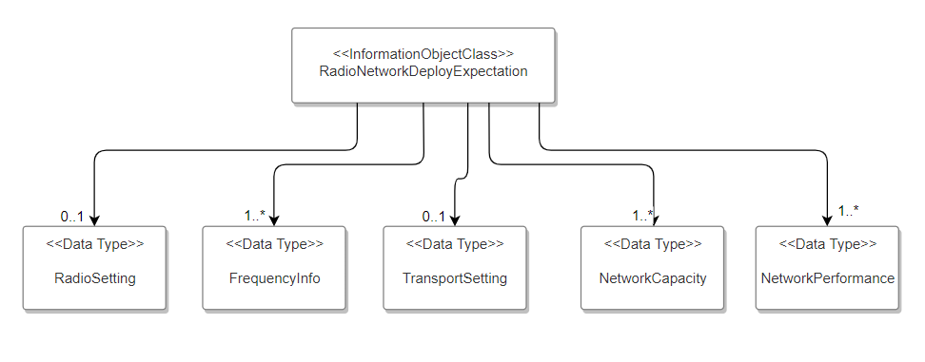
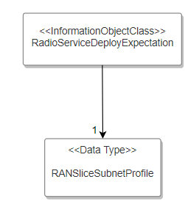

6.2.2.2.1.2 Inheritence
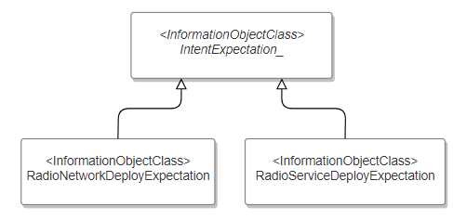

6.2.2.2.2 Class definition

6.2.2.2.2.1 RadioNetworkDeployExpectation <<IOC>>

6.2.2.3.2.1.1 Definition
This IOC represents the properties of an IntentExpectation for radio network deployment. RadioNetworkDeployExpectation <<IOC>> is one realization of abstract class IntentExpectation <<IOC>>. The RadioNetworkDeployExpectation represent the MnS consumer’s expectation on deployment of a radio network.
For RadioNetworkDeployExpectation <<IOC>>, the allowed value for attribute “expectationType” can be “RadioNetworkDeployment”.
The attribute “deploymentAreas” is used to represent a list of coverage areas to deploy the radio network. Coverage area is used as intent driven object for the intent expectation expressed by a MnS consumer. The intent attribute “deploymentAreas” can be implemented by multiple choices, e.g. CoverageAreaPolygon, TrackingAreaCode.

6.2.2.1.2.1.2 Attribute
The RadioNetworkDeployExpectation includes attributes inherited from IntentExpectation_ <<IOC>> and the following attributes:
Attribute Name | Support Qualifier | isReadable | isWritable | isInvariant | isNotifyable
radioSetting | M | T | T | F | T
frequencySettings | M | T | T | F | T
transportSetting | M | T | T | F | T
networkPerformance | M | T | T | F | T
networkCapacity | M | T | T | F | T
deploymentAreas | M | T | T | F | T

6.2.2.2.2.1 RadioServiceDeployExpectation <<IOC>>

6.2.2.3.2.1.1 Definition
This IOC represents the properties of an IntentExpectation for radio service deployment. RadioServiceDeployExpectation <<IOC>> is one realization of abstract class IntentExpectation <<IOC>>. The RadioServiceDeployExpectation represent the MnS consumer’s expectation on deployment of a radio service.
For RadioServiceDeployExpectation <<IOC>>, the allowed value for attribute “expectationType” is “RadioServiceDeployment”.

6.2.2.2.2.1.2 Attribute
The RadioServiceDeployExpectation includes attributes inherited from IntentExpectation_ <<IOC>> and the following attributes:
Attribute Name | Support Qualifier | isReadable | isWritable | isInvariant | isNotifyable
RANSliceSubnetProfile | M | T | T | F | T

6.2.2.2.2.1.3 Attribute constraints

6.2.2.2.3 DataType definition

6.2.2.2.3.1 RadioSetting <<dataType>>

6.2.2.2.3.1.1 Definition
This <<dataType>> represents the properties of a set of radio configuration parameters for the radio network to be deployed.

6.2.2.2.3.1.2 Attribute
Attribute Name | Support Qualifier | isReadable | isWritable | isInvariant | isNotifyable
cellIdList | M | T | T | F | T
gNBIdList | M | T | T | F | T
tACList | M | T | T | F | T
pLMNList | M | T | T | F | T
nRPCIList | M | T | T | F | T

6.2.2..2.3.1.3 Attribute constraints
None

6.2.2.2.3.2 FrequencySetting <<dataType>>

6.2.2.2.3.2.1 Definition
This <<dataType>> represents the properties of a set of frequency configuration parameters for the radio network to be deployed.

6.2.2.2.3.2.2 Attribute
Attribute Name | Support Qualifier | isReadable | isWritable | isInvariant | isNotifyable
arfcnDL | M | T | T | F | T
arfcnUL | M | T | T | F | T
bSChannelBwDL | M | T | T | F | T
bSChannelBwUL | M | T | T | F | T

6.2.2.2.3.2.3 Attribute constraints
None

6.2.2.2.3.3 TransportSetting <<dataType>>

6.2.2.2.3.3.1 Definition
This <<dataType>> represents the properties of a set of transport configuration parameters for the radio network to be deployed.

6.2.2.2.3.3.2 Attribute
Attribute Name | Support Qualifier | isReadable | isWritable | isInvariant | isNotifyable
ngcLocalIpAddressList | M | T | T | F | T
nguRemoteIpAddressList | M | T | T | F | T
logicInterfaceId | M | T | T | F | T
nextHopInfo | M | T | T | F | T

6.2.2.2.3.3.3 Attribute constraints
None

6.2.2.2.3.4 NetworkCapacity <<dataType>>

6.2.2.2.3.4.1 Definition
This <<dataType>> represents the properties of network capacity for the radio network to be deployed.

6.2.2.2.3.4.2 Attribute
Attribute Name | Support Qualifier | isReadable | isWritable | isInvariant | isNotifyable
targetMaximumUENumber | M | T | T | F | T
targetActivityFactor | M | T | T | F | T

6.2.2.2.3.4.3 Attribute constraints
None

6.2.2.2.3.5 NetworkPerformance <<dataType>>

6.2.2.2.3.5.1 Definition
This <<dataType>> represents the properties of network performance for the radio network to be deployed.

6.2.2.2.3.5.2 Attribute
Attribute Name | Support Qualifier | isReadable | isWritable | isInvariant | isNotifyable
targetAveULRANUEThpt | M | T | T | F | T
targetAveDLRANUEthpt | M | T | T | F | T

6.2.2.2.3.5.3 Attribute constraints
None

6.2.2.2.4 Attribute definition

Attribute Name | Documentation and Allowed Values | Properties
radioSetting | It describes a set of radio configuration parameters for the radio network to be deployed. | type: RadioSetting  multiplicity: 1  isOrdered: N/A  isUnique: N/A  defaultValue: False  isNullable: True
frequencySettings | It describes a list of set of frequency configuration parameters for the radio network to be deployed. | type: FrequencySetting  multiplicity: 1..*  isOrdered: N/A  isUnique: N/A  defaultValue: False  isNullable: True
transportSetting | It describes a set of transport configuration parameters for the radio network to be deployed. | type: TransportSetting  multiplicity: 1  isOrdered: N/A  isUnique: N/A  defaultValue: False  isNullable: True
networkCapacity | It describes the properties of network capacity for the radio network to be deployed | type: NetworkCapacity  multiplicity: 1  isOrdered: N/A  isUnique: N/A  defaultValue: False  isNullable: True
networkPerformance | It describes the properties of network performance for the radio network to be deployed | type: NetworkPerformance  multiplicity: 1  isOrdered: N/A  isUnique: N/A  defaultValue: False  isNullable: True
rANSliceSubnetProfile | It describes the SLS for the radio service to be deployed.  For the detailed definition of RANSliceSubnetProfile see clause 6.3.23 in TS 28.541[X]. | type: RANSliceSubnetProfile  multiplicity: 1  isOrdered: N/A  isUnique: N/A  defaultValue: None  isNullable: False
cellIdList | It describes a list of cell identity which can be assigned to the radio network to be deployed.  The detailed definition of cell identity see TS 28.541[X]. | type: String  multiplicity: *  isOrdered: N/A  isUnique: N/A  defaultValue: None  isNullable: False
gNBIdList | It describes a list of gNB Id which can be assigned to the radio network to be deployed.  The detailed definition of gNB Id see TS 28.541[X]. | type: Integer  multiplicity: *  isOrdered: N/A  isUnique: N/A  defaultValue: None  isNullable: False
tACList | It describes a list of nRTAC which can be assigned to the radio network to be deployed.  The detailed definition of nRTAC see TS 28.541[X]. | type: Integer  multiplicity: *  isOrdered: N/A  isUnique: N/A  defaultValue: None  isNullable: False
pLMNList | It describes a list of PLMN Id which can be assigned to the radio network to be deployed.  The detailed definition of PLMN Id see TS 28.541[X]. | type: PLMNId  multiplicity: *  isOrdered: N/A  isUnique: N/A  defaultValue: None  isNullable: False
nRPCIList | It describes a list of nRPCI which can be assigned to the radio network to be deployed.  The detailed definition of nRPCI Id see TS 28.541[X]. | type: Integer  multiplicity: *  isOrdered: N/A  isUnique: N/A  defaultValue: None  isNullable: False
arfcnDL | It describes the arfcnDL for the radio network to be deployed.  The detailed definition of arfcnDL see TS 28.541[X]. | type: Integer  multiplicity: 1  isOrdered: N/A  isUnique: N/A  defaultValue: None  isNullable: False
arfcnUL | It describes the arfcnUL for the radio network to be deployed.  The detailed definition of arfcnUL see TS 28.541[X]. | type: Integer  multiplicity: 1  isOrdered: N/A  isUnique: N/A  defaultValue: None  isNullable: False
bSChannelBwDL | It describes the bSChannelBwDL for the radio network to be deployed.  The detailed definition of bSChannelBwDL see TS 28.541[X]. | type: Integer  multiplicity: 1  isOrdered: N/A  isUnique: N/A  defaultValue: None  isNullable: False
bSChannelBwUL | It describes the bSChannelBwUL of the radio network to be deployed.  The detailed definition for bSChannelBwUL see TS 28.541[X]. | type: Integer  multiplicity: 1  isOrdered: N/A  isUnique: N/A  defaultValue: None  isNullable: False
ngcLocalIpAddressList | It describes a list of ngcLocalIpAddress of the NG control plane interface (NG-C) for the radio network to be deployed. | type: String  multiplicity: 1..*  isOrdered: N/A  isUnique: N/A  defaultValue: None  isNullable: False
nguRemoteIpAddressList | It describes a list of nguLocalIpAddress of the NG user plane interface (NG-U) for the radio network to be deployed. | type: String  multiplicity: 1..*  isOrdered: N/A  isUnique: N/A  defaultValue: None  isNullable: False
logicInterfaceId | It describes a logical transport interface for the radio network to be deployed  The detailed definition of logicInterfaceId see TS 28.541. | type: String  multiplicity: 1  isOrdered: N/A  isUnique: N/A  defaultValue: None  isNullable: False
nextHopInfoList | It describes the ingress transport node for the radio network to be deployed  The detailed definition of nextHopInfolist see TS 28.541[X]. | type: String  multiplicity: *  isOrdered: N/A  isUnique: N/A  defaultValue: None  isNullable: False
targetMaximumUENumber | It describes the maximum number of should be supported by the radio network to be deployed. | type: Integer  multiplicity: *  isOrdered: N/A  isUnique: N/A  defaultValue: None  isNullable: False
targetActivityFactor | It describes the percentage value of the amount of simultaneous active UEs to the total number of UEs where active means the UEs are exchanging data with the radio network. | type: Real  multiplicity: 1  isOrdered: N/A  isUnique: N/A  defaultValue: False  isNullable: True
targetAveULRANUEThpt | It describes the average UL RAN UE throughput for the radio network to be deployed. | type: Integer  multiplicity: 1  isOrdered: N/A  isUnique: N/A  defaultValue: False  isNullable: True
targetAveDLRANUEThpt | It describes the average UL RAN UE throughput for the radio network to be deployed. | type: Integer  multiplicity: 1  isOrdered: N/A  isUnique: N/A  defaultValue: False  isNullable: True
deploymentAreas | It describes a list of coverage areas for the network to be deployed. Coverage area is used as intent driven object for the intent expectation expressed by a MnS consumer | type: CoverageArea  multiplicity: 1..*  isOrdered: N/A  isUnique: N/A  defaultValue: None  isNullable: False

End of changes

