3GPP TSG SA WG5 Meeting 137-e S5-213165

electronic meeting, online, 10 - 19 May 2021

Source: Huawei,China Telecom, China Mobile, AsiaInfo

Title: Update stage2 information model definition for intent

Document for: Approval
Agenda Item: 6.4.10

1 Decision/action requested
The group is asked to discuss and approval.

2 References
[1] 3GPP draft TS 28.312: “Management and orchestration; Intent driven management services for mobile networks v0.4.0”.

3 Rationale
This contribution proposes to update stage2 information model definition for intent.

4 Detailed proposal
It proposes to make the following changes to TS 28.312[1].
1st Change

6.2 Information model definition for Intent (MnS component typeB)

6.2.1 Information model definition for Intent
Editor’s Note: The following information model needs to be revisited based on the further discussion, and the alignment/coordination work with other SDO needs to be considered, which may impact the following information model.

6.2.1.1 Class diagram

6.2.1.1.1 Relationship

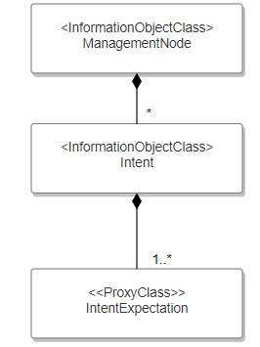
Figure 6.2.1.1.1-1 Relationship UML diagram for intent
Editor’s Note: Whether the intentExpectation is a <<dataType>> or a <<IOC>> is FFS.

6.2.1.1.2 Inheritance
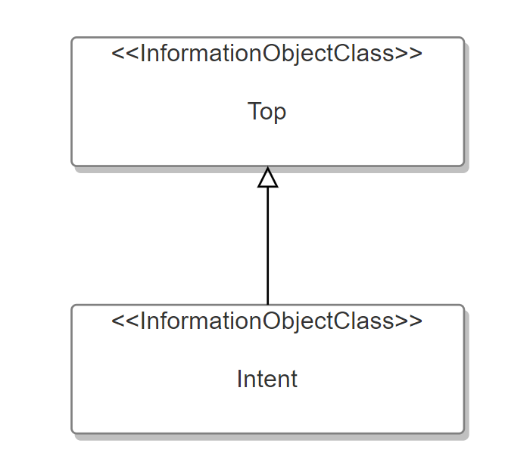

Figure 6.2.1.1.2-1 Inheritance UML diagram for intent

6.2.1.2 Class definition

6.2.1.2.1 Intent <<IOC>>

6.2.1.2.1.1 Definition
This IOC represents the properties of an Intent. The Intent IOC contains one or multiple intentExpectation(s) which includes MnS consumer’s requirements, goals and constraints given to a 3GPP system.
To express a new intent, a MnS consumer needs to request MnS producer to create an Intent instance and containing sub-classes (e.g. intentExpectations). For ultimate delete an expressed intent, the MnS consumer should request MnS producer to delete the Intent instance and containing sub-classes (e.g. intentExpectations).
The intent IOC includes the attribute objectClass and objectInstance from the TOP IOC. The value of attribute objectClass is “Intent” and the value of attribute objectInstance is the DN of the instance of intent IOC.

6.2.1.2.1.2 Attributes
The Intent includes attributes inherited from TOP IOC (defined in TS 28.622) and the following attributes:
Attribute Name | Support Qualifier | isReadable | isWritable | isInvariant | isNotifyable
userLabel | M | T | T | F | T
intentFulfilStatus | M | T | F | F | T
intentConflictState | M | T | F | F | T
intentExpresserInfo | M | T | T | F | T

6.2.1.2.1.3 Attribute constraints
None

6.2.1.2.2 IntentExpectation <<proxyClass>>

6.2.1.2.2.1 Definition

This represents concrete IntentExpectation<<IOC>> see the clause 6.2.2

6.2.1.2.2.2 Attributes

See that defined in the concrete IntentExpectation <<IOC>>.

6.2.1.2.2.3 Attribute constraints

See that defined in the concrete IntentExpectation<<IOC>>

6.2.1.3 DataType definition

.2.1.3.1.2 Attributes

.2.1.3.1.3 Attribute constraint

None

6.2.1.4 Attribute definition
Attribute Name | Documentation and Allowed Values | Properties
userLabel | A user-friendly (and user assignable) name of the intent.  allowedValues: Not Applicable | type: String  multiplicity: 1  isOrdered: F  isUnique: F  defaultValue: None  isNullable: False
intentFulfilStateus | It describes the current status of the intent fulfilment result, which is configured by MnS producer and can be read by MnS consumer.  allowedValues: "FULFILLED", “NOT_FULFILLED | type: ENUM  multiplicity: 1  isOrdered: N/A  isUnique: N/A  defaultValue: None  isNullable: False
intentExpresserInfo | It describes the information of the consumer who expresses the intent to the 3gpp management system. | type: String  multiplicity: 1  isOrdered: N/A  isUnique: N/A  defaultValue: None  isNullable: False
expectationType | It describes the type of the intent expectation expressed by the MnS consumer.  allowedValues: see Clause 6.2.2 for the concrete IntentExpectation | type: String  multiplicity: 1  isOrdered: N/A  isUnique: N/A  defaultValue: None  isNullable: False
intentConflictState | It describes whther the intent is conflicted with other intents on the MnS roducer.  allowedValues: “CONFLICTED”, “NON-CONFLICTED” | type: ENUM  multiplicity: 1  isOrdered: F  isUnique: F  defaultValue: None  isNullable: False

End of changes

