3GPP TS 28.537 V17.0.0 (2021-03)
Technical Specification
3rd Generation Partnership Project;
Technical Specification Group Services and System Aspects;
Management and orchestration;
Management capabilities
(Release 17)



The present document has been developed within the 3rd Generation Partnership Project (3GPP TM) and may be further elaborated for the purposes of 3GPP..
The present document has not been subject to any approval process by the 3GPP Organizational Partners and shall not be implemented.
This Specification is provided for future development work within 3GPP only. The Organizational Partners accept no liability for any use of this Specification.
Specifications and Reports for implementation of the 3GPP TM system should be obtained via the 3GPP Organizational Partners' Publications Offices.

3GPP
Postal address

3GPP support office address
650 Route des Lucioles - Sophia Antipolis
Valbonne - FRANCE
Tel.: +33 4 92 94 42 00 Fax: +33 4 93 65 47 16
Internet
http://www.3gpp.org
Copyright Notification
No part may be reproduced except as authorized by written permission.
The copyright and the foregoing restriction extend to reproduction in all media.

© 2021, 3GPP Organizational Partners (ARIB, ATIS, CCSA, ETSI, TSDSI, TTA, TTC).
All rights reserved.

UMTS™ is a Trade Mark of ETSI registered for the benefit of its members
3GPP™ is a Trade Mark of ETSI registered for the benefit of its Members and of the 3GPP Organizational Partners
LTE™ is a Trade Mark of ETSI registered for the benefit of its Members and of the 3GPP Organizational Partners
GSM® and the GSM logo are registered and owned by the GSM Association
Contents
Foreword 4
1 Scope 6
2 References 6
3 Definitions of terms, symbols and abbreviations 6
3.1 Terms 6
3.2 Symbols 6
3.3 Abbreviations 6
4 Heartbeat 6
4.1 Overview 6
4.2 Specification level requirements 7
4.2.1 Use cases 7
4.2.1.1 Configuring heartbeat notification periodicity 7
4.2.1.2 Requesting immediate heartbeat notification 7
4.2.1.3 Emitting periodic heartbeat notifications 8
4.2.2 Requirements 8
4.2.2.1 Requirements for controlling heartbeat 8
4.2.2.2 Requirements for notifying heartbeat 8
4.3 Procedures for heartbeat 8
4.3.1 Procedure for configuring heartbeat notification periodicity 8
4.3.2 Procedure for requesting immediate heartbeat notification 9
4.3.3 Procedure for notifying periodic heartbeat notifications 9
5 Discovery of Management Services 10
5.1 Overview 10
5.2 Specification level requirements 11
5.2.1 Use cases 11
5.2.1.1 Adding a new management service producer 11
5.2.1.2 Removing a management service producer 11
5.2.1.3 Adding a new management service consumer 12
5.2.2 Requirements 12
Annex A (informative): Heartbeat PlantUML source code 12
A.1 Procedure for configuring heartbeat notification periodicity 12
A.2 Procedure for requesting immediate heartbeat notification 13
A.3 Procedure for notifying periodic heartbeat notifications 14
Annex B (informative): Change history 15

Foreword
This Technical Specification has been produced by the 3rd Generation Partnership Project (3GPP).
The contents of the present document are subject to continuing work within the TSG and may change following formal TSG approval. Should the TSG modify the contents of the present document, it will be re-released by the TSG with an identifying change of release date and an increase in version number as follows:
Version x.y.z
where:
x the first digit:
1 presented to TSG for information;
2 presented to TSG for approval;
3 or greater indicates TSG approved document under change control.
y the second digit is incremented for all changes of substance, i.e. technical enhancements, corrections, updates, etc.
z the third digit is incremented when editorial only changes have been incorporated in the document.
In the present document, certain modal verbs have the following meanings:
shall indicates a mandatory requirement to do something
shall not indicates an interdiction (prohibition) to do something
The constructions "shall" and "shall not" are confined to the context of normative provisions, and do not appear in Technical Reports.
The constructions "must" and "must not" are not used as substitutes for "shall" and "shall not". Their use is avoided insofar as possible, and they are not used in a normative context except in a direct citation from an external, referenced, non-3GPP document, or so as to maintain continuity of style when extending or modifying the provisions of such a referenced document.
should indicates a recommendation to do something
should not indicates a recommendation not to do something
may indicates permission to do something
need not indicates permission not to do something
The construction "may not" is ambiguous and is not used in normative elements. The unambiguous constructions "might not" or "shall not" are used instead, depending upon the meaning intended.
can indicates that something is possible
cannot indicates that something is impossible
The constructions "can" and "cannot" shall not to be used as substitutes for "may" and "need not".
will indicates that something is certain or expected to happen as a result of action taken by an agency the behaviour of which is outside the scope of the present document
will not indicates that something is certain or expected not to happen as a result of action taken by an agency the behaviour of which is outside the scope of the present document
might indicates a likelihood that something will happen as a result of action taken by some agency the behaviour of which is outside the scope of the present document
might not indicates a likelihood that something will not happen as a result of action taken by some agency the behaviour of which is outside the scope of the present document
In addition:
is (or any other verb in the indicative mood) indicates a statement of fact
is not (or any other negative verb in the indicative mood) indicates a statement of fact
The constructions "is" and "is not" do not indicate requirements.

1 Scope
The present document specifies use cases, requirements and procedures for management capabilities of 5G networks.

2 References
The following documents contain provisions which, through reference in this text, constitute provisions of the present document.
- References are either specific (identified by date of publication, edition number, version number, etc.) or non-specific.
- For a specific reference, subsequent revisions do not apply.
- For a non-specific reference, the latest version applies. In the case of a reference to a 3GPP document (including a GSM document), a non-specific reference implicitly refers to the latest version of that document in the same Release as the present document.
[1] 3GPP TR 21.905: "Vocabulary for 3GPP Specifications".
[2] 3GPP TS 28.532: "Management and orchestration; Generic management services".
[3] 3GPP TS 28.533: " Management and orchestration; Architecture framework".

3 Definitions of terms, symbols and abbreviations

3.1 Terms
For the purposes of the present document, the terms given in 3GPP TR 21.905 [1] and the following apply. A term defined in the present document takes precedence over the definition of the same term, if any, in 3GPP TR 21.905 [1].

3.2 Symbols
Void.

3.3 Abbreviations
For the purposes of the present document, the abbreviations given in 3GPP TR 21.905 [1] and the following apply. An abbreviation defined in the present document takes precedence over the definition of the same abbreviation, if any, in 3GPP TR 21.905 [1].
MnS Management Service

4 Heartbeat

4.1 Overview
The communication between Management Service (MnS) producers and MnS consumers shall be monitored, and communication link breaks between them shall be discovered by MnS consumers as early as possible. The behaviour of the MnS consumers, after detection of communication failure, is outside the scope of the present document.

4.2 Specification level requirements

4.2.1 Use cases

4.2.1.1 Configuring heartbeat notification periodicity
Use case stage | Evolution/Specification | <<Uses>>  Related use
Goal | To configure the periodicity at which the management service producer shall emit heartbeat notifications to its authorized management service consumer.
Actors and Roles | An authorized consumer of the management service.
Telecom resources | The management service producer.
Assumptions | N/A
Pre-conditions | The periodicity requested by the management service consumer has a valid value.
Begins when | The management service consumer sends a request to the management service producer to set the periodicity at which it shall emit heartbeat notifications.
Step 1 | The management service producer receives the request and sets its internal countdown timer to a value (which can be zero) equal to the periodicity requested by the management service consumer.
Step 2 | The management service producer sends a heartbeat notification to all authorized management service consumer(s), provided they previously subscribed to heartbeat notifications.
Ends when | All the steps identified above are successfully completed.
Exceptions | One of the steps identified above fails.
Post-conditions | The notification periodicity has been configured according to the management service consumer request.  A heartbeat notification is sent out to all authorized management service consumer(s).
Traceability | REQ-HB-CTRL-FUN-2.

4.2.1.2 Requesting immediate heartbeat notification
Use case stage | Evolution/Specification | <<Uses>>  Related use
Goal | To trigger the emission of an immediate heartbeat notification by the management service producer.
Actors and Roles | An authorized consumer of the management service.
Telecom resources | The management service producer.
Assumptions | N/A
Pre-conditions | N/A
Begins when | The soliciting management service consumer sends a request to the management service producer to emit immediately a heartbeat notification.
Step 1 | The management service producer receives the request and sends immediately a heartbeat notification to all authorized management service consumer(s) who had previously subscribed to heartbeat notifications.  The management service producer count down timer is not impacted.
Ends when | All the steps identified above are successfully completed.
Exceptions | One of the steps identified above fails.
Post-conditions | The immediate heartbeat notification has been emitted according to the soliciting management service consumer request.
Traceability | REQ-HB-CTRL-FUN-3, REQ-HB-NOTIF-FUN-2.

4.2.1.3 Emitting periodic heartbeat notifications
Use case stage | Evolution/Specification | <<Uses>>  Related use
Goal | To send periodic heartbeat notifications at the periodicity requested by the management service consumer.
Actors and Roles | An authorized producer of the management service.
Telecom resources | The management service consumer.
Assumptions | The heartbeat notification periodicity has been configured according to the management service consumer request. | Configuring heartbeat notification periodicity
Pre-conditions | N/A
Begins when | The internal countdown timer managed by the management service producer has reached the value 0.
Step 1 | The management service producer sends a heartbeat notification to all authorized management service consumer(s), provided they previously subscribed to heartbeat notifications..
Step 2 | The management service producer resets its internal countdown timer to the value of the heartbeat notification periodicity. | Configuring heartbeat notification periodicity
Ends when | All the steps identified above are successfully completed.
Exceptions | One of the steps identified above fails.
Post-conditions | The periodic heartbeat notification has been emitted to all authorized management service consumer(s) at the requested periodicity.
Traceability | REQ-HB-NOTIF-FUN-1.

4.2.2 Requirements

4.2.2.1 Requirements for controlling heartbeat
REQ-HB-CTRL-FUN-1: The management service provider shall have the capability to allow its authorized consumer to read the heartbeat period.
REQ-HB-CTRL-FUN-2: The management service provider shall have the capability to allow its authorized consumer to set the heartbeat period.
REQ-HB-CTRL-FUN-3: The management service provider shall have the capability to allow its authorized consumer to request the emission of an immediate heartbeat notification.

4.2.2.2 Requirements for notifying heartbeat
REQ-HB-NOTIF-FUN-1: The management service provider shall have the capability to send periodic heartbeat notifications to its authorized consumer at the frequency specified by the management service consumer.
REQ-HB-NOTIF-FUN-2: The management service provider shall have the capability to send immediate heartbeat notifications to its authorized consumer, upon request from the management service consumer.

4.3 Procedures for heartbeat

4.3.1 Procedure for configuring heartbeat notification periodicity
Figure 4.3.1-1 illustrates the procedure for configuring the periodicity of heartbeat notifications using operations and notifications of the provisioning MnS (see clause 11.1.1 of [2]).
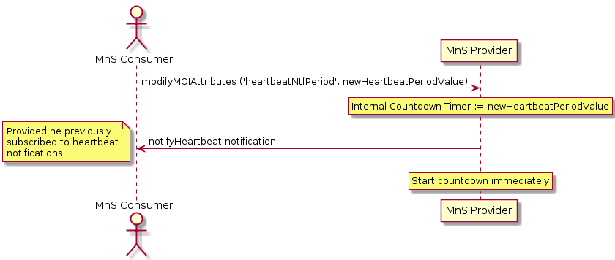
Figure 4.3.1-1: Procedure for configuring heartbeat notification periodicity

4.3.2 Procedure for requesting immediate heartbeat notification
Figure 4.3.2-1 illustrates the procedure for requesting immediate heartbeat notification using operations and notifications of the provisioning MnS (see clause 11.1.1 of [2]).

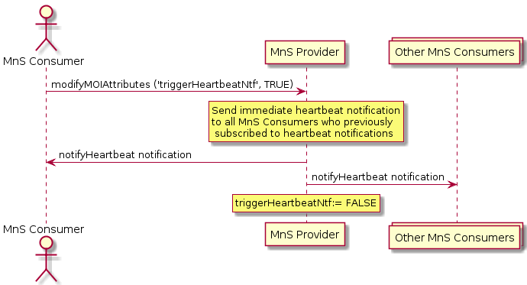
Figure 4.3.2-1: Procedure for requesting immediate heartbeat notification

4.3.3 Procedure for notifying periodic heartbeat notifications
Figure 4.3.3-1 illustrates the procedure for notifying periodic heartbeat notifications using operations and notifications of the provisioning MnS (see clause 11.1.1 of [2]).
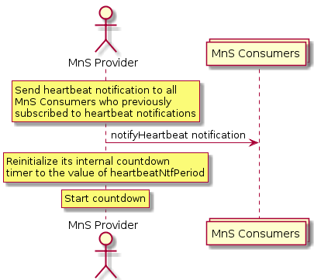
Figure 4.3.3-1: Procedure for notifying periodic heartbeat notifications

5 Discovery of Management Services

5.1 Overview
To enable communication between Management Service (MnS) consumers and MnS producers, the MnS consumers need a mechanism to discover the Management Services that are available in the 3GPP Management System.

5.2 Specification level requirements

5.2.1 Use cases

5.2.1.1 Adding a new management service producer
Use case stage | Evolution/Specification | <<Uses>>  Related use
Goal | Add a new MnS producer to a 3GPP management system.
Actors and Roles | Network operator.
Telecom resources | New MnS producer.  MnS discovery service producer.
Assumptions | New MnS producer is authorized to publish the MnS data [x] for a management service to MnS discovery service producer.
Pre-conditions | -
Begins when | Network operator wishes to add a new MnS producer to the 3GPP management system.
Step 1 (M) | Network operator adds the new MnS producer to the 3GPP management system.
Step 2 (M) | Network operator activates the new MnS producer.
Step 3 (M) | New MnS producer sends a request to MnS discovery service producer to publish the MnS data.
Step 4 (M) | MnS discovery service producer stores the MnS data.
Step 5 (M) | MnS discovery service producer sends confirmation to the new MnS producer that the MnS data has been stored.
Ends when | All the steps identified above are successfully completed.
Exceptions | One of the mandatory steps fails.
Post-conditions | MnS discovery service producer has stored the MnS data.
Traceability | REQ-DMS-CON-1

5.2.1.2 Removing a management service producer
Use case stage | Evolution/Specification | <<Uses>>  Related use
Goal | Remove an existing MnS producer in a 3GPP management system.
Actors and Roles | Network operator.
Telecom resources | MnS producer.  MnS discovery service producer.
Assumptions | -
Pre-conditions | MnS discovery service producer has stored the MnS data for the MnS producer.  The network operator has decided that it is safe to remove the MnS producer.
Begins when | Network operator wishes to remove an existing MnS producer in the 3GPP management system.
Step 1 (M) | Network operator orders removal of the MnS producer.
Step 2 (M) | MnS producer sends a request to MnS discovery service producer to remove the MnS data related to the MnS Producer.
Step 3 (M) | MnS discovery service producer removes the MnS data related to the MnS Producer.
Step 4 (M) | MnS discovery service producer sends confirmation to the MnS producer that the MnS data has been removed.
Ends when | All the steps identified above are successfully completed.
Exceptions | One of the mandatory steps fails.
Post-conditions | MnS discovery service producer has removed the MnS data related to the MnS Producer.
Traceability | REQ-DMS-CON-1

5.2.1.3 Adding a new management service consumer
Use case stage | Evolution/Specification | <<Uses>>  Related use
Goal | Add a new MnS consumer of an MnS provided by a 3GPP management system.
Actors and Roles | Network operator.
Telecom resources | New MnS consumer.  MnS discovery service producer.
Assumptions | New MnS consumer is authorized to obtain the MnS data [x] for the available a management service(s) from MnS discovery service producer.
Pre-conditions | MnS data exists in MnS discovery service producer.
Begins when | Network operator wishes to add a new MnS consumer of an MnS provided by a 3GPP management system.
Step 1 (M) | Network operator adds the new MnS consumer to the 3GPP management system or to an external system.
Step 2 (M) | Network operator configures the new MnS consumer with the address of the MnS discovery service producer.
Step 3 (M) | Network operator activates the new MnS consumer.
Step 4 (M) | For each MnS that the new MnS consumer wishes to consume, the following steps are repeated.
Step 4.1 (M) | New MnS consumer sends a request to MnS discovery service producer to read the MnS data for relevant management services. The request may optionally request that the MnS data is filtered by MnS type (e.g. provisioning MnS, fault supervision MnS, performance assurance MnS) and description of MnS components.
Step 4.2 (M) | MnS discovery service producer reads the stored MnS data of the management service(s) and decides if the MnS data of the management service(s) can satisfy the received request, then sends the relevant MnS data of the management service(s) to the new MnS Consumer.
Step 4.3 (M) | New MnS consumer reads the MnS data to check if a suitable version of the desired MnS is available. If more than one suitable version exists, the new MnS consumer selects the management service with the highest suitable version of the MnS.
Step 4.4 (M) | New MnS consumer reads the MnS data for the selected management service to find details of the MnS producer for example root URL for MnS operations and root DN for MnS objects.
Ends when | All the steps identified above are successfully completed.
Exceptions | One of the mandatory steps fails.
Post-conditions | New MnS consumer is ready to use the selected version for each needed MnS.
Traceability | REQ-DMS-CON-2

5.2.2 Requirements
REQ-DMS-CON-1 The MnS discovery service producer shall provide capabilities allowing its authorized consumer to publish its MnS data for use by other authorized MnS discovery service consumers.
REQ-DMS-CON-2 The MnS discovery service producer shall provide capabilities allowing its authorized consumer to retrieve the published MnS data.

Annex A (informative):
Heartbeat PlantUML source code

A.1 Procedure for configuring heartbeat notification periodicity
The following PlantUML source code is used to describe the procedure for configuring heartbeat notification periodicity, as depicted by Figure 4.3.1-1:

@startuml

title "Configuring heartbeat notification periodicity"

actor "MnS Consumer" as CONS
participant "MnS Provider" as PROV
CONS -> PROV: modifyMOIAttributes ('heartbeatNtfPeriod', newHeartbeatPeriodValue)

rnote over PROV
Internal Countdown Timer := newHeartbeatPeriodValue
endrnote

PROV -> CONS: notifyHeartbeat notification
note left
Provided he previously
subscribed to heartbeat
notifications
end note

rnote over PROV
Start countdown immediately
endrnote

@enduml

A.2 Procedure for requesting immediate heartbeat notification
The following PlantUML source code is used to describe the procedure for requesting immediate heartbeat notification, as depicted by Figure 4.3.2-1:

@startuml

title "Requesting immediate heartbeat notification"

actor "MnS Consumer" as CONS
participant "MnS Provider" as PROV
collections "Other MnS Consumers" as OTHER
CONS -> PROV: modifyMOIAttributes ('triggerHeartbeatNtf', TRUE)

rnote over PROV
Send immediate heartbeat notification
to all MnS Consumers who previously
subscribed to heartbeat notifications
endrnote

PROV -> CONS: notifyHeartbeat notification
PROV -> OTHER: notifyHeartbeat notification

rnote over PROV
triggerHeartbeatNtf:= FALSE
endrnote

@enduml

A.3 Procedure for notifying periodic heartbeat notifications
The following PlantUML source code is used to describe the procedure for notifying periodic heartbeat notifications, as depicted by Figure 4.3.3-1:

@startuml

title "Notifying periodic heartbeat notifications"

actor "MnS Provider" as PROV
collections "MnS Consumers" as CONS

rnote over PROV
Send heartbeat notification to all
MnS Consumers who previously
subscribed to heartbeat notifications
endrnote

PROV -> CONS: notifyHeartbeat notification

rnote over PROV
Reinitialize its internal countdown
timer to the value of heartbeatNtfPeriod
endrnote

rnote over PROV
Start countdown
endrnote

@enduml

Annex B (informative):
Change history
Change history
Date | Meeting | TDoc | CR | Rev | Cat | Subject/Comment | New version
2020-03 | SA#87-e |  |  |  |  | Upgrade to changecontrol version | 16.0.0
2021-03 | SA#91e | SP-210152 | 0003 | - | B | Add use cases for discovery of management services | 17.0.0

