3GPP TSG SA WG5 Meeting 136-e S5-212247

electronic meeting, online, 1 - 9 March 2021

Source: China Mobile, Huawei, China Telecom, China Unicom

Title: pCR 28.100 Add generic classification of autonomous network level for network optimization

Document for: Approval
Agenda Item: 6.4.9

1 Decision/action requested
The group is asked to discuss and approval.

2 References
[1] 3GPP draft TS 28.100: “Levels of autonomous network v0.3.0”.
[2] 3GPP TR 28.810: “Study on concept, requirements and solutions for levels of autonomous network v17.0.0”

3 Rationale
This contribution proposes to add generic classification of autonomous network level for the network optimization.

4 Detailed proposal
It proposes to make the following changes to TS 28.100[1].
1st Change

5.X Generic autonomous network level for network optimization

5.X.1 Generic workflow
Following is the generic entire workflow for the network optimization:
Intent handling:
- Task A: Network optimization policies generation and determination. The tasks of generating and determining the network optimization related policies (e.g., network issue identification policies, network issue analysis policies and network parameters adjustment policies) based on received network optimization intent (e.g. network targets for the specified areas).
- Task B: Network optimization intent fulfilment evaluation. The tasks of evaluating network optimization intent fulfilment information (e.g. corresponding network targets are satisfied or not).
Awareness:
- Task C: Network related information collection. The tasks of collecting network related data, including network performance data (i.e. performance measurement, MDT data), network configuration data and environment data (e.g. electronic map)).
Analysis:
- Task D: Network issues identification. The tasks of analysing the network performance (e.g. geographical grid based network performance) and identifying the network issues (e.g. coverage related issues, RAN UE throughput related issues) and corresponding location.
- Task E: Network deterioration prediction. The tasks of analysing current network performance and historical network performance, predicting the network performance trend in the future and identifying potential network performance deterioration in advance.
- Task F: Network issue analysis. The tasks of analysing the root cause (e.g. affected Cells) of the identified or predicted network issues.
- Task G: Network adjustment solutions generation. The tasks of generating the recommended network adjustment solution which can address the identified or predicted network issues.
Decision:
- Task H: Network adjustment solutions evaluation and determination. The tasks of evaluating the recommended network adjustment solutions, and deciding the network adjustment solutions to be executed.
Execution:
- Task I: Network adjustment solutions execution. The tasks of adjusting and configuring the network configuration parameters.

5.X.2 Generic autonomous network level
Level 0:
- All the tasks in the network optimization workflow (Task A, Task B, Task C, Task D, Task E, Task F, Task G, Task H, Task I) are accomplished by human.
Level 1:
- Telecom system executes the tasks of network adjustment solutions execution based on the specified network related parameters (Task I). Telecom system also can execute the tasks of network related information collection based on the specified collection rule (Task C). At this level, telecom system can assist human to improve the execution and awareness efficiency for network optimization.
- All the other tasks in the network optimization workflow (Task A, Task B, Task D, Task E, Task F, Task G, Task H) are accomplished by human.
Level 2:
- Compared to Level 1, telecom system additionally executes the tasks of network issues identification, network issue analysis based on the specified network issue identification and analysis rule (Task D, Task F). At this level, telecom system can assist human to achieve the closed loop for network optimization based on human defined rules.
- All the other tasks in the network optimization workflow (Task A, Task B, Task E, Task G, Task H) are accomplished by human.
Level 3:
- Compared to Level 2, telecom system additionally executes the tasks of network adjustment solutions generation (Task G) and network adjustment solutions evaluation and determination (Task H) based on the specified network adjustment policies and evaluation policies. At this level, the telecom system can achieve the closed loop automation for network optimization based on the human defined optimization policies.
- All the other tasks in the network optimization workflow (Task A, Task B, Task E) are accomplished by human.
Level 4:
- Compared to Level 3, the telecom system additionally executes the tasks of network deterioration prediction (Task E), network optimization policies determination (Task A), and network optimization intent evaluation (Task B) based on received network optimization intent and intent translation/evaluation policies. At this level, telecom system can achieve the intent driven closed loop automation for network optimization based on human defined intent translation and evaluation policies.
- The intent translation and evaluation policies maybe pre-defined and specified by human to assist the telecom system.
Level 5:
- Telecom system can autonomously execute the entire workflow of radio network optimization for all scenarios, which means the telecom system can achieve the full autonomy for network optimization for full scenarios.
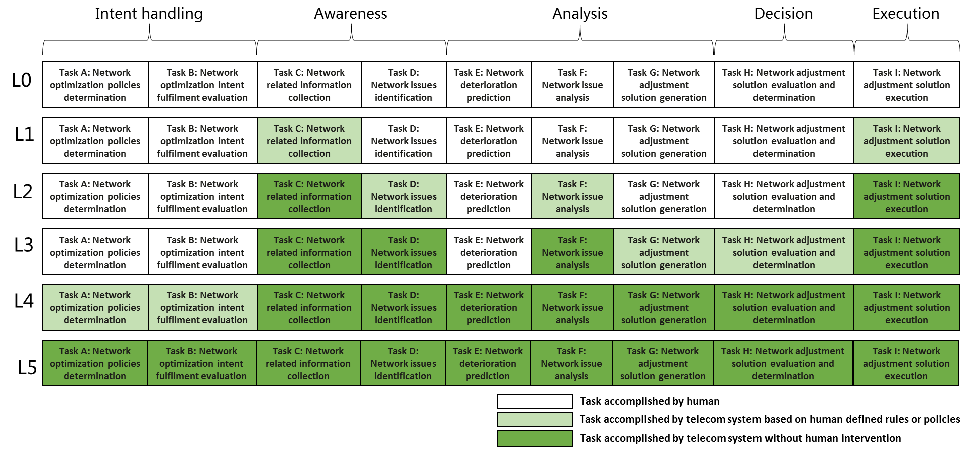
Figure 5.X.2-1 Classification of gneric autonomous network level for network optimization
End of changes

