3GPP TSG-SA5 Meeting #136e S5-212244

e-meeting, 1 – 10 March 2021

Source:

Title: TD clarify roles and actors related to network slice management

Document for: Discussion and Endorsement
Agenda Item:

1 Decision/action requested
Please discuss and endorse

2 References
[1] 3GPP TS 28.530: "Management and orchestration; Concepts, use cases and requirements".

3 Rationale
There are a bounch of services and roles defined and used in existing specificaiton, but the difference of the services and demarcation point/boundary of the roles are very unclear that caused confusion and misleading.
Observation 1:
There are many services defined and used in the TS 28.530 and other specificaitons, e.g. communication service, connectivity service, network service, network slice as a service, etc., however, the differnece and relationship between those services is still unclear, especially between communication service and network slice as a service. A discussion paper (S5-205287) and CR (S5-205288) for decoupling communication service and network slice concepts were drastically discussed and finally agreed in SA5#133e, but further cleanup in 28.530 is still needed to make the two concepts more clear
Observation 2:
There’s no defintion for actor, in addition roles and actors are mixed in the use cases and other clauses. e.g. in sentence “A Network Operator (NOP) plays the role of a Network Slice Provider (NSP)” extracted from use cases ( clause 5.4 of TS 28.530), which term in this sentence is role? and which term is actor? From pure english point of view (after google search), it’s more nature that “an actor” plays a specific “role”. So in this sense, NOP is actor and NSP is role. But in our defintion, NOP is role but NSP was not defined as role at all. Another example, in 4.1.6 of TS 28.530, who is the actor which could play both NOP and CSP roles defined in 4.8?
Extracted some google search result of “role” for reference:
- an actor's part in a play, film, etc.
- the function assumed or part played by a person or thing in a particular situation.
- the position or purpose that someone or something has in a situation, organization, society, or relationship
- an actor's part in a film or play
- the duty or use that someone or something usually has or is expected to have
- a part or character played by an actor or actress.
- proper or customary function: the teacher's role in society.
- the rights, obligations, and expected behavior patterns associated with a particular social status

Observation 3:
There are a plenty of roles defined and used in TS 28.530 and 28.531, but the demarcation point/boundary between roles are not clear. E.g. in clause 4.8 of TS 28.530, it clear described NOP role Designs, builds and operates networks and provides related services, including network services and network slices, while CSP role Provides communication services. Designs, builds and operates its communication services. However, in other clauses of TS 28.530, e.g. clause 4.1.6, it’s CSP role provides network slice as a service.
Observation 4:
NOP role is a bit confusion. All other roles defined in 4.8 of 28.530 were named as “xSP” (e.g. DCSP, VISP, CSP) except for NOP, although all other xSP also have function/purpose of “operating”. E.g. CSP could also Designs, builds and operates its communication services, VISP could Designs, builds and operates its virtualization infrastructure(s), DSP could Designs, builds and operates its data centres

4 Detailed proposal
- Proposal 1: Based on observation 4, to align with other role defintions, remove “NOP” role and add Network Service/Slice Provider (NSSP) which could design, build and operate networks and provides related services, including network services and network slices. Optionally, add NSSC role as customer of NSSP.
Note: CSP and NSSP can be client of NSSP, so maybe explicitly definition of NSSC role is not needed. This can be decided in conrecte CR for role definition update.
Note: the impacted part of Figure 4.8.1: High-level model of roles of 28.530 will be looked as following (only show the impacted part in conceptual view for simplicity):
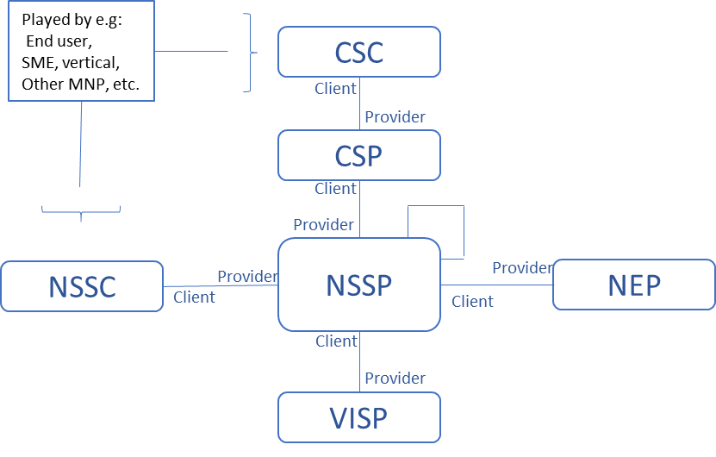
- Proposal 2: Based on observation 2&3, clearly separate resposbilities/functinaliies of each role and avoid any overlapping between roles, while a single actor could play multiple roles. In addition, distinguish actor and role with clearly definition of role and actor.
Note 1: role can be defined as:
Role represents responsibilities and capabilities of an organization (or legal enity) or person.
The roles related to 5G networks and network slicing management include CSC, CSP, NSSP, NSSC (optional), VISP, NEP, DCSP, etc.
Note 2: actor can be defined as:
Actor represents an organization (or legal enity) or person who can play one or multiple roles.
e.g. the actor could be (Mobile) Network Operator (MNP/NOP) who can play role of CSP, NSSP, NSSC, etc., vertical/enterprise who can play role of CSP, CSC, etc., Virtualization Infrastructure Operator who can play role of VISP, Data Center Operator who can play role of DCSP, etc.
- Proposal 3: Based on obeservation 2, in the table of use cases (e.g. 5.4 of 28.530), focus on role and remove all actors
Please endorse the proposals 1-3

