3GPP TSG SA WG5 Meeting 136-e S5-212242

electronic meeting, online, 1st - 10th March 2021 revision for S5-21xxxx

Source: Nokia, Nokia Shanghai Bell

Title: use case – integrate with existing AAA system of operator

Document for: Approval
Agenda Item:

1 Decision/action requested
The group is asked to discuss and approve the proposal..

2 References
[1] 3GPP TR 28.817: "Management and orchestration; Study on access control for management service"
[2] 3GPP TS 28.533: "Management and orchestration; Architecture framework"

3 Rationale
Generally, Authentication, Authorization and Audit (AAA) system has been built in the operator’s data center to support access control of legacy telecom network management, as well as other IT operations, especially centralized identity and role management and single sign on for administrators of the operator. To save OPEX, enforce security policies, and streamline identity, authentication and role management, a new management system needs to be integrated with existing AAA framework.
This pCR is to study the potential requirements on integrating 3GPP management system with AAA system of operator

4 Detailed proposal

Start of 1st Change

5.x use case – integrate with existing AAA system of operator

5.x.1 Description
Generally, there’re always huge number of heterogeneous management platforms in big operator’s data center. Administrators of the operator access the platforms for daily management and operation, while some platforms are exposed to external users. To save OPEX and minimize administration burden, centralized Authentication, Authorization and Audit (AAA) system is always built in the operator’s data center for identity lifecycle management, user provisioning and role assignment, access request review and approval, security policies (e.g. password rotation policy, multi-factor authentication policy) management, and Single Sign On (SSO), etc.
Similarly, the 3GPP management system (e.g. 5G network and network slice management system) needs to be integrated with existing AAA platform of operator, probably with extension of both 3GPP management system (e.g. specify interface to enable AAA platform to sync identity information or security policies with 3GPP management system) and existing AAA platform (e.g. provide interface to enable 3GPP and other management system to send security logs to AAA platform for audit and accountability, but potential extension of AAA system is out the scope of 3GPP ), as shown in the figure 5.x.1-1
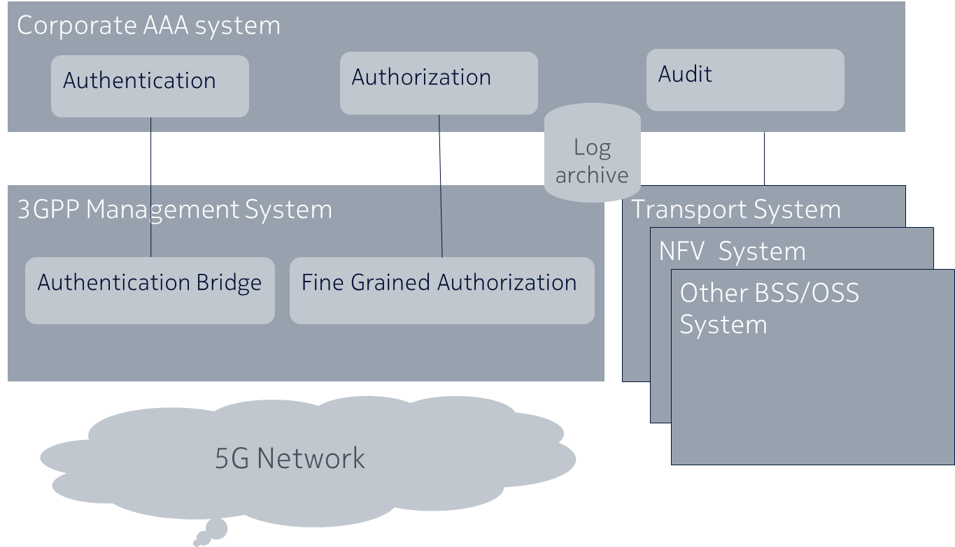
figure 5.x.1-1 Centralized AAA framework in operator data center

5.x.2 Issue and gaps
Requirements and solution of access control for 3GPP management system (e.g. 5G network and network slice management system), as well as integrating 3GPP management system to AAA platform have not been specified in existing 3GPP and other SDOs. Currently, some management systems have its own vendor specific AAA solution independent from centralized AAA. Some systems integrate its AAA to centralized AAA of operator during deployment/upgrade and maintain/synchronize the AAA related information in both systems during runtime manually (may with various customization scripts). The existing situation incurs high OPEX and administrative complexity for both vendor and operator. E.g. If a new human/machine consumer added in the central AAA system, an administrator of the operator may manually import this new consumer into various management systems for later authorization of the new consumer by the impacted management systems, or they need to write vendor specific script to import the consumer to management systems supplied by different vendors without standardized interface.
The complexity of vendor/operator specific solution could be dramatically amplified in 5G network because more actors (vertical, operator, end user, enterprise, transport/virtual infrastructure supplier, etc.) and operation roles (security administrator, 5G network administrator, transport network administrator, virtual infrastructure administrator, etc. of operator, service administrator of vertical customer, application client of an end user or enterprise customer, etc. ) in 5G network which need to be maintained by the operator, E2E service and slice management and orchestration need closely collaboration and automation between different systems (e.g. 3GPP management systems (E2E, RAN, 5GC, etc.), transport network management system, MANO, etc.) from various vendors. Therefore, standardized interface of 3GPP management system is required to facilitate automation of security policy, identity and roles synchronisation between 3GPP management system and AAA system, hence reduce the OPEX and complexity of 3GPP network management.
In addition, Service Based Management Architecture (SBMA) introduced in 5G since Rel15 enables the automation based on standardize interface.

End of Change

Start of 2nd Change

6 Potential requirements for access control for MnS

- REQ-MNSAC-x The 3GPP management system may have the capability to support integration with AAA framework automatically based on standardize interface
- REQ-MNSAC-x The 3GPP management system may have the capability to support synchronization of security policies between 3GPP management system and AAA framework automatically.
Note: e.g. security policy could be password length, character, aging/rotation policy, multi-factor authentication policy, etc.
- REQ-MNSAC-y The 3GPP management system may have the capability to support centralized identity lifecycle management together with AAA framework automatically.
Note: identity is used to identify a human user (e.g. administrator of the operator) or machine consumer (e.g. a MnF or other application which access a MnS) of 3GPP management system , etc.
- REQ-MNSAC-z The 3GPP management system may have the capability to support centralized user profile management for the consumer of the management system together with AAA framework automatically.
- REQ-MNSAC-xx The 3GPP management system may have the capability to support synchronization of identities between 3GPP management system and AAA framework automatically.
- REQ-MNSAC-yy The 3GPP management system may have the capability to support centralized role management but distributed fine grain authorization management together with AAA framework.
- REQ-MNSAC-zz The 3GPP management system may have the capability to support synchronization of roles between 3GPP management system and AAA framework automatically.
Note: role is assigned to an identity or a group of identities to perform specific task, e.g. the role could be security/network administrator of an operator, a manager of an operator, etc.
- REQ-MNSAC-xxx The 3GPP management system may have the capability to support single sign on provided by AAA framework for human user of the system.
- REQ-MNSAC-yyy The 3GPP management system may have the capability to support centralized security log and audit management together with AAA framework.

End of Change

