3GPP TSG-SA5 Meeting #133e S5-205xxx

e-meeting 12th -21st October 2020

Source: Ericsson, Deutsche Telekom

Title: Discussion paper on Assurance Closed Loop model updates

Document for: Endorsement
Agenda Item: 6.3

1 Decision/action requested
The group is asked to endorse the proposal in section 4.

2 References
[1] SA5-204007 SA5#132e OAM Chair notes and conclusions
[2] 3GPP TS 28.535 Management and orchestration; Management services for communication service assurance; Requirements
[3] 3GPP TS 28.536 Management and orchestration; Management services for communication service assurance; Stage 2 and stage 3
[4] 3GPP TS 28.622 Telecommunication management; Generic Network Resource Model (NRM) Integration Reference Point (IRP); Information Service (IS)
[5] 3GPP TS 28.623 Telecommunication management; Generic Network Resource Model (NRM) Integration Reference Point (IRP); Solution Set (SS) definitions
[6] 3GPP TS 28.541 Management and orchestration; 5G Network Resource Model (NRM); Stage 2 and stage 3

3 Rationale
At the last meeting #132e the group agreed to clean-up the model for the assurance closed loop specified in TS 28.536 [2] before agreeing any new Rel-17 contributions. This contribution discusses the changes proposed to the stage 2 model and the CR’s in which the detailed changes are proposed for stage 2 and stage 3.
The following aspects regarding the stage 2 where identified as issues:
- The association relationship between SubNetwork and AssuranceControlLoop
- The relationship between the AssuranceControlLoop and Managed Entities
- The difference between AssuranceGoalStatus and AssuranceGoal
This contribution describes the relationships between SubNetwork and AssuranceControlLoop, AssuranceControlLoop and NetworkSlice (Managed Entity), and AssuranceControlLoop and AssuranceGoal (including AssuranceControlStatus)
The association relationship between SubNetwork and AssuranceControlLoop
As shown in Figure 4.1.2.2.1.1 in [3] a SubNetwork can contain 0.. * instances of class AssuranceControlLoop. A SubNetwork has zero or more AssuranceControlLoop instances, and
each AssuranceControlLoop belongs to exactly one SubNetwork. If the SubNetwork is removed, all of its AssuranceControlLoop instances are removed. The way to show this relationship is to use stereotype <<names>> on the association relationship between SubNetwork and AssuranceControlLoop. Through the name containment the consumer can find the ManagedElement instances and ManagedFunction instances participating in an AssuranceControlLoop instance. The updated relationship diagram is shown in the figure 3.1 below.
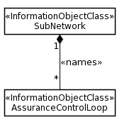
Figure 3.1: Relationship diagram for AssuranceControlLoop
The relationship where an AssuranceControlLoop is directly associated through the <<names>> association with SubNetwork shown in Figure 3.1 is not documented. The proper place to document this relationship is is in TS 28.536 [3] and importing SubNetwork from 28.622 [4].
NOTE: It is common practice to have an NRM fragment with containment relationship to SubNetwork documented in separate specification(s). In this case the feature is introduced for 5G and does not represent network domains, ManagedElement or ManagedFunction and potentially evolves in later releases, therefore there is no reason to include this relationship in 28.622 or 28.541.

The relationship between the AssuranceControlLoop and Managed Entities
A network slice is subject to requirements derived from one or more SLSs (Service Level Specification). For each SLS one or more AssuranceControlLoops may be created in the corresponding (root) network slice subnet. This relationship was not shown correctly in Figure 4.1.2.2.1.1 in [3]. It is proposed to insert a new diagam showing this relationship, the new relationship diagram is shown in figure 3.2 below.
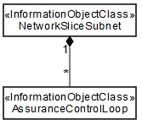
Figure 3.2: Relationship between AssuranceControlLoop and NetworkSliceSubnet
The requirements on a network slice are documented in a set of ServiceProfiles where a ServiceProfile represents an SLS. To assure the SLS an AssuranceControlLoop may be used.
The requirements on a network slice subnet are documented in a set of SliceProfiles where a SliceProfile represents an SLS. To assure the SLS an AssuranceControlLoop may be used.
Due to the one to one relationship between NetworkSlice and root NetworkSliceSubnet, an AssuranceControlLoop is either contained by a NetworkSlice or by a root NetworkSliceSubnet but cannot be contained by both. This is shown in Figure 3.3.

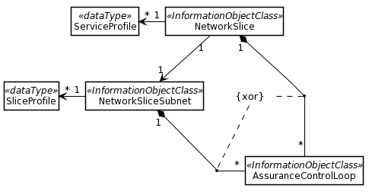
Figure 3.3: Relationship between and NetworkSlice, root NetworkSliceSubnet and AssuranceControlLoop
Relationship wih AssuranceGoal
An assurance control loop includes one or more assurance goals that contain information from an SLS. The AssuranceGoal points to the SLS attributes which are subject to assurance requirements. Attribute and attribute value are indicated with goaltarget(s)). It is proposed to insert a new diagam showing this relationship, see figure 3.4 below.

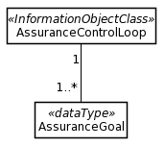
Figure 3.4: Relationship diagram for AssuranceGoal
AssuranceControlLoop attributes
The attributes of an AssuranceControlLoop shown in Table 4.1.2.4.1.1 in [3] should include a list of assuranceGoals instead of assuranceGoalStatus.A list of assuranceGoals may be defined containing multiple attributes. The update is shown in Table 3.1 below.
Attribute name | Support Qualifier | isReadable | isWritable | isInvariant | isNotifyable
operationalState | M | T | F | F | T
administrativeState | M | T | T | F | T
controlLoopLifeCyclePhase | M | T | T | F | T
observationTimePeriod | M | T | T | F | T
assuranceGoalList | M | T | F | F | T
Table 3.1: Overview of attributes included in AssuranceControlLoop
AssuranceGoal attributes
The AssuranceGoal includes all relevant information associated with a goal that should be assured by a control loop. The attibutes are shown in the Table 3.2 below. An example of a value for an assuranceGoal is latency=x. Another example of an assuranceGoal is latency=k, throughput=l and maxNumberof UEs=m i.e. a set of characteristcs attributes that have to be assured together.

An example SLS specifies the throughput of a NetworkSlice is 150 kb/s. The requirement is fulfilled by the associated NetworkSliceSubnet.
Note that the SLS also specifies other characteristics which may or may not be included in the AssuranceGoal. In this example the only goal is to assure that the NetworkSlice throughput is 150 kbit/s.
In this example the throughput of the NetworkSlice instance as part of the AssuranceGoal is captured by the attribute-value-pair assuranceGoalTarget dLThptPerSlice=150. The OAM system monitors the throughput of the NetworkSlice and captures the current value of the throughput and observes that the target has not been reached. The OAM system reconfigures the NetworkSlice or any of its dependent resources to improve the throughput.. The consumer can check the effectiveness of the assuranceControlLoop by consulting the performance measurements and KPI’s associated with the named assuranceGoalTarget.
The AssuranceGoal attributes are shown in Table 3.2.
Attribute name | Support Qualifier | isReadable | isWritable | isInvariant | isNotifyable
assuranceGoalTargets | M | T | F | F | T
Table 3.2: Overview of attributes included in AssuranceGoal
Examples of assuranceGoalTarget
An AssuranceControlLoop takes its assurance requirements from the ServiceProfile or SliceProfile. Each attribute value pair that is included in the AssuranceGoal is referenced by a list of AssuranceGoalTargets, where each AssuranceGoalTarget points to an attribute in the ServiceProfile or SliceProfile. Examples of names of goal target attribute names are latency, dLThptPerSlice, dLThptPerUE etc.

Datastructure for AssuranceGoal
One AssuranceGoalconsists of on or more AssuranceGoalTargets which each of the AssuranceGoalTargets representing one or more attributes (with values) like delay, throughput, packetloss etc…
The AssuranceGoal is a list AssuranceGoalTargets where an AssuranceGoalTarget is an attribute in an SLS (for example Latency=100), i.e. ServiceProfile or SliceProfile. In figure 3.5 the AssuranceGoal: goalId=1 represents SLS-A and AssuranceGoal: goalId=8 represents SLS-B.

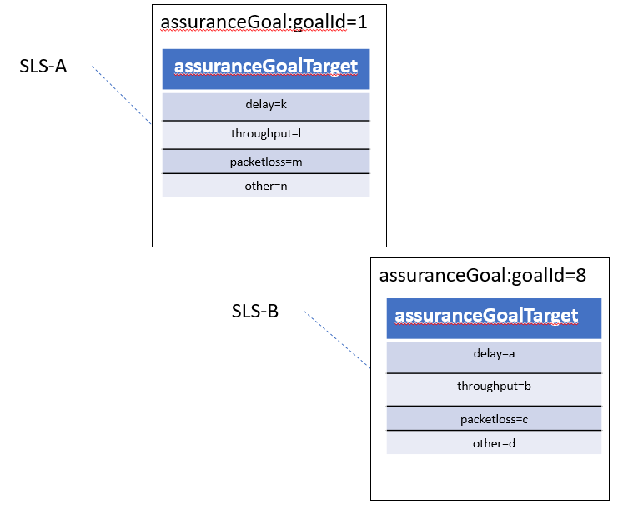
Figure 3.5: example data structure for assuranceGoal
The mapping of the tables in figure 3.5 to a generic datastructure is shown in figure 3.6 below.

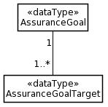
Figure 3.6: Relationship diagram
Overview
Figure 3.7 shows the relationship diagram for Cosla in Rel-16. All the model elements described in this discussion paper together including the relationship to NetworkSlice and NetworkSliceSubnet
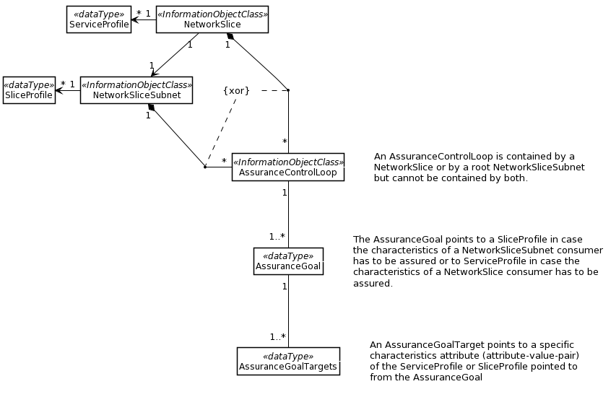
Figure 3.7: Overview

Discussion
The discussion paper proposes to update the class diagram, inheritance, definitions and attribute definition table. These changes impact both stage 2 and stage 3 clauses in TS 28.536

- S5-205xxx Rel-16 CR 28.536 Update stage 2 and stage 3 of class diagram inheritance definitions and attribute definition

4 Detailed proposal
The group is asked to endorse the proposed updates to the class diagram, inheritance, definitions and attribute definition table in TS 28.536 as described in the rational.

