3GPP TSG-SA5 Meeting #132e S5-204299

e-meeting 17th 28th August 2020

Source: Huawei, China Mobile

Title: Update workflow

Document for: Approval
Agenda Item: 6.6.2

1 Decision/action requested
The group is asked to discuss and approval.

2 References
[1] 3GPP TR 28.810: “Study on concept, requirements and solutions for levels of autonomous network v1.0.0”.

3 Rationale
This contribution proposes to update the workflow in the following aspect:
- Change the intent translation to intent management which include not only intent translation but also intent feedback which evaluate whether the intent is satisfied or not and feed back to the operator or customer, to make up a complete intent driven closed loop.
- Update the description of Awareness by adding awareness of the network status based on the collected network data besides collecting network data.

4 Detailed proposal
It proposes to make the following changes to TR 28.810[1].
1st Change

4.4.2 Workflow
Workflow is used to describe the necessary steps to fulfil certain management purposes. A workflow is composed of one or more management tasks. Each workflow task may be accomplished by human, or accomplished by telecom system with human assistance, or accomplished by telecom system without human intervention. The autonomy capabilities of the tasks in the workflow may impact the network autonomy level.
Following are the potential categorization of the tasks in a workflow:
- Intent management: The group of tasks which translate network or service intent from operator or customer into detailed management operations which may affect one or more of the following groups of tasks (i.e. awareness, analysis, decision, execution) and feed back the evaluation result/information about the intent fulfillment (e.g. the intent is satisfied or not).
- Awareness: The group of tasks which monitor network information (including network performance, network anomaly, network event, etc) by collecting and pre-process (e.g. filtering, associating and statistic) network data.
- Analysis: The group of tasks which analyse the obtained network information (e.g. network status, network issues and so on) or based on the historical network information to further predict the future change trend of the above network status, and make recommendation for decision.
- Decision: The group of tasks which evaluate and decide the necessary management operation for execution, e.g. network configuration or adjustment.
- Execution: The group of tasks which execute the management operations.
Figure 4.4.2-1 illustrate the general workflow for network autonomy.

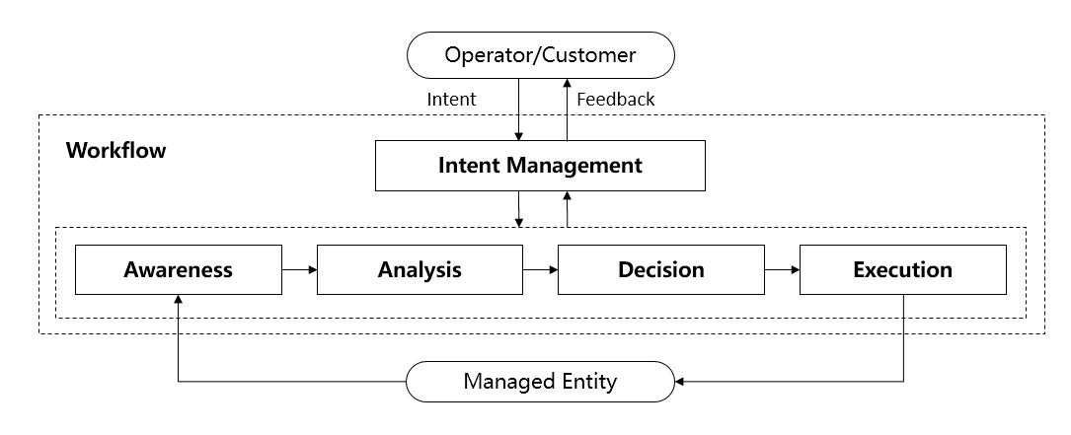
Figure 4.4.2-1: General workflow for network autonomy

2nd Change

5.1 Fault recovery use case example for network autonomy level

5.1.1 Introduction
Fault recovery use case refers to the entire workflow of network fault management, full autonomy of fault recovery can help the network operator to reduce OPEX by reducing manual involvement in such tasks and to enhance user experience by reducing the time for network fault recovery. However, full autonomy of fault recovery is a long term goal, it will be beneficial for operator to achieve this goal step by step and have clear view on which typical issues can be addressed by utilizing network autonomy mechanism in corresponding steps.

5.1.2 Entire workflow
The entire workflow of fault recovery is as following:
- Task A: Fault recovery intent management. The task which translate the fault recovery intent to the detailed fault management operations and feed back the evaluation result/information about the fault recovery intent fulfilment.
NOTE: The examples of fault recovery intent are alarm compression rate increasing, fault recovery response time reducing, etc.
- Task B: Fault related information collection. The task which collect the alarm information and other fault related information (e.g. performance information and configuration information etc.).
- Task C: Alarm filtering. The task which filter the alarms collected in Task B based on the filtering rules specified. A single network fault may generate a large number of correlative alarms over space and time, therefore it is considered advantageous to have methods filtering the redundant alarms. Reporting only effective alarms without redundant alarms would improve the efficiency of alarm management.
- Task D: Fault recognition. The task which recognize or predict the fault and its category based on the alarm information and other fault related information.
- Task E: Fault root cause analysis (RCA). The task which analyse the detailed root cause of the network fault.
- Task F: Fault recovery mechanism analysis. The task which analyse the possible fault recovery mechanisms and corresponding solutions for support of maintenance based on the fault root cause, thereby generate the feasible options (e.g. recovery procedures).
- Task G: Fault recovery action generation. The task which determine the fault recovery action.
- Task H: Fault recovery execution. The task which execute the fault recovery actions (e.g. reconfiguring the network), and other corresponding actions (e.g. clearing of alarms, storage and retrieval of alarms).

5.1.3 Potential classification of network autonomy for fault recovery
Each of the detailed task in clause 5.1.2 can be accomplished either manually by the operator or automatically by the telecom system. Following are the potential classifications of network autonomy for fault recovery based on the participation degree of the human operator and the telecom system:
Level 0:
- All the tasks in the fault recovery workflow in clause 5.1.2 are accomplished by human.
Level 1:
- Fault related information are collected (Task B) automatically by telecom system based on human predefined rules. Fault recovery actions (Task H) which can be executed without human intervention (e.g. system initialisations, activation of a backup or fall back software load) are triggered by human and executed by telecom system based on human defined execution rules.
- All the other tasks in the fault recovery workflow are accomplished by human.
Level 2:
- Compared to Level 1, telecom system additionally assist human operator to filter the alarms (Task C) based on the filtering rules predefined by human operator. Fault recovery execution (only for the actions that can be executed without human intervention) (Task H) are triggered by human and fully executed by telecom system based on human defined rules.
- All the other tasks (Task A, Task D, Task E, Task F and Task G) are accomplished by human.
Level 3:
- Compared to Level 2, telecom system can additionally identify the fault domain and type (Task D except for fault prediction) and analyse the root cause of the network fault (Task E). For certain network faults, telecom system can accomplish the fault recovery mechanism analysis (Task F) and action generation (Task G) based on the fault recovery policies pre-defined and specified by human.
- Fault recovery intent translation (Task A) is accomplished by human, and all the other tasks (Task F and Task G) are accomplished by human operator for most of the faults except several conventional ones.
Level 4:
- Compared to Level 3, the fault recovery mechanism analysis (Task F) and action generation (Task G) are accomplished automatically by telecom system without human intervention. Telecom system also can predict the fault based on service performance (e.g. QoE, call drop ratio, user experience). For certain scenario, telecom system additionally assist human operator to translate the fault recovery intent to the detailed fault recovery policies (Task A) and feed back the evaluation result/information about the fault recovery intent fulfilment based on human predefined policies.
- Intent translation policies can be pre-defined and specified by human.
Level 5:
- The entire fault RCA and recovery workflow is accomplished automatically by telecom system without human intervention and human predefined rules or policies.
- Human can but not have to supervise the fault recovery decision generated by telecom system.
Figure 5.1.3-1 illustrate the classification of network autonomy for fault recovery.

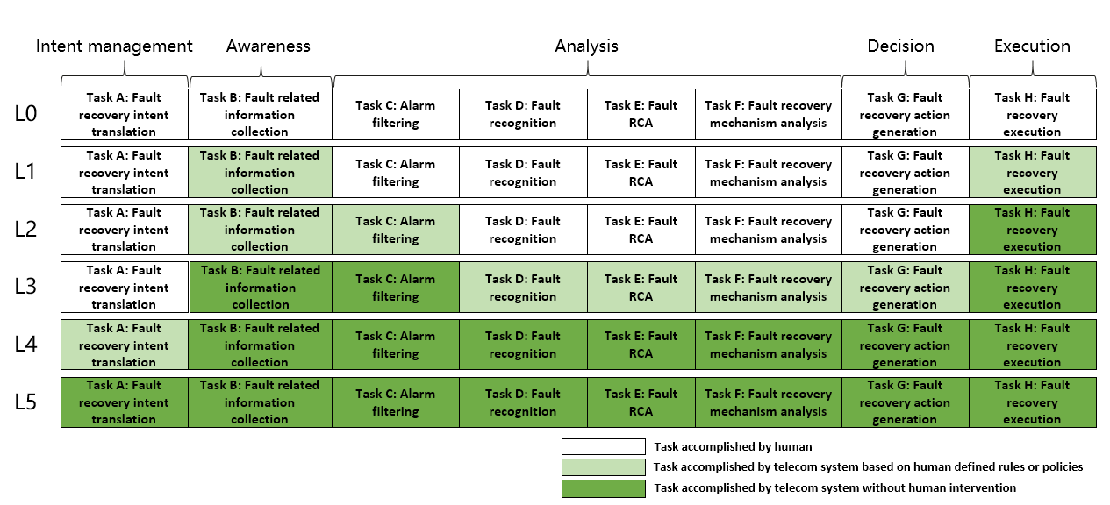
Figure 5.1.3-1: Classification of network autonomy for fault recovery

5.2 Network optimization use case example for classification of network autonomy

5.2.1 Coverage optimization use case example for classification of network autonomy

5.2.1.1 Introduction
Coverage is critical for good user experience, however, coverage optimization is complexity. Full autonomy of coverage optimization for whole network is a long term goal, it will be beneficial for operator to achieve this goal step by step and have clear view on which typical issues can be addressed by utilizing network autonomy mechanism in corresponding steps.

5.2.1.2 Entire workflow
Following are the entire workflow for the radio network coverage optimization:
- Task A: Coverage requirements determination. The tasks of determining the coverage requirements (e.g. coverage area, weak coverage ratio) based on service assurance intent specified by customer.
- Task B: Coverage optimization policies determination. The tasks of determining the coverage optimization related policies (e.g., weak coverage analysis policies, weak coverage optimization policies).
- Task C: Coverage related information collection. The tasks of collecting coverage performance data (e.g. measurement data, MDT data).
- Task D: Coverage issues identification. The tasks of analysing the coverage performance and identifying the coverage issues (e.g. weak coverage).
- Task E: Coverage adjustment solution analysis and generation. The tasks of analysing the cause of the identified coverage issues and generating the coverage adjustment actions.
- Task F: Coverage adjustment actions determination. The tasks of deciding the coverage adjustment actions to be executed.
- Task G: Coverage adjustment actions execution (e.g. selection of coverageShape, digitalTilt and digitalAzimuth). The tasks of adjusting and configuring the coverage related parameters.

5.2.1.3 Potential classification of network autonomy for coverage optimization
Level 0:
- All the tasks in the radio network coverage optimization workflow (Task A, Task B, Task C, Task D, Task E, Task F, Task G) are accomplished by human.
Level 1:
- Telecom system executes the tasks of adjusting and configuring coverage related parameters (e.g. coverageShape, digitalTilt and digitalAzimuth) based on coverage related parameters specified by human (Task G). Telecom system also can execute the tasks of collecting coverage related data (e.g. measurement data, MDT data and trace data) based on collection rule specified by human (Task C).
- All the other tasks in the radio network coverage optimization workflow (Task A, Task B, Task D, Task E, Task F) are accomplished by human.
Level 2:
- Compared to Level 1, telecom system can analyse the coverage performance and identify the coverage issue based on the coverage issue rule specified by human (Task D).
- All the other tasks in the radio network coverage optimization workflow (Task A, Task B, Task E, Task F) are accomplished by human.
Level 3:
- Compared to Level 2, telecom system additionally executes the tasks of analysing the coverage optimization solution (Task E) and determining the coverage adjustment actions (Task F) to be executed based on coverage requirements and/or optimization policies specified by human.
- All the other tasks in the radio network coverage optimization workflow (Task A, Task B) are accomplished by human.
Level 4:
- Compared to Level 3, the telecom system additionally executes the tasks of determining coverage optimization policies (e.g., weak coverage cause analysis policies, weak coverage adjustment policies) (Task B). For certain scenarios, the telecom system can determines the coverage requirements (e.g. coverage area, weak coverage ratio) based on service assurance intent.
- The intent translation policies maybe pre-defined and specified by human to assist the telecom system.
Level 5:
- Telecom system can autonomously execute the entire workflow of radio network coverage optimization for all scenarios, which means the telecom system can achieve the full autonomy for radio network coverage optimization for full scenarios.

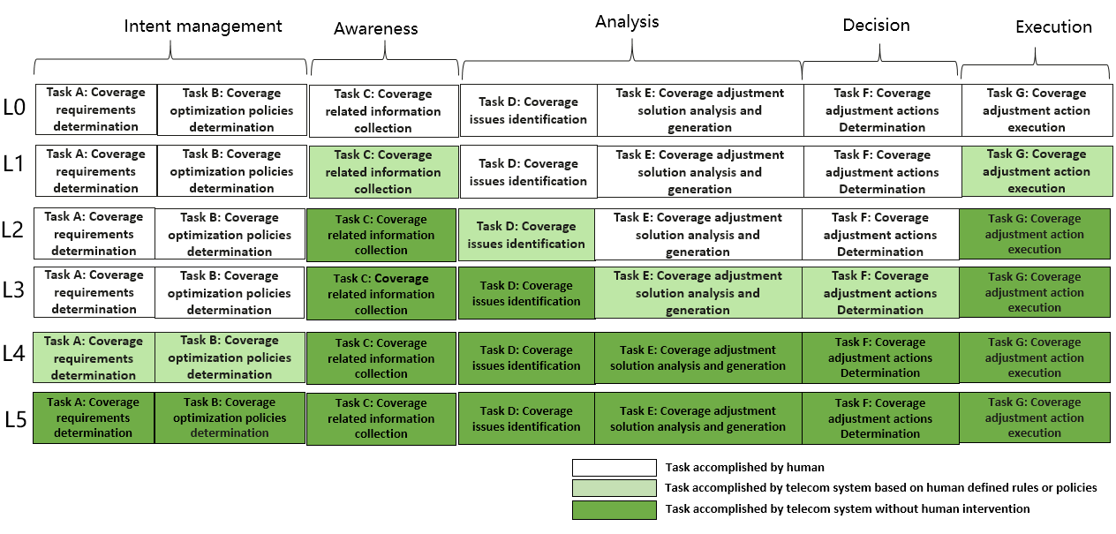
Fgiure 5.2.1.3-1: Classification of network autonomy for radio network coverage optimization
Editor’s Note: The relation of above classification of network autonomy for radio network coverage optimization and Framework approach for classification of network autonomy level defined in Clause 6.1.2 is FFS.

5.2.2 Capacity optimization use case example for classification of network autonomy

5.2.2.1 Introduction
Network resources, especially radio resources are limited. In order to utilize radio resources in the most efficient way and improve user service experience, it is important to achieve higher system capacity by distributing user traffic across the system radio resources. Currently the flow of traffic simply follows the physical topology of the network or network slice, or static radio resource management policies, and resource usage may be unreasonable. Autonomous capacity optimization can help to improve resource usage efficiency greatly by taking into account the traffic steering when scheduling the network or network slice. For example, by creating a traffic prediction model, 3GPP management system can provide precise traffic prediction and the optimal network topology and traffic distribution.

5.2.2.2 Entire workflow
The entire workflow of capacity optimization is as following:
- Task A: Capacity optimization intent translation. Translate the intent to the capacity optimization target information (e.g., capacity planning data, network topology, traffic model, etc.).
- Task B: Capacity information collection. Collect the current and historical performance data related to resource usage (e.g., PRB usage, RRC connection number, QoS flows, etc.) and network traffic (e.g., composite available capacity per cell (DL/UL), cell level load (DL/UL/SUL), TNL Load, etc.) for the network.
- Task C: Capacity data analysis. Analyse the current and historical performance data related to resource usage and network traffic for the network or network slices.
- Task D: Capacity issues identification and/or prediction. Identify the ongoing issues on resource utilization and predict the potential issues, and generate the capacity or resource utilization possible solutions (e.g., RRM policy adjustment, user migration, handover policy adjustment).
- Task E: Capacity optimization decision. Decide recommended solutions to optimize capacity and resource utilization.
- Task F: Capacity optimization execution. Apply capacity optimization solutions to telecom system (e.g., configuration of parameters and/or policies).

5.2.2.3 Potential classification of network autonomy for capacity optimization
Each of the detailed tasks in clause 5.2.2.2 can be accomplished either manually by the operator or automatically by the telecom system. Following are the potential classifications of network autonomy for capacity optimization based on the participation degree of the human operator and the telecom system:
Level 0:
All the tasks in the capacity optimization workflow are accomplished by human.
Level 1:
- Capacity related information is collected (Task B) automatically by telecom system based on human predefined rules or configurations. Capacity optimization solutions can be triggered by human and executed by telecom system based on human-defined rules (Task F).
- All the other tasks in the capacity optimization workflow are accomplished by human.
Level 2:
- Compared to Level 1, telecom system additionally assists human to execute tasks of analysing the current and historical performance data (Task C) related to resource usage and network traffic for the network or network slices, and identifying the ongoing issues on resource utilization and predict the potential issues (Task D) based on human-defined rules. Capacity optimization solutions (Task F) are executed by telecom system without human intervention.
- Task A and Task E are accomplished by human.
Level 3:
- Compared to Level 2, the telecom system can automatically collect the current and historical performance data related to resource usage and network traffic (Task B). Telecom system could additionally assist human to review the capacity optimization solutions (Task E), which will finally be decided by human (operator).
- Task A is accomplished by human.
Level 4:
- Compared to Level 3, the capacity data analysis (Task C), capacity issues identification and/or prediction (Task D), and decision making (Task E) are accomplished automatically by telecom system without human intervention. Telecom system could additionally assist human to translate the intent to capacity optimization target information (Task A).
- The intent translation policies may be pre-defined and specified by human to assist the telecom system.
Level 5:
- The entire workflow of capacity optimization is accomplished automatically by telecom system without human intervention and human-defined rules.
Figure 5.2.2.3 -1 illustrate the classification of network autonomy for capacity optimization.

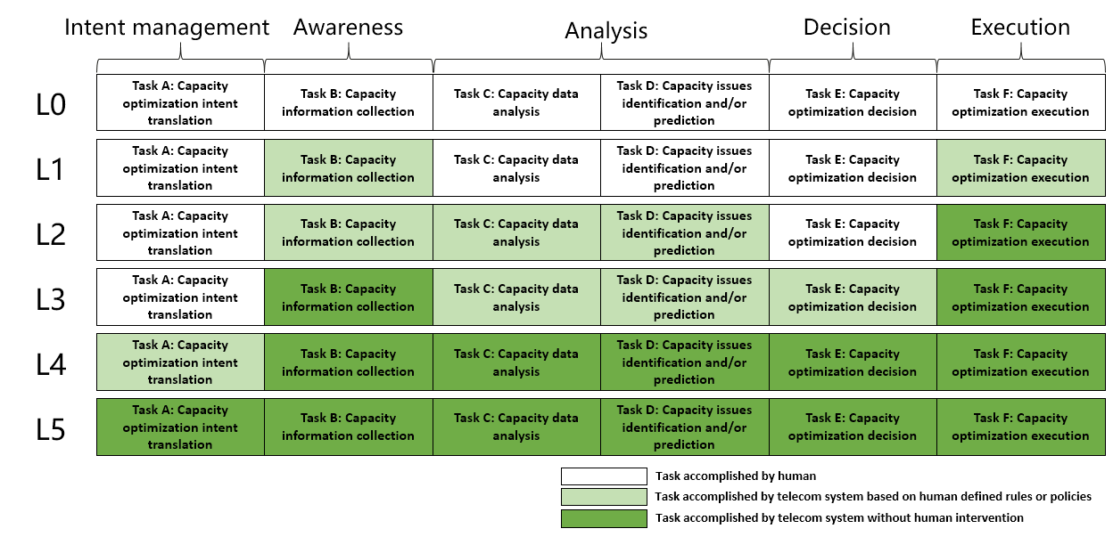
Figure 5.2.2.3 -1: Classification of network autonomy for capacity optimization
Editor’s Note: The relation of above classification of network autonomy for radio network capacity optimization and framework approach for classification of network autonomy level defined in Clause 6.1.2 is FFS.

5.3 RAN NE provisioning use case example for classification of network autonomy

5.3.1 Introduction
RAN NE provisioning use case refers to the entire workflow of deploying an RAN NE, full autonomy of RAN NE provisioning can help the network operator to reduce OPEX by reducing manual involvement in such tasks. However, full autonomy of RAN NE provisioning is a long term goal, it will be beneficial for operator to achieve this goal step by step and have clear view on which typical issues can be addressed by utilizing network autonomy mechanism in corresponding steps.

5.3.2 Entire workflow
Following are the entire workflow for RAN NE provisioning:
- Task A: RAN NE provisioning decision making.
- Task B: RAN NE planning data determination, the tasks of analysing and determining the network planning data (i.e. radio planning data, transport planning data) for the new RAN NE to be provisioned.
- Task C: RAN NE configuration data generation, the tasks of generating the network configuration data for the RAN NE based on the network planning data for the RAN NE and hardware information collected.
- Task D: RAN NE connection and hardware information collection, the tasks of connecting the RAN NE to the management system (including NE acquire its IP address and corresponding management system IP address) and collecting the RAN NE information (e.g. hardware information).
- Task E: RAN NE configuration data and software download and activation, the tasks of downloading and activating network configuration data and software in RAN NE.
- Task F: RAN NE verification, the tasks of performing the RAN NE verification (e.g. RAN NE test).

5.3.3 Potential classification of network autonomy for RAN NE provisioning
Following are the potential classification of network autonomy for RAN NE provisioning:
Level 0:
- All the tasks in the RAN NE provisioning workflow (Task A, Task B, Task C, Task D, Task E, Task F) are accomplished by human.
Level 1:
- Telecom system executes tasks of downloading and activating the available RAN NE network configuration data (i.e. transport and radio configuration data) and software prepared by human (Task E).
- Human makes the RAN NE provisioning decision and prepares the network configuration data for the RAN NE (Task A, Task B, Task C). Human connects the RAN NE to the management system and collects the RAN NE information (Task D). Human performs the RAN NE verification (Task F).
Level 2:
- Compared to Level 1, telecom system additionally executes the tasks of connecting RAN NE to the management system and collecting the RAN NE information (Task D).
- Human makes the RAN NE provisioning decision and prepares the network configuration data for the RAN NE (Task A, Task B, Task C). Human performs the RAN NE verification (Task F).
Level 3:
- Compared to Level 2, based on the network configuration data generation policies specified by human, the telecom system additionally executes tasks of analysing and determining the network configuration data for the RAN NE according to the network planning data specified by human (Task C). Telecom system also can executes tasks of performing the RAN NE verification (e.g. RAN NE test) (Task F) based on test policies specified by human.
- Human makes the RAN NE provisioning decision and prepares the network planning data (Task A and Task B). Human pre-defines the network configuration data generation policies.
Level 4:
- Compared to Level 3, for certain scenarios, the telecom system additionally execute the task of making the RAN NE provisioning decision (Task A), analysing and determining network planning data (i.e. radio planning data, transport planning data) for the RAN NE to be provisioned (Task B) based on radio network deployment intent (e.g. provisioning radio network in certain area with network characteristics or SLA specified).
- The intent translation policies maybe pre-defined and specified by human.
Level 5:
- Telecom system can autonomously execute the entire workflow of provisioning an RAN NE for all scenarios, which means the telecom system can achieve the full autonomy for RAN NE provisioning.

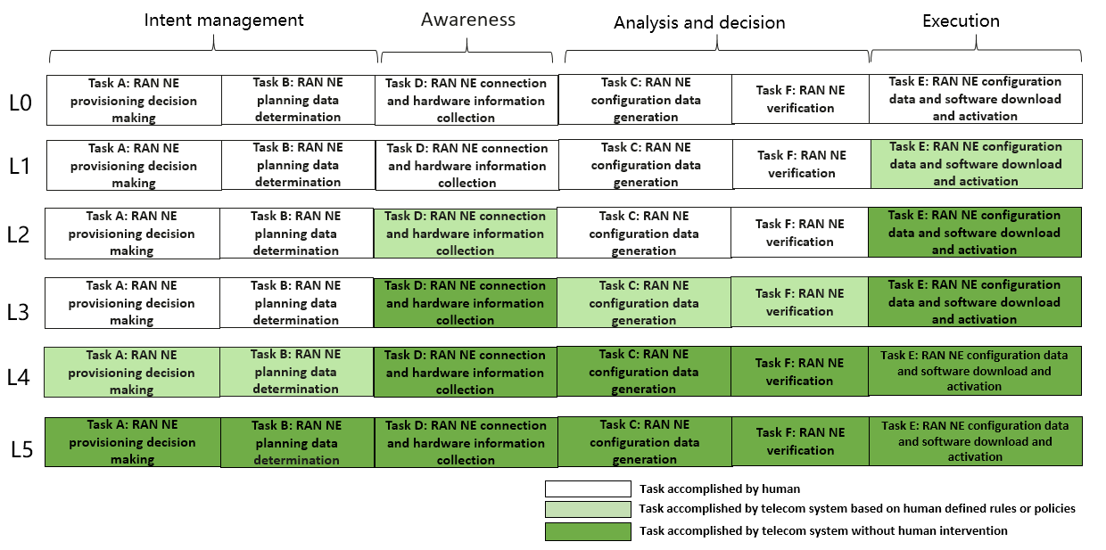
Figure 5.3.3-1: Classification of network autonomy for RAN NE provisioning
Editor’s Note: The relation of above classification of network autonomy for RAN NE provisioning and Framework approach for classification of network autonomy level defined in Clause 6.1.2 is FFS.

3rd Change

6.1.2 Framework approach for classification of autonomous network level
According to the potential categorization of the tasks in a general network autonomy workflow, a framework approach for classification of autonomous network level is introduced as following, which is used for evaluating the autonomy capability of telecom system.
Table 6.1.2-1: Framework approach for classification of autonomous network level
Network autonomy level |  | Task categories
 |  | Execution | Awareness | Analysis | Decision | Intent management
L0 | Manual operating network | Human | Human | Human | Human | Human
L1 | Assisted operating network | Human & Telecom system | Human & Telecom system | Human | Human | Human
L2 | Preliminary autonomous network | Telecom system | Human & Telecom system | Human & Telecom system | Human | Human
L3 | Intermediate autonomous network | Telecom system | Telecom system | Human & Telecom system | Human & Telecom system | Human
L4 | Advanced autonomous network | Telecom system | Telecom system | Telecom system | Telecom system | Human & Telecom system
L5 | Full autonomous network | Telecom system | Telecom system | Telecom system | Telecom system | Telecom system
Note 1: Human reviewed decision have the highest authority in each level if there is any confliction between human reviewed decision and telecom system generated decision.
Note 2: The present of above five task categories does not reflect the workflow sequence.

Level 0 manual operating network: No categorization of the tasks is accomplished by telecom system itself.
Level 1 assisted operating network: A part of the execution and awareness tasks are accomplished automatically by telecom system itself based on human defined rules. At this level, telecom system can assist human to improve the execution and awareness efficiency.
Level 2 preliminary autonomous network: All the execution tasks are accomplished automatically by telecom system itself. A part of the awareness and analysis tasks are accomplished automatically by telecom system itself based on human defined policies. At this level, telecom system can assist human to achieve the close loop based on human defined policies.
Level 3 intermediate autonomous network: All the execution and awareness tasks are accomplished automatically by telecom system itself. A part of the analysis and decision tasks are accomplished automatically by telecom system itself based on human defined policies. At this level, the telecom system can achieve the close loop automation based on the human defined close loop automation policies.
Level 4 advanced autonomous network: All the execution, awareness, analysis and decision tasks are accomplished automatically by telecom system itself. And intent management tasks can be partly accomplished automatically by telecom system itself based on human defined intent management policies. At this level, telecom system can achieve the intent driven close loop automation based on human defined intent managementpolicies, which means the telecom system can translate the intent to the detailed close loop automation policies and feed back the evaluation result/information about the fault recovery intent fulfilment based on human defined intent management policies.
Level 5 fully autonomous network: The entire network autonomy workflow is accomplished automatically by telecom system without human intervention. At this level, telecom system can achieve the whole network autonomy.
Note: Above framework approach for classification of autonomous network level are applicable for evaluating the autonomous network level from both management scope and scenario perspective. The overall autonomous network level of the whole telecom system is a comprehensive reflection of autonomous network level of the individual management scope and scenarios, which means in fully autonomous network level, the telecom system can achieve the whole network autonomy for all management scopes and scenarios.

End of changes

