3GPP TSG-SA5 Meeting #132e S5-204126

Online, , 17 Aug- 28 Aug 2020

Source: Samsung

Title: pCR Management Aspect of Edge and Deployment Model.

Document for: Approval

Agenda Item: 6.6.6

1 Decision/action requested
The group is asked to discuss and agree on the proposal.

2 References

3 Rationale
This contribution provides Management aspect of Edge and Deployemnt model as new sections in the TR.

4 Detailed proposal
1st Modified Section

X. Management Aspect of Edge
An architecture for enabling edge service is defined in TS 23.558[x]. The architecture includes various edge components and interfaces working together to enable edge services. EAS, EES and ECS, as defined in [x], are considered to be edge components deployed in a 3GPP network as 3GPP Network Functions.
The management aspect of edge includes (not limited to) the following:
- Lifecyle management of EDN as a 3GPP Local Data Network.
- Lifecycle management of edge components including EAS, EES and ECS.
- Performance Assurance of edge components components including EAS, EES and ECS.
- Fault Supervision of edge components including EAS, EES and ECS.
- Virtual resource management for edge components including EAS, EES and ECS.
- EDN capability management including the type and capabilities of EAS(s) available in the EDN.
1st Modified Section

2nd Modified Section

Annex A (informative): Deployment model
Several entities are envolved in an edge computing ecosystem as defined in SA6 including ASP (Application Service Provider), ECSP (Edge Computing Service Provider), PLMN Operator etc. The application service provider consumes the edge services (e.g. infrastructure, platform) provided by the edge computing service provider (ECSP). As per the architecture defined in TS 23.558 there can be multiple deployment variations. While some of the deployment model are very well in-scope of this document, some falls out of the scope. The following figures captures various deployment model pertaining to EAS, EES and ECS management.
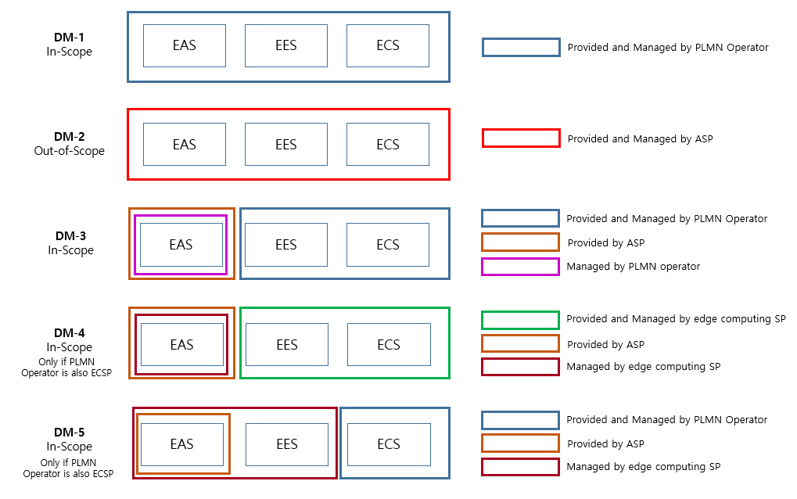
In the above figure “Provided by” imply that the functionality is created by a particular entity. Whereas, “Managed by” imply that the LCM, PA and FS of the functionality is done by a particular entity.
2nd Modified Section

