3GPP TSG-SA5 Meeting #131-e S5-203252rev4

Online, , 25th May 2020 - 3rd Jun 2020
CR-Form-v12.0
CHANGE REQUEST
 | 28.532 | CR | 0126 | rev | - | Current version: | 16.3.0
For HELP on using this form: comprehensive instructions can be found at
http://www.3gpp.org/Change-Requests.

Proposed change affects: | UICC apps |  | ME |  | Radio Access Network | X | Core Network | X

Title: | Rel-16 CR 28.532 Update Fault Supervision MnS (stage 2)
Source to WG: | Nokia, Nokia Shanghai Bell
Source to TSG: | SA5
Work item code: | TEI16, REST_SS |  |  |  |  |  | Date: |  |  | 2020-05-15
Category: | F |  |  |  |  |  | Release: |  |  | Rel-16
 | Use one of the following categories:  F (correction)  A (mirror corresponding to a change in an earlier release)  B (addition of feature),  C (functional modification of feature)  D (editorial modification)  Detailed explanations of the above categories can  be found in 3GPP TR 21.900. |  |  |  |  |  |  |  | Use one of the following releases:  Rel-8 (Release 8)  Rel-9 (Release 9)  Rel-10 (Release 10)  Rel-11 (Release 11)  Rel-12 (Release 12)  Rel-13 (Release 13)  Rel-14 (Release 14)  Rel-15 (Release 15)  Rel-16 (Release 16)
Reason for change: |  | The Fault Supervision MnS stage 2 has many editorial issues and also some ambiguous technical details.
Summary of change: |  | The complete specification of the Fault Supervision MnS stage 2 is cleaned up.
Consequences if not approved: |  | Editorial issues and ambiguous technical details remain.
Clauses affected: |  | 2, 11.2.1.1.1.1, 11.2.1.1.1.3, 11.2.1.1.2.1, 11.2.1.1.2.2, 11.2.1.1.2.3, 11.2.1.1.3.1, 11.2.1.1.3.2, 11.2.1.1.3.3, 11.2.1.1.4.1, 11.2.1.1.4.2, 11.2.1.1.4.2a (new), 11.2.1.1.4.3.2, 11.2.1.1.5.1, 11.2.1.1.5.2, 11.2.1.1.5.3.2, 11.2.1.1.6.1, 11.2.1.1.6.2, 11.2.1.1.7.1, 11.2.1.1.7.2, 11.2.1.1.7.3.2, 11.2.1.1.8.1, 11.2.1.1.8.2, 11.2.1.1.8.3, 11.2.1.1.9.1, 11.2.1.1.9.2, 11.2.1.1.9.3, 11.2.1.2.1.1, 11.2.1.2.1.2, 11.2.1.2.1.3, 11.2.1.2.2.1, 11.2.1.2.2.2, 11.2.1.2.2.3, 11.2.1.2.3.2, 11.2.1.2.3.3, 11.2.1.2.4.1, 11.2.1.2.4.2, 11.2.1.2.4.3.2, 11.2.1.2.5.1, 11.2.1.2.5.2, 11.2.1.2.6.1, 11.2.1.2.6.2, 11.2.1.2.7.1, 11.2.1.2.7.2, 11.2.1.2.8.1, 11.2.1.2.8.2, 11.2.1.2.8.3, 11.2.2.1.3.1.1, 11.2.2.1.3.1.2, 11.2.2.1.3.2.1, 11.2.2.1.3.4.2, 11.2.2.1.3.5.1, 11.2.2.1.5.1, 11.2.2.1.5.2,
 |  | Y | N
Other specs |  |  | X | Other core specifications |  |  |  | TS/TR ... CR ...
affected: |  |  | X | Test specifications |  |  |  | TS/TR ... CR ...
(show related CRs) |  |  | X | O&M Specifications |  |  |  | TS/TR ... CR ...
Other comments:
This CR's revision history:

First modification

2 References
- The following documents contain provisions which, through reference in this text, constitute provisions of the present document.
- References are either specific (identified by date of publication, edition number, version number, etc.) or non-specific.
- For a specific reference, subsequent revisions do not apply.
- For a non-specific reference, the latest version applies. In the case of a reference to a 3GPP document (including a GSM document), a non-specific reference implicitly refers to the latest version of that document in the same Release as the present document.
[1] 3GPP TR 21.905: "Vocabulary for 3GPP Specifications".
[2] 3GPP TS 28.526: "Telecommunication management; Life Cycle Management (LCM) for mobile networks that include virtualized network functions; Procedures".
[3] 3GPP TS 28.541: "Management and orchestration ; 5G Network Resource Model (NRM); Stage 2 and stage3".
[4] ITU-T Recommendation X.733 (02/92): "Information technology - Open Systems Interconnection - Systems Management: Alarm reporting function".
[5] 3GPP TS 28.531: "Management and orchestration ; Provisioning; ".
[6] 3GPP TS 28.554: "Management and orchestration ; 5G end to end Key Performance Indicators (KPI)".
[7] 3GPP TS 22.261: "Technical Specification Group Services and System Aspects; Service requirements for the 5G system; Stage 1".
[8] 3GPP TS 23.501: "Technical Specification Group Services and System Aspects; System Architecture for the 5G System; Stage 2".
[9] 3GPP TS 23.003: "Technical Specification Group Core Network and Terminals; Numbering, addressing and identification".
[10] ETSI GS NFV-IFA 013 V2.4.1 (2018-02) "Network Function Virtualization (NFV); Management and Orchestration; Os-Ma-nfvo Reference Point - Interface and Information Model Specification".
[11] 3GPP TS 28.622: "Telecommunication management; Generic Network Resource Model (NRM) Integration Reference Point (IRP); Information Service (IS)".
[12] ETSI GS NFV-IFA 015 (V2.4.1): "Network Function Virtualisation (NFV); Management and Orchestration; Report on NFV Information Model".
[13] 3GPP TS 28.533: "Management and orchestration; Architecture framework"
[14] ITU-T Recommendation X.734 (1992): "Information technology - Open Systems Interconnection - Systems management: Event report management function".
[15] 3GPP TS 32.158: "Management and orchestration; Design rules for REpresentational State Transfer (REST) Solution Sets (SS)".
[16] 3GPP TS 32.302: "Telecommunication management; Configuration Management (CM); Notification Integration Reference Point (IRP); Information Service (IS)".
[17] 3GPP TS 32.401: "Telecommunication management; Performance Management (PM); Concept and requirements".
[18] 3GPP TS 28.552: "Management and orchestration; 5G performance measurements".
[19] 3GPP TS 32.401: "Telecommunication management; Perfomance Measurement (PM); Concept and requirements".
[20] ISO 8601:2004: "Data elements and interchange formats – Information interchange – Representation of dates and times".
[21] Text Attribution: Creator: ONAP, under Creative Commons Attribution 4.0 International License, https://creativecommons.org/licenses/by/4.0/, URI to access the text: https://docs.onap.org/en/latest/_downloads/2c2b5962df52a0c1f2862f3bba3d67c7/CommonEventFormat_30.1_ONAP.json, accessed 21.03.2019.
[22] Figure Attribution: Creator: ONAP, under Creative Commons Attribution 4.0 International License, https://creativecommons.org/licenses/by/4.0/, URI to access the figure: https://docs.onap.org/en/latest/submodules/vnfsdk/model.git/docs/files/ves7_1spec.html?highlight=heartbeatIntervalChange#resource-structure, accessed 21.03.2019).
[23] Text Attribution: Creator: ONAP, under Creative Commons Attribution 4.0 International License, https://creativecommons.org/licenses/by/4.0/, URI to access the text: https://docs.onap.org/en/latest/submodules/vnfsdk/model.git/docs/files/VESEventListener_7_0_1.html?highlight=ves%207#naming-standards-for-eventname, accessed 11.04.2019).
[24] Text Attribution: Creator: ONAP, under Creative Commons Attribution 4.0 International License, https://creativecommons.org/licenses/by/4.0/, URI to access the text: https://docs.onap.org/en/latest/submodules/vnfsdk/model.git/docs/files/VESEventListener_7_0_1.html?highlight=ves%207#datatype-commoneventheader, accessed 11.04.2019).
[25] 3GPP TS 32.300: "Telecommunication management; Configuration Management (CM); Name convention for Managed Objects ".
[26] W3C REC-xmlschema-0-20010502: "XML Schema Part 0: Primer".
[27] W3C REC-xmlschema-1-20010502: "XML Schema Part 1: Structures".
[28] W3C REC-xmlschema-2-20010502: "XML Schema Part 2: Datatypes".
[29] W3C REC-xml-names-19990114: "Namespaces in XML".
[30] Text Attribution: Creator: ONAP, under Creative Commons Attribution 4.0 International License, https://creativecommons.org/licenses/by/4.0/, URI to access the text: https://onap.readthedocs.io/en/latest/submodules/vnfrqts/requirements.git/docs/Chapter8/ves7_1spec.html#datatype-heartbeatfields, accessed 06.11.2019).
[31] 3GPP TS 32.111-2: " Telecommunication management; Fault Management; Part 2: Alarm Integration Reference Point (IRP): Information Service (IS)".
[32] IETF RFC 6241 "Network Configuration Protocol (NETCONF)".
[33] 3GPP TS 32.160 " Management and orchestration; Management service template ".
[34] IETF RFC 7950 "The YANG 1.1 Data Modeling Language".
[35] OpenAPI: "OpenAPI 3.0.1 Specification", https://github.com/OAI/OpenAPI-Specification/blob/master/versions/3.0.1.md.
[36] IETF RFC 6902: "JavaScript Object Notation (JSON) Patch".
[37] IETF RFC 7396: "JSON Merge Patch".
[x] ITU-T Recommendation X.733 (02/92): "Information technology - Open Systems Interconnection - Systems Management: Alarm reporting function".

Next modification

11.2 Generic fault supervision management service

11.2.1 Operations and notifications

11.2.1.1 Operation and notification of fault supervision data report management service

11.2.1.1.1 subscribe

11.2.1.1.1.1 Definition
A MnS consumer invokes this operation to establish subscription to receive network events via notifications, under the filter constraint specified in this operation.

11.2.1.1.1.2 Input parameters
Parameter Name |  | Information Type / Legal Values | Comment
consumerReference | M | NtfSubscriber.ntfManagerReference | It specifies the reference of the authorized consumer to which notifications shall be sent.
timeTick | O | NtfSubscription.ntfTimeTick | It specifies the value of a timer held for the subject management service consumer.  The value is in unit of whole minute.  A special infinite value is assumed when parameter is absent or present but equal to zero.
filter | O | This Attribute represents the filter of a subscription. | It specifies a filter constraint that service provider shall use to filter notification of the alarms.  If this parameter is absent, then no filter constraint shall be applied.

11.2.1.1.1.3 Output parameters
Parameter Name | S | Matching Information /  Information Type / Legal Values | Comment
subscriptionId | M | NtfSubscription.ntfSubscriptionId. | It holds an unambiguous identity of this subscription.
status | M | ENUM (OperationSucceeded, OperationFailedExistingSubscription, OperationFailed) | If subscriptionCreated is true, status = OperationSuceeded.  If operation_failed_existing_subscription is true, status = OperationFailedExistingSubscription  If operation_failed is true, status = OperationFailed.

11.2.1.1.1.4 Pre-condition
notificationCategoriesNotAllSubscribed OR notificationCategoriesParameterAbsentAndNotAllSubscribed.
Assertion Name | Definition
notificationCategoriesNotAllSubscribed | At least one notificationCategory identified in the notificationCategories input parameter is supported by management service producer and is not a member of the ntfNotificationCategorySet attribute of an NtfSubscription which is involved in a subscription relationship with the NtfSubscriber identified by the managerReference input parameter.
notificationCategoriesParameterAbsentAndNotAllSubscribed | The notificationCategories input parameter is absent and at least one notificationCategory supported by management service producer is not a member of the ntfNotificationCategorySet attribute of an ntfSsubscription which is involved in a subscription relationship with the NtfSubscriber identified by the managerReference input parameter.

11.2.1.1.1.5 Post-condition
subscriberPossiblyCreated AND subscriptionCreated.
Assertion Name | Definition
subscriberPossiblyCreated | An NtfSubscriber with an ntfManagerReference attribute equal to the value of the managerReference input parameter is involved in a subscriptionRegistration relationship.
subscriptionCreated | An NtfSubscription has been created according to the following rules:  - ntfSubscriptionState attribute value has been set to "notSuspended";  - ntfTimeTick attribute value has been set to the value of the timeTick input parameter if This value was higher or equal to 15, or set to 15 if this parameter value was between 1 and 15, or set to a special infinite value if the parameter value was lower or equal to 0 or if parameter was absent;  - ntfTimeTickTimer has been reset with the value of timeTick attribute;  - ntfFilter attribute value has been set to the value of the filter input parameter if present;  - NtfSubscription is involved in a subscription relationship with the NtfSubscriber identified by the managerReference input parameter;  - attribute ntfNotificationCategorySet of NtfSubscription contains EITHER the notification categories identified by the notificationCategories input parameter that were not already contained in the ntfNotificationCategorySet attribute of other NtfSubscription of the same NtfSubscriber identified by the managerReference input parameter OR if notificationCategories input parameter is absent, all notification categories supported by management service producer that were not already contained in the ntfNotificationCategorySet attribute of other subscriptions of the same NtfSubscriber identified by the managerReference input parameter.

11.2.1.1.1.6 Exceptions
Name | Definition
operation_failed_existing_subscription | Condition: (notificationCategoriesNotAllSubscribed OR notificationCategoriesParameterAbsentAndNotAllSubscribed) not true  Returned Information: The output parameter status  Exit state: Entry State
operation_failed | Condition: Post-condition is false  Returned Information: The output parameter status  Exit state: Entry State

11.2.1.1.2 unsubscribe

11.2.1.1.2.1 Definition
A MnS consumer invokes this operation to cancel subscriptions. The MnS consumer can cancel one subscription made with a consumerReference by providing the corresponding subscriptionId or all subscriptions made with the same consumerReference by leaving the subscriptionId parameter absent.

11.2.1.1.2.2 Input parameters
Parameter Name | S | Information Type / Legal Values | Comment
consumerReference | M | DN | It specifies the reference of the MnS consumer to which notifications shall be sent.
subscriptionId | O | A unique identifier that is SS dependent. | It holds a subscriptionId carried as the output parameter in the subscribe operation.

11.2.1.1.2.3 Output parameters
Parameter Name | S | Matching Information /  Information Type / Legal Values | Comment
status | M | ENUM (OperationSucceeded, OperationFailed) | If (subscriptionDeleted OR allSubscriptionDeleted) is true, status = OperationSucceeded.  If operation_failed is true, status = OperationFailed.

11.2.1.1.2.4 Pre-condition
validSubscriptionId&ManagerReference OR SubscriptionIdAbsent&ValidManagerReference.
Assertion Name | Definition
validSubscriptionId&ManagerReference | The NtfSubscription identified by subscriptionId input parameter is involved in a subscription relationship with the NtfSubscriber identified by the managerReference input parameter.
subscriptionIdAbsent&ValidManagerReference | The subscriptionId input parameter is absent and the NtfSubscriber identified by the managerReference input parameter exists.

11.2.1.1.2.5 Post-condition
subscriptionDeleted OR allSubscriptionDeleted.
Assertion Name | Definition
subscriptionDeleted | The NtfSubscription identified by subscriptionId input parameter is no more involved in a subscription relationship with the NtfSubscriber identified by the managerReference input parameter and has been deleted. If this NtfSubscriber has no more NtfSubscription, it is deleted as well.
allSubscriptionDeleted | "In the case subscriptionId input parameter was absent, the NtfSubscriber identified by the managerReference input parameter is no more involved in any subscription relationship and is deleted, the corresponding NtfSubscription have been deleted as well.

11.2.1.1.2.6 Exceptions
Name | Definition
operation_failed | Condition: Pre-condition is false or post-condition is false  Returned Information: The output parameter status  Exit state: Entry State

11.2.1.1.3 getAlarmList

11.2.1.1.3.1 Definition
A MnS consumer invokes this operation to request the service provider to provide either the complete list of AlarmInformation instances in the AlarmList or only a part of this list (partial alarm alignment).
The parameters baseObjectClass and baseObjectInstance are used to identify the part of the alarm list to be returned. If they are absent, then the complete alarm list shall be provided (full alarm alignment). If they identify a particular class instance, then only a) the AlarmInformation instances related to this class instance and b) the AlarmInformation instances related to the subordinate class instances of this class instance shall be provided (partial alarm alignment). An instance-a is said to be subordinate to instance-b if the DN of the latter is part of the DN of the former.
There are two modes of operation. One mode is synchronous. In this mode, the list of AlarmInformation instances in AlarmList is returned synchronously with the operation. The other mode is asynchronous. In this mode, the list of AlarmInformation instances is returned via alarm notifications. In asynchronous mode of operation, the only information returned synchronously is the status of the operation. A method allowing to abort an ongoing alarm alignment process shall be available in the asynchronous mode. The mode of operation to be used is determined by means outside the scope of specification. To use asynchronous mode, the authorized consumer needs to have established a subscription via the subscribe operation.

11.2.1.1.3.2 Input parameters
Parameter Name | S | Information Type / Legal Values | Comment
alarmAckState | O | ENUM (all alarms, all active alarms, all active and acknowledged alarms, all active and unacknowledged, all Cleared and unacknowledged alarms, all unacknowledged) | It carries a constraint. The FaultSupervision MnS producer shall apply it on AlarmInformation instances in AlarmList when constructing its output parameter AlarmInformationList.
baseObjectClass | O, see note 1 | This parameter is either absent or carries the object class of a certain class. | See how this attribute is used to support full alarm alignment and partial alarm alignment in 11.1.2.3.3.1.  See note 2.
baseObjectInstance | O, see note 1 | This parameter is either absent or carries the DN of a certain class instance. | See how this attribute is used to support full alarm alignment and partial alarm alignment in 11.1.2.3.3.1.  See note 2.
filter | O | N/A | It carries a filter constraint.  If the filter is present, the service provider shall apply it on AlarmInformation instances in AlarmList when constructing its output parameter AlarmInformationList.  If the filter is not present, all of the AlarmInformation instances included by the scope are selected.
NOTE 1: If the notification notifyAlarmListRebuilt supports indicating that only a part of the alarm list has been rebuilt then the operation getAlarmList shall support partial alarm alignment.
NOTE 2: The legal values of the parameters baseObjectClass and baseObjectInstance are restricted to those carried by the parameters baseObjectClass and baseObjectInstance in the recent notifyAlarmListRebuilt notifications. The timeline for "recent" is vendor-specific.

11.2.1.1.3.3 Output parameters
Table 11.2.1.1.3.3-1: Output parameters for the operation getAlarmList
Parameter Name | S | Matching Information /  Information Type / Legal Values | Comment
alarmInformationList | M | List of AlarmInformation. | It carries the requested AlarmInformation instances.  Case when synchronous mode of operation is used:  (a) The service provider shall apply the constraints expressed in alarmAckState and filter to AlarmInformation instances when constructing this output parameter.  Case when asynchronous mode of operation is used (i.e. this output parameter is conveyed via notifications):  (a) If the filter parameter is present, the service provider shall apply the constraint when constructing this output parameter. Furthermore, if the alarmAckState constraint is present, the service provider shall apply that constraint as well. The filter constraint, if any, that is currently active in the notification channel is not used for the construction of this output parameter.  (b) If the filter parameter is absent, the service provider shall apply the filter constraint currently active in the notification channel when constructing this output parameter. If the alarmAckState constraint is present, the service provider shall apply that constraint as well.
status | M | ENUM (OperationSucceeded, OperationFailed) | If all the AlarmInformation are returned, status = OperationSucceeded.  If operation is failed, status = OperationFailed.

The following table defines an item of alarmInformationList.
Table 11.2.1.1.3.3-2: Definition of an item of alarmInformationList
Parameter name | S | Matching information | Comment
objectClass,  objectInstance | M | MonitoredEntity.objectClass,  MonitoredEntity.objectInstance | The MonitoredEntity is identified by the relation-AlarmedObject-AlarmInformation.
notificationId | M | AlarmInformation.notificationId
notificationType | M | "notifyNewAlarm"  or  "notifyChangedAlarm"  or  "notifyClearedAlarm" | The parameter carries  - notifyNewAlarm in case the alarm has not yet changed and has not yet been cleared.  - notifyChangedAlarm in case the alarm has changed but has not yet been cleared.  - notifyClearedAlarm in case the alarm has been cleared but not yet acknowledged.
eventTime | O | AlarmInformation.alarmRaisedTime or  AlarmInformation.alarmChangedTime or  AlarmInformation.alarmClearedTime | The parameter carries the  - alarmRaisedTime in case notificationType carries notifyNewAlarm  - alarmChangedTime in case notificationType carries notifyChangedAlarm  - alarmClearedTime in case notificationType carries notifyClearedAlarm
systemDN | M | --
alarmId | M | AlarmInformation.alarmId
[objectClass],  [objectInstance] | n/a | MonitoredEntity.objectClass,  MonitoredEntity.objectInstance | Parmeter identical to the first parameter in this list, shown here to clarify all elements of AlarmInformation are present
[notificationId] | n/a | AlarmInformation.notificationId | Parmeter identical to the second parameter in this list, shown here to clarify all elements of AlarmInformation are present
alarmRaisedTime | M | AlarmInformation.alarmRaisedTime
alarmChangedTime | O | AlarmInformation.alarmChangedTime | not applicable if the severity of related alarm was not changed
alarmClearedTime | M | AlarmInformation.alarmClearedTime | not applicable if related alarm was not cleared
alarmType | M | AlarmInformation.alarmType
probableCause | M | AlarmInformation.probableCause
specificProblem | O | AlarmInformation.specificProblem
perceivedSeverity | M | AlarmInformation.perceivedSeverity
backedUpStatus | O | AlarmInformation.backedUpStatus | not applicable if related alarm is a security alarm
backUpObject | O | MonitoredEntity.objectInstance | The MonitoredEntity is identified by relation-BackUpObject-AlarmInformation.  Not applicable if related alarm is a security alarm
trendIndication | O | AlarmInformation.trendIndication | not applicable if related alarm is a security alarm
thresholdInfo | O | AlarmInformation.thresholdInfo | not applicable if related alarm is a security alarm
correlatedNotifications | O | The set of CorrelatedNotification instances related to this AlarmInformation.
stateChangeDefinition | O | AlarmInformation.stateChange | not applicable if related alarm is a security alarm
monitoredAttributes | O | AlarmInformation.monitoredAttributes | not applicable if related alarm is a security alarm
proposedRepairActions | O | AlarmInformation.proposedRepairActions | not applicable if related alarm is a security alarm
additionalText | O | AlarmInformation.additionalText
additionalInformation | O | AlarmInformation.additionalInformation
rootCauseIndicator | O | AlarmInformation.rootCauseIndicator
ackTime | M | AlarmInformation.ackTime | not applicable if related alarm was not acknowledged nor unacknowledged  The availability and accuracy of time carried by the time parameters in individual entries of the list (i.e. eventTime, alarmRaisedTime, alarmClearedTime and ackTime) shall be "best effort".  Reason: A Management System is not required to persistently store these times or other alarm information (as in case of synchronization information may be provided by the NE), while also some NE's do not keep these times (and a later attempt to retrieve the alarm data from the NEs will not deliver these time data).
ackUserId | M | AlarmInformation.ackUserId | not applicable if related alarm was not acknowledged nor unacknowledged
ackSystemId | O | AlarmInformation.ackSystemId | not applicable if related alarm was not acknowledged nor unacknowledged
ackState | M | AlarmInformation.ackState | not applicable if related alarm was not acknowledged nor unacknowledged
clearUserId | O | AlarmInformation.clearUserId | not applicable if related alarm was not cleared
clearSystemId | O | AlarmInformation.clearSystemId | not applicable if related alarm was not cleared
serviceUser | M | AlarmInformation.serviceUser | not applicable if related alarm is not a security alarm
serviceProvider | M | AlarmInformation.serviceProvider | not applicable if related alarm is not a security alarm
securityAlarmDetector | M | AlarmInformation.securityAlarmDetector | not applicable if related alarm is not a security alarm
comments | M | The set of Comment instances related to this AlarmInformation. | Not applicable if the related alarm has no related comments

11.2.1.1.3.4 Exceptions and constraints
Exception Name | Definition
operation_failed | Condition: Operation is failed  Returned Information: The output parameter status  Exit state: Entry State

11.2.1.1.4 notifyNewAlarm

11.2.1.1.4.1 Definition
This notification is generated by the MnS producer when a new AlarmInformation is added to the AlarmList. The notification parameters depend on the alarmType and are different for non-security and security alarms.

11.2.1.1.4.2 Input parameters for notifications related to non-security alarms
The notifyNewAlarm notification is defined by Table 11.2.1.1.4.2-1, if the alarmType is equal to "Communications Alarm", "Processing Error Alarm", "Environmental Alarm". "Quality Of Service Alarm" or "Equipment Alarm".

Table 11.2.1.1.4.2-1: Input parameters for notifications related to non-security alarms
Parameter Name | S | Matching Information/ Information Type / Legal Values | Comment
objectClass | M | MonitoredEntity.objectClass | The MonitoredEntity is identified by the relation-AlarmedObject-AlarmInformation of the new AlarmInformation.
objectInstance | M | MonitoredEntity.objectInstance | The MonitoredEntity is identified by the relation-AlarmedObject-AlarmInformation of the new AlarmInformation.
notificationId | M | --
notificationType | M | "notifyNewAlarm"
eventTime | M | AlarmInformation.alarmRaisedTime
systemDN | M | --
alarmId | M | AlarmInformation.alarmId
alarmType | M | AlarmInformation.alarmType
probableCause | M | AlarmInformation.probableCause
perceivedSeverity | M | AlarmInformation.perceivedSeverity
specificProblem | O | AlarmInformation.specificProblem
backedUpStatus | O | AlarmInformation.backedUpStatus
backUpObject | O | MonitoredEntity.objectInstance  It carries the DN of the back up object. | The object is identified by relation-BackUpObject-AlarmInformation of the new AlarmInformation.
trendIndication | O | AlarmInformation.trendIndication
thresholdInfo | O | AlarmInformation.thresholdInfo
correlatedNotifications | O | The CorrelatedNotification instances related to this AlarmInformation.
stateChangeDefinition | O | AlarmInformation.stateChangeDefinition
monitoredAttributes | O | AlarmInformation.monitoredAttributes
proposedRepairActions | O | AlarmInformaton.proposedRepairActions
additionalText | O | AlarmInformation.additionalText
additionalInformation | O | AlarmInformation.additionalInformation
rootCauseIndicator | O | AlarmInformation.rootCauseIndicator

11.2.1.1.4.2a Input parameters for notifications related to non-security alarms
The notifyNewAlarm notification is defined by Table 11.2.1.1.4.2a-1, if the alarmType is equal to "Integrity Violation", "Operational Violation", "Physical Violation", "Security Service or Mechanism Violation" or "Time Domain Violation".
Table 11.2.1.1.4.2a-1: Input parameters for notifications related to security alarms
Parameter Name | S | Matching Information/ Information Type / Legal Values | Comment
objectClass | M | MonitoredEntity.objectClass | The MonitoredEntity is identified by the relation-AlarmedObject-AlarmInformation of the new AlarmInformation.
objectInstance | M | MonitoredEntity.objectInstance | The MonitoredEntity is identified by the relation-AlarmedObject-AlarmInformation of the new AlarmInformation.
notificationId | M | --
notificationType | M | "notifyNewAlarm"
eventTime | M | AlarmInformation.alarmRaisedTime
systemDN | M | --
alarmId | M | AlarmInformation.alarmId
alarmType | M | AlarmInformation.alarmType
probableCause | M | AlarmInformation.probableCause
perceivedSeverity | M | AlarmInformation.perceivedSeverity
correlatedNotifications | O | The set of CorrelatedNotification related to this AlarmInformation.
additionalText | O | AlarmInformation.additionalText
additionalInformation | O | AlarmInformation.additionalInformation
rootCauseIndicator | O | AlarmIngormation.rootCauseIndicator
serviceUser | M | AlarmInformation.securityServiceUser | This may contain no information if the identify of the service-user (requesting the service) is not known.
serviceProvider | M | AlarmInformation.securityServiceProvider | This shall always identify the service-provider receiving a service request, from serviceUser, that provokes the security alarm.
securityAlarmDetector | M | AlarmInformation.securityAlarmDetector | This may contain no information if the detector of the security alarm is the serviceProvider.

11.2.1.1.4.3 Triggering event

11.2.1.1.4.3.1 From-state
noMatchedAlarm.
Assertion Name | Definition
noMatchedAlarm | AlarmList does not contain an AlarmInformation that has the following properties:  Its matching-criteria-attributes values are identical to that of the newly generated network alarm and it is involved in relation-AlarmObject-AlarmInformation with the same MonitoredEntity as the one identified by the newly generated network alarm.

11.2.1.1.4.3.2 To-state
newAlarmInAlarmList.
Assertion Name | Definition
newAlarmInAlarmList | AlarmList contains an AlarmInformation holding information conveyed by the newly generated network alarm. This AlarmInformation is involved in relation-AlarmObject-AlarmInformation with the same MonitoredEntity as the one identified by the newly generated network alarm.  The following attributes of the AlarmInformation shall be populated with information of the newly generated alarm:  notificationId, alarmRaisedTime, alarmId, alarmType, , probableCause, perceivedSeverity.  The following attributes of the same AlarmInformation shall be populated with information of the newly generated alarm if the information is present (in the newly generated alarm) and if the attribute is supported:  specificProblem, backedUpStatus, trendIndication, thresholdInfo, stateChangeDefinition, monitoredAttributes, proposedRepairActions, additionalText, additionalInformation.

11.2.1.1.5 notifyChangedAlarm

11.2.1.1.5.1 Definition
This notification is generated by the MnS producer when the perceivedSeverity of an existing AlarmInformation changes (except to the value "CLEARED").

11.2.1.1.5.2 Input parameters
Parameter Name | S | Matching Information/ Information Type / Legal Values | Comment
objectClass | M | MonitoredEntity.objectClass | The MonitoredEntity is identified by the relation-AlarmedObject-AlarmInformation.
objectInstance | M | MonitoredEntity.objectInstance | The MonitoredEntity is identified by the relation-AlarmedObject-AlarmInformation.
notificationId | M | --
notificationType | M | "notifyChangedAlarm"
eventTime | M | AlarmInformation.alarmChangedTime
systemDN | M | --
alarmId | M | AlarmInformation.alarmId
alarmType | M | AlarmInformation.alarmType
probableCause | M | AlarmInformation.probableCause
perceivedSeverity | M | AlarmInformation.perceivedSeverity

11.2.1.1.5.3 Triggering event

11.2.1.1.5.3.1 From-state
alarmMatched AND alarmNotCleared AND alarmChanged.
Assertion Name | Definition
alarmMatched | The matching-criteria-attributes of the newly generated network alarm has values that are identical (matches) with ones in one AlarmInformation in AlarmList.
alarmNotCleared | The perceivedSeverity of the newly generated network alarm is not Cleared.
alarmChanged | The perceivedSeverity of the newly generated network alarm and of the matched AlarmInformation are different.

11.2.1.1.5.3.2 To-state
informationUpdate.
Assertion Name | Definition
informationUpdate | The AlarmInformation identified in alarmMatched in from-state has been updated according to the following rules:  - notificationId is updated;  - alarmChangedTime is updated;  - perceivedSeverity is updated;  - ackTime, ackUserId and ackSystemId are updated to contain no information;  - ackState is updated to "unacknowledged";

11.2.1.1.6 notifyAlarmListRebuilt

11.2.1.1.6.1 Definition
This notification is generated by the MnS producer when the AlarmList has been completely or partially rebuilt.

11.2.1.1.6.2 Input parameters
Parameter Name | S | Legal type | Comment
objectClass | M | -- | Identifies, together with the objectInstance parameter, the part of the alarm list that has been rebuilt.  If this paramter specifies the class of the instance carried in systemDN, then all AlarmInformation instances in the AlarmList may have been rebuilt.  If this parameter specifies some class represented by MonitoredEntity, then a subset of the AlarmInformation instances in the AlarmList may have been rebuilt
objectInstance | M | -- | Identifies, together with the objetClass parameter, the part of the alarm list that has been rebuilt.  If this parameter is equal to the instance carried in systemDN, then all AlarmInformation instances in the AlarmList may have been rebuilt.  If this parameter is equal to some instance represented by MonitoredEntity, then only AlarmInformation related to this instance and its descendants may have been rebuilt.
notificationId | M | -- | --
notificationType | M | "notifyAlarmListRebuilt"
eventTime | M | -- | The time when the alarm list has been rebuilt
systemDN | M | --
reason | M | "System-NE communication error", "System restarts", "indeterminate". Other values can be added. | The reason why the system has rebuilt the AlarmList. This may carry different reasons than that carried by the immediate previous notifyPotentialFaultyAlarmList.
alarmListAlignmentRequirement | O | "alignmentRequired", "alignmentNotRequired". | It carries an enumeration of "alignmentRequired" and "alignmentNotRequired".

11.2.1.1.6.3 Triggering event

11.2.1.1.6.3.1 From-state
alarmListRebuilt_0 OR alarmListRebuilt_1.
Assertion Name | Definition
alarmListRebuilt_0 | Provider has cold-started, initialized, re-initialized or rebooted and it has initiated procedure to rebuild its AlarmList.
alarmListRebuilt_1 | Provider loses confidence in part or whole of its AlarmList. Provider has initiated procedure to repair its AlarmList.

11.2.1.1.6.3.2 To-state
alarmListRebuilt_2.
Assertion Name | Definition
alarmListRebuilt_2 | Provider rebuilds the whole or part of AlarmList.

11.2.1.1.7 notifyCorrelatedNotificationChanged

11.2.1.1.7.1 Definition
This notification is generated by the MnS producer when the set of CorrelatedNotification is created, updated or deleted.

11.2.1.1.7.2 Input parameters
Parameter Name | S | Matching Information/ Information Type / Legal Values | Comment
objectClass | M | MonitoredEntity.objectClass | The MonitoredEntity is identified by the relation-AlarmedObject-AlarmInformation.
objectInstance | M | MonitoredEntity.objectInstance | The MonitoredEntity is identified by the relation-AlarmedObject-AlarmInformation.
notificationId | M | --
notificationType | M | "notifyCorrelatedNotificationChanged"
eventTime | M | It carries the time when the CorrelatedNotification is created, updated or deleted.
systemDN | M | --
alarmId | M | AlarmInformation.alarmId
correlatedNotifications | M | The CorrelatedNotification instances related to this AlarmInformation.
rootCauseIndicator | O | AlarmInformation.rootCauseIndicator

11.2.1.1.7.3 Triggering event

11.2.1.1.7.3.1 From-state
newAlarmCorrelationInfoIsAvailable AND alarmInformationExists.
Assertion Name | Definition
newAlarmCorrelationInfoIsAvailable | New alarm correlation information is available but not yet conveyed to any consumer.
alarmInformationExists | The AlarmInformation is in AlarmList.

11.2.1.1.7.3.2 To-state
alarmCorrelatedInfoUpdated.
Assertion Name | Definition
alarmCorrelatedInfoUpdated | The set of CorrelatedNotification network slice instances is created, updated or deleted.

11.2.1.1.8 getAlarmCount

11.2.1.1.8.1 Definition
A MnS consumer invokes this operation to get the number of alarms in the alarm list. The alarms are counted separately for each perceived severity level. An input parameter allows to control which alarms are counted.

11.2.1.1.8.2 Input parameters
Name | S | Information Type | Comment
filter | O | N/A | It carries a filter constraint. The operation shall apply it when counting the AlarmInformation instances in AlarmList.  Case when synchronous mode of operation is used for getAlarmList:  (a) If this parameter is present, the operation shall count the AlarmInformation instances which satisfy both (a) this filter constraint and (b) the condition set by input parameter alarmAckState.  (b) If this parameter is absent, the operation shall count all AlarmInformation instances that satisfy the condition set by input parameter alarmAckState.  Case when asynchronous mode of operation is used for getAlarmList:  (a) If this parameter is present, the operation shall count all AlarmInformation instances that satisfy this filter constraint and the condition set by input parameter alarmAckState.  (b) If this parameter is absent, the operation shall count AlarmInformation instances that satisfy (a) the filter constraint currently active in the notification channel established between the authorized consumer and the service provider and (b) the condition set by input parameter alarmAckState.
alarmAckState | O | ENUM (all alarms, all active alarms, all active and acknowledged alarms, all active and unacknowledged, all cleared and unacknowledged alarms, all unacknowledged) | It carries a constraint. The operation shall apply it on AlarmInformation instances in AlarmList when counting.

11.2.1.1.8.3 Output parameters
Name | S | Matching Information | Comment
criticalCount, majorCount, minorCount, warningCount, indeterminateCount, clearedCount | M | N/A | They carry the number of AlarmInformation in AlarmList that has the following properties.  Case when synchronous mode of operation is used:  (a) The operation shall apply the constraints expressed in alarmAckState and filter to AlarmInformation instances when counting.  Case when asynchronous mode of operation is used (i.e. this output parameter is conveyed via notifications):  (a) If the filter parameter is present, the operation shall apply the constraint when counting. Furthermore, if the alarmAckState constraint is present, the operation shall apply that constraint as well. The filter constraint, if any, that is currently active in the notification channel is not used for the counting.  (b) If the filter parameter is absent, the operation shall apply the filter constraint currently active in the notification channel when counting. If the alarmAckState constraint is present, the operation shall apply that constraint as well.
status | M | ENUM (OperationSucceeded, OperationFailed) | If allAlarmInformationCounted is true, status = OperationSucceeded.  If operation_failed is true, status = OperationFailed.

11.2.1.1.8.4 Pre-condition
There are no pre-conditions.

11.2.1.1.8.5 Post-condition
allAlarmInformationCounted.
Assertion Name | Definition
allAlarmInformationCounted | All AlarmInformation that satisfy the constraints expressed in input parameters filter and alarmAckState and are present in the AlarmList at the moment of this operation invocation are counted and the result returned.  All AlarmInformation in AlarmList remains unchanged as the result of this operation.

11.2.1.1.8.6 Exceptions
Name | Definition
operation_failed | Condition: the pre-condition is false or the post-condition is true.  Returned Information: The output parameter status.  Exit state: Entry state.
filter_complexity_limit | Condition: Operation not performed because the filter parameter is too complex.  Returned Information: The output parameter status.  Exit state: Entry state.

11.2.1.1.9 setComment

11.2.1.1.9.1 Definition
A MnS consumer invokes this operation to set a comment in one or more AlarmInformation instances in AlarmList.

11.2.1.1.9.2 Input parameters
Name | S | Information Type | Comment
alarmInformation ReferenceList | M | List of AlarmInformation.alarmId | It carries one or more identifiers identifying AlarmInformation instances in the AlarmList.
commentUserId | M | Comment.commentUserId | The Comment is identified by the relation-AlarmInformation-Comment.
commentSystemId | O | Comment.commentSystemId | The Comment is identified by the relation-AlarmInformation-Comment.
commentText | M | Comment.commentText | The Comment is identified by the relation-AlarmInformation-Comment.

11.2.1.1.9.3 Output parameters
Name | S | Matching Information | Comment
badAlarm Information ReferenceList | M | List of pair of AlarmInformation.alarmId and the failure reason. | If allUpdated is true, it contains no information.  If someUpdated is true, then it contains identifications of AlarmInformation that are not present in AlarmList or that they are present, but AlarmInformation.comments has not changed, in contrast to authorized consumer's request.
status | M | ENUM(  Operation succeeded,  Operation failed,  Operation partially failed) | If allUpdated is true, then status = OperationSucceeded.  If someUpdated is true, then status = OperationPartiallyFailed.  If exception operationFailed is raised, then status = OperationFailed.

11.2.1.2 Fault supervision data control management service

11.2.1.2.1 acknowledgeAlarms

11.2.1.2.1.1 Definition
The MnS consumer invokes this operation to acknowledge one or more alarms.
When this operation is not supported, the MnS producer shall support acknowledging alarms.

11.2.1.2.1.2 Input parameters
Parameter Name | S | Information Type / Legal Values | Comment
alarmInformationReferenceList | M | SET OF SEQUENCE {  AlarmInformation.alarmId (M)  AlarmInformation.perceivedSeverity (O)  } | It identifies the alarms to be acknowledged. If an alarm id is qualified with an optional perceived severity, the alarm shall be acknowledged only when the perceived severity in the alarm list matches the perceived severity provided in the operation request.
ackUserId | M | AlarmInformation.ackUserId | The identifier of the user acknowledgeding the alarm.
ackSystemId | O | AlarmInformation.ackSystemId | The identifier of the system where the acknowledgement request was originated.

11.2.1.2.1.3 Output parameters
Parameter Name | S | Matching Information /  Information Type / Legal Values | Comment
badAlarm Information ReferenceList | M | SET OF SEQUENCE {  AlarmInformation.alarmId (M)  errorReason (M)  }  errorReason ::= ENUM {  UnknownAlarmId,  AcknowledgmentFailed,  WrongPerceivedSeverity  } | If all alarms are acknowledged, it contains no information.  If only some alarms are acknowledged, then it contains identifications of AlarmInformation that are  (a) present in input parameter AlarmInformationReferenceList but absent in the AlarmList (errorReason = UnknownAlarmId; or  (b) present in input parameter AlarmInformationReferenceList and present in the AlarmList but the Acknowledgement Information (see note below table) has not changed despite the consumer's request (errorReason = AcknowledgmentFailed); or  (c) present in input parameter AlarmInformationReferenceList and present in the AlarmList but the perceivedSeverity to be acknowledged has changed and/or is different in the Alarm List (ErrorReason = WrongPerceivedSeverity), applicable only if perceivedSeverity is provided.
status | M | ENUM {  OperationSucceeded,  OperationPartiallySucceeded,  OperationFailed  } | If all alarms acknowledged, then  status = OperationSucceeded.  If some alarms are acknowledged, then status = OperationPartiallySuceeded.  If operation failed is true, then  status = OperationFailed.

NOTE: Acknowledgement Information is defined as the information contained in AlarmInformation.ackTime, AlarmInformation.ackUserId, AlarmInformaton.ackSystemId, AlarmInformation.ackState.

11.2.1.2.1.4 Exceptions and constraints
Exception Name | Definition
operation_failed | Condition: Operation is failed  Returned Information: The output parameter status  Exit state: Entry State

11.2.1.2.2 unacknowledgeAlarms

11.2.1.2.2.1 Definition
The MnS consumer invokes this operation to remove acknowledgement information kept in one or more AlarmInformation instances.

11.2.1.2.2.2 Input parameters
Parameter Name | S | Information Type / Legal Values | Comment
alarmInformationReferenceList | M | List of AlarmInformation.alarmId | It carries one or more identifiers identifying AlarmInformation in AlarmList.
ackUserId | M | AlarmInformation.ackUserId | The identifier of the user unacknowledgeding the alarm.
ackSystemId | O | AlarmInformation.ackSystemId | The identifier of the system where the acknowledgement request was originated.

11.2.1.2.2.3 Output parameters
Parameter Name | S | Matching Information /  Information Type / Legal Values | Comment
badAlarmInformation  ReferenceList | M | SET OF SEQUENCE {  AlarmInformation.alarmId (M)  errorReason (M)  }  errorReason ::= ENUM {  UnknownAlarmId,  AcknowledgmentFailed,  WrongPerceivedSeverity,  } | If all alarms are acknowledged, it contains no information.  If only some alarms are acknowledged, then it contains identifications of AlarmInformation that are  (a) present in input parameter AlarmInformationReferenceList but absent in the AlarmList (errorReason = UnknownAlarmId; or  (b) present in input parameter AlarmInformationReferenceList and present in the AlarmList but the Acknowledgement Information (see note below table) has not changed despite the consumer's request (errorReason = AcknowledgmentFailed); or  (c) present in input parameter AlarmInformationReferenceList and present in the AlarmList but the perceivedSeverity to be acknowledged has changed and/or is different in the Alarm List (ErrorReason = WrongPerceivedSeverity), applicable only if perceivedSeverity is provided.
status | M | ENUM {  OperationSucceeded,  OperationPartiallySucceeded,  OperationFailed  } | If all alarms acknowledged, then  status = OperationSucceeded.  If some alarms are acknowledged, then  status = OperationPartiallySuceeded.  If operation failed is true, then  status = OperationFailed.

NOTE: Acknowledgement Information is defined as the information contained in AlarmInformation.ackTime, AlarmInformation.ackUserId, AlarmInformaton.ackSystemId, AlarmInformation.ackState.

11.2.1.2.2.4 Exceptions and constraints
Exception Name | Definition
Operation_failed | Condition: Operation is failed  Returned Information: The output parameter status  Exit state: Entry State

11.2.1.2.3 clearAlarms

11.2.1.2.3.1 Definition
The authorized consumer invokes this operation to clear one or more AlarmInformation instances in AlarmList. For example, this operation can be used to support the manual clearing of the ADMC (automatic detection and manual clearing, see also 3GPP TS 32.111-1 [3]) alarms.

11.2.1.2.3.2 Input parameters
Parameter Name | S | Information Type / Legal Values | Comment
alarmInformation ReferenceList | M | List of AlarmInformation.alarmId | It carries one or more identifiers identifying AlarmInformation instances in the AlarmList.
clearUserId | M | AlarmInformation.clearUserId | It identities the user clearing the alarm.
clearSystemId | O | AlarmInformation.clearSystemId | It identifies the authorized consumer. It may be absent implying that consumer does not wish this information be known to the service provider.

11.2.1.2.3.3 Output parameters
Parameter Name | S | Matching Information /  Information Type / Legal Values | Comment
badAlarmInformation ReferenceList | M | List of pair of AlarmInformation.alarmId and the failure reason. | If all alarms are cleared, it contains no information.  If some alarms are cleared, then it contains identifications of AlarmInformation that are not present in AlarmList or that are present in AlarmList but remain unchanged, in contrast to consumer's request.
status | M | ENUM(  OperationSucceeded,  OperationFailed,  OperationPartiallySucceeded) | If all alarms are cleared, then status = OperationSucceeded.  If some alarms are cleared, then status = OperationPartiallySucceeded.  If operation is failed, then status = OperationFailed.

11.2.1.2.3.4 Exceptions and constraints
Exception Name | Definition
operation_failed | Condition: Operation is failed  Returned Information: The output parameter status  Exit state: Entry State

11.2.1.2.4 notifyClearedAlarm

11.2.1.2.4.1 Definition
This notification is generated by the MnS producer when the perceivedSeverity of an existing AlarmInformation changes to "CLEARED".

11.2.1.2.4.2 Input parameters
Parameter Name | S | Matching Information/ Information Type / Legal Values | Comment
objectClass | M | MonitoredEntity.objectClass
objectInstance | M | MonitoredEntity.objectInstance
notificationId | M | --
notificationType | M | "notifyClearedAlarm"
eventTime | M | AlarmInformation.alarmClearedTime
systemDN | M | --
alarmId | M | AlarmInformation.alarmId
alarmType | M | AlarmInformation.alarmType
probableCause | M | AlarmInformation.probablaCause
perceivedSeverity | M | AlarmInformation.perceivedSeverity | Value shall be "CLEARED"
correlatedNotifications | O | The CorrelatedNotification instances related to this AlarmInformation. | This parameter contains references to other AlarmInformation instances whose perceivedSeverity levels are cleared as well. In this way, the perceivedSeverity level of multiple AlarmInformation instances can be cleared by one notification.
clearUserId | O | AlarmInformation.clearUserId | This parameter shall be present and contain valid information if the AlarmInformation is cleared by a clearAlarms operation request.
clearSystemId | O | AlarmInformation.clearSystemId | This parameter is present if clearUserId is present and if AlarmInformation.clearSystemId contains valid information.

11.2.1.2.4.3 Triggering event

11.2.1.2.4.3.1 From-state
alarmMatchedAndCleared OR clearedByProvider.
Assertion Name | Definition
alarmMatchedAndCleared | The matching-criteria-attributes of the newly generated network alarm have values that are identical (matched) with ones in one AlarmInformation in AlarmList and the perceivedSeverity of the matched AlarmInformation is not Cleared  AND  The perceivedSeverity of the newly generated network alarm is cleared.
clearedByProvider | Reception of a valid clearAlarms operation that identifies the subject AlarmInformation instances. This triggering event shall occur regardless of the perceivedSeverity state of the identified AlarmInformation instances.

11.2.1.2.4.3.2 To-state
alarmInformationCleared_1 OR alarmInformationCleared_2.
Assertion Name | Definition
alarmInformationCleared_1 | Case if From-state is alarmMatchedAndCleared:  The following attributes of the subject AlarmInformation are updated:  notificationId, perceivedSeverity (updated to Cleared), alarmClearedTime.
alarmInformationCleared_2 | Case if From-state is clearedByProvider:  The following attributes of the subject AlarmInformation are updated:  notificationId, alarmClearedTime, perceivedSeverity (updated to CLEARED), alarmClearedUserId, alarmClearedSystemId.

11.2.1.2.5 notifyAckStateChanged

11.2.1.2.5.1 Definition
This notification is generated by the MnS producer when a the acknowledgement state of an alarm changes from "UNACKNOWLEDGED" to "ACKNOWLEDGED" or back from "ACKNOWLEDGED" to "UNACKNOWLEDGED".
Alarms can be acknowledged by a MnS consumer or, optionally, by the MnS producer maintainig the alarm list. When the acknowledgeAlarms operation is not supported, the MnS producer shall support acknowledging alarms.
Alarm acknowledgement by the MnS producer is based on some vendor specific policy. For example, checking for alarms to be acknowledged may run once a day, once every 4 hours, or always. Alarms selected for being acknowldeged may include alarms that are cleared for more than 24 hours or those whose perceived severity is MINOR

11.2.1.2.5.2 Input parameters
Parameter Name | S | Matching Information/ Information Type / Legal Values | Comment
objectClass | M | MonitoredEntity.objectClass
objectInstance | M | MonitoredEntity.objectInstance
notificationId | M | --
notificationType | M | "notifyAckStateChanged"
eventTime | M | AlarmInformation.ackTime
systemDN | M | --
alarmId | M | AlarmInformation.alarmId
alarmType | M | AlarmInformation.alarmType
probableCause | M | AlarmInformation.probableCause
perceivedSeverity | M | AlarmInformation.perceivedSeverity
ackState | M | AlarmInformation.ackState
ackUserId | M | AlarmInformation.ackUserId | The identifier of the user who acknowledged or unacknowledged the alarm.
ackSystemId | O | AlarmInformation.ackSystemId | The identifier of the system where the acknowledgement or unacknowledgement request was originated.

11.2.1.2.5.3 Triggering event

11.2.1.2.5.3.1 From-state
ackedByConsumer OR ackedByProvider AND alarmInformationExists.
Assertion Name | Definition
ackedByConsumer | Reception of an acknowledgeAlarms operation and a subsequent operation success return.
ackedByProvider | Reception of a local (non-standard) acknowlegeAlarms equivalent operation and a subsequent operation success return.
alarmInformationExists | The AlarmInformation exists in AlarmList.

11.2.1.2.5.3.2 To-state
alarmAckStateHasChanged.
Assertion Name | Definition
alarmAckStateHasChanged | The AlarmInformation.ackState of the AlarmInformation identified by from-state assertion alarmInformationExists have been updated. Specifically, the following attributes of the subject AlarmInformation are updated:  -- notificationId, ackTime, ackUserId, ackState, ackSystemId.

11.2.1.2.6 notifyComments

11.2.1.2.6.1 Definition
This notification is generated by the MnS producer when a Comment instance is added to an AlarmInformation instance in the AlarmList.

A MnS producer shall support this notification if it supports the operation setComment.

11.2.1.2.6.2 Input parameters
Parameter Name | S | Matching Information/ Information Type / Legal Values | Comment
objectClass | M | MonitoredEntity.objectClass
objectInstance | M | MonitoredEntity.objectInstance
notificationId | M | --
notificationType | M | "notifyComments"
eventTime | M | Comment.commentTime
systemDN | M | --
alarmId | M | AlarmInformation.alarmId
alarmType | M | AlarmInformation.alarmType
probableCause | M | AlarmInformation.probableCause
perceived Severity | M | AlarmInformation.perceivedSeverity
comments | M | The Comment instances related to this AlarmInformation.

11.2.1.2.6.3 Trigger event

11.2.1.2.6.3.1 From-state
commentedByServiceprovider OR commentedByServiceprovider AND alarmInformationExists.
Assertion Name | Definition
commentedByServiceprovider | Reception of a setComment operation and a subsequent operation success return.
commentedByServiceprovider | Reception of a local (non-standard) setComment equivalent operation and a subsequent operation success return.
alarmInformationExists | The AlarmInformation is in AlarmList.

11.2.1.2.6.3.2 To-state
commentInserted.
Assertion Name | Definition
commentInserted | One Comment has been created and it is involved in a relationship with the AlarmInformation identified by from-state assertion alarmInformationExists. The following attributes of the newly created Comment instance shall be populated:  commentTime, commentText, commentUserId and commentSystemId.

11.2.1.2.7 notifyPotentialFaultyAlarmList

11.2.1.2.7.1 Definition
This notification is generated by the MnS producer when the MnS producer looses confidence in the integrity of its alarm list.
The MnS producer may then rebuilt the faulty alarm list. When the alarm List is rebuilt or confidence in the existing alarm list is re-established the MnS producer may generate a notifyAlarmListRebuilt notification.
The parameters objectClass and objectInstance are used to specify if the complete alarm list is unreliable or only parts thereof.

The MnS consumer behaviour, on reception of this notifyPotentialFaultyAlarmList notification, is not specified. The authorized consumer behaviour is considered not essential for the specification of the interface itself. However, the following are recommended actions the uthorized consumer should take, in case it receives this notification.
1) The uthorized consumer should not perform any task requiring the integrity of the AlarmInformation identified as faulty or unreliable by the subject notification.
2) The uthorized consumer should not invoke operations that require integrity of the AlarmList such as getAlarmList., acknolwedgeAlarms operations.

11.2.1.2.7.2 Input parameters
Parameter Name | S | Matching Information/ Information Type / Legal Values | Comment
objectClass | M | It identifies  the class of the instance identified by systemDN or  the class of MonitoredEntity. | Identifies, together with the objectInstance parameter, the part of the alarm list that is not reliable.  If this paramter specifies the class of the instance carried in systemDN, then all AlarmInformation instances in the AlarmList may not be reliable.  If this parameter specifies some class represented by MonitoredEntity, then a subset of the AlarmInformation instances in the AlarmList is not reliable.
objectInstance | M | It identifies  the instance identified by systemDN or  an instance of MonitoredEntity. | Identifies, together with the objetClass parameter, the part of the alarm list that may not be reliable.  If this parameter is equal to the instance carried in systemDN, then all AlarmInformation instances in the AlarmList may not be reliable.  If this parameter is equal to some instance represented by MonitoredEntity, then only AlarmInformation related to this instance and its descendants may not be reliable.
notificationId | M | --
notificationType | M | "notifyPotentialFaultyAlarmList"
eventTime | M | -- | Time when the MnS producer lost confidence in the integrity of the alarm list
systemDN | M | --
reason | M | "serviceprovider-NE communication error", " serviceprovider restarts", "indeterminate". Other values can be added. | Reason why the MnS producer has to rebuild its AlarmList.

11.2.1.2.7.3 Trigger event

11.2.1.2.7.3.1 From-state
faultyAlarmListDetected.
Assertion Name | Definition
faultyAlarmListDetected | Service provider detects faults in part or whole of its AlarmList.

11.2.1.2.7.3.2 To-state
faultyAlarmList
Assertion Name | Definition
faultyAlarmList | Service provider initiates the AlarmList rebuild process.

11.2.1.2.8 notifyChangedAlarmGeneral

11.2.1.2.8.1 Definition
This notification is generated by the MnS producer when one or more of the following attributes of an AlarmInformation instance in the AlarmList changes its value: backedUpStatus, backUpObject, trendIndication, thresholdInfo, stateChangeDefinition, monitoredAttributes, proposedRepairActions, additionalText, additionalInformation, serviceUser, serviceProvider or securityAlarmDetector.
The notification parameters depend on the alarmType and are different for non-security and security alarms.

11.2.1.2.8.2 Input parameters for notifications related to non-security alarms
The notifyChangedAlarmGeneral notification is defined by Table 11.2.1.2.8.2-1, if the alarmType is equal to "Communications Alarm", "Processing Error Alarm", "Environmental Alarm". "Quality Of Service Alarm" or "Equipment Alarm".

Table 11.2.1.2.8.2-1: Input parameters for notifications related to non-security alarms
Parameter Name | S | Matching Information/ Information Type / Legal Values | Comment
objectClass | M | MonitoredEntity.objectClass
objectInstance | M | MonitoredEntity.objectInstance
notificationId | M | --
notificationType | M | "notifyChangedAlarmGeneral"
eventTime | M | AlarmInformation.alarmChangedTime
systemDN | M | --
alarmId | M | AlarmInformation.alarmId
alarmType | M | AlarmInformation.alarmType
probableCause | M | AlarmInformation.probableCause
specificProblem | O | AlarmInformation.specificProblem
perceivedSeverity | M | AlarmInformation.perceivedSeverity
backedUpStatus | O | AlarmInformation.backedUpStatus
backUpObject | O | MonitoredEntity.objectInstance | The DN of the back up object. The object is identified by relation-BackUpObject-AlarmInformation of the new AlarmInformation.
trendIndication | O | AlarmInformation.trendIndication
thresholdInfo | O | AlarmInformation.thresholdInfo
correlatedNotifications | O | Set of CorrelatedNotification related to this AlarmInformation.
stateChangeDefinition | O | AlarmInformation.stateChange
monitoredAttributes | O | AlarmInformation.monitoredAttributes
proposedRepairActions | O | AlarmInformaton.proposedRepairActions
additionalText | O | AlarmInformation.additionalText
additionalInformation | O | AlarmInformation.additionalInformation
rootCauseIndicator | O | alarmInformation.rootCauseIndicator
changedAlarmAttributes | M | LIST OF SEQUENCE <AttributeName, OldAttributeValue> | The changed alarm attributes (name/value pairs) (with old values).

11.2.1.2.8.3 Input parameters for notifications related to security alarms
The notifyChangedAlarmGeneral notification is defined by Table 11.2.1.1.4.2a-1, if the alarmType is equal to "Integrity Violation", "Operational Violation", "Physical Violation", "Security Service or Mechanism Violation" or "Time Domain Violation".
Table 11.2.1.2.8.3-1: Input parameters for notifications related to security alarms
Parameter Name | S | Matching Information/ Information Type / Legal Values | Comment
objectClass | M | MonitoredEntity.objectClass
objectInstance | M | MonitoredEntity.objectInstance
notificationId | M | --
notificationType | M | "notifyChangedAlarmGeneral".
eventTime | M | AlarmInformation.alarmChangedTime
systemDN | M | --
alarmId | M | AlarmInformation.alarmId
alarmType | M | AlarmInformation.alarmType
probableCause | M | AlarmInformation.probableCause
perceivedSeverity | M | AlarmInformation.perceivedSeverity
correlatedNotifications | O | Set of CorrelatedNotification related to this AlarmInformation.
additionalText | O | AlarmInformation.additionalText
additionalInformation | O | AlarmInformation.additionalInformation
rootCauseIndicator | O | alarmInformation.rootCauseIndicator
serviceUser | M | AlarmInformation.serviceUser | This may contain no information if the identify of the service-user (requesting the service) is not known.
serviceProvider | M | AlarmInformation.serviceProvider | This shall always identify the service-provider receiving a service request, from serviceUser, that provokes the security alarm.
securityAlarmDetector | M | AlarmInformation.securityAlarmDetector | This may contain no information if the detector of the security alarm is the serviceProvider.
changedAlarmAttributes | M | LIST OF SEQUENCE <AttributeName, OldAttributeValue> | The changed alarm attributes (name/value pairs) (with old values).

11.2.1.2.8.4 Trigger event

11.2.1.2.8.4.1 From-state
alarmMatched AND alarmNotCleared AND alarmChanged.
Assertion Name | Definition
alarmMatched | The matching-criteria-attributes of the newly generated network alarm has values that are identical (matches) with ones in one AlarmInformation in AlarmList.
alarmChanged | The backedUpStatus, backUpObject, trendIndication, thresholdInfo, stateChangeDefinition, monitoredAttributes, proposedRepairActions, additionalText, additionalInformation, serviceUser, serviceProvider or securityAlarmDetector of the newly generated network alarm and of the matched AlarmInformation are different.

11.2.1.2.8.4.2 To-state
informationUpdate.
Assertion Name | Definition
informationUpdate | The AlarmInformation identified in alarmMatched in from-state has been updated according to the following rules: backedUpStatus, backUpObject, trendIndication, thresholdInfo, stateChangeDefinition, monitoredAttributes, proposedRepairActions, additionalText, additionalInformation, serviceUser, serviceProvider or securityAlarmDetector is updated;  notificationId is updated;  alarmChangedTime is updated;  ackTime, ackUserId and ackSystemId are updated to contain no information;  ackState is updated to "unacknowledged";

11.2.2 Managed information

11.2.2.1 Alarm information, alarm state change and Information Object Classes

11.2.2.1.1 Imported information entities and local labels
None.

11.2.2.1.2 Class diagram

11.2.2.1.2.1 Introduction
This clause introduces the fault supervision related classes (i.e. IOCs, SupportIOCs). The intent is to identify the information required for the Fault management service implementation of its operations and notification emission. This clause provides the overview of all support object classes in UML. Subsequent clauses provide more detailed specification of various aspects of these support object classes.

11.2.2.1.2.2 Attributes and relationships
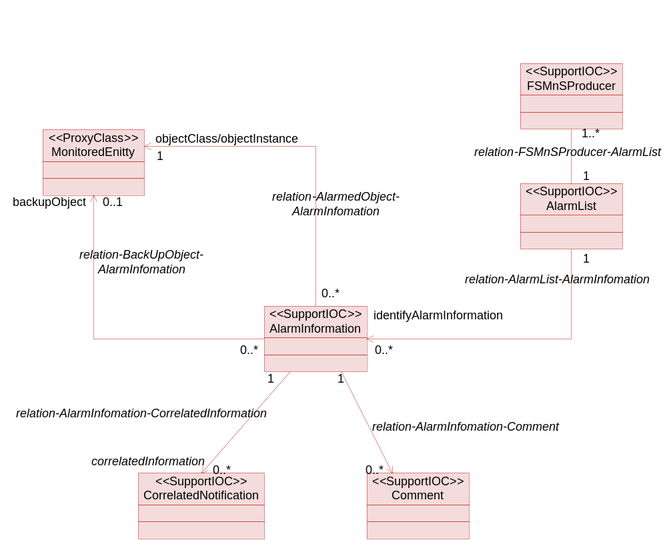

11.2.2.1.3 Information Object Class Definitions

11.2.2.1.3.1 AlarmInformation

11.2.2.1.3.1.1 Definition
AlarmInformation contains information about alarm conditions of an alarmed MonitoredEntity.
A MnS producer is related to at most one AlarmList. The MnS producer assigns an identifier, called alarmId, to each AlarmInformation in the AlarmList. An alarmId unambiguously identifies one AlarmInformation in the AlarmList.

11.2.2.1.3.1.2 Attribute
Attribute name | S
alarmId | M
objectClass/objectInstance (attribute related to role) | M
notificationId | M
alarmRaisedTime | M
alarmChangedTime | O
alarmClearedTime | M
alarmType | M
probableCause | M
specificProblem | O
perceivedSeverity | M
backedUpStatus | O
backUpObject (attribute related to role) | O
trendIndication | O
thresholdInfo | O
correlatedNotifications (attribute related to role) | O
stateChangeDefinition | O
monitoredAttributes | O
proposedRepairActions | O
additionalText | O
additionalInformation | O(see note 3)
rootCauseIndicator | O
ackTime | M
ackUserId | M
ackSystemId | O
ackState | M
clearUserId | O (see note 1)
clearSystemId | O (see note 1)
serviceUser | O (see note 2)
serviceProvider | O (see note 2)
securityAlarmDetector | O (see note 2)
NOTE 1: These attributes and qualifiers are applicable only if the management service producer supports clearAlarms() (they are absent if clearAlarms() is not supported).
NOTE 2: These attributes are supported if the management service producer emits notifyNewAlarm that carries security alarm information.
NOTE 3: This attribute is optionally populated whenever vendor specific attributes are needed.

11.2.2.1.3.1.3 State diagram
Alarms have states. The alarm state information is captured in AlarmInformation in AlarmList.
The solid circle icon represents the Start State. The double circle icon represents the End State. In this state, the alarm is Cleared and acknowledged. The AlarmInformation shall not be accessible via the Service interface and is removed from the AlarmList.
Note the state diagram uses " X / Y ^ Z " to label the arc that indicates state transition. The meanings of X, Y and Z are:
- X identifies the triggering event;
- Y identifies the action of FaultSupervision MnS producer because of the triggering event;
- Z is the notification to be emitted by FaultSupervision MnS producer because of the triggering event.
Note that acknowledgeAlarm^notifyAckStateChanged and the unacknowledgeAlarm^notifyAckStateChanged refer to cases when the request of the management service consumer is successful for the AlarmInformation concerned. They do not refer to the cases when the request is a failure since in the failure cases, no state transition would occur.
Note that, to reduce cluttering to the diagram, the setComment^notifyComment is not included in the figure . One transition should be applied from unack&unclear to itself. Similarly, another transition should be applied from ack&unclear to itself. Another one is from unack&clear to itself.
"PS" used in the state diagram stands for "perceived severity".
Figure 11.2.2.1.3.1.3-1 is used if it supports ^notifyChangedAlarm and Figure 11.2.2.1.3.1.3-2 is used if it does not support ^notifyChangedAlarm.
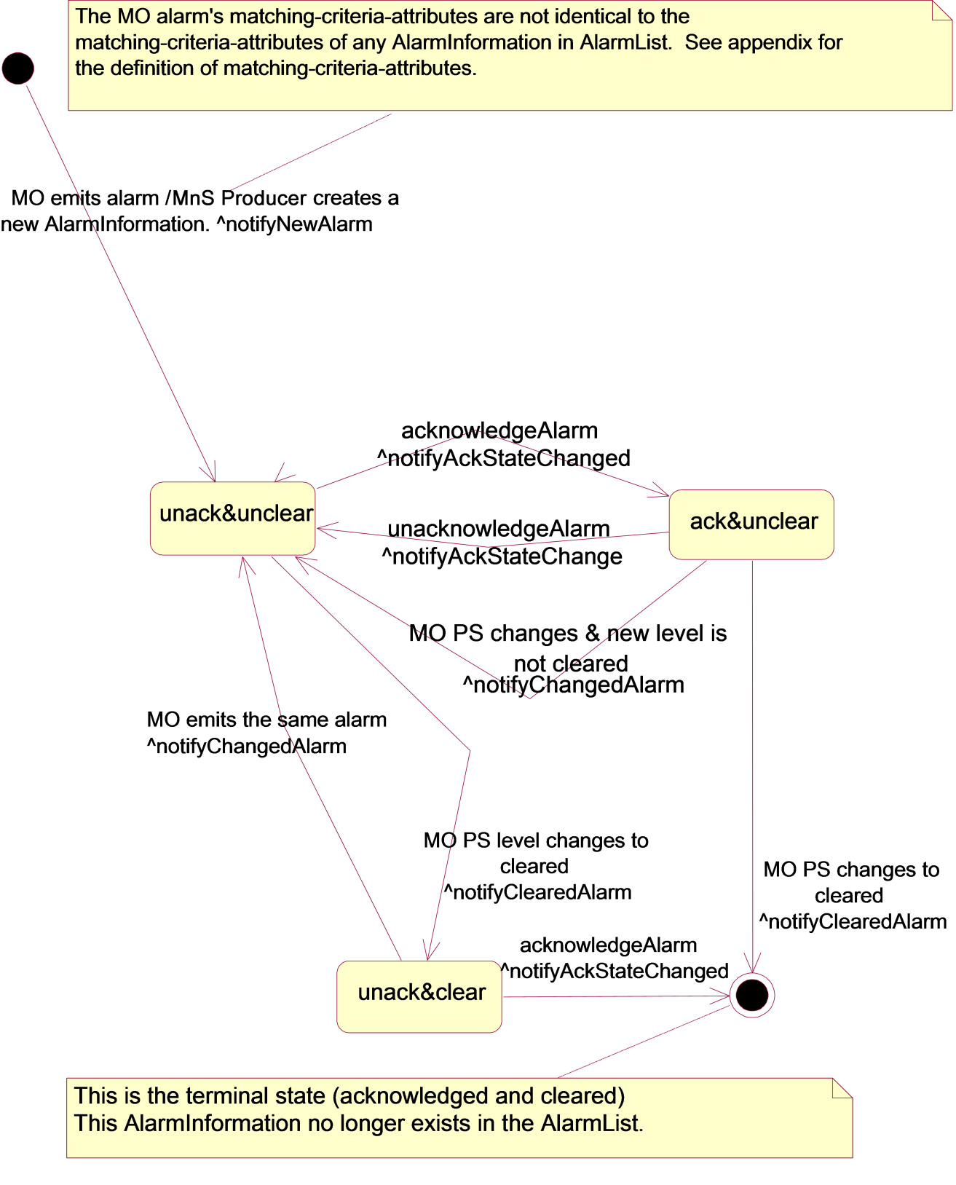
Figure 11.2.2.1.3.1.3-1 notifyChangedAlarm supported

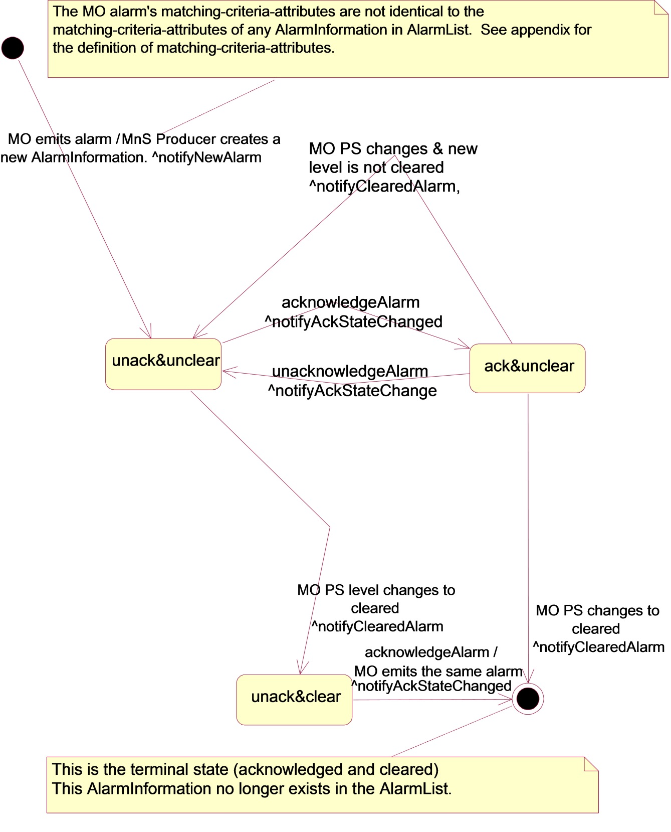
Figure 11.2.2.1.3.1.3-2 notifyChangedAlarm not supported

11.2.2.1.3.2 AlarmList

11.2.2.1.3.2.1 Definition
The MnS producer maintains an AlarmList that contains currently active alarms (i.e. AlarmInformation whose perceivedSeverity is not Cleared) and alarms that are Cleared but not yet acknowledged.

11.2.2.1.3.2.2 Attribute
There is no additional attribute defined for this class besides those inherited.

11.2.2.1.3.3 FSMnSProducer

11.2.2.1.3.3.1 Definition
FSMnSProducer is the representation of the entity who provides the fault supervision management service(s) and contains the AlarmList.

11.2.2.1.3.3.2 Attribute
There is no additional attribute defined for this class besides those inherited.

11.2.2.1.3.3.3 Notification Table
Name | S | Notes
notifyAlarmListRebuilt | M
notifyPotentialFaultyAlarmList | O | .

11.2.2.1.3.4 Comment

11.2.2.1.3.4.1 Definition
Comment contains commentary and associated information such as the time when the commentary is made.

11.2.2.1.3.4.2 Attribute
Attribute Name | S
commentTime | M
commentUserId | M
commentSystemId | O
commentText | M

11.2.2.1.3.5 CorrelatedNotification

11.2.2.1.3.5.1 Definition
The sourceObjectInstance attribute of CorrelatedNotification identifies one MonitoredEntity. For the MonitoredEntity identified, a set of notification identifiers is also identified. One or more CorrelatedNotification instances can be related to an AlarmInformation. In this case, the information of the AlarmInformation is said to be correlated to information carried in the notifications identified by the CorrelatedNotification instances. See further definition of correlated notification in ITU-T Recommendation X.733 [4], clause 8.1.2.9.
The notification identified by the CorrelatedNotification, as defined in ITU-T and used here, can carry all types of information and is not restricted to carrying alarm information only. For example, a notification, identified by the CorrelatedNotification, can indicate a managed instance attribute value change. In this case, the information of the AlarmInformation is said to be correlated to the managed instance attribute value change event.
The meaning of correlation is dependent on the type of notification itself. See the comment column of the correlatedNotification input parameter for each type of notification, such as notifyNewAlarm.
Notification carries AlarmInformation. The AlarmInformation instances referred to by the correlatedNotification may or may not exist in the AlarmList. For example, the AlarmInformation carried by the identified notification may have been acknowledged and Cleared and therefore, no longer exist in the AlarmList.

11.2.2.1.3.5.2 Attribute
Attribute Name | S
sourceObjectInstance | M
notificationIdSet | M

11.2.2.1.3.6 MonitoredEntity

11.2.2.1.3.6.1 Definition
It represents classes that can have an alarmed state. The types of classes that can have alarmed state are:
a) All classes whose Notification Tables include alarm notifications.
b) VSE subclass of 3GPP defined classes and VSE defined classes that can have alarmed state.
The objectClass and objectInstance of this class identifies an instance of this class. The AlarmInformation uses this information in two places. In one place, the information is used to identify the instance that is in alarmed state. In another place, the information is used to identify an instance that can be used as the back up network resource for the instance that is in alarmed state.

11.2.2.1.3.6.2 Attribute
There is no attribute for this class.

11.2.2.1.4 Information relationships definition

11.2.2.1.4.1 relation-FSMnSProducer-AlarmList (M)

11.2.2.1.4.1.1 Definition
This represents the relationship between FSMnSProducer and AlarmList.

11.2.2.1.4.1.2 Role
There is no role defined for this relationship.

11.2.2.1.4.1.3 Constraint
There is no constraint for this relationship.

11.2.2.1.4.2 relation-AlarmList-AlarmInformation (M)

11.2.2.1.4.2.1 Definition
This represents the relationship between AlarmList and AlarmInformation.

11.2.2.1.4.2.2 Role
Name | Definition
identifyAlarmInformation | It represents a capability to obtain the information contained in AlarmInformation.

11.2.2.1.4.2.3 Constraint
Name | Definition
inv_ hasAlarmInformation1 | No AlarmInformation playing the role of theAlarmInformation shall have its perceivedSeverity = "cleared" and its ackState = "acknowledged".
inv_ hasAlarmInformation2 | The alarmId of all AlarmInformation instances playing the role of theAlarmInformation are distinct.

11.2.2.1.4.3 relation-AlarmInformation-Comment (M)

11.2.2.1.4.3.1 Definition
This represents the relationship between AlarmInformation and Comment.

11.2.2.1.4.3.2 Role
Name | Definition
comment | It represents a capability to obtain the information contained in Comment.

11.2.2.1.4.3.3 Constraint
There is no constraint.

11.2.2.1.4.4 relation-AlarmInformation-CorrelatedNotification (M)

11.2.2.1.4.4.1 Definition
This represents the relationship between AlarmInformation and CorrelatedNotification.

11.2.2.1.4.4.2 Role
Name | Definition
correlatedNotification | It represents a capability to obtain the information contained in CorrelatedNotification.

11.2.1.4.4.3 Constraint
There is no constraint.

11.2.2.1.4.5 relation-AlarmedObject-AlarmInformation (M)

11.2.2.1.4.5.1 Definition
This represents the relationship between MonitoredEntity and AlarmInformation.

11.2.2.1.4.5.2 Role
Name | Definition
objectClass/objectInstance | It represents the capability to obtain the identification, in terms of objectClass and objectInstance, of alarmed network resource.

11.2.2.1.4.5.3 Constraint
Name | Definition
inv_relation-AI-ME | All AlarmInformation involved in this relationship with the same MonitoredEntity shall have at least one different value in the following attributes: alarmType, probableCause and specificProblem.

11.2.2.1.4.6 relation-backUpObject-AlarmInformation (O)

11.2.2.1.4.6.1 Definition
The relationship represents the relationship between AlarmInformation and the backUpObject.

11.2.2.1.4.6.2 Role
Name | Definition
backUpObject | It represents a capability to obtain the identification, in terms of objectClass and objectInstance, of the backUpObject.

11.2.2.1.4.6.3 Constraint
Name | Definition
inv_identifyBackUpObject | This relationship is present if and only if the AlarmInformation.backedUpStatus attribute is present and is indicating true.

11.2.2.1.5 Information attribute definition

11.2.2.1.5.1 Definition and legal values
Name | Definition | Legal Values
alarmId | It identifies one AlarmInformation in the AlarmList.
notificationId | It identifies the notification that carries the AlarmInformation.
alarmRaisedTime | It indicates the date and time when the alarm is first raised by the alarmed resource. | All values indicating valid date and time.
alarmChangedTime | It indicates the last date and time when the AlarmInformation is changed by the alarmed resource. Changes to AlarmInformation caused by invocations of the management service consumer would not change this date and time. | All values indicating valid date and time.
alarmClearedTime | It indicates the date and time when the alarm is cleared. | All values indicating valid date and time.
alarmType | It indicates the type of alarm.  Communications Alarm:  An alarm of this type is associated with the procedure and/or process required conveying information from one point to another (ITU-T Recommendation X.733 [x]).  Processing Error Alarm:  An alarm of this type is associated with a software or processing fault (ITU T Recommendation X.733 [x]).  Environmental Alarm:  An alarm of this type is associated with a condition related to an enclosure in which the equipment resides (ITU-T Recommendation X.733 [x]).  Quality of Service Alarm:  An alarm of this type is associated with degradation in the quality of a service (ITU T Recommendation X.733 [x]).  Equipment Alarm:  An alarm of this type is associated with an equipment fault (ITU-T Recommendation X.733 [x]).  Integrity Violation:  An indication that information may have been illegally modified, inserted or deleted.  Operational Violation:  An indication that the provision of the requested service was not possible due to the unavailability, malfunction or incorrect invocation of the service.  Physical Violation:  An indication that a physical resource has been violated in a way that suggests a security attack.  Security Service or Mechanism Violation:  An indication that a security attack has been detected by a security service or mechanism.  Time Domain Violation: An indication that an event has occurred at an unexpected or prohibited time.
probableCause | It qualifies alarm and provides further information than alarmType. Probable causes are ouside the scope of the present document.
specificProblem | It provides further refinement to the probableCause. This attribute value shall be single-valued and of simple type such as integer or string. See definition in ITU-T Recommendation X.733 [4] clause 8.1.2.2. | Provided by vendor.
perceivedSeverity | It indicates the relative level of urgency for operator attention. | Critical, Major, Minor, Warning, Indeterminate, Cleared: see ITU-T Recommendation X.733 [4]. This TS does not recommend the use of indeterminate.
backedUpStatus | It indicates if an object (the MonitoredEntity) has a back up. See definition in ITU-T Recommendation X.733 [4] clause 8.1.2.4. | All values that carry the semantics of backedUpStatus defined by ITU-T X.733 [4] clause 8.1.2.4.
trendIndication | It indicates if some observed condition is getting better, worse, or not changing. | "Less severe", "no change", "more severe": see definition in ITU-T Recommendation X.733 [4] clause 8.1.2.6.
thresholdInfo | It indicates the crossed threshold information such as:  - The identifier of the monitored attribute whose value has crossed a threshold,  - The threshold settings,  - The observed value that have crossed a threshold, etc.  See definition in ITU-T Recommendation X.733 [4] clause 8.1.2.7. See also for information in TS 32.401 [19] clause 5.6.
stateChangeDefinition | It indicates attribute value changes associated with the alarm for state attributes of the monitored entity (state transitions). The change is reported with the name of the state attribute, the new value and an optional old value. See definition in ITU-T Recommendation X.733 [4] clause 8.1.2.11
monitoredAttributes | It indicates attributes of the monitored entity and their values at the time the alarm occurred that are of interest for the alarm report. How these attributes are chosen is outside of the scope of the present document. See definition in ITU-T Recommendation X.733 [4] clause 8.1.2.11.
proposedRepairActions | Used if the cause is known and the system being managed can suggest one or more solutions to fix the problem causing the alarm as defined in ITU-T Rec. X. 733 [4]
additionalText | Allows a free form text description to be reported as defined in ITU-T Rec. X. 733 [4] | N/A
additionalInformation | This attribute when present allows the inclusion of a set of vendor specific alarm information in the alarm.  A specific condition for this optional population is when an alarm presented by the Management System (e.g. via the user interface) has different values of perceived severity, and / or alarm type, compared with the values presented to the Itf-N.  Any other uses of additional information on the alarm and its semantics is outside the scope of the present document | The additional information field is a list of one or more information parts.  The present document allows the support of two such information parts to carry  - vendor defined perceived severity  - vendor defined alarm type  using defined identification.  Other vendor specific information parts are allowed by using vendor specific identifications.
rootCauseIndicator | It indicates that this AlarmInformation is the root cause of the events captured by the notifications whose identifiers are in the related CorrelatedNotification instances. | boolean
ackTime | It identifies the time when the alarm has been acknowledged or unacknowledged the last time, i.e. it registers the time when ackState changes. | All values that indicate valid time that are later than that carried in alarmRaisedTime.
ackUserId | It identifies the last user who has changed the acknowledgement state. | It can be used to identify the human operator such as "John Smith" or it can identify a group, such as "Team Six", or it can contain no information such as "".
ackSystemId | It identifies the system that last changed the ackState of an alarm, i.e. acknowledged or unacknowledged the alarm. | It can be used to identify the system, such as "system 6" or it can contain no information such as "".
ackState | It identifies the acknowledgement state of an alarm. | Acknowledged: the alarm has been acknowledged.  Unacknowledged: the alarm has been unacknowledged or the alarm has never been acknowledged.
commentTime | It carries the time when the comment has been added to the alarm.
commentText | It carries the textual comment.
commentUserId | It carries the identification of the user who made the comment.
commentSystemId | It carries the identification of the system (Management System) from which the comment is made. That system supports the user that made the comment.
clearUserId | It carries the identity of the user who invokes the clearAlarms operation. | It can be used to identify the human operator such as "John Smith" or it can identify a group, such as "Team Six", or it can contain no information such as "".
clearSystemId | It carries the identity of the system in consuming the fault management service. That management service consumer supports the user who invokes the clearAlarms(). | It can be used to identify the system, such as "system 6" or it can contain no information such as "".
serviceUser | It identifies the service-user whose request for service provided by the serviceProvider led to the generation of the security alarm. | This attribute may carry no information if the server user is not identifiable.
serviceProvider | It identifies the service-provider whose service is requested by the serviceUser and the service request provokes the generation of the security alarm.
securityAlarmDetector | It carries the identity of the detector of the security alarm. | This attribute may carry no information if the security alarm detector is not identifiable.
sourceObjectInstance | It identifies one MonitoredEntity. | All values that carry the semantics of DN.
notificationIdSet | It carries one or more notification identifiers.

11.2.2.1.5.2 Constraints
Name | Definition
inv_alarmChangedTime | Time indicated shall be later than that carried in alarmRaisedTime.
inv_alarmClearedTime | Time indicated shall be later than that carried in alarmRaisedTime.
inv_ackTime | Time indicated shall be later than that carried in alarmRaisedTime.
inv_notificationId | NotificationIds shall be chosen to be unique across all notifications of a particular Managed Object throughout the time that alarm correlation is significant. The algorithm by which alarm correlation is accomplished is outside the scope of the present document.

11.2.2.2 Subscription information, subscription state and Information Object Classes

11.2.2.2.1 Imported information entities and local labels
None.

11.2.2.2.2 Class Diagram

11.2.2.2.2.1 Attributes and relationships
This clause depicts the set of Support IOCs that encapsulate information within the notification IRP. The intent is to identify the information required for the notification IRP implementation of its operations and notification emission. This clause provides the overview of all Support IOCs in UML. Subsequent clauses provide more detailed specification of various aspects of these Support IOCs.
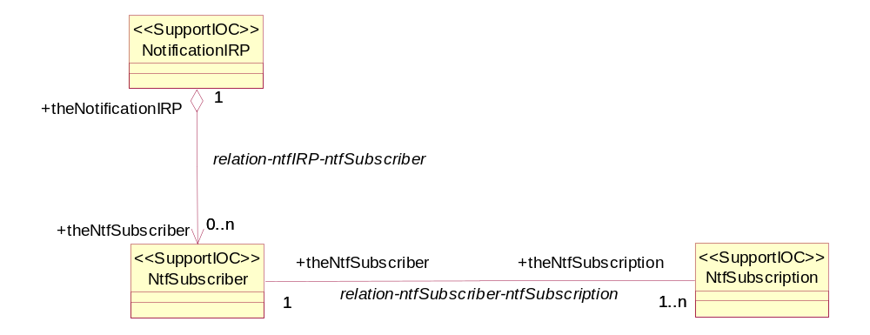

11.2.2.2.2.2 Inheritance
This clause depicts the inheritance relationships that exist between Support IOCs.
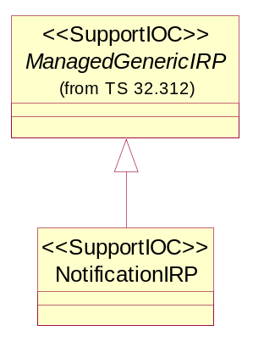

11.2.2.2.3 Information object classes definition

11.2.2.2.3.1 NtfSubscriber

11.2.2.2.3.1.1 Definition
This Support IOC represents a Subscriber from a notification perspective: a subscriber is fully identified by a management service consumer reference. A management service consumer using multiple management service consumer reference attributes to subscribe will result in multiple NtfSubscriber instances.

11.2.2.2.3.1.2 Attributes
Attribute name | Support Qualifier | Read Qualifier | Write Qualifier
ntfConsumerReference | M | M | M

11.2.2.2.3.2 NtfSubscription

11.2.2.2.3.2.1 Definition
This Support IOC represents a subscription that has been requested by a management service consumer and created.

11.2.2.2.3.2.2 Attributes
Attribute name | Support Qualifier | Read Qualifier | Write Qualifier
ntfSubscriptionId | M | M | -
ntfSubscriptionState | M | M | M
ntfTimeTick | M | M | M
ntfTimeTickTimer | M | - | -
ntfNotificationCategorySet | M | M | M
ntfFilter | M | M | M

11.2.2.2.3.2.3 Void

11.2.2.2.3.3 NotificationIRP

11.2.2.2.3.3.1 Definition
This Support IOC represents a notification IRP. It inherits from Support IOC ManagedGenericIRP.

11.2.2.2.4 Information relationship definitions

11.2.2.2.4.1 relation-ntfSubscriber-ntfSubscription (M)

11.2.2.2.4.1.1 Definition
This relationship defines the relationship between a NtfSubscriber and its current subscriptions.

11.2.2.2.4.1.2 Roles
Name | Definition
theNtfSubscriber | This role represents the one who has subscribed. It can be played by instances of Support IOC NtfSubscriber
theNtfSubscription | This role represents the subscriptions which were made and not unsubscribed. It can be played by instances of Support IOC NtfSubscription

11.2.2.2.4.1.3 Constraints
Name | Definition
inv_notificationCategoriesAllDistinct | The notification categories contained in the ntfNotificationCategorySet attribute of NtfSubscription playing the role theNtfSubscription are all distinct from each other.

11.2.2.2.4.2 relation-ntfIRP-ntfSubscriber (M)

11.2.2.2.4.2.1 Definition
This relationship defines the relationship between the NotificationIRP and the current subscribers of notifications.

11.2.2.2.4.2.2 Roles
Name | Definition
theNtfSubscriber | This role represents the entities to which IRPAgent will notify events. It is played by instances of Support IOC NtfSubscriber
theNotificationIRP | This role represents the NotificationIRP to which an IRPManager has subscribed. It is played by instances of Support IOC NotificationIRP

11.2.2.2.4.2.3 Constraints
Name | Definition
inv_uniqueManagerReference | All NtfSubscriber involved in the subscriptionRegistration relationship are distinguished from each other by their ntfManagerReference Attribute.

11.2.2.2.5 Information attribute definitions

11.2.2.2.5.0 Introduction
This clause defines the semantics of the Attributes used in Support IOCs.

11.2.2.2.5.1 Definitions and legal values
Attribute Name | Definition | Legal Values
ntfSubscriptionId | It identifies uniquely a subscription | N/A
ntfSubscriptionState | It indicates the activation state of a subscription | "suspended": the subscription is suspended  "notSuspended": the subscription is active
ntfTimeTick | This attribute represents the initial value of ntfTimeTickTimer. It is in unit of whole minute. This value defines a time window within which management service consumer intends to invoke getSubscriptionStatus (or subscribe) operation to confirm its subscription. A special value indicates infinity which is such that timer will never expire and management service producer needs other means to decide when to delete resources allocated to the management service consumer | Integer greater or equal to 15, OR special infinite value
ntfTimeTickTimer | This attribute represents the current value of a timer | integer greater or equal to zero
ntfNotificationCategorySet | This attribute represents a set of notification categories (see also Definition of notification category in clause 3.1)
ntfFilter | This attribute represents the filter of a subscription. The filter can be applied to parameters of notification header (see Notificationmaanagement service producer interface) and to parameters of notifications defined as filterable to  IManagement service producer shall notifymanagement service consumer if the event satisfies the filter constraint.
ntfConsumerReference | This attribute contains the reference of a consumer. It uniquely identifies a subscriber

11.2.2.2.5.2 Constraints
- "ntfTimeTickTimer is lower.

End of modification

