3GPP TSG-SA5 Meeting #130e S5-202400

e-meeting 20-28 April 2020

Source: Nokia, Nokia Shanghai Bell

Title: Charging architecture for Network Slice Charging in 5GS

Document for: Discussion
Agenda Item: 7.4.3

1 Decision/action requested
This discussion paper intends to discuss Charging architecture for both Network Slice Management charging and Network slice performance and analytics charging with the full picture.

2 References
[1] 3GPP TS 32.845 Study on Charging Aspects of Network Slicing
[2] 3GPP TS 28.202 "Charging management; Network slice management charging in the 5G System (5GS); Stage 2".
[3] 3GPP TS 28.201 "Charging management; Network slice performance and analytics charging in the 5G System (5GS); Stage 2".
[4] 3GPP TS 28.533: "Management and orchestration; Architecture framework".
[5] 3GPP TS 28.530: "Management and orchestration; Concepts, use cases and requirements".
[6] 3GPP TS 28.531: "Management and orchestration; Provisioning".
[7] 3GPP TS 28.532: "Management and orchestration; Management services".
[8] 3GPP TS 28.541: "Management and orchestration; 5G Network Resource Model (NRM); Stage 2 and stage 3".

3 Rationale

Full picture based on an example of deployment model for Network Slice Management
From TS 28.533 [4]

Annex A.1 Utilization of Management services in network and subnet layers:
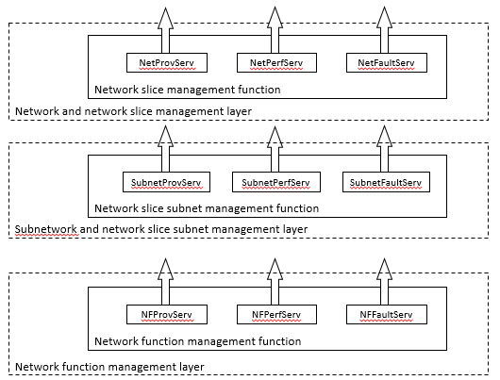

Annex A.6 Utilization of management services in functional management architecture:
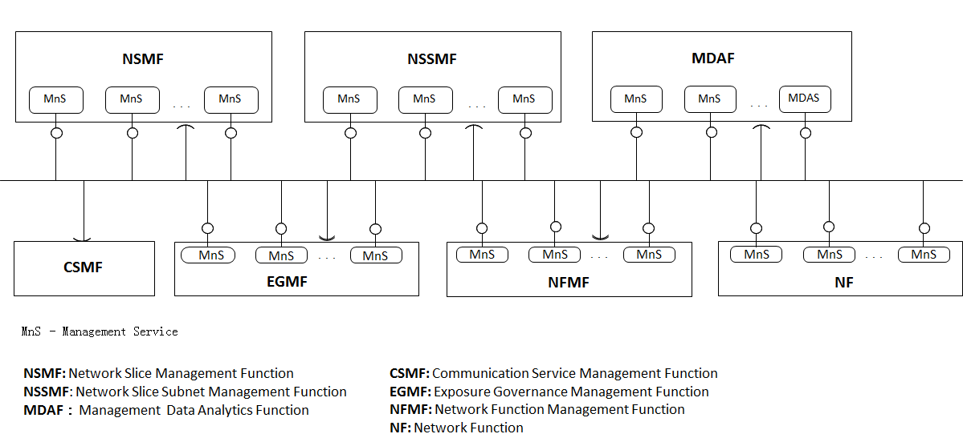

Combined in following example deployment model:
Information flow:
NSI allocation/modification/deallocation:
- CSMF consumes Provisioning MnS service produced by NSMF
- The NSMF own the mapping between the "Consumer identifier" and the created NSI, and also with the S-NSSAI
- Subsequent processes at NSSMF level induced by this provisioning, and in particular it is expected that NSMF subscribes to corresponding Performance MnS at NSSMF level.
NSI/S-NSSAI Performance charging:
- NSMF consumes Performance MnS service produced by NSSMF
- The NSMF own the mapping between the created NSI, and the PM subscriptions
Role of the CTF:
- Act as a CTF for the Provisioning MnS service produced by NSMF (as proposed in the S5-202094 (Nokia) for 5GS_NSMCH)
- Act as a CTF (CIF part of CSIF) for the Performance data from PM MnS service consumed by NSMF and produced by NSSMF. The role of the CSF part of CSIF is play by the NSMF as the "consumer of PM MnS service in blue square. (5GS_NSPACH).

4 Detailed proposal
It is proposed to discuss on charging architecture for Network slicing

