3GPP TSG-SA5 Meeting #130e S5-202258

e-meeting, 20 April – 29 April 2020

Source: Ericsson, Deutsche Telekom

Title: Communication service assurance stage 2 solution

Document for: Approval
Agenda Item: 6.4.7

1 Decision/action requested
In this box give a very clear / short /concise statement of what is wanted.

2 References
[1] 3GPP TS 28.535: Management and orchestration; Management Services for Communication Service Assurance; Requirements
[2] 3GPP TS 28.541: Management and orchestration; 5G Network Resource Model (NRM); Stage 2 and stage 3 (Release 16)
[3] 3GPP TS 28.622: Telecommunication management; Generic Network Resource Model (NRM) Integration Reference Point (IRP); Information Service (IS) (Release 16)

3 Rationale
This contribution proposes to add text for closed loop assurance stage 2 solution.
The solution shown in Figure 1 describes a management service that can provide control services based on input such as goal, permissible deviation of the goal and other essential information, and reports the actual devation from the goal. The management service includes configuration (control) interface for the provisioning of the guidance to the assurance management service regarding policies and constraints to network resources before a control loop is active, for example changing the resource allocation in RAN by configuring the RRM policy. Both the management service and the control loop report the result of their actions.
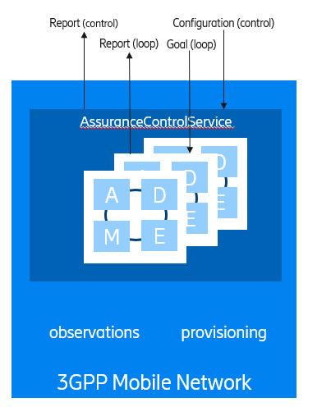
Figure 2: Assurance management service

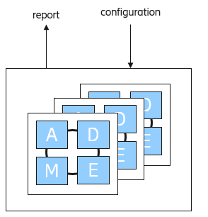
Figure 2: Assurance Control service

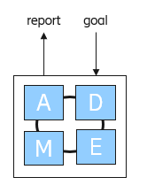

Figure 3: Assurance Control Loop

The assurance management service manages each control loop that is configured by the assurance control service. Each time a control loop is created, a run-time instance of an Assurance Control Loop is born and managed by the Assurance Management Service. Figure 1 shows how the Assurance Management Service interacts with information (observations) from the Mobile Network i.e. collection of performance measurements, alarms, MDT trace events and the provisioning of the mobile network resources in RAN and CN (NRM).
The Assurance Control Service is shown in Figure 2 is configured to lifecycle manage the instance of Assurance Control Loops shown in Figure 3. An instance of a control loop performs the following steps Monitor, Analyse, Decide, Execute. The goal is input to the loop and the loop execution effectiveness is reported as output. The control loop adjust the properties of a Managed Entity (NSI, NSSI etc..) to assure that the performance is of the controlled entity is within the bounderies of the goal.

4 Detailed proposal
First change

2 References
The following documents contain provisions which, through reference in this text, constitute provisions of the present document.
- References are either specific (identified by date of publication, edition number, version number, etc.) or non-specific.
- For a specific reference, subsequent revisions do not apply.
- For a non-specific reference, the latest version applies. In the case of a reference to a 3GPP document (including a GSM document), a non-specific reference implicitly refers to the latest version of that document in the same Release as the present document.
[1] 3GPP TR 21.905: "Vocabulary for 3GPP Specifications".
[2] ETSI GS ZSM 002 V1.1.1 (2019-08): “Zero-touch network and Service Management (ZSM); Reference Architecture”
[3] 3GPP TS 28.550: "Management and orchestration; Performance assurance”
[4] 3GPP TS 28.545: "Management and orchestration; Fault Supervision (FS) "
[a] 3GPP TS 28.622: "Telecommunication management; Generic Network Resource Model (NRM) Integration Reference Point (IRP); Information Service (IS)".
[b] 3GPP TS 28.541: "Management and orchestration; 5G Network Resource Model (NRM); Stage 2 and stage 3"
[c] 3GPP TS 28.532: "Management and orchestration; Management services".
[d] 3GPP TS 28.531: "Management and orchestration; Provisioning".
[e] 3GPP TS 32.302: "Telecommunication management; Configuration Management (CM); Notification Integration Reference Point (IRP); Information Service (IS)".

Second change

4.1.x Model

4.1.x.1 Imported and associated information entities

4.1.x.1.1 Imported information entities and local labels
Label reference | Local label
TS 28.622 [a], IOC, Top | Top
TS 28.622 [a], IOC, SubNetwork | SubNetwork
TS 28.622 [a], IOC, ManagedEntity | ManagedEntity
TS 28.622 [a], IOC, MeasurementControl | MeasurementControl
TS 28.622 [a], IOC, MeasurementReader | MeasurementReader
TS 28.622 [a], IOC, FMControl | FMControl
TS 28.622 [a], dataType, Measurements | Measurements
TS 28.622 [a], dataType, KPIs | KPIs
TS 28.622 [a], dataType, AlarmRecord | AlarmRecord
Editor’s Note: The MDT Trace related information (TraceControl and TraceRecord) will be added when Rel-16 solution is completed

4.1.x.1.2 Associated information entities and local labels
Label reference | Local label
TS 28.541 [b], IOC, NSI | Nsi
TS 28.541 [b], IOC, NSSI | Nssi
TS 28.541 [b], IOC, ME | ME
TS 28.541 [b], IOC, MF | MF

4.1.x.2 Class diagram

4.1.x.2.1 Relationships
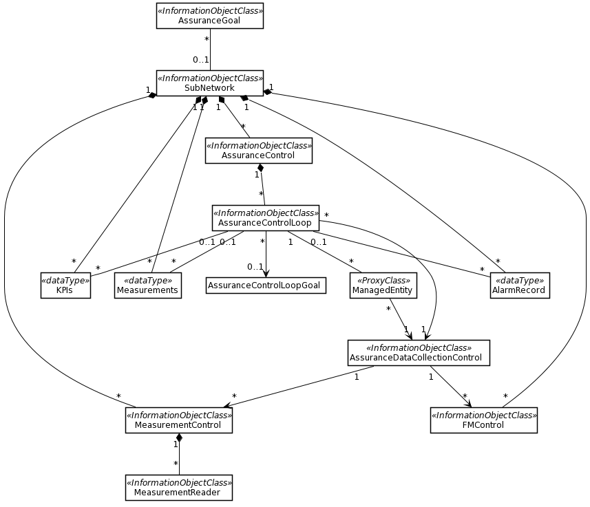
Editor’s Note: The MDT Trace related information (TraceControl and TraceRecord) will be added when Rel-16 solution is completed
Editor’s Note: The cardinalities and the association end-points is work in progress and FFS.
NOTE: The MeasurementControl/MeasurementReader fragment is connected to the ManagedEntity which is not shown here for readability purposes. The full fragment can b found in 28.622

Figure 4.1.x.2.1.1: Assurance management NRM fragment

Editor’s Note: the relationship between the AssuranceGoal, AssuranceControlLoopGoal and ServicProfile are FFS

4.1.x.2.2 Inheritance
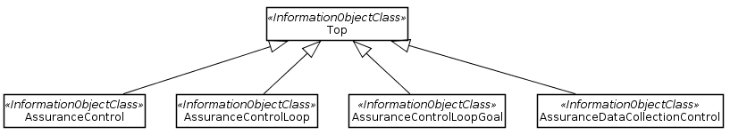
Figure 4.1.x.2.2.1: Assurance management inheritance relationships

4.1.x.3 Class definitions

4.1.x.3.1 AssuranceGoal
Editor’s Note: the definition of AssuranceGoal is FFS

4.1.x.3.1 AssuranceControl

4.1.x.3.1.1 Definition
This IOC represents the following capabilities:
- lifecycle management of a control loop
- to activate and de-activate a control loop independent of the lifecycle phase.
- to report the status of the control loops

4.1.x.3.1.2 Attributes
Attribute name | Support Qualifier | isReadable | isWritable | isInvariant | isNotifyable
assuranceControlisOn | M | T | T | F | T

Editor’s Note: An attribute for reporting the number of AssuranceControlLoop is FFS

4.1.x.3.1.3 Attribute constraints
None.

4.1.x.3.1.4 Notifications
The common notifications defined in clause 4.1.x.5 are valid for this IOC, without exceptions or additions.

4.1.x.3.2 AssuranceControlLoop

4.1.x.3.2.1 Definition
This IOC represents the capabilities of a control loop, these include:
- to automatically adjust the resources of a Managed Entity (for example a network slice) to stay within the boundaries of the goal
- to report the effectiveness of a control loop through the attribute goalFulfilmentDeviation.

4.1.x.3.2.2 Attributes
Attribute name | Support Qualifier | isReadable | isWritable | isInvariant | isNotifyable
assuranceControlLoopLifeCyclePhase | M | T | T | F | T
assuranceControlLoopisActive | M | T | T | F | T
goalFulfilmentDeviation | M | T | T | F | T
Related to role
managedEntityRef | O | T | T | F | T

4.1.x.3.2.3 Constraints
Editor’s Note: attribute constraints are FFS

4.1.x.3.2.4 Notifications
The common notifications defined in clause 4.1.x.5 are valid for this IOC, without exceptions or additions.

4.1.x.3.3 AssuranceControlLoopGoal

4.1.x.3.3.1 Definition
This IOC represents the specification of a goal that is used by the control loop. The goal applies to a group of service users that are allowed to consume the service in a specified area and it includes the metric that is observed, the expected quality level and the observation time.
NOTE: an example of an AssuranceControlLoopGoal is given as follows: serviceObservationMetric is QoE, with a serviceQualityLevel of MOS > 4.2 for 85% of the serviceUsers in Ireland observed for 1 week.

4.1.x.3.3.2 Attributes
Attribute name | Support Qualifier | isReadable | isWritable | isInvariant | isNotifyable
serviceUsers | M | T | T | F | T
serviceArea | M | T | T | F | T
serviceQualityLevel | M | T | T | F | T
serviceObservationMetric | M | T | T | F | T
serviceObservationTime | M | T | T | F | T

4.1.x.3.3.3 Attribute constraints
Editor’s Note: attribute constraints are FFS

4.1.x.3.3.4 Notifications
The common notifications defined in clause 4.1.x.5 are valid for this IOC, without exceptions or additions.

4.1.x.3.4 AssuranceDataCollectionControl

4.1.x.3.4.1 Definition
This IOC represents the capability to configure the data collection from the sources that provide the assurance data to a control loop.

4.1.x.3.4.2 Attributes
Editor’s Note: attribute constraints are FFS
Attribute name | Support Qualifier | isReadable | isWritable | isInvariant | isNotifyable

4.1.x.3.4.3 Constraints
Editor’s Note: attribute constraints are FFS

4.1.x.3.4.4 Notifications
. Editor’s Note: notifications are FFS

4.1.x.3.5 AssuranceData

4.1.x.3.5.1 Definition
Editor’s Note: the definition of this class is FFS

4.1.x.3.5.2 Attributes
Editor’s Note: attributes are FFS
Attribute name | Support Qualifier | isReadable | isWritable | isInvariant | isNotifyable

4.1.x.3.5.3 Constraints
Editor’s Note: attribute constraints are FFS

4.1.x.3.5.4 Notifications
. Editor’s Note: notifications are FFS

4.1.x.4 Attribute definitions

4.1.x.4.1 Attribute properties
The following table defines the properties of attributes that are specified in the present document.
Attribute Name | Documentation and Allowed Values | Properties
assuranceControlisOn | It indicates if the assuranceControl service is switched on.  allowedValues: TRUE or FALSE. | type: Boolean  multiplicity: 1  isOrdered: N/A  isUnique: N/A  defaultValue: None  isNullable: False
assuranceControlLoopLifeCyclePhase | It indicates in which phase of the lifecycle the assuranceControlLoop is.  AllowedValues: Preparation, Commisioning, Operation and Decommisioning. | type: Enum  multiplicity: 1  isOrdered: N/A  isUnique: N/A  defaultValue: None  isNullable: False
assuranceControlLoopisActive | It indicates if an assuranceControlLoop is activate or inactive.  Editro’s Note: other state such as inactive and not working is FFS.  AllowedValues: TRUE, or FALSE | type: Boolean  multiplicity: 1  isOrdered: N/A  isUnique: N/A  defaultValue: None  isNullable: False
serviceUsers | It indicates the number of users  Range is FFS | type: Integer  multiplicity: 1  isOrdered: N/A  isUnique: N/A  defaultValue: None  isNullable: False
serviceArea | It indicates the geographical area (in X, Y, Z coordinates) in which a communication service is accessible to the service users with a reasonable expectation of quality of service | type: FFS  multiplicity: FFS  isOrdered: N/A  isUnique: N/A  defaultValue: None  isNullable: False
serviceQualityLevel | This attribute is for FFS
serviceObservation-Metric | It indicates the metric that is used to monitor the service quality.  AllowedValues: FFS  Editor’s Note: possible values are MOS, PacketDelay are FFS | type: Enum  multiplicity: FFS  isOrdered: N/A  isUnique: N/A  defaultValue: None  isNullable: False
serviceObservation-Time | It indicates the service observation time.  AllowedValue: FFS | type: FFS  multiplicity: 1  isOrdered: N/A  isUnique: N/A  defaultValue: None  isNullable: False
goalFulfilmentTarget | It indicates the permissible deviation of the goal.  AllowedValues: FFS | type: FFS  multiplicity: FFS  isOrdered: N/A  isUnique: N/A  defaultValue: None  isNullable: False
goalFulfilmentDeviation | It indicates the difference between the goalFulfilmentTarget and measured goal fulfilment.  Editor’s Note: FFS  AllowedValues or range: FFS | type: Real  multiplicity: FFS  isOrdered: N/A  isUnique: N/A  defaultValue: None  isNullable: False
assuranceServiceObservationTime | It indicates the time over which a communication service is observed. During the observation period various observation data is collected to assess the assurance service performance.  The service observation time is expressed in seconds  AllowedValues: FFS | type: Integer  multiplicity: 1  isOrdered: N/A  isUnique: N/A  defaultValue: None  isNullable: False
servedUsers | It indicates the average number of UE’s being observed during the assuranceServiceObservationTime  Allowed values: FFS | type: Integer  multiplicity: 1  isOrdered: N/A  isUnique: N/A  defaultValue: None  isNullable: False
Attribute related to role
managedEntityRef | It indicates the managedEntity that is subject to possible configuration changes as result of a management control loop..  Allowed values: ME, MF, NSI, NSSI | type: DN  multiplicity: 1  isOrdered: N/A  isUnique: N/A  defaultValue: None  isNullable: False

4.1.x.4.2 Constraints
Editor’s Note: attribute constraints are FFS

4.1.x.5 Common notifications

4.1.x.5.1 Alarm notifications
This clause presents a list of notifications, defined in TS 28.532 [c], that an MnS consumer may receive. The notification header attribute objectClass/objectInstance, defined in TS 32.302 [e], shall capture the DN of an instance of a class defined in the present document.

4.1.x.5.2 Configuration notifications
This clause presents a list of notifications, defined in TS 28.532 [c], that an MnS consumer may receive. The notification header attribute objectClass/objectInstance, defined in TS 32.302 [e], shall capture the DN of an instance of a class defined in the present document.

