3GPP TSG-SA5 Meeting #130e S5-202226

e-meeting 20-28 April 2020

Source: Huawei

Title: Discussion on general CRUD operation for different management purposes

Document for: Discussion and endorsement
Agenda Item: 6.3

1 Decision/action requested
The group is asked to discuss and approval.

2 References
[1] 3GPP TS 28.532 Management and Orchestration; Generic management services;

3 Rationale
Following Action point is created in SA5#129 emeeting based on the discussion of contribution S5-201319.
129e.2 | Clarify the definition and solution for MnS with CRUD operations for different management purposes (e.g. Node configuration, PM control, NotificationSubscriptionControl). (related tdoc S5-201319) | Rel-16 | Xuruiyue, Olaf,Edwin | Open | SA5#130

This contribution proposes to discuss and clarify the definition and solution for MnS with CRUD operations for different management purposes (e.g. Node configuration, PM control, NotificationSubscriptionControl).
Following are some observations of existing specification which can be used as background for this discussion.
Background observation#1: As described in TS 28.533 Clause 4.3, A MnS is composed by a MnS component type A and
- a MnS component type B, or
- a MnS component type B and a MnS component type C.
Background observation#2: As described in TS 28.531 Clause 4.1, provisioning MnS described in TS 28.531 means the provisioning of network slicing/network slice subnet which includes the four phases which are preparation, commissioning, operation and decommissioning.
Background observation#3: As described in TS 28.622, several concrete NRM fragments are introduced in R16 to be work together with CRUD operation/notification for certain control purpose, for example, NRM fragment for Measurement control, NRM fragment for FM control, NRM fragment for Subscription control, NRM fragment for Threshold control, NRM fragment for Heartbeat control.
Background observation#4: As described in TS 28.532, the generic provisioning MnS include CRUD operations and ProxyClsss ManagedEntity.

RAN Node management for configuration and PM control purposes is illustrated as a concrete example for discussion.
Following is the NRM tree implemented by MnS Producer for the RAN Node management for configuration and PM control purposes.
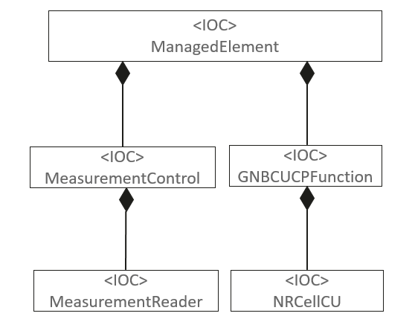
NRM tree implemented by MnF (plays the roles of multiple MnS producer)
Following are the poential MnS(s) that can be provided by the MnS Producer based on the above NRM.
- MnS X: MnS with CRUD operation and NRM fragment for RAN Node configuration purpose;
  - The MnS X consumer can access the ManagedElement<IOC> and containing subtree on the right (GNBCUCPFunction-> NRCellCU).
  - The MnS X consumer can configure attributes of ManagedElement <IOC>, GNBCUCPFunction<IOC> and NRCellCU<IOC>.
  - In the Restful Solution Set view, the MnS X consumer can access following URI with both writable and readable capability:
http://{URI-DN-prefix}/{root}/ProvMnS/v1630/ManagedElement=1 ,
http://{URI-DN-prefix}/{root}/ProvMnS/v1630/ManagedElement=1/GNBCUCPFunction=2 ,
http://{URI-DN-prefix}/{root}/ProvMnS/v1630/ManagedElement=1/GNBCUCPFunction=2/NRCellCU=3 ,
It is clear that the MnS Y is Provisioning MnS.

- MnS Y: MnS with CRUD operation and Measurement control NRM fragment for RAN Node PM control purpose;
  - The MnS Y consumer can access the ManagedElement<IOC> and containing subtree on the left (MeasurementControl->MeasurementReader).
  - The MnS Y consumer can only configure attributes of MeasurementControl<IOC> and MeasurementReader<IOC>. The ManagedElement<IOC> can not be configured and read by MnS Y consumer, except the attribute “DN” which can be read.
  - In the Restful Solution Set view, the MnS Y consumer can access following URI with both writable and readable capability:
http://{URI-DN-prefix}/{root}/MnSname?/v1630/ManagedElement=1/MeasurementControl=4 ,
http://{URI-DN-prefix}/{root}/MnSname?/v1630/ManagedElement=1/MeasurementControl=4/MeasurementReader=5 .
It is confuse for MnS Y?
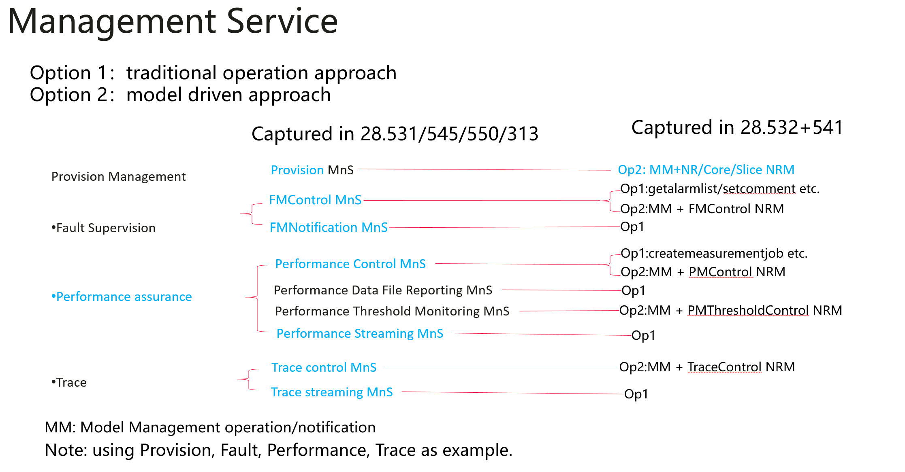

4 Detailed proposal
1. Based on the above analysis, following are two options to address the confuse issue of provisioning MnS used in TS 28.532 and TS 28.531.
Option1: Keep the generic provisioning MnS in TS 28.532 for CRUD operations and notifications. Keep the provisining MnS in TS 28.531 for Lifecycle management and configuration management of NR/5GC/NetworkSlicing.
Option2: Rename the generic provisioning MnS in TS 28.532 to model management or object management for CRUD operations and notifications. Keep the provisining MnS in TS 28.531 for Lifecycle management and configuration management of NR/5GC/NetworkSlicing.

