3GPP TSG-SA5 Meeting #130e S5-202222

e-meeting 20-28 April 2020

Source: Ericsson

Title: pCR R16 28.405-120 Update of R16

Document for: Approval
Agenda Item: 6.4.1

1 Decision/action requested
Approve the changes.

2 References
-

3 Rationale
The functionality in other WGs are minimised to minimise the implementaion needed to be done in those WGs.

4 Detailed proposal

First change.

Introduction
The present document is part of a TS-family covering the 3rd Generation Partnership Project; Technical Specification Group Services and System Aspects; Telecommunication management, as identified below:
TS 28.404: “Quality of Experience (QoE) measurement collection; Concepts, use cases and requirements”;
TS 28.405: “Quality of Experience (QoE) measurement collection; Control and configuration”;
TS 28.406: “Quality of Experience (QoE) measurement collection; Information definition and transport”.
One main motivation of mobile network evolution is to improve the user experience, which is why the evaluation of the user experience at the UE side is vital to network operators. This is especially true when the operators provide high bit rate real-time services like streaming services (typically video services), where even intermittent quality degradation is very annoying. Many of these streaming services are a significant part of the commercial traffic growth rate, therefore the focus is on the end users’ experience.
Quality of Experience (QoE) information collection provides detailed information at session level on a number of UEs.
The capability to log information within a UE, and in particular the QoE of an end user service, initiated by an operator, provides the operator with QoE information. The collected information (specified in 3GPP TS 26.247 [6]) cannot be deduced from performance measurements in the mobile network.
The QoE information is information collected by the end user application in the UE.
The QoE information is collected by the management system for analysis and/or KPI calculations.

Next change.

4.1.1 Activation of measurement collection job and reporting of collected information in UTRAN
The parameters for the network request session are sent from the management system to the RNCs that host the cells that are included in the collection job request in the activateAreaQoEJob operation [3]. The RNC starts a network request session, with the Network request session id [3] given in activateAreaQoEJob operation [3]. For the duration of the network request session, the RNC(s) checks for connections where the UE has the UE Application Layer Measurement Capability [11]. TheUE Application Layer Measurement Capability is sent from the UE to RNC (via the core network) in message INITIAL UE MESSAGE [11].
When a session is found that has an UE with the UE Application Layer Measurement Capability, the RNC starts a UE request session and sends a MEASUREMENT CONTROL message [4] to the UE via the NB.
The AT command +CAPPLEVMC [5] activates provisioning of measurement reporting from the lower layers to the application within the UE by an unsolicited result code +CAPPLEVMC. When information about a measurement report is received in the UE from the network, the unsolicited result code +CAPPLEVMC contains the relevant parameters (service_type, start_stop-indication and config-file & config-file length if applicable) that are provided from the lower layers in the UE to the application.

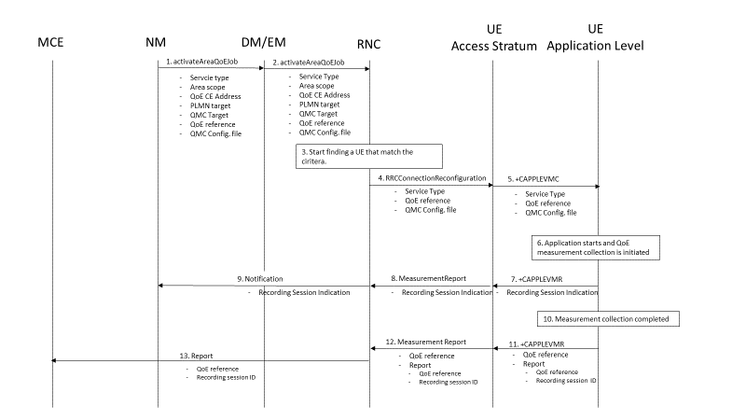

Figure 4.1.1-1: QMC activation and reporting in UTRAN
1 The NM sends activateAreaQoEJob to DM/EM that controls the impacted RNC(s), and includes the parameters: serviceType, areaScope, qoECollectionEentityAddress, pLMNTarget, qoETarget, qoEReference and QMC configuration file.
2 The DM/EM forwards activateAreaQoEJob to impacted RNC(s), and includes the parameters: serviceType, areaScope, qoECollectionEentityAddress, pLMNTarget, qoETarget, qoEReference and QMC configuration file.
3 The RNC checks for connections where the UE has the UE Application Layer Measurement Capability [11] that match the criteria for serviceType in the activateAreaQoEJob.
4 When a connection is found that has theUE Application Layer Measurement Capability [11], the RNC start a UE request session and stores the associated QoECollectionEntityAddress, sends the message RRCConnectionReconfiguration to the UE, and includes the following: serviceType, qoEReferenceand QMC configuration file.
5 The access stratum in the UE sends the AT command +CAPPLEVMC to application level and includes the following: serviceType, qoEReferenceand QMC configuration file.
6 When the application in the serviceType starts, the QMC is initiated.
7 The application layer sends the AT command +CAPPLEVMR including a recording session indication that a session has started to the access stratum.
8 The UE sends the message MeasurementReport including the recording sessionindication to the RNC.
9 The RNC sends a notification including the recording sessionindication to the NM.
10 When the QMC is completed, the recorded information is collected in a QMC report [6], [7], including qoEReference and recordingSessionId. The qoEReference, Client Id in the reporting container (that represent the UE request session), and recordingSessionId are needed in the QMC collection entity for post processing purposes.
11 The application layer sends the AT command +CAPPLEVMR including qoEReference and the QMC report to the access stratum.
12 The UE sends the message MeasurementReport including qoEReference and the QMC report to the RNC.
13 The RNC sends the QMC report to the MCE associated to the qoEReference.

Next change.

4.1.2.1 Handover between cells within an RNC
When handover is made and , the measurement area is checked.
- If the mobile is inside the measurement area after the handover, the RNC sends in an indication that the UE is inside the measurement area in the RRCConnectionReconfiguration message [4] to the UE. The UE send the +CAPPLEVMC AT command [5] to the application to inform that recording shall start if the application becomes active (when the UE moves into the measurement area).
- If the mobile has moved outside the measurement area, there is no indication that the UE is inside the measurement area in the RRCConnectionReconfiguration message [4] from the RNC to the UE. The UE sends the +CAPPLEVMC AT command [5] to the application to inform that recording shall not be started even if the application becomes active.

- Next change.

4.1.2.2 Handover between RNCs
The figure 4.1.2.1-1 and the text below describes the handling at handover between RNCs.

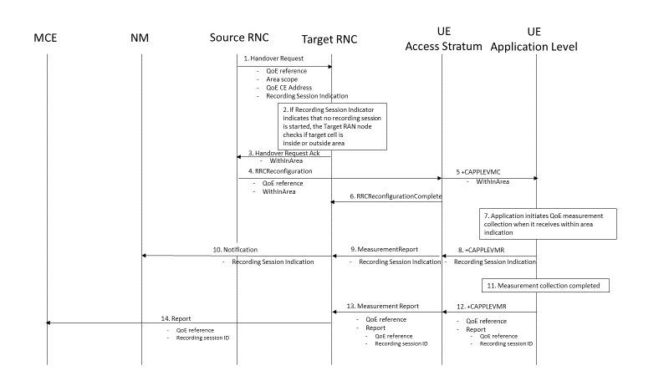
Figure 4.1.2.1-1: Handling of QMC activation in case of handover in UTRAN

- Source RNC sends the message HandoverRequest to Target RNC and includes areaScope and qoECollectionEentityAddress recording session indication indicating whether a recording session has started.
- If a recording session has not startedthe target RNC checks if the target cell is inside the areaScope or not.
- The target RNC sends the message Handover Request Ack to the source RNC and indicates if the target cell is inside or outside the areaScope in the WithinArea IE.
- The source RNC sends the message RRCReconfiguration to the UE indicating if the target cell is inside or outside the Area in the WithinArea IE.
- The access stratum in the UE sends the AT command +CAPPLEVMC to application level indicating if the target cell is inside or outside the areaScope in the WithinArea IE.
- The UE sends the message RRCReconfigurationComplete to the RNC.
- When the application becomes active, QMC is initiated if the UE is inside the areaScope as indicated in the WithinArea IE.
- The application layer sends the AT command +CAPPLEVMR including a streaming indication to the access stratum.
- The UE sends the message MeasurementReport including the streaming indication to the RNC.
- The RNC sends a notification including the streaming indication to the NM.
- When the QMC is completed, the recorded information is collected in a QMC report [6], [7]. including qoEReference and recordingSessionId. The qoEReference, Client Id in the reporting container (that represent the UE request session), and recordingSessionId are needed in the QoE collection entity for post processing purposes.
- The application layer sends the AT command +CAPPLEVMR including qoEReference and the QMC report to the access stratum.
- The UE sends the message MeasurementReport including qoEReference and the QMC report to the RNC.
- The RNC sends the QMC report to the MCE associated to the qoEReference.

Next change.

Next change.

4.1.3.1 Forced deactivation in UTRAN
When the operator technician or the management application wants to deactivate a measurement collection job, the management system sends the deactivateQoEJob operation [3] to the RNC. The RNC sets the network request session to ended, but does not delete the UE request session id and the Collection Entity Address parameters [3], as the UE still may send reports which shall be send to the collection centre. For UE request sessions which have reported that a recording session is started, the RNC sends the MeasurementControl message [4] with the DeactivateJob request to relevant UEs. The Access stratum sends +CAPPLEVMC AT command [5] to the application with the DeactivateJob request. The application stops the recording session and stops recording of the requested information. The UE request session id and the Collection Entity Address parameters [3] in the RNC are deleted when the UE request session is ended.

Next change.

4.1.3.2 Deactivation of recording session in UTRAN
Regardless of whether the pre-set time has elapsed or not, the recording session continues to be active until the session for the application is ended.

Next change.

4.2.1 Activation of measurement collection job and reporting of collected information in LTE
The parameters for the network request session are sent from the management system to the eNBs that host the cells that are included in the collection job request in the activateAreaQoEJob operation [3]. The eNB starts a network request session, with the Network request session id [3] given in activateAreaQoEJob operation [3]. For the duration of the network request session, the eNB(s) checks for connections where the UE has the QoE-MeasReport capability [9] for collection of streaming services or the QoE-MTSI-MeasReport capability [9] for collection of MTSI services. The UE capability is sent from the UE to eNB via the core network in message UE CAPABILITY INFO INDICATION [10].
When a session is found that has an UE with the wanted UE capability, the eNB starts a UE request session and sends a RRCConnectionReconfiguration [9] to the UE.
The AT command +CAPPLEVMC [5] activates provisioning of measurement reporting from the lower layers to the application within the UE by an unsolicited result code +CAPPLEVMC. When information about a measurement report is received in the UE from the network, the unsolicited result code +CAPPLEVMC contains the relevant parameters (service_type, start_stop-indication and config-file & config-file length if applicable) that are provided from the lower layers in the UE to the application.

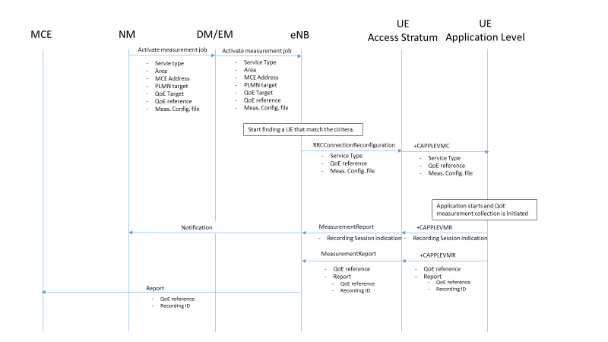
Figure 4.2.1-1: QMC activation and reporting in LTE
1 The NM sends activateAreaQoEJob to DM/EM that controls the impacted eNB(s), and includes the parameters: serviceType, areaScope, qoECollectionEentityAddress, pLMNTarget, qoETarget, qoEReference and QMC configuration file.
2 The DM/EM forwards activateAreaQoEJob to impacted eNB(s), and includes the parameters: serviceType, areaScope, qoECollectionEentityAddress, pLMNTarget, qoETarget, qoEReference and QMC configuration file.
3 The eNB checks for connections where the UE has the UE capability [10] that match the criteria for serviceType in the activateAreaQoEJob.
4 When a connection is found that has the wanted UE capability [10], the eNB starts a UE request session and stores the associated QoECollectionEntityAddress, sends the message RRCConnectionReconfiguration to the UE, and includes the following: serviceType, qoEReference and QMC configuration file.
5 The access stratum in the UE sends the AT command +CAPPLEVMC to application level and includes the following: serviceType, qoEReference and QMC configuration file.
- When the application in the serviceType starts, the QMC is initiated.
- The application layer sends the AT command +CAPPLEVMR including a recording session indication that indicates that a session is started to the access stratum.
- The UE sends the message MeasReportAppLayer including the recording sessionindication to the eNB.
- The eNB sends a notification including the recording sessionindication to the NM.
- When the QMC is completed, the recorded information is collected in a QMC report [6], [7], including qoEReference and recordingSessionId. The qoEReference, Client Id in the reporting container (that represent the UE request session), and recordingSessionId are needed in the QMC collection entity for post processing purposes.
- The application layer sends the AT command +CAPPLEVMR including qoEReference and the QMC report to the access stratum.
- The UE sends the message MeasReportAppLayer including qoEReference and the QMC report to the eNB.
- The eNB sends the QMC report to the MCE associated to the qoEReference.

Next change.

4.2.2.2 Handover between eNBs
The figure 4.1.2.1-1 and the text below describes the handling at handover between eNBs.

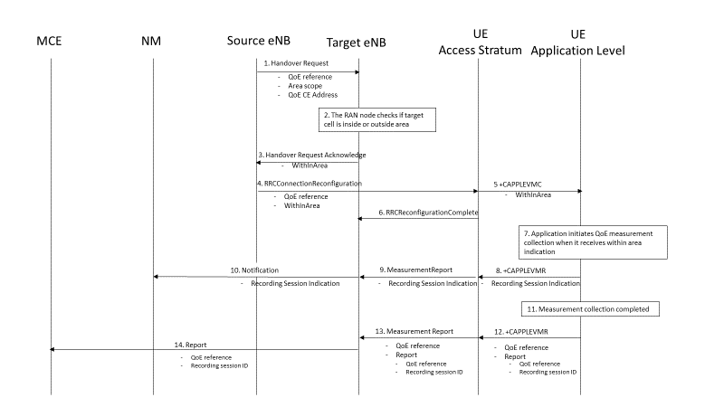

Figure 4.2.2.2-1: Handling of QMC activation in case of handover in LTE

1 Source eNB sends the message HandoverRequest to Target eNB and includes areaScope and qoECollectionEentityAddress.
2 The target eNB checks if the target cell is inside the areaScope or not.
3 The target eNB sends the message HandoverRequestAcknowledge to the source eNB and indicates if the target cell is inside or outside the areaScope in the WithinArea IE.
4 The source eNB sends the message RRCConnectionReconfiguration to the UE indicating if the target cell is inside or outside the Area in the WithinArea IE.
5 The access stratum in the UE sends the AT command +CAPPLEVMC to application level indicating if the target cell is inside or outside the areaScope in the WithinArea IE.
6 The UE sends the message RRCConnectionReconfigurationComplete to the eNB.
7 When the application becomes active, QMC is initiated if the UE is inside the areaScope as indicated in the WithinArea IE.
8 The application layer sends the AT command +CAPPLEVMR including a recording session indication indicating that a session has started to the access stratum.
9 The UE sends the message MeasReportAppLayer including the recording sessionindication to the eNB.
10 The eNB sends a notification including the recording sessionindication to the NM.
11 When the QMC is completed, the recorded information is collected in a QMC report [6], [7]. including qoEReference and recordingSessionId. The qoEReference, Client Id in the reporting container (that represent the UE request session) and recordingSessionId are needed in the QoE collection entity for post processing purposes.
12 The application layer sends the AT command +CAPPLEVMR including qoEReference and the QMC report to the access stratum.
13 The UE sends the message MeasReportAppLayer including qoEReference and the QMC report to the eNB.
14 The eNB sends the QMC report to the MCE associated to the qoEReference.

Next change.

Next change.

4.2.3.1 Forced deactivation
When the operator technician or the management application wants to deactivate a measurement collection job, the management system sends the deactivateQoEJob operation [3] to the eNB. The eNB sets the network request session to ended, but does not delete the UE request session id and the Collection Entity Address parameters [3], as the UE still may send reports which shall be send to the collection centre. For UE request sessions which have reported that a recording session is started, the eNB sends the RRCConnectionReconfiguration message [9] to relevant UEs. The RRCConnectionReconfiguration message is including measConfigAppLayer set to discard application layer measurement report information in otherConfig [9]. The Access stratum sends +CAPPLEVMC AT command [5] to the application with the discard request. The application stops the recording session and stops recording of the requested information. The UE request session id and the Collection Entity Address parameters [3] in the eNB are deleted when the UE request session is ended.

Next change.

5.7 Recording session id (M)
This parameter shall be a 2 byte octet string. The recording session id shall be the same for the whole session in the application, while for each different session in the application the recording session id shall be changed. The recording session id is generated by the application in the UE.
It is used in the measurement collection centre to identify which session within a UE has collected information in the application.

Next change.

Next change.

End of changes.

