3GPP TSG-SA5 Meeting #130e S5-202218

e-meeting 20-28 April 2020

Source: Huawei

Title: Update Clause 4.2 Management control loops

Document for: Approval

Agenda Item: 6.4.7

1 Decision/action requested
The group is asked to discuss and approval.

2 References
[1] 3GPP TS 28.535: “Management and orchestration; Management services for communication service assurance; Requirements v1.1.0”.

3 Rationale
Clause 4.2 mixed the concept of communication service assurance (clause 4.2.1) and concept of generic control loop (clause 4.2.2-4.2.4), this contribution proposes to:
- Separate these two concept, move the management control loop supporting communication service assuarance as separate section.
- Provide update to the control loop description.

4 Detailed proposal
It proposes to make the following changes to TS 28.535[1].
1st Change

4.2 Management control loops

4.2.1 Control loops
A control loop is a building block for management of networks and services. The basic principle of any control loop is to adjust the value of a measured or observed variable (expressed as for example an attribute) to equal the value of a desired goal (expressed as for example an attribute). The producer of the measurements or observations, the control service, and the controlled entity are all required to create a control loop.
For the control loop to act on input in the context of the set goal, the control loop provided through following four steps that continuously consume and produce information from each other in a loop in the following sequence monitor, analyse, decide and execute
A control loop can be an open control loop in which case a human operator or other operations system intervenes inside the loop. A control loop can be closed and operates without human operator or other operations system involvement inside the loop other than possibly the initial configuration of the measurement producer and configuration of control loop.

4.2.2 Open control loops
In an open control loop, the human operator intervenes in one or more of the process steps inside the loop, see Figure 4.3.2-1. The human is in full control of all aspects of the detail steps in control loop, including decisions taken in the loop. The management system collects, analyses and presents the data to the operator, the operator decides which action to take. In this case, the completion time for control loop is dependent on availability and reaction time of a human operator or other operations system.
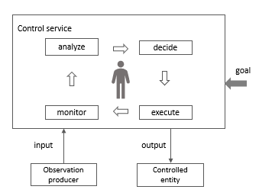
Figure 4.3.2-1: Open control loop entities

4.2.3 Closed control loops
In a closed control loop, there is no direct involvement of a human operator or other operations system in the control loop, the control loop is fully automated. As shown in Figure 4.3.3-1 the human operator or other operations system is not directly controlling the details inside the process steps but provide control outside the loop. For example, configuring goals that allow the control loop to make autonomous decisions within the boundaries of the set goal. Once the control loop is configured with the goal, the controlled entity is adjusted automatically according to the set goals.
In a closed loop, the input to the control loop provided by human operator or other operations system may include the goal, policies or the AI/ML models. The output of the control loop may include closed loop reports and explanations to a human operator or other operations system.
Typically the goal is set within certain parameter boundaries, the control loop can automatically adjust the output based on the input within the parameter boundaries. Once control loop cannot automatically adjust by itself, the human operator or other operations system needs to be informed. Human operator may decide to change the management of closed control loop to an open control loop, any decisions are made by the human operator or other operations system and not by the closed control loop.
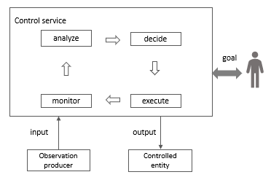
Figure 4.3.3-1: Closed control loop entities

4.X Management control loops supporting communication service assurance

4.X.1 Overview
For communication service assurance one can identify two interactions of management control loops:
- between the CSC and the CSP: In this case, the CSC provides the requirements for an assured communication service to the CSP, the CSP provides the corresponding communication service, the CSP also provides feedback to the CSC. The CSP adjusts the CSI or the CSC adjusts the SLS continuously to achieve the assured requirements.
- between the CSP and the NSP: the CSI provided by CSP requires the network capabilities. For example, the CSP requires a certain network latency. The NSP management system adjusts the network or CSP adjusts the latency requirement continuously to satisfy the latency requirement.
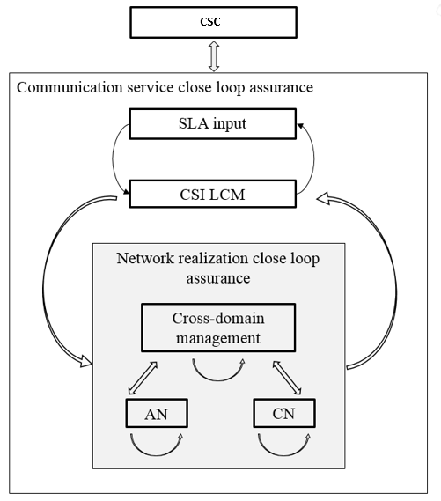
Figure 4.x.1.1: Communication service closed loop assurance
Generally, the management control loop for a CSI consists of Monitoring, Analysis, Decision and Execution, and the adjustment of CSI is completed by the continuous iteration of the steps in a management control loop. As described in section 4.1, the management control loop for CSI is deployed in the preparation phrase and takes effect during the preparation phase and operation phase.
Figure 4.x.1.2 shows the overall process of the CSI management control loop:
Figure 4.x.1.2: Management Control Loop

End of changes

