3GPP TSG-SA5 Meeting #130e S5-202190

e-meeting 20-28 April 2020

Source: Huawei

Title: Clarification on network slice related identifiers

Document for: Discussion
Agenda Item: 6.4.5

1 Decision/action requested
The group is asked to discuss and endorse the proposal.

2 References
[1] TS 23.501 System architecture for the 5G System (5GS) v16.4.0
[2] TS 28.530 Management and orchestration; Concepts, use cases and requirements v16.1.0
[3] TS 28.531 Management and orchestration; Provisioning v16.5.0
[4] TS 28.541 Management and orchestration; 5G Network Resource Model (NRM); Stage 2 and stage 3 v16.4.1

3 Rationale
Based on the recent discussion on definition of network slicing terms, it is proposed to make clarification on some network slicing terms and respective specifications.

There are 3 concepts which need clarifications:
- Network Slice
- Network Slice Instance
- NSI ID

The existing definitions of network slicing in SA2 and SA5 specs are below (Note: for reader convenience, some key terms are colour highlighted intentionally):

3.1 Definitions from SA2 TS 23.501 [1]
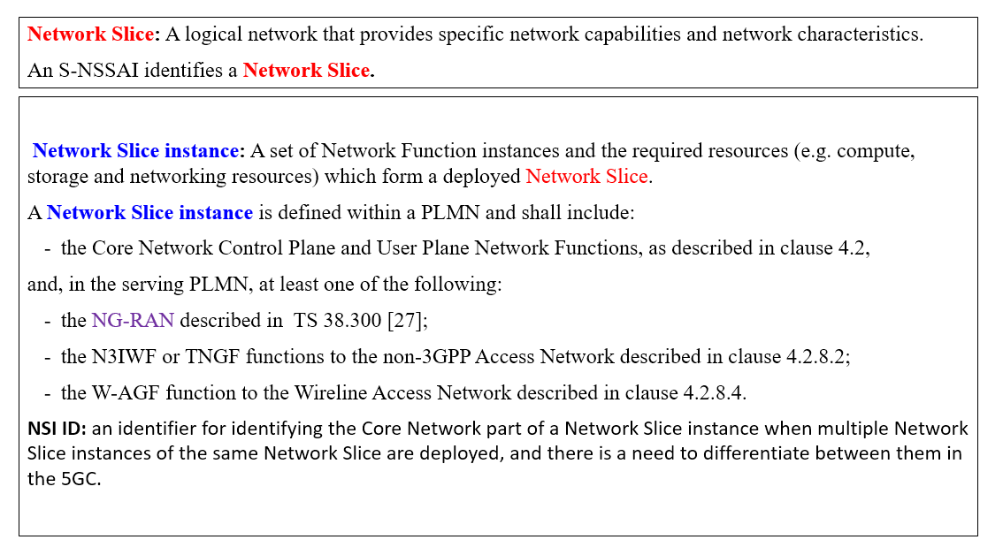

3.2 Definitions and description from SA5 TS 28.530 [2]
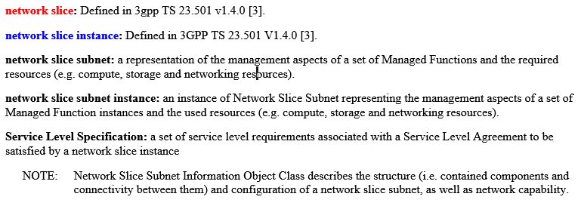

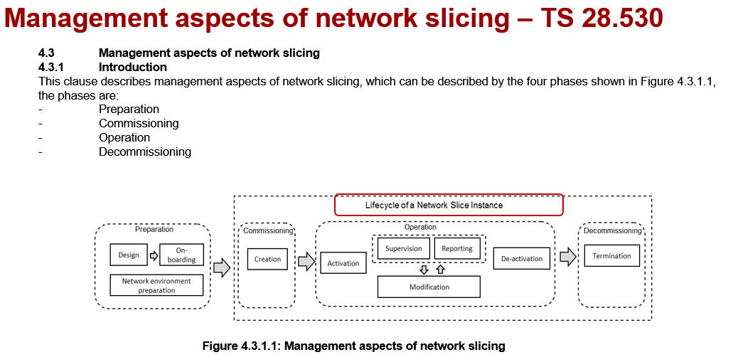
Deployment aspects of network slicing:
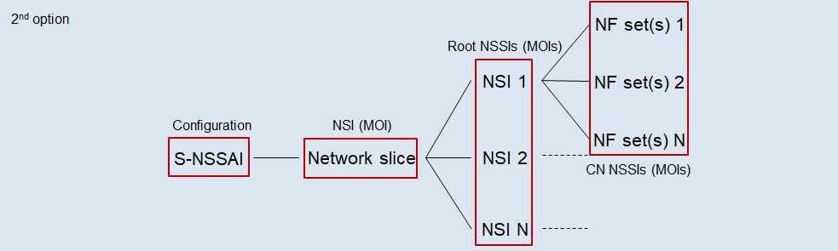
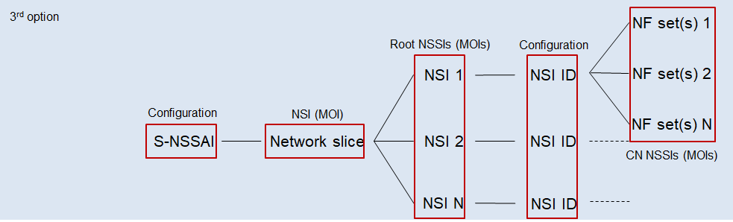
Figure 3.1.1: Different deployment scenarios for network slicing with applied SA5 concepts
Obesrvation 1
- SA2 used S-NSSAI is defined in SA5 as data type (NF configuration parameter)
Observation 2
- Difference between 1st option and 2nd/3rd deployment options is in the mechanims of NF set(s) selection (by NSSF configuration vs by NSSF configuration + NRF)
Observation 3
- SA2 defined Network slice management aspect is represented in SA5 as NSI (MOI)
Observation 4
- SA2 defined NSI can be represented in SA5 as Root NSSI (MOI)
- Root NSSI (MOI) has 1:1 relationship with NSI (MOI)
- SA2 defined Network slice and SA2 defined NSI concepts have 1:N relationship in 2nd option and 3rd option
Observation 5
- SA2 defined NSI ID is defined in SA5 as 5GC NF configuration parameter (i.e. for NSSF and NRF)
Observation 6
- SA2 defined NF set(s) management aspect can be represented in SA5 as CN NSSI(s) (MOI(s))

Analysis:
- “Network Slice”: The definition of “Network Slice” (defined in TS 23.501) is conceptually aligned between SA2 and SA5. “NetworkSlice” IOC represents the SA2 defined “Network Slice” for the management purpose. This is the general network slicing management approach as we did for management of other network elements.
- “Network Slice Instance”: The definition of “Network Slice Instance” (defined in TS 23.501) is conceptually aligned between SA2 and SA5. It focuses on the depolyment aspect and composition of Network Slice (defined in TS 23.501). In SA5 understanding, the Network Slice Instance contains the related resources which are needed to compose a network slice including both 3GPP defined Core network and RAN. In SA2, Network Slice Instance scope only covers the Core network based on their definiton of “NSI ID”.
- “NSI ID”: The term “NSI ID” might lead to conslusion that it is the identifier of NSI, which is actually DN of NSI. In the context of SA2, the NSI ID usage is optional and for the purpose to identify the core network part of NSI using NRF discovery mechanism.
Potential confusion is mainly caused by the use of “NSI ID” term.
Reminder:
In the context of SA2, "NSI ID", defined in TS 23.501 [1], is use to identify the Core Network part of a Network Slice instance, when multiple Network Slice instances of the same Network Slice are deployed.
To resolve the confusion, the following proposals are proposed in clause 4.

4 Detailed proposal
We propose:
- In TS 28.530 [2]: make changes in 3.1 definition clause to clarify terms of network slice instance from management aspect. Detailed changes please see in the corresponding CR (S5-202192).
- In TS 28.531 [3]: make changes in 4.6 General information for network slice related identifiers clause to introduce "identifier of NSI", used for identifying the NSI management aspect and make it clear that "NSI ID" defined in TS 23.501 [1] is only for 5GC signaling usage and not applicable for management.
For detailed changes, please see in the corresponding CR (S5-202193).
- In TS 28.541 [4]: make changes in 6.1 NetworkSlice clause to make it clear that the DN of NetworkSlice IOC (i.e. the objectinstance attribute) is the identifier of an NSI. And change nSIIdList (which is a list of SA2::NSI ID for signalling usage only) to cNSIIdList in NRFFunction and NSSFfunction.
For detailed changes please see in the corresponding CR (S5-202191).
- Since in SA5 specifications (TS 28.530 and 28.531), term "Network Slice Instance (NSI)" appears in many places, but potentially for two different purposes, i.e.
  - In some places, NSI is used to represent SA2::Network Slice
  - In other places, NSI is used to represent (Managed Object) instance of SA5::NetworkSlice (IOC).
Therefore, it is needed to revisit the SA5 specs (TS 28.530 [2] and TS 28.531 [3]) to check the usage of Network Slice Instance (NSI), and make it clear how to use it in different context with corresponding changes (to align with the proposed changes in bullet 2/3/4 above).
For detailed changes, please see in the corresponding CRs (S5-202146, S5-202145).
- Send an LS to SA2 to inform the management mechanism in SA5 for the configuration of the Network Slice and NSI ID, ask SA2 to use cNSI ID as replacement of NSI ID to avoid the potential confusion.

