3GPP TSG-SA5 Meeting #129 S5-201356rev4

e-meeting, 24 February – 4 March 2020 Merge of 201271, 201356, 201345

Source: Ericsson, China Mobile, Huawei, China Southern Power Grid Co.

Title: Add text for clause 4.2 Management control loops

Document for: Approval
Agenda Item: 6.4.9

1 Decision/action requested
The group is asked to approve this text proposal.

2 References
[1] 3GPP TR 28.805: " Telecommunication management; Study on management aspects of communication services".

3 Rationale
This contribution introduces the text that describes the concept of control loops, the interaction between management control loops and identifies different types of control loops.

4 Detailed proposal
First change.

3 Definitions of terms, symbols and abbreviations

3.1 Terms
For the purposes of the present document, the terms given in 3GPP TR 21.905 [1] and the following apply. A term defined in the present document takes precedence over the definition of the same term, if any, in 3GPP TR 21.905 [1].
example: text used to clarify abstract rules by applying them literally.

3.2 Symbols
For the purposes of the present document, the following symbols apply:
<symbol> <Explanation>

3.3 Abbreviations
For the purposes of the present document, the abbreviations given in 3GPP TR 21.905 [1] and the following apply. An abbreviation defined in the present document takes precedence over the definition of the same abbreviation, if any, in 3GPP TR 21.905 [1].
CS Communication Service
CSI Communication Service Instance
CSA Communication Service Assurance
SLA Service Level agreement
SLS Service Level Specification

Second change.

4 Concepts and background

Editor’s Note: the following concepts are amongst others to be described in this clause, lifecycle of a communication service, service level specification, management control loop, interface/management services,

4.1 Lifecycle of a communication service
Communication service assurance applies to different phases in the life of a communication service instance (CSI), a CSI goes through the following lifecycle phases; preparation, commissioning, operation and decommissioning.
- Preparation phase:
Providing a CSI starts with preparation, which includes communication service design, pre-planning, feasibility check, i.e., checking the attainable communication service quality from both resource and service aspects, negotiation of the communication service attributes, preparing communication service and network requirements derived from SLA.
- CSI commissioning phase:
Once the CSI is prepared, it can be established by converting the communication service requirement for the CSI to network requirements (interaction and use of NF resources including RAN, CN) and creation of the CSI. When the CSI is created, it is deployed on the network resources and ready to be used by the communication service consumers (subscribers, UEs). Before allowing the maximum agreed number of communication service consumers to use the CSI a communication service assurance control loop is deployed to allow the network to converge to a state where the communication service assurance is stable and within the boundaries of the SLS. The assurance control loop learns the communication service behaviour during an initial deployment or trail phase.
- CSI operation phase:
After the commissioning phase, the CSI is activated for use of all communication service consumers (subscribers, UEs) that are allowed to use the communication service. The initial deployment or trail phase for the training of the communication service assurance algorithms has entered the operation phase. An activated CSI allows run-time operation of the communication service, e.g., quality of experience assurance, quality of service assurance. The optimization of CSI utilization may continue during the operation phase of the CSI.
- CSI decommissioning phase:
When the CSI is no longer needed, after being de-activated, the lifecycle of the CSI ends with CSI termination.
Figure 4.1.1 Lifecycle of a communication service instance

4.2 Management control loops

4.2.1 Overview

For communication service assurance one can identify two interactions of management control loops,
- between the CSC and the CSP: In this case, the CSC provides the requirements for an assured communication service to the CSP, the CSP provides the corresponding communication service.The CSP also provides feedback to the CSC. The CSP adjusts the CSI or the CSC adjusts the SLS continuously to achieve the assured requirements.
- . between the CSP and the NSP: The CSI provided by CSP requires the network capabilities. For example the CSP requires the network latency capability The NSP management system adjusts the network or CSP adjusts the latency requirement continuously to satisfy the latency requirement.

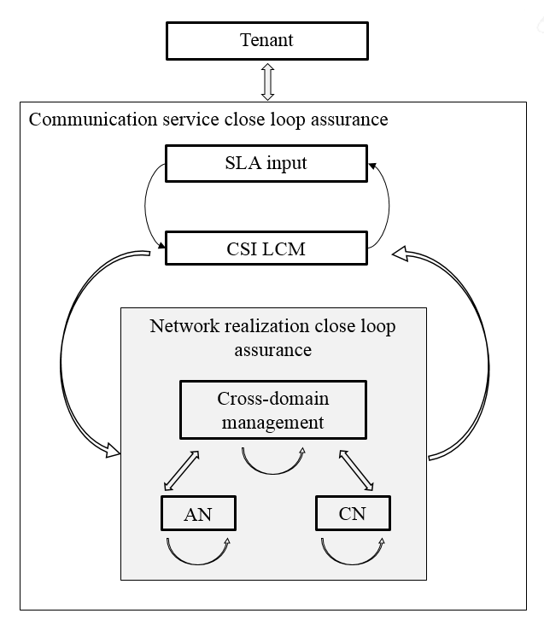
Figure 4.2.1.1 Communication service close loop assurance
Generally, the management control loop for a CSI consists of Service Monitoring, Analysis, Decision and Execution, and the adjustment of CSI is completed by the continuous iteration of the steps in a management control loop. As described in section 4.1, the management control loop for CSI is deployed in the preparation phrase and takes effect during the preparation phase and operation phase.
Figure 4.2.1.1 shows the overall process of the CSI management control loop:

Figure 4.2.1.1 Management Control Loop

4.2.2 Control loops
A control loop is a building block for management of networks and services. The basic principle of any control loop is to adjust the value of a measured or observed variable (expressed as for example an attribute) to equal the value of a desired goal (expressed as for example an attribute). The producer of the measurements or observations, the control service, and the controlled entity are all required to create a control loop.
For the control loop to act on input in the context of the set goal, the control loop provided through following four steps that continuously consume and produce information from each other in a loop in the following sequence monitor, analyse, decide and execute
A control loop can be an open control loop in which case a human operator or other operation system is involved and the control loop is dependent on availability and reaction time of a human operator or other operation system. A control loop can be closed and operates without human operator or other operation system involvement other than possibly the initial configuration of the measurement producer and configuration of control loop.

4.2.3 Open control loops
In an open control loop, the human operator intervenes in one or more of the process steps of the loop, see Figure 4.2.3.1. The human is in full control of all aspects of the detail steps in control loop, including decisions taken in the loop. The management system collects, analyses and presents the data to the operator, but the operator decides which action to take.
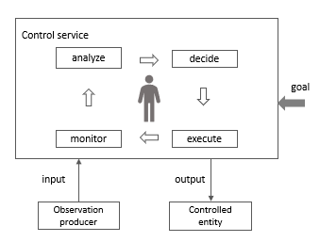
Figure 4.2.3.1: Open control loop entities

4.2.4 Closed control loops
In a closed control loop, there is no direct involvement of a human operator or other operation system in the control loop, the control loop is fully automated. As shown in Figure 4.2.4.1 the human operator or other operation system is not fully absent but in a different role, not directly controlling the details inside the process steps but using goals that allow the control loop to make autonomous decisions within the boundaries of the set goal. Once the control loop is configured and the goal is set the controlled entity is adjusted according the input and the set goals.
In a closed loop the input to the control loop provided by human operator or other operation system is the goal which allows the control loop to operate autonomously, whilst providing reports and explanations as output to a human operator or other operation system.
Typically the goal is set within certain parameter boundaries, the control loop can automatically adjust the output based on the input within the parameter boundaries, however once control loop cannot automatically adjust the human operator or other operation system needs to be informed and the control loop becomes an open control loop, any decisions are now made by the human operator or other operation system and not by the control loop.
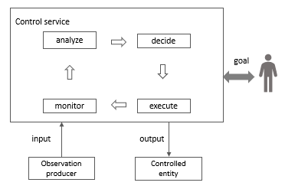

Figure 4.2.4.1: Closed control loop entities

End of changes.

Annex X (Informative)

Management control loop in different layers
This example gives a high-level view of management control loops in different layers, which consists of CSI control loop, NSI control loop, NSSI control loop and NF control loop, which described as Figure X.1, where the analytic could be leverage MDAS, and different control loop can provide input to other control loops.
Editor Note: the management control loop inside the ME is FFS.

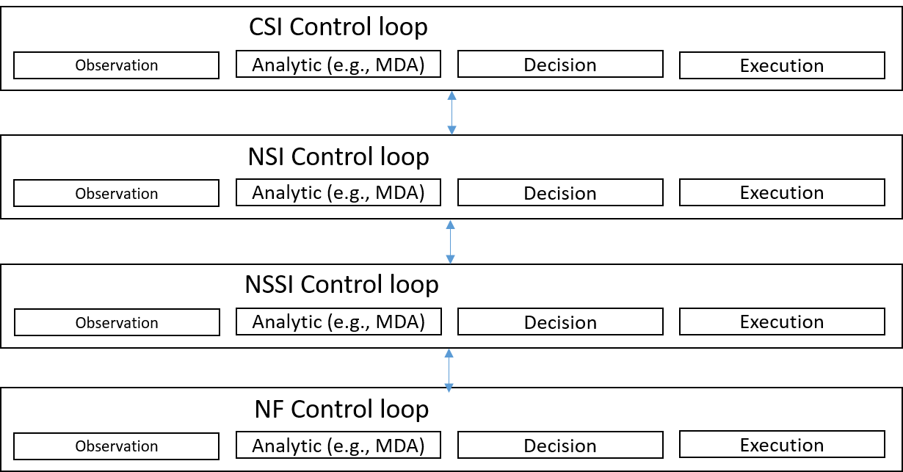
Figure X.1 Management control loop in different layers

End of changes.

