3GPP TSG-SA5 Meeting #129 S5-201356rev1

e-meeting, 24 February – 4 March 2020 Merge of 201250, 201271, 201356

Source: Ericsson, China Mobile, Huawei, China Southern Power Grid Co.

Title: Add text for clause 4.2 Management control loops

Document for: Approval
Agenda Item: 6.4.9

1 Decision/action requested
The group is asked to approve this text proposal.

2 References
[1] 3GPP TR 28.805: " Telecommunication management; Study on management aspects of communication services".

3 Rationale
This contribution introduces the text that describes the concept of control loops, the interaction between management control loops and identifies different types of control loops.

4 Detailed proposal
First change.

3 Definitions of terms, symbols and abbreviations

3.1 Terms
For the purposes of the present document, the terms given in 3GPP TR 21.905 [1] and the following apply. A term defined in the present document takes precedence over the definition of the same term, if any, in 3GPP TR 21.905 [1].
example: text used to clarify abstract rules by applying them literally.

3.2 Symbols
For the purposes of the present document, the following symbols apply:
<symbol> <Explanation>

3.3 Abbreviations
For the purposes of the present document, the abbreviations given in 3GPP TR 21.905 [1] and the following apply. An abbreviation defined in the present document takes precedence over the definition of the same abbreviation, if any, in 3GPP TR 21.905 [1].
CS Communication Service
CSI Communication Service Instance
CSA Communication Service Assurance
SLA Service Level agreement
SLS Service Level Specification

Second change.

4 Concepts and background

Editor’s Note: the following concepts are amongst others to be described in this clause, lifecycle of a communication service, service level specification, management control loop, interface/management services,

4.1 Lifecycle of a communication service
Communication service assurance applies to different phases in the life of a communication service instance (CSI), a CSI goes through the following lifecycle phases; preparation, commissioning, operation and decommissioning.
- Preparation phase:
Providing a CSI starts with preparation, which includes communication service design, pre-planning, feasibility check, i.e., checking the attainable communication service quality from both resource and service aspects, negotiation of the communication service attributes, preparing communication service and network requirements derived from SLA.
- CSI commissioning phase:
Once the CSI is prepared, it can be established by converting the communication service requirement for the CSI to network requirements (interaction and use of NF resources including RAN, CN) and creation of the CSI. When the CSI is created, it is deployed on the network resources and ready to be used by the communication service consumers (subscribers, UEs). Before allowing the maximum agreed number of communication service consumers to use the CSI a communication service assurance control loop is deployed to allow the network to converge to a state where the communication service assurance is stable and within the boundaries of the SLS. The assurance control loop learns the communication service behaviour during an initial deployment or trail phase.
- CSI operation phase:
After the commissioning phase, the CSI is activated for use of all communication service consumers (subscribers, UEs) that are allowed to use the communication service. The initial deployment or trail phase for the training of the communication service assurance algorithms has entered the operation phase. An activated CSI allows run-time operation of the communication service, e.g., quality of experience assurance, quality of service assurance. The optimization of CSI utilization may continue during the operation phase of the CSI.
- CSI decommissioning phase:
When the CSI is no longer needed, after being de-activated, the lifecycle of the CSI ends with CSI termination.
Figure 4.1.1 Lifecycle of a communication service instance

4.2 Management control loops

4.2.1 Overview

For communication service assurance one can indentify two types of management control loops,
- between the CSC and the CSP where the CSC provides the requirements for an assured communication service to the CSP, the CSP provides the service together with feedback to the CSC and in a continuous dialog the CSP adjust the CSI or the CSC adjust the SLS.
- . between the CSI and the network (resources) where the CSI requires network capabilities such as for example latency and the network produces the service with the feedback (on the latency) and in a continuous dialog the management system adjust the CSI latency requirement or the latency in the network.
The communication service assurance management loop realization shown in the grey box in Figure 4.2.1.1 consist of at least one management control loop that includes all resources the CSI depends on but may, depending on network size and complexity consist of multiple loops, such as AN management control loops and CN management control loops.

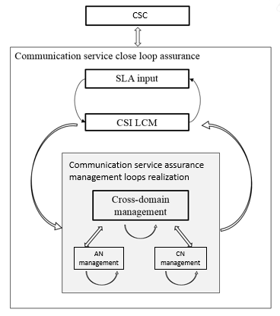

Figure 4.2.1.1 Communication service close loop assurance
Generally, the management control loop for a CSI consists of Monitoring, Analysis, Decision and Execution, and the adjustment of CSI is completed by the continuous iteration of the steps in a management control loop. As described in section 4.1, the management control loop for CSI is deployed in the preparation phase and takes effect during the preparation phase and operation phase.
Figure 4.2.1.1 shows the overall process of the CSI management control loop:
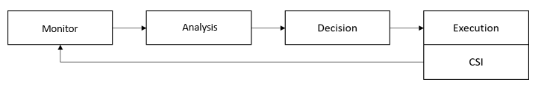

Figure 4.2.1.1 Management Control Loop

4.2.2 Control loops
A control loop is a building block for management of networks and services. The basic principle of any control loop is to adjust the value of a measured or observed variable (expressed as for example an attribute) to equal the value of a desired goal (expressed as for example an attribute). The producer of the measurements or observations, the control service, and the controlled entity are all required to create a control loop.
For the control service to act on input in the context of the set goal, the control loop provided through the control service can be described by the following four steps that continuously consume and produce information from eachother in a loop in the following sequence monitor, analyse, decide and execute
A control loop can be an open control loop in which case a human or external system is involved and the control loop is dependent on availability and reaction time of a human/other system or a control loop can be closed and operates without human/other system involvement other than possibly the initial configuration of the measurement producer and configuration of control service.

4.2.3 Open control loops
In an open control loop the human operator human operator intervenes in one or more of the control services of the loop, see Figure 4.2.3.1, and is in full control of all aspects of the control service, including decisions taken in the loop. The management system collects, analyses and presents the data to the operator, but the operator decides which action to take.
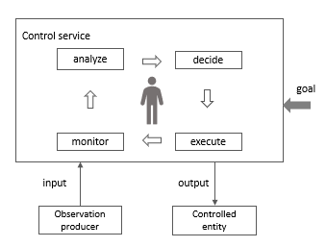
Figure 4.2.3.1: Open control loop entities

4.2.4 Closed control loops
In a closed control loop the control service is in control of decisions taken in the loop, there is no direct involvement of a human operator/external system, the control loop is fully automated. As shown in Figure 4.2.4.1 the human operator/external system is not fully absent but in a different role, not directly controlling the control service but using goals that allow the control service to make autonomous decisions within the bounderaries of the set goal. Once the control service is configured and the goal is set the controlled entity is adjusted according the input and the set goals.
In a closed loop the input to the control service provided by human or external system is the goal which allows the control service to operate autonomously, whilst providing reports and explanations as output to a human or external system.
Typically the goal is set within certain parameter boundaries, the control service can automatically adjust the output based on the input within the parameter boundaries, however once control service cannot automatically adjust the human operator/external system (BSS) needs to be informed and the control loop becomes an open control loop, any decisions are now made by the human operator/external system (BSS) and not by the control service.
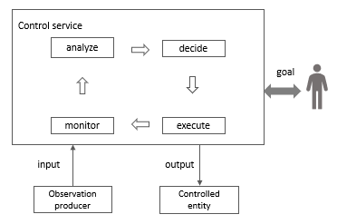

Figure 4.2.4.1: Closed control loop entities
In a deployed 5G network control loops are in operation on various layers, addressing different types of inputs, outputs and goals. As example for communication service assurance the input to reach a goal “MOS at least 4.5 for 80% of subscribers for communication service X” can be calculated from QoE measurements and the output can be many things as a QoE degradation can be caused by any part of the 5G network that is traversed by the communication service that is being observed.
The output of a control loop can be input to another control loop, for example a control loop that adjusts for service assurance can be input to a control loop that adjusts resource assurance. In some cases, the resource control loops may expose an external interface to OAM for example RRMPolicy, QoS, SON and in other cases a resource control loop can be an NF internal process and not visible to OAM.
Editor’s Note: other types of CS assurance information are FFS.
Managing closed control loops for CSA includes managing control loops for the individual CSI’s as well as the correlation between the closed control loops of different CSIs. The latter is needed as different CSI share resources and an adjustment in favour of one CSI may impact the performance of another CSI using the same resource(s).
An SLS will have thresholds (parameter boundaries), within thresholds the control service operates as a closed loop, while outside thresholds the control service becomes open loops where humans and other systems are allowed to interaction with the control service (for example decide on most appropriate action to mitigate a performance degradation).

Before a CSI enters the operation phase a CSC can provide specific settings for controlled parameters where the settings are within the parameter boundaries, to the CSP, and the SLS becomes an SLA that is monitored as long as the CSI is in operation.
The closed loops can only function within boundaries of parameter values, when the values are exceeded or fall behind then notifications shall be sent to operator or other systems (i.e. BSS) as result of that notifications a new SLS or new parameters boundaries of existing SLS can be commissioned.

End of changes.

Annex X (Informative)

Composition of a management control loop
This example gives a high-level view of management control loops on CS management layer, which consists of Business management layer, Service management layer and Network management layer, the CSI management control loop in this document is focusing on the Service management layer and Network management layer.
Editor Note: the management control loop inside the ME is FFS.
The management control loop for a CSI could reside in each of the management layer and management entities, the whole management control loop solution for a CSI comprises of the follwong loops:
- Management control loop 1, between CSMF and NSMF/NM
- Management control loop 2, between NSMF/NM and NSSMF/NFMF
- Management control loop 3, between NSSMF/NFMF and MEs
From loop 1 to loop 3, the management control of a CSI is gradually refined from the service management layer to the network management layer, the adjustment granularity is gradually refined, the adjustment latency is gradually reduced, and the adjustment range is gradually reduced.
Figure A.1 shows the set of management control loops, including management entities and NFs (MEs) involved in the assurance of the CSI.
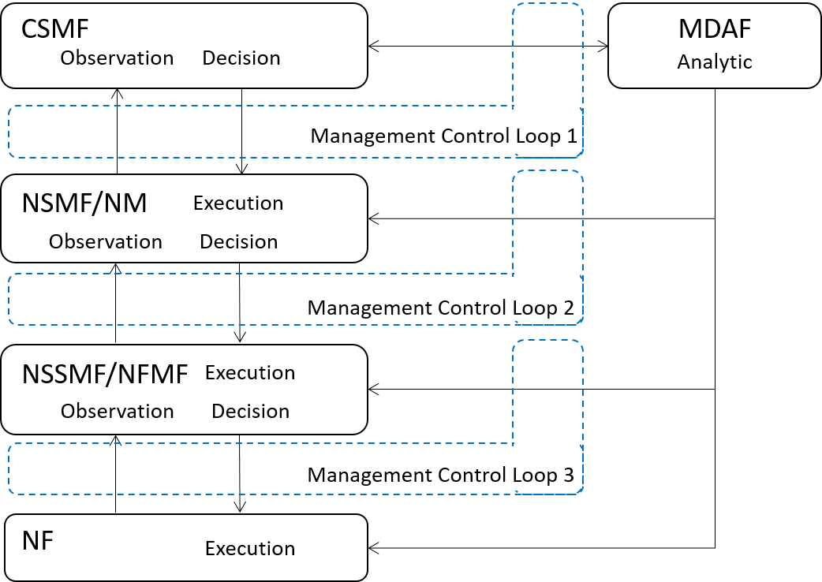
Figure X.1 CSI Management Control Loop
Editor’s Note: The use of dotted lines in Figure X.1 is FFS
- In the Service management layer:
- Service Observation, the CSMF could have the capability of Service Observation (e.g., KPI, event, etc. supervision of the network or NSI)
- Analysis, the MDAF could provide the analytic service to the CSMF
- Decision, the CSMF could generate decisions of management actions according to the analytic result (e.g., network or NSI resource adjustment, new collection task, etc.)
- Execution, the NSMF/NM execute the management actions (e.g., the NSMF convert the decision to target NSSMFs in the CN domain and/or RAN domain), and report the execution result
- In the Network management layer:
- Service Observation:
- to the management control loop 2, the NSMF could have the capability of Service Observationto the NSI (e.g., KPI, event, etc. supervision of the network or NSSI), as well as the NM to the network
- to the management control loop 3, the NSSMF/NFMF could have the capability of Service Observation (e.g., the supervision to the NSSI and NF)
- Analysis:
- to the management control loop 2, the MDAF could provide service to the NSMF and NM
- to the management control loop 3, the MDAF could provide service to the NSSMF and NFMF
- Decision:
- to the management control loop 2, the NSMF could generate decisions of management actions to the NSI according to the analytic result, as well as the NM to the network
- to the management control loop 3, the NSSMF/NFMF could generate decision of management actions to the NSSI/NF
- Execution:
- to the management control loop 2, the NSSMF/ NFMF execute the management actions and report the execution result
- to the management control loop 3, the NFs execute the management actions and report the execution result

End of changes.

