3GPP TSG-SA5 Meeting #129e S5-201184rev1

e-meeting, 24 February – 4 March 2020
CR-Form-v11.4
CHANGE REQUEST
 | 28.550 | CR | 0043 | rev | 1 | Current version: | 15.3.0
For HELP on using this form: comprehensive instructions can be found at
http://www.3gpp.org/Change-Requests.

Proposed change affects: | UICC apps |  | ME |  | Radio Access Network | X | Core Network | X

Title: | Update the peformance data streaming procedure
Source to WG: | Intel
Source to TSG: | S5
Work item code: | NETSLICE-ADPM5G |  |  |  |  |  | Date: |  |  | 2020-02-25
Category: | F |  |  |  |  |  | Release: |  |  | Rel-15
 | Use one of the following categories:  F (correction)  A (mirror corresponding to a change in an earlier release)  B (addition of feature),  C (functional modification of feature)  D (editorial modification)  Detailed explanations of the above categories can  be found in 3GPP TR 21.900. |  |  |  |  |  |  |  | Use one of the following releases:  Rel-8 (Release 8)  Rel-9 (Release 9)  Rel-10 (Release 10)  Rel-11 (Release 11)  Rel-12 (Release 12)  Rel-13 (Release 13)  Rel-14 (Release 14)  Rel-15 (Release 15)  Rel-16 (Release 16)
Reason for change: |  | The peformance data streaming procedure illustrated in Annex D needs to be updated due to:  - The procedure did not take the NRM fragement based measurement collection control into account;  - The operations name related to streaming are not up-to-date;  - The streaming connection termination needs to be illustrated separately from this procdure.
Summary of change: |  | Update the peformance data streaming procedure illustrated in Annex D
Consequences if not approved: |  | The existing peformance data streaming procedure illustrated in Annex D will mislead the implementation.
Clauses affected: |  | Annex D
 |  | Y | N
Other specs |  |  | X | Other core specifications |  |  |  | TS/TR ... CR ...
affected: |  |  | X | Test specifications |  |  |  | TS/TR ... CR ...
(show related CRs) |  |  | X | O&M Specifications |  |  |  | TS/TR ... CR ...
Other comments:

1st Modified Section

Annex D (informative):
Performance data streaming holistic sequence

D.1 Performance data streaming for starting measurement collection

D.1.1 Sequence flow

This annex shows the holistic sequence for performance data streaming, starting from starting the measurement collection (by job or configuration) to sending the performance data to the performance data streaming consumer (stream target).

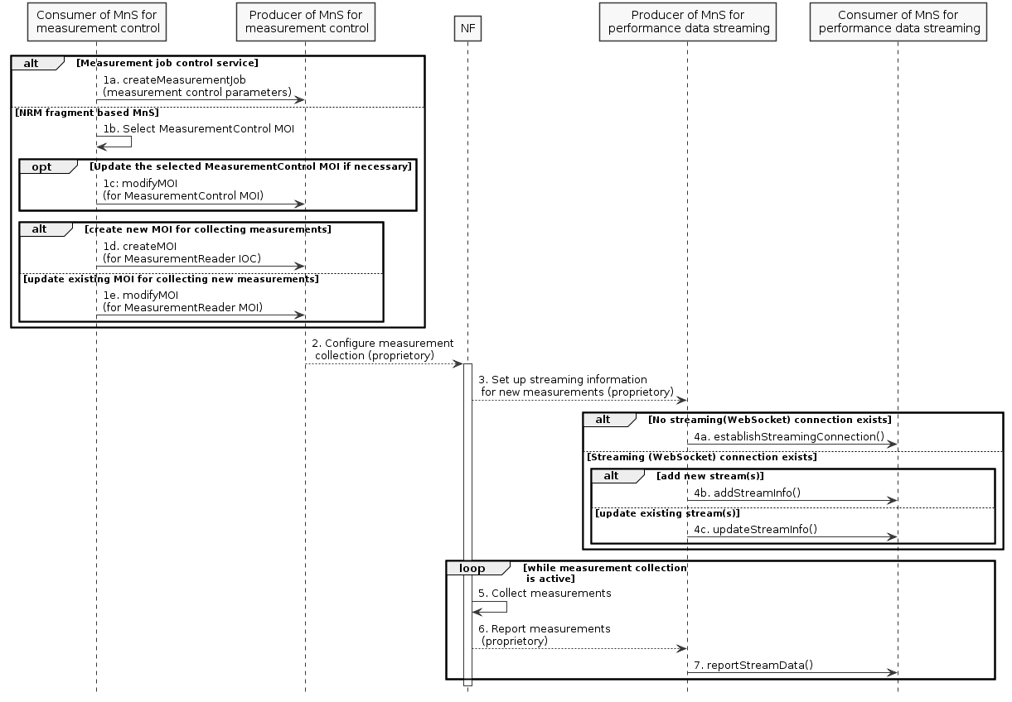
Figure D.1.1-1
1. The consumer of MnS for measurement control requests the MnS producer to start the measurement collection by the following two alternatives:
1) by the measurement job control service
1a. The MnS consumer invokes the createMeasurementJob operation towards the MnS producer;
2) by the NRM fragment-based measurement control service
1b. The MnS consumer selects the correct MeasurementControl MOI for new measurement collection, as a system may have multiple MeasurementControl MOIs;
1c. If necessary, the MnS consumer modifies the MeasurementControl MOI by invoking the modifyMOI operation towards the MnS producer;
1d. The MnS consumer creates a new MeasurementReader MOI under the selected MeasurementControl MOI for collecting the measurements, by invoking the createMOI operation; or
1e. The MnS consumer modifies an existing MeasurementReader MOI under the selected MeasurementControl MOI to add new measurements to be collected, by invoking the modifyMOI operation.
2. The producer of MnS for measurement control configures the NF to collect the measurements. The mechanism of this step is vendor specific. If producer of MnS for measurement control is in the NF, this step can be skipped.
3. The NF triggers the producer of MnS for performance data streaming to set up the streaming information for the new measurements to be collected. The mechanism of this step is vendor specific. If producer of MnS for performance data streaming is in the NF, this step can be skipped.
4. The producer of MnS for performance data streaming communicates with the consumer to:
4a. establish the streaming (WebSocket) connection containing the stream information if it does not exist yet, by invoking the establishStreamingConnection operation;
4b. add the stream information for the new measurements if they will be reported by new streams, by invoking the addStreamInfo operation;
4c. update the stream information for the new measurements if they will be reported by existing streams, by invoking the updateStreamInfo operation.
5. The NF collects the measurements. This step is the internal behaviour of the NF.
6. The NF report the collected measurements to the producer of MnS for performance data streaming. The mechanism of this step is vendor specific. If producer of MnS for performance data streaming is in the NF, this step can be skipped.
7. The producer of MnS for performance data streaming sends the collected measurements to the consumer via performance data streams, by invoking the reportStreamData operation.

D.1.2 PlantUML codes
@startuml
skinparam shadowing false
skinparam monochrome true
hide footbox

participant "Consumer of MnS for\n measurement control" as MC
participant "Producer of MnS for\n measurement control" as MP
participant "NF" as NF
participant "Producer of MnS for\n performance data streaming" as SP
participant "Consumer of MnS for\n performance data streaming" as SC

alt Measurement job control service
MC -> MP : 1a. createMeasurementJob\n(measurement control parameters)
else NRM fragment based MnS
MC –> MC: 1b. Select MeasurementControl MOI
Opt Update the selected MeasurementControl MOI if necessary
MC -> MP: 1c: modifyMOI\n(for MeasurementControl MOI)
end
alt create new MOI for collecting measurements
MC -> MP : 1d. createMOI\n(for MeasurementReader IOC)
Else update existing MOI for collecting new measurements
MC -> MP : 1e. modifyMOI\n(for MeasurementReader MOI)
end
end

MP --> NF: 2. Configure measurement\n collection (proprietory)

activate NF
NF --> SP: 3. Set up streaming information\n for new measurements (proprietory)
alt No streaming(WebSocket) connection exists
SP->SC: 4a. establishStreamingConnection()

else Streaming (WebSocket) connection exists
alt add new stream(s)
SP->SC: 4b. addStreamInfo()
else update existing stream(s)
SP->SC: 4c. updateStreamInfo()
end
end

Loop while measurement collection\n is active
NF->NF: 5. Collect measurements
NF --> SP: 6. Report measurements\n (proprietory)
SP -> SC: 7. reportStreamData()
end

@enduml

End of Modified Sections

