**3GPP TSG SA WG4#129-e S4-241518**

**Online, 19th - 23rd August 2024**

|  |  |  |  |  |  |  |  |  |
| --- | --- | --- | --- | --- | --- | --- | --- | --- |
| *CR-Form-v12.2* | | | | | | | | |
| **PSEUDO CHANGE REQUEST** | | | | | | | | |
|  | | | | | | | | |
|  | **26.956** | **CR** | **pseudo** | **rev** | **-** | **Current version:** | **0.0.3** |  |
|  | | | | | | | | |
| *For* [***HE******LP***](http://www.3gpp.org/3G_Specs/CRs.htm#_blank)*on using this form: comprehensive instructions can be found at* [*http://www.3gpp.org/Change-Requests*](http://www.3gpp.org/Change-Requests)*.* | | | | | | | | |
|  | | | | | | | | |

|  |  |  |  |  |  |  |  |  |
| --- | --- | --- | --- | --- | --- | --- | --- | --- |
| ***Proposed change affects:*** | UICC apps |  | ME | **X** | Radio Access Network |  | Core Network | **X** |

|  |  |  |  |  |  |  |  |  |  |  |
| --- | --- | --- | --- | --- | --- | --- | --- | --- | --- | --- |
|  | | | | | | | | | | |
| ***Title:*** | [FS_Beyond2D] Representation Format - Neural Radiance Fields (NeRF) | | | | | | | | | |
|  |  | | | | | | | | | |
| ***Source to WG:*** | China Mobile Com. Corporation | | | | | | | | | |
| ***Source to TSG:*** |  | | | | | | | | | |
|  |  | | | | | | | | | |
| ***Work item code:*** | FS_Beyond2D | | | | |  | ***Date:*** | | | 2024-08-08 |
|  |  | | | |  | |  | | |  |
| ***Category:*** | **B** |  | | | | | ***Release:*** | | | Rel-19 |
|  | *Use one of the following categories:* ***F*** *(correction)* ***A*** *(mirror corresponding to a change in an earlier release)* ***B*** *(addition of feature),* ***C*** *(functional modification of feature)* ***D*** *(editorial modification)*  Detailed explanations of the above categories can be found in 3GPP [TR 21.900](http://www.3gpp.org/ftp/Specs/html-info/21900.htm). | | | | | | | | *Use one of the following releases: Rel-8 (Release 8) Rel-9 (Release 9) Rel-10 (Release 10) Rel-11 (Release 11) … Rel-16 (Release 16) Rel-17 (Release 17) Rel-18 (Release 18) Rel-19 (Release 19)* | |
|  |  | | | | | | | | | |
| ***Reason for change:*** | | The study item description in SP-240479 addresses the following objectives   1. Identify and document beyond 2D formats, that are market-relevant within the next years, generated from established and emerging capturing systems (including cameras for spatial video capturing), contribution, and usable on display technologies (smartphones, VR HMDs, AR glasses, autostereoscopic and multiscopic displays).   During SA4#128, several scenarios were defined, that are considered to address the distribution scenarios and evaluation frameworks. However, some of the scenarios already assume a specific Representation Format that seems to be of less relevance initially.  The evaluation framework is important, once Representation formats are defined. | | | | | | | | |
|  | |  | | | | | | | | |
| ***Summary of change:*** | | This document focuses on Neural Radiance Fields (NeRF) . It is a starting point. | | | | | | | | |
|  | |  | | | | | | | | |
| ***Consequences if not approved:*** | |  | | | | | | | | |
|  | |  | | | | | | | | |
| ***Clauses affected:*** | | 4.3 | | | | | | | | |
|  | |  | | | | | | | | |
|  | | **Y** | **N** |  | | | |  | | |
| ***Other specs*** | |  | **X** | Other core specifications | | | | TS/TR ... CR ... | | |
| ***affected:*** | |  | **X** | Test specifications | | | | TS/TR ... CR ... | | |
| ***(show related CRs)*** | |  | **X** | O&M Specifications | | | | TS/TR ... CR ... | | |
|  | |  | | | | | | | | |
| ***Other comments:*** | |  | | | | | | | | |
|  | |  | | | | | | | | |
| ***This CR's revision history:*** | |  | | | | | | | | |

## ===== CHANGE ===== (add to References)

[1] Ben Mildenhall, Pratul P. Srinivasan, Matthew Tancik, Jonathan T. Barron, Ravi Ramamoorthi, and Ren Ng. 2021. NeRF: representing scenes as neural radiance fields for view synthesis. Commun. ACM 65, 1 (January 2022), 99–106. https://doi.org/10.1145/3503250

[2] Gao, Kyle et al. “NeRF: Neural Radiance Field in 3D Vision, A Comprehensive Review.” (2022).

[5] Li, Sicheng et al. “NeRFCodec: Neural Feature Compression Meets Neural Radiance Fields for Memory-Efficient Scene Representation.” ArXiv abs/2404.02185 (2024): n. pag.

[6] Dong-Ha Kim, Jun Young Jeong, Gwangsoon Lee, and Jae-Gon Kim "Compression method of NeRF model using NNC and VVC", Proc. SPIE 13164, International Workshop on Advanced Imaging Technology (IWAIT) 2024, 131642V (2 May 2024); https://doi.org/10.1117/12.3019533

[7] G. Lafruit, Y. Liao, and G. Bang, “AhG on Implicit Neural Video Representations (INVR),” ISO/IEC JTC1/SC 29/WG04, M60641, Oct. 2022.G. Lafruit, Y. Liao, and G. Bang, “AhG on Implicit Neural Video Representations (INVR),” ISO/IEC JTC1/SC 29/WG04, M60641, Oct. 2022

[8] RABBY, AKM SHAHARIAR AZAD and Chengcui Zhang. “BeyondPixels: A Comprehensive Review of the Evolution of Neural Radiance Fields.” ArXiv abs/2306.03000 (2023): n. pag.

## ===== CHANGE =====

### 4.3.X Future formats

Editor’s Note: formats in that section will not be part of the evaluation framework of release 19, due to their maturity status, or complexity.

#### 4.3.X.1 Neural Radiance Fields

##### 4.3.X.1.1 Definition

Neural Radiance Field (NeRF) is the implicit representation of a 3D scene or object using a fully-connected (non-convolutional) deep network, whose input is a single continuous 5D coordinate (spatial location (x, y, z) and viewing direction (Θ,Φ)) and whose output is the volume density (α) and view-dependent emitted radiance (r, g, b) at that spatial location [1].

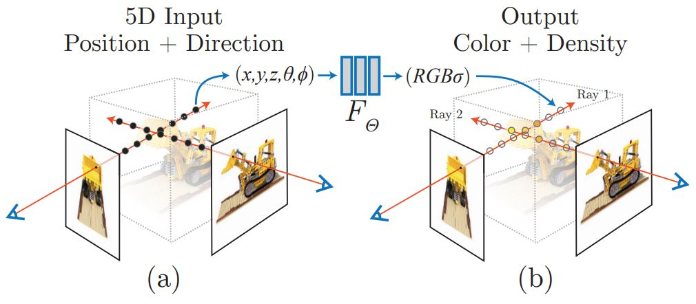

**Figure.4.3.X.1.1-1 NeRF representation**

The following is an overview pipeline for NeRF:

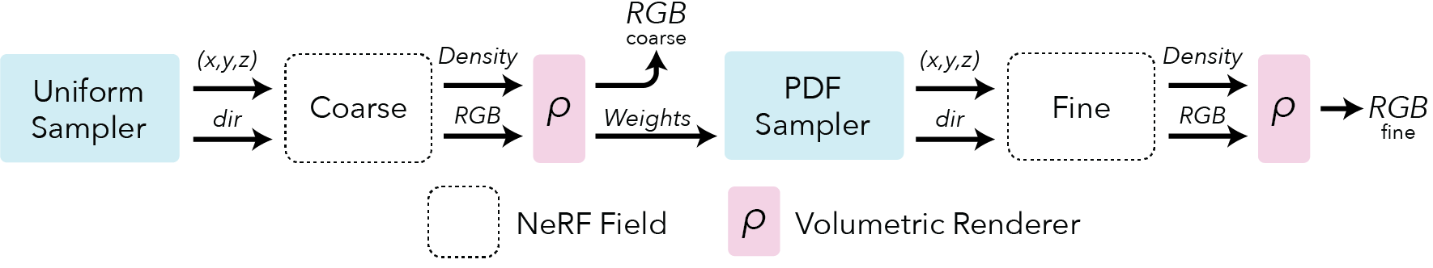

**Figure.4.3.X.1.1-2 NeRF pipeline (source: https://docs.nerf.studio/nerfology/methods/nerf.html )**

**Field representation:** For each point in space the NeRF represents a view dependent radiance.

**Positional encoding:** The input coordinates (x,y,z,θ,ϕ) need to be encoded to a higher dimensional space prior to being input into the network.

**Rendering**: NeRF rely on classic volumetric rendering techniques to composite the points into a predicted color.

**Sampling:** NeRF use a hierarchical sampling scheme that first uses a uniform sampler and is followed by a PDF sampler.

##### 4.3.X.1.2 Production and Capturing Systems

Mobile apps such as NeRFCapture (https://github.com/jc211/NeRFCapture), Spectacular AI (https://github.com/SpectacularAI), Record3D (https://record3d.app/).

Tutorial for capturing NeRF: https://github.com/NVlabs/instant-ngp/blob/master/docs/nerf_dataset_tips.md

The NeRFCapture app allows any iPhone or iPad to quickly collect or stream posed images to InstantNGP. If your device has a LiDAR, the depth images will be saved/streamed as well. It has two modes: Offline and Online. In Offline mode, the dataset is saved to the device and can be accessed in the Files App in the NeRFCapture folder. Online mode uses CycloneDDS to publish the posed images on the network. A Python script then collects the images and provides them to InstantNGP.

The Spectacular AI SDK and apps can be used to capture data from various devices:

- iPhones (with LiDAR)

- OAK-D cameras

- RealSense D455/D435i

- Azure Kinect DK

The Record3D can create a dataset with an iPhone 12 Pro or newer (based on ARKit), a python code is needed to convert the captured data to NeRF (https://github.com/NVlabs/instant-ngp/blob/master/scripts/record3d2nerf.py)

[NerfStudio](https://docs.nerf.studio/" \t "https://medium.com/@heyulei/_blank) (https://docs.nerf.studio/), which is open-source and combines many radiance fields methods, and supports the storage of NeRF data in a structured format, which includes key elements as follows. An example is attached to the zip file:

Camera intrinsics:

{

"camera_model": "OPENCV_FISHEYE", // camera model type [OPENCV, OPENCV_FISHEYE]

"fl_x": 1072.0, // focal length x

"fl_y": 1068.0, // focal length y

"cx": 1504.0, // principal point x

"cy": 1000.0, // principal point y

"w": 3008, // image width

"h": 2000, // image height

"k1": 0.0312, // first radial distortion parameter, used by [OPENCV, OPENCV_FISHEYE]

"k2": 0.0051, // second radial distortion parameter, used by [OPENCV, OPENCV_FISHEYE]

"k3": 0.0006, // third radial distortion parameter, used by [OPENCV_FISHEYE]

"k4": 0.0001, // fourth radial distortion parameter, used by [OPENCV_FISHEYE]

"p1": -6.47e-5, // first tangential distortion parameter, used by [OPENCV]

"p2": -1.37e-7, // second tangential distortion parameter, used by [OPENCV]

"frames": // ... per-frame intrinsics and extrinsics parameters

}

Camera extrinsics:

{

// ...

"frames": [

{

"file_path": "images/frame_00001.jpeg",

"transform_matrix": [

// [+X0 +Y0 +Z0 X]

// [+X1 +Y1 +Z1 Y]

// [+X2 +Y2 +Z2 Z]

// [0.0 0.0 0.0 1]

[1.0, 0.0, 0.0, 0.0],

[0.0, 1.0, 0.0, 0.0],

[0.0, 0.0, 1.0, 0.0],

[0.0, 0.0, 0.0, 1.0]

]

// Additional per-frame info

}

]

}

Depth images:

{

"frames": [

{

// ...

"depth_file_path": "depth/0001.png"

}

]

}

Masks:

{

"frames": [

{

// ...

"mask_path": "masks/mask.jpeg"

}

]

}

##### 4.3.X.1.3 Rendering and Display Systems

NeRF heavily relies on the volumetric rendering process to obtain rendered pixels. This rendering function is differentiable, so we can optimize our scene representation by minimizing the residual between synthesized and ground truth observed images. The rendering process requires sampling tens to hundreds of points along each ray and inputting them into the neural network to produce the final imaging result. Consequently, rendering a single 1080p image necessitates on the order of 108 neural network forward passes, which often takes several seconds [2].

Display System: VR HMD, mobile devices.

##### 4.3.X.1.4 Supporting Information

- Typical quality criteria for evaluating the format

- Evaluation metrics such as PSNR (Peak Signal-to-Noise Ratio), SSIM (Structural Similarity Index), and LPIPS (LearnedPerceptual Image Patch Similarity)

- Training iteration, training time, inference speed.

- Conversion from other formats (lossless, lossy)

- Meshes, point clouds

- Uncompressed data size

The original NeRF model has 8 fully connected layers, with a layer width of 256, and each pixel is synthesized based on 128 samplings along the ray. The standard NeRF model demands an impractical 5,600 Terabytes cache size.

- Known compression technologies:

Early research on NeRF compression is ongoing. The MPEG established the ad-hoc group called Implicit Neural Visual Representation (INVR) and is currently exploring the potential standardization of 6 Degree of Freedom (6DoF) video compression using NeRF-based technologies [7]. The following methods are applied in current research for NeRF compression and encoding:

- Parameter quantization techniques, transform coding, and entropy coding [5]

- VVC and NNC [6]

- Extensibility of the format

- Mip-NeRF, Point-NeRF, KiloNeRF, Mega-NeRF and etc [8].

##### 4.3.X.1.5 Benefits and Limitations

###### 4.3.X.1.5.1 Benefits

- High-quality 3D representation: NeRF can create photo-realistic 3D reconstructions of complex scenes, including fine surface details and reflections.

- Improved view synthesis capabilities: NeRF can synthesize novel views of a scene or object from a small number of input images, allowing rendering from any viewpoint.

- Flexibility: NeRF can handle non-rigid and dynamic scenes, adapting well to varying spatial conditions and changes over time.

- Unsupervised training: NeRF can learn to reconstruct a scene or object without explicit supervision.

###### 

###### 4.3.X.1.5.2 Limitations

- More computationally demanding and slower to render compared to photogrammetry and 3D Gaussian Splatting.

- Not reductionistic

- Currently, NeRF representation formats do not seem to effectively handle dynamic content within 3D scenes.