3GPP SA4 #129-e S4-241499
Online, 19 August 2024 Revision of S4aR240041
CR-Form-v12.0
PSEUDO CHANGE REQUEST
 | 26.822 | CR | pseudo | rev | - | Current version: | 0.0.1
For HELP on using this form: comprehensive instructions can be found at
http://www.3gpp.org/Change-Requests.

Proposed change affects: | UICC apps |  | ME | x | Radio Access Network | x | Core Network | x

Title: | [FS_5G_RTP_Ph2] Overhead of Application-layer FEC
Source to WG: | Qualcomm Incorporated
Source to TSG:
Work item code: | FS_5G_RTP_Ph2 |  |  |  |  |  | Date: |  |  | 08/19/2024
Category: | B |  |  |  |  |  | Release: |  |  | Rel-19
 | Use one of the following categories:  F (correction)  A (mirror corresponding to a change in an earlier release)  B (addition of feature),  C (functional modification of feature)  D (editorial modification)  Detailed explanations of the above categories can  be found in 3GPP TR 21.900. |  |  |  |  |  |  |  | Use one of the following releases:  Rel-10 (Release 10)  Rel-11 (Release 11)  Rel-12 (Release 12)  Rel-13 (Release 13)  Rel-14 (Release 14)  Rel-15 (Release 15)  Rel-16 (Release 16)  Rel-17 (Release 17)  Rel-18 (Release 18)
Reason for change: |  | This addresses Key issue #4: Application-layer FEC awareness for PDU Set handling.  The overhead of AL-FEC may be underestimated and there is a need to analyze the overhead.  To address comments received during the June 26 RTC AH meeting.
Summary of change: |  | Added an analysis of the overhead of AL-FEC for various values of the packet loss probability.
Consequences if not approved: |  | Lack of understanding of the inefficiency of AL-FEC.
Clauses affected:
 |  | Y | N
Other specs |  |  |  | Other core specifications |  |  |  | TS/TR ... CR ...
affected: |  |  |  | Test specifications |  |  |  | TS/TR ... CR ...
(show related CRs) |  |  |  | O&M Specifications |  |  |  | TS/TR ... CR ...
Other comments:
This CR's revision history:

* * * * 1st change * * * *

5.4.2.x Overhead of AL-FEC
To all the application receiver to reconstruct the source packets, the application sender sets the redundancy for AL-FEC based on the end-to-end packet loss rate in the network. It is important to understand the overhead, i.e., the ratio of the number of repair packets to the number of source packets needed to meet a probability that the application receiver can reconsturct all the source packets.
For a small number of source packets, the overhead can be significantly higher than the theoretical limit for the case of an infinite number of source packets (which is equal to p/(1-p), where p is the end-to-end packet loss rate). This is because in a realization of the random packet losses, the packet loss rate may be higher than p and this effect is more prominent when the number of source packets is smaller. To illustrate, consider an example where p=0.1%, 1% and 10%, and the probability of reconstructing all the source packets, denoted preconstruct, is set to 99.9%. The 10% represents the BLER without HARQ retransmission in typical implementations, and the 1% and 0.1% may represent the BLERs with HARQ retransmissions. Furthermore, it is assumed that the packet losses are independent, and each packet is sent in a separate transport block. The overhead (in percent) as a function of K is shown in Figure 5.4.2.x. For K=20, the overhead is 45%, and even as K increases to 100 the overhead still stays at 24%. In contrast, the theoretical limit is 11.1% (the red dashed line). The theoretical limit can be considered as the overhead needed to let the application receiver receive K packets on average.

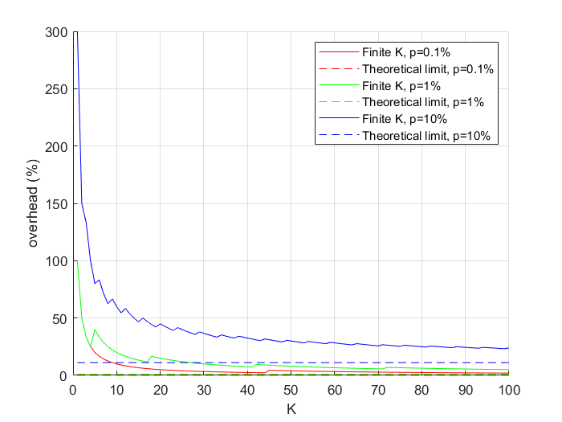
(a)
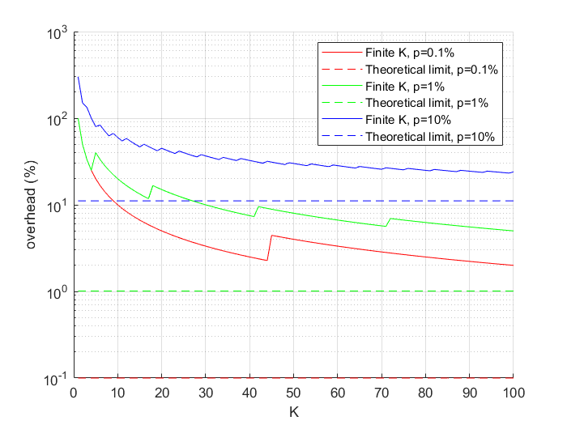
(b)
Figure 5.4.2.x The overhead of AL-FEC as a function of the number of source packets K for 99.9% probability of reconstructing all the source packets at the application receiver: (a) linear scale; (b) logrithmic scale.

The steps for calculating the overhead are as follows:
- Find the minimum value (denoted $m^{*}$) of $m$ that satisfies $\sum_{n=K}^{m}{\left(\begin{matrix}m \\ n\end{matrix}\right){(1-p)}^{n}}$ $p^{m-n}> p_{reconstruct}$, where $p_{reconstruct}=$0.999
- The overhead is $(m^{*}-K)/K$

Note that in the RAN, a transport block may carry multiple packets. Thus, even if K is large, the effective value for the purpose of reconstructing the source packets may be small. For example, if K=100 and each transport block carries 4 packets, then effectively we are dealing with 25 transmissions and the overhead would be corresponding to the overhead for K=25 rather than the overhead for K=100 in Figure 5.4.2.x.
Observation 1: the overhead of AL-FEC may be much higher than the overhead needed to let the application receiver receive K packets on average, where K is the numer of source packets.
If the RAN transmits every packet (or PDU) of a PDU Set with AL-FEC encoding, then the overhead at the RAN (i.e., on average how many packets beyond the number of source packets the RAN needs to transmit normalized by the numer of source packets) can be high.
In contrast, if the RAN can drop obsolete packets (or PDUs), the overhead at the RAN can be reduced. With ideal assumptions, e.g., the base station knows immediately and reliabily which PDUs are delivered successfully, the overhead at the RAN can drop to the theoretical limit. With practical assumptions, the overhead will be higher than but still can still be close to the theoretical limit.
Observation 2: if the RAN can drop obsolete PDUs of a PDU Set with AL-FEC encoding, the overhead at the RAN can be dropped to be close to the theoretical limit.

* * * * End of 1st change * * * *

