3GPP TSG-SA WG4 Meeting #129-e S4-241453

Online, 19 – 23 August 2024 revision of S4-241265

Source: Nokia
Title: Solution KI#8: PSI indication to optimize RTP retransmission
Agenda item: 10.6
Document for: Agreement

Introduction
TR 26.822 contains the key issue #8 on RTP retransmission for supporting XR services in 5G. An introduction to RTP retransmission payload format and its usage in WebRTC was provided in S4aR240032 and incorporated into the TR.
PDU Set Information and QoS parameters are sent by the Media AF to the 5G network, where they can be used to improve scheduling and capacity, when PDU Set based handling is enabled
This contribution proposes a solution where the RTP sender conveys PDU Set related information to the RTP receiver to improve the efficiency of (selective) RTP retransmission.
This is a revision of S4-241265 handled in SA4#128. The minutes from the discussion in SA4#128 are copied below for reference.
Discussion:
- Qi: in 26.114, any RTP Retx –the RTP receiver will decide the relative importance of PDU. Now we use another way (explicit priority)?
- Serhan: RTP receiver may prefer not to send NACK for every packet.
- Qi: the receiver already knows the importance, and can selectively send the NACK.
- Serhan: the receiver can infer the PSI of the lost PDU.
- Srinivas: there is no mechanism to select retransmission
- Andrei: SDP … 2nd question on “Editor’s Note: this solution requires the RTC AF to communicate PSIHI to the RTC AS” … dynamic policy
- Serhan: the AS will use …
- Rufael: I could not find SDP signaling for PSIHI
- Serhan: I meant the signaling could be defined
- Rufael: Still have some concerns on the signaling plus the receiver’s need to interpret the RTP HE, I prefer to note it and work further on it
- Serhan: We can do that and improve
Decision: revised to 1265 and 1265 is noted

Background

RTP Retransmission requests
RTCP Generick NACK feedback message format defined in the RTP/AVPF profile should be used by receivers to send retransmission requests [RFC 4588].
The Generic NACK is used to indicate the loss of one or more RTP packets. The Generic NACK message is identified by PT=RTPFB and FMT=1.
The Feedback Control Information (FCI) field MUST contain at least one and MAY contain more than one Generic NACK. Format of the FCI field for the generic NACK message is shown below [RFC 4585].
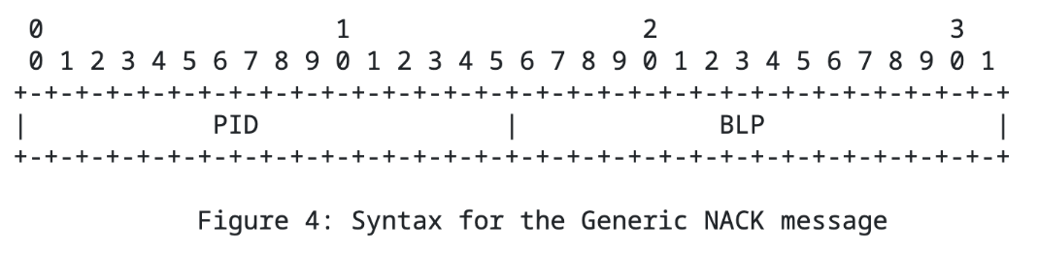
Syntax for the Generic NACK message
The lost packet(s) are identified by the means of a packet identifier and a bit mask. Semantics of the fields are:
- Packet ID (PID): Refers to the RTP sequence number of the lost packet.
- Bitmask of following lost packets (BLP): allows for reporting losses of any of the 16 RTP packets immediately following the RTP packet indicated by the PID.

Proposal
A solution to KI#8 is proposed for incorporation into TR 26.822.

========================== CHANGE 1 (all new) =============================

6.X Solution #X: PSI indication to optimize RTP retransmission

6.X.1 Key Issue mapping
This solution addresses the key issue #8.

6.X.2 Description

Senders have the best view on which packets are sufficiently important to be retransmitted. Selective RTP retransmission prioritizes the packets that contain crucial data, such as keyframes in video streaming or important audio segments in voice calls.

In this solution, the sender signals a threshold/upper bound to the receiver indicating the range of PSI values assigned to the PDU Sets that are deemed critical for the application. The PSI threshold can be sent by the sender in an SDP negotiation, e.g., by means of a new SDP attribute “psi-thr” that can be set a value between 0 and 15 (inclusive).

By this signaling, the sender indicates that such PDU Sets are critical for the session and need to be retransmitted in case they are lost. For example, a PSI threshold of 8 means that the sender asks the receiver to consider requests retransmissions for the PDU Sets with PSI between 0 and 8 (inclusive).
The receiver uses the indicated PSI threshold to determine for which lost packets it will send retransmission requests (NACKs). Upon detection of a lost packet, the receiver inspects the PSI values of the received packets within the same PDU Set (i.e., have the same PSSN) and have RTP sequence numbers (SN) adjacent to the lost packet. From these PSI values, it can derive the PSI value of the lost packet. The receiver then sends a NACK, if the PSI value of the lost packet is lower than or equal to the PSI threshold.
NOTE: While making retransmission requests, receivers may also consider other factors such as the possibility of timely arrival of requested packets, as described in TS 26.114, clause 9.3.2.
The sender may also consider other factors (e.g. network conditions, number of lost packets) to decide whether to retransmit packets falling into the indicated PSI range during the session.
NOTE: This solution assumes that the PDU Set integrated handling is not used, i.e., the network does not discard the whole PDU Set when one PDU of a PDU Set is lost.
Figure X illustrates the solution with two example cases. The labels in the boxes show the PSN values of the PDUs with subscripts showing the PSI values for the respective PDU Sets.
In example 1, the PDU with RTP SN=14 (PSN=2, PSSN=3) is lost. When the receiver detects that loss, it can look at either the previous or the next PDU to infer the PSI since they are both in the PDU Set 3.
In example 2, the PDU with the RTP SN=15 (PSN=3, PSSN=3) is lost. In this case, the next PDU would not provide the correct PSI since it belongs to PDU Set 4, which has a different PSI value 9. The receiver can first inspect the PSSN value to check whether the next PDU is in a different PDU Set. If that is the case, it can instead use the value from the previous PDU with RTP SN=14 to obtain the correct PSI value 7 for the lost PDU.
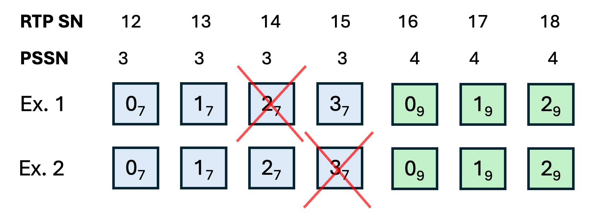
Figure X. Example cases illustrating the solution. Subscripts denote the PSI values.

Benefit of the solution: With guidance from the sender on the PSI range that is assigned to critical PDU Sets, the receiver can make more informed retransmission requests and improve bandwidth usage.

