CR-Form-v12.2
PSEUDO CHANGE REQUEST
 | 26.927 | CR |  | rev |  | Current version: | 0.2.0
For HELP on using this form: comprehensive instructions can be found at
http://www.3gpp.org/Change-Requests.

Proposed change affects: | UICC apps |  | ME | X | Radio Access Network |  | Core Network | X

Title: | pCR on Introduction of split models and configurations
Source to WG: | Tencent, Samsung
Source to TSG: | S4
Work item code: | FS_AI4Media |  |  |  |  |  | Date: |  |  | 2023-02-14
Category: |  |  |  |  |  |  | Release: |  |  | Rel-18
 | Use one of the following categories:  F (correction)  A (mirror corresponding to a change in an earlier release)  B (addition of feature),  C (functional modification of feature)  D (editorial modification)  Detailed explanations of the above categories can  be found in 3GPP TR 21.900. |  |  |  |  |  |  |  | Use one of the following releases:  Rel-8 (Release 8)  Rel-9 (Release 9)  Rel-10 (Release 10)  Rel-11 (Release 11)  …  Rel-16 (Release 16)  Rel-17 (Release 17)  Rel-18 (Release 18)  Rel-19 (Release 19)
Reason for change: |  | Proposed text taken from the Permanent document on Media Service Architecture for AI/ML
Summary of change: |  | General section describing the different topologies and introducing the concept of sub-model
Consequences if not approved:
Clauses affected:
 |  | Y | N
Other specs |  |  | X | Other core specifications |  |  |  | TS/TR ... CR ...
affected: |  |  | X | Test specifications |  |  |  | TS/TR ... CR ...
(show related CRs) |  |  | X | O&M Specifications |  |  |  | TS/TR ... CR ...
Other comments:
This CR's revision history:

5.1 AI/ML Split configurations

5.1.1 AI/ML model composition
An AI/ML model may be splittable, meaning that it may be theoretically represented by several sub-models separated by split points as illustrated for a fully connected artificial neural network (ANN) example in Figure 5.1-1.
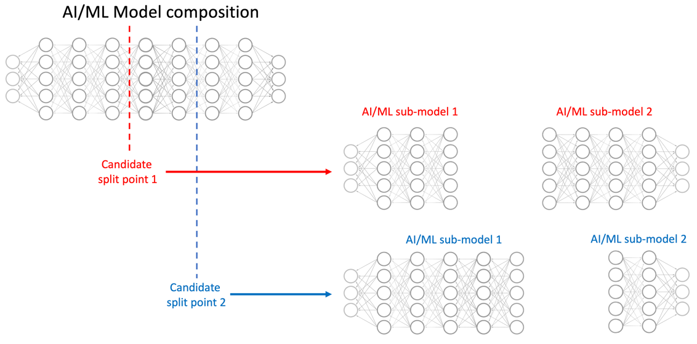
Figure 5.1-1: AI/ML model composition examples with a fully connected ANN
In a general case, illustrated in Figure 5.1-2, several compositions of the same AI/ML model are represented by the AI/ML subsets (M0, M1), (M’0, M’1), or (M “0, M “1, M “2) with split points highlighted in red. The same AI/ML sub-model may be used in different compositions depending on the configurations of the model composition (e.g. M’0 and M”0 according to figure 5.1-1).
In Figure 5.1-2, (a) and (b) are examples of AI/ML inference endpoints running an AI/ML model composed of two sub-models M0 and M1.
Examples (c) and (d) demonstrate AI/ML split models where M0, M’0 run on the UE while M1, M1’ run on the network respectively.
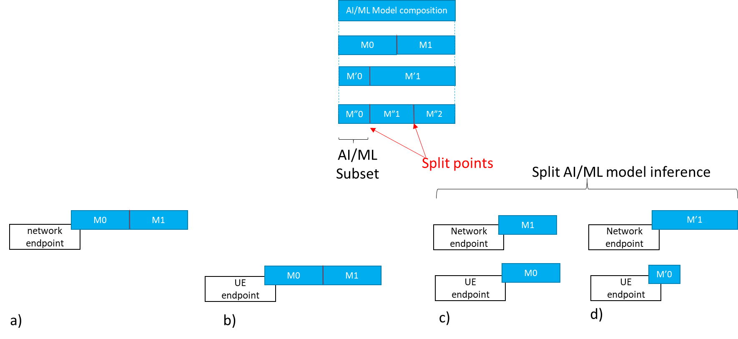
Figure 5.1-2: General AI/ML model composition examples
In this document the following working assumptions are made:
- Each sub-model describes a unique part of the inference process.
- The combination of the inference of all sub-models is equivalent to the inference of the entire AI/ML model.
- Several split points, identifying the frontier between AI/ML sub-models, may be identified within an AI/ML model.
- Those split points are predefined and may be selected dynamically.
- In this report, only service configurations limited to one split-point (i.e., only two sub-models) are addressed in this report.

NOTE: Service configurations addressing more than 2 AI/ML sub-models are for further study.

5.1.2 Topologies of split AI/ML inference

5.1.2.1 Introduction
In the context of split AI/ML models, for which one AI/ML sub-model is run in the UE and the other sub-model in the network, there may be different orders of operations and consequently different media flows depending on where the process is initiated and where the media source to be processed is.
This clause introduces the different topologies of AI/ML split operations with the media source being in the UE (Clause 5.1.2.2) and in the network (Clause 5.1.2.3).

5.1.2.2 UE as the media source
In this scenario, the media data to be processed by the AI/ML model is in the UE. 2 cases distinguished:
- The first AI/ML sub-model runs a partial inference in the UE. The intermedia data is then sent to the network and used by the second AI/ML sub-model that completes the inference process. The result is finally sent back to the UE. The configuration is illustrated in figure 5.1-3.
- The media source is sent to the network where the first AI/ML sub-model runs a partial inference. The intermediate data is then sent to the UE and used locally by the second AI/ML sub-model that completes the inference process. The result of the inference is available directly in the UE. This configuration is illustrated in figure 5.1-4.
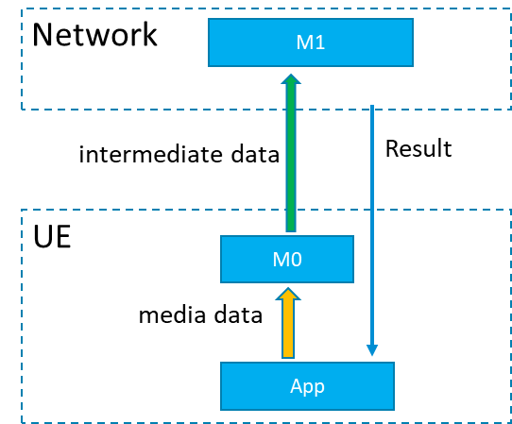
Figure 5.1-3: Split AI/ML model inference where the UE is the media data source with first inference endpoint on the UE

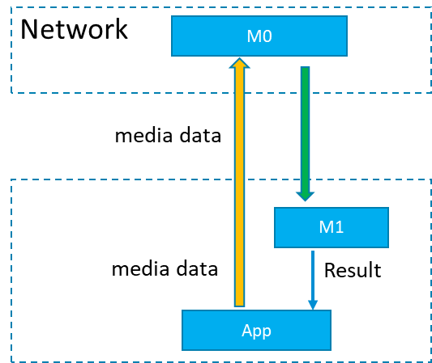
Figure 5.1-4: Split AI/ML model inference where the UE is the media data source with first inference endpoint on the network

5.1.2.3 Network as the media source
In this scenario, the media data to be processed by the AI/ML model is in the network. There, the first AI/ML sub-model runs a partial inference. The intermediate data is sent to the UE that already has the second AI/ML sub-model available. This second AI/ML sub-model uses the intermediate data to complete the inference process. The result of the inference is available directly in the UE. This configuration is illustrated in figure 5.1-5.
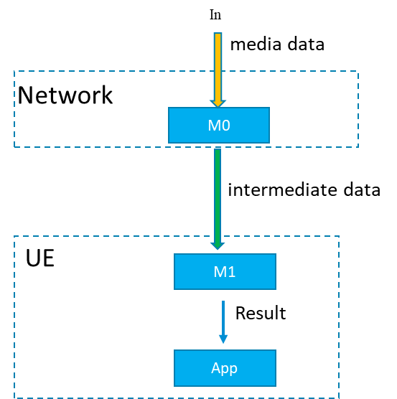
Figure 5.1-5: Split AI/ML Model inference where the network is the media source

--- NEXT Change ---

