Source: Xiaomi, ???
Title: XR Baseline Client

Document for: Agreement

Agenda Item: 14.4

1 Introduction
At the 3GPP meeting #121, SA4 delegates discussed the definition of a XR Baseline Client. The goal of this XR Baseline Client is to provide a single point of reference among the various Work Items addressing XR-related aspects. This way, a certain level of harmonization across Work items and Study Items can be achieved. Within a given Work Item or Study Item, this baseline client may be extended to address its specific requirements.

2 XR Baseline Client

2.1 General
The XR Baseline Client represents the functionalities, the peripherals and the interfaces that are present on a generic XR UE. The actual device may be realised by a single device or a combination of devices linked together. The details on how to instantiate an XR Baseline Client in the context of a service or deployment scenario is left for the respective Work Items and Study Items to define.
In terms of functionalities, an XR Baseline Client is composed of:
- an XR application: a software application that integrates audio-visual content into the user’s real-world environment
- an XR Runtime: a set of functions that interface with a platform to perform commonly required operations, such as accessing the controller/peripheral state, getting current and/or predicted tracking positions, performing spatial computing, and submitting rendered frames to the display processing unit.
- An XR Source Management: management of data sources provided through the XR runtime such as microphones, cameras, trackers, etc.
- a Media Access Function: A set of functions that enables access to media and other XR-related data that is needed in the Scene manager or XR Runtime to provide an XR experience.
- a Scene Manager: a set of functions that supports the application in arranging the logical and spatial representation of a multisensorial scene based on support from the XR Runtime.
In addition, those functional blocks are integrated together via interfaces. Interfaces may be made of APIs and/or data formats and collectively act as a contract between the two sides of the interface.
The XR Baseline Client contains the following interfaces:
- IF-1 lies between the XR Runtime on one side and the XR Source Management and the Presentation Engine.
- IF-2 lies between the Media Access Function and the 5G System.
- IF-3 lies between the XR Source Management and the Media Access Function.
- IF-4 lies between the Scene Manager and the Media Access Function.
- IF-5 lies between the Scene Manager and the XR Application.

2.2 Architecture
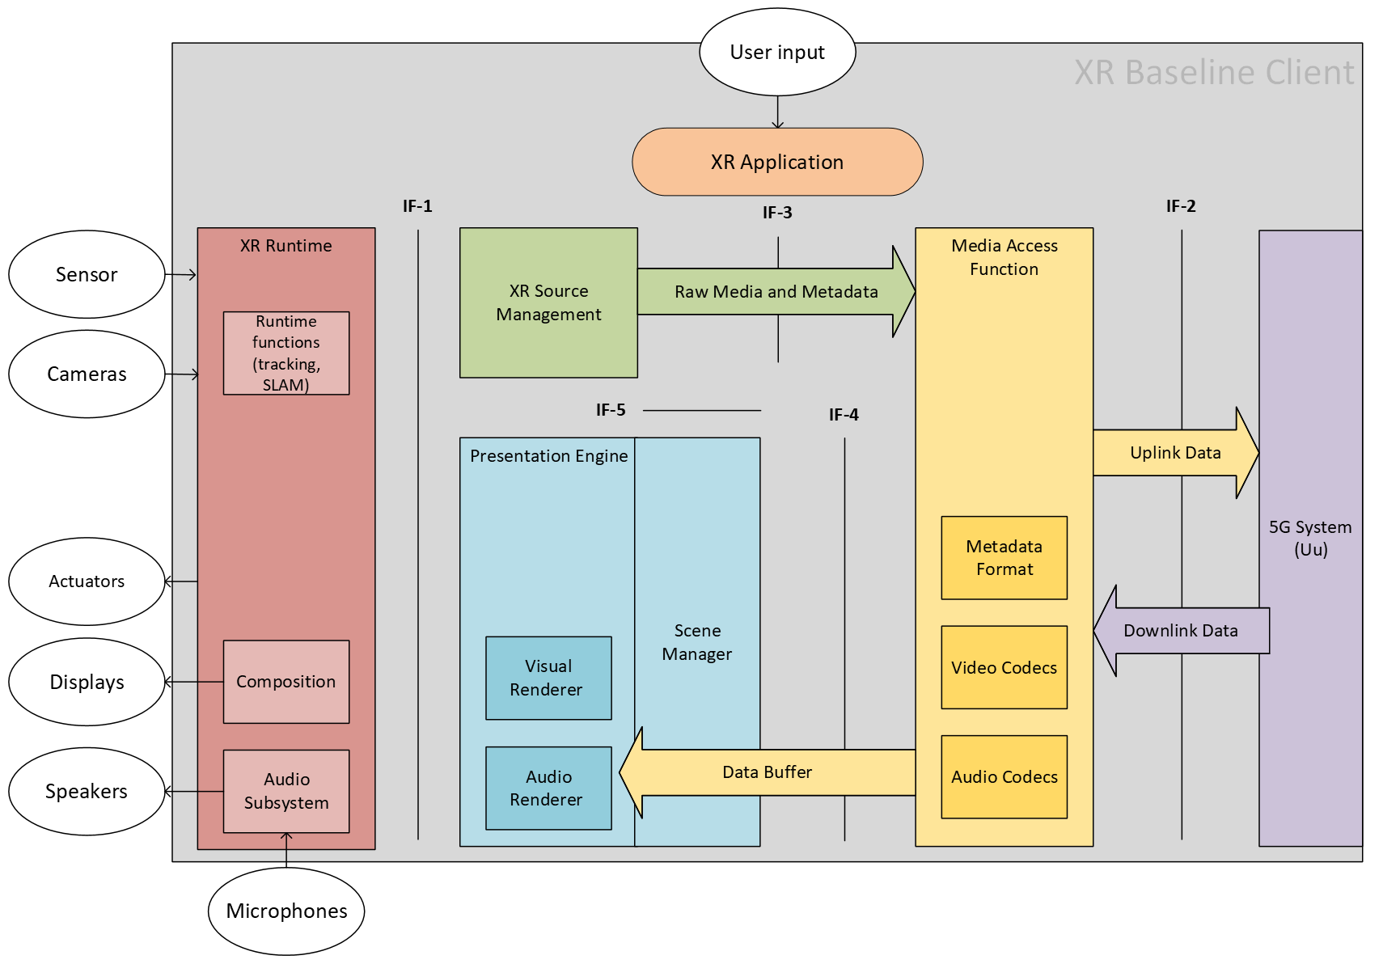
Figure 1 - XR Baseline Client

3 Conclusion
We recommend adopting the XR Baseline Client (Clause 2) into the next revision of the MeCAR Permanent Document. While being in the MeCAR Permanent Document, the scope of this client is SA4 wide. As a result, we also encourage the use of this XR Baseline Client as a starting point for possible extensions developped by the respective Work and Study Items.

