**Source: Tencent Cloud**

**Title: [MeCAR] AR UE provisioning of edge/cloud resources**

**Agenda Item: 9.5**

**Document for: Agreement**

1. Introduction

This contribution provides a process for edge provisioning for an AR UE device. For more details on edge provisioning reference architecture, please see S4-221294.

1. Edge provisioning requirements

The WI description provides the following objectives regarding split-rendering:

* Define capability exchange mechanisms based on complexity of AR media and capability of device to support EAS KPIs for provisioning of edge/cloud resources

1. Work plan

Clause 8.3 list the work to start at SA4#121, including:

* To be started at SA4#121
  + Capability exchange mechanisms to support edge provisioning
  + Typical traffic characteristics for AR media
  + Addition of AR Media Capabilities for 5G Media Streaming

1. Split management

In the SR_MSE, we propose a reference architecture for split-rendering management. The goal of split-rendering management is to decide what part of the processing will be performed on edge when a device wants to access an application/service.

In order to manage the split, several entities in the device and network need to interact with each other. The split management architecture defines these entities and their interfaces. The reference architecture for split management is shown in Figure 1.



Figure 1 – Split management architecture

In this architecture:

1. The Split-Rendering Client (SRC) is responsible on the behalf of the UE for negotiations with edge to find the split-rendering configuration.
2. The Split-Rendering Function (SRF) is responsible on behalf of the edge for negotiations with the UE to find the split-rendering configuration.

The above entities use the following interfaces to interact with other entities:

1. MSE-4S for SRC and SRF negotiation on split: This interface is used for negotiation at the beginning of the media delivery session and/or during the media delivery session to update/change the split.
2. MSE-7 for SRC to discover the client’s capabilities: The device capabilities are retrieved by SRC with this interface. The interface may provide static and dynamic capabilities, i.e. capabilities that do not change or may change during the media delivery session.
3. MSE-6 for SRC to interact with the Application: This interface is used by the Application to request SRC to manage a split and to retrieve the status of the split management.
4. MSE-1 for SRF to interact with the Application Service Provider: (ASP). The ASP uses this interface to provision the split management session and also to retrieve the status of a split during the media delivery session.
5. MSE-3 for SRF to discover the 5GMS AS capabilities: This interface is used by SRF to retrieve the static and dynamic capabilities of the 5GMS AS.
6. MSE-8 for communication between the Application and Application Service Provider.

## Update to MeCAR device architecture

If the split-rendering management architecture in section 4 is agreed, then we propose to update the MeCAR device architectures accordingly proposed for updating the PD.

4.2 Augmented Reality User Equipment (AR UE)

4.2.1 Device architecture

[Editor’s note] At SA4#119, this section was added while further improvements were improved. In particular, the audio rendering may need further clarification in terms of interfaces and roles between the AR/MR Application, the AR Scene Manager and the AR Runtime.

[Editor’s note] At SA4#120, it was identified to be high priority for the upcoming telcos to stabilise the AR UE architecture so that the work can progress in lower level of details such as:

* Identifying the subsets of API that can be part of the AR Runtime API
* Identifying the mandatory aspects present in OpenXR related to media, e.g. projection format for the images in the, etc…

Figure 11 provides the technical architecture of the AR UE.

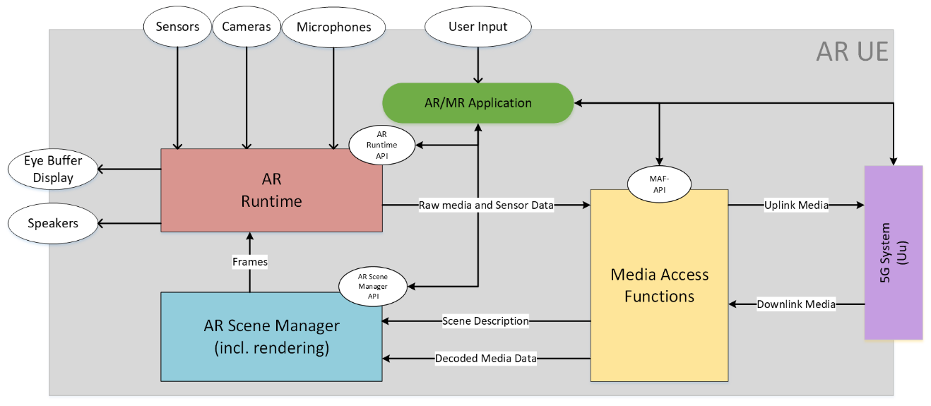

Split-Rendering Client

**Figure 11 – Device architecture of AR UE**

The AR UE is regular 5G UE with 5G connectivity provided through an embedded 5G modem and 5G system components. The AR UE also features several sensors and user controllers relevant for AR experiences that are cameras, microphones, speakers, display and generic user input. The AR/MR Application is responsible for orchestrating the various device resources to offer the AR experience to the user. In particular, the AR/MR Application can leverage three main internal components on the device which are:

* The Media Access Functions (MAF)
* The AR Runtime
* The AR Scene Manager

The AR/MR Application can communicate with those three components via dedicated APIs called the MAF-API, the AR Scene Manager API and the AR Runtime API. Among other functionalities, those APIs enables the AR/MR Application to discover and query the media capabilities in terms of support as well as available resources at runtime. Regarding rendering, the AR/MR application obtains the head pose information from the AR Runtime which is then provided to the AR Scene Manager. Based on this information, the AR Scene Manager determines the objects visible to the user at a given point in time or more generally the objects that may be needed to be rendered in the next rendering cycles. The AR scene manager then submits the rendered views to the AR Runtime as frames written to the images of the Swapchains, of which formats where configured beforehand by the AR/MR Application using the information provided by the AR Runtime API. From those images in the Swapchains, the AR Runtime then generates the left and right eye buffers possibly based on late adjustment techniques using updated head pose information, if available, commonly known as late stage reprojection (LSR).

Once the AR/MR application is running, the downlink media flows from the 5G System to the MAF in compressed form and then from The MAF to the AR Scene Manger in a decoded form. In parallel, the AR UE is capable of establishing an uplink data flow from the AR Runtime to the MAF wherein the data may be in an uncompressed form and then from the MAF to the 5G System wherein the MAF may have compressed the data in order to facilitate the expected transmission over the network.

The AR/MR Application also has access to the Split-Rendering Client on the device. The Split-Rendering Client (SRC) is responsible to negotiate with the network to run a part of the application on the edge network. The SRC has APIs to MAF, AR Runtime, and AR Scene Manager to discover the capabilities of the device. The SRC negotiates with the network through its 5G system interface. Note that the split-rendering management is run in parallel to the media delivery pipeline.

1. Proposal

We propose the update the PD with clause 5 of this document.