Source: Samsung Electronics Co. Ltd

**Title: [FS_MS_NS_Ph2] Key Issue #6: Resolve slice-specific application instances**

**Agenda Item: 8.10**

**Document for: Discussion and Agreement**

# **Introduction**

During the MBS SWG Ad-hoc Post 120-e meeting on October 20, 2022, a contribution S4aI221395 was discussed that covered the aspect of resolving 5GMS AS instances serving different network slices. Few comments were received during the call. This contribution revises the proposed text from the above contribution based on the received comments. Specifically, below are changes that were discussed as a way forward:

|  |  |
| --- | --- |
| Discussed Change | Changes in current revision |
| 1. Rename entity in call flow diagrams to remove indication that they are slice-specific | Incorporated the suggestion. Call flow diagrams in current revision do not show slice-specific AS instance |
| 2. Add note to say that the AS instances, in this use case, is dedicated to specific network slice | Added Note 1 in clause 6.6.2.x |
| 3. Use case for the contribution | Added clause 3 for use case description |
| 4. Do not exclude edge computing use cases | Added Note 2 in clause 6.6.2.x |
| 5. Accept prior changes discussed during prior MBS adhoc calls post 120e as there are many changes on changes | Accepted changes on changes, and proposed as one single change |

# **Discussion** (carried over from S4aI221395)

Few key points relevant to the discussion for this topic are included below:

- The IP address for the UE is scoped to the PDUSession as described in clause 5.8 of TS 23.501

- Clause 5.15 of TS 23.501 describes the relationship between a network slice instance and PDUSession – “*A PDUSession belongs to one and only one specific Network Slice instance per PLMN. Different Network Slice instances do not share a PDU Session, though different Network Slice instances may have slice-specific PDU Sessions using the same DNN.*”

The notion of network slicing specified by 3GPP is to enable sharing of RAN, core, and transport (sub)-networks to provide a logical instantiation of network called as a network slice instance. Communication services can be delivered through these network slice instances. However, the implementation of network slicing using the underlying network can be achieved through multiple ways e.g., using network technologies such as MPLS, VXLAN, L2VPN, L3VPN, SRV6 [1][2][3]. These network technologies provide the ability to create network overlays over the same underlying network infrastructure, thus enabling the creation of network slices.

3GPP specifies that network slice instances terminate at the UPF, and the N6 subnet connecting the UPF to the DN is not part of a network slice instance. However, as described above, and in clause 4.3.2 of TS 23502, a PDU session association includes the N6 subnet into the DN. With a network slice created using any of the network technologies above, routing table entries should be available to forward traffic in the network slice to a destination in the DN. Therefore, a 5GMS AS instance in the DN is likely to be reachable from any network slice given the routing table entries are properly configured and DNS entries are populated correctly.

# **Use case: Slice-specific AS instances**

Clause 5.12.6 of TR 26804 describes a candidate solution for network slices and operation points provisioned at M1. This clause describes a use case for using multiple network slices for media streaming with different operation points. An excerpt from this clause is below:

“*The 5GMS Application Provider may use the M1 provisioning interface to define a set of network slices that can be used for the media streaming sessions that it offers. This is done when the 5GMS Application Provider would like to request that its media traffic is isolated from other traffic. This may facilitate features such charging and QoS accounting.*

*It may associate each operation point (e.g. 4K HDR, HD, SD) with a dedicated network slice. Access to each network slice at reference point M4 is restricted to UEs with a valid subscription to that service level. The list or groups of users that are to be authorized to use a certain slice is provided by the 5GMS Application Provider during the provisioning step and can be updated subsequently*”

The above clause provides a detailed call flow for realizing the above use case. As part of the solution, the service access information from the 5GMS AF to the MSH may include mapping information between the operation points and the S-NSSAIs that should be used by the session. Once the 5GMS-Aware Application retrieves the allowed operation points through M8, it selects one of the operation points and communicates with the MSH which will then establish a PDU session through that slice so M4 media streaming can proceed.

It is possible that the application provider may provision multiple AS instances in the DN domain for serving traffic through different network slices for the above use case. For example, the application provider may provision a dedicated AS instance per slice to perform all the necessary tasks for a specific operation point. An example operation point specific media processing is shown in [4] which shows multiple AWS Elemental Live appliances generating different quality streams for feed from a live source as shown in Figure (a) below (the packaging and caching workflow tasks can be performed together along with video encoding tasks for an operation point specific processing). With this kind of a setup, the application provider intends that the media streaming between the application on the UE and operation point specific AS instance happens through a specific network slice.

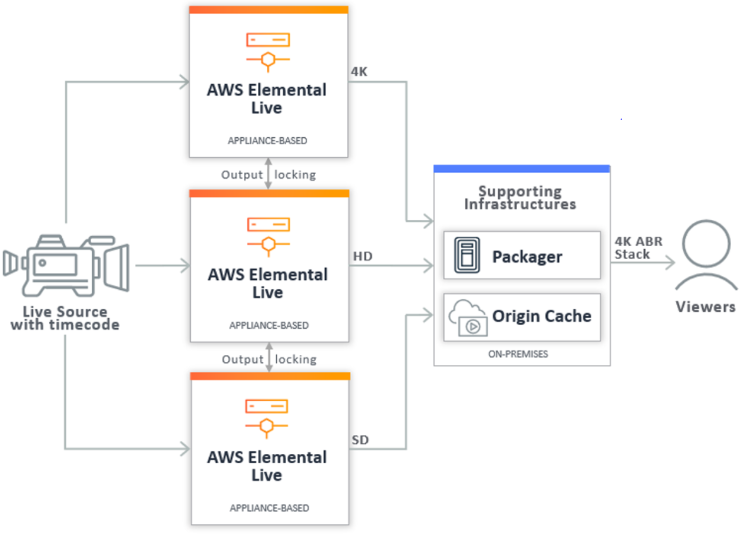

Figure (a): Multiple AWS Elemental Live appliances to produce 4K ABR stack [4]

# **References**

[1] “A Realization of IETF Network Slices for 5G Networks Using Current IP/MPLS Technologies”, IETF draft, <https://www.ietf.org/id/draft-srld-teas-5g-slicing-00.html>, 2022

[2] [J. Ordonez-Lucena](https://pubmed.ncbi.nlm.nih.gov/?term=Ordonez-Lucena%20J%5BAuthor%5D), [P. Ameigeiras](https://pubmed.ncbi.nlm.nih.gov/?term=Ameigeiras%20P%5BAuthor%5D), [L. M. Contreras](https://pubmed.ncbi.nlm.nih.gov/?term=Contreras%20LM%5BAuthor%5D), [J. Folgueira](https://pubmed.ncbi.nlm.nih.gov/?term=Folgueira%20J%5BAuthor%5D), [D. R. López](https://pubmed.ncbi.nlm.nih.gov/?term=L%C3%B3pez%20DR%5BAuthor%5D), “On the Rollout of Network Slicing in Carrier Networks: A Technology Radar”, Sensors 2021, 21, 8094. DOI: 10.3390/s21238094

[3] S. Bhattacharjee., K. Katsalis, O. Arouk, R. Schmidt, T. Wang, X. An, T. Bauschert, N. Nikaein, “Network Slicing for TSN-Based Transport Networks” IEEE Access. 2021;9:62788–62809. doi: 10.1109/ACCESS.2021.3074802

[4] “AWS Elemental Live encoder 4K/UHD advancements and workflows”, https://aws.amazon.com/blogs/media/aws-elemental-live-encoder-4k-uhd-advancements-and-workflows/

# **Proposal**

We propose that the following change be adopted into TR 26.941 for key issue #6.

**===== 1. CHANGE =====**

## 6.6 Key Issue #6: Slice resource resolution

### 6.6.1 Description

#### 6.6.1.1 Resolve application instances serving specific network slices

Editor’s Note: Key issue to cover study objective of identifying methods for deploying, supporting, and resolving slice-specific 5GMS AS instances. Solutions all levels – higher layer methods such as modification of media description documents to lower layer methods using networking protocols – can be included.

TS 26.501 [20] describes procedures for download media streaming wherein the 5GMS Application Provider configures a 5G Media Streaming M1 provisioning session at the 5GMS AF and an M2 content ingest/egest session at the 5GMS AS. The UE may have access to multiple PDU sessions on different network slices using which it may receive content for a media service. Depending on the media service, different network slices may provide different Qualities of Service or packet treatment behaviour for media streams sent through those network slices.

To enable media streaming through multiple network slices, it is possible that one or more 5GMS AS instances serve different network slices. Traditional media streaming solutions include steps wherein the UE is informed of media streaming endpoint information of 5GMS AS instances using media description documents (e.g., DASH MPD). With this information, UE knows how to resolve the media streaming endpoints so it can request streaming of media content from those 5GMS AS instances. However, with multiple possible 5GMS AS instances serving different network slices, the issue remains of how a UE resolves the appropriate 5GMS AS instance for requesting media content.

Open issues:

- Whether and how application layer solutions can assist in informing the 5GMS Client about endpoint information of 5GMS AS instances serving different network slices.

- Whether and how lower-level networking and routing procedures can assist in resolving 5GMS AS instances serving specific network slices.

### 6.6.2 Candidate solutions

#### 6.6.2.1 Candidate solution #1: DNS based resolution of 5GMS AS instance serving a network slice

The AS instance described in this solution is dedicated to specific network slice. The procedures for three different cases are described.

NOTE: The proposed solution is transparent to the DN domain and does not impact resolution of 5GMS EAS instances in edge networks.

Figure 6.6.2.1-1 illustrates the procedure for DNS based resolution of 5GMS AS instance serving specific slice when the MNO DNS Server is authoritative for the 5GMS AS host name.



Figure 6.6.2.1-1: Procedure for DNS based resolution of 5GMS AS instance serving network slice  
when MNO DNS is authoritative

The steps are as follows:

1. The 5GMS Application Provider configures a provisioning session at the 5GMS AF at reference point M1.

a. The provisioning session configuration at 5GMS AF is as described in clause 5 for downlink media streaming and clause 6 for uplink streaming as specified in [20].

b. Since the 5GMS AF is the authoritative owner of the DNS host name, a DNS A (and/or AAAA) record for the 5GMS AS instance serving the network slice is stored in the MNO DNS server by the 5GMS AF.

c. The FQDN of the 5GMS AS is sent to the 5GMS Application Provider for constructing Service Announcement information.

2. The 5GMS Application Provider provides service announcement information to the 5GMS-Aware Application in the UE as described in step 4 of clause 5.1 for downlink streaming and step 4 of clause 6.1 for uplink streaming in [20].

3. (Optional) In case the 5GMS Client in UE received only a reference to the Service Access Information, then it acquires the Service Access Information from the 5GMS AF as described in step 6 of clause 5.1 of [20].

4. The 5GMS Client in the UE resolves the host name of 5GMS AS instance serving the network slice to its IP address using DNS resolution methods at the MNO DNS Server.

5. The M5 Media Session Handling procedure is then performed as specified in step 7 of clause 5.1 for downlink media streaming and step 7 of clause 6.1 for uplink media streaming in [20].

6. The M4 Media Streaming procedures are then carried out as specified in step 8 of clause 5.1 for downlink media streaming and step 8 of clause 6.1 for uplink media streaming in [20].

Figure 6.6.2.1-2 illustrates the DNS resolution procedure wherein the DN DNS Server assists in resolving its announced host name alias of the 5GMS AS serving the network slice to a canonical FQDN nominated by the serving mobile network.



Figure 6.6.2.1-2: Procedure for DNS based resolution wherein the DN DNS Server assists in resolving the hostname of the 5GMS AS instance serving the network slice to an FQDN from the serving mobile network

The steps are as follows:

1. The 5GMS Application Provider configures a provisioning session at the 5GMS AF at reference point M1.

a. The provisioning session configuration at 5GMS AF is as described in clause 5 for downlink media streaming and clause 6 for uplink streaming as specified in [20].

b. The 5GMS AF creates a canonical domain name for 5GMS AS instance serving the network slice and sends it to the 5GMS Application Provider.

c. The 5GMS Application Provider creates a host name alias to the canonical domain name which is added into the DN DNS Server (CNAME record).

2. The 5GMS Application Provider prepares service announcement information with host name alias and provides it to the 5GMS-Aware Application in the UE as described in step 4 of clause 5.1 for downlink streaming and step 4 of clause 6.1 for uplink streaming in [20]

3. (Optional) In case the 5GMS Client in UE received only a reference to the Service Access Information, then it acquires the Service Access Information from the 5GMS AF as described in step 6 of clause 5.1 of [20].

4. The 5GMS Client uses MNO DNS Server to resolve the FQDN of the 5GMS AS serving the network slice. The 5GMS Client sends a DNS request to the MNO DNS Server.

5. The MNO DNS Server is not responsible for the host alias FQDN and forwards the DNS request to the DNS Server in the DN domain.

6. Based on the information from the originating network, the DNS Server in DN domain creates a response. The response is a CNAME redirect (i.e. FQDN from the serving mobile network responsibility) or an IP address .

7. The MNO DNS Server forwards the DNS response to the 5GMS Client in the UE.

8. When the 5GMS Client in the UE receives another FQDN with the response (i.e. CNAME DNS record), it resolves the FQDN to an IP address. The resolved IP address is the IP address of 5GMS AS instance serving the network slice.

9. The M5 Media Session Handling procedure is then performed as specified in step 7 of clause 5.1 for downlink media streaming and step 7 of clause 6.1 for uplink media streaming in [20].

10. The M4 Media Streaming procedures are then carried out as specified in step 8 of clause 5.1 for downlink media streaming and step 8 of clause 6.1 for uplink media streaming in [20].

Figure 6.6.2.1-3 illustrates the DNS resolution procedure when the DNS server in DN domain is authoritative.



Figure 6.6.2.1-3: Procedure for DNS based resolution of 5GMS AS instance serving specific network slice when DNS Server in DN domain is authoritative

The steps are as follows:

1. The 5GMS Application Provider configures a provisioning session at the 5GMS AF at reference point M1.

a. The provisioning session configuration at 5GMS AF is as described in clause 5 for downlink media streaming and clause 6 for uplink streaming as specified in TS 26.501 [20].

b. The 5GMS Application Provider creates a canonical domain name FQDN which is added to the DNS Server in DN domain.

2. The 5GMS Application Provider prepares service announcement information and provides it to the 5GMS-Aware Application in the UE as described in step 4 of clause 5.1 for downlink streaming and step 4 of clause 6.1 for uplink streaming in [20]

3. (Optional) In case the 5GMS Client in UE received only a reference to the Service Access Information, then it acquires the Service Access Information from the 5GMS AF as described in step 6 of clause 5.1 of [20].

4. The 5GMS Client in UE uses the MNO DNS Server to resolve the FQDN of the 5GMS AS instance serving the network slice. The 5GMS Client sends a DNS request to the MNO DNS Server.

5. The MNO DNS is not responsible for the canonical domain name FQDN and forwards the DNS request to the DNS Server in the DN domain.

6. The DNS Server in DN domain creates a response. The response is the IP address of the 5GMS AS instance serving the network slice.

7. The MNO DNS Server forwards the DNS response with the IP address of the 5GMS AS instance serving the network slice to the 5GMS Client in the UE.

8. The M5 Media Session Handling procedure is then performed as specified in step 7 of clause 5.1 for downlink media streaming and step 7 of clause 6.1 for uplink media streaming in [20].

9. The M4 Media Streaming procedures are then carried out as specified in step 8 of clause 5.1 for downlink media streaming and step 8 of clause 6.1 for uplink media streaming in [20].

**===== END CHANGES =====**