3GPPSA4 #121 S4-221294
Toulouse, 14-20 Nov 2022
CR-Form-v12.0
PSEUDO CHANGE REQUEST
 | 26.565 | CR | pseudo | rev | - | Current version: | 0.1.0
For HELP on using this form: comprehensive instructions can be found at
http://www.3gpp.org/Change-Requests.

Proposed change affects: | UICC apps |  | ME |  | Radio Access Network |  | Core Network

Title: | [SR_MSE] Baseline architecture
Source to WG: | Tencent
Source to TSG:
Work item code: | SR_MSE |  |  |  |  |  | Date: |  |  | 2022-11-8
Category: | B |  |  |  |  |  | Release: |  |  | 19
 | Use one of the following categories:  F (correction)  A (mirror corresponding to a change in an earlier release)  B (addition of feature),  C (functional modification of feature)  D (editorial modification)  Detailed explanations of the above categories can  be found in 3GPP TR 21.900. |  |  |  |  |  |  |  | Use one of the following releases:  Rel-8 (Release 8)  Rel-9 (Release 9)  Rel-10 (Release 10)  Rel-11 (Release 11)  Rel-12 (Release 12)  Rel-13 (Release 13)  Rel-14 (Release 14)  Rel-15 (Release 15)  Rel-16 (Release 16)
Reason for change: |  | This document proposes a baseline architecture based on FS_MSE for split management architecture. The architecture allows the negotiation between device and edge to split any client media functions into two sections: edge and device.
Summary of change: |  | - 5.1 Reference architecture
Consequences if not approved:
Clauses affected:
 |  | Y | N
Other specs |  |  |  | Other core specifications |  |  |  | TS/TR ... CR ...
affected: |  |  |  | Test specifications |  |  |  | TS/TR ... CR ...
(show related CRs) |  |  |  | O&M Specifications |  |  |  | TS/TR ... CR ...
Other comments:
This CR's revision history:

CHANGE

5.1 Reference Architecture
To demonstrate the need for a reference architecture for split rendering management, we start with a typical AR/XR client architecture as shown in Figure 5.1-1.
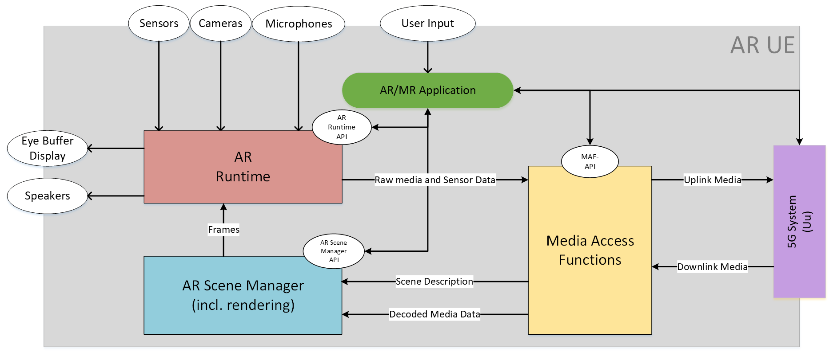
Client media functions
Figure 5.1-1 – Device architecture of AR UE

This figure represents the AR UE device architecture defined in MeCAR Permanent Document v3.1.
When the Application and/or Application Service Provider decide to run the client media functions in the split-rendering fashion, they have to replace this functionality with two new modules:
1. The edge-dependent light media service client, and
2. The media processing application running on 5GMS AS.
A successful split would result in a new media delivery architecture, such as the one shown in Figure 5.1-2.
Figure 5.1-2 – Architecture of 5G_STAR EDGAR-type device
This figure is also defined in MeCAR Permanent Document v3.1.
In order to manage the split, several entities in the device and network need to interact with each other. The split management architecture defines these entities and their interfaces. The reference architecture for split management is shown in Figure 5.1-3.

Figure 5.1-3 – Split management architecture
In this architecture:
- The Split-Rendering Client (SRC) is responsible on the behalf of the UE for negotiations with edge to find the split-rendering configuration.
- The Split-Rendering Function (SRF) is responsible on behalf of the edge for negotiations with the UE to find the split-rendering configuration.
The above entities use the following interfaces to interact with other entities:
- MSE-4S for SRC and SRF negotiation on split: This interface is used for negotiation at the beginning of the media delivery session and/or during the media delivery session to update/change the split.
- MSE-7 for SRC to discover the client’s capabilities: The device capabilities are retrieved by SRC with this interface. The interface may provide static and dynamic capabilities, i.e. capabilities that do not change or may change during the media delivery session.
- MSE-6 for SRC to interact with the Application: This interface is used by the Application to request SRC to manage a split and to retrieve the status of the split management.
- MSE-1 for SRF to interact with the Application Service Provider: (ASP). The ASP uses this interface to provision the split management session and also to retrieve the status of a split during the media delivery session.
- MSE-3 for SRF to discover the 5GMS AS capabilities: This interface is used by SRF to retrieve the static and dynamic capabilities of the 5GMS AS.
- MSE-8 for communication between the Application and Application Service Provider.
This document defines the following interfaces: MSE-1, MSE-4S, MSE-6, and MSE-7.
The following interfaces are out of the scope of this document: MSE-3 and MSE-6.
Note that depending on the deployment scenario, one of the following cases might be used:
- Client-initiated: The Application requests the SRC to initiate the split negotiation. The SRC negotiates with SRF to find the best split. The Application may also authorize the SRC to renegotiate the split during the session due to a change in the client’s available resources.
- Network-initiated: The ASP requests the SRF to initiate the split negotiation. The SRF offers the possibility to SRC and starts negotiating to find the best split. The ASP may also authorize the SRF to renegotiate the split during the session due to a change in the 5GMS AS available resources.
Two classes of split management are defined:
- Static split management, where the split management architecture is run before starting the media delivery session or when a non-split-rendering media delivery session is decided to be split. In this case, the splitting of the client media functions occurs only once before or during the media delivery session.
- Dynamic split management, where the split management architecture is run in parallel to the media delivery session. In this case, the performance of the client and 5GMS AS are monitored during the media delivery session and a new split may be performed depending on their conditions.

CHANGE

5.2 Procedures and Call Flows

5.2.1 Client-driven procedures and call flows
Figure 5.2.1-1 demonstrates a call flow for setting up the split rendering by the client.

Figure 5.2.1-1: High-level call flow for initiating a split
Steps:
- The 5GMS Application Service Provider requests the SRF the provisioning a split management session.
- The split management session is announced to the Application as part of the Service Access Information.
- The 5GMS-Aware application requests a split of the client media functions from the SRC.
- The SRC inquires the Media Service Client to discover the client’s media capabilities.
- The SRC requests the SRF split of the client media functions.
- The SRF inquires the 5GMS AS about its capabilities.
- The SRC and SRF negotiate on the acceptable capabilities for the device, and agree on the split option.
- The SRF requests the 5GMS AS to start the split-rendering process on the edge.
- The SRF acknowledges the SRC that the split-rendering on edge is running and provides its access information.
- The SRC acknowledges the Application that the split-rendering on edge is running.
- The 5GMS-aware Application request starting a media session from the 5GMS client.
- The 5GMS client connects to the split-rendering on the 5GMS AS using provided information in step 9.

5.2.2 Network-driven procedures and call flows
Figure 5.2.2-1 demonstrates a call flow for setting up the split rendering by the client.
Figure 5.2.2-1: High-level call flow for the network-driven split management
Steps:
- The 5GMS Application Service Provider requests the SRF the provisioning a split management session.
- The split management session is announced to the Application as part of the Service Access Information.
- The SRF inquires the 5GMS AS about its capabilities.
- The SRF requests the SRC split of the client media functions.
- The SRC inquires the Media Service Client to discover the client’s media capabilities.
- The SRC and SRF negotiate on the acceptable capabilities for the device, and agree on the split option.
- The SRF requests the 5GMS AS to start the split-rendering process on the edge.
- The SRF acknowledges the SRC that the split-rendering on edge is running and provides its access information.
- The SRC acknowledges the Application that the split-rendering on edge is running.
- The 5GMS-aware Application request starting a media session from the 5GMS client.
- The 5GMS client connects to the split-rendering on the 5GMS AS using provided information in step 9.

