3GPP TSG|WG4 Meeting #121 meeting S4-221409

Toulouse, France, 14th – 18th November 2022 Revision of S4-221190

**Source: *Beijing Xiaomi Mobile Software Co., Ltd, Huawei Technologies Co Ltd, Beijing Bytedance Technology Co., Ltd,*** ***ZTE Corporation, BUPT***

**Title: *Draft SID: Feasibility Study on Diverse*** ***audio Capturing system for End-user Devices***

**Document for: Approval**

**Agenda Item: 7.9**

3GPP™ Work Item Description

Information on Work Items can be found at <http://www.3gpp.org/Work-Items>   
See also the [3GPP Working Procedures](http://www.3gpp.org/specifications-groups/working-procedures), article 39 and the TSG Working Methods in [3GPP TR 21.900](http://www.3gpp.org/ftp/Specs/html-info/21900.htm)

Title: Feasibility Study on Diverse audio Capturing system for End-user Devices

Acronym: FS_DaCED

Unique identifier:

Potential target Release: Rel-18

# 1 Impacts

*{For Normative work, identify the anticipated impacts. For a Study, identify the scope of the study}*

|  |  |  |  |  |  |
| --- | --- | --- | --- | --- | --- |
| **Affects:** | **UICC apps** | **ME** | **AN** | **CN** | **Others (specify)** |
| **Yes** |  | X |  | X |  |
| **No** | X |  | X |  |  |
| **Don't know** |  |  |  |  | X |

# 2 Classification of the Work Item and linked work items

## 2.1 Primary classification

### This work item is a …

|  |  |
| --- | --- |
| X | **Feature** |
|  | **Building Block** |
|  | *Work Task* |
|  | **Study Item** |

## 2.2 Parent Work Item

For a brand-new topic, use “N/A” in the table below. Otherwise indicate the parent Work Item.

|  |  |  |  |
| --- | --- | --- | --- |
| **Parent Work / Study Items** | | | |
| **Acronym** | **Working Group** | **Unique ID** | **Title (as in 3GPP Work Plan)** |
| N/A |  |  |  |

### 2.3 Other related Work Items and dependencies

|  |  |  |
| --- | --- | --- |
| **Other related Work /Study Items (if any)** | | |
| **Unique ID** | **Title** | **Nature of relationship** |
| *770024* | *EVS Codec Extension for Immersive Voice and Audio Services* | *Codec for spatial audio in conversational services* |
| *950015* | *Media Capabilities for Augmented Reality Glasses* | *To define media capabilities for AR devices* |
| *830005* | *Terminal Audio quality performance and Test methods for Immersive Audio Services* | *Develop test specifications for objective characterization of terminals for 3GPP immersive services* |

**Dependency on non-3GPP (draft) specification:**

n/a

# 3 Justification

Following the development of the 4G/5G high-speed wireless access to telecommunications, providing immersive voice and audio service by end-user devices is becoming more and more practicable. For the creation of immersive services and experiences, related requirements have been investigated in 3GPP TR 22.891. Several use cases for VR are envisioned in TR 26.918, and for these the capturing system for channel-based audio, object-based audio and scene-based audio are generally considered. As such, capturing capabilities is crucial for truly immersive audio experiences.

Due to physical constraints on their outline shapes and sizes, end-user devices are usually configured with different numbers of microphones and different microphone setup configurations, hence different audio format generation capabilities. If to use accessory capturing device, more varied audio formats are expected. In the short run, smartphones are expected to be one of the preferred end-user devices for a real-time communication service, e.g., two smartphones should be able to negotiate the best appropriate format depending on the capturing and rendering capabilities of each, and the network environment characteristics. Therefore, specific signalling information should be used for building up the bilateral link.

The goal is to study diverse audio capturing methods and applicable audio formats for the end-user device considering the current physical and software constraints.

The scope of the work is shown in Figure 1, and the scope of the ongoing ATIAS and IVAS are also pointed out in it.

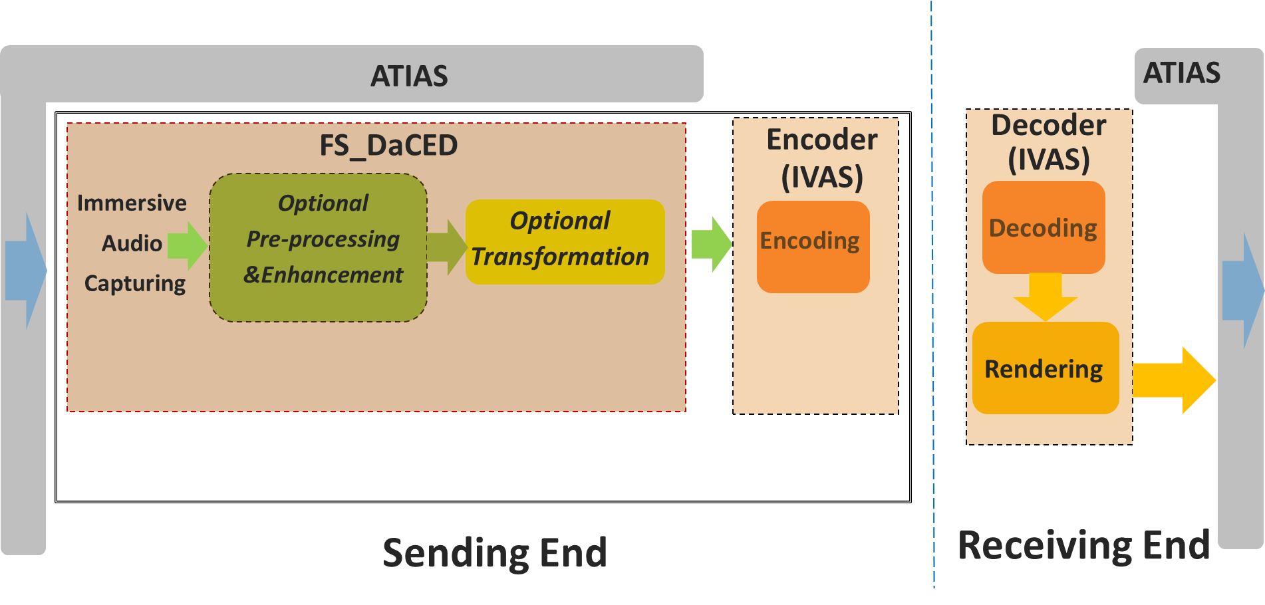

Figure 1

# 4 Objective

This study item considers codec-independent immersive voice and audio capturing configurations for end-user devices. The outcome of the studies can be used as guidelines for the manufacturers to deploy immersive voice and audio services. In particular, the following objectives are envisioned:

* Study audio capturing configurations for end-user devices considering:
  + Different UE form factor designs and categories such as:
    - Smartphone, Headset, Earbud, AR/VR device, Vehicle, Desktop, Laptop, Conference phones and other envisioned future devices.
  + Microphone placement/orientation/quantity and positioning, acoustic structures coupled to the microphones, and necessary processing for audio format.
  + Analog-to-Digital conversion if needed, Signal to Noise Ratio aspects, frequency band & group delay compensation.
  + Methods for improving the immersive audio experience, including signal enhancement (e.g. gain, noise, echo and spatiality control).
  + The set of audio formats generated by the different audio capturing configurations.
  + Test methods for characterizing the audio capture performance from e.g., :
    - ITU-T P.800/811, ITU-R.BS2132, ITU-R BS.2051-3, ATIAS
  + Different device tiers (low-end, middle-end, high-end)
  + Modelling and theoretical analysis for capture configuration.
  + The set of supported audio formats, including mono, stereo, binaural, MASA, multichannel, object-based audio and scene-based audio.
* Study example audio capture processing solutions that can be used in conjunction with immersive voice and audio services codecs.

# 5 Expected Output and Time scale

|  |  |  |  |  |  |
| --- | --- | --- | --- | --- | --- |
| **New specifications {One line per specification. Create/delete lines as needed}** | | | | | |
| **Type** | **TS/TR number** | **Title** | **For info  at TSG#** | **For approval at TSG#** | **Rapporteur** |
| *TR* | *26.XXX* | *Diverse Audio Capturing system* | *SA#104(*June 2024*)* | *SA#105*(Sep. 2024) | *Wang Bin: wangbin23@xiaomi.com* |
|  |  |  |  |  |  |

|  |  |  |  |
| --- | --- | --- | --- |
| **Impacted existing TS/TR {One line per specification. Create/delete lines as needed}** | | | |
| **TS/TR No.** | **Description of change** | **Target completion plenary#** | **Remarks** |
|  |  |  |  |
|  |  |  |  |

# 6 Work item Rapporteur(s)

*{Wang Bin: wangbin23@xiaomi.com}*

*{Optional: <FamilyName>, <GivenName>, <Company>, <email address>: Secondary task(s).}*

# 7 Work item leadership

SA4

# 8 Aspects that involve other WGs

none

# 9 Supporting Individual Members

|  |
| --- |
| **Supporting IM name** |
| Beijing Xiaomi Mobile Software Co., Ltd |
| Huawei Technologies Co Ltd |
| Beijing Bytedance Technology Co., Ltd |
| ZTE Corporation |
| BUPT |
|  |
|  |