3GPP TSG SA WG4 Meeting #120eS4-221038r01

17th – 26th August 2022

**Source:** Samsung Electronics Co., Ltd.

**Title:** On display capability of AR glasses

**Document for** Discussion and Agreement

**Agenda item** 9.5

# Introduction

At the previous 119th meeting, it was identified that the MeCAR discussion distinguishes AR glasses with OST (Optical See Through) and VST (Video See Through) type displays as proposed in [1].

This contribution proposes a more suitable method to distinguish devices with its colour reproducibility of display, rather than OST or VST type.

The colour reproducibility is important especially for AR split rendering service, because the rendered and augmented graphics component may imperceptible to human eyes in some circumstances. For example, projected light rays on glass display may be seen only if ambient light intensity is lower than the light rays. Black color or opacity of object are another examples that may or may not be seen depending on display capability and circumstances.

Device should report the colour reproducibility of its display to server so that the server's renderer selects a better colour (or palette) to make the AR content visible on the display.

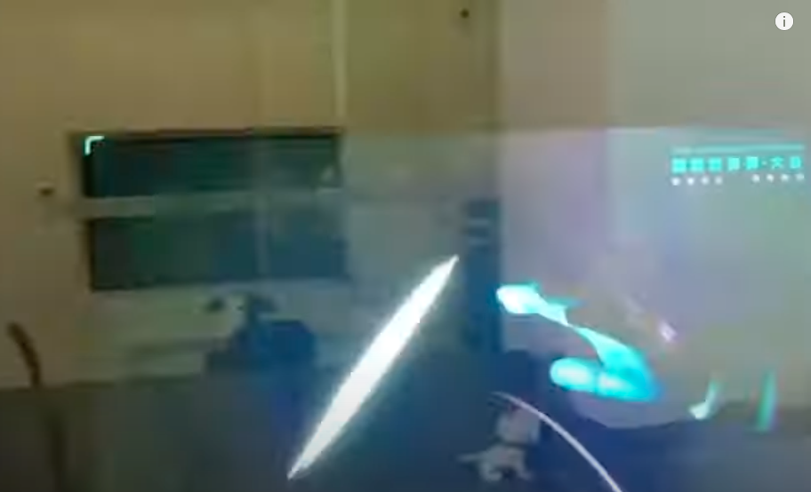

Figure 1 Image captured shows white text and limited level of perceptible colors

# Proposed information for AR glass display

5.X Display capability

The capability of a display for AR glasses may be characterised by its ability to reproduce colour and the ability to change its opacity comprised in to a given opacity range.

The followings are the relevant information to describe the capability of such display.

* display
  + Reference colour space (For example, https://registry.khronos.org/OpenXR/specs/1.0/html/xrspec.html#XR_FB_color_space)
  + Perceptible colours (For example, https://registry.khronos.org/OpenXR/specs/1.0/html/xrspec.html#XR_KHR_composition_layer_color_scale_bias)
  + Coordinate of primary colours in the reference colour space (For example, https://registry.khronos.org/OpenXR/specs/1.0/html/xrspec.html#XR_FB_color_space)
  + Colour map (For example, https://registry.khronos.org/OpenXR/specs/1.0/html/xrspec.html#XrPassthroughColorMapMonoToRgbaFB)
  + Opacity range (For example, https://registry.khronos.org/OpenXR/specs/1.0/html/xrspec.html#XrPassthroughStyleFB)
* sensor
  + Ambient light intensity (For example, https://www.w3.org/TR/ambient-light)
  + Ambient light intensity range

The reference colour space is the colour space in which the display is compatible.

The perceptible colours is a list of the colours perceptible or reproducible. Primary colours such as R, G, B and their coordinates in the reference colour space are listed. The display may provide the colour space coordinate according to dedicated reference condition, or according to measured ambient light.

The colour map is the array of colours that remapped by the device. It is a list of colours and their target RGBA values in the reference colour space. The application may provide the colours map according to dedicated display capability of a device.

The opacity range is the range of supported opaque/transparency level of the display. From fully opaque as 1.0 to fully transparent as 0.0, the display may provide its capability on blocking light rays from outside.

The ambient light intensity is the intensity of the ambient light measured at a given point in time.

The ambient light intensity range is the minimum and maximum level of light in the unit of lux that the sensor can measure and provide.

# Proposal

We propose to add information in clause 2 under the media capability section of MeCAR.

# References

1. S4-220736, InterDigital communications, "Clarification on the AR glasses device type"