**3GPP TSG-WG SA4 Meeting #120E e-meeting  *S4-221003***

**Elbonia, Aug 17th– 26th, 2022**

|  |  |  |  |  |  |  |  |  |
| --- | --- | --- | --- | --- | --- | --- | --- | --- |
| *CR-Form-v12.1* | | | | | | | | |
| **Pseudo CHANGE REQUEST** | | | | | | | | |
|  | | | | | | | | |
|  | **26.812** | **CR** | **-** | **rev** | **-** | **Current version:** | **0.0.x** |  |
|  | | | | | | | | |
| *For* [***HE******LP***](http://www.3gpp.org/3G_Specs/CRs.htm#_blank)*on using this form: comprehensive instructions can be found at* [*http://www.3gpp.org/Change-Requests*](http://www.3gpp.org/Change-Requests)*.* | | | | | | | | |
|  | | | | | | | | |

|  |  |  |  |  |  |  |  |  |
| --- | --- | --- | --- | --- | --- | --- | --- | --- |
| ***Proposed change affects:*** | UICC apps |  | ME |  | Radio Access Network |  | Core Network |  |

|  |  |  |  |  |  |  |  |  |  |  |
| --- | --- | --- | --- | --- | --- | --- | --- | --- | --- | --- |
|  | | | | | | | | | | |
| ***Title:*** | Collection of current work on AR/MR QoE in ITU-T. | | | | | | | | | |
|  |  | | | | | | | | | |
| ***Source to WG:*** | Huawei, HiSilicon, China Unicom | | | | | | | | | |
| ***Source to TSG:*** | SA4 | | | | | | | | | |
|  |  | | | | | | | | | |
| ***Work item code:*** | FS_ARMRQoE | | | | |  | ***Date:*** | | | 2022-08-04 |
|  |  | | | |  | |  | | |  |
| ***Category:*** | **B** |  | | | | | ***Release:*** | | | Rel-18 |
|  | *Use one of the following categories:* ***F*** *(correction)* ***A*** *(mirror corresponding to a change in an earlier release)* ***B*** *(addition of feature),* ***C*** *(functional modification of feature)* ***D*** *(editorial modification)*  Detailed explanations of the above categories can be found in 3GPP [TR 21.900](http://www.3gpp.org/ftp/Specs/html-info/21900.htm). | | | | | | | | *Use one of the following releases: Rel-8 (Release 8) Rel-9 (Release 9) Rel-10 (Release 10) Rel-11 (Release 11) … Rel-15 (Release 15) Rel-16 (Release 16) Rel-17 (Release 17) Rel-18 (Release 18)* | |
|  |  | | | | | | | | | |
| ***Reason for change:*** | | One objective of this study item is to collect the current work on AR/MR QoE in other standardization organizations, e.g. ITU-T, MPEG. This pCR intends to collect the current work on AR/MR QoE in ITU-T, including the detailed QoE factors which can be as basis for further work. | | | | | | | | |
|  | |  | | | | | | | | |
| ***Summary of change:*** | | Collection of current work on AR/MR QoE in ITU-T. | | | | | | | | |
|  | |  | | | | | | | | |
| ***Consequences if not approved:*** | | The SID is not complete. | | | | | | | | |
|  | |  | | | | | | | | |
| ***Clauses affected:*** | | 2, 4 | | | | | | | | |
|  | |  | | | | | | | | |
|  | | **Y** | **N** |  | | | |  | | |
| ***Other specs*** | |  | **X** | Other core specifications | | | | TS/TR ... CR ... | | |
| ***affected:*** | |  | **X** | Test specifications | | | | TS/TR ... CR ... | | |
| ***(show related CRs)*** | |  | **X** | O&M Specifications | | | | TS/TR ... CR ... | | |
|  | |  | | | | | | | | |
| ***Other comments:*** | |  | | | | | | | | |
|  | |  | | | | | | | | |
| ***This CR's revision history:*** | |  | | | | | | | | |

* * * * First change * * * *

# 2 References

The following documents contain provisions which, through reference in this text, constitute provisions of the present document.

- References are either specific (identified by date of publication, edition number, version number, etc.) or non‑specific.

- For a specific reference, subsequent revisions do not apply.

- For a non-specific reference, the latest version applies. In the case of a reference to a 3GPP document (including a GSM document), a non-specific reference implicitly refers to the latest version of that document *in the same Release as the present document*.

[1] 3GPP TR 21.905: "Vocabulary for 3GPP Specifications".

[2] 3GPP TR 26.998: "Support of 5G glass-type Augmented Reality / Mixed Reality (AR/MR) devices".

[3] 3GPP TR 26.928: "Extended Reality (XR) in 5G".

[4] 3GPP TR 26.926: "Traffic Models and Quality Evaluation Methods for Media and XR Services in 5G Systems".

[5] 3GPP TS 26.119: "Media Capabilities for Augmented Reality".

[X] ITU-T G.1036, “Quality of experience (QoE) influencing factors for augmented reality (AR) services”.

[Y] ITU-T P.1320, “QoE assessment of extended reality (XR) meetings”.

[Z] Technical Report ITU-T GSTR-5GQoE, QoE requirements for real-time multimedia services over 5G networks.

* * * * Second change * * * *

## 4.X AR/MR QoE related work in ITU-T

In ITU-T, there are many study groups focusing on the quality of experience (QoE) for XR services. Typically, Study Group 12 (SG12) majoring in the P​erformance, QoS & QoE​ is quite relevant to the study of AR/MR QoE in SA4.

In SG12, there are several ongoing or completed work about the AR/MR QoE.

1. ITU-T G.1036 “Quality of experience (QoE) influencing factors for augmented reality (AR) services”[X].

This Recommendation has been consented by the recent ITU-T Study Group 12 meeting, June 2022. It lists typical use cases of augmented reality services and identifies the key QoE factors in it, and also gives a suggested scheme for AR QoE assessment in future works.

Different from Virtual Reality, which aims to completely replace the user’s real world environment with a simulated one, Augmented Reality keeps the real world and puts additional information to the natural environment.

Due to addition of new ways to locate the self-position of users and new display mode of perceptual information, a set of new requirements to QoE assessment to characterize AR’s immersive video, spatial audio, and interactivity are emerging. Besides, it’s important to address the requirements and basic factors affecting the VR QoE before benchmarking work is executed. This document identifies the key factors affecting user-perceived experience.

The identified AR QoE metrics can be shown as following:

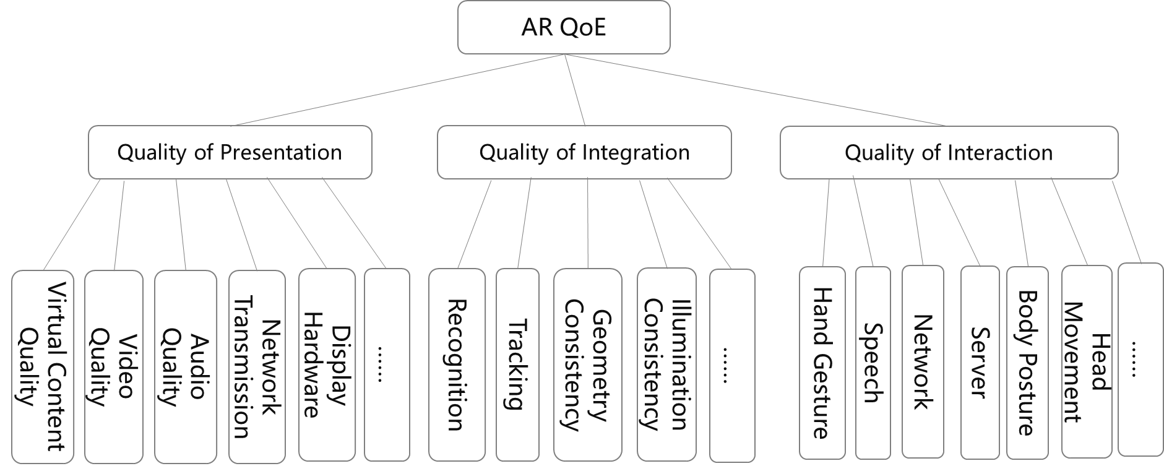

Figure 1 AR QoE assessment scheme

Table 1 Identified QoE factors for AR services

|  |  |  |
| --- | --- | --- |
| Human Factors | Vision | myopia, hyperopia, astigmatism, and amblyopia. |
| Hearing | the audio perceptibility |
| Touch/Force Sensation | tactile/force and other types of perceptual enhancement. |
| System Influence Factors | Content Related | Real Environment, virtual content, Superimposition of Real Environment and Virtual Content |
| Media and Coding Related | Codec, Bitrate, Resolutionl, Framerate, coding delay, streaming quality, stordage and transport. |
| Network and Transmission related | Bandwidth, latency, packet loss, jitter. |
| Recognition related | Marker attributes, Recognition response. |
| Consistency | Geometry consistency, Lighting consistency, Time consistency |
| Harware Related | Comfortableness, FoV, stereo, depth range |
| Interaction Related | Hand Gesture, Speech, Body Posture, Tangible Interface, Eye/head based interfaces, Brain-computer interfaces |
| Content Influence Factors | Physical context | physical environment condition |
| Colloboration context | collaborative environment for multi-person AR services. |
| Task context | tasks and goals users are aiming to in their minds. |
| Temporal context | the frequency and duration is to use AR services. |
| General factors | Human factors | Olfactory, Multisensory integration, Simulator sickness, Static and Dynamic Human Factor |
| Hardware related factors | Colour Space, Dynamic Range, Refresh Rate |

2. ITU-T P.1320 “QoE assessment of extended reality (XR) meetings”[Y] .

This Recommendation has been consent by the recent ITU-T Study Group 12 meeting, June 2022. It advises on aspects of importance for QoE assessment of telemeetings with extended reality elements. The goal is to define the human, context, and system factors that affect the choice of the QoE assessment procedure and metrics when extended reality telemeeting systems are under evaluation.

This Recommendation focuses on aspects of importance for the assessment of Quality of Experience (QoE) of different types of eXtended Reality (XR) telemeetings, which may comprise a combination of telemeetings taking place in virtual reality (VR), augmented reality (AR), or mixed reality (MR) environments. It targets XR services aiming to immerse the user and augment the exchange of information by delivering interactive real-time uni- or multimodal sensory information for two-party and multiparty communication. The services include telemeetings taking place in a virtual location or a combination of virtual and real locations; telemeetings with mixtures of real and virtual participants; telemeetings with augmented elements for collaboration; virtual conferences; and joint teleoperation of equipment.

While multiple QoE evaluation methodologies for telemeetings have been developed, novel XR telemeeting services may result in cognitive effects that are not covered by the existing Recommendations. These effects may include simulator sickness, fatigue, immersion, or presence, for example. This document advises on the key QoE factors affecting the user experience of an XR telemeeting service.

The identified QoE metrics for XR meetings can be found as the following.

Table 2 Factors influencing QoE of XR telemeetings.

|  |  |  |
| --- | --- | --- |
| Human Influence Factors | Perceptual and congnitive characteristics | Visual, audio, olfactory, tactile acuity. |
| Internal state of individual participants | Similator sickness, immersion, level of expertise, spatial intelligence and introversion, etc. |
| Conversation behaviour | Conversation behaviour, degress of involvement. |
| Relations between participants | A closer (e.g., romantic) relationship may be preferred for this kind of tactile stimulation. |
| Language and body language aspects | linguistic social cues and body language. |
| Content Influence Factors | Communication environment | Real Environment, virtual content, Superimposition of Real Environment and Virtual Content |
| Communication scenarios | Codec, Bitrate, Resolutionl, Framerate, coding delay, streaming quality, stordage and transport. |
| Time aspects | Bandwidth, latency, packet loss, jitter. |
| System Influence Factors | Human/world-related factors | Degree of freedom, representation of users, realism/style, locamotion, position, proxemics |
| Rendering | Rendering per client, multi-party effects on rendering, redering errors, resolutions, foveated rendering, overlaying rendering images. |
| Network and compression | Media encoding/decoding, latency, bandwidth, synchronization |
| Temporal context | the frequency and duration is to use AR services. |

3. Technical Report ITU-T GSTR-5GQoE, QoE requirements for real-time multimedia services over 5G networks[Z]

This report has been produced by the 5G-KPI working group of the Video Quality Experts Group (VQEG) and defines a scope for the analysis of QoE in 5G services and serveral use cases where this scope is applicable.

This Technical Report defines a scope for the analysis of QoE in 5G services and several use cases where this scope is applicable. Such use cases are: Tele-operated Driving, Wireless Content Production, Mixed Reality Offloading, and First Responder Networks. For all the targeted use cases, the work item aims to study the specific QoE requirements, as well as the required performance and features from the network. By addressing them in parallel, it is possible to find synergies between them and, more relevantly, extract the common information that can be used to also analyze other use cases that may arise outside the scope of this work item.

Specially, the MR Offloading case assumes that the immersive environment where the application takes place is either the real world around the user (AR) or a completely virtual environment (VR). 5G-network capabilities (i.e. Edge Computing) are used to enable running state-of-the-art MR algorithms while wearing a lightweight HMD.

The identified QoE factors for MR Offloading can be found in the following.

* Motion-to-photon latency
* responsiveness in human-virtual interaction
* Embodiment feeling
* RTT time
* Peak uplink/downlink throughputs
* Coding/processing delay
* Mean network througput
* Type of MR application
* Temporal context

* * * * End of changes * * * *