Source: Nokia Corporation
Title: Rcl yai 3D representation use cases and requirements
Document for Agreement
Agenda item: 5.3

Introduction
During Release 18, the SA4 RTC SWG has two WIs, IBACS and IRTCW, that have AR conversational requirements based on the two earlier studies, FS_XR5G (TR 26.928) and FS_5GSTAR (TR 26.998).
The purpose of this document is to synthesize from the use cases and requirements identified in these studies to evaluate a detailed set of requirements for IBACS that address support for dynamic 3D representation, which is required for AR conversational use cases. Although there are several use cases in the two studies with similar requirements, the following figure from use case 19 of TR 26.998 shows a representative case:

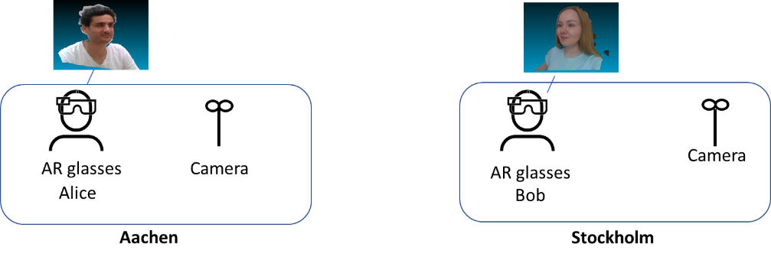

We use IBACS as a basis since the MTSI architecture and capabilities are already specified in TS 26.114. However, a similar set of requirements would apply to the IRTCW case, with possibly some difference in terms of session signalling.
The 5G AR conversational service is discussed in section 6.5 of TR 26.998.
- The relevant use cases are divided into two categories, where AR media consists of both 2D and 3D media for both categories:
  - AR two-party call
  - AR conferencing/multi-party call
- The first use-case realizes the AR conversational use case, with the requirement for both real-time encoding and decoding of dynamic 3D representations.
- The second use case is more complicated as it requires creating conversational 3D scenes and delivering Dcyamic 3D representationsobjet ultiple users. This use case should be addressed later when we have a good basis for the first one and if required can be handled in a separate study or even as part of Release 19.
- Spatial audio is to be considered at a later stage due to dependency on iVAS.
- Split rendering is not considered as a separate WI may address those requirements.

Use cases and requirements for dynamic 3D representation
Use cases 19 and 22 in TR 26.998 provide an AR conferencing experience. In both cases, participants can capture their 3D dynamic representation in real-time and share it with others in a shared AR experience. In this clause we state the requirements related to capturing and transporting the dynamic 3D representation of an object under conversational constraints. uprigvyai Drt. Dynamic 3D representation in this context is a format for defining the 3D model of an object (e.g., a caller) that is captured in real-time using one or more cameras. A dynamic 3D representation can be a point cloud or 3D mesh.
TR 26.998 section 4.4.5 defines some existing formats used for dynamic 3D representations. The Virtual Reality Industry Forum (VRIF) has recently issued their first Volumetric Video Guidelines, addressing volumetric video producion workflows and media profile standards for volumetric media distribution [1]. Based on the requirements for encoding, transporting, and decoding volumetric media, the following sub-categories are defined for the different use cases and their associated requirements. The proposed solution uses RTP for low-latency delivery of dynamic 3D representations.

2.1 AR two-party calls

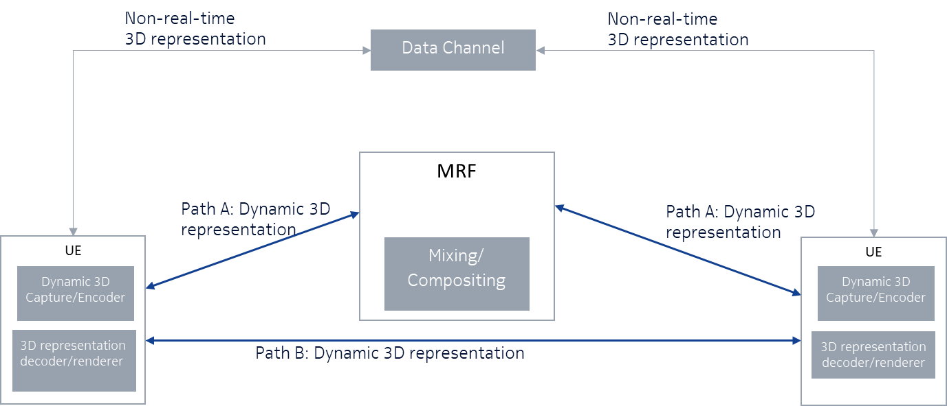
Figure xx: AR two-party call
The use case in Figure xx establishes a bidirectional AR two-party call, which may or may not use the MCU (MRF for IMS). It should be possible to combine other functions, e.g., 2D video, 360-degree video, images, etc., which are not shown in the figure for simplicity.
The dynamic 3D representations delivery in this case is over RTP. It is bidirectional with conversational latency requirements. The dynamic 3D representation can be delivered over one of the two paths shown in the figure. Path A goes through the MCU (MRF for IMS) and Path B is point-to-point.
Non-real-time 3D representations can be delivered via the data channel as shown in the figure.; the term 3D representation here includes both dynamic and static 3D representations, which are not captured and delivered under conversational latency requirements. The data channel is a WebRTC data channel or an IMS data channel. The IMS data channel used is as defined by TS 26.114. Further requirements, if needed, can be defined for using the data channel to transport 3D representationsojcs
The following set of requirements relate to the bidirectional conversational dynamic 3D representation:
- Call setup and control: this building block covers
  - signalling to setup a call or a conference – basic functions already provided by MTSI and will be covered also in IRTCW.
  - fetching of the entry point for the AR experience. The protocol needs to support upgrading and downgrading to/from an AR experience. Dependency on MeCAR to define device types.
- Formats: The media and metadata types and formats include in addition to the ones already covered by MTSI, volumetric media. Format properties and codecs need to be defined for dynamic 3D representations along with appropriate RTP payload formats and functions. Appropriate codecs need to be defined by MeCAR for encoding, decoding and rendering dynamic 3D representations.
- Real-time encoding and decoding with latency requirements for conversational media.
- Enhancements to SDP, scene description to support AR telephony.
- For AR telephony media types(e.g., dynamic 3D representation), the necessary QoS characteristics need to be defined.
- Support for AR media processing in the MCU (MRF for IMS).
- 5G system integration: offering the appropriate support by the 5G system to AR telephony includes:
  - discovery and setup of MCU (MRF) resources to process AR telephony media types.
  - defining the necessary QoS characteristics for AR telephony media types.
  - data collection and reporting.

AR multi-party calls

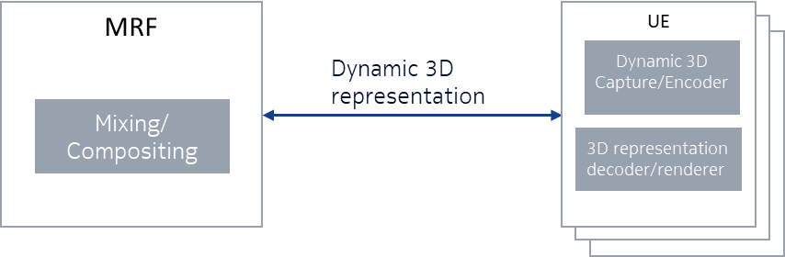
Figure yy: AR multi-party call
The use case in Figure xy establishes a multiparty call. The call may be unidirectional (one dynamic 3D representation sender and multiple receivers, 1:N) or bidirectional (multiple dynamic 3D representation senders and multiple dynamic 3D representation receivers, N:N). The 1:N case can be addressed first as part of this work as it is simpler. The N:N case can be addressed later.
In addition to the requirements of use case 2.1, the following requirements need to be considered for AR multi-party calls:
- Signalling for establishing a multiparty call. This may be done in a similar way as for traditional MTSI/WebRTC calls.
- Expanding scene description to address the case of multiple senders and multiple receivers; defining appropriate procedures to maintain position of all participants in the rendered space for each participant.
- Mixing/transcoding in the MCU (MRF for IMS) to combine content from multiple participants. This may include e.g., scaling and placement of 3D representations in a virtual room. Other requirements can also be studied.
More advanced requirements may also be considered based on the existing use cases in FS_5GXR and FS_5GSTAR
- Integration with other 5G services such as 5GMS for DASH delivery of AR media (that is not used for delivering conversational AR media but possibly video streams for a shared experience) along with conversational media.
- Maintaining consistent head motion and eye-contact in a multiparty call with 3D avatars.

Proposal
The proposal is to agree on section 2 as a basis for future work. The section can be included in the IBACS and IRTCW permanent documents as a guideline for AR workflow. The following next steps should be taken:
- Formalizing the requirements for media formats, specifically dynamic 3D media formats that are required by the RTC WIs and communicating these to MeCAR so the appropriate actions can be taken.
- The work can be prioritized in the order proposed in Section 2.
- The following note is added to the IRTCW permanent document:
Note: The discussion here uses entities, such as MRF, from the IMS architecture. The figures can be modified once the architecture for WebRTC has been defined.

References
[1] VRIF Volumetric Video Guidelines v. 0.95, https://www.vr-if.org/guidelines/.

Contact: Igor Curcio, Saba Ahsan, Nokia Technologies, Finland. Emails: ⎨igor.curcio, saba.ahsan⎬@nokia.com.
VRIF Volumetric Video Guidelines v0.95, https://www.vr-if.org/guidelines/

