**3GPP TSG-SA4 Meeting # 120 *S4-221053***

**Online 17. Aug. - 26. Aug. 2022**

|  |  |  |  |  |  |  |  |  |
| --- | --- | --- | --- | --- | --- | --- | --- | --- |
| *CR-Form-v12.2* | | | | | | | | |
| **CHANGE REQUEST** | | | | | | | | |
|  | | | | | | | | |
|  | **26.502** | **CR** | **<CR#>** | **rev** | **<Rev#>** | **Current version:** | **17.1.1** |  |
|  | | | | | | | | |
| *For* [***HE******LP***](http://www.3gpp.org/3G_Specs/CRs.htm#_blank)*on using this form: comprehensive instructions can be found at* [*http://www.3gpp.org/Change-Requests*](http://www.3gpp.org/Change-Requests)*.* | | | | | | | | |
|  | | | | | | | | |

|  |  |  |  |  |  |  |  |  |
| --- | --- | --- | --- | --- | --- | --- | --- | --- |
| ***Proposed change affects:*** | UICC apps |  | ME |  | Radio Access Network |  | Core Network |  |

|  |  |  |  |  |  |  |  |  |  |  |
| --- | --- | --- | --- | --- | --- | --- | --- | --- | --- | --- |
|  | | | | | | | | | | |
| ***Title:*** | [5MBUSA] New Annex on Data Model example instantiations | | | | | | | | | |
|  |  | | | | | | | | | |
| ***Source to WG:*** | Ericsson | | | | | | | | | |
| ***Source to TSG:*** | S4 | | | | | | | | | |
|  |  | | | | | | | | | |
| ***Work item code:*** | 5MBUSA | | | | |  | ***Date:*** | | | 11.8.2022 |
|  |  | | | |  | |  | | |  |
| ***Category:*** | **F** |  | | | | | ***Release:*** | | | Rel-17 |
|  | *Use one of the following categories:* ***F*** *(correction)* ***A*** *(mirror corresponding to a change in an earlier release)* ***B*** *(addition of feature),* ***C*** *(functional modification of feature)* ***D*** *(editorial modification)*  Detailed explanations of the above categories can be found in 3GPP [TR 21.900](http://www.3gpp.org/ftp/Specs/html-info/21900.htm). | | | | | | | | *Use one of the following releases: Rel-8 (Release 8) Rel-9 (Release 9) Rel-10 (Release 10) Rel-11 (Release 11) … Rel-16 (Release 16) Rel-17 (Release 17) Rel-18 (Release 18) Rel-19 (Release 19)* | |
|  |  | | | | | | | | | |
| ***Reason for change:*** | | The 5MBS Services and the MBS User Service Data Model contains a number of optional and conditional parameters. The intention of this annex is to give guidance for developers and also to stage 3 groups on the parameter usages. | | | | | | | | |
|  | |  | | | | | | | | |
| ***Summary of change:*** | | A new information annex is provided, which describes the data model instances for a set of content distribution use-cases (incl. location dependent services), using push and pull ingest. | | | | | | | | |
|  | |  | | | | | | | | |
| ***Consequences if not approved:*** | | Usage of the MBS User Services is error prone, due to high number of option variations. | | | | | | | | |
|  | |  | | | | | | | | |
| ***Clauses affected:*** | | Annex C (New) | | | | | | | | |
|  | |  | | | | | | | | |
|  | | **Y** | **N** |  | | | |  | | |
| ***Other specs*** | |  | **x** | Other core specifications | | | | TS/TR ... CR ... | | |
| ***affected:*** | |  | **x** | Test specifications | | | | TS/TR ... CR ... | | |
| ***(show related CRs)*** | |  | **x** | O&M Specifications | | | | TS/TR ... CR ... | | |
|  | |  | | | | | | | | |
| ***Other comments:*** | |  | | | | | | | | |
|  | |  | | | | | | | | |
| ***This CR's revision history:*** | |  | | | | | | | | |

**** First Change ****

Annex C (informative):  
Data model examples

# C.1 General

This annex contains a set of examples of the MBS User Services data model as defined in clause 4.5.

# C.2 Object Distribution Method with push-based ingest

## C.2.1 DASH content distribution with push-based ingest

This example focuses on DASH content distribution with push-based ingest. The DASH segment packager continuously publishes media segments to the MBSTF as they become available. Media segments from all relevant DASH Adaptation Sets and Representations are multiplexed into the same MBS Distribution session. The data model parameters are provided in Figure C.2.1-1.

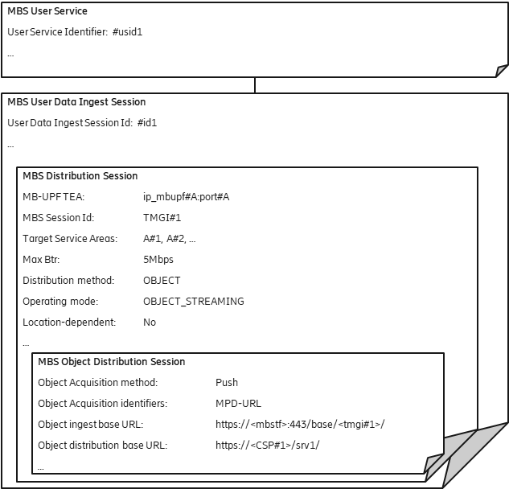

Figure C.2.1-1: DASH content distribution with push-based ingest

The DASH segment packager is configured to use the *Object ingest base URL* to upload media segments using HTTP. Each segment is identified by a unique URL relative to this base. The distribution URL generated by the MBSTF is formed by replacing the *Object iingest base URL* prefix with the value of *Object distribution base URL*.

EXAMPLE:

URL of ingested object: https://<mbstf>:443/base/<tmgi#1>/video/segment_1000.m4s

URL of distributed object: https://<CSP#1>/srv1/video/segment_1000.m4s

The string <mbstf> refers to the IP address or the hostname of the MBSTF function. The string <tmgi#1> refers to the TMGI, which is assigned to the MBS Session. The TMGI of the MBS Session is used in this example to make the ingest URL uniqueue within the 5G System. Other solutions to ensure uniqueness are possible. The term <CSP#1> refers to a fully qualified domain name of the CSP. The string ip_mbupf#A:port#A refers to the IP address and port for the tunnel, at which the MB-UPF expects the data for the MBS Session.

access to in order to compile theMBS Distribution SessionA. The MBSF may also modify the contents of the MPD"" before compiling it into the Session Announcement and/or publishing it for retrieval at reference point MBS‑4‑UC

The MBSTF does not need to inpsect the contents of the DASH MPD.

The MBSTF uses the *Maximum bit rate* parameter to pace the packets towards the MB-UPF. The MBSTF uses a tunnel to inject the MBS data into the MB-UPF.

## C.2.2 DASH content distribution with push-based ingest using separate MBS Distribution Sessions for audio and video

This example focuses on DASH content distribution with push-based ingest. The DASH segment packager continuously publishes media segments to the MBSTF as they become available. In this case, media segments from the video and audio Adaptation Sets are multiplexed into different MBS Distribution Sessions. onwith the two resulting MBS Distribution Sessions multiplexed onto

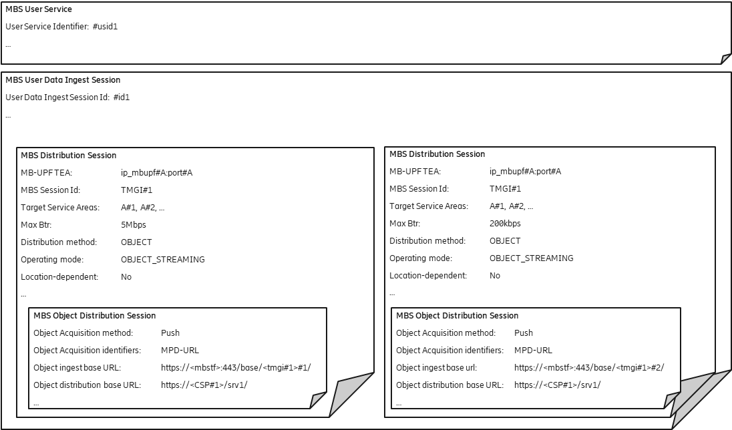

Figure C.2.2-1: DASH content distribution with push-based ingest  
using separate MBS Distribution Sessions for audio and video

For each MBS Session, the MBSTF uses a specific *Maximum bit rate* parameter to pace the packets towards the MB-UPF (here 5 Mbps for video segments and 200 kbps for audio segments). The MBSTF uses the same tunnel to inject the data into the MB-UPF, so that the data is distributed via the same MBS Session.

## C.2.3 Generic object distribution with push-based ingest

This example focuses on generic object distribution using push-based ingest. In this case, objects are pushed into the MBSTF without usage of a manifest.

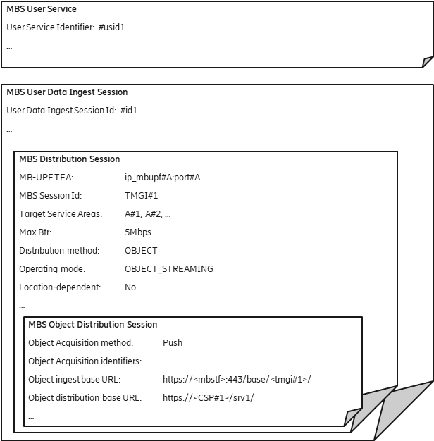

Figure C.2.3-1: Generic object distribution with push-based ingest

The case is very similar to the previous DASH content distribution cases, with the difference that no *Object acquisition identifiers* are provisioned. Any object pushed to the *Object ingest base URL* nominated by the MBSF is distributed in the MBS Distribution Session by the MBSTF after substituting the *Object ingest base URL* prefix with the *Object distribution base URL*.

# C.3 Object Distribution Method with pull-based ingest

## C.3.1 DASH content distribution with pull-based ingest

This example focuses on DASH content distribution with pull-based ingest. The DASH segment packager publishes media segments to an external origin server and the MBSTF pulls them according to the DASH MPD.

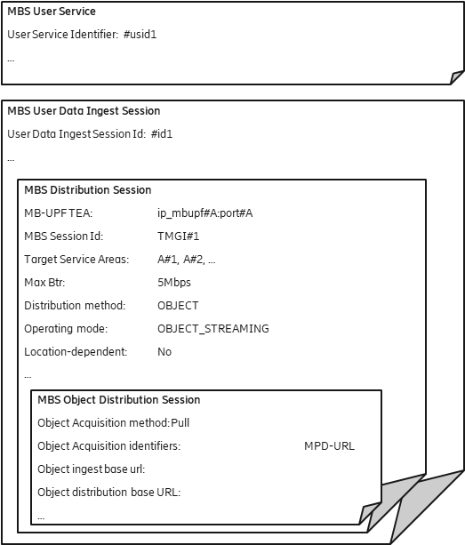

Figure C.3.1-1: DASH content with pull-based ingest

The Object ingest base url remains empty, since the segments are fetched according to the manifest provided with the Object Acquisition identifiers property.

In this example, the *Object ingest base URL* and *Object distribution base URL* are both omitted, resulting in the same URL used for fetching each media segment being used for distribution.

## C.3.2 DASH content distribution with pull-based ingest using separate MBS Distribution Sessions for audio and video

This example focuses on DASH content distribution with pull-based ingest. The DASH segment packager publishes media segments to an external origin server and the MBSTF pulls them according to a DASH MPD. In this case, the MBS User Service is provisioned to distribute the audio and video segments on separate MBS Distribution Sessions, with the two resulting FLUTE sessions multiplexed onto the same MBS Session.

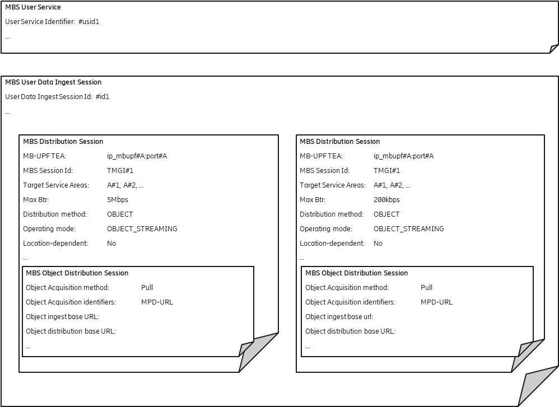

Figure C.3.2-1: DASH content distribution with pull-based ingest  
using separate FLUTE sessions for audio and video

The *Object ingest base URL* is ignored in this case because the media segments are fetched according to the DASH MPD referenced by the *Object acquisition identifiers* property.

In this example, the *Object distribution base URL* is also omitted, resulting in the same URL used for fetching the media segments being used for distribution.

Editor’s Note: The association between the Adaptation Set and the MBS Distribution Session is left to implementations.

## C.3.3 Generic object distribution with pull-based ingest

This example focuses on generic object distribution using pull-based ingest. In this case, objects are pulled into the MBSTF according to an object manifest.

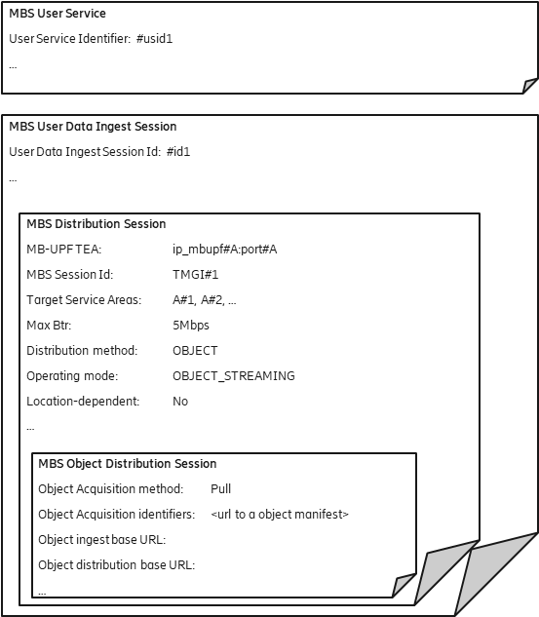

Figure C.3.3-1: Generic object distribution with pull-based ingest

The URL of the object manifest is provisioned by the MBS Application Provider using the *Object acquisition identifiers* parameter.

In this example, the *Object ingest base URL* and *Object distribution base URL* are both omitted, resulting in the same URL used for fetching the objects being used for distribution.

# C.4. Locationdependent Object Distribution Method using push-based Ingest

## C.4.1 Location-dependent DASH content distribution using push-based ingest

A locationdependent MBS Serivce allows regional content variants to be distributed to different MBS Service areas within the scope of a common MBS Session. The UE receives the content variant appropriate to its current location. This feature allows realization of MBS User Services such as local traffic information.

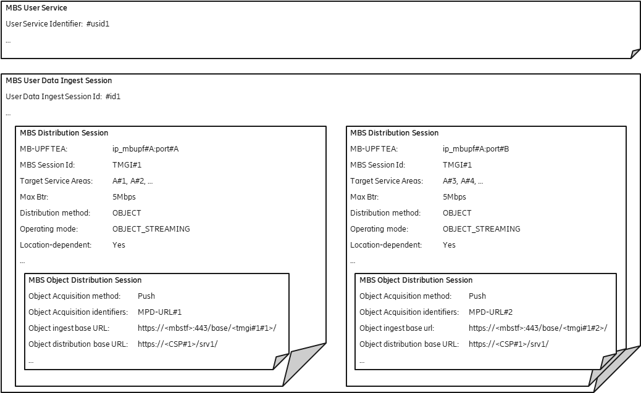

Figure C.4.1-1: Location-dependent DASH content distribution using push-based ingest

Two MBS Distribution Sessions with different *Target service areas* are provisioned. Each MBS Distribution Session has a different *Object ingest base URL* so that two content sources can push different media objects to the two MBS Distribution Sessions. Each content source uses a different DASH manifest.

The MBSF provisions a different MBS Session in the MB-SMF for each MBS Distribution Session and arranges for the user plane traffic of each one to be distributed to the correct MBS service area.

The MBSTF uses a separate tunnel to inject the MBS data for each MBS Distribution Session into the MB-UPF.

The MB-UPF listens on two separate UDP ports (port#A and port#B) for the MBS data streams for the separate area sessions.

## C.4.2 Location-dependent generic object distribution with push-based ingest

The location-dependent MBS Serivce described in this clause is very similar to the example in the previous clause. The difference is the distribution of a generic object stream which is not described by a manifest.

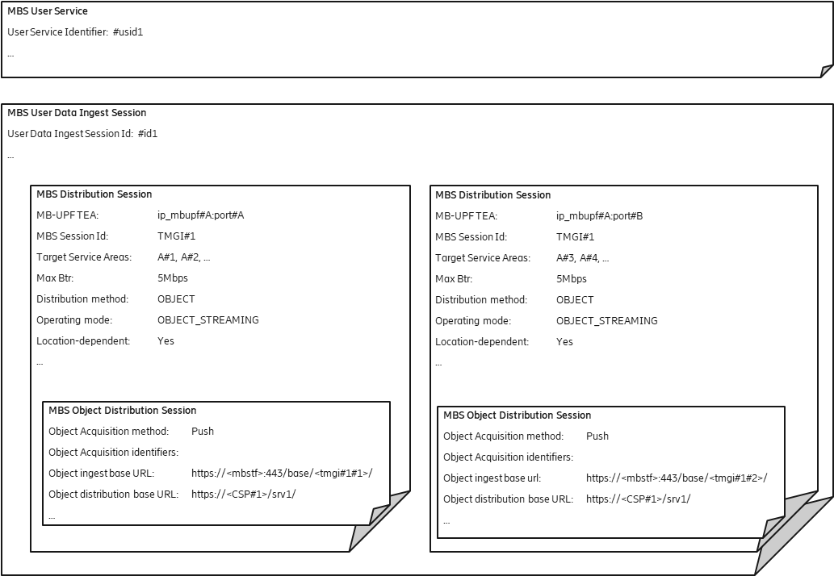

Figure C.4.2-1: Location-dependent generic object distribution with push-based ingest

As in clauses C.2.3, no *Object acquisition identifiers* are provisioned. Any object pushed to one of the *Object ingest base URL*s nominated by the MBSF is distributed in the MBS Distribution Session by the MBSTF after substituting the relevant *Object ingest base URL* prefix with the corresponding *Object distribution base URL*.

**** Last Change ****