**3GPP TSG-SA WG4 Meeting #120-e *S4-221005***

***E-meeting, 17th-26th Aug 2022***

**Title:** [draft] **Reply LS on questions on RAN visible QoE**

**Response to:** **LS S4-220909(****R2-2206833)**

**Release: Release 17**

**Work Item: NR_QoE-Core**

**Source: SA4**

**To: RAN2, RAN3**

**Cc:**

**Contact person: Qi Pan**

**panqi8@huawei.com**

**Send any reply LS to: 3GPP Liaisons Coordinator,** [**mailto:3GPPLiaison@etsi.org**](mailto:3GPPLiaison@etsi.org)

**Attachments:** **None**

1 Overall description

SA4 thanks to RAN2 for the LS which raises the questions on RAN visible QoE. SA4 has discussed the question, and would like to provide the answers as shown below:

Question 1: Is a periodicity specific for buffer level measurement necessary for RVQoE? If yes, what is the motivation and what should be the configurable values? If not, what are the assumptions on how often the application layer performs the measurements of buffer level and how the buffer level list is filled?

*Answer to Question 1:* *In the legacy QoE configuration, there is a measurement interval which indicates how often to measure the QoE metrics. Each report shall contain only the newly measured information since the previous report. Similarly, for RVQoE, there may be a specific reporting interval for RVQoE (which may be different from the reporting interval for legacy QoE configuration).*

*Both legacy QoE reports and RVQoE reports may contain a list of buffer level measurements (up to max eight entries for RVQoE). For legacy QoE measurements the interval between adding a new buffer level measurement to the list is specified by the key "n" (see the marked part of the description below, from* *ISO/IEC 23009-1). For instance, legacy QoE reporting might be configured to be sent every 10 minutes, with buffer level measurements done every n=10000 ms, resulting in a buffer level list with 60 buffer level entries being reported.  
  
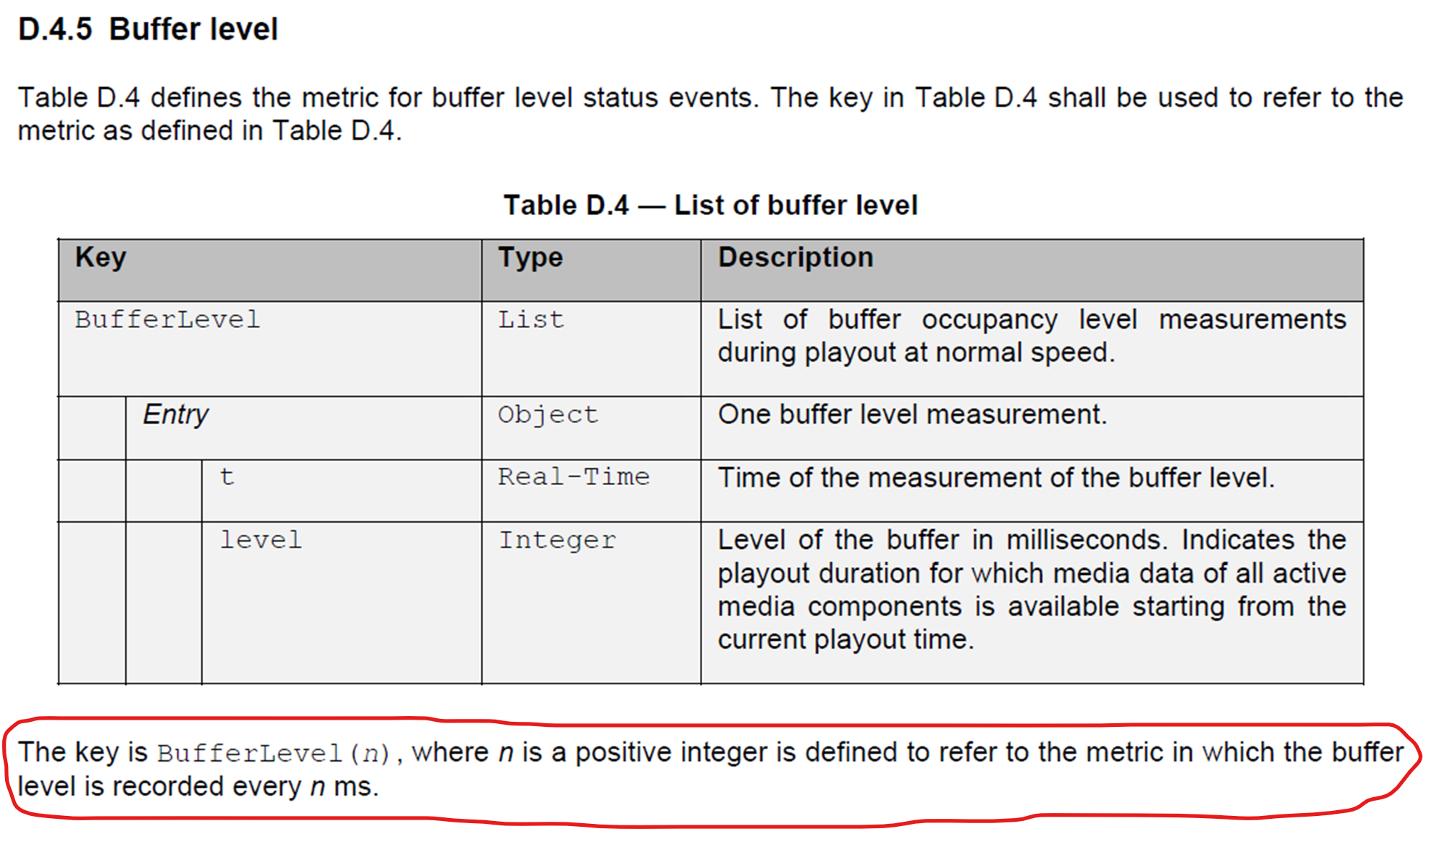  
  
However, for RVQoE there is currently no specification on how often the application layer needs to measure the buffer level. For instance, if the RVQoE reporting interval is configured as 640 ms, the measurements could follow the reporting interval by UE implementation, e.g. in principle the application layer does eight equally divided buffer level measurements in case of 8 entries to be filled in one RVQoE report (i.e., 80 ms between each buffer level measurement). Alternatively, RAN2/3 could also add a configuration parameter (similar to "n") which specifies the fixed measurement interval. Anyway, from SA4’s perspective, the periodicity for buffer level measurement for RVQoE must be clearly specified for the application layer.*

*As to how the periodicity of buffer level measurements for RVQoE should be determined, we believe that will depend on the RVQoE requirements and intended usage of these RVQoE reports. SA4 defers to RAN3 to making such detemination/decision and inform us of the associated reasons.*

2 Actions

**To RAN2 and RAN3:**

**ACTION: SA4 kindly asks RAN2 and RAN3 to take the feedback above into account, and to inform SA4 about any decisions regarding the buffer level measurement interval.**

3 Dates of next SA4 meetings

SA4#121 14th – 18th November 2022 EU

SA4#122 20th – 24th February 2023 EU