3GPP TSG-SA4 Meeting # 120-e S4-221186

Online, 17 Aug 2022 - 26 Aug 2022 revision of S4-220979
CR-Form-v12.2
CHANGE REQUEST
 | 26.131 | CR | 0084 | rev | 0 | Current version: | 17.1.1
For HELP on using this form: comprehensive instructions can be found at
http://www.3gpp.org/Change-Requests.

Proposed change affects: | UICC apps |  | ME | x | Radio Access Network |  | Core Network

Title: | Missing definition of performance requirements for receive frequency response (electrical interface UE)
Source to WG: | HEAD acoustics GmbH
Source to TSG: | S4
Work item code: | HInT, TEI17 |  |  |  |  |  | Date: |  |  | 2022-08-26
Category: | F |  |  |  |  |  | Release: |  |  | Rel-17
 | Use one of the following categories:  F (correction)  A (mirror corresponding to a change in an earlier release)  B (addition of feature),  C (functional modification of feature)  D (editorial modification)  Detailed explanations of the above categories can  be found in 3GPP TR 21.900. |  |  |  |  |  |  |  | Use one of the following releases:  Rel-8 (Release 8)  Rel-9 (Release 9)  Rel-10 (Release 10)  Rel-11 (Release 11)  …  Rel-16 (Release 16)  Rel-17 (Release 17)  Rel-18 (Release 18)  Rel-19 (Release 19)
Reason for change: |  | In clause 7.4.8 (receive frequency response for electrical interface UE), some text, a table and a figure that define and describe performance requirements are missing. They were not taken over from the CR that was approved in SP-211350.
Summary of change: |  | Add text, table and figure as in SP-211350 that complete the description of performance requirements in clause 7.4.8.
Consequences if not approved: |  | No performance requirements is defined in clause 7.4.8, which would remain incomplete and ambigious.
Clauses affected: |  | 7.4.8
 |  | Y | N
Other specs |  |  | x | Other core specifications |  |  |  | TS/TR ... CR ...
affected: |  |  | x | Test specifications |  |  |  | TS/TR ... CR ...
(show related CRs) |  |  | x | O&M Specifications |  |  |  | TS/TR ... CR ...
Other comments:
This CR's revision history:

7.4.8 Electrical interface UE receiving
The sensitivity/frequency characteristics shall be as follows:
The receiving sensitivity frequency response measured at the electrical reference point shall be within a mask, which can be drawn with straight lines between the breaking points in table 30a2 on a logarithmic (frequency) - linear (dB sensitivity) scale.
Table 30a2: Handset receiving sensitivity/frequency requirement mask
Frequency (Hz) | Upper limit | Lower limit
100 | 2 | -10
200 | 2 | -7
1000 | 2 | -2
3000 | 2 | –2
5000 | 2 | –2
8000 | 2 | -3
12500 | 2 | -6
16000 | 2
NOTE: All sensitivity values are expressed in dB on an arbitrary scale.

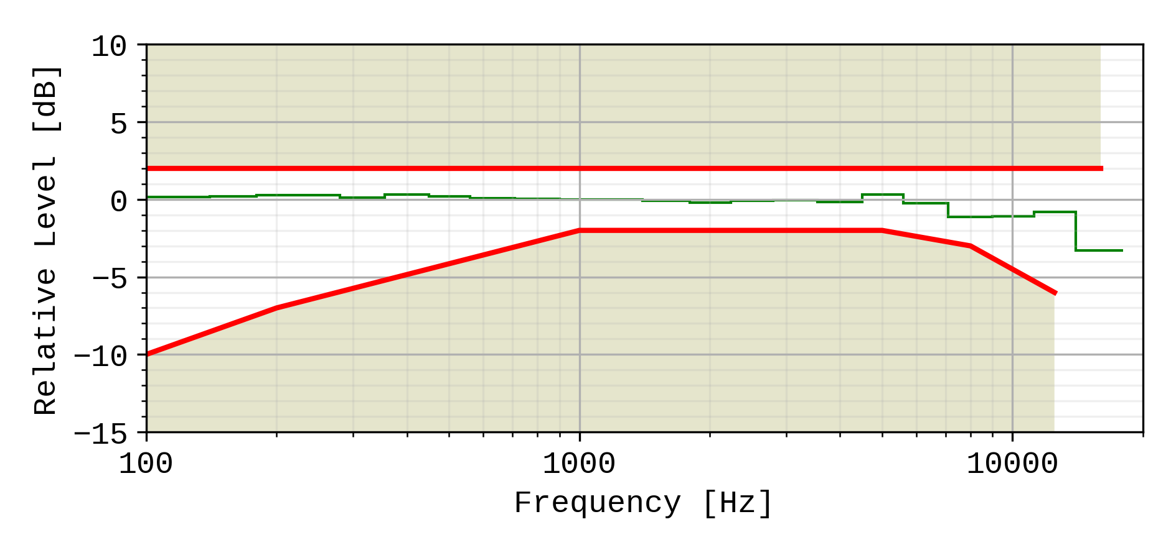
Figure 16b: Electrical interface sensitivity/frequency masks. The frequency response of the EVS codec operating as specified in TS 26.132 (super-wideband 24,4kbit/s, using the specified P.501 speech test signal), is plotted for reference, normalized to 0dB at 1kHz.
A UE operating in super-wideband mode shall pass the super-wideband requirements (i.e. when measured according to in 1/3rd octaves) as specified in Table 30a2, and shall also pass the wideband sensitivity/frequency characteristics requirements in the wideband range using the wideband measurement (i.e. measured in 1/12th octaves) as specified in Table 14a2.
Compliance shall be checked by the relevant test described in TS 26.132.

