Source: Nokia Corporation
Title: Scalability and optimization of Viewport Dependent Processing (VDP)
Document for Agreement
Agenda item: 11.5

Introduction
The document provides the following updates to TR 26.962 document:
- Indicate that Region-Wise Packing signalling is needed for sphere-locked VDP.
- Introduces negative margins for using low-quality content within the viewport region for bandwidth saving.
- Guidelines for design of a VDP implementation that can scale to a large number of users
- Discussion on bitrate spikes due to I-frame insertion and methods to mitigate insertion.

[X1] J. van der Hooft, M. Torres Vega, S. Petrangeli, T. Wauters and F. De Turck, "Quality Assessment for Adaptive Virtual Reality Video Streaming: A Probabilistic Approach on the User’s Gaze," 2019 22nd Conference on Innovation in Clouds, Internet and Networks and Workshops (ICIN), 2019, pp. 19-24, doi: 10.1109/ICIN.2019.8685904.

4.3.1 Sphere-locked
For the ITT4RT-Rx client to be able to display the received viewport correctly in reference to the capture orientation (sphere-locked), the ITT4RT-Tx client can signal the rotation information to the ITT4RT-Rx client using the rotation SEI message.. The ITT4RT-Rx client can then reverse the rotation before rendering. The solution also requires the region-wise packing SEI message to indicate the size of the projected region, which may change if different sizesizes of margins are used during the session.
Signalling and Delivery
The video is delivered as a single stream. The SDP signalling needs to indicate VDP and rotation and region-wise packing SEI message are used.
The resolution in the imageattr corresponds to the resolution of the delivered viewport region.

4.6 Comparisons of the Proposed Solutions
We present here a short discussion on the advantages and disadvantages of each of the proposed solutions. The purpose is to formulate a clear recommendation for ITT4RT applications on what type of VDP solution to use.
- 360-degree video with optimized viewport as described in 4.1 is delivered entirely as a single stream and does not require any bitstream signalling, packing/unpacking or rotation. It can be made scalable if multiple versions with different viewport orientations are encoded. However, the bandwidth savings when the full 360-degree video is delivered are low.
- Tiled video as described in 4.2 is scalable to a large number of receivers with different viewport sizes. The tiles are independently decodeable, and hence only the required tiles can be delivered (e.g., only the viewport with or without a viewport margin) but decoding the tiles independently requires either multiple decoders or serializing the decoding process (introducing latency). Decoding all tiles within the frame is more suited to a single decoder solution. This way the receiver also maintains media availability in case of head motion. However, this comes at the expense of bit rate savings. Finally, since tiled encoding at multiple qualities has higher storage and processing requirements it is, therefore, less suited to smaller conference sizes and may work better in the presence of an MRF/MCU.
- A HQ viewport region only solution described in 4.3 is able to maximize bandwidth savings and also does not require packing but limits the availability of media in case of head motion. Viewport margins as described in 4.6 may be used to extend the viewport for better experience. The frames maintain shape and resolution despite projection. The content is delivered as a single stream and a single encoder/decoder is required making it suitable for simpler ITT4RT-Tx and ITT4RT-Rx clients. However, additional bitstream signalling about the rotation and region-wise packing is required from the ITT4RT-Tx to ITT4RT-Rx client to reverse the rotation and render for sphere-locked mode. The special viewport-locked case in 4.3.2 omits the reverse rotation and provides a simplistic solution for ITT4RT clients with 2D screens and also ultra-low latency operation.
- A HQ viewport region can be paired with a background LQ 360-degree video for a fuller viewing experience as described in 4.4. When packed in a single stream, the LQ background + HQ viewport solution does not require updating the packing information with a changing viewport. The packing information (PPM) can be signaled once in the beginning using SDP. This method delivers redundant content in the viewport region.

4.7 Viewport Margins
Editor’s Note: Signalling the extent of margins is FFS. The section below is informative about the use of viewport margins in viewport-dependent delivery.
When VDP is used, a change in viewport, e.g., due to head motion at the ITT4RT-Rx client in terminal, may require an update in the viewport region. This change is triggered by an RTCP feedback with the new viewport information. It may take up to at least one Round Trip Time (RTT) or more for the viewport to update, resulting in a motion-to-high-quality delay. Motion-to-high-quality delay is the amount of time it takes for the new viewport to reach comparable quality to the early viewport after head motion. An ITT4RT-Tx client that support VDP may use viewport margins to minimize this delay and also to reduce the need for frequent viewport updates.
Viewport margins can be extended on all or some sides of the viewport and may be at the same quality (or resolution) as the viewport or at a quality (or resolution) lower than the viewport but higher than the background. Figure 4.11 shows an ERP with the viewport, viewport margin and background regions in different colours.
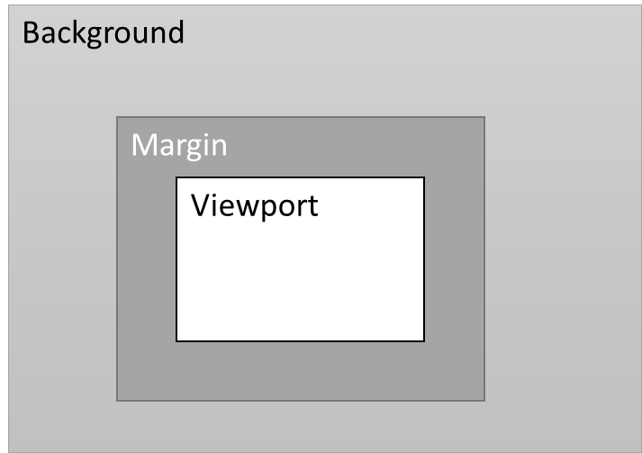
Figure 4.11: An equirectangular projected picture with viewport, margin and background areas.
Viewport margins may be extended around the viewport evenly or unevenly. Some example scenarios where viewport margins may be used to improve playout are listed below:
- Equally extended margins (symmetric) around the viewport in all directions may be used to decrease the motion to high-quality delay. The margins may be gradually extended farther by probing the network and reduced when the network is congested. In this scenario, the use of margins is akin to sending a larger viewport.
- Margins may be unevenly extended around the viewport (directional) with larger margins in the direction the user’s head is turning. In the absence of head motion, the margins may return to being equally extended all around the viewport. In this case, RTCP viewport feedback is used to decide the distribution of margins. See Figure 4.12.
- Margins may be unevenly extended around the viewport with larger margins in the direction of the predicted head motion, e.g., based on audio input, motion tracking or other application level functions.
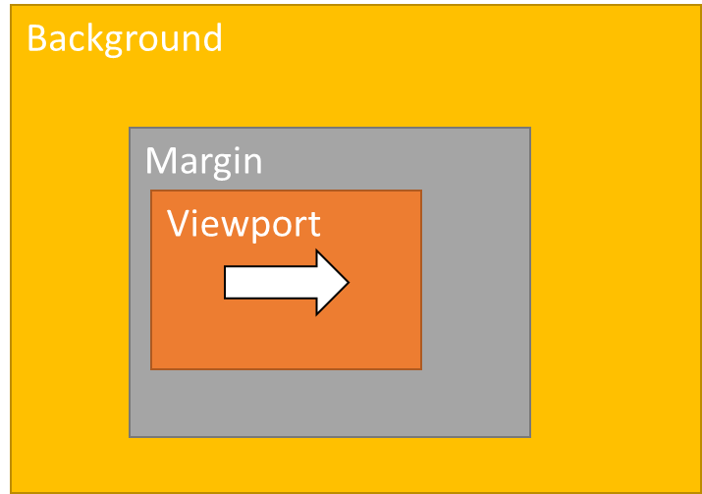  a.head turning right | 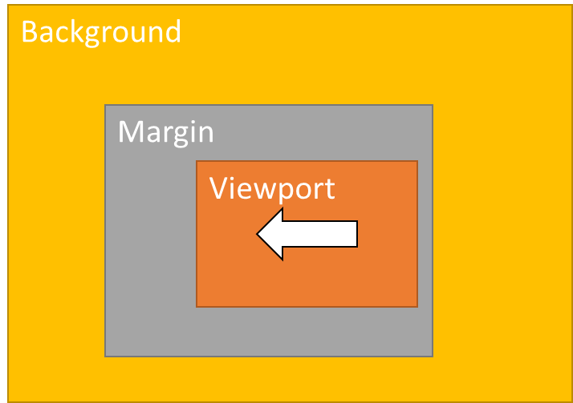  b. head turning left | 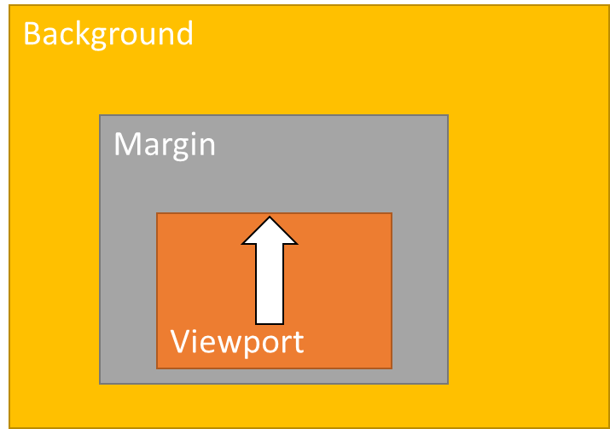  c. head turning up | 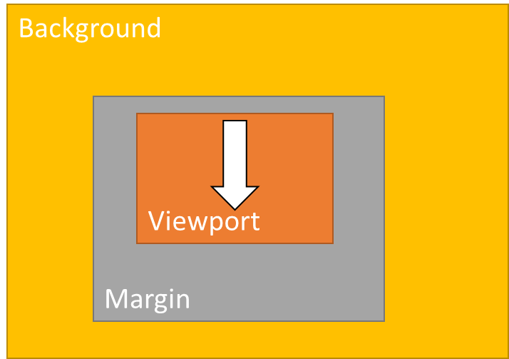  d. head turning down
Figure 4.12: Uneven extension of margins based on the user head motion. Similar uneven extensions may be used based on other application-level parameters.
Negative margins may also be utilized, which extend inward into the viewport region instead of extending outward into the background region. Negative margins are transmitted at a quality lower than the viewport. Introducing lower quality in the viewport can lower user experience. It may still be useful to do so in some cases, for example:
- Negative margins can be used when bandwidth is insufficient. This may lead to lower quality in parts of the viewport. However, this may be acceptable since the gaze is likely to be centered towards the ideete of the viewport[X1].
- Negative margin can h eaiemri stasitdonodda oe ult hntevepr n a eue ntedrcinopst otedrcino oin eaiemrismyb sed in a bandwidth neutral way, where any bandwidth savings frmuigte a euiie o xedn h oiievewport margin farther in the direction of motion. In this case the negative margins are likelyto be not visible in the update viewport.

4.8 Encoding recommendations
Several encoding techniques could be used to optimize the real-time transmission and consumption of 360 video in conjunction with VDP.
Some of these techniques are briefly described in this section.
Adaptive RAP frequency
The inter-RAP distance may be varied according to the user’s head movement. When the user’s head motion increases beyond a certain threshold (H_{TH}), the inter-RAP distance is reduced. Therefore, an ITT4RT-Tx client may encode the RTP bitstream with a shorter duration between successive RAPs in real-time. When the viewport of the end-user is slowly changed, or the network bandwidth is not enough, the ITT4RT-Tx client may encode and transmit RTP bitstream with a longer distance between successive RAPs since this scheme allows the videos to be compressed optimally, thereby reducing the required bandwidth. The ITT4RT-Tx client can define a lower bound for the interval between two successive RAPs due to the bandwidth constraints. A maximum threshold (H_{MAX}) for the user’s head motion may be defined. Therefore, even if the user’s head motion increases beyond the corresponding maximum threshold (H_{MAX}), the ITT4RT-Tx client does not reduce the duration between two successive RAPs from that lower bound.
If the user’s head motion is within the viewport margin, the new tiles or sub-pictures sent by the ITT4RT-Tx client (to update the margins) may have RTP bitstream encoded with a longer duration between successive RAPs. This is applicable when the resolution of the margin is the same as that of the viewport, i.e. high-resolution tiles or sub-pictures. If the resolution of the tiles or sub-pictures in the margin is lower compared to the tiles in the viewport, the ITT4RT-Tx client may send high-resolution RTP bitstream encoded with a shorter duration between successive RAPs as the user’s head moves even within the margin to reduce the M2HQ delay.
Adaptive Code Mode
The encoder may be instructed to favor INTRA mode decisions for CUs of newly covered areas during the user’s head motion. This may be performed by adjusting the thresholds and lambda values for INTRA mode selection. This will produce INTRA slices for the newly covered picture tiles. Refer to [X1] on HEVC encoder description section 6.3.
Adaptive QP
This tool varies the quantization parameter for each CU to adjust the quality. Adaptive QP may prove useful to adjust the quality of the slices and tiles that fall within the current viewport. Higher QPs may be used for slices and tiles that cover the margins. Refer to [X1] on HEVC encoder description section 6.5.4.
Note that the use of higher QP helps only if the receiver decodes all the tiles of the viewport and margin area (and if needed the tile beyond the margin) for the entire GOP since due to the motion of HMD, in order to reduce the M2HQ delay, the corresponding tiles must be decoded starting from the last RAP.
Video Alignment to Viewport Change Axis
Vertical or diagonal head motion in the viewport-only and viewport-locked solutions causes such transformations in the ERP content that translational block-based motion is unlikely to succeed well. Consequently, this may lead to an insertion of intra frames, which in turn causes bitrate spikes. nal block-based motion of video codecs, wherein a viewport change leads to ann causes frequent bitrate spikes. Thisviewport-only solution in seectional content is aligned with the dominant axis of viewport change. For a coernero etn,tedmnn xso iwotcag ol etehrzna ieto htwudgnrlyb h a.I h aeweetedmnn xso viewport change is different than the yaw of the 360-degree video, the sender may align them for efficient encoding. A wider margin in the vertical direction can reduce viewport updates for small vertical head movements. The dominant axis of viewport change can be determined during the session based on viewport feedback using ML techniques or it may be predetermined based on content or application.
To illustrate this, we encoded 17 frames of a 360-degree sequence with varying degrees of head motion, from 0-4 degrees of motion per picture in the downward direction (towards the south pole) using VVC codec. We show results in the figures below where M0 is the case when we do not do spherical rotation and M2 is the case where we rotate the sphere to match the dominant axis of viewport change (vertical in this case). Figure X1 shows the ERP cropped for viewport-locked case (90x90 viewport size) for both cases.

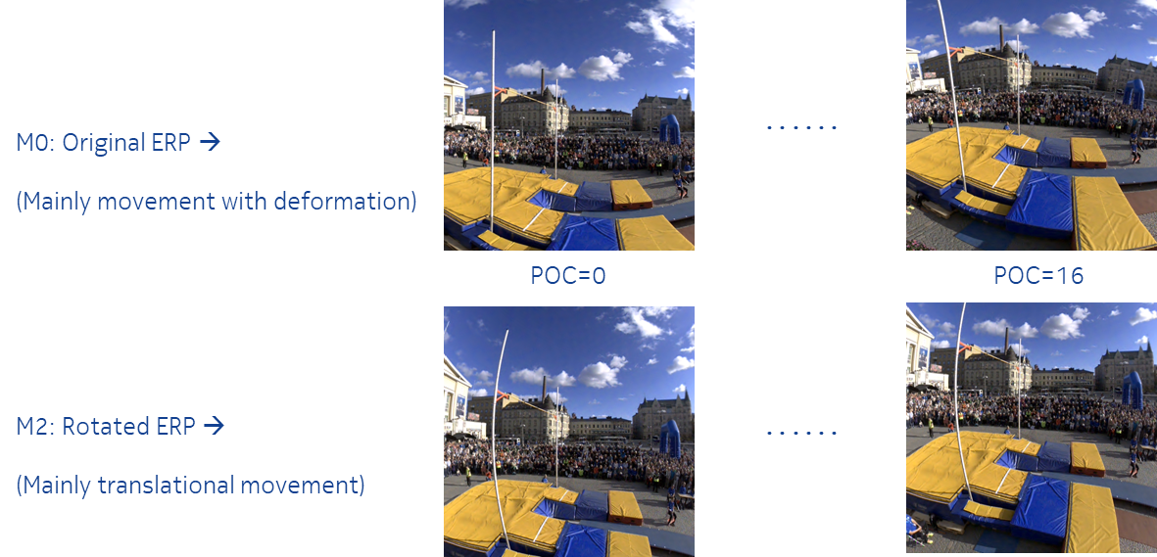
Figure X1: The viewport-locked case with and without spherical rotation to dominant axis
In Figure X2, we show a side-by-side comparison of the second frame. The light below in the bottom is the intra coded frames. The block size and the affine motion compensation is also shown. Overall it can be seen the encoding complexity of the M0 case is higher.
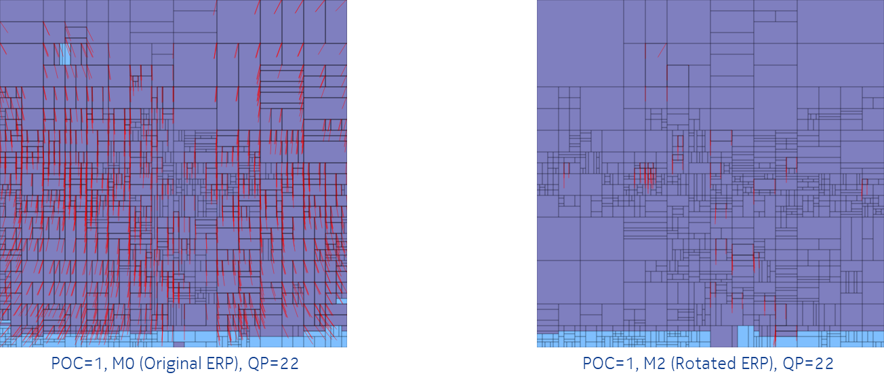
Figure X2: Encoding complexity after motion for M0 (no rotation) and M2 (dominant axis rotation)
Finally, Figure X3 shows a comparison of the results using Bdrate, which is the percentage of bit rate increase at the same quality level. The results shown are for:
Test condition: PoleVault, 17-frames, low delay B, Encoded viewport area = 512x512 = 90°x90°, head motion for 0-4 degrees per picture in the downward direction (towards the south pole).
The curve shows the Bdrate difference for M2 vs M0 using M0 is the anchor. When there is no head motion M0 is slightly better. But in the presence of head motion M2 performs much better. In our comparison, the increase in bit rate for M2 was roughly half of M0 in the presence of head motion. The following observations can be made:
irt nrae hnhvn ihrha oin(pt xBitrate increase of M2 is much lower than M0 (roughly half)

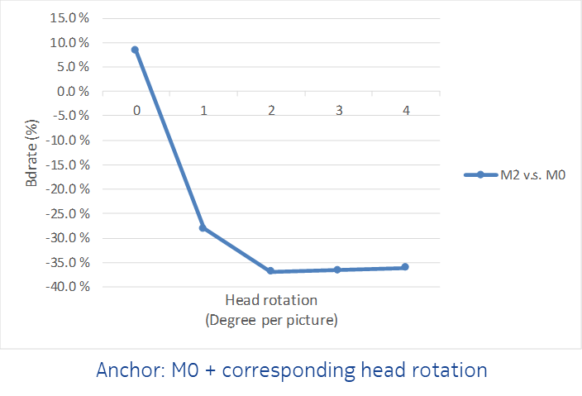
Figure X3: Bdrate comparison with dominate axis rotation (M2) with no rotation (M0)

4.9 Scalability
Tiled encoding can be used for providing VDP when there are a large number of receivers as ntnelrdydiscussed earlier.
The HQ viewport region-only solution in clause 4.3 can require an encoder for each receiver if the encoded viewport is matched exactly to the receiver viewport. The solution can be made scalable by encoding multiple predefinedpre-defined overlapping or non-overlapping viewport regions. The appropriate HQ viewport region is then delivered based on the current viewport of the receiver.
Figure 4.13 illustrates a sample architecture for an MRF that provides VDP for a large number of receivers. It is assumed here that the 360-degree video is encoded into four regions (HQ viewport + margin). It should be ensured that all possible viewports are covered by at least one of the regions. The viewport selector then provides the appropriate region to the ITT4RT-Rx client based on viewport feedback. The MRF may save on resources by only encoding the regions that have active viewers.

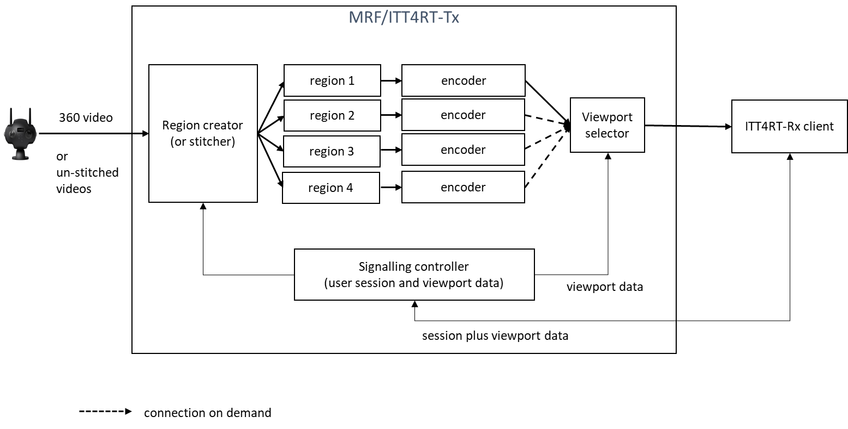
Figure 4.13: An MRF/ITT4RT-Tx client with four regions to cover all possible viewports.

One aspect to consider with creating such encoded region is the switching frequency from one region to another sincesa switch would require an I-frame update. Switching may result in visual artefacts in the absence of an I-frame. An I-frame may be inserted when a new ITT4RT-Rx client joins or when a region is switched. However, excessive I-frames can increase bandwidth requirements and impact encoding quality, ., thu implementations should weigh the benefits before inserting one. Advanced implementations may use ML/AI solutions to define regions dynamically based on user head movement to minimize the need for switching between regions. In Figure 4.13, the signalling controller provides a feedback to the region creator for this purpose.

Proposal
The proposal is to include the proposed changes to TR 26.962.

Contact: Igor Curcio, Saba Ahsan, Alireza Aminlou Nokia Technologies, Finland. Emails: ⎨firstname.lastname⎬@nokia.com.

