**3GPP TSG-SA4 Meeting #115-e *S4-211279***

**Online, 18-27 August 2021 Revision of S4-211178**

|  |  |  |  |  |  |  |  |  |
| --- | --- | --- | --- | --- | --- | --- | --- | --- |
| *CR-Form-v12.1* | | | | | | | | |
| **CHANGE REQUEST** | | | | | | | | |
|  | | | | | | | | |
|  | **26.131** | **CR** | **0082** | **rev** | **2** | **Current version:** | **16.0.0** |  |
|  | | | | | | | | |
| *For* [***HE******LP***](http://www.3gpp.org/3G_Specs/CRs.htm#_blank)*on using this form: comprehensive instructions can be found at* [*http://www.3gpp.org/Change-Requests*](http://www.3gpp.org/Change-Requests)*.* | | | | | | | | |
|  | | | | | | | | |

|  |  |  |  |  |  |  |  |  |
| --- | --- | --- | --- | --- | --- | --- | --- | --- |
| ***Proposed change affects:*** | UICC apps |  | ME | **x** | Radio Access Network |  | Core Network |  |

|  |  |  |  |  |  |  |  |  |  |  |
| --- | --- | --- | --- | --- | --- | --- | --- | --- | --- | --- |
|  | | | | | | | | | | |
| ***Title:*** | Correction of missing figure for WB frequency mask in receiving | | | | | | | | | |
|  |  | | | | | | | | | |
| ***Source to WG:*** | Apple, HEAD acoustics GmbH, Orange | | | | | | | | | |
| ***Source to TSG:*** | S4 | | | | | | | | | |
|  |  | | | | | | | | | |
| ***Work item code:*** | TEI17 | | | | |  | ***Date:*** | | | 2021-08-19 |
|  |  | | | |  | |  | | |  |
| ***Category:*** | F |  | | | | | ***Release:*** | | | Rel-17 |
|  | *Use one of the following categories:* ***F*** *(correction)* ***A*** *(mirror corresponding to a change in an earlier release)* ***B*** *(addition of feature),* ***C*** *(functional modification of feature)* ***D*** *(editorial modification)*  Detailed explanations of the above categories can be found in 3GPP [TR 21.900](http://www.3gpp.org/ftp/Specs/html-info/21900.htm). | | | | | | | | *Use one of the following releases: Rel-8 (Release 8) Rel-9 (Release 9) Rel-10 (Release 10) Rel-11 (Release 11) … Rel-15 (Release 15) Rel-16 (Release 16) Rel-17 (Release 17) Rel-18 (Release 18)* | |
|  |  | | | | | | | | | |
| ***Reason for change:*** | | In V10.1.0 of TS 26.131 figures were introduced to illustrate frequency masks in NB and WB. Figure 10 has been missing since this first introduction of figures in TS 26.131. This bug was present in the approved CR (CR0041 SP-11042) and creates some confusion due to a missing figure in a normative specification. Besides, the note below Table 10 indicating that requirements ‘are enforced but are under evaluation’ may be removed (since this text dates back to 2011). | | | | | | | | |
| ***r*** | |  | | | | | | | | |
| ***Summary of change:*** | | Figure 10 is introduced and the note indicating that limits are under evaluation is removed.  To avoid an inconsistent presentation of masks in figures, all other figures in NB, WB and SWB are corrected (in an editorial way) using the generation script. Minor editorial fixes are also implemented: an editorial fix in a caption (Figure 14a), wrong closing bracket (left over), table formatting. | | | | | | | | |
|  | |  | | | | | | | | |
| ***Consequences if not approved:*** | | Missing illustration for WB frequency mask in receiving.  The specification is confusing because Figure 9 and 11 are present and Figure 10 is missing. Different formats for figures. | | | | | | | | |
|  | |  | | | | | | | | |
| ***Clauses affected:*** | | 5.4, 6.4, 7.4 | | | | | | | | |
|  | |  | | | | | | | | |
|  | | **Y** | **N** |  | | | |  | | |
| ***Other specs*** | |  | **x** | Other core specifications | | | | TS/TR ... CR ... | | |
| ***affected:*** | |  | **x** | Test specifications | | | | TS/TR ... CR ... | | |
| ***(show related CRs)*** | |  | **x** | O&M Specifications | | | | TS/TR ... CR ... | | |
|  | |  | | | | | | | | |
| ***Other comments:*** | |  | | | | | | | | |
|  | |  | | | | | | | | |
| ***This CR's revision history:*** | |  | | | | | | | | |

## 5.4 Sensitivity/frequency characteristics

### 5.4.1 Handset and headset UE sending

The sensitivity/frequency characteristics shall be as follows:

The sending sensitivity frequency response, measured either from the mouth reference point (MRP) to the digital interface or from the MRP to the SS audio output (digital output of the reference speech decoder of the SS), shall be within a mask, which can be drawn between the points given in table 1. The mask is drawn with straight lines between the breaking points in table 1 on a logarithmic (frequency) - linear (dB sensitivity) scale.

Table 1: Handset and headset sending sensitivity/frequency mask

|  |  |  |
| --- | --- | --- |
| Frequency (Hz) | Upper limit | Lower limit |
| 100 | ‑12 |  |
| 200 | 0 |  |
| 300 | 0 | ‑12 |
| 1 000 | 0 | ‑6 |
| 2 000 | 4 | ‑6 |
| 3 000 | 4 | ‑6 |
| 3 400 | 4 | ‑9 |
| 4 000 | 0 |  |
| NOTE: All sensitivity values are expressed in dB on an arbitrary scale. | | |

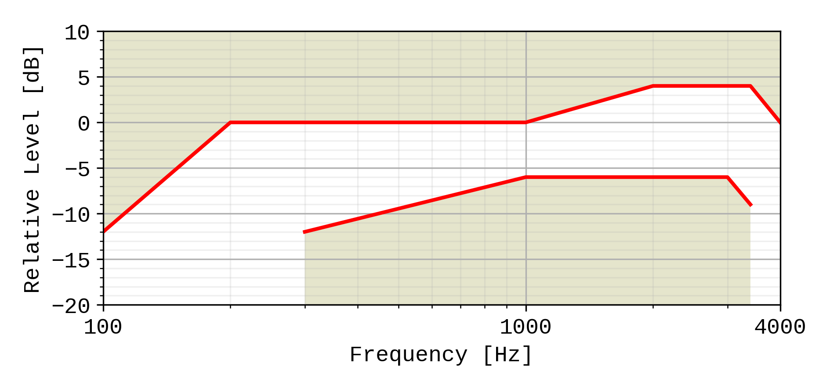

Figure 1: Handset and headset sending sensitivity/frequency mask

Compliance shall be checked by the relevant test described in TS 26.132.

### 5.4.2 Handset and headset UE receiving

The sensitivity/frequency characteristics shall be as follows:

The receiving sensitivity frequency response, measured either from the digital interface to the DRP with diffuse-field correction or from the SS audio input (analogue or digital input of the reference speech encoder of the SS) to the DRP with diffuse-field correction shall be within a mask, which can be drawn with straight lines between the breaking points in table 2 on a logarithmic (frequency) - linear (dB sensitivity) scale.

Table 2: Handset and headset receiving sensitivity/frequency mask for 8N application force

|  |  |  |
| --- | --- | --- |
| Frequency (Hz) | Upper limit  8 ± 2 N | Lower limit  8 ± 2 N |
| 100 | 6 |  |
| 300 | 6 | -6 |
| 3 400 | 6 | -6 |
| 4 000 | 6 |  |
| NOTE 1: All sensitivity values are expressed in dB on an arbitrary scale  NOTE 2: The basis for the target frequency responses in send and receive is the orthotelephonic reference response measured between 2 subjects 1 m apart under free-field conditions and assumes an ideal receive characteristic. Under these conditions the overall frequency response shows a rising slope. The present document no longer uses the ERP as the reference point for receive but the diffuse-field. With the concept of diffuse-field based receive measurements a rising slope for the overall frequency response is achieved by a flat target frequency response in send and a flat diffuse-field based receive frequency response. | | |

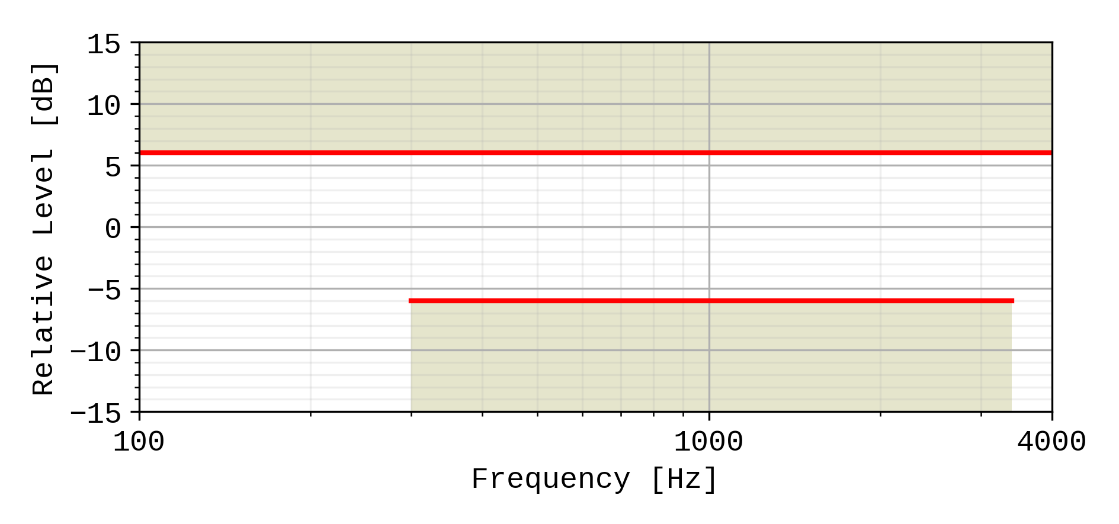

Figure 2: Handset and headset receiving sensitivity/frequency mask for 8N application force

Compliance shall be checked by the relevant test described in TS 26.132.

### 5.4.3 Desktop and vehicle-mounted hands-free UE sending

The sending sensitivity frequency response from the MRP to the SS audio output (digital output of the reference speech decoder of the SS) shall be as follows:

The sending sensitivity frequency response shall be within the mask which can be drawn with straight lines between the breaking points in table 3 on a logarithmic (frequency) - linear (dB sensitivity) scale.

Table 3: Desktop and vehicle-mounted hands-free sending sensitivity/frequency mask

|  |  |  |
| --- | --- | --- |
| Frequency (Hz) | Upper limit | Lower limit |
| 100 | ‑12 |  |
| 200 | 0 |  |
| 300 | 0 | ‑12 |
| 1 000 | 0 | ‑6 |
| 2 000 | 4 | ‑6 |
| 3 000 | 4 | ‑6 |
| 3 400 | 4 | ‑9 |
| 4 000 | 0 |  |
| NOTE: All sensitivity values are expressed in dB on an arbitrary scale. | | |



Figure 3: Desktop and vehicle-mounted hands-free sending sensitivity/frequency mask

Compliance shall be checked by the relevant test described in TS 26.132.

### 5.4.4 Desktop and vehicle-mounted hands-free UE receiving

The receiving sensitivity frequency response from the SS audio input (analogue or digital input of the reference speech encoder of the SS) to the free-field shall be as follows:

The receiving sensitivity frequency response shall be within the mask which can be drawn with straight lines between the breaking points in table 4 on a logarithmic (frequency) - linear (dB sensitivity) scale.

Table 4: Desktop and vehicle-mounted hands-free receiving sensitivity/frequency mask

|  |  |  |
| --- | --- | --- |
| Frequency (Hz) | Upper limit | Lower limit |
| 200 | 6 |  |
| 315 | 6 | -9 |
| 400 | 6 | -6 |
| 3 100 | 6 | -6 |
| 4 000 | 6 |  |
| NOTE: All sensitivity values are expressed in dB on an arbitrary scale. | | |

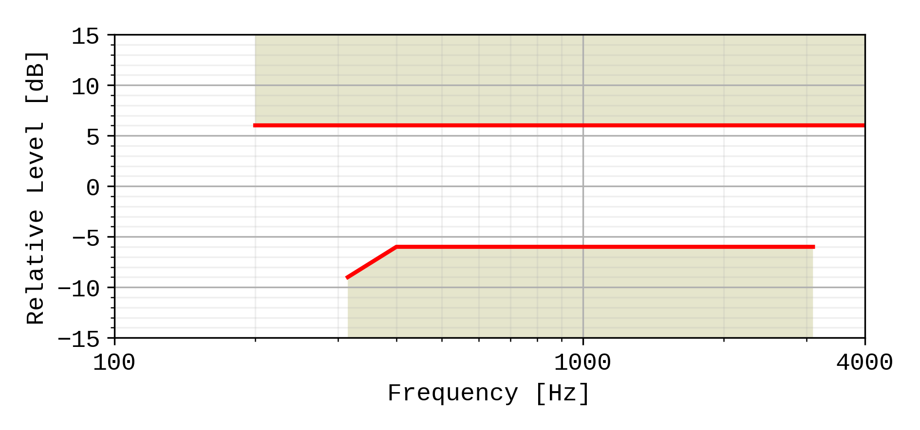

Figure 4: Desktop and vehicle-mounted receiving sensitivity/frequency mask

Compliance shall be checked by the relevant test described in TS 26.132.

### 5.4.5 Hand-held hands-free UE sending

The sending sensitivity frequency response from the MRP to the SS audio output (digital output of the reference speech decoder of the SS) shall be as follows:

The sending sensitivity frequency response shall be within the mask which can be drawn with straight lines between the breaking points in table 5 on a logarithmic (frequency) - linear (dB sensitivity) scale.

Table 5: Hand-held hands-free sending sensitivity/frequency mask

|  |  |  |
| --- | --- | --- |
| Frequency (Hz) | Upper limit | Lower limit |
| 100 | ‑12 |  |
| 200 | 0 |  |
| 300 | 0 | ‑12 |
| 1 000 | 0 | ‑6 |
| 2 000 | 4 | ‑6 |
| 3 000 | 4 | ‑6 |
| 3 400 | 4 | ‑9 |
| 4 000 | 0 |  |
| NOTE: All sensitivity values are expressed in dB on an arbitrary scale. | | |



Figure 5: Hand-held hands-free sending sensitivity/frequency mask

Compliance shall be checked by the relevant test described in TS 26.132.

### 5.4.6 Hand-held hands-free UE receiving

The receiving sensitivity frequency response from the SS audio input (analogue or digital input of the reference speech encoder of the SS) to the free-field shall be as follows:

The receiving sensitivity frequency response shall be within the mask which can be drawn with straight lines between the breaking points in table 6 on a logarithmic (frequency) - linear (dB sensitivity) scale.

Table 6: Hand-held hands-free receiving sensitivity/frequency mask

|  |  |  |
| --- | --- | --- |
| Frequency (Hz) | Upper limit | Lower limit |
| 200 | 6 |  |
| 500 | 6 | -9 (Note 2) |
| 630 | 6 | -6 (Note 2) |
| 800 | 6 | ‑6 |
| 3 100 | 6 | ‑6 |
| 4 000 | 6 |  |
| NOTE 1: All sensitivity values are expressed in dB on an arbitrary scale.  NOTE 2: The values stated in the Table 6 for 500 and 630 Hz are listed for performance objective purposes. (not mandatory) | | |

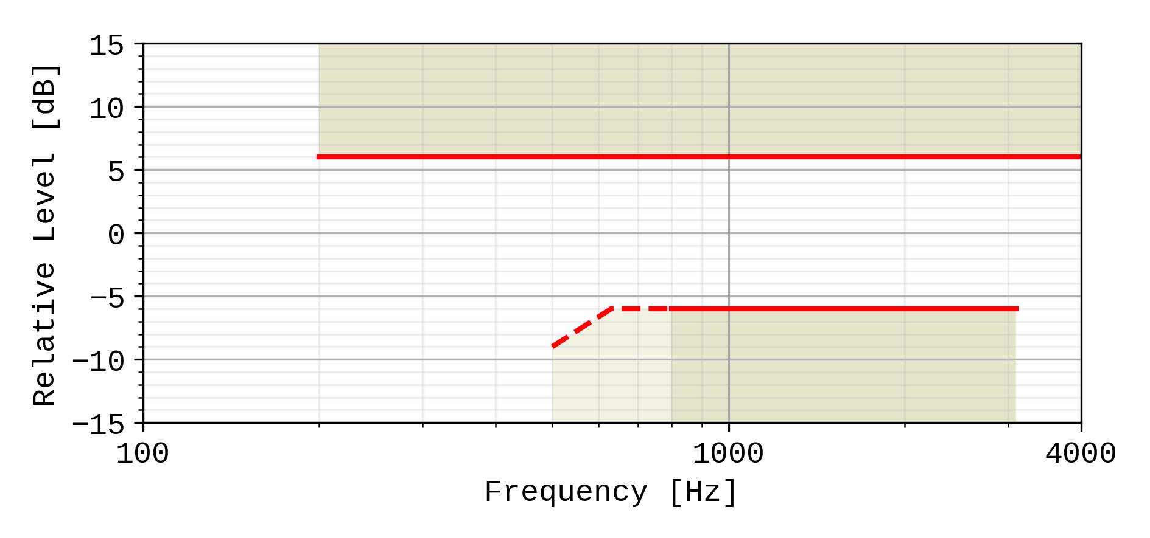

Figure 6: Hand-held hands-free receiving sensitivity/frequency mask

Compliance shall be checked by the relevant test described in TS 26.132.

## 6.4 Sensitivity/frequency characteristics

In general it is recommended for all configurations to have a flat sending frequency response.

### 6.4.1 Handset and headset UE sending

The sensitivity/frequency characteristics shall be as follows:

The sending sensitivity frequency response, measured either from the mouth reference point (MRP) to the digital interface or from the MRP to the SS audio output (digital output of the reference speech decoder of the SS), shall be within a mask, which can be drawn between the points given in table 9. The mask is drawn with straight lines between the breaking points in table 1 on a logarithmic (frequency) - linear (dB sensitivity) scale.

Table 9: Handset and headset sending sensitivity/frequency mask

|  |  |  |
| --- | --- | --- |
| Send sensitivity/frequency response Frequency (Hz) | Upper limit | Lower limit |
| 100 | 0 |  |
| 200 | 5 | -5 |
| 5 000 | 5 | -5 |
| 6 300 | 5 | -10 |
| 8 000 | 5 |  |
| NOTE: All sensitivity values are expressed in dB on an arbitrary scale. | | |

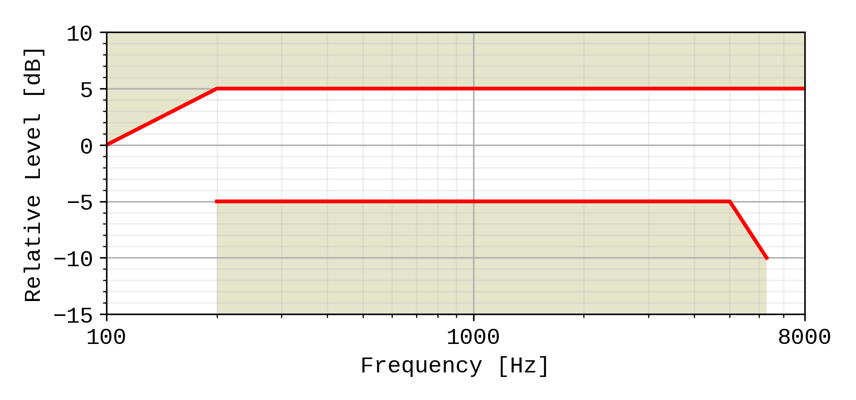

Figure 9: Handset and headset sending sensitivity/frequency mask

Compliance shall be checked by the relevant test described in TS 26.132.

### 6.4.2 Handset and headset UE receiving

The sensitivity/frequency characteristics shall be as follows:

The receiving sensitivity frequency response, measured either from the digital interface to the DRP with diffuse-field correction or from the SS audio input (analogue or digital input of the reference speech encoder of the SS) to the DRP with diffuse-field correction,shall be within a mask, which can be drawn with straight lines between the breaking points in table 10 on a logarithmic (frequency) - linear (dB sensitivity) scale.

Table 10: Handset and headset receiving sensitivity/frequency mask

|  |  |  |
| --- | --- | --- |
| Frequency (Hz) | Upper limit  8 ± 2 N | Lower limit  8 ± 2 N |
| 100 | 6 |  |
| 200 | 6 | -10 |
| 300 | 6 | -6 |
| 1 000 | 6 | -6 |
| 2 000 | 8 | -6 |
| 5 000 | 8 | -6 |
| 6 300 | 8 | -12 |
| 8 000 | 8 |  |
| NOTE: All sensitivity values are expressed in dB on an arbitrary scale. | | |

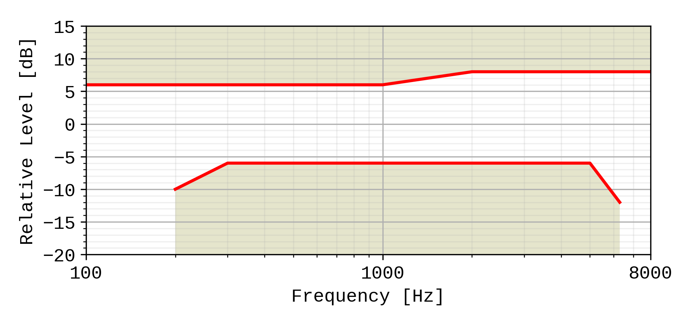

Figure 10: Handset and headset receiving sensitivity/frequency mask

Compliance shall be checked by the relevant test described in TS 26.132.

### 6.4.3 Desktop and vehicle-mounted hands-free UE sending

The sending sensitivity frequency response from the MRP to the SS audio output (digital output of the reference speech decoder of the SS) shall be as follows:

The sending sensitivity frequency response shall be within the mask which can be drawn with straight lines between the breaking points in table 11 on a logarithmic (frequency) - linear (dB sensitivity) scale.

Table 11: Desktop and vehicle-mounted hands-free sending sensitivity/frequency mask

|  |  |  |
| --- | --- | --- |
| Frequency (Hz) | Upper limit | Lower limit |
| 100 | 0 |  |
| 200 | 5 | -5 |
| 5 000 | 5 | -5 |
| 6 300 | 5 | -10 |
| 8 000 | 5 |  |
| NOTE: All sensitivity values are expressed in dB on an arbitrary scale. | | |



Figure 11: Desktop and vehicle-mounted hands-free sending sensitivity/frequency mask

Compliance shall be checked by the relevant test described in TS 26.132.

### 6.4.4 Desktop and vehicle-mounted hands-free UE receiving

The receiving sensitivity frequency response from the SS audio input (analogue or digital input of the reference speech encoder of the SS) to the free-field shall be as follows:

The receiving sensitivity frequency response shall be within the mask which can be drawn with straight lines between the breaking points in table 12 on a logarithmic (frequency) - linear (dB sensitivity) scale.

Table 12: Desktop and vehicle-mounted hands-free receiving sensitivity/frequency mask

| Frequency (Hz) | Upper limit | Lower limit |
| --- | --- | --- |
| 125 | 8 |  |
| 200 | 8 | -12 |
| 250 | 8 | -9 |
| 315 | 7 | -6 |
| 400 | 6 | -6 |
| 5 000 | 6 | -6 |
| 6 300 | 6 | -9 |
| 8 000 | 6 |  |
| NOTE: The limits for intermediate frequencies lie on a straight line drawn between the given values on a linear (dB) - logarithmic (Hz) scale.  All sensitivity values are expressed in dB on an arbitrary scale. | | |

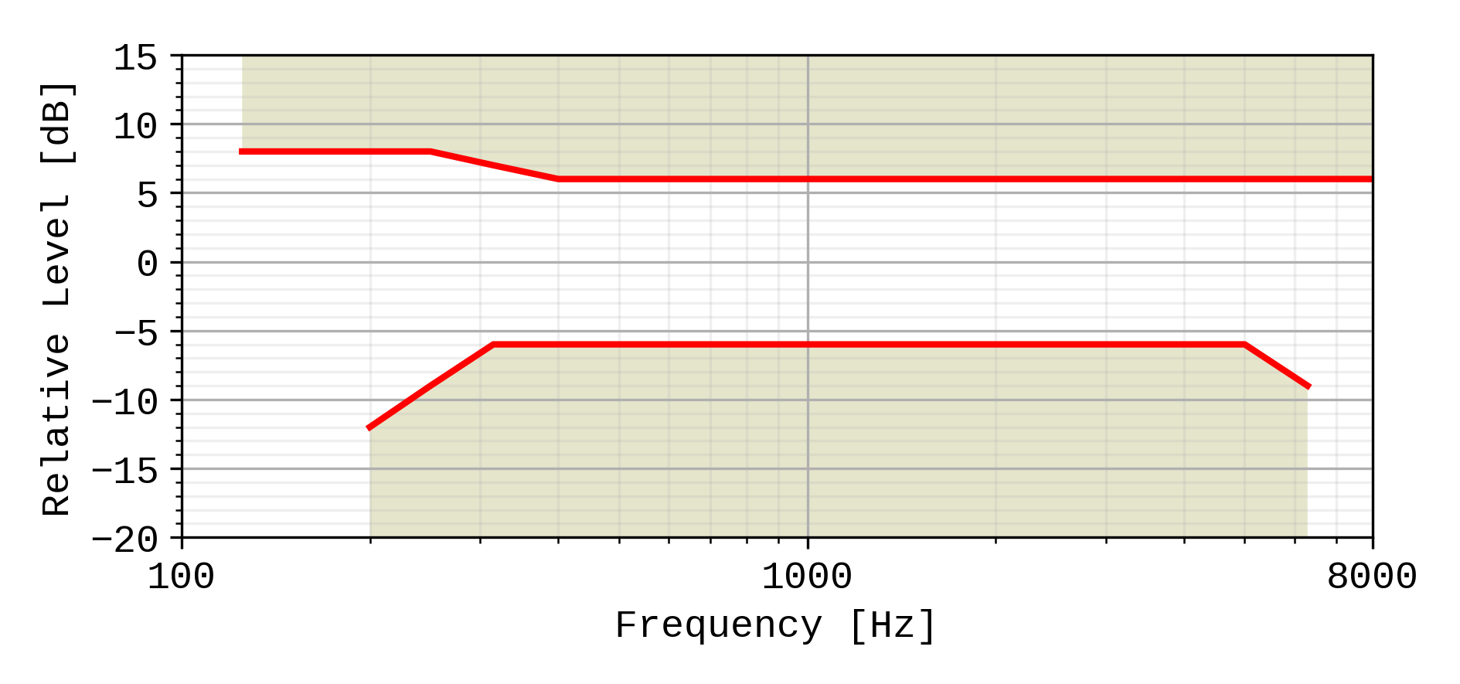

Figure 12: Desktop and vehicle-mounted hands-free receiving sensitivity/frequency mask

It is recommended as a performance objective that the receiving sensitivity frequency response be within the mask which can be drawn with straight lines between the breaking points in table 12.a on a logarithmic (frequency) - linear (dB sensitivity) scale.

Table 12a: Performance objective for desktop and vehicle-mounted hands-free receiving sensitivity/frequency response

|  |  |  |
| --- | --- | --- |
| Frequency (Hz) | Upper limit | Lower limit |
| 100 | 0 |  |
| 200 | 0 | -18 |
| 250 | 0 | -15 |
| 315 | 0 | -12 |
| 6 300 | 0 | -12 |
| 8 000 | 0 |  |

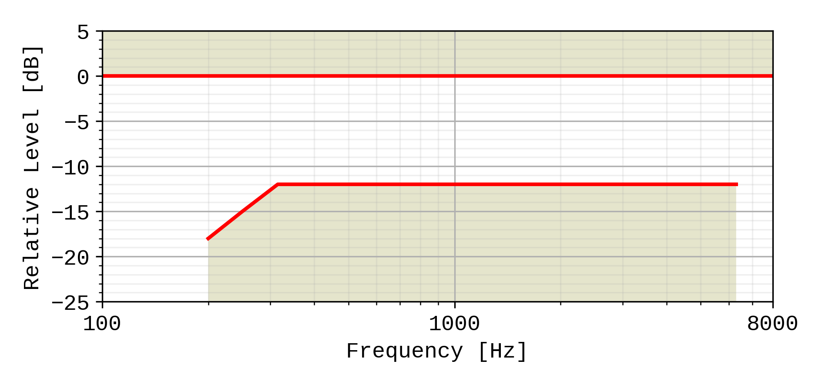

Figure 12a: Performance objective for desktop and vehicle-mounted hands-free receiving sensitivity/frequency response

Compliance shall be checked by the relevant test described in TS 26.132.

### 6.4.5 Hand-held hands-free UE sending

The sending sensitivity frequency response from the MRP to the SS audio output (digital output of the reference speech decoder of the SS) shall be as follows:

The sending sensitivity frequency response shall be within the mask which can be drawn with straight lines between the breaking points in table 13 on a logarithmic (frequency) - linear (dB sensitivity) scale.

Table 13: Hand-held hands-free sending sensitivity/frequency mask

|  |  |  |
| --- | --- | --- |
| Frequency (Hz) | Upper limit | Lower limit |
| 100 | 0 |  |
| 200 | 5 | -5 |
| 5 000 | 5 | -5 |
| 6 300 | 5 | -10 |
| 8 000 | 5 |  |
| NOTE: All sensitivity values are expressed in dB on an arbitrary scale. | | |



Figure 13: Hand-held hands-free sending sensitivity/frequency mask

Compliance shall be checked by the relevant test described in TS 26.132.

### 6.4.6 Hand-held hands-free UE receiving

The receiving sensitivity frequency response from the SS audio input (analogue or digital input of the reference speech encoder of the SS) to the free-field shall be as follows:

The receiving sensitivity frequency response shall be within the mask which can be drawn with straight lines between the breaking points in table 14 on a logarithmic (frequency) - linear (dB sensitivity) scale.

Table 14: Hand-held hands-free receiving sensitivity/frequency mask

| Frequency (Hz) | Upper limit | Lower limit |
| --- | --- | --- |
| 315 | 6 |  |
| 630 | 6 | -12 |
| 800 | 6 | -6 |
| 4 000 | 6 | -6 |
| 6 300 | 6 | -12 |
| 8 000 | 6 |  |
| NOTE: All sensitivity values are expressed in dB on an arbitrary scale. | | |

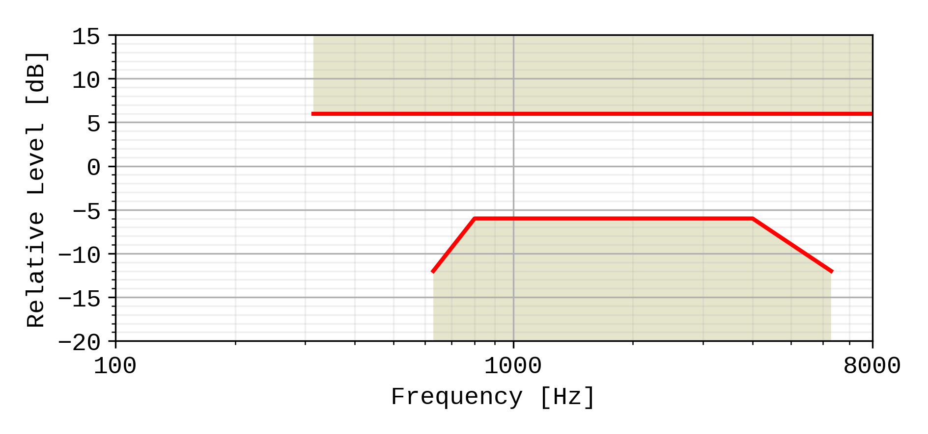

Figure 14: Hand-held hands-free receiving sensitivity/frequency mask

It is recommended as a performance requirement that the receiving sensitivity frequency response be within the mask which can be drawn with straight lines between the breaking points in table 14a on a logarithmic (frequency) - linear (dB sensitivity) scale.

Table 14a: Performance objective for hand-held hands-free receiving sensitivity/frequency mask

|  |  |  |  |
| --- | --- | --- | --- |
| Frequency (Hz) | Upper limit | Lower limit | |
| 315 | 6 |  | |
| 400 | 6 | -12 | |
| 500 | 6 | -6 | |
| 4 000 | 6 | -6 | |
| 6 300 | 6 | -12 | |
| 8 000 | 6 |  | |
| NOTE: All sensitivity values are expressed in dB on an arbitrary scale. | | | |

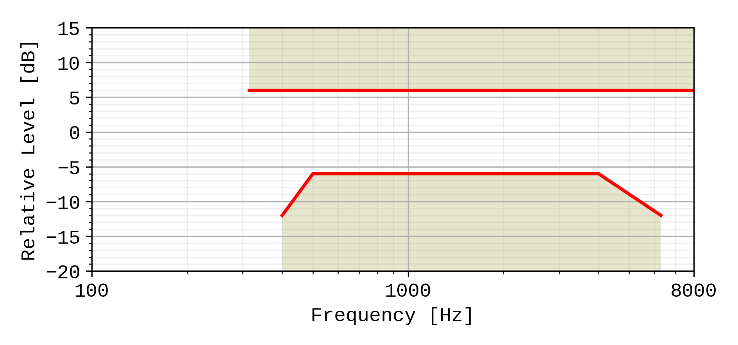

Figure 14a: Performance objective for hand-held hands-free receiving sensitivity/frequency mask

Compliance shall be checked by the relevant test described in TS 26.132.

## 7.4 Sensitivity/frequency characteristics

### 7.4.0 General

It is recommended for all configurations (handset, headset etc) to have a flat sending frequency response in super-wideband mode.

Tolerance masks apply to the center frequencies of the fractional octave bands specified for the respective tests in TS 26.132.

### 7.4.1 Handset and headset UE sending

The sensitivity/frequency characteristics shall be as follows:

The sending sensitivity frequency response, measured either from the mouth reference point (MRP) to the digital interface or from the MRP to the SS audio output (digital output of the reference speech decoder of the SS), shall be within a mask, which can be drawn between the points given in table 17.

The masks are drawn with straight lines between the breaking points in the tables on a logarithmic (frequency) - linear (dB sensitivity) scale.

Table 17: Handset and headset sending sensitivity/frequency requirement mask

|  |  |  |
| --- | --- | --- |
| Frequency (Hz) | Upper limit (dB) | Lower limit (dB) |
| 100 | 4 |  |
| 200 | 4 | -4 |
| 5000 | 4 | -4 |
| 12500 | 4 | -6 |
| 16000 | 4 |  |
| NOTE: All sensitivity values are expressed in dB on an arbitrary scale. | | |

Table 18: Void

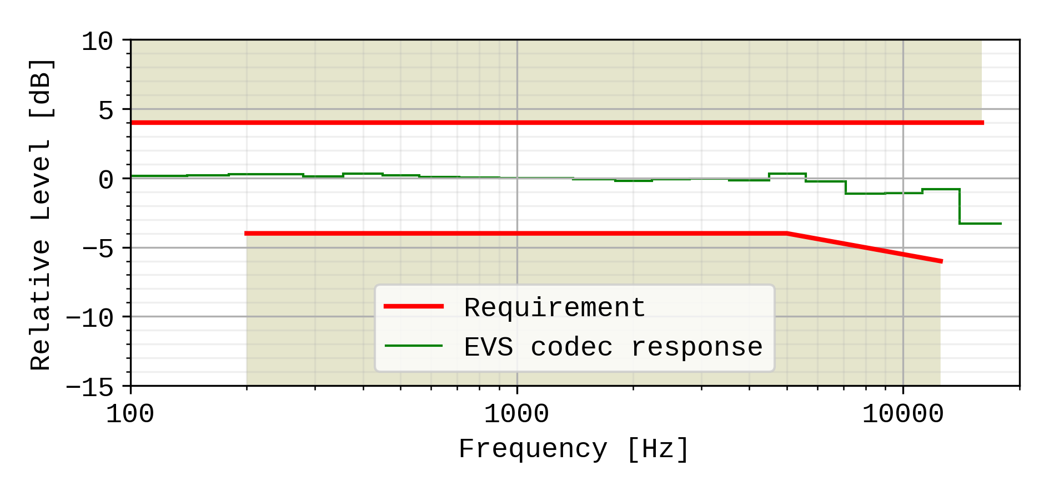

Figure 15: Handset and headset sending sensitivity/frequency masks. The frequency response of the EVS codec operating as specified in TS 26.132 (super-wideband 24,4kbit/s, using the specified P.501 speech test signal), is plotted for reference, normalized to 0dB at 1kHz.

A UE operating in super-wideband mode shall pass the super-wideband requirements (i.e. when measured according to in 1/3rd octaves) as specified in Table 17, and shall also pass the wideband sensitivity/frequency characteristics requirements in the wideband range using the wideband measurement (i.e. measured in 1/12th octaves) as specified in Table 9.

Compliance shall be checked by the relevant test described in TS 26.132.

### 7.4.2 Handset and headset UE receiving

#### 7.4.2.1 Handset UE receiving

The sensitivity/frequency characteristics shall be as follows:

The receiving sensitivity frequency response, measured either from the digital interface to the DRP with diffuse-field correction or from the SS audio input (analogue or digital input of the reference speech encoder of the SS) to the DRP with diffuse-field correction,shall be within a mask, which can be drawn with straight lines between the breaking points in table 19 on a logarithmic (frequency) - linear (dB sensitivity) scale.

Table 19: Handset receiving sensitivity/frequency requirement mask

|  |  |  |
| --- | --- | --- |
| Frequency (Hz) | Upper limit (dB) | Lower limit (dB) |
| 100 | 5 |  |
| 200 | 5 | -8 |
| 250 | 5 | -5 |
| 5000 | 5 | -5 |
| 12500 | 5 | -11 |
| 16000 | 5 |  |
| NOTE: All sensitivity values are expressed in dB on an arbitrary scale. | | |

It is desired as a performance objective that the receiving sensitivity/frequency response be within the mask which can be drawn with straight lines between the breaking points in table 20.

Table 20: Handset receiving sensitivity/frequency performance objective mask

|  |  |  |
| --- | --- | --- |
| Frequency (Hz) | Upper limit (dB) | Lower limit (dB) |
| 100 | 4 |  |
| 200 | 4 | -4 |
| 250 | 4 | -4 |
| 5000 | 4 | -4 |
| 12500 | 4 | -7 |
| 16000 | 4 |  |
| NOTE: All sensitivity values are expressed in dB on an arbitrary scale. | | |

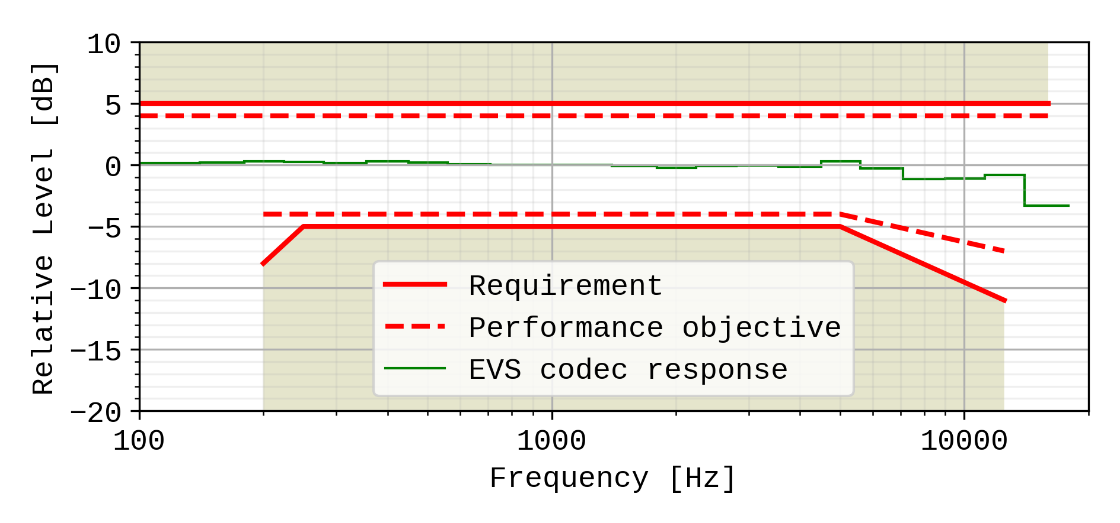

Figure 16: Handset receiving sensitivity/frequency masks. The frequency response of the EVS codec operating as specified in TS 26.132 (super-wideband 24,4kbit/s, using the specified P.501 speech test signal), is plotted for reference, normalized to 0dB at 1kHz.

A UE operating in super-wideband mode shall pass the super-wideband requirements (i.e. when measured according to in 1/3rd octaves) as specified in Table 19, and shall also pass the wideband sensitivity/frequency characteristics requirements in the wideband range using the wideband measurement (i.e. measured in 1/12th octaves) as specified in Table 10.

Compliance shall be checked by the relevant test described in TS 26.132.

#### 7.4.2.2 Headset UE receiving

The sensitivity/frequency characteristics shall be as follows:

The receiving sensitivity frequency response, measured either from the digital interface to the DRP with diffuse-field correction or from the SS audio input (analogue or digital input of the reference speech encoder of the SS) to the DRP with diffuse-field correction,shall be within a mask, which can be drawn with straight lines between the breaking points in table 21 on a logarithmic (frequency) - linear (dB sensitivity) scale.

Table 21: Headset receiving sensitivity/frequency requirement mask

|  |  |  |
| --- | --- | --- |
| Frequency (Hz) | Upper limit (dB) | Lower limit (dB) |
| 100 | [TBD] | [TBD] |
| 200 |  |  |
| 250 |  |  |
| 5000 |  |  |
| 12500 |  |  |
| 16000 |  |  |
| NOTE: All sensitivity values are expressed in dB on an arbitrary scale. | | |

It is recommended as a performance objective that the receiving sensitivity/frequency response be within the mask which can be drawn with straight lines between the breaking points in table 22.

Table 22: Headset receiving sensitivity/frequency performance objective mask

|  |  |  |
| --- | --- | --- |
| Frequency (Hz) | Upper limit (dB) | Lower limit (dB) |
| 100 | [3] |  |
| 200 | [3] | [-6] |
| 250 | [3] | [-3] |
| 5000 | [3] | [-3] |
| 12500 | [3] | [-6] |
| 16000 | [3] |  |
| NOTE 1: All sensitivity values are expressed in dB on an arbitrary scale.  NOTE 2: Values within [] are provisional and expected to be confirmed, revised or removed based on future studies. | | |

TBD

Figure 17: Headset receiving sensitivity/frequency masks

Compliance shall be checked by the relevant test described in TS 26.132.

### 7.4.3 Desktop and vehicle-mounted hands-free UE sending

The sending sensitivity frequency response from the MRP to the SS audio output (digital output of the reference speech decoder of the SS) shall be as follows:

The sending sensitivity frequency response shall be within the mask which can be drawn with straight lines between the breaking points in table 23 on a logarithmic (frequency) - linear (dB sensitivity) scale.

Table 23: Desktop and vehicle-mounted hands-free sending sensitivity/frequency mask

|  |  |  |
| --- | --- | --- |
| Frequency (Hz) | Upper limit (dB) | Lower limit (dB) |
| 100 | [3...5] |  |
| 200 | [3...5] | [-3...-5] |
| 5000 | [3...5] | [-3...-5] |
| 12500 | [3...5] | [-5...-7] |
| 16000 | [3...5] |  |
| NOTE 1: All sensitivity values are expressed in dB on an arbitrary scale.  NOTE 2: Values within [] are provisional and expected to be defined as single values based on future studies. | | |

It is recommended as a performance objective that the sending sensitivity/frequency response be within the mask which can be drawn with straight lines between the breaking points in table 24.

Table 24: Handset and headset sending sensitivity/frequency performance objective mask

|  |  |  |
| --- | --- | --- |
| Frequency (Hz) | Upper limit (dB) | Lower limit (dB) |
| 100 | [3] |  |
| 200 | [3] | [-3] |
| 5000 | [3] | [-3] |
| 12500 | [3] | [-5] |
| 16000 | [3] |  |
| NOTE 1: All sensitivity values are expressed in dB on an arbitrary scale.  NOTE 2: Values within [] are provisional and expected to be confirmed, revised or removed based on future studies. | | |

TBD

Figure 18: Desktop and vehicle-mounted hands-free sending sensitivity/frequency masks

Compliance shall be checked by the relevant test described in TS 26.132.

### 7.4.4 Desktop and vehicle-mounted hands-free UE receiving

The receiving sensitivity frequency response from the SS audio input (analogue or digital input of the reference speech encoder of the SS) to the free-field shall be as follows:

The receiving sensitivity frequency response shall be within the mask which can be drawn with straight lines between the breaking points in table 25 on a logarithmic (frequency) - linear (dB sensitivity) scale.

Table 25: Desktop and vehicle-mounted hands-free receiving sensitivity/frequency mask

| Frequency | Upper limit (dB) | Lower limit (dB) |
| --- | --- | --- |
| TBD | TBD | TBD |
|  |  |  |
|  |  |  |
|  |  |  |
|  |  |  |
|  |  |  |
|  |  |  |
|  |  |  |
| NOTE: The limits for intermediate frequencies lie on a straight line drawn between the given values on a linear (dB) - logarithmic (Hz) scale.  All sensitivity values are expressed in dB on an arbitrary scale. | | |

It is recommended as a performance objective that the receiving sensitivity frequency response be within the mask which can be drawn with straight lines between the breaking points in table 26 on a logarithmic (frequency) - linear (dB sensitivity) scale.

Table 26: Performance objective for desktop and vehicle-mounted hands-free receiving sensitivity/frequency response

|  |  |  |
| --- | --- | --- |
| Frequency (Hz) | Upper limit (dB) | Lower limit (dB) |
| TBD | TBD | TBD |
|  |  |  |
|  |  |  |
|  |  |  |
|  |  |  |
|  |  |  |

TBD

Figure 19: Desktop and vehicle-mounted hands-free receiving sensitivity/frequency masks

Compliance shall be checked by the relevant test described in TS 26.132.

### 7.4.5 Hand-held hands-free UE sending

The sending sensitivity frequency response from the MRP to the SS audio output (digital output of the reference speech decoder of the SS) shall be as follows:

The sending sensitivity frequency response shall be within the mask which can be drawn with straight lines between the breaking points in table 27 on a logarithmic (frequency) - linear (dB sensitivity) scale.

Table 27: Hand-held hands-free sending sensitivity/frequency mask

|  |  |  |
| --- | --- | --- |
| Frequency (Hz) | Upper limit (dB) | Lower limit (dB) |
| 100 | [3...5] |  |
| 200 | [3...5] | [-3...-5] |
| 5000 | [3...5] | [-3...-5] |
| 12500 | [3...5] | [-5...-7] |
| 16000 | [3...5] |  |
| NOTE 1: All sensitivity values are expressed in dB on an arbitrary scale.  NOTE 2: Values within [] are provisional and expected to be defined as single values based on future studies. | | |

It is recommended as a performance objective that the sending sensitivity/frequency response be within the mask which can be drawn with straight lines between the breaking points in table 28.

Table 28: Hand-held hands-free sending sensitivity/frequency performance objective mask

|  |  |  |
| --- | --- | --- |
| Frequency (Hz) | Upper limit (dB) | Lower limit (dB) |
| 100 | [3] |  |
| 200 | [3] | [-3] |
| 5000 | [3] | [-3] |
| 12500 | [3] | [-5] |
| 16000 | [3] |  |
| NOTE 1: All sensitivity values are expressed in dB on an arbitrary scale.  NOTE 2: Values within [] are provisional and expected to be confirmed, revised, or removed, based on future studies. | | |

TBD

Figure 20: Hand-held hands-free sending sensitivity/frequency masks

Compliance shall be checked by the relevant test described in TS 26.132.

### 7.4.6 Hand-held hands-free UE receiving

The receiving sensitivity frequency response from the SS audio input (analogue or digital input of the reference speech encoder of the SS) to the free-field shall be as follows:

The receiving sensitivity frequency response shall be within the mask which can be drawn with straight lines between the breaking points in table 29 on a logarithmic (frequency) - linear (dB sensitivity) scale.

Table 29: Hand-held hands-free receiving sensitivity/frequency mask

| Frequency (Hz) | Upper limit (dB) | Lower limit (dB) |
| --- | --- | --- |
| TBD | TBD | TBD |
|  |  |  |
|  |  |  |
|  |  |  |
|  |  |  |
|  |  |  |
| NOTE: All sensitivity values are expressed in dB on an arbitrary scale. | | |

TBD

It is recommended as a performance requirement that the receiving sensitivity frequency response be within the mask which can be drawn with straight lines between the breaking points in table 30 on a logarithmic (frequency) - linear (dB sensitivity) scale.

Table 30: Performance objective for hand-held hands-free receiving sensitivity/frequency mask

| Frequency (Hz) | | Upper limit (dB) | | | Lower limit (dB) | |
| --- | --- | --- | --- | --- | --- | --- |
| TBD | | TBD | | | TBD | |
|  | |  | | |  | |
|  | |  | | |  | |
|  | |  | | |  | |
|  | |  | | |  | |
|  | |  | | |  | |
| NOTE: All sensitivity values are expressed in dB on an arbitrary scale. | | | | | | |

TBD

Figure 21: Hand-held hands-free receiving sensitivity/frequency masks

Compliance shall be checked by the relevant test described in TS 26.132.

End of changes