**3GPP TSG-SA4 Meeting #115e *S4-211226***

**Electronic meeting, Telco, Aug 18-27, 2021 Revision of S4-211137**

|  |  |  |  |  |  |  |  |  |
| --- | --- | --- | --- | --- | --- | --- | --- | --- |
| *CR-Form-v11.4* | | | | | | | | |
| **CHANGE REQUEST** | | | | | | | | |
|  | | | | | | | | |
|  | **26.247** | **CR** | **0168** | **Rev** | **1** | **Current version:** | **16.4.1** |  |
|  | | | | | | | | |
| *For* [***HE******LP***](http://www.3gpp.org/3G_Specs/CRs.htm#_blank)*on using this form: comprehensive instructions can be found at* [*http://www.3gpp.org/Change-Requests*](http://www.3gpp.org/Change-Requests)*.* | | | | | | | | |
|  | | | | | | | | |

|  |  |  |  |  |  |  |  |  |
| --- | --- | --- | --- | --- | --- | --- | --- | --- |
| ***Proposed change affects:*** | UICC apps | **X** | ME |  | Radio Access Network |  | Core Network |  |

|  |  |  |  |  |  |  |  |  |  |  |
| --- | --- | --- | --- | --- | --- | --- | --- | --- | --- | --- |
|  | | | | | | | | | | |
| ***Title:*** | |  | | --- | | QoE configuration release | |  | | | | | | | | | | |
|  |  | | | | | | | | | |
| ***Source to WG:*** | Huawei Technologies Co.,Ltd. | | | | | | | | | |
| ***Source to TSG:*** | S4 | | | | | | | | | |
|  |  | | | | | | | | | |
| ***Work item code:*** | NR_QoE | | | | |  | ***Date:*** | | | 2021-07-27 |
|  |  | | | |  | |  | | |  |
| ***Category:*** | **F** |  | | | | | ***Release:*** | | | Rel-16 |
|  | *Use one of the following categories:* ***F*** *(correction)* ***A*** *(mirror corresponding to a change in an earlier release)* ***B*** *(addition of feature),* ***C*** *(functional modification of feature)* ***D*** *(editorial modification)*  Detailed explanations of the above categories can be found in 3GPP [TR 21.900](http://www.3gpp.org/ftp/Specs/html-info/21900.htm). | | | | | | | | *Use one of the following releases: Rel-8 (Release 8) Rel-9 (Release 9) Rel-10 (Release 10) Rel-11 (Release 11) Rel-12 (Release 12)* *Rel-13 (Release 13) Rel-14 (Release 14) Rel-15 (Release 15) Rel-16 (Release 16)* | |
|  |  | | | | | | | | | |
| ***Reason for change:*** | | RAN2/3 has supported the functionality of QoE configuration release/de-configuration in relevant specifications, however, the description of the functionality is missing in SA4 specifications. In addition, the application layer can also receive the discard request from the AS layer. | | | | | | | | |
|  | |  | | | | | | | | |
| ***Summary of change:*** | | Add the QoE configuration release description. | | | | | | | | |
|  | |  | | | | | | | | |
| ***Consequences if not approved:*** | | Unalignment between SA4 and RAN2/3, SA5 about the QoE configuration release. | | | | | | | | |
|  | |  | | | | | | | | |
| ***Clauses affected:*** | | 10.1, L.1 | | | | | | | | |
|  | |  | | | | | | | | |
|  | | **Y** | **N** |  | | | |  | | |
| ***Other specs*** | |  | **X** | Other core specifications | | | | TS/TR ... CR ... | | |
| ***affected:*** | |  | **X** | Test specifications | | | | TS/TR ... CR ... | | |
| ***(show related CRs)*** | |  | **X** | O&M Specifications | | | | TS/TR ... CR ... | | |
|  | |  | | | | | | | | |
| ***Other comments:*** | |  | | | | | | | | |

* * * * First change * * * *

## 10.1 General

A progressive download or 3GP-DASH client supporting Quality of Experience (QoE) shall report QoE metrics according to the QoE configuration. QoE reporting is optional, but if a 3GP-DASH client reports DASH metrics, it shall report all requested metrics.

The quality metrics are defined in subclause 10.2.

The quality metrics applicable for progressive download are specified in section 10.3. In this case the activation and configuration of QoE reporting framework is achieved by a corresponding OMA DM QoE Management Object as specified in Annex F, or by the QMC functionality as specified in Annex L.

The quality metrics for DASH are specified in section 10.4. In this case, QoE reporting may be triggered using the MPD ( i.e. when the **Metrics** element is present in the MPD) or using OMA DM QoE Management Object as specified in Annex F, or by the QMC functionality as specified in Annex L. When QoE reporting is triggered via any of the above methods, the 3GP-DASH client is expected to collect quality metrics according to the QoE configuration. When using the MPD or the QMC functionality, the Quality Reporting scheme as defined in section 10.5 may be used.

The QoE configuration shall only be checked by the client when each session starts, and thus all logging and reporting criterias for an ongoing session shall be unaffected by any QoE configuration changes received during that session. This also includes evaluation of any filtering criterias, such as geographical filtering, which shall only be done when the session starts. Thus changes to the QoE configuration will only affect sessions started after these configuration changes have been received. When the QoE configuration is released, the client shall stop collecting quality metrics and discard any already collected information [63].

The quality metric reporting protocol is defined in subclause 10.6. This protocol shall be used when QoE reporting is triggered via the MPD or OMA DM QoE Management Object. When QoE reporting is triggered via the QMC functionality, the reporting is specified in Annex L.

The usage of ITU-T P.1203 [49] Audio/Video Mean Opinion Score (A/V MOS) estimation is defined in Annex K.

* * * * Second change * * * *

# L.1 Configuration and reporting

As an alternative to configuration via MPD or OMA-DM, the QoE configuration can optionally be specified by the QoE Measurement Collection (QMC) functionality. In this case the QoE configuration is received via specific RRC [53] messages for UMTS and RRC [59] messages for LTE over the control plane, and the QoE reporting is also sent back via RRC messages over the control plane.

If QMC is supported, the UE shall support the following QMC functionalities:

- QoE Configuration: The QoE configuration will be delivered via RRC to the UE as a container according to "Application Layer Measurement Configuration" (see [53]) for UMTS, and "measConfigApplicationLayer" (see [59]) for LTE. The container is an octet string with a maximum length of 1000 bytes, with gzip-encoded data (see [18]) stored in network byte order. The container shall be uncompressed, and is then expected to conform to XML-formatted QoE configuration data according to clause L.2 in the current specification. This QoE Configuration shall be forwarded to the DASH client. The interface towards the RRC signalling is handled by the AT command +CAPPLEVMC [61].

- QoE Metrics: QoE Metrics from the DASH client shall be XML-formatted according to clause 10.6 in the current specification. The XML data shall be compressed with gzip (see [18]) and stored in network byte order into an octet string container with a maximum length of 8000 bytes. The container shall be delivered via RRC to the RNC according to "Application Layer Measurement Reporting" (see [53]) for UMTS, and to the eNB according to "measReportApplicationLayer" (see [59]) for LTE. The behaviour if the compressed data is larger than 8000 bytes is unspecified in this version of the specification. The interface towards the RRC signalling is handled by the AT command +CAPPLEVMR [61].

- The UE shall also set the QMC capability "QoE Measurement Collection for streaming services" (see [53]) to TRUE for UMTS, and include the QMC capability "qoe-MeasReport" (see [59]) for LTE.

- The QoE configuration AT command +CAPPLEVMC [61] may also indicate with an Within-area Indication if the UE is inside or outside a wanted geographic area. Such an indication may arrive with or without any QoE configuration container attached. If the DASH client is informed that it is not inside the area, it shall not start any new QoE measurements even if it has received a valid QoE configuration container, but shall continue measuring for already started sessions.

- When a new session is started, the QoE reporting AT command +CAPPLEVMR [61] shall be used to send a Recording Session Indication. Such an indication does not contain any QoE report, but indicates that QoE recording has started for a session.

- When the QoE configuration is released, the QoE configuration AT command +CAPPLEVMC [61] shall be used to send a discard request. Then the client shall stop collecting quality metrics and discard any already collected information [63].

The exact implementation is not specified here, but example signalling diagrams for UMTS and LTE below show the QMC functionality with a hypothetical "QMC Handler" entity.



Figure L-1: Example signalling diagram for UMTS

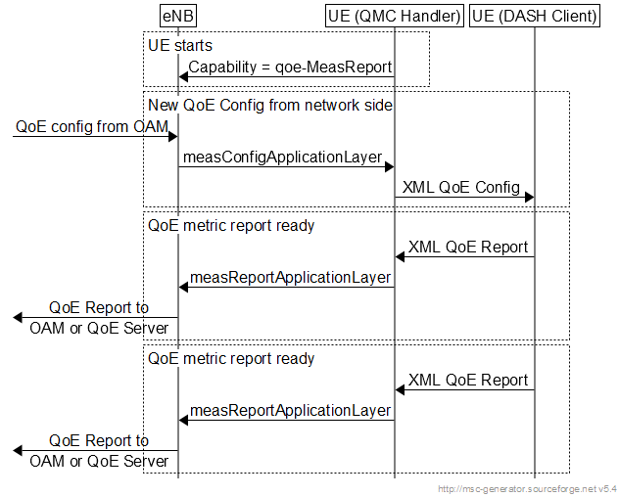

Figure L-2: Example signalling diagram for LTE

Note that the QMC Handler is only shown here as one possible implementation, and it need not be implemented as such. The corresponding QMC functionality could be built into the DASH client or into other UE entities. In this version of the specification the detailed implementation of the above functionalities is left to the UE vendor.

* * * * End of Changes * * * *