**Agenda item:** 9.6

**Source:** Huawei Technologies Co.,Ltd.

**Title:** Discussion on Data Collection AF design based on CAPIF

**Document for** Discussion andAgreement

# Introduction

In the past discussion about the reference architecture of general data collection and reporting in the work item “EVEX”, when the information exchanges across the trust boundary, the NEF is needed to bridge the communications between entities in the trust domain and those outside the trust domain.

However, the NEF need to be enhanced to support the provisioning, subscription/notification and data collection configuration and reporting, which will depend on SA2’s decision about whether and how to do the enhancements. To avoid that, this paper proposes one design based on the well-defined CAPIF, which don’t need NEF at all.

# Brief introduction of CAPIF

**Figure 1: Functional model for the CAPIF**

The CAPIF is hosted within the PLMN operator network. The API invoker is typically provided by a 3rd party application provider who has service agreement with PLMN operator. The API invoker may also reside within the same trust domain as the PLMN operator network.

In a reference point based model, the API invoker within the PLMN trust domain interacts with the CAPIF via CAPIF-1 and CAPIF-2. The API invoker from outside the PLMN trust domain interacts with the CAPIF via CAPIF-1e and CAPIF-2e. The API exposing function, the API publishing function and the API management function of the API provider domain (together known as API provider domain functions) within the PLMN trust domain interacts with the CAPIF core function via CAPIF-3, CAPIF-4 and CAPIF-5 respectively. Besides, the 3rd party API provider domain functions outside the PLMN trust domain can also be supported.

# Implementation of Data Collection AF via CAPIF

Based on the CAPIF design, two implementation options are presented as the following.

## Option A

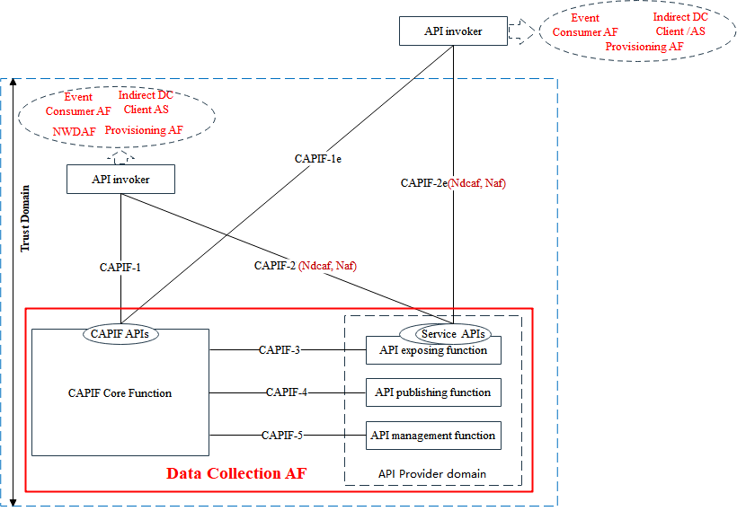

Figure 1 Data Collection AF implements the CAPIF architecture

The Data Collection AF can implement the functionalities of the CAPIF core function, the API exposing function, the API publishing function and the API management function.

According to the CAPIF architecture, CAPIF-2 and CAPIF-2e consist of framework aspects and service specific aspects. And the service aspects in this architecture can be implemented by the Data Collection AF, like *Ndcaf* service for data collection configuration and reporting, *Naf* service for the event (un) subscription and notification.

In this case, the Data Collection AF can be located in the Trusted Domain. At first, the API invokers, within or outside the Trust Domain, shall initiate the onboarding procedure to enrol the API invokers as a recognized user of the CAPIF. In addition, the API publishing function within the Data Collection AF shall also publish the service APIs to the CAPIF Core function, which consist of the *Ndcaf* and *Naf* services including the API name, API type, description, interface details, data format, etc. as defined in Table 8.3.2.1-1 of TS 23.222 [1]. If topology hiding is enabled for the service API, the interface details shall be the interface details of API exposing function acting as service communication entry point for the service API.

Then the API invokers can send the service API discover request to the CAPIF core function within the Data Collection AF via the CAPIF-1/CAPIF-1e. So the NWDAF, the event consumer AF or the indirect data collection client, as an API invoker, can obtain the detailed information about the *Ndcaf* and *Naf* APIs.

Besides, the authentication between the API invoker and the CAPIF core function, together with the API invoker obtaining authorization to access service API are also supported.

Via such design, the *Ndcaf* and *Naf* services can be implemented to be discovered and invoked by the API invokers, no matter it is inside of the trusted domain or outside the domain, which means no enhancements of NEF is needed at all.

If the Data Collection AF is located outside the Trust Domain, that will be the same as the details in the above, which means the Trust Domain as shown in Figure 2 will be the External Domain, the API invoker outside the dashed box shall be the one within the Trust Domain.

## Option B

In another option, the 5GS operator can deploy the CAPIF core function along with the Data Collection AF and the Data Collection AF can implement the functionalities of the API provider domain functions. The API invokers, no matter inside or outside the Trust Domain, can communicate with the API Provider via the CAPIF-2 or CAPIF-2e. *Ndcaf* and *Naf* API services can implement the service specific aspects of CAPIF-2 and CAPIF-2e. Then these two service APIs can be provided to the API invokers, like NWDAF, provisioning AF, event consumer AF, indirect/direct data collection AF, etc. Also the Data Collection AF can implement the CAPIF-3 or CAPIF-3e reference point/interface to the CAPIF core function.

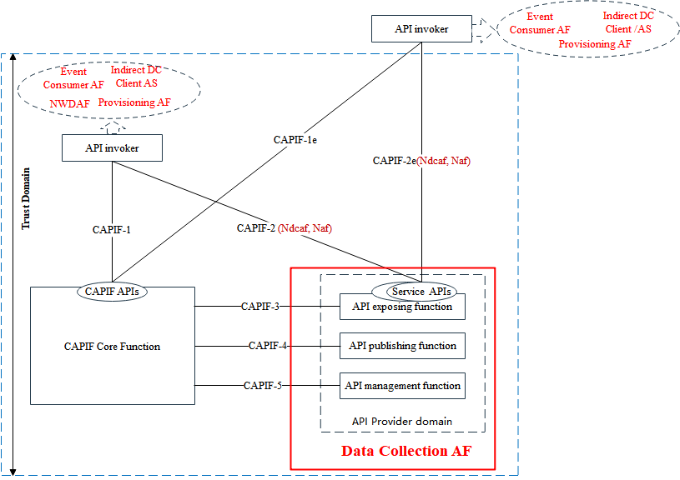

Figure 2 DC-AF in trust domain implements the service specific aspect compliant with the CAPIF.

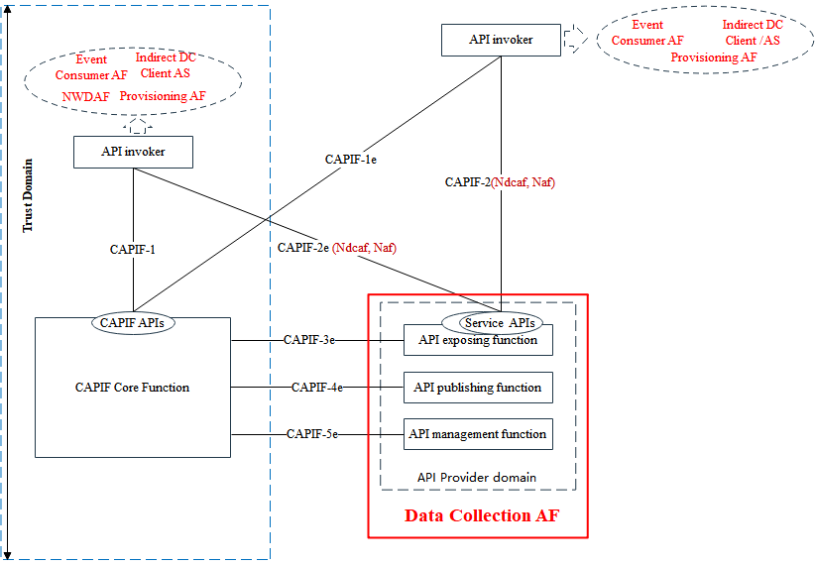

Figure 3 DC-AF outside trust domain implements the service specific aspect compliant with the CAPIF.

There are two cases where the Data Collection AF can be located within or outside the Trusted Domain. And the two cases can cover all the collaboration scenarios of Data Collection AF as detailed in S4al211221[2].

Similar to Option A, the API publishing function within the Data Collection AF shall publish the *Naf* and *Ndcaf* service API information to the 5GS deployed/controlled CAPIF core function. Then the onboarding API invokers shall communicate with CAPIF core function to discover these service APIs for provisioning, data collection configuration and reporting, event (un)subscription and notification, etc. After obtaining the detailed information of *Ndcaf* and *Naf* service APIs, the API invokers, like NWDAF, data collection client and so on, can invoke the related service APIs for data collection configuration and reporting, which also does not need the involvements and enhancements of NEF functionality.

# Formal changes

In all CAPIF deployments (as captured in TS 23.222[x]), the DC-AF must perform the role of the API Exposing Function to provide APIs to other applications (i.e. API Invokers). The DC-AF may optionally perform the roles of the CAPIF Core Function, API Publishing Function or API Management Function and detailed description can be found in Annex. Y.

# Proposal

It is proposed to agree and add Clause 3 to the Annex of TS 26.531 as one way for implementing the Data Collection AF without the need of NEF for the exchanges across trust boundary and also add clause 4 as a “NOTE” in the formal text.

# Reference

[1]. 3GPP TS 23.222: "Functional architecture and information flows to support Common API Framework for 3GPP Northbound APIs".

[2]. S4aI211221, [EVEX] Collaboration scenarios for data collection and reporting.