3GPP TSG-SA 4 Meeting #115-e S4-211076
Online, 17 – 27 August 2021
CR-Form-v12.1
DRAFT CHANGE REQUEST
 | 26.501 | CR |  | rev |  | Current version: | 16.8.0
For HELP on using this form: comprehensive instructions can be found at
http://www.3gpp.org/Change-Requests.

Proposed change affects: | UICC apps |  | ME | X | Radio Access Network |  | Core Network | X

Title: | dCR on the Support of Edge Media Processing in 5GMS
Source to WG: | Qualcomm Incorporated
Source to TSG: | S4
Work item code: | 5GMS_EDGE |  |  |  |  |  | Date: |  |  | 2021-08-12
Category: | B |  |  |  |  |  | Release: |  |  | Rel-17
 | Use one of the following categories:  F (correction)  A (mirror corresponding to a change in an earlier release)  B (addition of feature),  C (functional modification of feature)  D (editorial modification)  Detailed explanations of the above categories can  be found in 3GPP TR 21.900. |  |  |  |  |  |  |  | Use one of the following releases:  Rel-8 (Release 8)  Rel-9 (Release 9)  Rel-10 (Release 10)  Rel-11 (Release 11)  …  Rel-15 (Release 15)  Rel-16 (Release 16)  Rel-17 (Release 17)  Rel-18 (Release 18)
Reason for change: |  | Adding support for Edge Media Processing to the 5GMS architecture.
Summary of change: |  | This pCR introduces the edge media processing funcationlity to the 5GMS architecture.
Consequences if not approved: |  | Edge processing is not supported.
Clauses affected: |  | 7.4
 |  | Y | N
Other specs |  |  |  | Other core specifications |  |  |  | TS/TR ... CR ...
affected: |  |  |  | Test specifications |  |  |  | TS/TR ... CR ...
(show related CRs) |  |  |  | O&M Specifications |  |  |  | TS/TR ... CR ...
Other comments:
This CR's revision history:

First Change

7.4 Edge Computing

7.4.1 General
Support for media processing in the edge requires extensions to the 5GMS architecture. The 5GMS System allows an Application Provider to provision edge resources for an application through the M1 interface by configuring an edge processing resource template.
Media processing in the edge may be achieved in one of two different ways at the application layer:
1. Client-driven management. 5GMS-Aware Applications that are aware of the edge processing can directly request an edge resource and discover the EAS that is best suited to serve the application.
2. Application Provider-driven management. The 5GMS AF automatically allocates edge resources for new media streaming sessions on behalf of the application using information in the 5GMS provisioning session.

7.4.2 Extended 5GMS Architecture
The 5GMS architecture is extended to add support for media processing in the edge. The extended architecture is an integration of the 5GMS architecture, the SA6 Edge architecture, and the SA5 management architecture. The extended architecture is depicted in figure 7.4.2-1.
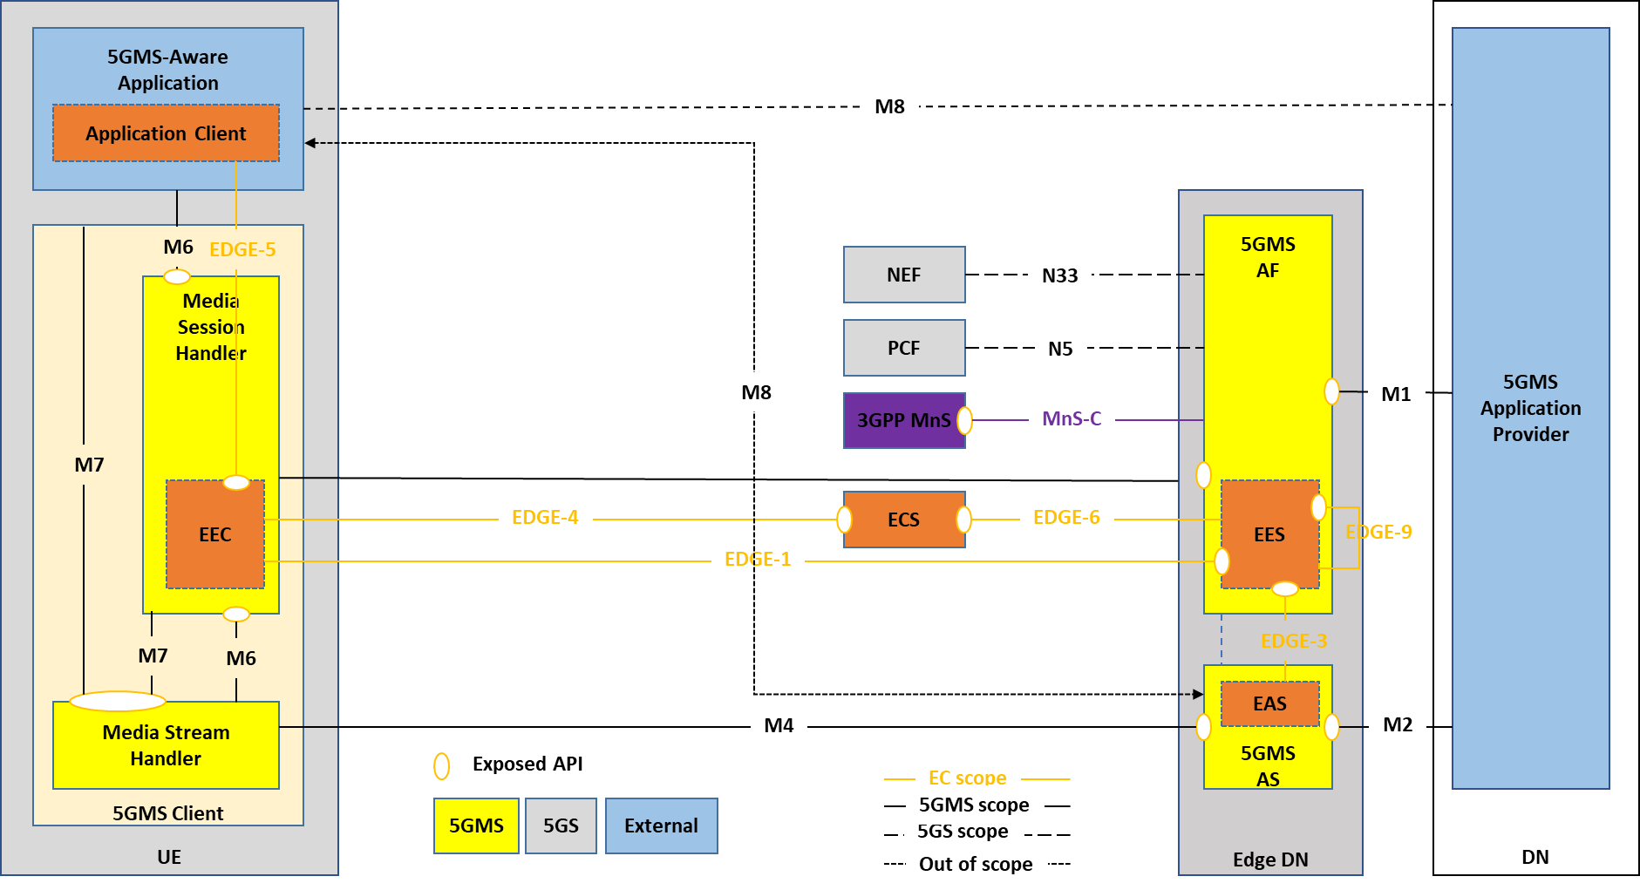
Figure 7.4.2-1: Reference edge-enabled 5GMS media architecture
Based on the extended architecture, the following assumptions shall apply:
1. A Media Session Handler (MSH) that is edge-enabled shall implement the EDGE-5 API.
2. A 5GMS AF that is edge-enabled shall support EES functionality including:
- EDGE-1 API for supporting registration and provisioning of EEC functions, and discovery by them of EAS instances.
- EDGE-3 API towards the EAS function of 5GMS AS instances.
- EDGE-6 API for registering with an ECS function.
- EDGE-9 API for media session relocation.

3. A 5GMS AF that is edge-enabled may perform compute resource allocation using the MnS-C interface.
4. A 5GMS AS that is edge-enabled shall support EAS functionality including EDGE-3 API.
The extended 5GMS architecture supports both client-driven as well as Application Provider-driven management of the edge processing session.
The 5GMS Application Provider may request the deployment of edge resources as part of the Provisioning Session.
In the client-driven approach, the 5GMS-Aware Application is aware of the support of edge processing in the network and takes steps, such as using the EDGE-5 APIs, to discover and locate a suitable 5GMS AS instance in the edge DN.
In the AP-driven approach, the Application Provider configures the 5GMS AF to automatically deploy edge processing for the media sessions of the corresponding Provisioning Session based on the provisioned edge processing resource template. The 5GMS-Aware Application may not be aware of the edge deployment and the EAS is discovered through other means, such as DNS resolution with support from the EASDF.

7.4.3 Call Flows

7.4.3.1 Client-driven Management of 5GMS Edge Processing
Figure 7.4.3.1-1 outlines a detailed call flow for client-driven session establishment.
Figure 7.4.3.1-1: Client-driven session establishment
The Edge Computing Provisioning phase is a provisioning phase, that may be repeated several times (e.g. to extend edge processing coverage to new geographical areas or to increase the capacity of an already provisioned area). All steps in this phase are optional and performed on need basis. The steps are:
1. Spawn ECS: In this step, a new ECS is instantiated to manage new or increased demand for edge processing.
2. Spawn 5GMS AF: In this step, a new 5GMS AF that is edge-enabled is instantiated to handle new or increased demand for media sessions with edge processing.
3. EES Configuration: The EES is configured for a specific Edge Data Network.
4. EES Registration with ECS: The EES registers with the ECS that is in authority over the target EDN.
The 5GMS Application Provider Provisioning phase is performed prior to the establishment of any related media streaming sessions by the 5GMS Application Provider. Subsequent updates to the provisioning session are possible.
5. Create Provisioning Session: In this step, the 5GMS Application Provider creates a new provisioning session.
6. Provision 5GMS features: In this step, the 5GMS Application Provider may create different configurations such as Content Hosting, Reporting, Edge Processing, etc.
During the UE Edge Computing Discovery phase, the UE discovers an EAS instance offering 5GMS AS functionality.
7. Application Initialization: The user launches the 5GMS-Aware Application. The application performs any required initialization steps.
8. Locate EAS/5GMS AS: The Application Client requests the location of one or more suitable EAS instances offering the "5GMS AS" capability that are able to serve the application.
9. Locate local EES: The EEC queries the ECS for a suitable EES.10. Register with EES: The EEC registers with the selected EES.
10. Register with EES: The EEC registers with the selected EES.
11. Request list of "5GMS AS" EAS instances: The EEC contacts the EES to query for one or more EAS instances offering the "5GMS AS" capability that can serve the session, using EAS discovery filters (see Table 8.5.4.2-2 in TS 23.558 [3]) provided by the Application Client, e.g. "5GMS AS" for EAS type, appropriate values for service feature(s), and other EAS characteristics.
The optional sub-flow is for provisioning an additional 5GMS AS instance if a suitable EAS instance offering the "5GMS AS" capability cannot be located. The steps are:
12. Check resource template: The 5GMS AF checks the provisioned edge processing resource template for the related application to determine the requirements of the application.
13. Instantiate new EAS/5MGS AS: The 5GMS AF requests the MnS to instantiate a new "5GMS AS" EAS instance with the specified requirements and considering parameters provided in the query by the EEC.
14. Spawn 5GMS AS instance: The MnS creates a new instance of the EAS offering "5GMS AS" capability with the requested placement and resources.
15. EAS configuration: The newly instantiated "5GMS AS" EAS instance is configured.
16. Register EAS with EES: The newly instantiated EAS instance registers itself with the triggering EES.
17. Configure provisioned features: This may include configuring and launching the server-side application in the 5GMS AS.
Completion of UE Edge Computing Discovery phase:
18. List of suitable "5GMS AS" EAS instances: The EES/5GMS AF responds to the EEC with a list of "5GMS AS" EAS instances and their characteristics in an EAS discovery response (see Table 8.5.3.3-1 in TS 23.558 [3]).
19. Select preferred “5GMS AS” EAS instance: The AC and/or EC select(s) a “5GMS AS” EAS instance from the provided list, based on the AC’s desired criteria.
After successful discovery of a “5GMS AS” EAS instance, the actual streaming session may start in the 5GMS Session phase:
20. Start session: The 5GMS-Aware Application invokes the Media Streamer with appropriate streaming access parameters (e.g. a Media Player Entry such as a DASH MPD URL).
21. Session starting event: The application informs the Media Session Handler about the start of a new 5GMS session.
22. Retrieve service access information: The Media Session Handler retrieves Service Access Information from the 5GMS AF appropriate to the 5GMS session.
23. Media transfer: The 5GMS-Aware Application connects to the selected EAS "5GMS AS" and the streaming starts.
24. Method calls and notifications: Supporting information about the 5GMS session is passed from the Media Stream Handler to the Media Session Handler.
25. Reporting, network assistance, and dynamic policy: The Media Session Handler exchanges supporting information about the 5GMS session with the 5GMS AF.
26. End session: the 5GMS-Aware Application informs the Media Session Handler that the 5GMS session has ended.
27. Session ending event: The Media Streamer informs the Media Session Handler about the end of the 5GMS session.
28. Final reporting: The Media Session Handler performs any final reporting to the 5GMS AF.

7.4.3.2 AP-driven Management of 5GMS Edge Processing
Figure 7.4.3.2-1 outlines a detailed call flow for the AP-driven management of edge processing. In the previous sequence, the optional provisioning of an additional 5GMS AS instance occurs in response to an explicit call from the Application Client to an on-board EEC, whereas in this sequence it occurs, if needed, as part of and in response to Application Provider provisioning. The 5GMS AS instance may also be reprovisioned at any time during the lifetime of the 5GMS Provisioning Session in response to changing demand levels (not illustrated for brevity).
Figure 7.4.3.2-1: AP-driven management of 5GMS edge processing
The Edge Computing Provisioning phase is a provisioning phase, that may be repeated several times (e.g. to extend edge processing coverage to new geographical areas or to increase the capacity of an already provisioned area). All steps in this phase are optional and performed on need basis. Steps 1–4 are identical to those described in clause 7.4.3.1 above.
The 5GMS Application Provider Provisioning phase is performed prior to the establishment of any related media streaming sessions by the 5GMS Application Provider. Subsequent updates to the provisioning session are possible. Steps 5–6 are identical to those described in clause 7.4.3.1 above.
The optional sub-flow to provision an additional 5GMS AS instance may be repeated multiple times on need basis to add new capacity, to increase existing capacity for edge processing or to reallocate underused edge processing resources to other tasks. The edge processing capacity is tailored for the specific 5GMS Application Provider based on the information in the Provisioning Session. Steps 7–12 are identical to steps 11–16 described in clause 7.4.3.1 above.
After successful discovery, the actual streaming session may start in the 5GMS Session phase. Steps 13–21 are identical to steps 19–27 described in clause 7.4.3.1 above.
NOTE: In this call flow, the Application Client (AC) and EEC are not used to discover the 5GMS AS location. Instead, a Media Player Entry may be provided to the Media Session Handler by the 5GMS AF in the Service Access Information at M5 (step 15), or otherwise the location of the 5GMS AS is provided directly to the 5GMS-Aware Application via (out of scope) interface M8.

