**Agenda item:** 9.8

**Source:** Qualcomm Incorporated

**Title:** [5MBUSA] Re-use of MBMS

**Document for** Discussion andAgreement

# Introduction

This document addresses the following aspects identified in S4-210975 aspects:

10. Any new specification will take into consideration the need to maximize the reuse of components already specified in MBMS.

This relates to the objective documented in clause 4.

1. Specify the 5MBS User Service architecture, including the following reference points/interfaces and entities:

1. New entities MBSF, MBSTF, 5MBS Client, and 5MBS AS.
2. The northbound reference points Nmb6 and Nmb4.
3. The reference point Nmb2 between the MBSF and the MBSTF.
4. The interfaces between the 5MBS Client and 5MBS network functions: MBS-4-UC, MBS-4-MC and MBS‑5.
5. The 5MBS Client reference points MBS-6 and MBS-7.

This document assumes that architectures and session concepts from S4-211005 are agreed. Clause 2 summarizes the main proposals.

# Proposed Architecture and Procedures

Figure 3.1-1 updates Figure 5.1-2 from TS 23.247 to provide a more user service centric view. It also provides an update to Figure 4.4.3-1 from TR 26.802. The red highlights provide the main scope for User Service Specification from a northbound interface.



Figure 3.1-1 User Service Centric 5G MBS system architecture in reference point representation

In Figure 3.1-2, a proposed update to the 5MBS User Service Architecture is proposed that addresses the different interfaces defined in the work item description.



Figure 3.1-2 5G Multicast Broadcast User Service (5MBUS) Architecture

The following definitions are assumed

**Application Service**: An end-user service for which parts of the data or all of the data of this service is accessible by joining an 5MB User Service.

**5MB User Service:** The transport-level service using an MBS Delivery Sessions to delivery an Application Service.

**MBS delivery session:** time, protocols and protocol state (i.e. parameters) which define sender and receiver configuration and use an MBS session for the delivery of an application data session.

**Application data session:** time, protocols and protocol state (i.e. parameters) provided by an 5MBS application provider for delivery over 5MBS and provided to the 5MBS aware application.

This concept is now also presented in the below Figure

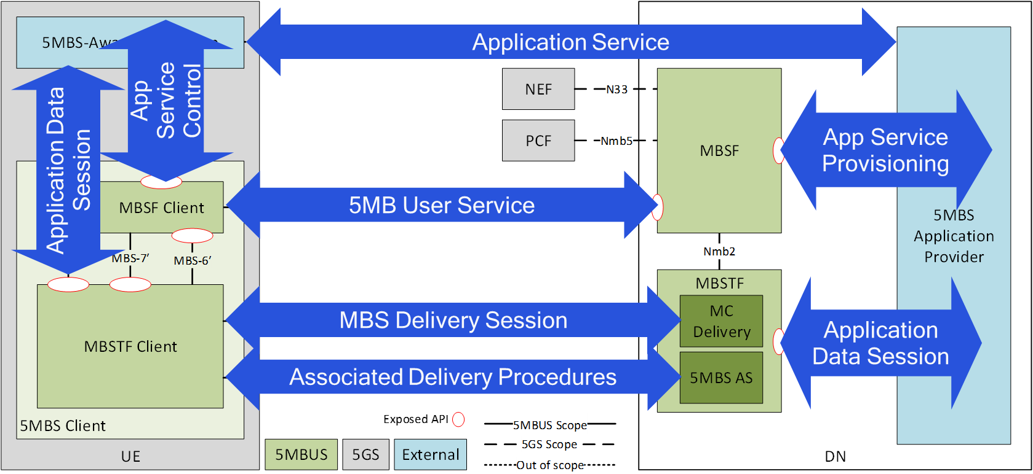

Initial session and service procedures are provided in Figure 6-1.



Figure 6-1 5MB User Service Workflow

# Some Conclusions from TR 26.802

Based on the discussions in this TR, the following re-use aspects are proposed.

1. The following “user service” functionalities (as defined in TS 26.346) with proper mapping to 5G MBS architecture (as to be defined in Rel-17, TS 23.247) are proposed to be reused and extended if needed. The combination with 5G Media Streaming is one deployment scenario.

a) Service Announcement and Discovery as defined in TS 26.346 based on userServiceDescription. Stage-3 aspects may be reconsidered, for example to align with 5GS design principles.

NOTE: the delivery of service announcement and discovery may be done using MBS delivery sessions or may be done independently from MBS.

b) Object delivery Method that includes:

- Download delivery method, File Delivery as defined in TS 26.346, clause 7.

- DASH/HLS over MBMS as defined in TS 26.346, clause 5.6 and 5.7, including Low-Latency CMAF as defined in 5GMS.

c) A common packet delivery method that includes the relevant delivery aspects of transparent delivery method, group communication delivery method and streaming delivery method as defined in TS 26.346, clause 8B, 8A and 8 respectively.

d) The relevant functions as now defined as Associated Delivery Procedures in TS 26.346, clause 9, and aligning with 5GMS.

2. Define the necessary extensions of relevant “MBMS Service Layer” functionalities to support 5GS and 5G MBS Sessions (as to be defined in Rel-17, TS 23.247). This pre-dominantly includes the definition or proper delivery method establishment.

3. Provide the relevant functions and protocols for northbound interfaces based on the xMB API defined in TS 26.348.

4. Define the separation of the User Plane and Control Plane Functionalities of “BM-SC” (now MBSF and MBSTF) and define the API between MBSF and MBSTF (named 'Nmb2').

5. Define the User Plane and Control Plane Functionalities/APIs of the 5MBS Client based on the MBMS Client functions as defined in TS 26.347 (Clause 6 is control, clause 7 is user-plane).

# Service Announcement

This clause deals with

1. Service Announcement and Discovery as defined in TS 26.346 based on userServiceDescription. Stage-3 aspects may be reconsidered, for example to align with 5GS design principles.

The MBMS user service description is provided in Figure 5 of TS 26.346.



This document proposes some modifications to the above, namely

1. The user service bundle is renamed to bouquet to address a collection of user services that can be announced jointly. The services may have some relation.
2. A user service may consist of multiple MBS delivery sessions (for example it may include a packet stream and two object streams)
3. The MBS Session description is used to map MBS delivery sessions to flows.
4. Flows are used to distribute data accordingly by mapping to the 5MBS delivery parameters
5. Based on this, there are four hierarchies
   1. Service Bundle
   2. 1 .. P User Service
   3. 1 .. M MBS Delivery Session (could be several over time in a service), but user service is only creating one session.
   4. 1 .. N Flows
6. Two types of reporting are introduced
   1. Session Reporting
   2. Service Reporting
7. The app service is simplified and the explicit DASH service is removed.

Based on this approach, the following data structure is proposed:

* User Service Bouquet Description
  + Bouquet Parameters
  + User Service 1 … N
    - User Service Parameters
    - MBS Delivery Sessions 1 … N (scheduled)
      * Delivery Session Parameters
        + Id
        + Type
        + Configuration
        + FEC parameters
      * Unicast Alternative
      * Session Reporting
    - MBS Session Description
      * Session Description parameters
      * Flows
        + MBS Delivery Session mapping
        + Flow Parameters
        + QoS Parameters
    - App Service
      * App Service Parameters
    - Schedule
    - Service Reporting
* Permit the distribution of Service Announcement through
  + Dedicated MBS User Service
  + Externally, e.g. through unicast
  + Do we want to support “inband” as well?

A profile that is “backward-compatible” to current MBMS may be defined.

From a stage-3 perspective, no decisions need to be taken yet. The concept of inband and fragments does not have to be solved yet. Preference is a modern approach based on service-based APIs.

# Object Delivery Method

This clause deals with

b) Object delivery Method that includes:

- Download delivery method, File Delivery as defined in TS 26.346, clause 7.

- DASH/HLS over MBMS as defined in TS 26.346, clause 5.6 and 5.7, including Low-Latency CMAF as defined in 5GMS.

For the object delivery method, it is proposed to differentiate two different cases.

1. Non-real time file delivery including Carouselling
   1. Using FLUTE as defined in TS 26.346
      1. Upgrade to the latest version of ALC, FLUTE and LCT? (stage 3 decision)
      2. Profile/remove any non-used functionalities based on MBMS Download Profile in TS 26.346, Annex L.4 (stage 3 decision)
2. Object Streaming addressing DASH/HLS with two options
   1. Using FLUTE as defined in TS 26.346 with the same as above
      1. Resolve and address object timing model (stage-3)
   2. Add ROUTE as option for real-time and low-latency streaming
      1. Use the profile defined DVB, with reference to IETF draft (stage-3)

It may be beneficial to create two distinct object delivery methods.

# Packet Delivery Method

This clause deals with

c) A common packet delivery method that includes the relevant delivery aspects of transparent delivery method, group communication delivery method and streaming delivery method as defined in TS 26.346, clause 8B, 8A and 8 respectively.

For the packet delivery method, it is proposed to only support the Transparent Delivery Method as defined in clause 8B, both the proxy and the forward-only mode. This includes RTP based delivery as a special case.

# Associated Delivery Procedures

This clause deals with

d) The relevant functions as now defined as Associated Delivery Procedures in TS 26.346, clause 9, and aligning with 5GMS.

For the associated delivery procedures as defined in clause 9 of TS 26.346, the following is proposed:

* Reuse file repair only with byte range, as defined in 9.3.6.2
* Implement a generic session reporting procedure based on clause 9.4 that may be further instantiated per delivery method
* Implement a very basic user service consumption reporting (needs to possibly be aligned with 5GMS consumption reporting)

# Northbound Interfaces

This clause deals with

3. Provide the relevant functions and protocols for northbound interfaces based on the xMB API defined in TS 26.348.

For the northbound interfaces the following is proposed:

* Re-use to the most extent the definitions in TS 26.348
* Modify TS 26.348 with the following functionalities
  + A user service may consist of multiple flows (for example it may include two object streams, each mapped to different flow)
  + Provide the ability to configure the low-latency DASH and object delivery streaming
  + Simplify to remove any unnecessary functionalities
  + take the concepts from xMB-C and to re-cast them as a more modern API design

# Nmb2

This clause deals with

4. Define the separation of the User Plane and Control Plane Functionalities of “BM-SC” (now MBSF and MBSTF) and define the API between MBSF and MBSTF (named 'Nmb2').

For Nmb2, it is proposed

* to reuse the findings in TR 26.802, Table 5.3.1.5-2, as the baseline
* identify the configuration parameters for each delivery method and use those to configure MBSTF. Note that it is expected that MBSF
  + “translates” generic service requirements in exact MBSTF delivery method parameters.
  + Generates the MBS Delivery Session information
  + Generates the MBS Session information
  + Provides this to the MBSTF for configuration of the delivery method
* Create a binding of Application Data session objects to MBS delivery sessions.

# Client APIs

This clause deals with

5. Define the User Plane and Control Plane Functionalities/APIs of the 5MBS Client based on the MBMS Client functions as defined in TS 26.347 (Clause 6 is control, clause 7 is user-plane).

For client APIs, it is proposed

* Reuse TS 26.347 as is but update the mapping description between user service parameters and APIs.
* Generalize the service APIs across different delivery methods
* Add low-latency streaming to the user plane APIs
* Create signaling and APIs that make the application as “unaware” as possible from specific 5MBS delivery.

# Proposal

It is proposed to agree on the principles on MBMS re-use as defined in clause 4-10.