3GPP TSG SA WG4 Meeting #114e S4-210931
19-28 May 2021, Online

CR-Form-v11.4
DRAFT CHANGE REQUEST
 | 26.114 | CR |  | Rev | - | Current version: | 17.0.0
For HELP on using this form: comprehensive instructions can be found at
http://www.3gpp.org/Change-Requests.

Proposed change affects: | UICC apps |  | ME | X | Radio Access Network |  | Core Network | X

Title:
  ITT4RT Draft CR 26.114 on Phase 2 Features
Source to WG: | Nokia Corporation, Tencent, Samsung Electronics Co., Ltd., Ericsson, Qualcomm
Source to TSG: | S4
Work item code: | ITT4RT |  |  |  |  |  | Date: |  |  | 2021-05-26
Category: | B |  |  |  |  |  | Release: |  |  | Rel-17
 | Use one of the following categories:  F (correction)  A (mirror corresponding to a change in an earlier release)  B (addition of feature),  C (functional modification of feature)  D (editorial modification)  Detailed explanations of the above categories can  be found in 3GPP TR 21.900. |  |  |  |  |  |  |  | Use one of the following releases:  Rel-8 (Release 8)  Rel-9 (Release 9)  Rel-10 (Release 10)  Rel-11 (Release 11)  Rel-12 (Release 12)  Rel-13 (Release 13)  Rel-14 (Release 14)  Rel-15 (Release 15)  Rel-16 (Release 16)
Reason for change:
Summary of change: |  | Changes as per  S4-210543, S4-210544, S4-210545, S4-210548, S4-210579, S4-210585, S4-210736, S4-210792, S4-210817, S4-210934.
585
Consequences if not approved:
Clauses affected:
 |  | Y | N
Other specs |  |  | X | Other core specifications |  |  |  | TS/TR ... CR ...
affected: |  |  | X | Test specifications |  |  |  | TS/TR ... CR ...
(show related CRs) |  |  | X | O&M Specifications |  |  |  | TS/TR ... CR ...
Other comments:

====== FIRST CHANGE ======

====== SECOND CHANGE ======

Y.6 Media configuration

Y.6.1 General
Based on the architecture described in clause Y.Y.2, an SDP framework for immersive video and immersive voice/audio exchange for ITT4RT is presented to negotiate codec support, SEI messages for decoder rendering metadata, as well as RTP/RTCP signaling necessary for viewport dependent processing.
The SDP attributes 3gpp_360video, 3gpp_fisheye, 3gpp_overlay, 3gpp_360bg shall be used to indicate respectively a 360-degree projected video stream, a 360-degree fisheye video stream, a spherical overlay, and a 360-degree background image (or series of images or video). ITT4RT-Tx clients that support both 360-degree projected video and 360-degree fisheye video may include both 3gpp_360video and 3gpp_fisheye attributes as alternatives in the SDP offer, but an ITT4RT-Rx client willing to receive 360-degree video shall include only one attribute (either 3gpp_360video or 3gpp_fisheye, based on support or selection) in the SDP answer. 3gpp_overlay and 3gpp_360bg attributes may be included in the SDP answer independent on whether projected or fisheye video is selected, since spherical overlays and 360-degree background images are applicable to both types of 360-degree video streams. The detailed definition and usage of these SDP attributes are presented in the clauses below.

Y.6.2 Main 360-degree video
Y.6.2.1 General
A new SDP attribute 3gpp_360video is defined with the following ABNF syntax:
3gpp_360video = "a=3gpp_360video:" [SP FOV] [SP FOV_CENTER] [SP "Stereo"] [VDP]

VDP = "VDP" [SP Projection] [SP PPM] SP viewport_ctrl SP viewport_size SP viewportfb_trigger

NOTE: If the SDP negotiations become too complex, defining profiles can be considered.
The semantics of the above attribute and parameters is provided below. Unsupported parameters of the 3gpp_360video attribute may be ignored.
An ITT4RT client supporting the 3gpp_360video attribute using viewport-independent processing or stereoscopic video for video shall support the following procedures:
- when sending an SDP offer, the ITT4RT client includes the 3gpp_360video attribute in the media description for video in the SDP offer,
- when sending an SDP answer, the ITT4RT client includes the 3gpp_360video attribute in the media description for video in the SDP answer if the 3gpp_360video attribute was received in an SDP offer,
- after successful negotiation of the 3gpp_360video attribute in the SDP, for the video streams based on the HEVC or AVC codec, the ITT4RT clients exchange an RTP-based video stream containing an HEVC or AVC bitstream with omnidirectional video specific SEI messages as defined in clause Y.3.

An ITT4RT client supporting the 3gpp_360video attribute supporting use of viewport-dependent processing (VDP) shall include the VDP parameter in the SDP offer and answer. Depending on the value indicated by the VDP parameter, the ITT4RT client shall further support the following procedures:
- the RTCP feedback (FB) message described in clause Y.7.2 of type ‘Viewport’ to carry requested viewport information during the RTP streaming of media (signalled from the ITT4RT-Rx client to the ITT4RT-Tx client).

An ITT4RT client shall not include VDP parameter in the SDP answer if the SDP offer contains the 3gpp_360video attribute without the VDP parameter.
[An ITT4RT-Rx client that supports viewport-locked VDP shall render the received 360-degree content such that its center is aligned to the center of the current viewport of the ITT4RT-Rx UE. This is in contrast to normal rendering of VDP content, in which it is necessary to map the delivered content to the global coordinates (real capture position) of the 360-degree video, i.e, the normal rendering is sphere-locked.
Viewport-locked VDP is suitable for devices with 2D screens. ITT4RT-Tx clients may fall back to viewport-locked mode if they detect a 2D ITT4RT-Rx UE. ITT4RT-Tx clients that deliver viewport-locked VDP should only encode and deliver the viewport region as the region beyond the viewport will not be rendered at the ITT4RT-Rx client. ]
Further details on VDP can be found in section Y.9.
Y.6.2.2 Projection
An ITT4RT- client supporting the 3gpp_360video attribute with VDP supporting projection may include the Projection parameter indicating the types of projection (e.g. ERP, CMP) it prefers (in the order of preference) in the SDP. An ITT4RT client may respond to an SDP offer with multiple options indicated in the Projection parameter with the agreed option. An ITT4RT-Tx client is not required to provide the preferred form of projection indicated by an ITT4RT-Rx client but may do so when possible.
The ABNF syntax is defined as follows:
Projection = “projection=ERP” / “projection=CMP”
Y.6.2.3 Field Of View (FOV)
An ITT4RT-Tx client may support sending a limited 360-degree video.
  - An ITT4RT-Tx client supporting the 3gpp_360video attribute capable of sending a limited 360-degree video shall include the parameter FOV in its SDP offer to indicate the cfov (Capture FoV) as the extent (range) of the 360-degree video with respect to the unit sphere. The range is expressed in units of 2^{–16} degrees with an x parameter for azimuth range and a y parameter for elevation range, sent as a comma-seperated tuple. The values for azimuth range shall be in the range of 0 to 360 * 2¹⁶ (i.e., 23 592 960), inclusive, and the values for elevation range shall be in the range of 0 to 180 * 2¹⁶ (i.e., 11 796 480), inclusive. In the absence of cfov, the default value of x and y are 360 and 180 degrees, respectively.
  - An ITT4RT-Rx client supporting the 3gpp_360video attribute capable that wants to receive a limited 360-degree video shall include the parameter FOV in its SDP offer/answer to indicate the pfov (Preferred FoV), where pfov <= cfov in one or both the x and y dimensions when cfov is known. The pfov range is expressed in units of 2^{–16} degrees with an x parameter for azimuth range and a y parameter for elevation range, sent as a comma-seperated tuple. The values for azimuth range shall be in the range of 0 to 360 * 2¹⁶ (i.e., 23 592 960), inclusive, and the values for elevation range shall be in the range of 0 to 180 * 2¹⁶ (i.e., 11 796 480), inclusive. In the absence of pfov, the default value of x and y are 360 and 180 degrees, respectively.
  - An ITT4RT-Tx client that has received an SDP offer from an ITT4RT-Rx client with the parameter FOV shall include in its SDP answer the parameter FOV to indicate the range of the 360-degree video it will provide. The value is the same as the FOV in the SDP offer or different based on the ITT4RT-Tx client capabilities.
An ITT4RT client supporting the 3gpp_360video attribute with the FOV parameter may include the paramater FOV_CENTER in the SDP. FOV_CENTER is expressed as a comma-separated tuple (x,y), where x is the azimuth (in units of 2^{–16} degrees) and y is the elevation (in units of 2^{–16} degrees) with respect to the global coordinates such that the range defined FOV bypasses through the coordinates defined by FOV_CENTER. The values for azimuth shall be in the range of −180 * 2¹⁶ (i.e., −11 796 480) to 180 * 2¹⁶ − 1 (i.e., 11 796 479), inclusive, and the values for elevation shall be in the range of −90 * 2¹⁶ (i.e., −5 898 240) to 90 * 2¹⁶ (i.e., 5 898 240), inclusive. The imageattr attribute indicates the resolution of the delivered content based on the cfov and pfov options.
The ABNF syntax is defined as follows
FOV = "fov=" 1*(fovset)
fovset = "[x=" azimuthrange ",y=" elevationrange "]"

azimuthrange = "0"
/ POS-DIGIT *6DIGIT
/ "1" 7DIGIT
/ "2" ("0"/"1"/"2") 6DIGIT
/ "23" ("0"/"1"/"2"/"3"/"4") 5DIGIT
/ "235" ("0"/"1"/"2"/"3"/"4"/"5"/"6"/"7"/"8") 4DIGIT
/ "2359" ("0"/"1") 3DIGIT
/ "23592" ("0"/"1"/"2"/"3"/"4"/"5"/"6"/"7"/"8") 2DIGIT
/ "235929" ("0"/"1"/"2"/"3"/"4"/"5") DIGIT
/ "23592960"
; 0 to 23 592 960, inclusive
elevationrange = "0"
/ POS-DIGIT *6DIGIT
/ "10" 6DIGIT
/ "11" ("0"/"1"/"2"/"3"/"4"/"5"/"6") 5DIGIT
/ "117" ("0"/"1"/"2"/"3"/"4"/"5"/"6"/"7"/"8") 4DIGIT
/ "1179" ("0"/"1"/"2"/"3"/"4"/"5") 3DIGIT
/ "11796" ("0"/"1"/"2"/"3") 2DIGIT
/ "117964" ("0"/"1"/"2"/"3"/"4"/"5"/"6"/"7") 1DIGIT
/ "11796480"
; 0 to 11 796 480, inclusive
FOV_CENTER = "fov_center=[x=" centerazimuth ",y=" centerelevation "]"
centerazimuth = "0"
/ ["-"] POS-DIGIT *6DIGIT
/ ["-"] "10" 6DIGIT
/ ["-"] "11" ("0"/"1"/"2"/"3"/"4"/"5"/"6") 5DIGIT
/ ["-"] "117" ("0"/"1"/"2"/"3"/"4"/"5"/"6"/"7"/"8") 4DIGIT
/ ["-"] "1179" ("0"/"1"/"2"/"3"/"4"/"5") 3DIGIT
/ ["-"] "11796" ("0"/"1"/"2"/"3") 2DIGIT
/ ["-"] "117964" ("0"/"1"/"2"/"3"/"4"/"5"/"6"/"7") 1DIGIT
/ "-11796480"
; -11 796 480 to 11 796 479, inclusive
centerelevation = "0"
/ ["-"] POS-DIGIT *5DIGIT
/ ["-"] ("1"/"2"/"3"/"4") 6DIGIT
/ ["-"] "5" ("0"/"1"/"2"/"3"/"4"/"5"/"6"/"7") 5DIGIT
/ ["-"] "58" ("0"/"1"/"2"/"3"/"4"/"5"/"6"/"7"/"8") 4DIGIT
/ ["-"] "589" ("0"/"1"/"2"/"3"/"4"/"5"/"6"/"7") 3DIGIT
/ ["-"] "5898" ("0"/"1") 2DIGIT
/ ["-"] "58982" ("0"/"1"/"2"/"3") DIGIT
/ ["-"] "5898240"
; -5 898 240 to 5 898 240, inclusive
POS-DIGIT = %x31-39 ; 1-9

Y.6.2.4 Picture Packing
An ITT4RT-Tx client may support sending the 360-degree video using tiled encoding, e.g., HEVC motion-constrained tiling. An ITT4RT-Tx client using the tiled encoding and supporting the 3gpp_360video attribute shall include in its SDP offer the parameter PPM such that:
- A PPM value of 1 indicates mixed-quality tiled encoding is used
- A PPM value of 2 indicates mixed-resolution tiled encoding is used
Tiled encoding may be used to deliver the full 360-degree video or a high-quality video which includes the viewport and may include viewport margins.
An ITT4RT-Tx client sending low-quality background 360-degree video frame-packed with a high-quality viewport (possibly with margins) such that the two regions have overlapping content shall include in its SDP offer the parameter PPM.In this case the PPM is an ordered comma-seperated list of the following six fields:
- PPWHQ defines packed_picture_width of the high-quality region in pixels
- PPHHQ defines packed_picture_height of the high-quality region in pixels
- TRHQ defines transform operations applied on the high-quality region.
- PPWLQ defines packed_picture_width of the low-quality region in pixels
- PPHLQ defines packed_picture_height of the low-quality region in pixels
- TRLQ defines transform operations applied on the low-quality region
The transform operations have a value of 0-7 where the values correspond to the following operations:
Transform value | Transform operation
0 | no transorm
1 | mirrored horizontally
2 | rotation by 180 degrees (counter-clockwise)
3 | rotation by 180 degrees (counter-clockwise) before mirroring horizontally
4 | rotation by 90 degrees (counter-clockwise) before mirroring horizontally
5 | rotation by 90 degrees (counter-clockwise)
6 | rotation by 270 degrees (counter-clockwise) before mirroring horizontally
7 | rotation by 270 degrees (counter-clockwise)

An ITT4RT-Rx client shall render the high-quality viewport region where these two regions are overlapping. The PPM parameter for defining the HQ and LQ regions should be used when the information remains constant during the session. When the packed regions are not overlapping, the high-quality and low-quality regions do not need to be explicitly defined and SEI messages for region-wise packing may be used instead of the SDP PPM parameter.

The ABNF syntax is defined as follows:
PPM = "ppm=" "1" / "2" / "["PPWHQ","PPHHQ","TRHQ","PPWLQ","PPHLQ","TRLQ"]"

Note: The size of the viewport and fov attributes define the size of projected regions. It should be considered if the two values should be included explicitly here
Y.6.2.5 Viewport Control
An ITT4RT client that supports the 3gpp_360video with VDP shall in its SDP offer include the parameter viewport_ctrl with one or more of the following control options:
- device_controlled if ITT4RT-Tx client will provide VDP based on the requested viewport indicated by the RTCP feedback (FB) message type ‘Viewport’ sent by the corresponding ITT4RT-Rx client.
- recommended_viewport if ITT4RT-Tx client will provide VDP with the help of a recommendation/prediction engine.
- presenter_viewport if ITT4RT_Tx will provide VDP based on the viewport of an ITT4RT-Rx client other than the one the SDP offer is being sent to.
Multiple options are provided as a comma-separated list. An ITT4RT client that receives an SDP offer with multiple viewport_ctrl options may include its preferred viewport_ctrl option in the SDP answer. If no options are given in the answer, the sender shall use the first option in the list. If the recommended_viewport is successfully negotiated as viewport_ctrl, the ITT4RT-Rx client should not use viewport prediction when sending the RTCP feedback (FB) message type ‘Viewport’ to avoid any conflicts with the prediction engine of the ITT4RT-Tx client. The ABNF syntax is defined as follows:
viewport_ctrl = "viewport_ctrl=" ("device_controlled"/"recommended_viewport"/"presenter_viewport") *2[(", device_controlled" / ", recommended_viewport" / ", presenter_viewport")]
Y.6.2.6 Overlay and 360-degree video
An ITT4RT client that sends an SDP message with at least one 360-degree video/audio and at least one overlay shall include in SDP the attribute itt4rt_group before any media lines. The itt4rt_group attribute is used to group 360-degree media and overlay media using the mid attribute as defined according to the ABNF below:
a = itt4rt_group: <mid1> SP <mid2> SP <mid3> …
The list of mids in the itt4rt_group shall include at least one mid associated with 360-degree media and at least one mid associated with an overlay as defined by the mid attribute in the corresponding media description.
An ITT4RT-Tx client and an ITT4RT-Rx client may negotiate the overlays that can be associated with the 360-degree video offered by the ITT4RT-Tx client using the itt4rt_group attribute. An ITT4RT client shall indicate in an offer the overlays to be grouped with the 360-degree video using the itt4rt_group attribute. The overlays that are acceptable shall be retained in the answer and the ones that are not acceptable shall be removed. An ITT4RT-Tx client may offer overlay configuration options using the 3gpp_overlay attribute based on the list of media lines (i.e., potential overlay sources) provided in the itt4rt_group attribute in an SDP offer initiated by an ITT4RT-Rx client. The 3gpp_overlay attribute is offered in an SDP renegotiation.
The order of the media included in the itt4rt_group indicates the synchronization source with the first media always being the synchronization anchor when synchronization is required.
NOTE: 2D video received from an ITT4RT-Rx clients may be offered as an overlay by the ITT4RT MRF to other ITT4RT-Rx clients. The ITT4RT MRF (acting as the ITT4RT-Tx client) would be the source of overlay media in this case.
Y.6.2.7 Viewport Size
An ITT4RT client that includes the 3gpp_360video with the VDP parameter shall also include in SDP the parameter viewport_size to indicate the size of the device viewport using the azimuth and elevation ranges expressed in degrees. An ITT4RT-Tx client may include the viewport_size of the ITT4RT-Rx client when this is known (e.g., in response to an SDP offer from an ITT4RT-Rx client) or include "viewport=0x0" and the value can be ignored by the ITT4RT-Rx client.
The ABNF syntax is given below:
viewport_size = "viewport=" azimuthrange"x"elevationrange
where azimuthrange is a non-fractional value with the range 0-180 inclusive, and the elevationrange is a non-fractional value with the range 0-360 inclusive expressed. For example, "viewport=110x90".
Note that the viewport size defines the size of the viewport of the ITT4RT-Rx client UE. An ITT4RT-Tx client provides VDP based on this viewport size. The capture and preferred FOV, on the other hand, defines the range of the 360-degree content, which should be larger than the viewport size and can be negotiated even for viewport-independent processing.
Y.6.2.8 Viewport-only VDP and Image attributes
An ITT4RT-Tx client supporting VDP may deliver only the viewport or viewport with viewport margins and not the full captured/preferred field-of-view of the 360-degree video. If the viewport region (with or without a viewport margin) is extracted from a projected picture (e.g., ERP), the resolution would change depending on where the viewport is located on the picture. To avoid this, the ITT4RT-Tx client may rotate the desired viewport region to the centre of the ERP before cropping it to the desired size as indicated by imageattr. The delivered bitstream shall contain the rotation SEI if the ITT4RT-Rx client is expected to do sphere-locked rendering by reversing the rotation of the received image before rendering.
Y.6.2.9 Viewport Feedback Trigger
An ITT4RT client include the parameter viewportfb_trigger in the 3gpp_360video attribute to define the minimum view port change to initiate an early or event-based RTCP feedback, with the following syntax
viewportfb_trigger = "<"D | D_azimuth, D_elevation">"
where D_azimuth, D_elevation are the minimum number of degrees that the viewport may change in the horizontal or vertical direction, respectively. The value D is the minimum spherical distance in degrees between the center of the old and the new viewport. The viewport feedback trigger value is estimated by the ITT4RT-Tx client based on the viewport margin configuration it intends to use. Further details on RTCP viewport feedback can be found in Y.9.

====== SECOND CHANGE ======
Y.6.4.3.3 Viewport-relative Overlay Configuration
An ITT4RT client supporting the 3gpp_overlay attribute to configure a viewport-relative overlay shall set parameter type = ‘0’ and additionally include the parameter viewport_relative_overlay_config defined as follows:
viewport_relative_overlay_config = Overlay_rect_left_percent "," Overlay_rect_top_percent "," Overlay_rect_width_percent "," Overlay_rect_height_percent "," Relative_disparity_flag "," (Disparity_in_percent / Disparity_in_pixels),” media_alignment”, ”layering_order”,”opacity”,”overlay_priority”
• Overlay_rect_left_percent: Specifies the x-coordinate of the left corner of the rectangular region of the overlay to be rendered on the viewport in per cents relative to the width of the viewport. The values are indicated in units of 2⁻¹⁶ in the range of 0 (indicating 0%), inclusive, up to but excluding 65536 (that indicates 100%).
• Overlay_rect_top_percent: Specifies the y-coordinate of the top corner of the rectangular region of the overlay to be rendered on the viewport in per cents relative to the height of the viewport. The values are indicated in units of 2⁻¹⁶ in the range of 0 (indicating 0%), inclusive, up to but excluding 65536 (that indicates 100%).
• Overlay_rect_width_percent: Specifies the width of the rectangular region of the overlay to be rendered on the viewport in per cents relative to the width of the viewport. The values are indicated in units of 2⁻¹⁶ in the range of 0 (indicating 0%), inclusive, up to but excluding 65536 (that indicates 100%).
• Overlay_rect_height_percent: Specifies the height of the rectangular region of the overlay to be rendered on the viewport in per cents relative to the height of the viewport. The values are indicated in units of 2⁻¹⁶ in the range of 0 (indicating 0%), inclusive, up to but excluding 65536 (that indicates 100%).
NOTE: The size of overlay region over the viewport changes according to the viewport resolution and aspect ratio. However, the aspect ratio of the overlaid media is not intended to be changed.
• Relative_disparity_flag indicates whether the disparity is provided as a percentage value of the width of the display window for one view (when the value is equal to 1) or as a number of pixels (when the value is equal to 0). This applies for the case when there is a monoscopic overlay.
• Disparity_in_percent: Specifies the disparity, in units of 2⁻¹⁶, as a fraction of the width of the display window for one view. The value may be negative, in which case the displacement direction is reversed. This value is used to displace the region to the left on the left eye view and to the right on the right eye view. This applies for the case when there is a monoscopic overlay and stereoscopic background visual media.
• Disparity_in_pixels indicates the disparity in pixels. The value may be negative, in which case the displacement direction is reversed. This value is used to displace the region to the left on the left eye view and to the right on the right eye view. This applies for the case when there is a monoscopic overlay and stereoscopic background visual media.
- Media_alignment: Specifies the default intended scaling of the overlay source depending on the dimensions of the specified rectangular region and the intended placement of the scaled overlay source relative to the specified rectangular region.
- Layering_order: Indicates the default layering order among the overlays that are relative to the viewport, and separately among each set of overlays that have the same depth. Viewport-relative overlays are overlaid on top of the viewport in descending order of layering_order, i.e., an overlay with a smaller layering_order value shall be in front of an overlay with a greater layering_order value. The layering order for overlays of the 360-degree video should be decided by the ITT4RT-Tx client.
- Opacity: Indicates an integer value that specifies the default opacity that is to be applied for the overlay and assigned by the ITT4RT-Tx client. Value 0 is fully transparent, and value 100 is fully opaque with a linear weighting between the two extremes. Values greater than 100 are reserved.
- Overlay_priority: Indicates which overlay should be prioritized in the case the ITT4RT-Rx client does not have enough decoding capacity to decode all overlays. A lower overlay_priority indicates higher priority. The value of overlay_priority, when present, shall be equal to 0 for overlays that are essential for displaying. More than one overlay may have the same overlay_priority and an ITT4RT-Rx client that does not support all overlays with the same priority may choose any subset of these.
NOTE 1: Other overlay definitions in OMAF are not excluded from ITT4RT. Which overlay definition(s) from OMAF are adopted for overlays in ITT4RT is currently TBD.
NOTE 2: For both of the above overlay types from OMAF, incorporate from the spec further details about the order of operations for overlay rendering (in particular order of translation and rotation).

Y.6.4.3.4 Overlay info parameter
The parameter overlay_info is a bit field consisting of flags describing the type of overlay interactivity recommended:
overlay_info= ‘overlay_info=’b4b3b2b1b0
- b0 = ‘0’: changing the position of the overlay is not recommended, overlay position is fixed
b0 = ‘1’: changing the position of the overlay is allowed, ITT4RT-Rx client may change position
- b1 = ‘0’: switching the overlay on/off is not recommended
b1 = ‘1’: switching the overlay on/off is allowed, ITT4RT-Rx client may switch overlay off
- b2 = ‘0’: rotating the overlay is not recommended
b2 = ‘1’: rotating the overlay is allowed
- b3 = ‘0’: resizing the overlay is not recommended
b3 = ‘1’: resizing the overlay is allowed
- b4 = ‘0’: changing the opacity of the overlay is not recommended
b4 = ‘1’: changing the opacity of the overlay is allowed.

Y.6.4.3.5 Additional Overlay Configuration
An ITT4RT client supporting the 3gpp_overlay attribute to configure a sphere-relative overlay or viewport-relative overlay may include the following additional parameter for overlay support:
- overlay_overlap_flag: Indicates if the ITT4RT-Rx client is allowed to overlap overlays from the ITT4RT-Tx client. If set to 1, the ITT4RT-Rx client may overlap overlays shared by the ITT4RT-Tx client.

====== THIRD CHANGE ======

Y.6.5.2 360-degree fisheye video SDP attribute parameters
Media-line level parameters are defined in order to aid session establishment between the ITT4RT-Tx and ITT4RT-Rx clients for 360-degree fisheye video, as well as to describe the fisheye video stream as identified by the 3gpp_fisheye attribute.
The syntax for the SDP attribute is:
a=3gpp_fisheye: <fisheye> <fisheye-img> <maxpack>

• Total number of fisheye circular videos at the capturing terminal
Depending on the camera configuration of the sending terminal, the 360-degree fisheye video may be comprised of multiple different fisheye circular videos, each captured through a different fisheye lens.
- <fisheye>: this parameter inside an SDP offer sent by an ITT4RT-Tx client indicates the total number of fisheye circular videos output by the camera configuration at the terminal.
• Fisheye circular video static parameters
In order to enable the quick selection of desired fisheye circular videos by the ITT4RT-Rx client during SDP negotiation, the following static parameters are defined for each fisheye circular video. These parameters are defined from the video bitstream fisheye video information SEI message as defined in ISO/IEC 23008-2 [119] and ISO/IEC 23090-2 [179].
- <fisheye-img> = <fisheye-img-1> … <fisheye-img-N>
- <fisheye-img-X> = [<id-X> <azi> <ele> <til> <fov>] for 1 ≤ X ≤ N where:
o <id>: an identifier for the fisheye video
o <azi>, <ele>: azimuth and elevation indicating the spherical coordinates that correspond to the centre of the circular region that contains the fisheye video, in units of 2⁻¹⁶ degrees. The values for azimuth shall be in the range of −180 * 2¹⁶ (i.e., −11 796 480) to 180 * 2¹⁶ − 1 (i.e., 11 796 479), inclusive, and the values for elevation shall be in the range of −90 * 2¹⁶ (i.e., −5 898 240) to 90 * 2¹⁶ (i.e., 5 898 240), inclusive
o <til>: tilt indicating the tilt angle of the sphere regions that corresponds to the fisheye video, in units of 2⁻¹⁶ degrees. The values for tilt shall be in the range of −180 * 2¹⁶ (i.e., −11 796 480) to 180 * 2¹⁶ − 1 (i.e., 11 796 479), inclusive
o <fov>: specifies the field of view of the lens that corresponds to the fisheye video in the coded picture, in units of 2⁻¹⁶ degrees. The field of view shall be in the range of 0 to 360 * 2¹⁶ (i.e., 23 592 960), inclusive
• Stream packing of fisheye circular videos
Depending on the terminal device capabilities and bandwidth availability, the packing of fisheye circular videos within the stream can be negotiated between the sending and receiving terminals.
- <maxpack>: this parameter inside an SDP offer indicates the maximum supported number of fisheye videos which can be packed into the video stream by the ITT4RT-Tx client. The value of this parameter inside an SDP answer indicates the number of fisheye videos to be packed, as selected by the ITT4RT-Rx client.

The ABNF syntax for this attribute is the following:
fisheye-attrib = “a=3gpp_fisheye:” SP maxpack [SP fisheye] SP fisheye-img SP maxpack

maxpack = integer

fisheye = integer

fisheye-img = 1*fisheye-img-X
fisheye-img-X = "[" "id=" idvalue "," "azi=" azivalue "," "ele=" elevalue "," "til=" tilvalue "," "fov=" fovvalue "]"

idvalue = byte-string ; byte-string defined by RFC 4566

azivalue = "0"
/ ["-"] POS-DIGIT *6DIGIT
/ ["-"] "10" 6DIGIT
/ ["-"] "11" ("0"/"1"/"2"/"3"/"4"/"5"/"6") 5DIGIT
/ ["-"] "117" ("0"/"1"/"2"/"3"/"4"/"5"/"6"/"7"/"8") 4DIGIT
/ ["-"] "1179" ("0"/"1"/"2"/"3"/"4"/"5") 3DIGIT
/ ["-"] "11796" ("0"/"1"/"2"/"3") 2DIGIT
/ ["-"] "117964" ("0"/"1"/"2"/"3"/"4"/"5"/"6"/"7") 1DIGIT
/ "-11796480"
; -11 796 480 to 11 796 479, inclusive

[“-”]POS-DIGIT *7DIGIT / “0”
elevalue = "0"
/ ["-"] POS-DIGIT *5DIGIT
/ ["-"] ("1"/"2"/"3"/"4") 6DIGIT
/ ["-"] "5" ("0"/"1"/"2"/"3"/"4"/"5"/"6"/"7") 5DIGIT
/ ["-"] "58" ("0"/"1"/"2"/"3"/"4"/"5"/"6"/"7"/"8") 4DIGIT
/ ["-"] "589" ("0"/"1"/"2"/"3"/"4"/"5"/"6"/"7") 3DIGIT
/ ["-"] "5898" ("0"/"1") 2DIGIT
/ ["-"] "58982" ("0"/"1"/"2"/"3") DIGIT
/ ["-"] "5898240"
; -5 898 240 to 5 898 240, inclusive

[“-”]POS-DIGIT *6DIGIT / “0”
tilvalue = azivalue
; -11 796 480 to 11 796 479, inclusive

[“-”]POS-DIGIT *7DIGIT / “0”
fovvalue = "0"
/ POS-DIGIT *6DIGIT
/ "1" 7DIGIT
/ "2" ("0"/"1"/"2") 6DIGIT
/ "23" ("0"/"1"/"2"/"3"/"4") 5DIGIT
/ "235" ("0"/"1"/"2"/"3"/"4"/"5"/"6"/"7"/"8") 4DIGIT
/ "2359" ("0"/"1") 3DIGIT
/ "23592" ("0"/"1"/"2"/"3"/"4"/"5"/"6"/"7"/"8") 2DIGIT
/ "235929" ("0"/"1"/"2"/"3"/"4"/"5") DIGIT
/ "23592960"
; 0 to 23 592 960, inclusive
POS-DIGIT *7DIGIT / “0”

maxpack = integer

POS-DIGIT = %x31-39 ; 1-9
integer = POS-DIGIT *DIGIT

An example SDP offer is shown in table Y.A.
Table Y.A: Example SDP offer with 360-degree fisheye video attribute parameters
SDP offer
m=video 49154 RTP/AVP 99
a=tcap:1 RTP/AVPF
a=pcfg:1 t=1
b=AS:10000
b=RS:0
b=RR:2500
a=rtpmap:99 H265/90000
a=fmtp:99 profile-id=1; level-id=93;
a=imageattr:99 send [x=1920,y=1080] [x=1280,y=720]
a=3gpp_fisheye:99 maxpack=2 fisheye=4 2 [id=1,azi=0,ele=0,til=0,fov=11796480id=1 azi ele til fov] [id=2,azi=11796479,ele=0,til=0,fov=11796480id=2 azi ele til fov] 2
a=sendonly

As an example, a receiving terminal which only receives 360-degree fisheye video (and possibly sends a 2D video to the sender) replies with an SDP answer containing only the selected fisheye videos equal to the number as selected by the value of maxpack in the corresponding m-line, which is set to recvonly.

====== FOURTH CHANGE ======

Y.6.7 Support for Stream Pausing/Resuming
An ITT4RT-Tx client shall use the a=rtcp-fb ccm pause attribute and parameter values as specified in [43] and [156] to indicate the capability to support receiving and acting on PAUSE and RESUME requests targeted for RTP streams it sends. The optional parameter setting of a=rtcp-fb ccm pause config=3 could be used by the ITT4RT-Tx client to indicate that it will only receive and react to PAUSE and RESUME requests but will not send them.
An ITRT4RT-Rx client shall use the a=rtcp-fb ccm pause attribute and parameter values as specified in [43] and [156] to indicate the capability to support sending PAUSE and RESUME requests targeted for RTP streams it receives. The optional parameter setting of a=rtcp-fb ccm pause config=2 could be used by the ITT4RT-Rx client to indicate that it will only send PAUSE and RESUME requests but does not support receiving these requests.

Y.6.8 Multiple 360-degree videos
An ITT4RT conference may contain multiple 360-degree videos which originate from multiple conference rooms at the conference location, or from remote participants. When multiple 360-degree videos are present in an ITT4RT conference, an ITT4RT MRF shall negotiate an SDP session with every remote participant.
In the SDP offer from the ITT4RT MRF, 360-degree video is identified by either the a=3gpp_360video or a=3gpp_fisheye media line attributes. When multiple 360-degree videos are present in the SDP offer, the ITT4RT MRF shall include the a=content attribute under the media lines for 2D or 360-degree video originating from the conference location. For media streams originating from the main default conference room, the content attribute is set to a=content:main. For media streams originating from other conference rooms, the content attribute is set to a=content:alt. 2D and 360-degree video from remote participants shall not include the a=content attribute under their corresponding media lines.
When there are multiple 360-degree videos from multiple sources available to the ITT4RT MRF, the ITT4RT MRF may include the itt4rt_group attribute to define one or more restricting groups, each group containing at least one mid associated with a 360-degree video media line, and at least one mid associated with an overlay.
The ABNF syntax is:
a = itt4rt_group: <mid1> SP <mid2> SP… <midn> [SP “/” <midn+1> SP <midn+2> SP… <midm>] [SP “/” …]
On receipt of an SDP offer containing multiple 360-degree videos from the ITT4RT MRF, an ITT4RT-Rx client shall select to receive only one 360-degree video media together with possible 2D video media from other sources, rejecting the other 360-degree video media.

An example SDP offer for multiple 360-degree video is shown in table X.A.
Table X.A: Example SDP offer with multiple 360-degree video
SDP offer
/*1st conference room @ conference location*/
m=video 49144 RTP/AVP 98 100
a=tcap:1 RTP/AVPF
a=pcfg:1 t=1
b=AS:950
b=RS:0
b=RR:5000
a=content:main /*indicates this m-line is from the main source from the conference location*/
a=rtpmap:98 H265/90000 /*360 video*/
a=3gpp_360video:98…
a=rtpmap:100 H265/90000 /*2D video*/

/*2nd conference room @ conference location*/
m=video 49154 RTP/AVP 102 104
a=tcap:1 RTP/AVPF
a=pcfg:1 t=1
b=AS:950
b=RS:0
b=RR:5000
a=content:alt /*indicates this m-line is from an alt source from the conference location*/
a=rtpmap:102 H265/90000 /*360 video*/
a=3gpp_360video:102…
a=rtpmap:104 H265/90000 /*2D video*/

/*Capture of a remote participant*/
m=video 49164 RTP/AVP 106 108
a=tcap:1 RTP/AVPF
a=pcfg:1 t=1
b=AS:950
b=RS:0
b=RR:5000
a=rtpmap:106 H265/90000 /*2D video*/
a=rtpmap:108 H265/90000 /*360 video*/
a=3gpp_360video:108…

An example SDP offer for multiple 360-degree video with group restrictions is shown in table X.B.
Table X.A: Example SDP offer with multiple 360-degree video containing group restrictions
SDP offer
a=itt4rt_group: D G H / E F H / H G I /*create multiple groups at MRF, each group between a different 360 video from a certain source, and 2D videos from other sources/

/*360 video of 1st conference room @ conference location*/
m=video 49144 RTP/AVP 98
a=tcap:1 RTP/AVPF
a=pcfg:1 t=1
b=AS:950
b=RS:0
b=RR:5000
a=content:main /*indicates this m-line is from the main source from the conference location*/
a=rtpmap:98 H265/90000 /*360 video*/
a=3gpp_360video:98…
a=mid=D

/*2D video of 1st conference room @ conference location*/
m=video 49154 RTP/AVP 100
a=tcap:1 RTP/AVPF
a=pcfg:1 t=1
b=AS:950
b=RS:0
b=RR:5000
a=content:main /*indicates this m-line is from the main source from the conference location*/
a=rtpmap:100 H265/90000 /*2D video*/
a=3gpp_overlay:100… /*optional attribute*/
a=mid=E

/*360 video of 2nd conference room @ conference location*/
m=video 49164 RTP/AVP 102
a=tcap:1 RTP/AVPF
a=pcfg:1 t=1
b=AS:950
b=RS:0
b=RR:5000
a=content:alt /*indicates this m-line is from an alt source from the conference location*/
a=rtpmap: 102 H265/90000 /*360 video*/
a=3gpp_360video:98…
a=mid=F

/*2D video of 2nd conference room @ conference location*/
m=video 49174 RTP/AVP 104
a=tcap:1 RTP/AVPF
a=pcfg:1 t=1
b=AS:950
b=RS:0
b=RR:5000
a=content:alt /*indicates this m-line is from an alt source from the conference location*/
a=rtpmap:100 H265/90000 /*2D video*/
a=3gpp_overlay:104… /*optional attribute*/
a=mid=G

/*2D video capture of a remote participant*/
m=video 49164 RTP/AVP 106
a=tcap:1 RTP/AVPF
a=pcfg:1 t=1
b=AS:950
b=RS:0
b=RR:5000
a=rtpmap:106 H265/90000 /*2D video*/
a=3gpp_overlay:100… /*optional attribute*/
a=mid=H

/*3D capture of a remote participant*/
m=video 49164 RTP/AVP 108
a=tcap:1 RTP/AVPF
a=pcfg:1 t=1
b=AS:950
b=RS:0
b=RR:5000
a=rtpmap:108 H265/90000 /*360 video*/
a=3gpp_360video:108…
a=mid=I

Editor’s Note: A section on viewport margins containing signalling related aspects of margins may be added here after agreement is reached on which, if any, parameters related to the use of margins need to be signaled. It should be considered if we need to add normative text to define margins.

Y.7 Media transport

Y.7.1 RTP
RTP signaling impacts are FFS.

Y.7.2 RTCP
When viewport-dependent processing (VDP) of 360-degree video is successfully negotiated between the ITT4RT-Tx client and ITT4RT-Rx client as per the SDP-based procedures described in clause Y.6.2, the RTCP feedback (FB) message type ‘Viewport’ shall carry requested viewport information during the RTP transmission of media signalled from the ITT4RT-Rx client to the ITT4RT-Tx client.
The signalling of ‘Viewport’ requests shall use RTCP feedback messages as specified in IETF 4585. The RTCP feedback message is identified by PT (payload type) = PSFB (206) which refers to payload-specific feedback message. FMT (feedback message type) shall be set to the value ‘X’ for Viewport feedback messages. The IANA registration information for the FMT value for ‘Viewport’ is provided in Annex R.1 of TS 26.114. The RTCP feedback method may involve signalling of viewport information in both of the immediate feedback and early RTCP modes.
The FCI (feedback control information) format for Viewport shall be as follows. The FCI shall contain exactly one viewport. The signalled desired viewport information in the RTCP feedback message for ‘Viewport’ is composed of the following parameters (as defined as shape type value equal to 0 in clause 7.5.6 of ISO/IEC 23090-2 [179]):):
• Viewport_azimuth: Specifies the azimuth of the centre point of the sphere region corresponding to the requested viewport in units of 2⁻¹⁶ degrees relative to the global coordinate axes expressed in signed 32-bit integer format, in the range of −180 * 2¹⁶ to 180 * 2¹⁶ − 1, inclusive.
• Viewport_elevation: Specifies the elevation of the centre point of the sphere region corresponding to the requested viewport in units of 2⁻¹⁶ degrees relative to the global coordinate axes expressed in signed 32-bit integer format, in the range of −90 * 2¹⁶ to 90 * 2¹⁶, inclusive.
• Viewport_tilt: Specifies the tilt angle of the sphere region corresponding to the requested viewport, in units of 2⁻¹⁶ degrees, relative to the global coordinate axes expressed in signed 32-bit integer format, in the range of −180 * 2¹⁶ to 180 * 2¹⁶ − 1, inclusive.
• Viewport_azimuth_range: Specifies the azimuth range of the sphere region corresponding to the requested viewport through the centre point of the sphere region in units of 2⁻¹⁶ degrees expressed in unsigned 32-bit integer format, in the range of 0 to 180 * 2¹⁶, inclusive.
• Viewport_elevation_range: Specifies the elevation range of the sphere region corresponding to the requested viewport through the centre point of the sphere region in units of 2⁻¹⁶ degrees expressed in unsigned 32-bit integer format, in the range of 0 to 180 * 2¹⁶, inclusive.
The RTCP feedback message for ‘Viewport’ shall contain all of the parameters Viewport_azimuth, Viewport_elevation, Viewport_tilt, Viewport_azimuth_range and Viewport_elevation_range. The values for the each of the parameters Viewport_azimuth, Viewport_elevation, Viewport_tilt, Viewport_azimuth_range and Viewport_elevation_range shall each be indicated using four bytes.
The FCI for the RTCP feedback message for ‘Viewport’ shall follow the following format:
0 1 2 3
0 1 2 3 4 5 6 7 8 9 0 1 2 3 4 5 6 7 8 9 0 1 2 3 4 5 6 7 8 9 0 1
+-+-+-+-+-+-+-+-+-+-+-+-+-+-+-+-+-+-+-+-+-+-+-+-+-+-+-+-+-+-+-+-+
| Viewport_azimuth |
+-+-+-+-+-+-+-+-+-+-+-+-+-+-+-+-+-+-+-+-+-+-+-+-+-+-+-+-+-+-+-+-+
| Viewport_elevation |
+-+-+-+-+-+-+-+-+-+-+-+-+-+-+-+-+-+-+-+-+-+-+-+-+-+-+-+-+-+-+-+-+
| Viewport_tilt |
+-+-+-+-+-+-+-+-+-+-+-+-+-+-+-+-+-+-+-+-+-+-+-+-+-+-+-+-+-+-+-+-+
| Viewport_azimuth_range | +-+-+-+-+-+-+-+-+-+-+-+-+-+-+-+-+-+-+-+-+-+-+-+-+-+-+-+-+-+-+-+-+ | Viewport_elevation_range | +-+-+-+-+-+-+-+-+-+-+-+-+-+-+-+-+-+-+-+-+-+-+-+-+-+-+-+-+-+-+-+-+
For each 4-byte indication of the Viewport_azimuth, Viewport_elevation, Viewport_tilt, Viewport_azimuth_range and Viewport_elevation_range, the bytes will be ordered in the order of importance such that high bytes shall be followed by the low bytes, where the highest byte holds the most significant bits and lowest byte holds the least significant bits.

[Y.8 Viewport-Dependent Processing (Informative)
Note: Informational text about VDP should be included in this section. Considerations for interoperability of ITT4RT clients using different VDP options need to be considered and normative text, if any, would be added to the sections above. The section provides a non-exhaustive list as guidance.
An ITT4RT-Tx client may offer Viewport Dependent Processing for delivering bandwidth-efficient 360-degree video to ITT4RT-Rx clients when both ends have successfully negotiated the required capabilities. There may be several ways in which the ITT4RT-Tx client may support VDP. This section lists some ways as informational with appropriate required signalling. This is a non-exhaustive list for guidance. Implementations may use other methods not defined here or a combination as long as the appropriate capabilities and required signalling is supported by ITT4RT clients.

Y.8.1 360-degree Video Optimized for the Viewport
An ITT4RT-Tx client may deliver the full 360-degree video as a single encoded stream with higher quality in the viewport region. This may be implemented by encoding parameters which provide higher quality in the viewport region compared to the other regions. The bitrate savings are limited when the full 360-degree video is delivered. However, a delay in viewport update does not cause disruption in the viewing experience in terms of content flow, but just a temporary lowered quality of the visible content.
The case described here is to provide an omnidirectional video to receiver UEs without the need for unpacking operation(s). It should be noted that region-wise packing may still be used with such encoding, if desired. Tiling, which may lead to lowered encoding efficiency, is not required in this case but multi-quality tiles may still be used without need for packing. For the sake of scalability, an MRF/MCU delivering content to multiple end users may receive viewport independent 360-video from the content source, and encode multiple versions of the content optimized for different viewing orientations, and deliver the version most suitable to the current viewport of each user.
The full processing pipeline consists of the ITT4RT-Tx client receiving an image from a capture device and stitching it, if not pre-stitched. It then determines the viewport of the receiver based on RTCP viewport feedback. Once the viewport has been determined, the video is encoded with higher quality in the viewport region, packetized and delivered to the ITT4RT-Rx client. The ITT4RT-Rx client decodes and renders the received video. No additional signalling is needed.

Y.8.2 Tiled Video with Multiple Quality Levels
An ITT4RT-Tx client may use tiled encoding, e.g., HEVC motion-constrained tiling, to create a tiled low-quality version of the 360-degree video and a tiled high-quality version of the 360-degree video (note that more than two quality levels for the encodings may be created). The delivered stream consists of high-quality tiles for the viewport region and low-quality tiles for the non-viewport region. When the low-quality and high-quality tiles are encoded using low fidelity and high fidelity, we refer to this as the mixed-quality tiled encoding approach. Whereas if the low-quality and high-quality tiles are created using lower resolution and higher resolution respectively, we refer to this as the mixed-resolution tiled encoding approach.
The main advantage of tiled encoding as described in this section is scalability, making it more suitable for implementation in an MRF. For example, a high-quality viewport-independent 360-degree video is delivered to an MRF, which re-encodes and delivers viewport-dependent 360-degree video to multiple ITT4RT-Rx clients The MRF does not have to produce content for each receiver individually, but the operations are limited to picking the right high quality tiles and low-quality tiles from the two versions of the video, and “assemble it” for each ITT4RT-Rx client based on its current viewport. However, tiled video has lower coding efficiency as inter-picture prediction is limited to each tile. Furthermore, the storage and processing requirements for encoding tiled video at multiple qualities may be unsuitable for smaller conference sizes and ITT4RT-Tx clients in terminal.
All tiles can be packaged and delivered in a single RTP stream and can be decoded using a single decoder when all tiles are decoded together. In case of mixed-resolution, packing information needs to be signaled to the receiver, which uses it for rendering after decoding. The SEI messages for region-wise packing (RWP) can be used to carry the information about packed picture mapping to assist the receiver in the understanding of the high-quality and low-quality areas. Note that multiple streams and multiple decoders may be used for the tiled case, but may increase complexity.
For the case of tiled video with multiple quality levels, the encoding process is the same regardless of the viewport of the ITT4RT-Rx client. Once encoding is done, the ITT4RT-Tx client can determine the viewport and select the tile qualities based on the viewport region. The tiles are packed and delivered to the ITT4RT-Rx client, which decodes and renders. The stream would carry information about RWP (using SEI) to assist the receiver in unpacking. The unpacking is part of the rendering process and may require upsampling tiles and arranging the upsampled tiles into the projected format in the mixed-resolution case. The packing/unpacking step and signalling packed picture information in the stream is not needed for the mixed-quality case.

Y.8.3 Viewport-only Delivery
For maximim bandwidth savings, the ITT4RT-Tx client may deliver only an extracted high-quality region corresponding to the viewport of the ITT4RT-Rx client. If the viewport region (with or without a viewport margin) is extracted from a projected picture (e.g., ERP), the resolution would change depending on where the viewport is located on the picture. To prevent changing resolution, the ITT4RT-Tx client may rotate the sphere to re-orient the selected viewport to the center of the projected picture. The delivered video may be rendered in one of two ways, which affect the signalling requirements i) sphere-locked, where the ITT4RT-Rx client reverses rotation of the received image before rendering, and ii) viewport-locked, where the ITT4RT-Rx client always renders the received image to the center of the viewport. Note that sphere-locked operation implies that it is necessary to map the delivered content to the global coordinate (real capture position) of the stitched 360-degree video. This is the default behaviour when VDP is used without the VL parameter regardless of the VDP method.
For this case, the ITT4RT-Tx client receives an image from a capture device/source and stitches it, if not pre-stitched. It then determines the viewport region (with or without a viewport margin) of the ITT4RT-Rx client based on RTCP viewport feedback. Once the viewport region has been determined, the center of the viewport region is rotated to the center of the projected picture and encoded. Depending on whether sphere-locked or viewport-locked operation is used, the following apply:
- For sphere-locked operation, the ITT4RT-Tx client must signal the rotation information to the ITT4RT-Rx client using the rotation SEI message. The ITT4RT-Rx client then reverses the rotation before rendering.
- For viewport-locked operation, the ITT4RT-Tx client does not need to signal the rotation information in the bitstream. The ITT4RT-Rx client renders the received video such that the center of the image is aligned to the center of the current viewport.
In both cases, the ITT4RT-Rx client always receives a constant sized, constant resolution image for the viewport region. The viewport-locked solution may be useful for any 2D display devices, as a delayed viewport update (at least 1 RTT) does not significantly lower the user experience. In case of ultra low-latency networks, the solution can be used for HMDs, but may cause motion sickness if latency increases and, hence, must be used carefully.

Y.8.4 HQ Viewport with LQ background
A viewport-only solution, like the one described in X.9.6, can be combined with a low-quality (LQ) viewport-independent 360-degree video as background to deliver a more continuous viewing experience in case of head motion. The LQ viewport-independent 360-degree video is frame packed with the viewport region (with or without margin) at a higher quality (HQ) and delivered as a single stream. Since the size and shape of the pictures remain same, the packing information is signaled in SDP, using the Packed Picture Mapping (PPM) parameter as defined in X.6.2.4. The ITT4RT-Rx client would render the HQ viewport region [on top of] the LQ background. Further details on the signalling and pipeline of a single stream case follow.
A high-quality viewport is encoded in the same way as described in clause Y.8.3 for HQ viewport-only delivery. In addition, a LQ 360-degree viewport-independent version of the video is encoded. Both streams are packed together, packetized and delivered to the ITT4RT-Rx client. The ITT4RT-Rx client unpacks, decodes and reverse rotates the HQ viewport to the right coordinates. The viewport region is rendered on top of the low-quality background.

Y.8.5 Viewport Margins
Editor’s Note: Signalling the extent of margins is FFS. The section below is informative about the use of viewport margins in viewport-dependent delivery.
When VDP is used, a change in viewport, e.g., due to head motion at the ITT4RT-Rx client in terminal, may require an update in the viewport region. This change is triggered by an RTCP feedback with the new viewport information. It may take up to at least one Round Trip Time (RTT) or more for the viewport to update, resulting in a motion-to-high-quality delay. Motion-to-high-quality delay is the amount of time it takes for the new viewport to reach comparable quality to the early viewport after head motion. An ITT4RT-Tx client that support VDP may use viewport margins to minimize this delay and also to reduce the need for frequent viewport updates.
Viewport margins can be extended on all or some sides of the viewport and may be at the same quality (or resolution) as the viewport or at a quality (or resolution) lower than the viewport but higher than the background. Viewport margins may be extended around the viewport evenly or unevenly. Some example scenarios where viewport margins may be used to improve playout are listed below:
- Equally extended margins (symmetric) around the viewport in all directions may be used to decrease the motion to high-quality delay. The margins may be gradually extended farther by probing the network and reduced when the network is congested. In this scenario, the use of margins is akin to sending a larger viewport.
- Margins may be unevenly extended around the viewport (directional) with larger margins in the direction the user’s head is turning. In the absence of head motion, the margins may return to being equally extended all around the viewport. In this case, RTCP viewport feedback is used to decide the distribution of margins. See Figure Y.8.1.
- Margins may be unevenly extended around the viewport with larger margins in the direction of the predicted head motion, e.g., based on audio input, motion tracking or other application level functions.

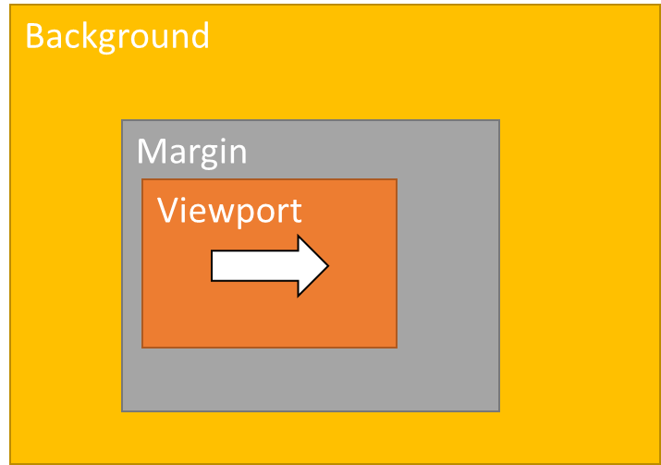  a.head turning right | 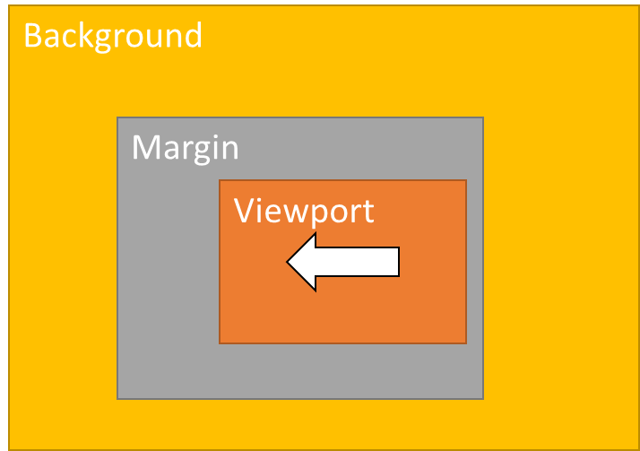  b. head turning left | 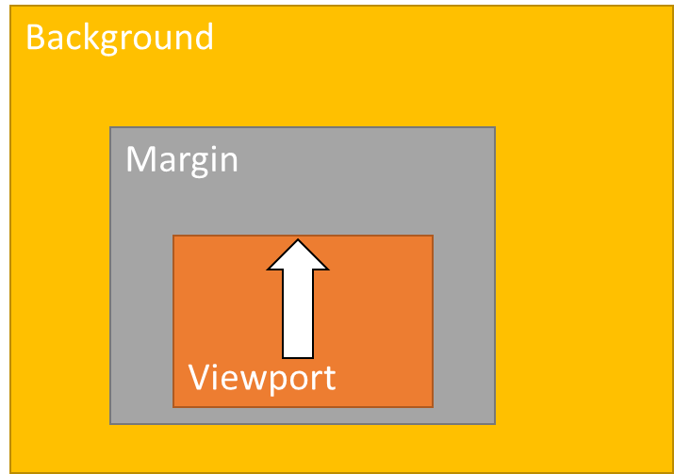  c. head turning up | 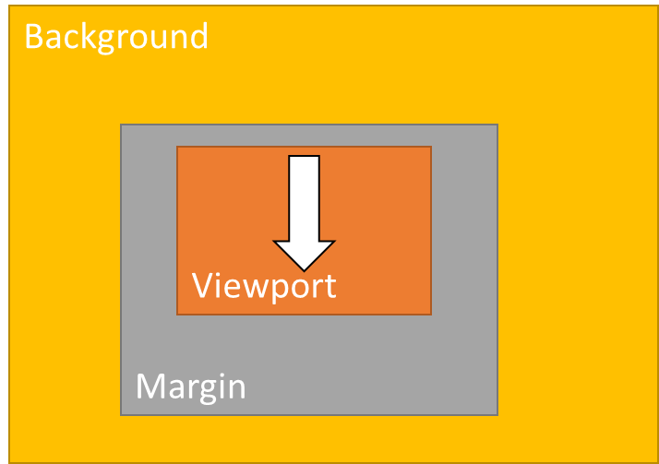  d. head turning down

Figure Y.8.1: Uneven extension of margins based on the user head motion. Similar uneven extensions may be used based on other application-level parameters. Symmetric margins extend evenly top, bottom and left, right of the viewport.

]

Y.9 Viewport RTCP Feedback
This section provides guidance for the implementation of the RTCP feedback message type ‘Viewport’ described in clause Y.7.2.
Figure Y.9.1 illustrates the impact of the viewport feedback message on motion-to-high-quality delay. The figure shows a sender (ITT4RT-Tx client) delivering viewport-dependent content to a receiver (ITT4RT-Rx client). After a change in viewport, an RTCP viewport feedback is sent by the receiver to the sender, which responds with updating the viewport in the viewport-dependent content. The motion-to-high quality delay includes the RTT, processing delays and also any delay in generating the RTCP viewport feedback. Therefore, the viewport feedback mechanism requires careful consideration.
An ITT4RT-Rx client may include a predicted viewport (using application-level viewport prediction techniques) in the viewport feedback if the viewport control is set to device_controlled during SDP negotiation. An ITT4RT-Rx client may use fixed interval RTCP feedback or fixed interval with early feedback.
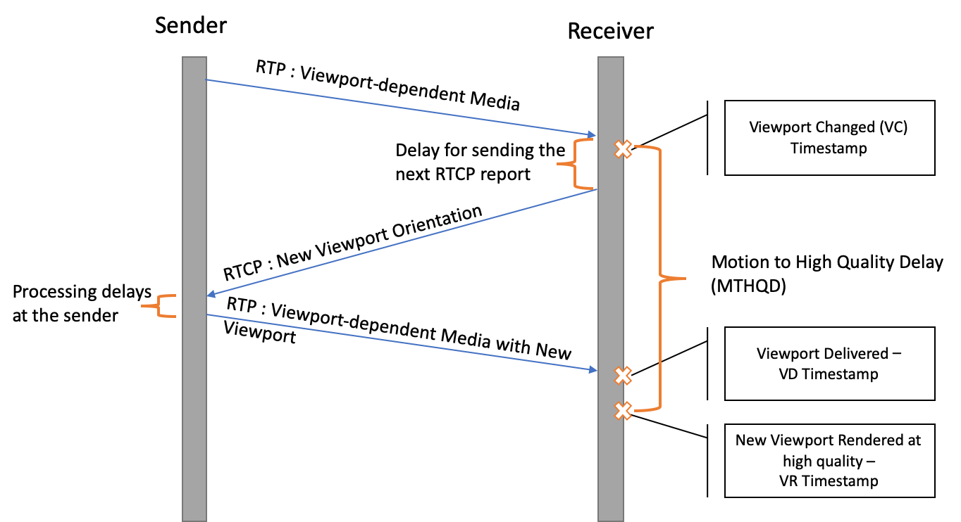
Figure Y.9.1. Motion to High Quality Delay

Y.9.1 Viewport Feedback Triggering Threshold
An ITT4RT-Tx may define a viewport feedback trigger value and signal this value to the ITT4RT-Rx client in the SDP. An ITT4RT-Tx client that uses viewport margins should define the trigger based on viewport margin region. The ITT4RT-TX client should select a threshold value that is suitable for the margin configuration that it intends to use for that stream. The threshold value should be defined within the viewport margin region such that the ITT4RT-Tx client would update the high-quality region (viewport and viewport margin) if the viewport breaches this threshold.
If an ITT4RT-Rx client does not have the capability to provide an RTCP viewport feedback at the viewport feedback threshold value provided by the ITT4RT-Tx client in an SDP offer, it may respond with the the minimum threshold value it can support. The ITT4RT-Tx client may adjust its viewport margin configuration based on thethreshold value in the answer. If an ITT4RT-Rx client only supports periodic feedback, it shall remove the viewportfb_trigger parameter from the response.
An ITT4RT-Rx client that supports a viewport feedback trigger shall include the parameter viewportfb_trigger with the minimum threshold value it can support in an SDP offer. The ITT4RT-Tx client may remove the parameter if it does not support this value or respond with an acceptable value that is equal or higher than the one in the ITT4RT-Rx’s offer.
If both sides acknowledge the support of viewportfb_trigger, the ITT4RT-Rx client shall use event-driven viewport feedback. If viewportfb_trigger is not defined by the ITT4RT-Tx client, the ITT4RT-Rx client may still use event-driven feedback. All ITT4RT-Rx client sending RTCP viewport feedback shall at least support sending periodic viewport feedback.

Editor’s Note: It should be considered to define margins briefly here if the informative section is moved to a TR.

Y.9.2 Event-Based Viewport Feedback
As per RFC 4585, the client can send event-based immediate feedback as long as:
Events per interval <= RTCP allocated bandwidth / Avg RTCP packet size
where,
Events per interval= Avg no of events reported/ Time interval.
For an RTCP viewport feedback, the event-based feedback interval can be calculated using the trigger angle by:
Events per interval = V / Trigger Angle
where V is the speed of the head mounted display and denotes the rate at which the viewport changes . Therefore, to respect the 5% bandwidth allocated for the RTCP traffic allowed by the RTP standard, it is recommended that the receiver does not trigger event-based immediate feedbacks for trigger angle smaller than TA_{min}, and
TA_{min} >= Average RTCP packet size / RTCP allocated bandwidth * V
With a changing trigger angle, receivers continue to operate within immediate feedback mode, where a feedback is sent as soon as an event is detected. However, the receiver redefines the event, which is the minimum trigger angle, based on current head speed. If the viewportfb_trigger is defined, then TA_{min} should be greater than or equal to the defined trigger values.
Editor’s Note: Trigger angle should be defined more clearly.

Y.9.3 Hybrid Fixed Interval and Event-driven Feedback
Alternatively, receivers may evaluate an average time interval, T, between RTCP feedback messages based on the allocated RTCP bandwidth. The value T can be used by the receiver to limit RTCP viewport feedbacks from exceeding the allocated bandwidth in case of high motion, as done for the early RTCP feedback mode in RFC 4585. Using the interval, it is possible to use a combination of regular and event-based feedback messages.
An ITT4RT-Rx client that uses this hybrid approach (a constant rate of RTCP feedback with event-driven feedback) may define a trigger that initiates an early RTCP feedback. An early RTCP feedback message is defined as a feedback message that is sent earlier than its scheduled transmission time. When viewport margins are used, the early viewport feedback trigger should take them into account. An ITT4RT-Rx client may use the viewportfb_trigger values to define the expected margin region. Alternatively, the extent of the viewport margin may be estimated from the bitstream. Figure Y.9.2 shows an image of an ERP of a 360-degree video with the current viewport and margins. As the viewport changes, the distance of the viewport, in degrees, from the boundary of the margins (shown as D_left, D_top, D_right, D_bottom and lastly D_direct, which is the distance in the direction of motion) decreases. An implementation may use the velocity of the head (causing the change in viewport), V, or the distance, D, to trigger the early viewport feedback i.e, an early viewport feedback is triggered when the V is above a certain threshold, V', and D is below a certain threshold, D'.

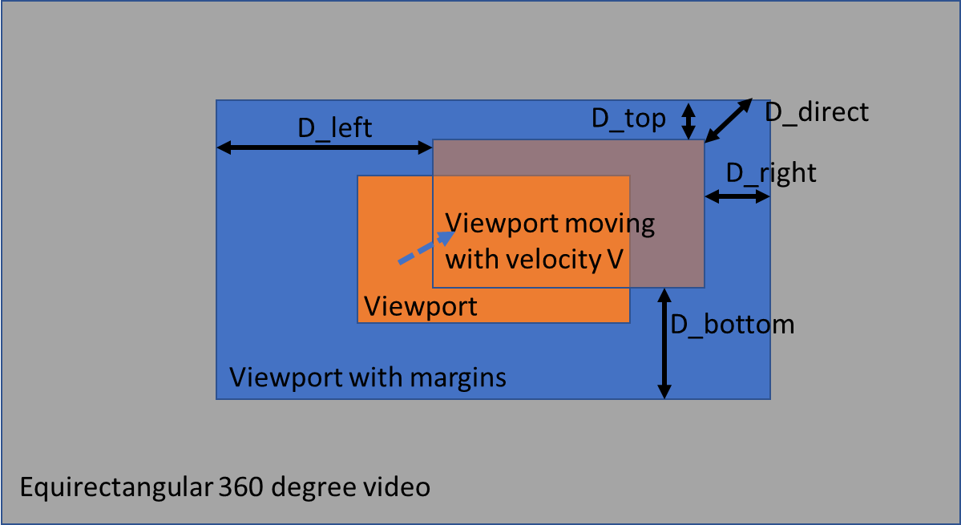
Figure Y.9.2. Moving viewport shown on an ERP of 360-degree video when viewport margins are used
Alternatively, the ITT4RT-Rx client may compute the time till the changing viewport will breach the boundary of the viewport margin, T_breach. An early viewport feedback is triggered when T_breach is below a certain threshold. Regardless of whether D, V or T_breach is used to trigger an early RTCP feedback, if the time to the next scheduled RTCP viewport feedback is small, the early feedback can be suppressed and the regular scheduled feedback is sent. As an example, Figure x.10.3 shows a timeline with T, the interval between two scheduled viewport feedbacks and T_breach, the time at which the viewport is expected to breach the viewport margin i.e., the high-quality region of the 360-degree video. An ITT4RT-Rx client may trigger an early RTCP viewport feedback as long as T-T_breach < T', where T' is the suppression threshold for an early RTCP feedback.

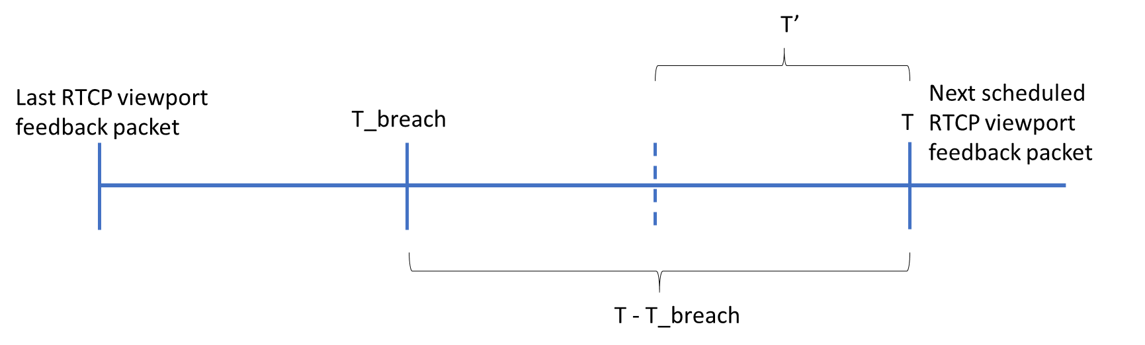
Figure Y.9.3: A timeline showing T, T’and T_breach in reference to the scheduled RTCP viewport feedback. Time increases left to right.
When viewport margins are not used, an ITT4RT-Rx client may trigger an early RTCP viewport feedback if the current viewport has deviated more than a threshold from the last reported viewport. This solution is independent of the received 360-degree content and the current high-quality region. Figure x.10.4 shows an illustration for the spherical distance D, in degrees, between the center of the viewport in the last RTCP viewport feedback and the center of the current viewport at the ITT4RT-Rx client. An ITT4RT-Rx client may trigger an early RTCP feedback message in this case when D > D', where D' is some threshold. However, if the time to next scheduled RTCP feedback is less than the suppression threshold T', the early RTCP feedback is not sent. The suppression threshold is used for controlling the rate of the viewport feedback. When an early RTCP feedback is sent, the ITT4RT-Rx client may send the next RTCP viewport feedback after T from the time of the event-driven viewport feedback. When the viewportfb_trigger is used, D' should be derived from it.
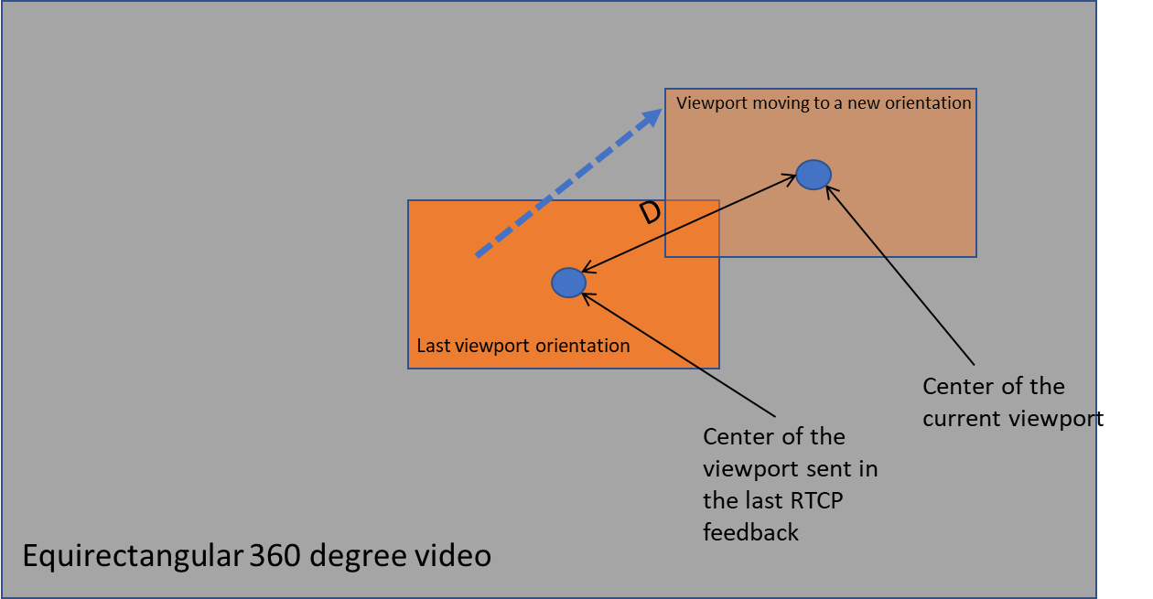
Figure Y.9.4 Changing viewport orientation (dotted blue arrow) shown on an ERP

Editor’s Note: Whether there is a need for signalling any of the thresholds for triggering or suppressing an early RTCP feedback message, for triggering an event-based feedback or for defining periodic feedbacks is FFS.

Y.10 SDP Examples (Informative)

====== END OF CHANGES ======

