Agenda item: 9.7
Source: Huawei Technologies Co. Ltd.
Title: Possible Deployment Options for EMSA Architecture
Document for Discussion and Agreement

Introduction
After discussion in the last SA4#112e meeting, it is agreed to collect the deployment scenarios as the Annex A of the TR. This paper proposes four possible deployment scenarios.

Possible Deployment Options

Deployment Scenario Option A
In one possible deployment option, the 5GMS functions and the SA6 MEC functions are co-located together and the 5GMS functions would be running on top of SA6 MEC functions as one media-specific application.
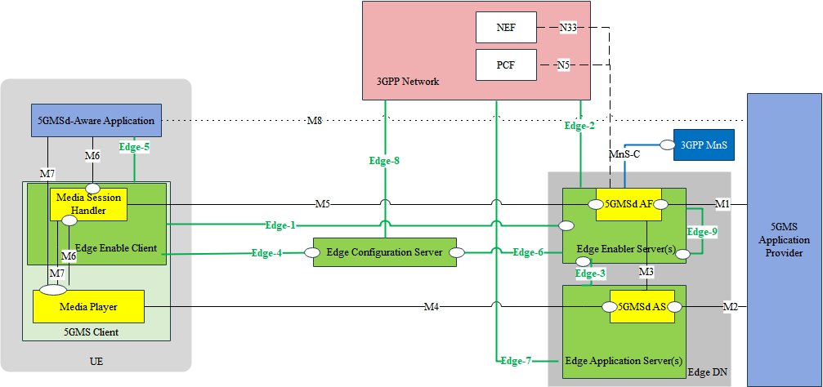
Figure 1 Potential deployment architecture option A
5GMS entities in the Specific Function Layer runs over the top of the SA6 MEC entities in the General Function Layer. Some parameter exchanges may be need for to trigger or receive the outcome of EC related procedures, i.e. the service provisioning, registration, EAS discovery, Service Continuity. For instance, during the EAS relocation procedure, the EES may help to find the target EAS and also provide this to 5GMSd AF. Then 5GMSd AF can connect to the new 5GMSd AS.

Deployment Scenario Option B
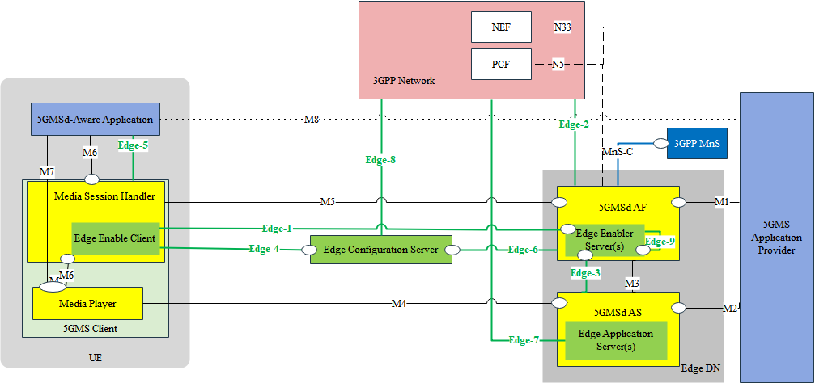
Figure 3 Potential deployment architecture option B
The 5GMS functions and SA6 MEC functions are co-located and the SA6 MEC functions are realized inside the 5GMS functions. It means the 5GMS functions also realize the SA6 MEC functionalities to enable the edge-based 5GMS service, including the necessary the edge server management functionalities, like registration, service provisioning, EAS discovery, etc.

Deployment Scenario Option C
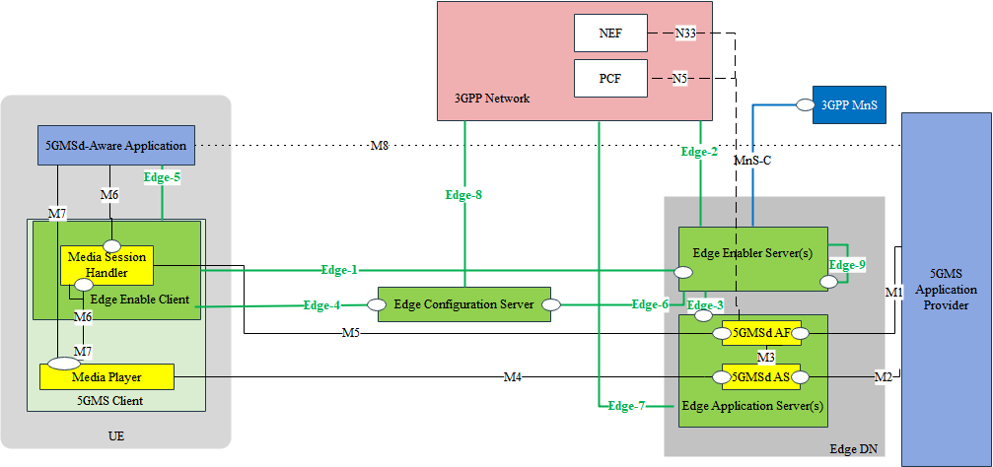
Figure 4 Potential deployment architecture option D
In this deployment scenario, the 5GMS (d) AF and 5GMS (d) AS are both co-located with the Edge Application Server (same or different EAS instances). For example, when the EAS may be closer to the user, the 5GMSd AF can also be co-located in the EAS and interact with the 3GPP Core Network via the Edge-7 interface. During the EAS discovery or relocation, the 5GMS AF and 5GMS AS are also need to be replaced with the new ones.

Proposal
We propose to accept the Section 2 as possible deployment options and add to the Annex A “Deployment Scenarios” of TR.

References
[1] 3GPP TS 23.558, Architecture for enabling Edge Applications, Rel-17.

