Source: Qualcomm Incorporated (Rapporteur)
Title: FS_XRTraffic: Permanent document, v0.3.1
Agenda Item: 10.8

Revision history
Version | Date | Meeting | Subject/Comment
0.0.1 | 2020-05-12 | Telco#1 | Initial Skeleton
0.1.0 | 2020-05-18 | SA4#109e | Input to SA4#109e
0.2.0 | 2020-05-28 | SA4#109e | Agreements during SA4#109e
0.3.0 | 2020-08-26 | SA4#110e | Agreements during SA4#110e
0.3.1 | 2020-11-09 | SA4#111e | Input to SA4#111e
0.4.0 | 2020-11-20 | SA4#111e | Agreements from SA4#111e

Contents
Revision history 1
Contents 1
1 Introduction 4
2 References 5
3 3GPP Related Work 5
3.1 General 5
3.2 3GPP RAN Study Item (see RP-193241) 5
3.2.1 Justification 5
Power Considerations for XR and Cloud Gaming 6
Capacity Considerations for XR and Cloud Gaming 6
Mobility Considerations for XR and Cloud Gaming 7
Coverage Considerations for XR and Cloud Gaming 7
3.2.2 Objective 7
3.2.3 Timeline 8
3.2.3 Status during SA4#111-e 8
1 Introduction 8
2 Status Summary in RAN1 with SA4 Highlights 8
3 Agreements during SA4#111-e 12
3.3 QoS Parameters 12
4 Standardization Efforts Outside 3GPP 12
4.1 Introduction 12
4.2 MPEG 12
4.3 Khronos/OpenXR 13
5 Relevant Technologies and Existing Services 13
5.1 Introduction 13
5.2 Online Games 13
5.3 Cloud and Edge Encoder Architectures 13
5.4 W3C 13
6 System Design Assumptions 13
6.1 Introduction 13
6.2 System Design for Split Rendering 13
6.2.1 Overview 13
6.2.2 Considered Content Formats 15
6.2.3 Considered System Parameters 15
6.2.4 Proposed Assumptions and Simulation Parameters 16
6.2.5 Quality aspects 17
6.2.6 Additional Assumptions and Background on XR/Cloud Gaming Traffic model 18
6.3 System Design for Viewport Dependent 3DoF Streaming 20
6.3.1 Overview 20
6.3.2 Considered Content Formats 22
6.3.3 Considered System Parameters 22
6.3.4 Proposed Assumptions and Simulation Parameters 23
6.4 Assumptions for Viewport Dependent 6DoF Streaming 24
6.4.1 Background 24
6.4.2 Feedback based on Paper 24
6.5 Assumptions for AR1: “XR Distributed Computing” and AR2: “XR Conversational” 24
6.5.1 General 24
7 End-to-End Simulation System 25
7.1 Introduction 25
7.2 Simulation System for Split Rendering 25
7.2.1 Overview 25
7.2.2 Proposed Model Considerations 26
7.2.3 Content Delivery Emulation and Simulation 30
7.2.4 RAN Simulation 36
7.2.4 RAN Simulation 36
7.2.5 Quality Evaluation 36
7.2.6 Software Package 39
XR-Traffic-Model 39
installation 39
V-trace to S-trace model encoder 39
V-trace format 39
Example usage 39
Configuration / CLI arguments 40
width / height 40
Slices 40
Error resilience modes 40
Rate control mode 41
Misc options 41
7.3 Simulation System for Viewport Dependent 3DoF Streaming 41
7.3.1 Overview 41

1 Introduction
During SA4#107 the New Study Item on “Feasibility Study on Extensions to Typical Traffic Characteristics” in S4-200334 was agreed and afterwards approved in by SA plenary #87 in SP-200054.
The objective of the study is as follows:
- Collect and document traffic characteristics including for different services, but not limited to
  - Downlink data rate ranges
  - Uplink data rate ranges
  - Maximum packet delay budget in uplink and downlink
  - Maximum Packet Error Rate,
  - Maximum Round Trip Time
  - Traffic Characteristics on IP level in uplink and downlink in terms of packet sizes, and temporal characteristics. XR Services and Cloud Gaming based on the initial information documented in TR26.928 including.
- Collect additional information, such as codecs and protocols in use.
- Provide the information from above at least for the following services (initial services)
  - Viewport independent 6DoF Streaming
  - Viewport dependent 6DoF Streaming
  - Simple Single Buffer split rendering for online cloud gaming
  - Cloud gaming
  - MTSI-based XR conversational services
- Identify additional relevant XR and other media services and document their traffic characteristics
- Document additional developments in the industry that impact traffic characteristics in future networks
- Identify the applicability of existing 5QIs/PQIs for such services and potentially identify requirements for new 5QIs/PQIs or QoS related parameters.
- Communicate with other 3GPP groups and external organizations on relevant aspects related to the study.
A CR to TR 26.925 is developed.
This document collects additional agreed information that either needs more refinement or input before added to the Technical Report or document the status of issues that are of no immediate relevance for the TR26.925.

2 References
- 3GPP TR 26.925, " Typical traffic characteristics of media services on 3GPP networks"
- 3GPP TR 38.838, " "Study on Extended Reality (XR) evaluations for NR"

3 3GPP Related Work

3.1 General
In an initial version of TR26.925, Typical Traffic Characteristics for Operator and Third-Party Services have been collected. The work was initiated based on communication between SA4 and SA1. During the course of the work, additional requests from SA1 were received that have been partially addressed in the initial version of TR26.925.
3GPP TSG SA WG4 (Codec) addressed their mandate on "Guidance to other 3GPP groups concerning required QoS parameters and other system implications, including channel coding requirements, imposed by different multimedia codecs in both circuit-switched and packet-switched environments."
Furthermore, during the study for eXtended Reality (XR) over 5G (FS_5GXR) documented in TR26.928, several initial considerations for XR services including cloud gaming had been collected. Specifically, parameters such as downlink and uplink bitrates, packet delay budgets, error rates and round-trip times are collected, but several of those for different cases are kept FFS and need more work.
In particular, eXtended Reality (XR) and Cloud Gaming are some of the most important 5G media applications under consideration in the industry. XR is an umbrella term for different types of realities and refers to all real-and-virtual combined environments and human-machine interactions generated by computer technology and wearables. It includes representative forms such as Augmented Reality (AR), Mixed Reality (MR) and Virtual Reality (VR) and the areas interpolated among them.
There are several ongoing XR and Cloud Gaming activities in 3GPP at various SA working groups:
- SA1: XR (and Cloud Gaming) use cases are outlined in the SA1 study item on Network Controlled Interactive Services: NCIS (TR 22.842)
- SA2: work item on 5G System Enhancement for Advanced Interactive Services (SP-190564) proposes to introduce new 5QIs to identify the requirements on traffic from SA1 NCIS
- SA4: XR use cases are discussed in detail in the SA4 study item Extended Reality (XR) in 5G (TR 26.928)
- SA6: Edge Computing is a network architecture to enable XR and Cloud Gaming and is under study in the SA6 Study on application architecture for enabling Edge Applications (TR 23.758)
- RAN1: Study on XR Evaluations for NR (no TR assigned yet)

3.2 3GPP RAN Study Item (see RP-193241)

3.2.1 Justification
eXtended Reality (XR) and Cloud Gaming are some of the most important 5G media applications under consideration in the industry. XR is an umbrella term for different types of realities and refers to all real-and-virtual combined environments and human-machine interactions generated by computer technology and wearables. It includes representative forms such as Augmented Reality (AR), Mixed Reality (MR) and Virtual Reality (VR) and the areas interpolated among them.
One specific aspect to be considered is the role of Edge Computing as a network architecture to enable XR and Cloud Gaming. Edge Computing is a concept that enables cloud computing capabilities and service environments to be deployed close to the cellular network. It promises several benefits such as lower latency, higher bandwidth, reduced backhaul traffic and prospects for several new services as indicated in the SA6 Study on application architecture for enabling Edge Applications (TR 23.758). Edge Applications are expected to take advantage of the low latencies enabled by 5G and the Edge network architecture to reduce the end-to-end Application level latencies. Edge Computing is a valuable enabler which should be considered to help 5G systems achieve the required performance to enable XR and Cloud Gaming.
5G NR is designed to support applications demanding high throughput and low latency in line with the requirements posed by the support of XR and Edge Computing applications in NR networks. XR and Edge Computing are services enabled by Rel-15 NR networks.
There are several ongoing XR and Cloud Gaming activities in 3GPP at various SA working groups:
- SA1: XR (and Cloud Gaming) use cases are outlined in the SA1 study item on Network Controlled Interactive Services: NCIS (TR 22.842)
- SA2: work item on 5G System Enhancement for Advanced Interactive Services (SP-190564) proposes to introduce new 5QIs to identify the requirements on traffic from SA1 NCIS
- SA4: XR use cases are discussed in detail in the SA4 study item Extended Reality (XR) in 5G (TR 26.928)
- SA6: Edge Computing is a network architecture to enable XR and Cloud Gaming and is under study in the SA6 Study on application architecture for enabling Edge Applications (TR 23.758)

Power Considerations for XR and Cloud Gaming
In addition to Smartphone based XR, XR experience is increasingly expected to be delivered via Head Mounted Displays (HMDs). The power considerations for HMDs are different from those of Smartphones. In particular, the power dissipation of AR glasses can be significantly lower than that of a smartphone, if the AR glass form factor is similar to that of prescription glasses and is expected to be worn for long durations. The AR glasses can have an embedded 5G modem providing 5G connectivity, or the AR glasses can be tethered (USB, Bluetooth, or WiFi) to a Smartphone for 5G connectivity. In both cases, the 5G connection must carry AR application traffic, and the UE power consumption from that traffic has a significant bearing on the viability of such AR glasses products.
Further, the AR computation can be split between the AR glasses and Edge servers as discussed before. The computation split can reduce the overall power consumption on the device if the resulting traffic from the computation split does not increase the UE power consumption significantly.
In the case of Cloud Gaming, the device is expected to be a Smartphone or Tablet. The power consumption and battery life of the device for a long duration Cloud Gaming experience is an important aspect to consider.
As such, power consumption is an important factor for XR and Cloud Gaming.

Capacity Considerations for XR and Cloud Gaming
On XR and Cloud Gaming traffic with high throughput, low latency and high reliability requirements, it is important to consider the capacity of these services over Rel-15 and Rel-16 based 5G networks. One way to represent the capacity of the XR and Cloud Gaming services is via the number of users who can simultaneously consume the service under given traffic requirements and for a given deployment scenario (e.g., Urban Macro, Indoor Hotspot) with some density of 5G cells. If the traffic requirements of the XR and Cloud Gaming service are flexible (e.g., the underlying architecture allows adaptation of content), then the capacity of the service can be studied by assessing the delay, throughput and reliability variations with increasing number of users in the system.
In either case, when the latency is low and the reliability requirements are high, two effects come into play:
- The burst throughput of the traffic measured over a time range that corresponds to the latency requirement, and extracted at the percentile represented by the reliability requirement, can be significantly higher than the average throughput requirement. For example, the average throughput requirement of an XR traffic can be 100Mbps, but its burst throughput requirement over short measurement windows can be 300Mbps while also requiring high reliability.
- The short-term throughput experienced by a UE measured a time range that corresponds to the latency requirement, and extracted at the percentile represented by the reliability requirement, can be significantly lower than the average throughput experienced by that UE.
These effects can significantly impact the capacity of XR services over a 5G network. Therefore, it is important to study capacity aspects for XR and cloud gaming, including key performance indicators (KPIs) that represent XR and Cloud Gaming services over 5G.
As such, capacity is an important factor for XR and Cloud Gaming.

Mobility Considerations for XR and Cloud Gaming
As XR and Cloud Gaming see consumer adoption, the services are expected to be consumed by users on the move. Minimizing user experience degradation through mobility events is a key consideration in enabling mass adoption of such services.
As such, mobility an important factor for XR and Cloud Gaming.

Coverage Considerations for XR and Cloud Gaming
Some XR and Cloud Gaming applications can require high-throughput and low-latency on the uplink. The performance of 5G on the uplink at the cell edge can be much different compared to performance at the cell-centre. The power limitations on the XR device can make this issue even more acute.
As such, coverage, particularly that of uplink, is an important factor for XR and Cloud Gaming.

3.2.2 Objective
The following applications are to be considered as starting points for this study:
- VR1: “Viewport dependent streaming”
- VR2: “Split Rendering: Viewport rendering with Time Warp in device”
- AR1: “XR Distributed Computing”
- AR2: “XR Conversational”
- CG: Cloud Gaming
Note: Use cases in quotes are from TR26.928.

The following traffic parameters for the different applications are to be considered as starting point for the study:
Traffic characteristics:
- UL and DL File Size distribution (e.g., Pareto with given parameters)
- UL and DL File arrival time distribution (e.g., Periodic every 1/60 seconds)
Traffic requirements:
- Round-trip-time or UL and DL one-way Packet delay budget (PDB)
- UL and DL Packet error rate (PER)

The objective of this study item are as follows:
- Confirm XR and Cloud Gaming applications of interest
- Identify the traffic model for each application of interest taking outcome of SA WG4 work as input, including considering different upper layer assumptions, e.g. rendering latency, codec compression capability etc.
- Identify evaluation methodology to assess XR and CG performance along with identification of KPIs of interest for relevant deployment scenarios
- Once traffic model and evaluation methodologies are agreed, carry out performance evaluations towards characterization of identified KPIs

Note 1: eURLLC SI/WI work relevant to XR should be taken into consideration.
Note 2: Traffic model for the performance evaluation shall be based on the standardization in SA WG4

3.2.3 Timeline
- Started during RAN1#103-e in November 2020

- Next Meeting in Jan 2021.

3.2.3 Status during SA4#111-e

Introduction
RAN1 has started work on their XR Work item. The revised formal SID is “RP-201145 Revised SI on XR Evaluations for NR”. RAN1 met last week in RAN1#103 and has progressed the work on XR Evaluations for NR.
Below is the formal 3GPP agreements from RAN1#103-e. This information is extracted from document R1-2009812, "FL Summary of RAN1 103-e agreements and email discussions on Rel-17 SI on XR evaluations for NR".

Status Summary in RAN1 with SA4 Highlights
Agreement 1. XR applications
RAN1 confirms that diverse applications of VR1/2, AR1/2, (XR conference FFS), CG are of interest for study. Potential prioritization/down selection of these applications for evaluation is to be discussed after detailed traffic models and relevant evaluation assumptions are stable.
- FFS: other applications, e.g., XR conferencing

Agreement 2. Traffic model
Traffic model for DL and UL should reflect various aspects, e.g., various bit rates, variable frame/packet (definition of frame/packet to be clarified with traffic model as necessary) size, and periodicity (how to model jitter is FFS). RAN1 will strive to conclude on detailed traffic models in the next RAN1 meeting (104-e) where SA4 outcome on traffic model is expected to be available.
- Statistical model is preferred.
- It is preferred traffic model for both UL and DL have a certain degree of variability so thatand the total number of traffic models can be reduced.
- Note: Taking into account the fact that the decision on traffic models may hold many other crucial decisions, discussion on traffic model in the next RAN1 meeting is prioritized from the beginning.

Agreement 3: Adopt the following deployment for XR/CG evaluations
- Indoor hotspot: FR1 and FR2
  - Detailed definition of Indoor hotspot refers to TR 38.913.
  - Channel model: InH. Detailed definition of InH refers to TR 38.901.
- Dense urban: FR1 and FR2
  - Detailed deployment refers to TR 38.913, where single layer with Marco layer is assumed.
  - Channel model: UMi. Detailed definition of UMi refers to TR 38.901.
FFS: Whether to prioritize FR1 for evaluation.
Note 1: When selecting the deployment and evaluation assumptions for XR/CG evaluations, it is up to company to evaluate FR1 or FR2 or both for the frequency range.
Note 2: It does not mean that all applications are evaluated for all the deployment scenarios.

Agreement 4: Urban Macro can be optionally reported for XR/CG evaluations only for FR1.
- FFS: whether Uma is optional or not
- Following parameters can be assumed.
Parameter | Proposed value
Parameter | Urban Macro (FR1)
Layout | 21cells with wraparound  ISD = 500 m
BS Tx power | FR1: 49 dBm/20 MHz

Agreement 5: It is to be further discussed how to prioritize the combinations of deployment scenarios and applications after traffic models for each application are stable.

Agreement 6: System capacity is defined as the maximum number of users per cell with at least X % of UEs being satisfied.
- X=90 (baseline) or 95 (optional)
- Other values of X can also be evaluated optionally
Note: The exact ‘satisfied’ requirements will be discussed separately
FFS: how to calculate the percentage of satisfied users across multiple drops of simulations

Agreement 7: Adopt the simulation assumptions in table 1 as below

Table 1: Simulation assumptions for XR evaluation (Part 1) (updated)
Parameter | Proposed value
Parameter | Indoor hotspot FR1/FR2 | Dense urban FR1/FR2
Layout | 120m x 50m  ISD: 20m  TRP numbers: 12 | 21cells with wraparound  ISD: 200m
Carrier frequency | FR1: 4 GHz  FR2: 30 GHz
Subcarrier spacing | FR1: 30 kHz  FR2: 120 kHz
BS height | 3m | 25m
UE height | hUT=1.5 m
BS noise figure | FR1: 5 dB  FR2: 7 dB
UE noise figure | FR1: 9 dB  FR2: 13 dB
BS receiver | MMSE-IRC
UE receiver | MMSE-IRC
Channel estimation | Realistic  FFS:Ideal(optional)
UE speed | 3 km/h
MCS | Up to 256QAM
BS antenna pattern | Ceiling-mount antenna radiation pattern, 5 dBi | 3-sector antenna radiation pattern, 8 dBi
UE antenna pattern | FR1: Omni-directional, 0 dBi,  FR2: UE antenna radiation pattern model 1, 5dBi

Agreement 8: Adopt the following UE distribution for XR/CG evaluation for outdoor scenario
- For outdoor scenario:
  - FR1: 80% indoor, 20% outdoor
  - FR2: 100% outdoor
Other UE distribution can be evaluated optionally.

Agreement 9: Adopt the following TDD configuration for XR/CG evaluation
- FR1:
  - Option 1: DDDSU
  - Option 2: DDDUU
- FR2:
  - Option 1: DDDSU
FFS detailed S slot format
Note: Other TDD configuration or FDD can be optionally evaluated.

Agreement 10: Adopt the following BS antenna parameters for indoor scenario for XR/CG evaluation
- FR1:
  - 32 TxRU, (M, N, P, Mg, Ng; Mp, Np) = (4,4,2,1,1;4,4)
  - (dH, dV) = (0.5, 0.5)λ
- FR2:
  - Option 2: 2 TxRU, (M, N, P, Mg, Ng; Mp, Np) = (16, 8, 2,1,1;1,1)
  - (dH, dV) = (0.5, 0.5)λ
Other BS antenna parameters can be optionally evaluated

Agreement 11: For XR/CG evaluation, adopt the following assumptions for downtilt
• For XR/CG evaluation, adopt the following assumptions for downtilt
- Dense Urban
  - FFS: 6 or 12 degree
  - Other downtilt can be optionally evaluated.
- Indoor hotspot
  - 90° (pointing to the ground)
Other downtilt can be optionally evaluated

Agreement 12: Adopt the simulation assumptions in table 3 as below

Table 3: Simulation assumptions for XR evaluation (Part 3)
Power control parameter | Companies should report
Transmission scheme | Companies should report, such as Type I/II codebook, rank assumption
Scheduler | SU/MU-MIMO PF scheduler (company to report SU or MU),  other scheduler (e.g., delay aware scheduler) is up to companies report
CSI acquisition | Realistic  Both CSI feedback and SRS are considered  Companies should report  • CSI feedback delay, CSI report periodicity, whether using CSI quantization, CSI error model or not,  • Assumptions on SRS: periodicity, processing gain, processing delay, etc  • and etc.
PHY processing delay | Baseline: UE PDSCH processing Capability #1  Optional: UE PDSCH processing Capability #2  Companies should report gNB processing delay, e.g. DL NACK to retransmission delay, UL previous transmission to current transmission delay and etc.
PDCCH overhead | Companies should report
DMRS overhead | Companies should report
Target BLER | Companies should report
Max HARQ transmission | Companies should report

Agreement 13: The following aspects are to be discussed after traffic model is stable.
- For the system capacity definition, how to determine whether a UE is satisfied or not is to be deferred until the exact traffic model along with how to measure E2E user experience is available. Additional metrics to be collected will be further discussed after traffic model is stable.
- Various options for traffic arrival offset among UEs per cell were proposed by companies, e.g., even offset, random offset, no offset. It will be discussed after traffic model is determined.

Agreement 14: System bandwidth for XR/CG evaluations are as follows.
- For FR1,
  - Baseline: 100 MHz
  - Optional: 20/40 MHz (FFS: 200 MHz)
- FFS FR2

Agreement 15: For outdoor scenarios, the baseline BS antenna parameters are as follows.
- FFS FR1,
  - Option 1: 64 TxRU, (M, N, P, Mg, Ng; Mp, Np) = (8,8,2,1,1;4,8)
  - Option 2: 32 TxRU, (M, N, P, Mg, Ng; Mp, Np) = (8,2,2,1,1,8,2)
  - Option 3: 32TxRUs (M, N, P, Mg, Ng; Mp, Np) = (4,4,2,1,1,4,4)
(dH, dV) = (0.5λ, 0.85λ)
- FR2:
  - 2 TxRU, (M, N, P, Mg, Ng; Mp, Np) = (4,8,2,2,2;1,1)
(dH, dV) = (0.5λ, 0.5λ)
Other configurations can be optionally evaluated.

Agreement 16: UE antenna parameters for XR/CG evaluations are as follows
- FR1:
  - Baseline: 2T/4R, (M, N, P, Mg, Ng; Mp, Np) = (1,2,2,1,1;1,2), (dH, dV) = (0.5, N/A)λ
  - Optional: 4T/4R, 1T/2R, 2T2R
- FFS FR2: down-selection between the next two options. Please indicate if you have preference.
  - Option 1 (Follow Rel-17 evaluation methodology for FeMIMO in R1-2007151)
    - (M, N, P)=(1, 4, 2), 3 panels (left, right, top)
    - (Mp, Np) is up to company. Need to be reported with simulation result.
  - Option 2 (from TR 38.802 – developed in Rel-14)
    - 4Tx/4Rx: (M, N, P, Mg, Ng; Mp, Np) = (2,4,2,1,2;1,2), (dH,dV) = (0.5, 0.5)λ, the polarization angles are 0° and 90°

Agreement 17: BS Tx power for XR/CG evaluations are as follows
- For Indoor hotspot:
  - FR1:
    - 24 dBm per 20 MHz
  - FR2:
    - 23 dBm per 80 MHz. EIRP should not exceed 58 dBm
- For Dense urban:
  - FR1:
    - 44 dBm per 20 MHz
  - FR2:
    - 40 dBm per 80 MHz. EIRP should not exceed 73 dBm
For system BW larger than above, Tx power scales up accordingly.

Agreement 18: UE max Tx power for XR/CG evaluations are as follows
- FR1: 23 dBm
- FR2: 23 dBm, maximum EIRP 43 dBm

Agreement 19. Baseline power evaluation methodology
If UE power consumption is agreed as a KPI for evaluation of XR performance over NR,TR38.840 is the baseline methodology potentially with some modifications if necessary. RAN1 aim to minimize modeling effort. For example, the following aspects can be considered for further discussion but not limited to.
• FFS whether/how to model UE power consumption for UE tx power other than 0dBm and 23dBm,
• FFS whether/how to model UE power consumption for UL slots that are not defined in TR38.840
• FFS whether/how to model UE power consumption for ‘S’ slot
• FFS whether/how to model UE power consumption for 400MHz in FR2 including scaling rule for FR2 BWP adaption.
• FFS whether/how to model UE consumption for the corresponding number of Tx antennas
• FFS whether/how to model the UE power consumption for UE tx power under FR2

Agreement 20.
- RAN1 continues to discuss evaluation methodologies for UE power consumption and system capacity.
- RAN1 is to discuss whether/how to study/evaluate mobility and coverage at a later stage, e.g., starting from Q1 2021.

Agreements during SA4#111-e
It is agreed to
- Prioritize the work that is needed by RAN1
- Schedule calls for XR Traffic according to S4-201633
- Provide information to the next RAN1#104-e meeting starting January 25 early enough
- Informally invite RAN1 delegates to upcoming telcos

3.3 QoS Parameters

4 Standardization Efforts Outside 3GPP

4.1 Introduction
This clause provides a brief overview on ongoing standardization, pre-standardization and industry for XR related activities in the context of this work. The information is expected to be updated regularly with new information being received.

4.2 MPEG
Tbd.

4.3 Khronos/OpenXR
Tbd.

5 Relevant Technologies and Existing Services

5.1 Introduction
This clause collects a set of technologies that relevant for XR Traffic Modeling and Services

5.2 Online Games
Tbd.

5.3 Cloud and Edge Encoder Architectures
Tbd.

5.4 W3C
tbd

6 System Design Assumptions

6.1 Introduction
This clause system design assumptions for XR Traffic modeling.

6.2 System Design for Split Rendering

6.2.1 Overview
The system design for split rendering follows the discussion and requirements from TR26.928, clause 6.2.5. The architecture us shown in Figure 1.
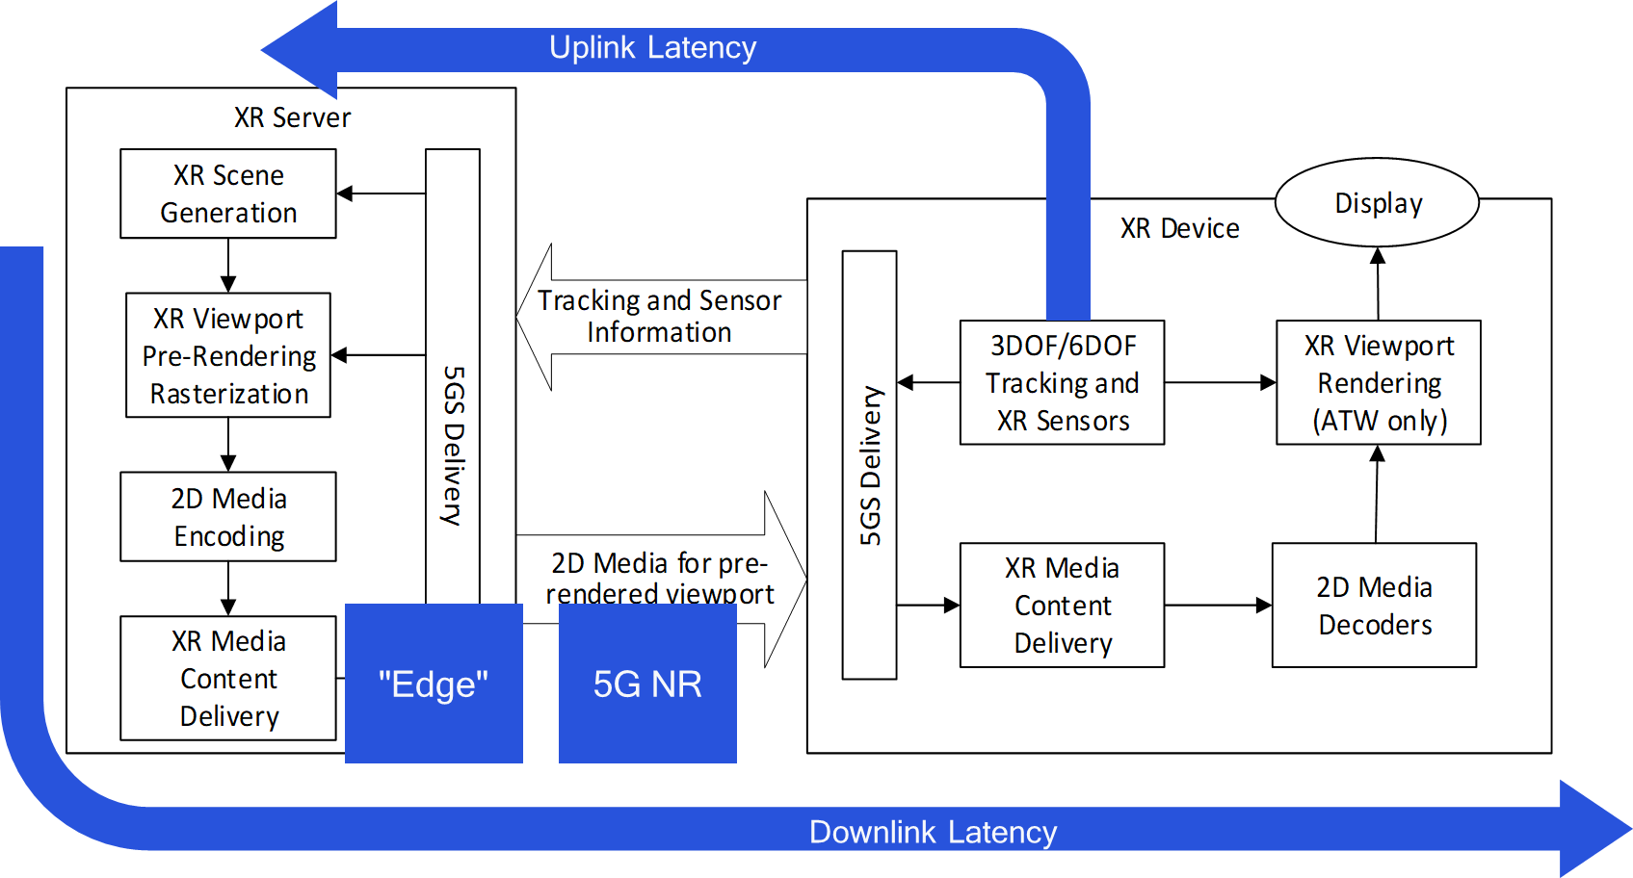
Figure 1 Split Rendering with Asynchronous Time Warping (ATW) Correction

Raster-based split rendering refers to the case where the XR Server runs an XR engine to generate the XR Scene based on information coming from an XR device. The XR Server rasterizes the XR viewport and does XR pre-rendering.
According to Figure Figure 1, the viewport is pre-dominantly rendered in the XR server, but the device is able to do latest pose correction, for example by asynchronuous time-warping (see clause 4.1 of TR26.928) or other XR pose correction to address changes in the pose.
- XR graphics workload is split into rendering workload on a powerful XR server (in the cloud or the edge) and pose correction (such as ATW) on the XR device
- Low motion-to-photon latency is preserved via on device Asynchronous Time Warping (ATW) or other pose correction methods.
The following call flow highlights the key steps:
1) An XR Device connects to the network and joins XR application
a) Sends static device information and capabilities (supported decoders, viewport)
2) Based on this information, the XR server sets up encoders and formats
3) Loop
a) XR Device collects XR pose (or a predicted XR pose)
b) XR Pose is sent to XR Server
c) The XR Server uses the pose to pre-render the XR viewport
d) XR Viewport is encoded with 2D media encoders
e) The compressed media is sent to XR device along with XR pose that it was rendered for
f) The XR device decompresses video
g) The XR device uses the XR pose provided with the video frame and the actual XR pose for an improved prediction using and to correct the local pose, e.g. using ATW.
According to TR 26.928, clause 4.2.2, the relevant processing and delay components are summarized as follows:
- User interaction delay is defined as the time duration between the moment at which a user action is initiated and the time such an action is taken into account by the content creation engine. In the context of gaming, this is the time between the moment the user interacts with the game and the moment at which the game engine processes such a player response.
- Age of content is defined as the time duration between the moment a content is created and the time it is presented to the user. In the context of gaming, this is the time between the creation of a video frame by the game engine and the time at which the frame is finally presented to the player.
The roundtrip interaction delay is therefore the sum of the Age of Content and the User Interaction Delay. If part of the rendering is done on an XR server and the service produces a frame buffer as rendering result of the state of the content, then for raster-based split rendering (as defined in clause 6.2.5) in cloud gaming applications, the following processes contribute to such a delay:
- User Interaction Delay (Pose and other interactions)
  - capture of user interaction in game client,
  - delivery of user interaction to the game engine, i.e. to the server (aka network delay),
  - processing of user interaction by the game engine/server,
- Age of Content
  - creation of one or several video buffers (e.g. one for each eye) by the game engine/server,
  - encoding of the video buffers into a video stream frame,
  - delivery of the video frame to the game client (a.k.a. network delay),
  - decoding of the video frame by the game client,
  - presentation of the video frame to the user (a.k.a. framerate delay).
As ATW is applied the motion-to-photon latency requirements (of at most 20 ms) are met by XR device internal processing. What determines the network requirements for split rendering is time of pose-to-render-to-photon and the roundtrip interaction delay. According to clause TR 26.928, clause 4.5, the permitted downlink latency is typically 50-60ms.

6.2.2 Considered Content Formats
Rasterized 3D scenes available in frame buffers (see clause 4.4 or TR 26.928) are provided by the XR engine and need to be encoded, distributed and decoded. According to TR 26.928, clause 4.2.1, relevant formats for frame buffers are 2k by 2k per eye, potentially even higher. Frame rates are expected to be at least 60fps, potentially higher up to 90 fps. The formats of frame buffers are regular texture video signals that are then directly rendered. As the processing is graphics centric, formats beyond commonly used 4:2:0 signals and YUV signals may be considered.
In practical considerations, the NVIDIA Encoding functions may be used. The parameters of such an encoder are documented here https://developer.nvidia.com/nvidia-video-codec-sdk.

6.2.3 Considered System Parameters
Based on the discussion on clause 2 and 3, several parameters are relevant for the overall system design.
- Game:
  - Type of game
  - state of game,
  - multi-user actions, etc.
- User Interaction:
  - 6DOF pose based on head and body movement,
  - Game interactions by controllers
- Formats of rasterized video signal. Typical parameters are:
  - 1.5K x 1.5K per eye at 60, 90, 120fps
  - 2K x 2K at 60, 90, 120fps
  - YUV 4:2:0 or 4:4:4
- Encoder configuration
  - Codec: H.264/AVC or H.265/HEVC
  - Bitrate: Bitrate setting to a specific value (e.g. 50 Mbit/s)
  - Rate control: CBR, Capped VBR, Feedback based, CRF, QP
  - Slice settings: 1 per frame, 1 per MB row, X per frame
  - Intra settings and error resilience: Regular IDR, GDR Pattern, adaptive Intra, feedback based Intra, feedback based predication and ACK-based, feedback-based prediction and NACK based
  - Latency settings: P pictures only, look-ahead units
  - Complexity settings for encoder
- Content Delivery
  - Slice to IP mapping: Fragmentation
  - RTP-based time codes and packet numbering
  - RTP/RTCP-based feedback ACK/NACK
  - RTP/RTCP-based feedback on bitrate
- 5G System/RAN Configuration:
  - QoS Settings (5QI): GBR, Latency, Loss Rate
  - HARQ transmissions, scheduling, etc.
- Content Delivery Receiver configuration:
  - Loss Detection: sequence numbers
  - Delay/Latency handling
  - Error Resilience
  - ATW
- Quality Aspects
  - Video quality (encoded)
  - Lost data
  - immersiveness

6.2.4 Proposed Assumptions and Simulation Parameters
It is proposed to only consider the following system parameters (some are striken):
- Game (details are tbd):
  - Type of game
  - state of game,
  - multi-user actions, etc.
- User Interaction:
  - 6DOF based on body/head movement,
  - Game interactions
- Formats of rasterized video signal. Typical parameters are:
  - 1.5K x 1.5K per eye at 60, 90, 120fps
  - 2K x 2K at 60, 90, 120fps
  - YUV 4:2:0 or 4:4:4
- Encoder configuration
  - Codec: H.264/AVC or H.265/HEVC
  - Rate control: CBR, Capped VBR, Feedback based, CRF, QP
    - CBR: tbd
    - CRF: 22, 25, 28, 31, 34
  - Slice settings: 1 per frame, 1 per row, 8 per frame
  - Intra settings and error resilience: Regular IDR, GDR Pattern, adaptive Intra, feedback based Intra, feedback based predication and ACK-based, feedback-based prediction and NACK based
  - Latency settings: P pictures only, look-ahead units only 0 (for minimum latency)
  - Complexity settings for encoders aligned with presets in x265
- Content Delivery
  - Slice to IP mapping: Fragmentation
  - RTP-based time codes and packet numbering
  - RTP/RTCP-based feedback ACK/NACK
  - RTP/RTCP-based feedback on bitrate
- RAN Configuration:
  - QoS Settings (5QI): GBR, Latency, Loss Rate
  - HARQ Handling, Scheduling
    - Defined by RAN group
- Delay budget:
  - Uplink streaming is considered to add at most 10ms
  - Downlink streaming budget: 50ms, 100ms, 200ms
- Receiver configuration:
  - Loss Detection: sequence numbers
  - Delay/Latency handling: Slices received after the deadline are treated as lost.
  - Error Concealment: Copy macroblock for lost ones
  - Warping: is considered sufficient if within delay budget.
- Quality Aspects
  - Video quality (encoded)
  - Lost data
  - immersiveness

6.2.5 Quality aspects
The video quality is impacted primarily be two factors:
- The coding artifacts based on encoding, determined for example by the PSNR.
- The artefacts due to lost packets and the resulting error propagation.
It is proposed to model quality for each simulation as a combination
- Average PSNR sent from encoding
- The percentage of damaged video area
  - where a damaged macroblock is defined as
    - If it is part of a slice that is lost for this transmission
    - If it is correctly received, but it predicts from a wrong macroblock
  - Macroblock is correct
    - If it is received correctly and it predicts for a non-damaged macroblock
    - Predicting from non-damaged macroblock means
      - Spatial prediction is correct
      - Temporal prediction is correct
  - Recovering MBs done by Intra Refresh or by predicting from correct MBs again.
A potentially quality diagram would look as follows:
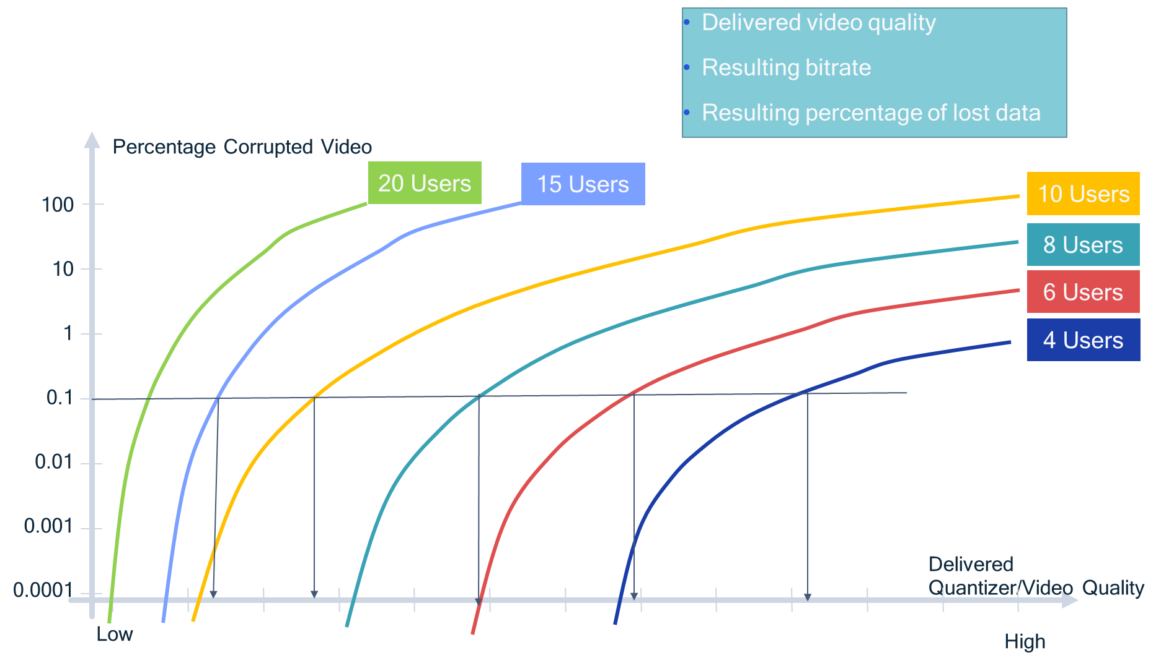

6.2.6 Additional Assumptions and Background on XR/Cloud Gaming Traffic model

6.2.6.1 Traffic source type
The traffic resource type for XR service is related to the application. To be specific, the traffic resource type refers to how the traffic is generated in the source end. For VR application, it refers to how the frames of two eyes are generated. It is assumed that there are two eye buffers and the frames for two eyes are generated independently for VR 3D video, assuming 2K resolution for the frames for each eye. To meet the latency requirement of VR video traffic, PDB for each frame is assumed as 10ms. The following two different types of VR video traffic are proposed regarding the frame arrival time in the case of X FPS, as illustrated in 1.
  - Traffic source type 1: every 1/X s, the packets of both eyes arrive at the same time for each frame.
  - Traffic source type 2: every 1/(2*X) s, the packet of left eye and right eye arrive in turn, e.g. the packet of left eye arrives at odd frames, while the packet of right eye arrives at even frames.
For traffic source type 1, frames for both eyes arrive at the same time such that visual scenes for both eyes can be updated and presented simultaneously. In order for that, transmissions of frames for both eyes need to be within the same PDB, e.g. 10ms. Based on our observation, traffic source type 1 is one of the typical configurations for video streaming. The sum of frame sizes for both eyes is equal to the size of a packet in simulation.
For traffic source type 2, frames for two eyes arrive alternately. With respect to the visual signal from frames for one eye, it is refreshed every 16.67ms. Therefore, a frame for right eye is refreshed with a delay equal to 8.33ms after refreshing a frame for left eye, i.e. there is an 8.33ms delay for frames for right eye compared to frames for left eye. In this case, PDBs for transmissions of frames for different eyes are independent, i.e. PDB for frames for each eye is 10ms. Although the total delay budget for a visual scene from frames of two eyes is great than 10ms, people with a normal visual acuity will not perceive different refreshing times for two eyes when the frame rate is above 60 FPS.
Figure 1. An example of traffic source type
Observation 1: For XR and Cloud Gaming, the following two traffic source types can be considered for evaluation, assuming frame rate is X FPS.
- Traffic source type 1: every 1/X s, the packets of both eyes arrive at the same time for each frame.
- Traffic source type 2: every 1/(2*X) s, the packets of left eye and right eye arrive in turn, e.g. the packet of left eye arrives at odd frames, while the packet of right eye arrives at even frames.

6.2.6.2 Packet modelling
Generally, for video streaming traffic, UDP (User Datagram Protocol) is used as the transport layer protocol, and typically a frame is segmented into one or multiple IP packets for transmissions. Therefore, following two different options for modelling packets of video traffic in evaluation can be considered.
  - Option 1: an application level packet is modelled as a packet during simulation, i.e. one frame consisting of one or more IP level packets ≈ one packet in simulation.
  - Option 2: an IP level packet is modelled as a packet during simulation, i.e. one IP level packet ≈ one packet in simulation.
Considering that the periodicity of video frames is deterministic and the PDB is actually for a frame, to simplify simulation, Option 1 is slightly preferred, i.e. a frame is modelled as a packet in our simulation. For Option 2, IP packets are segmented from the video frames arriving periodically. Besides, according to the analysis results of some video files, we see a similar distribution for Option 2 with that for Option 1.
Observation 1: For XR and Cloud Gaming, following options for packet modelling can be considered,
- Option 1: an application level packet is modelled as a packet during simulation, i.e. one frame consisting of one or more IP level packets ≈ one packet in simulation.
- Option 2: an IP level packet is modelled as a packet during simulation, i.e. one IP level packet ≈ one packet in simulation.

6.2.6.3 UL Traffic model
For VR/AR or CG in uplink, one of the typical UL traffic is the information for interaction with XR or game server. The pose information is sampled and packeted in the XR device, by the sensors equipped in the XR device e.g. gyroscope and gravity sensor. In general, the sampling rates are controlled by the application for which the pose information is applied. The more frequently the pose information is captured, the more accurate the rendered scenes and gaming control are. According to TR 26.928, in order to always be able to respond to the latest XR Viewer Pose, tracking needs to be done frequently and the minimum update rates should be 1000Hz and beyond.
Once the pose information is sampled and processed by the XR device, the pose information will be delivered to the XR or game server. The interval for delivering the pose information is dependent on the transmission resources in UL and the requirements of application. As a result, the interval for delivering the pose information may be different from the sampling interval of sensors for the pose capturing.
Therefore, the period of UL traffic model for XR evaluation refers to the transmission interval of uplink data packets controlled by the application rather than the sampling interval of sensors. Considering the transmission resources in UL and the potential power consumption at XR device, it is not necessary to always guarantee that the transmission interval is equal to the sampling interval.
Observation 3: the period of UL traffic model for XR evaluation is determined by the application, for example it may reduce the sending frequency of pose information compared to the frequency that pose information is produced.
Proposal: SA4 should take the traffic source type, the packet modelling and the periodicity of UL traffic model into account for XR/Cloud Gaming traffic model defination.

6.2.5.4 Summary Agreements
In this clause, some observations and proposal on XR and Cloud Gaming traffic model are provided as follows:
Observation 1: For XR and Cloud Gaming, the following two traffic source types can be considered for evaluation, assuming frame rate is X FPS.
- Traffic source type 1: every 1/X s, the packets of both eyes arrive at the same time for each frame.
- Traffic source type 2: every 1/(2*X) s, the packets of left eye and right eye arrive in turn, e.g. the packet of left eye arrives at odd frames, while the packet of right eye arrives at even frames.
Observation 2: For XR and Cloud Gaming, following options for packet modelling can be considered,
- Option 1: an application level packet is modelled as a packet during simulation, i.e. one frame consisting of one or more IP level packets ≈ one packet in simulation.
- Option 2: an IP level packet is modelled as a packet during simulation, i.e. one IP level packet ≈ one packet in simulation.
Observation 3: the period of UL traffic model for XR evaluation refers to the transmission interval of uplink data packets rather than the sampling interval of sensors.
Agreement: SA4 should take the traffic source type, the packet modelling and the periodicity of UL traffic model into account during XR/Cloud Gaming traffic model evaluation.

6.3 System Design for Viewport Dependent 3DoF Streaming

6.3.1 Overview
The system design for viewport dependent 3DoF streaming is basically similar to the discussion and requirements from TR26.928, clause 6.2.3. The architecture is shown in Figure 1.

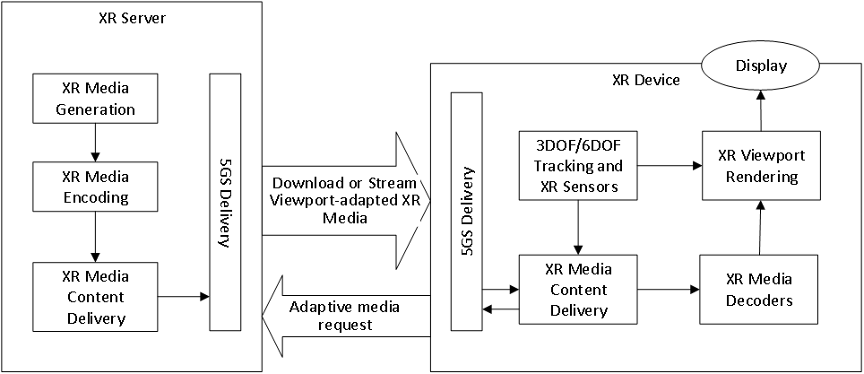
Figure 2Viewport-dependent Streaming Defined by TR26.928
Viewport Dependent 3DoF Streaming refers to the case where the XR server runs a 3DoF XR media generation engine, and the XR device collects local 3DoF tracking information to get the viewport related content to display.
According to Figure 1, the XR media is generated, encoded, and delivered by XR server depending on the adaptive media request sent by the XR device. The device works in two channels. One is to accept the XR media stream and the workflow of decoding, rendering, displaying is followed. Another is to use the tracking sensors to collect 3DoF parameters continuously, and ‘translate’ them into adaptive media request which will be sent to XR server by using 5GS delivery system.
The following call flow highlights the key steps:
- An XR device connects to the network and joins Viewport Dependent 3DoF Streaming application
- The device sends static device information and capabilities to server (supported decoders, display resolution)
- Based on these information, the XR server sets up encoders and formats, and pre-spilts the XR scene into blocks (e.g. several tiles used in HEVC encoders)
- Loop
  - The device collects XR 3DoF pose
  - XR pose is converted to media request by the device in order to cover the viewport of user and match the network condition
  - The XR server responses to these requests and provides the media segments
  - Compressed media is sent to XR device
  - The device decodes the media content
  - The device displays the media
According to TR 26.928, clause 6.2.3.5, for viewport dependent streaming, updated tracking and sensor information impacts the network interactivity. Typically, due to updated pose information, HTTP/TCP level information and responses are exchanged every 100-200 ms in viewport-dependent streaming.
In actual implementation process, in order to ensure the smooth transmission and viewing, sometimes it is adopted to transmit a channel of background data independent to the viewport in addition to the data described above, so as to replace these data to fill the playback when network condition is poor.

6.3.2 Considered Content Formats
In this scenario, the vast majority of transmitted media content is 2D or 3D 360 degree video. According to TR 26.928, clause 4.2.1, it is commonly accepted that 2k by 2k per eye provides acceptable quality. Thus the equivalent content resolution will be 6k~8k at 90 ~ 110 degree FOV. Framerate is 60 fps for common cases and 30 fps for some low demand services.
H.264/AVC Progressive High Profile Level 5.1 with additional restrictions or H.265/HEVC Main-10 Profile Main Tier Profile Level 5.1 are recommended as encoding codecs by TR 26.928 in clause 4.5.1. Network adaptive encapsulation format is usually used to ensure smooth transmission, e.g. MPEG-DASH.

6.3.3 Considered System Parameters
Based on the discussion above, several parameters are relevant for the overall system design.
- Streaming:
  - Type of streaming(live or video-on-demand)
  - state of streaming
- User Interaction:
  - 3DOF pose are collected
  - interactions by controllers
- Formats of transmitted content:
  - 6K or 8K at 30,60 fps on source end
  - 2K x 2K per eye at 30, 60fps
  - YUV 4:2:0
- Encoder configuration
  - Codec: H.264/AVC or H.265/HEVC
  - Bitrate: Several bitrate grades siutble for network adaptation needs (e.g. 100 Mbit/s+50Mbit/s+15Mbit/s)
  - Rate control: CBR, VBR, Feedback based
  - Slice settings:when using H.264/AVC, X per frame
  - Tile settings: when using H.265/HEVC, X per frame
  - Complexity settings for encoder
- Content Delivery
  - MPEG-DASH-based media delivery
  - HTTP-based feedback on bitrate
- 5G System/RAN Configuration:
  - QoS Settings (5QI): GBR, Latency, Loss Rate
- Content Delivery Receiver configuration:
  - Loss Detection: sequence numbers
  - Delay/Latency handling
  - Error Resilience
- Quality Aspects
  - Video quality (encoded)
  - Lost data
  - Immersiveness

6.3.4 Proposed Assumptions and Simulation Parameters
It is proposed to only consider the following system parameters:
- Streaming:
  - Types of streaming(live or video-on-demand)
  - state of streaming
- User Interaction:
  - 3DOF pose are collected
  - 3DOF interactions by controllers
- Formats of transmitted content:
  - 6K(6144 * 3072) or 8K(8192 * 4096) up to 60 fps on source end
  - 2K x 2K per eye up to 60fps
  - YUV 4:2:0, 4:2:2, 4:4:4
- Video Encoder configuration
  - Codec: H.264/AVC or H.265/HEVC
  - Operation Point (following 3GPP TS 26.118 Table 5.1-1): Basic H.264/AVC, Main H.265/HEVC, Flexible H.265/HEVC
  - Uplink Bitrate: for 6K up to 90Mbps, for 8K up to 150 Mbps
  - Rate control: CBR, VBR, Feedback based
  - Slice settings: when using H.264/AVC, X per frame
  - Tile settings: when using H.265/HEVC, 24 or 96 per frame
  - Complexity settings for encoder
- Audio Encoder configuration
  - Max Sampling Rate: 48 kHz
  - Operation Point(following 3GPP TS 26.118 Table 6.1-1): 3GPP MPEG-H Audio
- Content Delivery
  - MPEG-DASH-based media delivery
  - HTTP-based feedback on bitrate
- RAN Configuration:
  - QoS Settings (5QI): GBR, Latency, Loss Rate, Mobility, Power Consumption
- Receiver configuration:
  - Loss Detection: sequence numbers
  - Delay/Latency handling
  - Error Resilience
- Quality Aspects
  - Video quality (encoded)
  - Lost data
  - Immersiveness

6.4 Assumptions for Viewport Dependent 6DoF Streaming

6.4.1 Background
Attached to this document, please find a paper from IBC 2017 addressing network optimizations for VR Streaming. An author of the paper provided information beyond the paper.
It is considered that the model for VDP 3DOF streaming also applies for VDP 6DOF streaming.

6.4.2 Feedback based on Paper
Feedback based on the paper for 3DoF Viewport dependent Streaming:
- Downlink data rate ranges
  - for tiled streaming, 4K around 5 Mbit/s, up to 10.
  - 8K between 10 and 13, but can go under for static scenes and over for dynamic ones.
  - 5.5K stereo is the same as 8K mono.
  - Interestingly, for tiled streaming 360 or 180 make little difference if the viewport is the same.
- Maximum packet delay budget in uplink and downlink → for mass distribution I don’t care about the uplink much as long as the delay is not too jittery. Relate this to the segment size in an HLS pull – 2 secs is a good target segment size.
- Maximum Packet Error Rate, → for mass distribution applications, preferably use something reliable, like HLS push or pull or a proprietary reliable transport.
- Maximum Round Trip Time
  - for viewport-dependent, minimizing round-trip is crucial especially with head motion. That said there are no maximums.
  - There is a degradation as it increases. You should think in the order of frame duration, and know that head motion is about 500 degrees per second max, so 60 msec per tile, and that eyes also take some 60 msec to adapt to a new position, so you have a few frames to work with.

6.5 Assumptions for AR1: “XR Distributed Computing” and AR2: “XR Conversational”

6.5.1 General
The focus in clause 6.2 is currently on simulating split rendering where the uplink data consists of e.g. HMD pose information, but no video.
AR2 will however require video in the uplink. A more specific example is use case 8 in TR 26.928 (AR guided assistant at remote location (industrial services)), which requires one or two video streams in the uplink. Moreover, the XR-related work item ITT4RT includes support for an optional 2D video in the uplink.
It is expected that MNO:s may configure NR networks for less capacity in the uplink than the downlink, thus it would be relevant to confirm whether we can expect bottlenecks in the uplink, related to XR use cases. Also, it would be relevant to confirm whether the transmission of time-critical pose information in the uplink is impacted by the additional uplink video traffic.
As uplink video may in some use cases happen at the same time as split rendering in the downlink, it is relevant to add an uplink video signal with suitable characteristics, to the currently planned simulation scenario for AR2. It would be an option to include this video in the simulation.
Details are ffs.

7 End-to-End Simulation System

7.1 Introduction
This clause collects a system simulation system for different services.

7.2 Simulation System for Split Rendering

7.2.1 Overview
Figure 3 provides a simulation breakdown for split rendering. Three different areas of expertise are considered:
- Input on Video Signals related to the Split rendering use cases is expected to provide by companies
- SA4 addresses content encoding and content delivery, both on sender and receiver, and provides interfaces to 5G System and 5G radio.
- RAN addresses the simulation of 5G system and radio parameters.

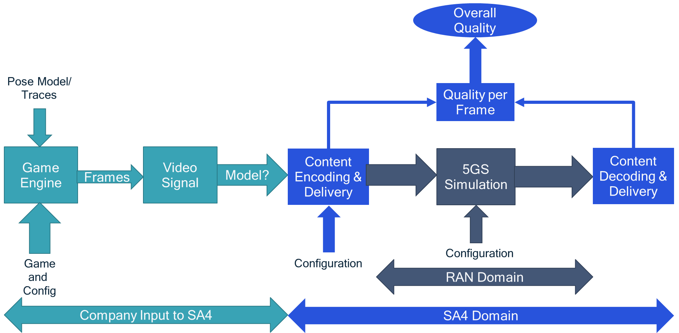
Figure 3 Simulation Breakdown for Split Rendering

Based on such a simulation, Figure 4 provides a potential simulation result that documents the delivered video quality and the percentage of bad video. It is expected that with more users in a cell, either the video quality needs to be degraded or more artefacts will happen.

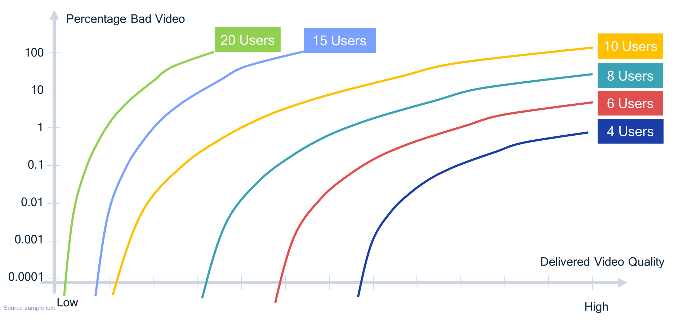
Figure 4 Potential Simulation Chart

7.2.2 Proposed Model Considerations

7.2.2.1 Overview
Tt is proposed to break down the simulation and modeling into separate individual components, namely
- Source video model
- Encoding and content delivery
- Radio access delivery
- Content delivery receiver and decoder
- Display process
- Uplink traffic
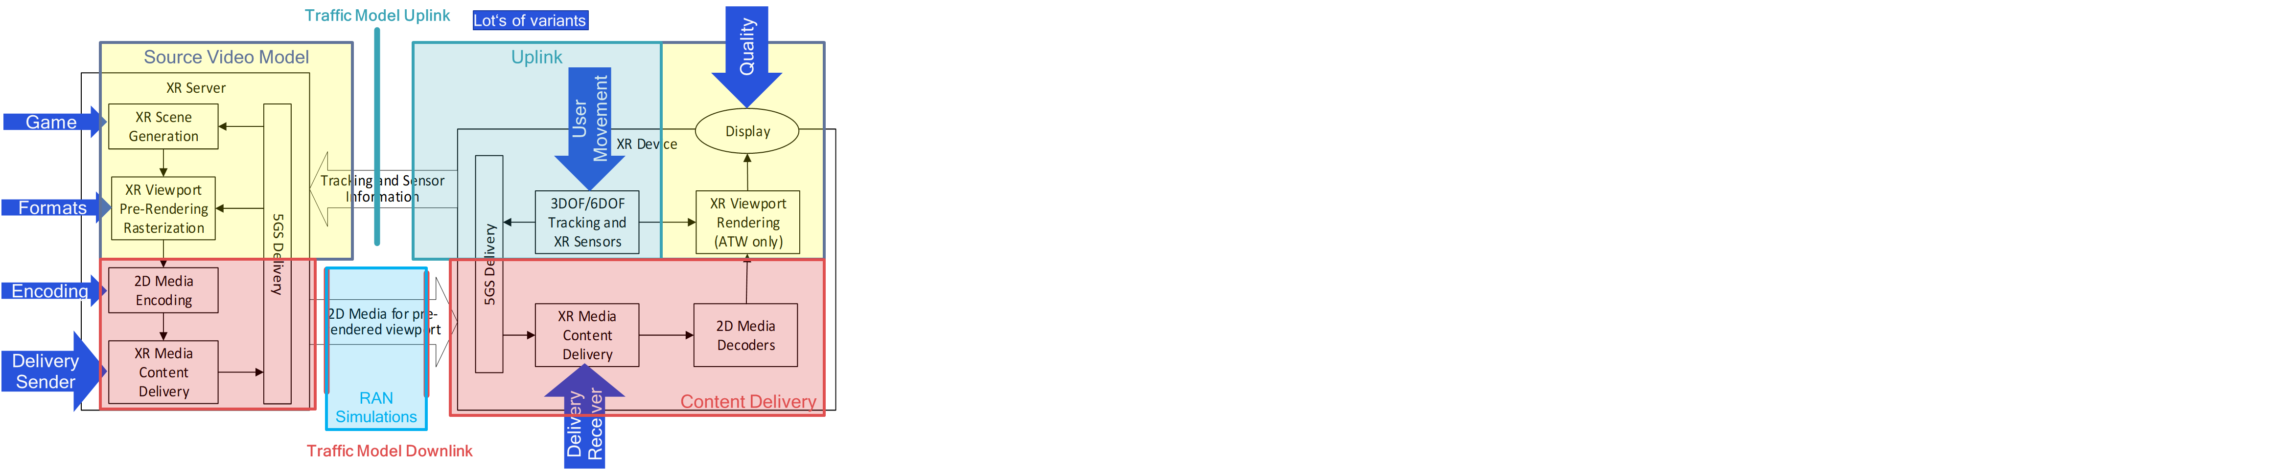
Figure 5 Breakdown of simulations

In order to split the tasks across different 3GPP working groups and companies, an approach as introduced in Figure 6 is proposed.
- Source model is provided based on company input that describes the used game, the pose model and a statistical model of the video signal that can be used to apply content delivery and encoding procedures.
- Based on these traces, 3GPP SA4 defines a content encoding and delivery model taking into account a system design based on TR26.928 and as documented in S4-200771. The system model includes encoding, delivery, decoding and also a quality definition.
- The system also provides an interface to RAN simulations. Then RAN groups may this model to simulate different traffic characteristics and evaluate different performance options.
Figure 6 Proposed Split of work for XR Traffic

A more detailed instantiation is provided in Figure 7. In particular, the following is defined:
- V-Traces: Video traces that provide sufficient information from a model encoding to understand the complexity and data rate for an encoding model, also taking into account delivery options such as bitrate control, intra refresh, feedback based error resilience and so on. Details are tbd, but we are currently investigating parameters provided by a model encoding from an x265 encoding run.
- S-Traces: a sequence of slices as an output of a model encoder. Each slice has assigned
  - Associated Frame (Timestamp)
  - Size of Slice
  - Quality of Slice (possibly some more information from V-Trace, for example complexity)
  - Number of Macroblocks (areas covered)
  - Timing of Slice, e.g. a deadline or a at least a origin time stamp.
- S'Trace:
  - All information from S-Trace Format
  - Slice loss indicator
  - Slice delay information
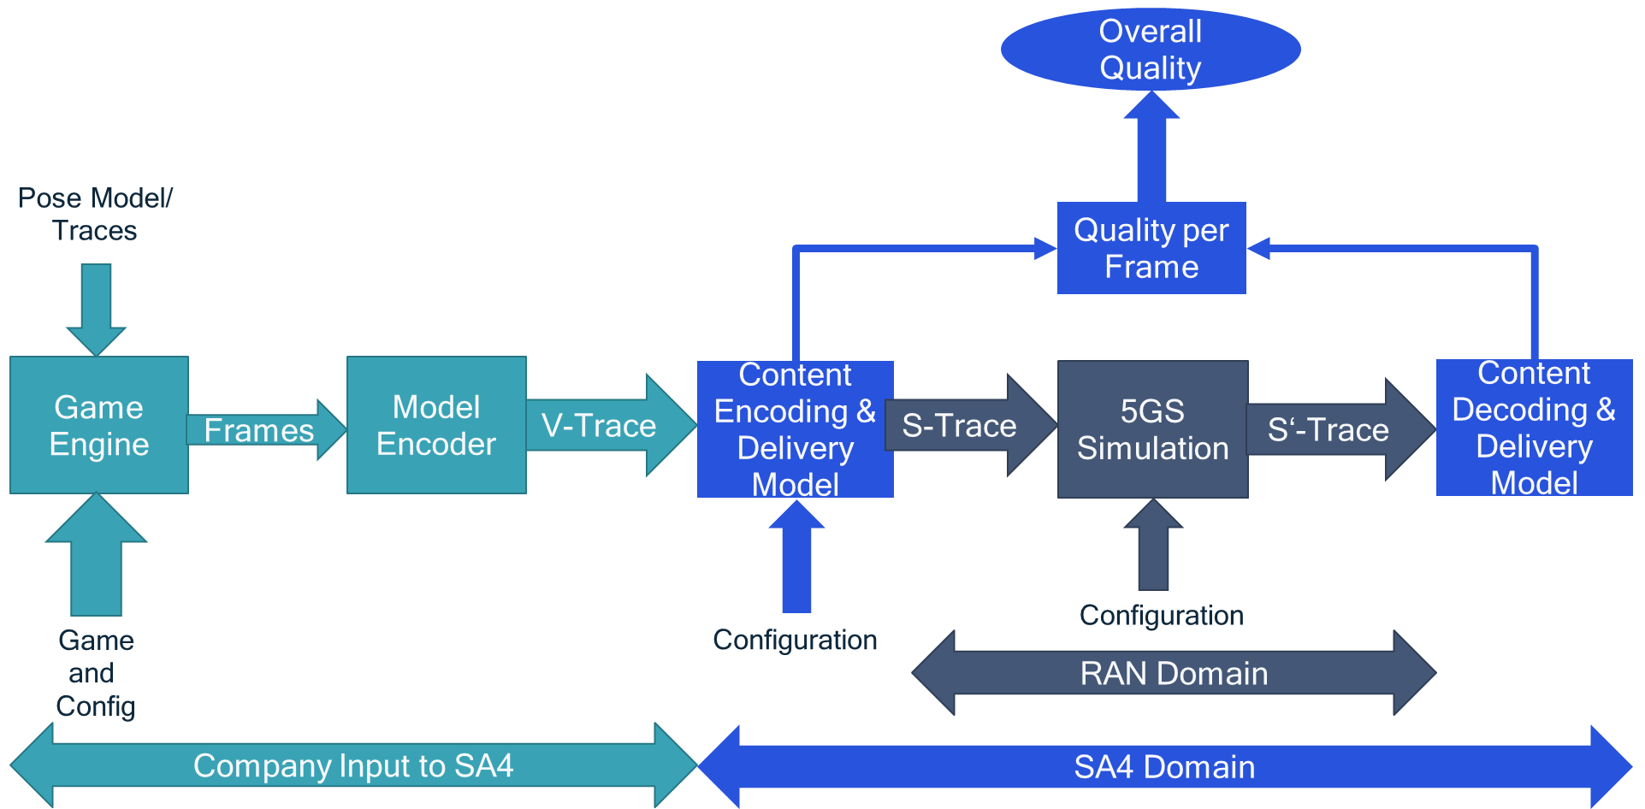
Figure 7 More detailed interface definitions for simulation interfaces

7.2.2.2 V-Trace Generation
V-Trace generation has been initiated by using a high-quality output of a game engine in H.264(AVC) for a model game and a repeatable trace, and decode this information into a 2K x 2K at 120 fps source frames.
This sequence is sent through a model encoder for identifying the impacts of different parameter settings. The following x.265 parameters are initially used:
  - --input viki.yuv (4:2:0)
  - --profile, -P main10
  - --input-res 2048x2048
  - --fps 120fps, 60fps, 30 fps
  - --psnr
  - --ssim
  - --frames 500 (initial testing)
  - --bframes 0
  - --crf 22, 25, 28, 31, 34
  - --csv logfile.csv
  - --csv-log-level 2
  - --log-level 4
  - --numa-pools "8"
  - --keyint, -I 1 and -1
  - --slices 1, 128 (2048), 8 (for 2048)
  - --output rvrviki.h265
  - --rc-lookahead 0/1
Based on these 180 encoding runs, we expect to get to a good encoder modeling such that only a subset of runs are necessary for longer game sequences.
The work is in progress.
An initial experiment was carried out.
A graphics-centric sequence of 8 seconds was generated using some pose information at 2K x 2K at 60fps from the output of a game engine. The sequence is attached to this document. Note that the sequence is only used initially in order to identify reasonable system parameter settings.
The sequence was encoded in total with 24 different configurations.
  - ./x265 --input input.yuv --input-res 2048x2048 --preset medium --fps [30,60] --crf [22, 28,34] --analysis-mode=save --analysis-file /csv_analfiles/00001.dat --keyint [-1,1] --slice [1,8] --csv /csv_analfiles/[i,p]_[30,60]_[22,28,34]_[1,8].csv --csv-log-level 2 --log-level full --rc-lookahead 0 --no-deblock --bframes 0 --frames 480 --psnr --ssim --output /output/xxxx.h265

Attached is also analysis file as output from x.265 with the results of all the different runs.
Analysis provided also in the excel.
A summary of the bitrates are provided
Mode | Framerate | CRF | Slice | Data  Rate  in Mbit/s | Average  QP | Average  Rate  Factor | Y  PSNR | U  PSNR | V  PSNR | YUV  PSNR | SSIM | SSIM(dB) | Frames
I | 60 | 22 | 1 | 43.77 | 27.29 | 19.09 | 42.58 | 46.58 | 46.12 | 43.52 | 0.979 | 16.82 | 480
I | 60 | 22 | 8 | 44.16 | 27.29 | 19.09 | 42.57 | 46.57 | 46.11 | 43.51 | 0.979 | 16.77 | 480
P | 60 | 22 | 1 | 14.14 | 23.82 | 21.99 | 43.46 | 48.27 | 47.83 | 44.60 | 0.983 | 17.80 | 480
P | 60 | 22 | 8 | 29.64 | 23.71 | 21.99 | 43.37 | 47.94 | 47.49 | 44.45 | 0.983 | 17.57 | 480
I | 60 | 28 | 1 | 21.56 | 33.30 | 25.09 | 39.07 | 44.11 | 43.64 | 40.27 | 0.960 | 14.00 | 480
I | 60 | 28 | 8 | 21.85 | 33.30 | 25.09 | 39.06 | 44.11 | 43.64 | 40.26 | 0.960 | 13.98 | 480
P | 60 | 28 | 1 | 3.86 | 30.17 | 27.99 | 40.36 | 46.12 | 45.57 | 41.73 | 0.972 | 15.51 | 480
P | 60 | 28 | 8 | 12.33 | 29.91 | 27.99 | 40.13 | 45.48 | 44.96 | 41.40 | 0.969 | 15.07 | 480
I | 60 | 34 | 1 | 10.55 | 39.35 | 31.09 | 35.68 | 42.62 | 42.16 | 37.36 | 0.928 | 11.44 | 480
I | 60 | 34 | 8 | 10.76 | 39.34 | 31.09 | 35.65 | 42.63 | 42.17 | 37.34 | 0.928 | 11.43 | 480
P | 60 | 34 | 1 | 1.30 | 36.75 | 33.99 | 37.16 | 43.84 | 43.32 | 38.77 | 0.949 | 12.94 | 480
P | 60 | 34 | 8 | 5.59 | 36.20 | 33.99 | 36.85 | 42.99 | 42.47 | 38.32 | 0.942 | 12.40 | 480
I | 30 | 22 | 1 | 29.43 | 24.88 | 19.28 | 44.08 | 47.70 | 47.27 | 44.93 | 0.984 | 17.99 | 250
I | 30 | 22 | 8 | 29.66 | 24.87 | 19.28 | 44.07 | 47.70 | 47.26 | 44.92 | 0.984 | 17.91 | 250
P | 30 | 22 | 1 | 12.78 | 21.87 | 22.18 | 44.43 | 48.95 | 48.51 | 45.50 | 0.986 | 18.41 | 250
P | 30 | 22 | 8 | 20.59 | 21.82 | 22.18 | 44.42 | 48.72 | 48.29 | 45.44 | 0.985 | 18.25 | 250
I | 30 | 28 | 1 | 14.54 | 30.88 | 25.27 | 39.07 | 44.11 | 43.64 | 40.27 | 0.960 | 14.00 | 250
I | 30 | 28 | 8 | 14.71 | 30.88 | 25.27 | 39.06 | 44.11 | 43.64 | 40.26 | 0.960 | 13.98 | 250
P | 30 | 28 | 8 | 3.82 | 28.07 | 28.17 | 41.23 | 46.69 | 46.19 | 42.53 | 0.976 | 16.11 | 250
P | 30 | 28 | 8 | 8.34 | 27.94 | 28.17 | 41.09 | 46.17 | 45.67 | 42.30 | 0.974 | 15.80 | 250
I | 30 | 34 | 1 | 7.14 | 36.91 | 31.26 | 37.07 | 43.19 | 42.73 | 38.54 | 0.943 | 12.44 | 250
I | 30 | 34 | 8 | 7.26 | 36.91 | 31.26 | 37.05 | 43.20 | 42.74 | 38.53 | 0.943 | 12.43 | 250
P | 30 | 34 | 1 | 1.29 | 34.38 | 34.16 | 38.09 | 44.36 | 43.83 | 39.59 | 0.957 | 13.62 | 250
P | 30 | 34 | 8 | 3.71 | 34.11 | 34.16 | 37.86 | 43.57 | 43.12 | 39.23 | 0.952 | 13.21 | 250

An analysis of the rate increase per frame is shown. Details in excel, summary below.
1 Slices
I only |  |  |  |  | P only
22->28/60 | 28->34/60 | 22->28/30 | 28->34/30 |  | 22->28/60 | 28->34/60 | 22->28/30 | 28->34/30
2.03 | 2.04 | 2.02 | 2.04 |  | 3.85 | 3.23 | 3.46 | 3.18

8 Slices
I only |  |  |  |  | P only
22->28/60 | 28->34/60 | 22->28/30 | 28->34/30 |  | 22->28/60 | 28->34/60 | 22->28/30 | 28->34/30
2.02 | 2.03 | 2.02 | 2.03 |  | 2.42 | 2.21 | 2.48 | 2.25

The rate increase for I-frames to P-frames are shown. Details in excel, summary below.
Frame | I/P 22/60/1 | I/P 28/60/1 | I/P 34/60/1 | I/P 22/60/8 | I/P 28/60/8 | I/P 34/60/8
Average | 3.17 | 6.10 | 10.03 | 1.51 | 1.81 | 1.81

The rate increase for 30fps for each frame is shown. Details in excel, summary below.
Frame | 22-1 | 28-1 | 34-1 | 22-8 | 28-8 | 34-8
Average | 1.83 | 2.13 | 2.28 | 1.39 | 1.38 | 1.36

From these results some initial conclusions:
- Data rates are quite different
- Slices are very costly if used without prediction across slice boundaries
- Prediction over 2 P-frames results roughly in factor 2
- Rate increase per CRF/QP for I is consistently 2 for QP increase 6

7.2.3 Content Delivery Emulation and Simulation

7.2.3.1 Introduction
Based on the discussion in clause 6.2, the content modeling is documented in Figure 8. This modeling includes:
- V-Model input
- Global configuration for encoder
- Statistical or dynamic feedback from content delivery receiver
- A decoding model
- Quality Model
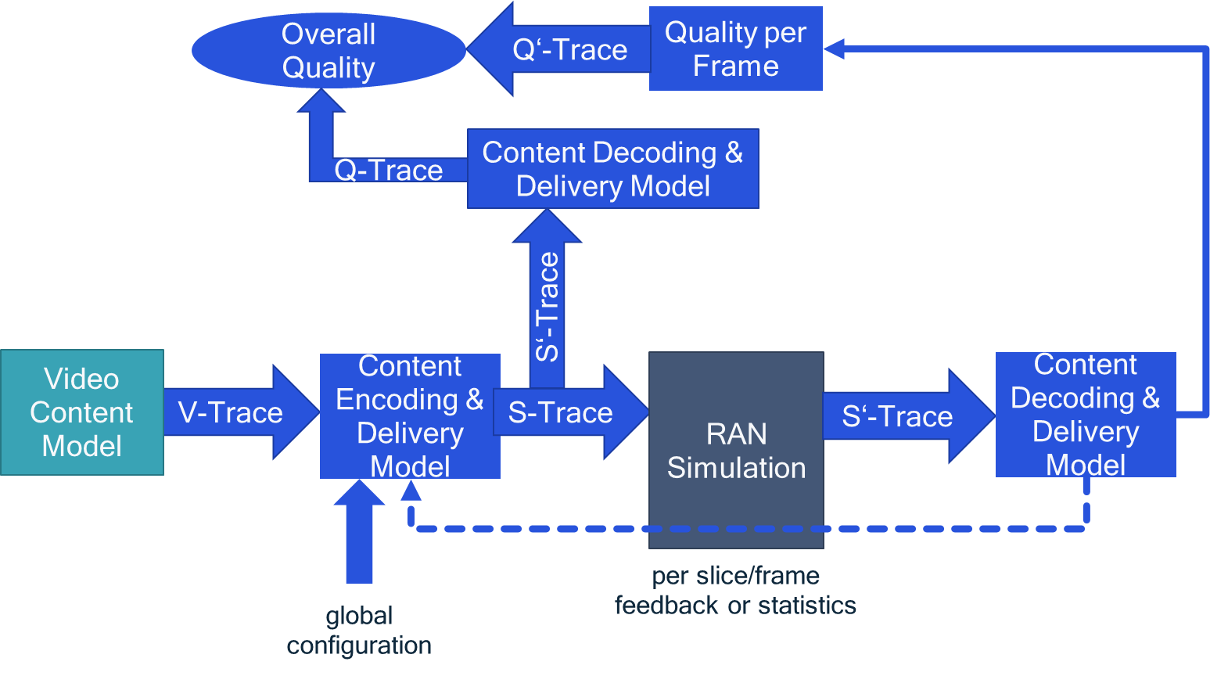
Figure 8 Content Delivery Modeling

The content encoding is modelled as follows:
- For frame i from V-Trace (based on sample time)
  - Read frame i from V-Trace (timestamp)
  - Read latest dynamic information from dynamic status info
  - Do a model encoding (based on input parameters)
  - For slice s=1, 2, …, S
    - Drop slice s with associated parameters
    - new slice available creates IP packets
    - For IP packet p=1, 2, …, P
      - Drop IP packet with associated parameters and with timestamp to S-Trace 1, but also parameters such as slice number
Configuration parameters for content encoding may include
- Input: Global configuration
  - Bitrate Control: Constant Quality, Constant Bitrate, Feedback-based Variable Bitrate, Constant Rate Factor 28
  - Slice Setting (number of slices 10, maximum slice size)
  - Error Resilience, Frame-based, Slice-based, Periodic Intra Refresh 10, Feedback-based intra refresh, Feedback-based prediction (NVIDIA: Period Intra Refresh, Reference Picture Invalidation)
- Input: Dynamic per slice information
  - off
  - statistically for bitrate or losses with some delay
  - operational for bitrate or losses with some delay
Model encoding is for further study, but aspects to be taken into account are:
- Impacts of QP settings and intra ratio and slice settings
- Feedback
  - Bitrate adjustments: Encoder gets an encoding bitrate and adjusts QP (see +/-1 ➔ 12%)
  - Add Intra in case of a lost slice: significantly more intra added in case of a reported loss. Intra covers large area (depending on motion vector activity)
  - Predicting from ACK only: statistical increase for frame size for lost slices, as not the latest one can be used
- Slice settings
Decoding emulation is based on the delay and loss of slices. Late and lost slices are considered unavailable and cause errors.

7.2.3.2 V-Trace Format:
- Needs some kind of encoding configuration
  - Applied bitrate control
  - Parameters of the command
  - CRF encoding with CRFref = 28
  - 1 slice, I and P encoding
  - Reference frames
- Presentation Time Stamp
- POC Picture Order Count - The display order of the frames.
- I-Frame
  - QP Quantization Parameter decided for the frame.
  - Bits Number of bits consumed by the frame.
  - PSNR Peak signal to noise ratio for Y, U and V planes.
  - SSIM A quality metric that denotes the structural similarity between frames.
  - Total frame time Total time spent to encode the frame.
- P-Frame
  - POC Picture Order Count - The display order of the frames.
  - QP Quantization Parameter decided for the frame.
  - Bits Number of bits consumed by the frame.
  - PSNR Peak signal to noise ratio for Y, U and V planes.
  - SSIM A quality metric that denotes the structural similarity between frames.
  - Latency Latency in terms of number of frames between when the frame was given in and when the frame is given out.
  - Ref lists POC of references in lists 0 and 1 for the frame.
  - Total frame time Total time spent to encode the frame.
  - Percentage CU Intra
  - Percentage CU Merge
  - Percentage CU Skip
  - Percentage CU Inter
In the example attached
- Yellow: Used for Encoding Modelling in CRF mode

7.2.3.3 Global Configuration (each of the following):
- Bitrate Control (one of the following):
  - Constant Bitrate – bitrate & buffer
  - Feedback-based Variable Bitrate - dynamic
  - Constant Rate Factor – rate factor with CRF (default: CRFref is used)
- Slice Setting (one of the following)
  - Default – no slices
  - number of slices – number of slices (typical numbers are 4, 8, 16)
  - maximum slice size – number in bytes
- Error Resilience (one of the following)
  - Intra-refresh frame parameter would be the period (default is no intra refresh)
  - Intra-refresh slice: period (1 ➔ 1 slice every 1 frame with the slice being picked as POC mod #slices ) 2 ➔ 1 slice every 2 frames)
  - Feedback-based
    - Mode:
      - intra refresh: add an intra for the lost slice
      - ACK-mode: only use acknowledge slices in prediction
      - NACK-mode: use an old reference frame or intra in case of loss

7.2.3.4 Dynamic status:
- Max number of bits for next frame (external rate control)
- frame Number, slice number ACK/NACK/unknown

7.2.3.5 Content Encoding Modelling
The content encoding is modelled as follows:
- Create a map of slices, CTU maps (64 x 64) and reference frames
  - Example: 2048 x 2048, 8 slices, 3 reference frames
    - Addresses for 2048 / (8 * 64) = 4 rows with 32 CTUs for 8 slices in 3 frames maintained.
    - For each CTU store encoding mode:
      - intra/inter+merge/skip
      - largest reference frame (only previous one is used in simple config)
- For frame i from V-Trace (based on sample time)
  - Read frame i from V-Trace (timestamp)
  - Read latest dynamic information from dynamic status info, if applicable
  - Do a model encoding
    - Input parameters: V-Trace, global configuration, dynamic status (if applicable)
    - Output: s slices with parameters
- Based on the map of intra and inter for each slice/MB
  - Constant CRF
    - Re-use the CRFref for which the Trace was generated.
    - For every CTU
      - Take P-frame intra/inter/merge/skip percentage and decide intra/inter/merge/skip randomly. This is done that the number of MBs is matching the trace entry.

    - For every slice,
      - apply intra/(inter + reference) decision as follows
        - Periodic: slice mode follows pattern, other inter + reference 1
        - Feedback intra: slice was lost => intra, else inter + reference 1
        - Feedback ack: only ACK slices => reference inter + reference backward (typically more than 1), such that the slice was acked.
        - Feedback NACK: slice nack => reference inter + reference backward (typically more than 1) prior to NACK or intra.
      - For intra slices,
        - overwrite the above CTU decision and make it an intra

      - draw a number of bits for the slice
        - that takes into account
          - the type of the CTU
          - the information in the trace file
        - the total amount of the bits for this slice by the following modelling
          - intra size:
            - take total intra size and divide by number of CTUs as medium value
            - apply Gaussian drawing with 10% variance of the total number of bits
            - Use the CRF and apply adjustment as follows
              - FinalBits = Bits * pow(2, (CRFref – CRF)/6)
              - QPnew = QPref - (CRF – CRFref)
          - skip:
            - 1 byte
          - merge + inter
            - compute medium value as total inter size (total P-size - intra-percentage*intra-size – skip-percentage) and divide by number of inter CTUs (total CTUs*(1 – intra_percentage – skip_percentage))
            - reference frame 1
              - apply Gaussian drawing with 20% variance of the total number of bits with medium value
              - Use the CRF and apply adjustment as follows
                - FinalBits = Bits * pow(2, (CRFref – CRF)/6)
                - QPnew = QPref - (CRF – CRFref)
            - reference frame more than 1, it is X
              - take total inter size and divide by number of CTUs as medium value
              - multiply the medium value with X
              - apply Gaussian drawing with 20% variance of the total number of bits
              - do also intra test as above, if intra is lower, apply intra, else this inter mode.
              - Use the CRF and apply adjustment as follows
                - FinalBits = Bits * pow(2, (CRFref – CRF)/6)
                - QPnew = QPref - (CRF – CRFref)
        - sum up the size of each CTU for the slice
      - Dump the following information:
        - Slice Timing/frame count
        - Left or right eye
        - Slice availability (after the slice timing) relative to 0.
          - Without encoding delay this is the same as the slice. time.
        - Quality/QPnew
        - New PSNR – add a function
        - Slice size
        - Slice type
        - CTU types
  - Bitrate constrained – a total max of bits available max_bits
    - Do the same as for constant CRF
    - Iterate to the smallest CRF that fulfill max_bits

The following issues are not yet included:

- Modelling of encoding times – no priority
  - Model encoding delay.
- We also need to address the two independent buffers for left and right eye.
  - Can we for now create the same process
    - Option 1: Same timing
    - Option 2: staggered left right at half the frame rate
- Can we derive a new PSNR for the updated QP?
  - (Thomas) check for model
  - In the absence of a model, we just make 1 QP step up reduces PSNR by 1dB (linear)
- What about slice modelling and all the issues that we saw
  - Ignore slice modelling for now, no bitrate change compared to not using slices.
- We need to also address ACK/NACK based feedback
  - NACK already addressed above.
  - ACK you only take acknowledged slice/frames for references – this basically extends the reference frame the feedback delay per slice.

7.2.3.6 Slice to RTP/IP Packets
Configuration
- Maximum MTU size, e.g. 1500 bytes – last packet just fills the remaining data.
For each slice, create fragmentation units
- Separate slice into several same size max packets except for the last.
- Add to each packet the slice number
Now we have a packet delay/loss simulator for the RTP packets.
covery thor recovering slice t- if one packet of a slice is lost the entire slice is lost
latest packet detrival time of Dump the following information:
  - Left or right eye
    - The time it took through system
  - Quality/QPnew
  - Slice size
  - CTU types

7.2.4 RAN Simulation
We believe that initially SA4 should emulate RAN simulation based on existing 5QIs. Once complete this should be provided to the RAN group for discussion.
The RAN simulation parameters are as follows:
- packet loss statistics
- delay statistic
- Is the loss probability/delay depending on the amount of data that is produced?

7.2.4 RAN Simulation
We believe that initially SA4 should emulate RAN simulation based on existing 5QIs. Once complete this should be provided to the RAN group for discussion.

7.2.5 Quality Evaluation

7.2.5.1 Overview
Quality Evaluation is based on two aspects, namely the encoding quality and the quality degradation due to lost slices. This evaluation is shown in Figure 9.

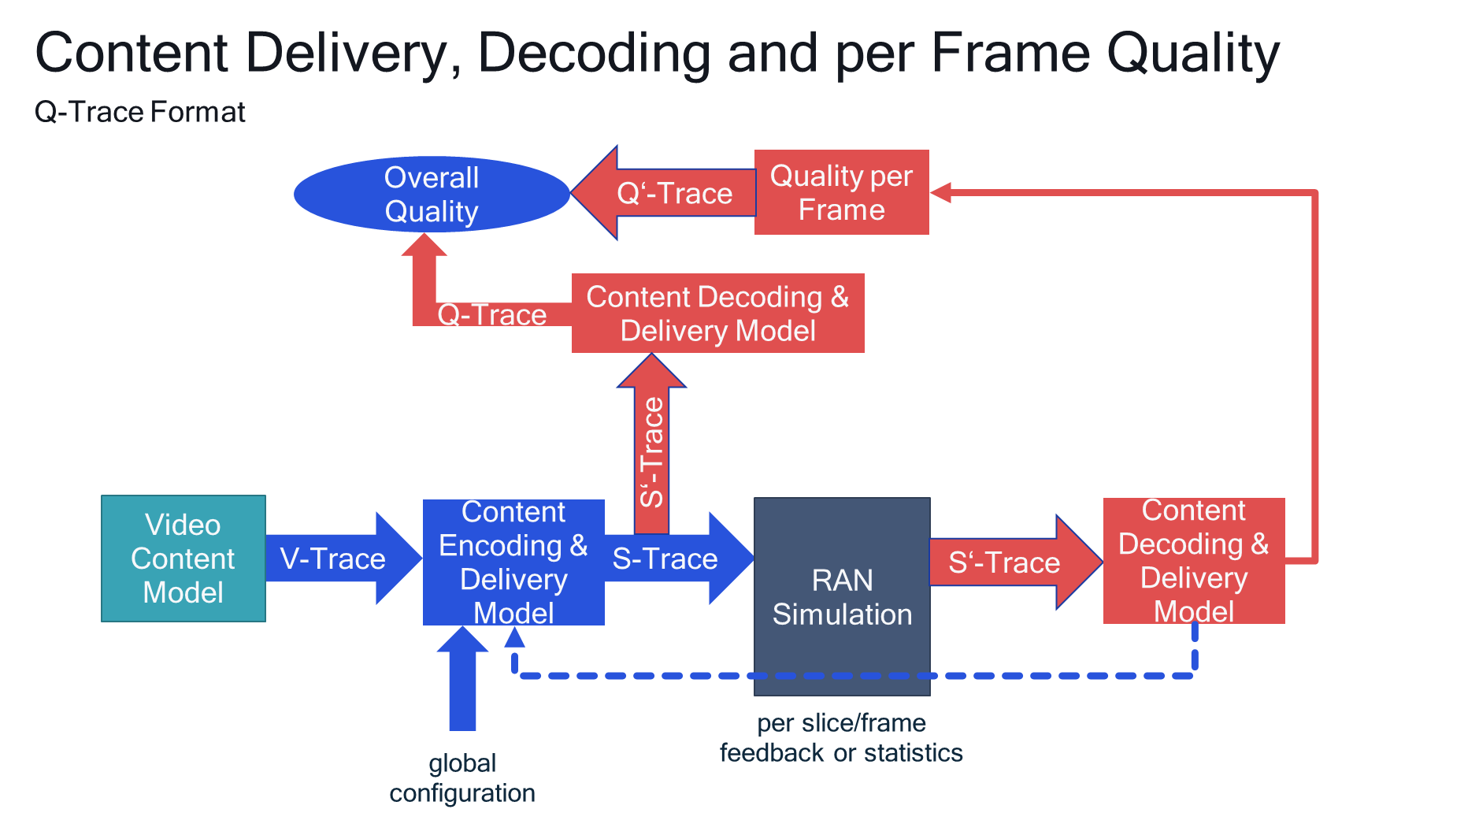
Figure 9 Quality Evaluation

The following simulation is proposed for identifying damaged macroblocks:
- Keep a state for each macroblock
  - Damaged
  - Correct
- Macroblock is damaged
  - If it is part of a slice that is lost for this transmission
  - If it is correctly received, but it predicts from a wrong macroblock
- Macroblock is correct
  - If it is received correctly and it predicts for a non-damaged macroblock
- Predicting from non-damaged macroblock means
  - Spatial prediction is correct
  - Temporal prediction is correct
  - Recovering MBs done by Intra Refresh and predicting from correct MBs again.
Depending on the configuration and the setting of the delivered video quality, different results may be obtained. An example is shown in Figure 10.
A quality threshold may for example be to have at most 0.1 % of damaged video area. Also the quality of the original content may be a threshold. Details are ffs.
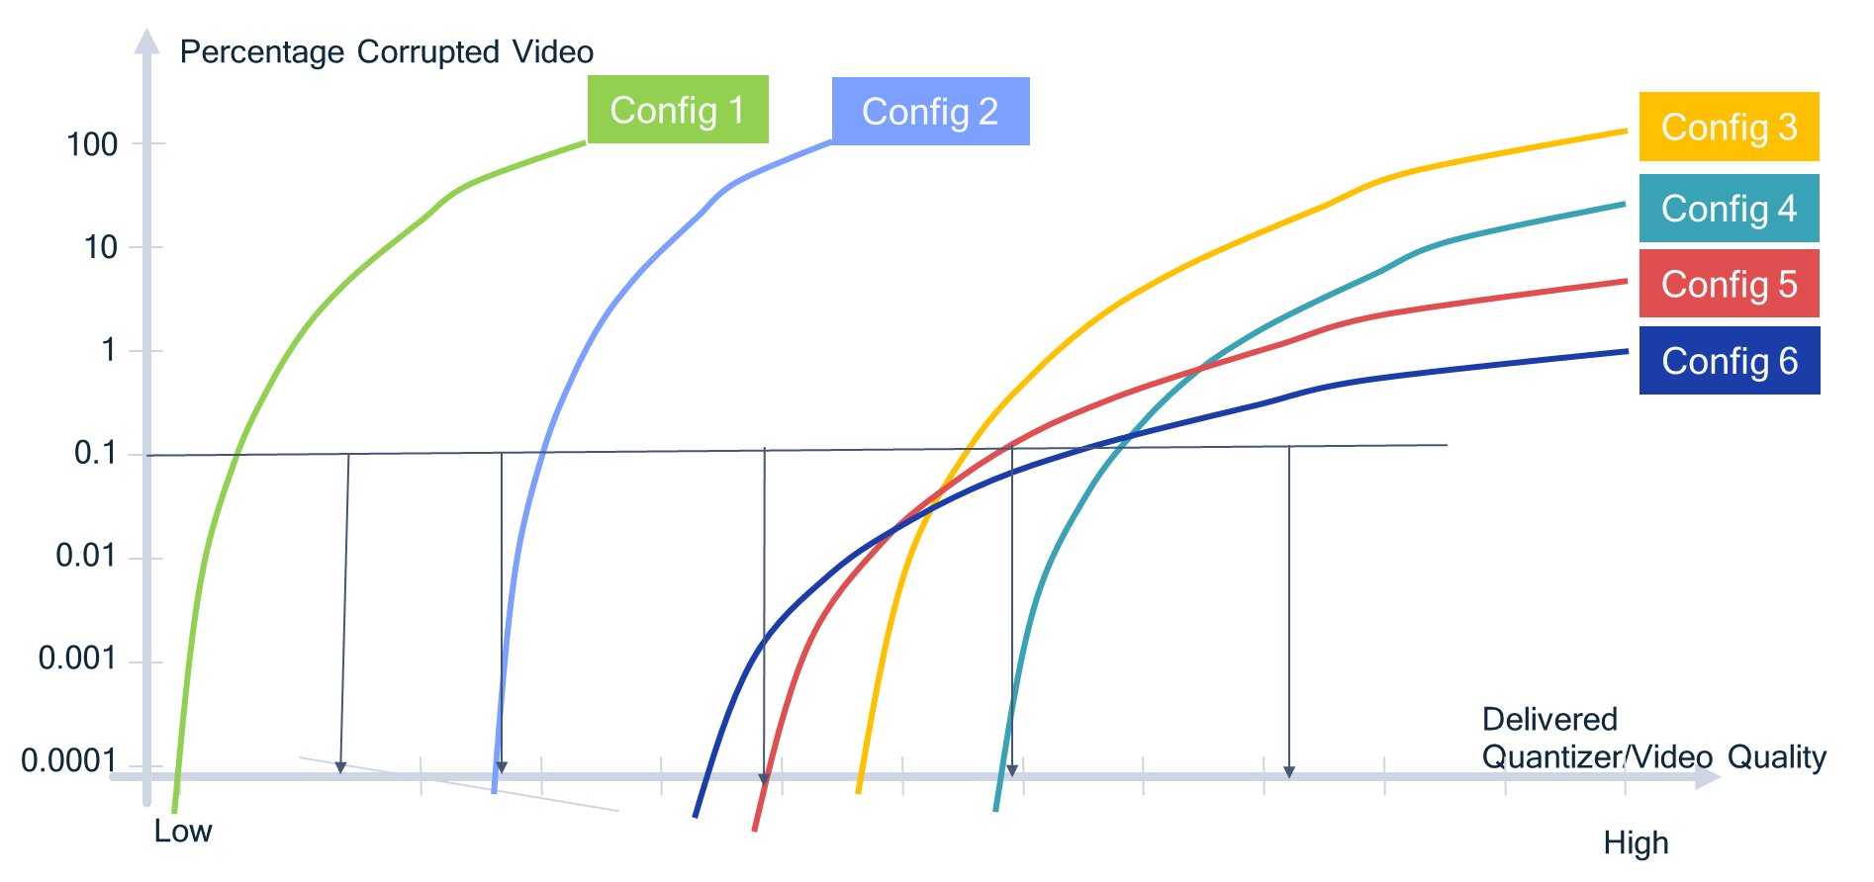
Figure 10 Potential Evaluation Graph

7.2.5.2 Slice Recovery
At the recovery the following happens for recovering RTP/IP packet traces:
- if one packet of a slice is lost the entire slice is lost
- the delay of the latest packet determines the arrival time of the slice.
- Dump the following information:
  - Slice Timing/frame count
  - Left or right eye
  - Slice availability (after the slice timing) relative to 0.
    - The time it took through system
    - It can also be infinite = lost
  - Quality/QPnew
  - New PSNR – add a function
  - Slice size
  - Slice type
  - CTU types

The result is a slice delay trace
- Slice Timing/frame count
- Left or right eye
- Slice availability (after the slice timing) relative to 0.
  - The time it took through system
  - It can also be infinite = lost
- Quality/QPnew
- New PSNR – add a function
- Slice size
- Slice type
- CTU types

7.2.5.3 Quality eoeyesrment
Input information
- Trace of
  - Slice Timing/frame count
  - Left or right eye
  - Slice availability (after the slice timing) relative to 0.
    - The time it took through system
    - It can also be infinite = lost
  - Quality/QPnew
  - New PSNR – add a function
  - Slice size
  - Slice type
  - CTU types

Run the following algorithm:
- Input parameters.
  - Parameters of source
    - Resolution
    - reference frames
  - Slice Trace
  - Loss delay
  - <Decoding delay>
- Create a map of slices, CTU maps (64 x 64) and reference frames
  - Example: 2048 x 2048, 8 slices, 3 reference frames
    - Addresses for 2048 / (8 * 64) = 4 rows with 32 CTUs for 8 slices in 3 frames maintained.
    - For each CTU of each frame, store mode:
      - Correct
      - Damaged
      - Unavailable
    - Initialize all CTUs as unavailable
- For each frame i
  - Get all slices from trace for the frame
  - For all slices that are lost or later than decoding delay
    - Mark all CTUs as unavailable
    - Indicate the slice loss for feedback
  - For all slices that than loss delay
    - Mark all CTUs as unavailable
    - Indicate the slice loss for feedback

To be continued

7.2.6 Software Package
All software packages are available here https://github.com/haudiobe/XR-Traffic-Model/tree/strace-encoder. The README is provided below.

XR-Traffic-Model

installation
Python 3.6.9 or above is required. To install dependencies, run :
pip install -r ./requirements.txt

V-trace to S-trace model encoder
The model encoder takes in a csv file with V-trace as rows, and by default outputs another csv with S-trace as rows.
Explicit configuration options need to be passed over as command line arguments. For the full list of options and their default values, just run:
python ./xrtm_encoder.py --help

V-trace format
see ./sample.vtrace.csv for sample data

Example usage
the default frame size (w)2048 * (h)2048. see next section for customization option details.
model encode w/ periodic slice refresh, 16 slices per frame, with a custom CRF adjustment
python ./xrtm_encoder.py -i ./sample.vtrace.csv -s=16 -e=2 --crf=25 -o ./strace_out.csv
model encode w/ feedback based error resilience, 32 slices per frame, no CRF adjustment
python ./xrtm_encoder.py -i ./sample.vtrace.csv -s=32 -e=3 ./strace_out.csv
model encode w/ periodic frame refresh, one I-frame every 60 frames, 8 slices per frame
python ./xrtm_encoder.py -i ./sample.vtrace.csv -e=1 -s=8 -g=60 ./strace_out.csv

Configuration / CLI arguments

width / height
-W or --width
-H or --height
Frame width/height is not specified as part of the V-trace model. Instead, you specify it explicitely. The default values are -W=2048 and -H=2048

Slices
-s or --slices
specifies how many slices (S-trace) per frame (V-trace) the model encoder must produce
the resulting slice height must be a multiple of 64.
Slices are generated by dividing the frame height evenly vertically, and using the full frame width.

Error resilience modes
-e or --erm
3 error resilience modes are implemented. Error resilience modes manages the intra coding decision, overriding the picture coding type specified in V-trace data.

PERIODIC_FRAME -e=1 or --erm=1 (default)
an intra frame is inserted every n frames.
how often intra frame must be inserted is specified using the -g or --gop option
python ./xrtm_encoder.py -i ./vtrace.csv -s=4 -e=1 -g=60
in this mode, feedack is not currently taken into account.

PERIODIC_SLICE -e=2 or --erm=2
Only the first frame will be a full intra. Then periodic intra refresh is performed through slices. The intra slice index incremented on each frame: is_intra_slice = ((frame_poc % slices_per_frame) == slice_idx).
python ./xrtm_encoder.py -i ./vtrace.csv -s=4 -e=2
in this mode, feedack is not currently taken into account.

FEEDBACK_BASED -e=3 or --erm=3
The first frame gets encoded as Intra, then all subsequent frames get encoded as Inter, unless client feedback status requests otherwise.
Currently, the reported status is generated randomly at slice level, the encoder handles only INTRA_REFRESH and NACK feedback status only.

Implementing a client for status reporting :
the client needs to implement the xrtm_feedback.FeedbackStatus interface. when the encoder class is instantiated, it receives the FeedbackStatus implementation as a dependency.

Rate control mode
the model encoder currently only supports CRF
--crf
This option generates S-trace with adjusted bit size that takes into account the specified target CRF. When unspecified, the CRF from V-trace is used and remains unchanged.

Misc options
--log_level
default=0 - set log level. 0:CRITICAL, 1:INFO, 2:DEBUG
--plot
plot V-trace and S-trace stats using matplotlib

7.3 Simulation System for Viewport Dependent 3DoF Streaming

7.3.1 Overview
Figure 1 shows the proposed simulation structure for Viewport Dependent 3DoF Streaming. As follows are several issues to be clarified:
- According to the simulation assumptions, content provider can provide appropriate raw VR media and processed VR panorama with required resolution, bitrate, and so on.
- RAN provides the 5GS simulation which consists of 5G system and radio configuration.
- SA4 addresses the encoding/decoding and content delivery part, and one thing worth explaining is that the tiling procedure may be realized using tools that are open or developed by companies, keeping within bounds of 3GPP and MPEG(OMAF) specifications.
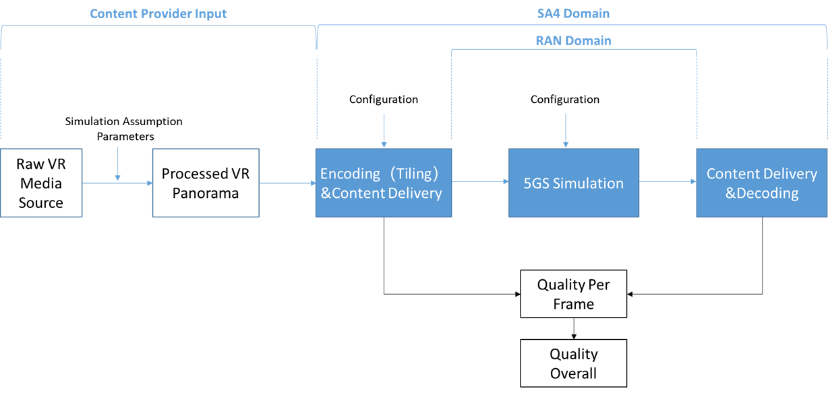
Figure 11 Simulation Structure For Viewport Dependent 3DoF Streaming

Figure 4 shows a potential simulation result.
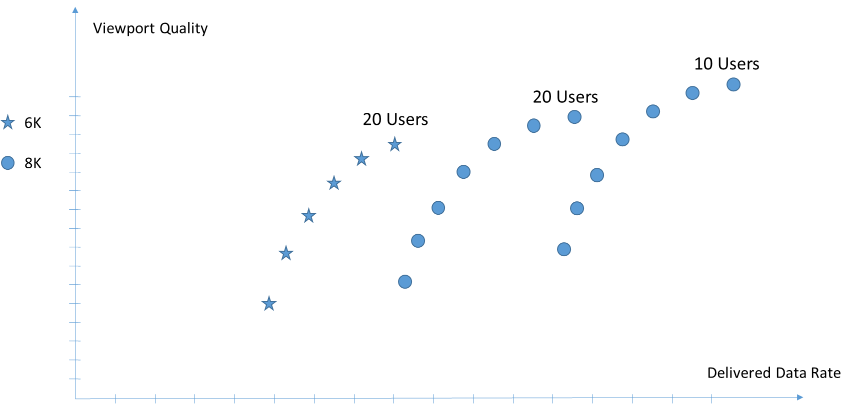
Figure 12 Potential Simulation Results
For the same number of users, the quality of viewport video at 8K resolution is expected to be relatively better than that of 6K video.
For the same resolution but different number of users, the video quality may decrease when the number of users grows, because of the limited network resource in one cell.

Dr. Thomas Stockhammer (Qualcomm Incorporated), tsto@qti.qualcomm.com

