Source: Intel, Nokia Corporation (ITT4RT Co-Rapporteurs)
Title: ITT4RT Permanent Document – Requirements, Working Assumptions and Potential Solutions
Version: 0.8.1
Document for: Agreement
Agenda Item: 11.5

Introduction

A new work item on “Support of Immersive Teleconferencing and Telepresence for Remote Terminals” (ITT4RT) as defined in SP-180985 was approved during SA#82 in Dec. 2018.

The objective of this Work Item is to specify VR support in MTSI in TS 26.114 [1] and IMS-based Telepresence in TS 26.223 [2] to enable support of an immersive experience for remote terminals joining teleconferencing and telepresence sessions. For MTSI, the work is expected to enable scenarios with two-way audio and one-way immersive video, e.g., a remote single user wearing an HMD participates to a conference will send audio and optionally 2D video (e.g., of a presentation, screen sharing and/or a capture of the user itself), but receives stereo or immersive voice/audio and immersive video captured by an omnidirectional camera in a conference room connected to a fixed network.

More specifically, this work item aims to conduct normative work in TS 26.114 and also in TS 26.223, toward specifying the following aspects for immersive video and immersive voice/audio support:

- Recommendations of audio and video codec configurations (e.g., profile, level, and encoding constraints of IVAS, EVS, HEVC, AVC as applicable) to deliver high quality VR experiences
- Constraints on media elementary streams and RTP encapsulation formats
- Recommendations of SDP configurations for negotiating of immersive video and voice/audio capabilities. For immersive voice and audio considerations using IVAS, this is dependent on specification of the IVAS RTP payload format to be developed as part of the IVAS WI
- An appropriate signalling mechanism, e.g., RTP/RTCP-based, for indication of viewport information to enable viewport-dependent media processing and delivery
The RTP payload format and SDP parameters to be developed under the IVAS WI will be considered to support use of the IVAS codec for immersive voice and audio. The RTP payload format and SDP parameters for HEVC will be considered to support immersive video.

For video codec(s), use of omnidirectional video specific Supplemental Enhancement Information (SEI) messages for carriage of metadata required for rendering of the omnidirectional video will be considered. Suitable video codec configurations for omnidirectional video specified in TS 26.118 as part of the VRStream Rel-15 work item will also be considered, subject to their applicability to the conversational service environment.

In case the IVAS codec cannot be finalized in the time frame of this work item, this work will provide only limited support for immersive voice/audio using the EVS codec based on multi-mono EVS coding, and in that case, full support for immersive voice/audio will be added subsequently when the IVAS codec is available as a separate work item.

Note that it is envisioned that work outside this work item will address suitable acoustic requirements in sending and receiving, considering stereo/immersive audio is not supported by current acoustic tests in TS 26.131 and TS 26.132, and taking into account objective requirements defined in TS 26.260.

This permanent document addresses the requirements, working assumptions and potential solution aspects for this Work Item.

Main Use Case

A group of colleagues is having a meeting in conference room A (see Figure 1). The room consists of a conference table (for physically present participants), a 360-degree camera, and a view screen. Two of their colleagues, Bonnie (B) and Clyde (C) are travelling and join the meeting through a conference call.

- Participants in conference room A use the screen to display a shared presentation and/or video streams coming from Bonnie and Clyde.
- Bonnie joins the conference from her home using a Head Mounted Display (HMD) and a camera that captures her video. She has a 360-degree view of the conference room.
- Clyde joins the conference from the airport using his mobile phone. He also has a 360-degree view of the conference room on his mobile screen and uses his mobile camera for capturing his own video.
Both Bonnie and Clyde can see the screen in the conference room as part of the 360-degree video. They also have the option to bring into focus any of the incoming video streams (a presentation or the other remote participant’s camera feed) using their own display devices. The manner in which this focused stream is displayed is a function of their display device and is not covered in this use case.

Within the 3GPP MTSI TS 26.114 [1] and Telepresence TS 26.223 [2] specifications, the above use case can be realized in two possible configurations, which are explained below. The participants are referred to as A, B and C from here onwards.

In the first scenario, shown in Figure 2.1, the call is set up without the support of any media-aware network elements. Both remote participants, B and C, send information about their viewport orientation to A, which in turn sends them a viewport-dependent video stream from the omnidirectional camera.

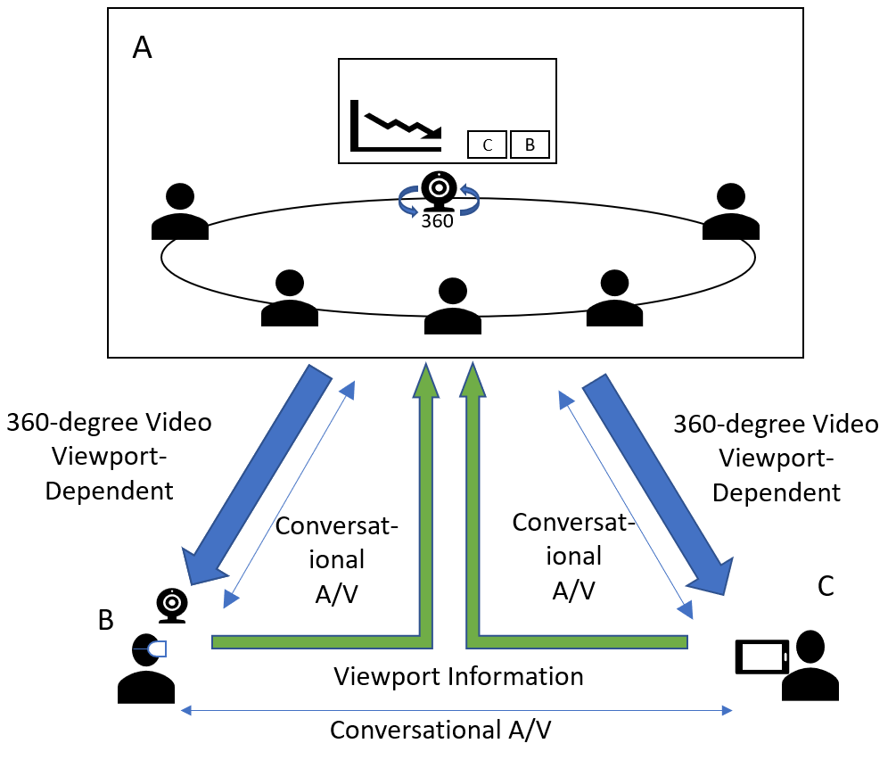
Figure 2.1 - 360-degree conference call
In the second scenario, the call is setup using a network function, which may be performed by either a Media Resource Function (MRF) [1] or a Media Control Unit (MCU) [2]. In this case, the MRF/MCU receives a viewport-independent stream from A. Both B and C, send viewport orientation information to the MRF/MCU and receive viewport-dependent streams from it. Figure 2.2 illustrates the scenario. The A/V channel for conversational non-immersive content also flows through the MRF/MCU in the figure.

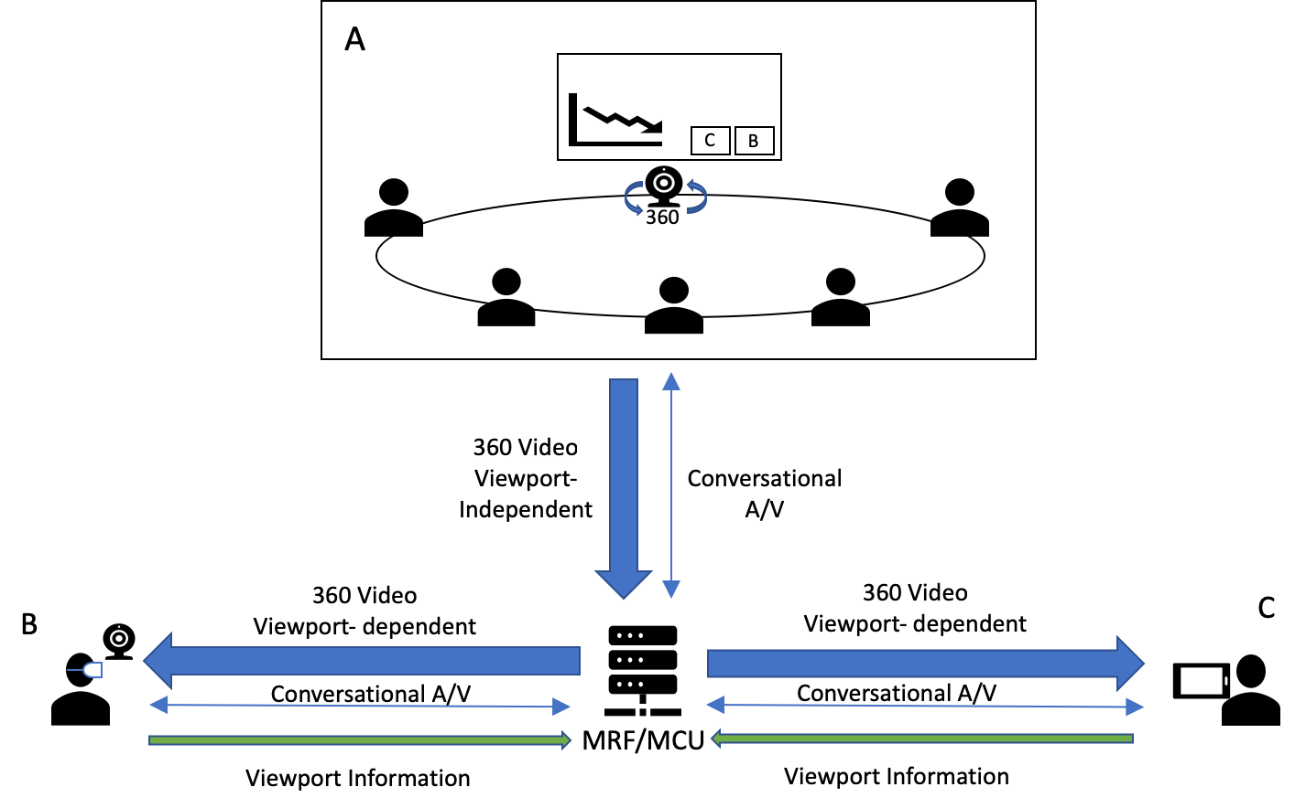
Figure 2.2 - A 360-degree conference call via MRF/MCU

The use case aims to enable immersive experience for remote terminals joining teleconferencing and telepresence sessions, with two-way audio and one-way immersive video, e.g., a remote single user wearing an HMD participates to a conference will send audio and optionally 2D video (e.g., of a presentation, screen sharing and/or a capture of the user itself), but receives stereo or immersive voice/audio and immersive video captured by an omnidirectional camera in a conference room connected to a fixed network.
Private side communication is also expected to be enabled as part of this use case. For instance, two users attending the conference may wish to talk privately and do not want to be heard by others. In this case, the audio information exchanged between these two users should not be transmitted to others, and the content of their conversation should be protected and only be fully rendered on their devices. Others may know that these users are interacting but would not be able to hear the specific content.

A special variation of this use case is when the 360 camera capture occurs not in a conference room but on a user device. [Requirements associated with this variation are TBD. Unless users in the conference room wear HMDs, is this feasible? For example, how would the viewing orientation of the conference room be determined for the 360 video captured by the user device of a remote participant? This seems only possible if there is only one user in the meeting room, and the display in the meeting room has a camera for tracking the position of the single user in the conference room.]

In the third scenario, multiple conference rooms are sending 360-degree video to an MRF/MCU. The rooms may choose to receive 2D video streams from other participants including one of the other rooms, which is displayed on the screen in the room. A pictorial representation is shown in Figure 2.3.

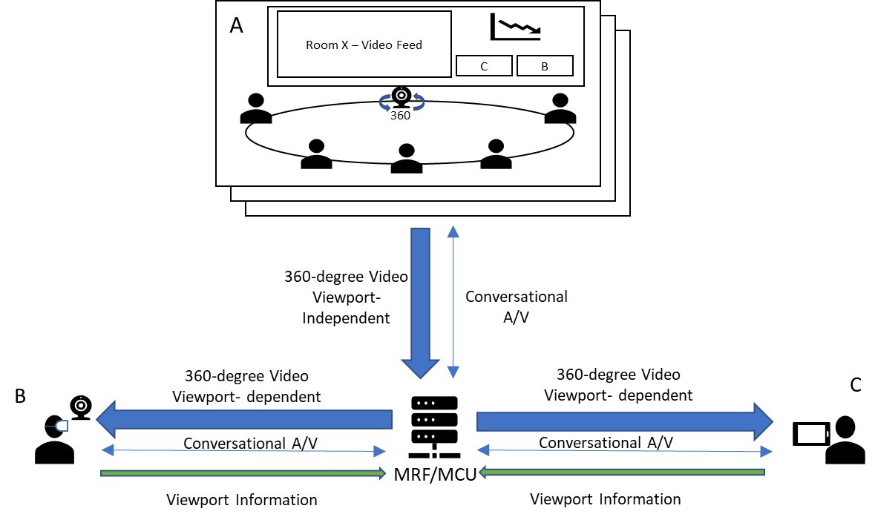
X
Figure 2.3: Multiple rooms with 360-degree video

Furthermore,
- The remote (single) users can choose to view any one or none (e.g., when only viewing the screenshare) of the available 360-degree videos from the multiple rooms. Switching from one room to another may be triggered manually, or using other mechanisms, such as, viewing direction or dominant speaker. However, for the case of the dominant speaker, it is important to consider effects of motion sickness while switching from one video to another as the user may not be sufficiently prepared for the switch.
- The MRF/MCU may signal to pause the receiving 360-degree video from any of the rooms that do not currently have any active viewers. The streams can be resumed if and when there are viewers [7].
- The presentation/screenshare stream is distributed to the single users and the rooms as a separate stream and can be identified using an explicit “a=content:slides” SDP field [1]. The single users may view the stream as an overlay on top of the 360-degree video.
- If the area of interest in the 360-degree video is limited (the preferred FoV is defined and negotiated between the participants) or the motion outside the FoV is limited, the background area (outside the viewport) can be transmitted as a still image to maintain continuity in the 360-degree view. The still-image may be updated at regular intervals or as needed.
- A still-image background area can also be used for placing overlays and avoiding unnecessary bandwidth utilization. In the scenario in the figure, this background area would be the wall with the screen and the presentation overlay may be placed on top of the screen for a better visual experience.
- Overlays may also be used for other 2D streams. These include videos from the single users and 2D video streams from the other rooms. Spatial audio should be associated with overlays when placed in the 360-degree view, i.e., the sound should appear to originate from the placement of the overlay, not necessarily associated with the elements within the video.
- MRF/MCU based media processing may be used for creating 360-degree views combining multiple input sources, e.g., 360-degree video with limited FoV, still image for background, overlays of screenshare and other 2D videos, etc., when the device capabilities are limited.

Use Case Extensions

Viewport sharing among remote participants
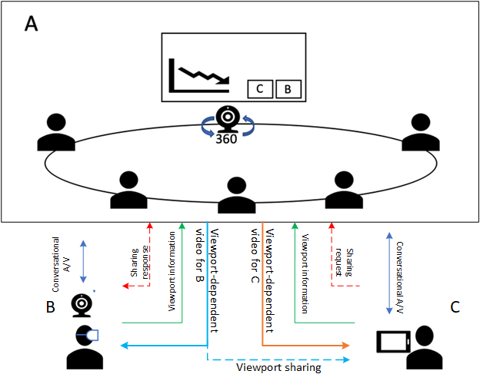
Figure 3.1.1 Viewport sharing between remote participants w/o MRF/MCU
Figure 3.1.1 illustrates viewport sharing capability added to the above use case. When B is presenting to the conference or B is communicating with C, C may be interested in B’s focus or her 360-degree viewport, especially when B is interacting with anything or anyone in room A. In such case, C would request to follow B’s viewport. Upon permission from B, C may follow B’s viewport on his own display device regardless of C’s orientation. In this scenario, room A may multicast (i.e., send the same information using unicast to different receivers as in usual MTSI/Telepresence) viewport dependent stream with embeddedB’s viewport metadata to both B and C. C’s device will follow embedded viewport metadata and playback the same viewport presented to B.
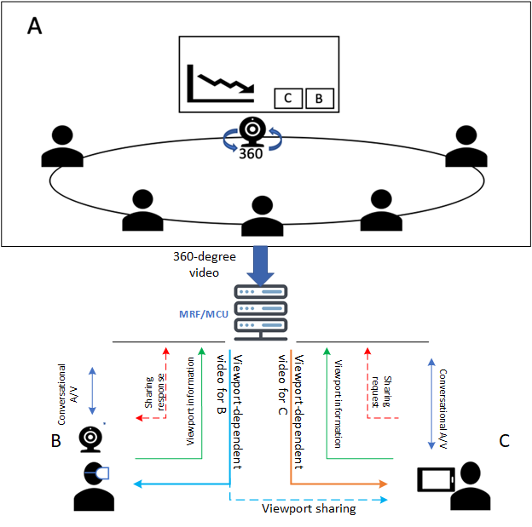
Figure 3.1.2 Viewport sharing between remote participants w/ MRF/MCU
Figure 3.1.2 shows the second scenario where the call is setup using a MRF or MCU. The MRF/MCU may receive C’s viewport sharing request and check B’s permission for such request. Once B’s permission is confirmed, MRF/MCU may forward the viewport dependent stream with B’s viewport metadata embedded to C. C’s device will follow embedded viewport metadata and playback the same viewport presented to B.

Viewport sharing feature may require capability of party A or MRF/MCU to forward B’s viewport-dependent video stream to C after request/response signalling exchange, and embed B’s viewport metadata into the stream.

EDITOR’S NOTE: Impact of motion sickness from viewport sharing is to be investigated

Viewport-dependent stream for display device
Participants in conference room A may have their own display device (HMD, AR glass or mobile phone) to receive a 360-degree video stream (viewport independent or dependent stream) from room A, or conversational video from remote participant B or C. For a large conferencing room, some participants may not sit close to the view screen or other participants he or she would like to communicate, a display device may offer high quality view of room A regardless where the participant sits. A viewport-independent or viewport dependent 360-video stream may send to participant’s display device.
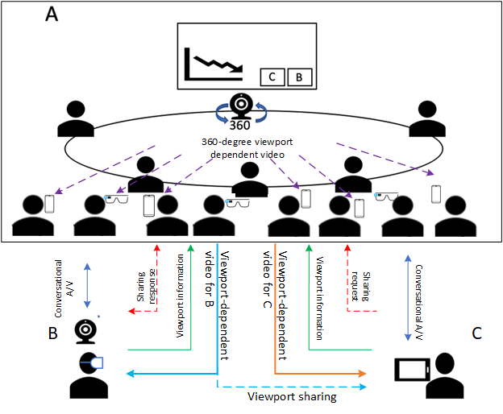
Figure 3.1.3 Proposed viewport sharing use case w/o MRF/MCU
Figure 3.1.3 shows the first scenario, the call is setup without the support of a MRF or MCU. B and C send viewing orientation information to A and receive corresponding viewport-dependent streams from the omnidirectional camera. For the participants with their own display device, the display device may receive 360-degree viewport-independent video from omnidirectional camera, or viewport-dependent video stream by sending orientation information to A.

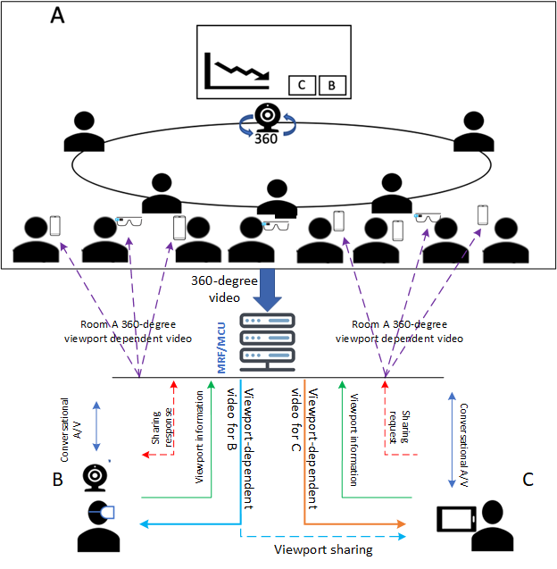
Figure 3.1.4 Proposed viewport sharing use case via MRF/MCU
Figure 3.1.4 shows a second scenario, the call is setup using a MEF or MCU. In this case, the viewport dependent streaming may be handled by MRF or MCU. For the participants with their own display device, the display device may receive 360-degree viewport-independent video from omnidirectional camera, or viewport-dependent video by sending orientation information to MRF/MCU.

Viewport sharing for second display device
When a remote participant B or C is presenting or communicate to the room A, participants in room A with their own display device may be interested in B or C’s focus or interaction on specific viewport of 360-degree video captured by omnidirectional camera, these participants may request to follow B or C’s viewport and receive the same viewport-dependent stream sending to B or C.
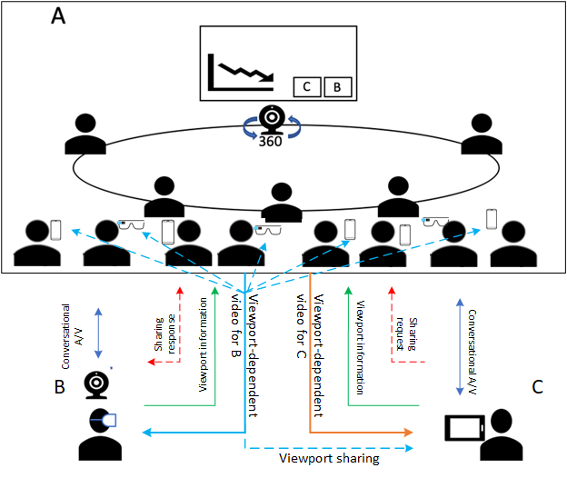
Figure 3.3.1 Viewport sharing to second display w/o MRF/MCU
Figure 3.3.1 shows the first scenario, the call is setup without MEF or MCU. Participants in room A with their own display device may like to follow B’s viewport, participant sends the request to B and is authorized by B. The viewport-dependent video for B is then played back on authorized participant display device with embedded viewport information, the display device would follow embedded viewport information to render the viewport regardless participant’s orientation.
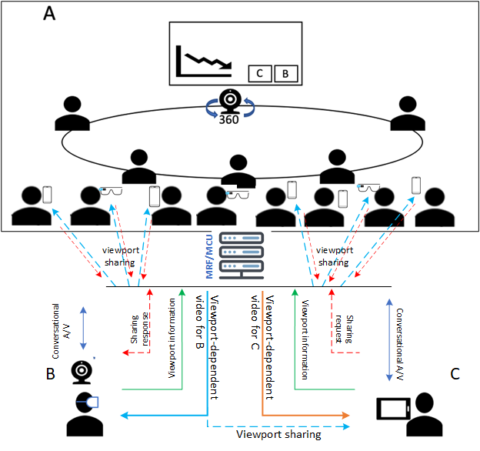
Figure 3.3.2 Proposed viewport sharing use case via MRF/MCU
Figure 3.3.2 shows a second scenario, the call is setup using a MEF or MCU. In this case, the viewport sharing request may be handled by MRF or MCU, MRF or MCU receive the request from participants and confirm the authorization from B. MRF or MCU then sends viewport-dependent video streams with embedded B’s viewport metadata to B and her followers in room A.

Separate stream for presentation content

John (a participant in conference room A) shares his current computer screen to present his work. This presentation audio/video stream is displayed in the conference room A, but also broadcasted (i.e., sending the same information using unicast to different receivers as in usual MTSI/Telepresence, same for the two instances of "broadcasted" below in this subclause and in subclause 3.5) to all other remote participants (in other conference rooms and for the VR users). While john is still presenting Alice (who is also in the conference room A) adds her screen to be shared with supportive materials for John’s presentation, resulting into two streams being displayed in the room and broadcasted to all other remote participants.

[3.4.1 Comments and questions
Sharing the presentation as a separate stream seems logical as it aligns to current video conferencing paradigms. The main question here is can this follow the conventional MTSI/Telepresence communications architecture or are additions necessary. E.g. is it envisioned that this stream is overlaid in the 360-degree image or displayed in parallel.]

[Room to room connection
Another conference room B joins the session. While both rooms and remote users are connected users can freely communicate and follow a common presentation (broadcasted by John). Each room displays the other room on a dedicated screen (either as a full 360 video, or a cut-out based on the current speaker or manual viewport selection.

3.5.1 Comments and questions
Does a room to room connection follow the same principle as a VR user? Is there more functionality needed in the network for audio and video orchestration (e.g. spatial mapping) or is it simply a problem of transferring the streams and rendering into an end device / room dependent layout?]

[

End device limitations of multiple streams
More participants join the conference call (conference room B, User C, User D), resulting into a total conference of two rooms, 4 remote users and two presentation streams. Clyde who joined the conference from his mobile phone from the airport now gets a prerendered video of the conference with the most relevant visual information. This is a network function which transcodes and merges different streams according the requirements of the end device (e.g. manual selection of streams, dominant speaker paradigm or viewing direction).

3.6.1 Comments and questions
After a certain number of streams even a modern phone might struggle in the encoding and rendering of multiple video streams. This is simply forwarding all streams of all users, room (as full or viewport adapted streams) and presentations and only leaving it for the client to decode and render to a suitable layout might not be enough to fulfil the limitations and restrictions of a given mobile device. Thus, we can envision network-based media processing (e.g. NBMP) e.g. in the MRF/MCU to assist such mobile end devices and reduce the processing load on end-device, in order to cope with its limitations and in order to increase battery life. However how such a network-based processing should be addressed in 3GPP requires more discussion, particularly in terms of metadata necessary.]

Applications to 3GPP FLUS
MTSI-based FLUS as defined in TS 26.238 [ADD_REF] relies on the use of RTP/RTCP-based protocols as defined in TS 26.114. Immersive video and immersive audio/speech may be delivered uplink using MTSI-based FLUS. Thus, even though FLUS is outside the scope of the current ITT4RT work item, the normative specification resulting from the ITT4RT work item could be (and are not required to be) reused in providing the immersive video and immersive audio/speech support for MTSI-based FLUS including (i) recommendations of audio and video codec configurations to deliver high quality VR experiences, (ii) constraints on media elementary streams and RTP encapsulation formats, (iii) recommendations of SDP configurations for negotiating of immersive video and voice/audio capabilities and (iv) RTP/RTCP-based signalling for indication of viewport information to enable viewport-dependent media processing and delivery. In that regard, potential solutions described in clauses 6 and 9 could also be applicable for live uplink streaming scenarios using MTSI-based FLUS.
For immersive video support over MTSI-based FLUS, both in-camera stitching and network-based stitching can be considered. In case of camera stitching, stitched immersive video is sent from the FLUS source (i.e., MTSI sender) to the FLUS sink (e.g., MTSI receiver, which is either in the UE, e.g., as a remote viewer, or in the network, e.g., as a media gateway). This is where immersive video gets delivered uplink using MTSI-based FLUS, and the normative specification output of ITT4RT becomes relevant. In case of network-based stitching, different 2D captures are sent from the FLUS sources (MTSI senders) to the FLUS sink (MTSI receiver as a media gateway) in the network and the media gateway server performs decoding, stitching, and re-encoding to produce the immersive video, which is then distributed to the remote viewers using MTSI or other means. In this case, only 2D video gets delivered using MTSI-based FLUS and immersive video is only delivered in the non-FLUS portion of the link, i.e. downlink. If MTSI-based means are used to deliver the immersive video to the remote viewers, only then the normative specification output of ITT4RT could be applicable.
Editor’s Note: There could also be certain FLUS features re-usable in ITT4RT, this is TBD.

Multiple Overlays
Scenario 1:
A user is streaming an immersive video, from a teleconference room A. Room A uses screen share to display two streams (overlay 1, overlay 2).
- The sender needs to send information about the overlays such as number of overlays, layering, priority etc to the user via SDP offer.
- The user based on its resource availability may decide if he/she wants to receive all the overlays or just a subset of overlays. This is conveyed back to the sender via SDP answer.
- The sender needs to inform the user if he/she is allowed to use multiple overlays. It may be possible that sender may not want the receiver to stream multiple overlays to avoid possible distractions. One such scenario is when multiple overlay videos are available and the user may be allowed to stream just one of the overlays.

Scenario 2:
This scenario consists of multi-party teleconference. A user is streaming an immersive video, from a teleconference room A. Room A uses screen share to display one stream (overlay 1). The overlay from room B is not shared by A. For the user to stream overlays which are not shared by A:
- Firstly, the sender needs to inform the user if he/she is allowed to use multiple overlays as described in scenario 1.
- Secondly, the sender of the 360-degree video should inform the user at the receiver if the user is allowed to use overlays from streams other than the ones shared by the sender. This is based on the content type of the overlays shared by A. The rationale behind the sender asserting control is that the sender may not want the receiver to mix overlays which may possibly cause a distraction to the user.
- Thirdly, the sender should inform the user if he/she is allowed to overlap overlays. A possible example may be when the sender side is presenting and does not want other overlays to overlap with its presentation stream.
- Lastly if the user’s resource availability is limited, default preference maybe given to the sender’s overlay as compared to streaming overlays from other sources.
[Editor’s note: Whether application management should take care of the above use-cases or should this be a part of ITT4RT scope is for further consideration]

Requirements

- Multiple single-user participants are supported.
- Communications between the single users can be conventional MTSI/Telepresence communications. MSMTSI could be used, and if that is used, then media data can be transmitted in separate media streams, and the layout of different participants is up to the client application/implementation.
- One 360 camera per location in multi-party conference scenarios involving multiple physical locations are allowed.
- Both in-camera stitching and network-based stitching are supported.
  - In case of camera stitching, stitched immersive video is sent from the conference room to the conferencing server (e.g., MSMTSI MRF or any other media gateway) and then from the conferencing server to the remote participants. If this is a one-to-one conversational session between the conferencing room and the remote participant, a media gateway in the middle may not be necessary.
  - In case of network-based stitching, different 2D captures are sent from the conference room to the conferencing server and the conferencing server performs decoding, stitching, and re-encoding to produce the immersive video, which is then distributed to the remote participants.

- It is recommended that MTSI and IMS Telepresence endpoints support codec, protocol and transport capabilities relevant for encoding, delivery and consumption of immersive speech/audio and immersive video.

- Capability for the party that sends 360-degree video to send viewport-dependent and/or viewport-independent streams.
- Timely delivery of the changes in viewport orientation from the remote participants, and appropriate low-delay actions to update the viewport-dependent streams. Any changes in viewport orientation should not lead to latency-prone signalling, such as SIP renegotiations.
- Capability to create viewport-dependent streams for individual UEs including an larger area of the original viewport for safe playback in the UE.
- A suitable coordinate system to be used as the standard way of communicating the orientation of the viewport.
- Given possible end device limitations as well as potential constraints on the conference room equipment, network-based processing should be considered for media workloads involving both conference room and remote participants, e.g., stitching of captured streams from the conference room, media composition, transcoding and prerendering for the remote participant, etc.
- The following parameters need to be signalled in the SDP during call setup in addition to normal MTSI call signaling [1].
  - Initial viewport orientation. It is the default orientation from which to start the view at the receivers’ side.
  - Decoding/Rendering metadata, e.g., region-wise packing information, projection mapping information, frame packing information, etc. It is subject of discussion whether this information is signaled via SDP and/or within SEI messages with the media stream.
  - Capture Field-of-View (CFoV): as discussed during the definition of the use case, the system supports transmission of 360-degree video. However, the range of the FoV may be restricted in order to enhance user experience. The negotiation requires signaling the capture FoV of the capture device, and a response carrying the receiver’s preferred FoV (PFoV) depending on the remote UE, where the preferred FoV will be less than or equal to the captured FoV.
  - Codec negotiation
The high level signaling flows are depicted in Figure 4.1. The user C is not represented here for simplicity, but this is not a restriction for our reasoning. In this example MRF/MCU is not used.

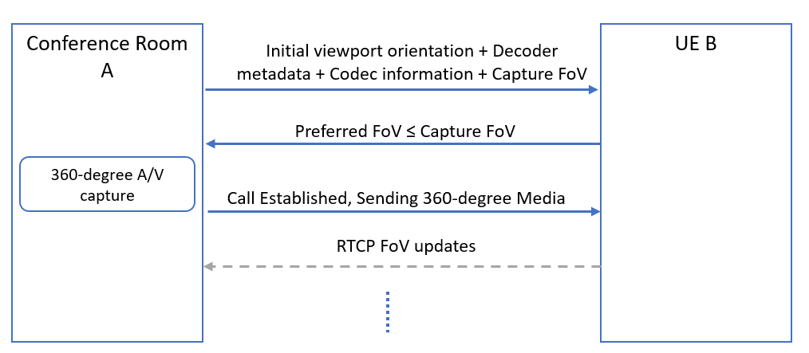
Figure 4.1 Signalling flow for a 360-degree conference call with unidirectional 360- degree video from A to B.

- Once the call has been established, remote parties (B or C) can send viewport orientation information using RTCP reports with yaw, pitch and roll data. These may be sent at fixed intervals or event-based, triggered by changes in viewport orientation. or hybrid combination of fixed interval and event-based triggers. When hybrid reporting scheme is used, the event-based feedback is triggered by any changes in viewport whereas the regular RTCP interval provides the sender with a regular update, in fixed intervals, of the viewport even if the event-based feedback is not received. The most efficient RTCP reporting scheme for viewport orientation information is for further study.
- Capability to support the interaction where all media types will be presented to certain users and a subset of the media types are presented to the others.
- Capability for the participant in room A with his or her own display device to receive a viewport independent or viewport dependent video from omnidirectional camera in room A.
- Capability for the remote party to share a viewport dependent video stream with embedded viewport metadata to another remote participant.
- Capability for the participant in room A with his or her own display device to follow remote participant viewport presentation.
- The capability to place overlays in the 360-degree video either within the device or pre-rendered through a network element.
- Transmission from sender to receiver of the coordinates of the location of the overlay (e.g. a presentation): this is a necessary and basic requirement that will give flexibility in the overlay placement at the receiver’s side. By sender/receiver it is meant either one of the parties or the MRF/MCU.
- Avoid that the overlaid background content is transmitted unnecessarily at high quality within the user viewport: this is a basic issue that overlays cause to viewport-dependent streaming. The content in the viewport is always streamed at higher quality. However, when an overlay with different content is sticked on top of (part of) the viewport, the content behind the overlay does not need to be sent ay higher quality. This allows saving bandwidth or increase the quality in the viewport for the non overlaid parts.
- Enable some form of interaction with the overlay (e.g., moving or rotating the overlay, resizing it, switching it on/off, etc.): these are basic and simple ways to interact with the overlay, to increase flexibility and utility of an overlay.
- Capability for users to receive an incoming interaction message (e.g., SMS, chat message, voice call or audio-visual call) from other users as an overlay: this is a good way to allow integration of other 3GPP services and applications into ITT4RT/MTSI applications in order to increase the value of the first VR applications for 3GPP.
- [Signalling to establish the format of the background area, especially if a limited “captured” FoV is used for immersive video content. For example, a still background image.]
- To facilitate network-based stitching, it is possible to signal camera calibration parameters for each 2D video capture (i.e., each camera lens) transported from the conference room to the conferencing server at the beginning of each session. Relevant intrinsic and extrinsic camera parameters can include lens numbers, layouts, positions, angles, radius, distortion, entrance pupil and resolutions.
- [Signalling for setting, unsetting or negotiating a margin area that extends on any or all of the sides of the viewport. ]
- [The maximum extent of the margins: a sender may indicate the maximum extent of the margins and a receiver may want to limit the maximum extent of the margin area to indicate a preference for high quality viewport.]
- An RTP receiver should be able to signal higher-level metrics such as Motion to High-Quality Delay to the sender to assist in bandwidth adaptation and monitoring.
- [Signalling to] allow still background images to be used when network conditions do not permit transmitting a video stream for the area outside the viewport.
- Capability to identify the location of the presentation and where to insert an overlay of the alternative presentation into the omnidirectional content:
- [while stitching the different camera images together in the sending client]
- while stitching the different camera images together in the network
- after the stitching of the camera images into the omnidirectional video (e.g. by reencoding the omnidirectional video in the network)
- after receiving the stitched omnidirectional video and the overlay by the receiving client

Architecture

The current MTSI service architecture depicted in Figure 4.1 of TS 26.114 is applicable for immersive teleconferencing. No further architectural gaps are identified.

In terms of the reuse of existing MTSI functionality, the following may be observed:

- For in-camera stitching, stitched immersive video is sent from the conferencing room to the conferencing server (e.g., MSMTSI MRF) or directly to the remote participant (e.g., one-to-one conversation) in one or more RTP streams (e.g., established via SDP). Multiple RTP streams may be used in case tile or sub-picture based delivery optimization is in use.
- For network-based stitching, multiple RTP streams are established (e.g., via SDP, using MSMTSI) between the conferencing server and conference room, each of which carries a particular 2D capture. These RTP streams are then sent from the conference room to the conferencing server and the conferencing server performs decoding, stitching, and re-encoding to produce one or more RTP streams containing the immersive video, which are then distributed to the remote participants (e.g., again via MSMTSI). Multiple RTP streams may be used for the immersive video in case tile or sub-picture based delivery optimization is in use.

Potential Solutions

6.1 Potential Solutions for Immersive Video

Figure 6.1 provides an overview of a possible receiver architecture that reconstructs the spherical video in an MTSI or IMS Telepresence UE. Note that this figure does not represent an actual implementation, but a logical set of receiver functions. Based on one or more received RTP media streams, the UE parses, possibly decrypts and feeds the elementary stream to the HEVC decoder. The HEVC decoder obtains the decoder output signal, referred to as the "texture", as well as the decoder metadata. The Decoder Metadata contains the Supplemental Information Enhancement (SEI) messages, i.e., information carried in the omnidirectional video specific SEI messages, to be used in the rendering phase. In particular, the Decoder Metadata may be used by the Texture-to-Sphere Mapping function to generate a spherical video (or part thereof) based on the decoded output signal, i.e., the texture. The viewport is then generated from the spherical video signal (or part thereof) by taking into account the viewport position information from sensors, display characteristics as well as possibly other metadata such as initial viewport information. A similar receiver architecture can also be supported for the AVC codec.
Figure 6.1 - Potential receiver architecture for VR support over MTSI and IMS Telepresence

For 360 degree video, the potential solutions can consider the following principles:

- The RTP stream would contain an HEVC or an AVC bitstream with omnidirectional video specific SEI messages. In particular, the omnidirectional video specific SEI messages as defined in ISO/IEC 23008-2 [3] and ISO/IEC 14496-10 [8] may be present.
- The video elementary stream(s) may be encoded following the requirements in the Omnidirectional Media Format (OMAF) specification ISO/IEC 23090-2 [4], clause 10.1.2.2.
Relevant SEI messages contained in the elementary stream(s) with decoder rendering metadata may include the following information as per ISO/IEC 23008-2 [3] and ISO/IEC 14496-10 [8]:

- Region-wise packing information, e.g., carrying region-wise packing format indication and also any coverage restrictions
- Projection mapping information, indicating the projection format in use, e.g., Equi-rectangular projection (ERP) or Cubemap projection (CMP)
- Padding, indicating whether there is padding or guard band in the packed picture
- Frame packing arrangement, indicating the frame packing format for stereoscopic content
- Content pre-rotation information, indicating the amount of sphere rotation, if any, applied to the sphere signal before projection and region-wise packing at the encoder side
- Fisheye video information, indicating that the picture is a fisheye video picture containing a number of active areas captured by fisheye camera lens. This information enables remapping of the colour samples of the pictures onto a sphere coordinate space
The output signal, i.e., the decoded picture or "texture", is then rendered using the Decoder Metadata information contained in relevant SEI messages contained in the video elementary streams. The Decoder Metadata is used when performing rendering operations such as region-wise unpacking, projection de-mapping and rotation toward creating spherical content for each eye.

Viewport-dependent processing could be supported for both point-to-point conversational sessions and multiparty conferencing scenarios and be achieved by sending from the MTSI receiver RTCP feedback or RTP header extension messages with the desired viewport information and then encoding and sending the corresponding viewport by the MTSI sender or by the media gateway, e.g., MRF. This is expected to deliver resolutions higher than the viewport independent approach for the desired viewport. The transmitted RTP stream from the MTSI sender or media gateway may also include the actual viewport or coverage information, e.g., in an RTP header extension message, as the 360 degree video generated, encoded and streamed by the sender may cover a larger area than the desired viewport. The media formats for tiling and sub-picture coding as described in the viewport-dependent profile of OMAF in ISO/IEC 23090-2 [4] etc. are not relevant for the 5G conversational setting. Instead, viewport-dependent processing based on tiling and sub-picture coding could be realized via RTP/RTCP based protocols that are supported by MTSI and IMS-based telepresence.

OMAF video profiles specified in ISO/IEC 23090-2 [4] are based on HEVC Main 10 Profile, Main Tier, Level 5.1 in order to deliver high quality VR experiences. In the meantime, MTSI in TS 26.114 [1] mandates H.265 (HEVC) Main Profile, Main Tier, Level 3.1 for video, and IMS telepresence in TS 26.223 [2] mandates H.265 (HEVC) Main Profile, Main Tier, Level 4.1 for video.

For achieving video quality required by VR services, it may be recommended that the video codecs for VR support in MTSI and IMS telepresence are aligned with OMAF and/or TS 26.118 [5], e.g., HEVC Main 10 Profile, Main Tier, Level 5.1 may be recommended for MTSI and IMS telepresence in TS 26.114 and TS 26.223 to ensure a high-quality VR experience. It is expected that both MTSI client and MTSI gateway codec requirements are aligned with these recommended video codec requirements for VR support. It is not expected that the mechanisms for session setup and negotiation would be different because of this changed requirement on video codecs.

With regards to the negotiation of SEI messages for carriage of decoder rendering metadata, procedures specified in IETF RFC 7798 [6] on the RTP payload format for HEVC may be reused. In particular, RFC 7798 can allow exposing SEI messages related to decoder rendering metadata for omnidirectional media in the SDP using the 'sprop-sei' parameter, which allows to convey one or more SEI messages that describe bitstream characteristics. When present, a decoder can rely on the bitstream characteristics that are described in the SEI messages for the entire duration of the session. Intentionally, RFC 7798 does not list an applicable or inapplicable SEI messages to be listed as part of this parameter, so the newly defined SEI messages for omnidirectional media in ISO/IEC 23008-2 can be signalled. It is expected that both MTSI clients and MTSI gateways support RTP payload formats for VR support.

For most one-to-one video telephony and multi-party video conferencing scenarios, it is expected that support of the following omnidirectional video specific SEI messages would be sufficient:

- the equirectangular projection SEI message,
- the cubemap projection SEI message,
- the sphere rotation SEI message,
- the region-wise packing SEI message, and
- the fisheye video information SEI message (for fisheye video)
For stereoscopic video support, in either one-to-one video telephony scenarios or multi-party video conferencing scenarios, support of a subset of the frame packing arrangement SEI message as in ISO/IEC 23090-2 [4] is also needed.

Based on the above, an SDP framework for immersive video exchange needs to be developed to negotiate codec support, SEI messages for decoder rendering metadata, as well as RTP/RTCP signaling necessary for viewport dependent processing. These capabilities may be individually negotiated, but to simplify the SDP exchange and avoid fragmentation of capabilities it would be more preferable to specify one or more MTSI client profiles and develop the SDP framework based on these profiles. Such an example compact SDP negotiation framework is described below.
A new SDP attribute 3gpp_360video may be defined with the following ABNF:

3gpp_360video = "a=3gpp_video:" [SP "VDP" SP "Stereo"]

A potential specification for the semantics of the above attribute and parameter is provided below. Unsupported parameters of the 3gpp_360video attribute may be ignored.

An MTSI terminal supporting the 360 video feature without using viewport-dependent processing (VDP) or stereoscopic video for video may support the following procedures:

- when sending an SDP offer, the MTSI client includes the 3gpp_360video attribute in the media description for video in the SDP offer
- when sending an SDP answer, the MTSI client includes the 3gpp_360video attribute in the media description for video in the SDP answer if the 3gpp_360video attribute was received in an SDP offer
- after successful negotiation of the 3gpp_360video attribute in the SDP, for the video streams based on the HEVC codec, the MTSI clients exchange an RTP-based video stream containing an HEVC bitstream with omnidirectional video specific SEI messages as defined in ISO/IEC 23008-2 [3] with the following characteristics:
  - OMAF video profiles specified in ISO/IEC 23090-2 [4] are based on HEVC Main 10 Profile, Main Tier, Level 5.1 are supported.
  - exchange of the following SEI messages are supported: (i) the equirectangular projection SEI message, (ii) the cubemap projection SEI message, (iii) the sphere rotation SEI message, (iv) the region-wise packing SEI message, and (v) the fisheye video information SEI message.
- after successful negotiation of the 3gpp_360video attribute in the SDP, for the video streams based on the AVC codec, the MTSI clients exchange an RTP-based video stream containing an AVC bitstream with omnidirectional video specific SEI messages as defined in ISO/IEC 14496-10 [8] with the following characteristics:
  - OMAF video profiles specified in ISO/IEC 23090-2 [4] are based on AVC Progressive High Profile, Main Tier, Level 5.1 are supported.
  - exchange of the following SEI messages are supported: (i) the equirectangular projection SEI message, (ii) the cubemap projection SEI message, (iii) the sphere rotation SEI message, (iv) the region-wise packing SEI message and (v) the fisheye video information SEI message.

An MTSI terminal supporting the 360 video feature supporting use of viewport-dependent processing (VDP) would include the VDP parameter in the SDP offer and answer. Depending on the value indicated by the VDP parameter, the MTSI terminal would further support the following procedures:

- the RTCP feedback (FB) message described in clause 9.2 type to carry desired or requested viewport information during the RTP streaming of media (signalled from the MTSI receiver to the MTSI sender).
- the RTCP feedback (FB) message described in clause 9.3 type to carry desired ROI (arbitrary or pre-defined) information during the RTP streaming of media (signalled from the MTSI receiver to the MTSI sender).
- [the new RTP header extension type described in clause 9.4 to carry actually transmitted viewport information during the RTP streaming of media (signalled from the MTSI sender to the MTSI receiver).]
An MTSI terminal supporting the 360 video feature with stereoscopic video would include the Stereo parameter and additionally support frame packing arrangement SEI message as in ISO/IEC 23090-2 [4] for HEVC and ISO/IEC 14496-10 [8].

6.2 Potential Solutions for Signalling of Camera Calibration Parameters

Alignment of the ITT4RT solution to be defined and what is in the FLUS spec is desirable.
Clause 4.5 of the FLUS specification in TS 26.238 describes the FLUS source system. Accordingly the MTSI instantiation of FLUS supports SDP-based description of the relationships among multiple streams in a FLUS source system identified using the SDP attribute a=3gpp-flus-system:<urn>. A vendor-specific source system may be identified by a unique vendor-specific urn identifier such as urn:[com]:[vendor_x]:[system_y]. Alternatively, a 3GPP-specific source system description may be specified using a 3GPP-specific urn identifier such as urn:org:3gpp:itt4rt:default:2020 which would provide interoperable means to signal source system description, including parameters for camera calibration. Further details can be found in Table 4.5-1 of TS 26.238.

One potential solution can be to adopt the FLUS signaling framework to provide the relationships among the 2D video captures to be used for network-based stitching in ITT4RT and amend the SDP-based signaling in Table 4.5-1 to also include the camera calibration parameters. The existing SDP syntax in Table 4.5-1 may be reused (e.g., a=3gpp-flus-configuration: which provides source system-specific configuration parameters for the source system at the session level or a=3gpp-flus-media-configuration: which provides media stream configuration parameters for the source system at the media level) or a dedicated new SDP attribute (e.g., a= a=3gpp-flus-camera-configuration:) may be defined to explicitly signal the camera calibration parameters.

The set of camera calibration parameters to be signaled can include lens numbers, layouts, positions, angles, radius and resolutions.

As a possible solution, the SDP syntax for a=3gpp-flus-media-configuration may be defined with the following ABNF:

3gpp-flus-media-configuration = "a=3gpp-flus-media-configuration:" [SP "Param 1" SP "Param 2" SP ……. SP "Param K"]

where “Param 1”, …. , “Param K” may be the set of intrinsic and extrinsic camera parameters.

3GPP-specific source system description conveyed using the urn identifier such as urn:org:3gpp:itt4rt:default:2020 may imply such an SDP syntax to communicate camera calibration parameters. If the set of parameters to be conveyed is found to considerably increase the SDP size, another alternative may be considered where the camera calibration parameters may be described by a JSON document embedded in the SDP.

For each 2D video capture to be used for network-based stitching, the SDP attribute 3gpp-flus-media-configuration may be included under the m= line to signal the camera calibration parameters associated with that particular media stream. Session-level camera configuration parameters may be signalled using 3gpp-flus-configuration.

The set of camera calibration parameters to be signaled can include lens numbers, layouts, positions, angles, radius and resolutions. More specifically the following parameters may be signaled:

- Number of cameras
- Layout of the cameras
- General intrinsic parameters: resolution, Focal length (focal_x, focal_y) in pixel unit (int), Principal point (center of projection), Lens distortion (deviation from ideal perspective or fisheye) of each camera. These are expressed in Figure 6b below by intrinsic parameters represented by image_height, image_width, center_x, center_y, radius in pixel unit (int) and camera field of view (fov_h, fov_v) in angle or radian degree unit (float)
- Extrinsic camera parameters for each camera represented in the above figure by translation (x, y, z coordinates) and orientation (yaw, pitch, roll) values of each camera to accommodate various rig geometries. These are depicted in Figure 6a below.
- Entrance pupil (EP), with 4 floating-point EP coefficients. EP coefficients provide a more precise model of various lens characteristics and improve the conversion from a sample location of an active area in a lens decoded picture to sphere coordinates relative to the global coordinate axes. Please note that the formulation of the distortion correction and the EP coefficients for any lens can be derived using the calibration provided in [10]. The EP coefficients are formulated using a polynomial, and added seamlessly on whatever lens projection type specified. The use of EP coefficients is especially encouraged for wide lens cameras, e.g., for fisheye omnidirectional video.
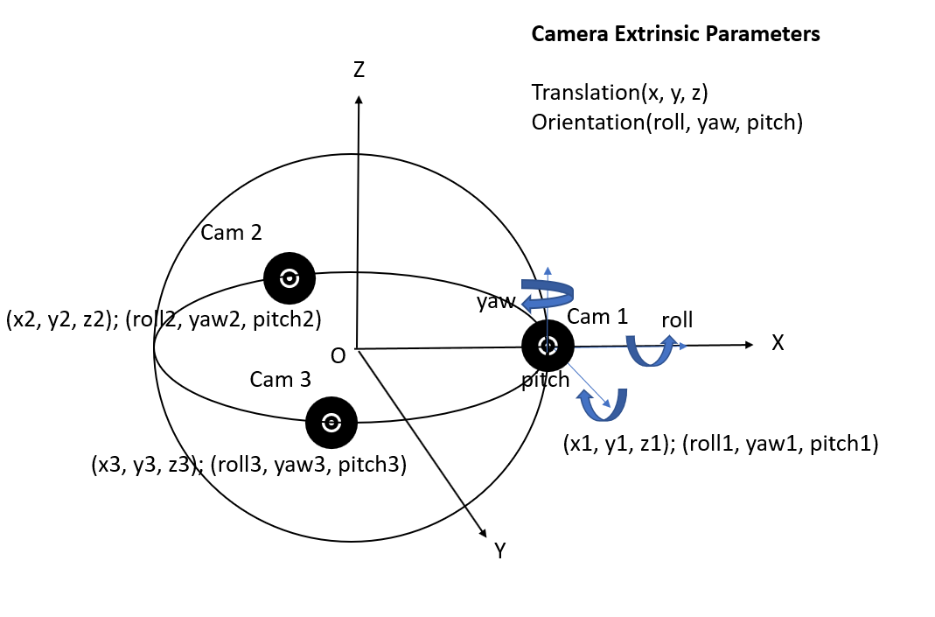
Figure 6a – Extrinsic camera calibration parameters.

Figure 6b – Intrinsic camera calibration parameters.

Below we provide further detail on potential camera calibration parameters based on ISO/IEC 23008-2 [3], considering the multi-view acquisition information SEI message for HEVC. With these specifications, a 3-dimensional world point, wP = [ x y z ] is mapped to a 2-dimensional camera point, cP[ i ] = [ u v 1 ], for the i-th camera according to:

s * cP[ i ] = A[ i ] * R⁻¹[ i ] * ( wP − T[ i ] ) (eqn. 1)
where A[ i ] denotes the intrinsic camera parameter matrix, R⁻¹[ i ] denotes the inverse of the rotation matrix R[ i ], T[ i ] denotes the translation vector, and s (a scalar value) is an arbitrary scale factor chosen to make the third coordinate of cP[ i ] equal to 1. The elements of A[ i ], R[ i ], T[ i ] are determined according to the syntax elements signalled in this SEI message and as specified below.

Earlier equation can be extended to incorporate the entrance pupil variation proposed in [10]. As a result, we propose to correct the incidence ray of cP[ i ] = [ u v 1 ] to always pass through the camera optical center. Due to this process the distortion is removed. By adapting the proposal in [10], we propose E[i] as a 1x1 vector that is individually incorporated as follows:

s * cP[ i ] = A[ i ] * R⁻¹[ i ] * ( (wP + E[i]) − T[ i ] ) (eqn. 2)

where wP + E[i]) = [ x y z+E[i] ], E[i] = e1* 𝞡³ + e2* 𝞡⁵ + e3* 𝞡⁷ + e4* 𝞡⁹, 𝞡 is the incidence angle pertaining to each ray formed by the pixel cP[ i ] = [ u v 1 ], and [e1, e2, e3, e4] are entrance pupil coefficients. In addition, the accuracy of these entrance pupil parameters have an influence of the accuracy of estimated extrinsic parameters and thus improve the future imaging tasks. If not available, vector E is considered as 0 and a fallback to eqn. 1 is expected.

More specifically, the following intrinsic camera parameters can be signalled in the SDP for each camera as per ISO/IEC 23008-2 [3]:

focalLengthX[ i ] specifies the focal length of the i-th camera in the horizontal direction as a signed floating-point number.

focalLengthY[ i ] specifies the focal length of the i-th camera in the vertical direction as a signed floating-point number.

principalPointX[ i ] specifies the principal point of the i-th camera in the horizontal direction as a signed floating-point number.

principalPointY[ i ] specifies the principal point of the i-th camera in the vertical direction as a signed floating-point number.

skewFactor[ i ] specifies the skew factor of the i-th camera as a signed floating-point number.

The intrinsic matrix A[ i ] for i-th camera is represented by:

It is possible that the intrinsic camera parameters are equal for all of the cameras. In that case, only one set of values based on the above parameters would need to be signalled, e.g., via SDP signalling at the session level.

Furthermore, the following extrinsic camera parameters can be signalled in the SDP for each camera as per ISO/IEC 23008-2 [3]:

rE[ i ][ j ][ k ] specifies the ( j, k ) component of the rotation matrix for the i-th camera as a signed floating-point number.

The rotation matrix R[ i ] for i-th camera is represented as follows:
tE[ i ][ j ] specifies the j-th component of the translation vector for the i-th camera as a signed floating-point number.

The translation vector T[ i ] for the i-th camera is represented by:
E[ i ][ j ] specifies the j-th component of the entrance pupil vector E[i] for the i-th camera as a signed floating-point number, as per eqn (2) above.

6.3 Potential Solutions for Overlays

ISO/IEC 23090-2 defines an overlay as a piece of visual media rendered over omnidirectional video or image item or over a viewport.

The SDP signaling semantics in Section 9.6 currently defined as a potential solution for predefined region signaling will have the following applicability:

- Allow adding real-time overlay on the top of a pre-defined region. Client devices may use the pre-defined regions as hints for personalized overlay operations. Compared to handling overlays for all audience on the server side, a client device may utilize its own computing power to generate overlays on pre-defined regions.
- Content to be overlaid on the predefined region may be encoded and transported separately with higher quality.
An MTSI sender supporting the ‘Overlay’ feature can allow adding real-time overlay on top of a 360 background and offer this capability in the SDP as part of the the initial offer-answer negotiation. Regions for overlays can be offered by including the "a=overlay" attribute under the relevant media line corresponding to the related 360 video and overlay images. The following parameters can be provided in the attribute for each overlay:

Editor’s Note: The parameters below are aligned with “Sphere-relative two-dimensional overlay” specification in OMAF.

- Overlay_ID – identifies the offered region for overlay
- Overlay_azimuth: Specifies the azimuth angle of the centre of the offered overlay region on the unit sphere in units of 2⁻¹⁶ degrees relative to the global coordinate axes.
- Overlay_elevation: Specifies the elevation angle of the centre of the offered overlay region on the unit sphere in units of 2⁻¹⁶ degrees relative to the global coordinate axes.
- Overlay_tilt: Specifies the tilt angle of the offered overlay region, in units of 2⁻¹⁶ degrees, relative to the global coordinate axes.
- Overlay_azimuth_range: Specifies the azimuth range of the offered region corresponding to the 2D plane on which the overlay is rendered through the centre point of the overlay region in units of 2⁻¹⁶ degrees.
- Overlay_elevation_range: Specifies the elevation range of the offered region corresponding to to the 2D plane on which the overlay is rendered through the centre point of the overlay region in units of 2⁻¹⁶ degrees.
- Overlay_rot_yaw, Overlay_rot_pitch, and Overlay_rot_roll specify the rotation of the 2D plane on which the overlay is rendered. Prior to rendering the 2D plane, it may be rotated as specified by overlay_rot_yaw, overlay_rot_pitch and overlay_rot_yaw and placed on a certain distance as specified by region_depth_minus1. The rotations are relative to the coordinate system as specified in clause Error: Reference source not found of ISO/IEC 23090-2 in which the origin of the coordinate system is in the centre of the overlay region, the X axis is towards the origin of the global coordinate axes, the Y axis is towards the point on the plane that corresponds to cAzimuth1 in Error: Reference source not found of ISO/IEC 23090-2, and the Z axis is towards the point on the plane that corresponds to cElevation2 in Error: Reference source not found of ISO/IEC 23090-2. overlay_rot_yaw expresses a rotation around the Z axis, overlay_rot_pitch rotates around the Y axis, and overlay_rot_roll rotates around the X axis. Rotations are extrinsic, i.e., around X, Y, and Z fixed reference axes. The angles increase clockwise when looking from the origin towards the positive end of an axis. The rotations are applied starting from overlay_rot_yaw, followed by overlay_rot_pitch, and ending with overlay_rot_roll.
- region_depth_minus1 - indicates the depth (z-value) of the region on which the overlay is to be rendered. The depth value is the norm of the normal vector of the overlay region. region_depth_minus1 + 1 specifies the depth value relative to a unit sphere in units of 2⁻¹⁶.
- timeline_change_flag equal to 1 specifies that the overlay content playback shall pause if the overlay is not in the user's current viewport, and when the overlay is back in the user's viewport the overlay content playback shall resume with the global presentation timeline of the content. The content in the intermediate interval is skipped. timeline_change_flag equal to 0 specifies that the overlay content playback shall pause if the overlay is not in the user's current viewport, and when the overlay is back in the user's viewport the overlay content playback resumes from the paused sample. This prevents loss of any content due to the overlay being away from the user's current viewport.
- Name- specifies the name of the offered region for overlay.
Editor’s Note: The parameters below are aligned with “Viewport-relative overlay” specification in OMAF.

- Overlay_ID – identifies the offered region for overlay
- Overlay_rect_left_percent: Specifies the x-coordinate of the top-left corner of the rectangular region of the overlay to be rendered on the viewport in per cents relative to the width and height of the viewport. The values are indicated in units of 2⁻¹⁶ in the range of 0 (indicating 0%), inclusive, up to but excluding 65536 (that indicates 100%).
- Overlay_rect_top_percent: Specifies the y-coordinate of the top-left corner of the rectangular region of the overlay to be rendered on the viewport in per cents relative to the width and height of the viewport. The values are indicated in units of 2⁻¹⁶ in the range of 0 (indicating 0%), inclusive, up to but excluding 65536 (that indicates 100%).
- Overlay_rect_width_percent: Specifies the width of the top-left corner of the rectangular region of the overlay to be rendered on the viewport in per cents relative to the width and height of the viewport. The values are indicated in units of 2⁻¹⁶ in the range of 0 (indicating 0%), inclusive, up to but excluding 65536 (that indicates 100%).
- Overlay_rect_height_percent: Specifies the height of the top-left corner of the rectangular region of the overlay to be rendered on the viewport in per cents relative to the width and height of the viewport. The values are indicated in units of 2⁻¹⁶ in the range of 0 (indicating 0%), inclusive, up to but excluding 65536 (that indicates 100%).
NOTE: The size of overlay region over the viewport changes according to the viewport resolution and aspect ratio. However, the aspect ratio of the overlaid media is not intended to be changed.
- Relative_disparity_flag indicates whether the disparity is provided as a percentage value of the width of the display window for one view (when the value is equal to 1) or as a number of pixels (when the value is equal to 0). This applies for the case when there is a monoscopic overlay.
- Disparity_in_percent: Specifies the disparity, in units of 2⁻¹⁶, as a fraction of the width of the display window for one view. The value may be negative, in which case the displacement direction is reversed. This value is used to displace the region to the left on the left eye view and to the right on the right eye view. This applies for the case when there is a monoscopic overlay and stereoscopic background visual media.
- Disparity_in_pixels indicates the disparity in pixels. The value may be negative, in which case the displacement direction is reversed. This value is used to displace the region to the left on the left eye view and to the right on the right eye view. This applies for the case when there is a monoscopic overlay and stereoscopic background visual media.
- Name- specifies the name of the offered region for overlay.
Editor’s Note: Other overlay definitions in OMAF are not excluded from ITT4RT. Which overlay definition(s) from OMAF are adopted for overlays in ITT4RT is currently TBD.

Editor’s Note: For both of the above overlay types from OMAF, incorporate from the spec further details about the order of operations for overlay rendering (in particular order of translation and rotation).

As controls for user interaction with the overlays, the a=overlay" signalling can optionally include the following additional parameters:

- change_position_flag, when set to 1, specifies that users are allowed to move the overlay window to any location on the viewing sphere or the viewport.
- change_depth_flag, when set to 1, specifies that the depth of overlay can be chosen by user interaction. When both change_position_flag and change_depth_flag are set to 1 then the X,Y,Z position of the overlay can be freely choosen by user interaction.

- switch_on_off_flag, when set to 1, specifies that the user is allowed to switch ON/OFF the overlay.

- change_opacity_flag, when set to 1, specifies that the user is allowed to change the opacity of the overlay.

- resize_flag, when set to 1, specifies that the user is allowed to resize the overlay window. The field-of-view of the resized overlay window shall be same as that of original overlay window.
- rotation_flag, when set to 1, specifies that the user is allowed to rotate the overlay window to different directions. The field-of-view of the rotated overlay window shall be same as that of original overlay window.
- change_position_flag, change_depth_flag, switch_on_off_flag, change_opacity_flag, resize_flag, or rotation_flag when set to 0, specifies that the user is disallowed to perform the respective operation on the overlay.
Editor’s Note: Default behaviour when the control parameters are not signalled should be explained. One interpretation is that if not signalled renderer is completely free to perform the above operations.

Editor’s Note: Consider the possibility of packing all the flags into a single field with different bit values corresponding to the flags above.

For the negotiated 360 video, a=overlay" attribute is expected to contain all of the above parameters for overlays under the m= line for “Viewport-relative overlay” or “Sphere-relative two-dimensional overlay” (controls for user interactivity are optional), each overlay image is expected to only contain the corresponding Overlay_ID parameter as part of a=overlay" attribute.

In response to the SDP offer with the set of offered regions provided using the "a=overlay" line(s), an MTSI client accepting ‘Overlay’ can provide an SDP answer using the "a=overlay" line(s) containing the accepted set of regions. The accepted set of regions for overlays would be a subset of the offered set of overlay regions.

A new SDP offer-answer negotiation can be performed to modify the set of regions for overlays. The MTSI sender may update all the content of overlay regions, including the total number of overlay regions, and the spherical coordinates and name of each of the overlay regions.

Support for Multiple Overlays

Multiple overlays may be offered in the SDP by including “a=itt4rt_group”.This contains the list of the overlays. A unique overlay id can be assigned to each overlay. Media-level attribute “content” can be added to each of the stream by including “a=content:slides/video/image. This is sent from the sender to the receiver/user. Based on the received offer, the receiver replies which overlays it wants to receive.

The following additional parameters are from the OMAF specification Clause (7.14.3) and can be used to describe the overlays:
- media_alignment: specifies the default intended scaling of the overlay source depending on the dimensions of the specified rectangular region and the intended placement of the scaled overlay source relative to the specified rectangular region.
- layering_order: indicates the default layering order among the overlays that are relative to the viewport, and separately among each set of overlays that have the same depth. Viewport-relative overlays are overlaid on top of the viewport in descending order of layering_order, i.e., an overlay with a smaller layering_order value is in front of an overlay with a greater layering_order value. The layering order for overlays from the originator of the 360 video should be decided by the sender. For overlays from other sources, the receiver may assign a greater layering_order value.
- opacity: Overlay opacity is an integer value that specifies the default opacity that is to be applied for the overlay and assigned by the sender. Value 0 is fully transparent and value 100 is fully opaque. Values greater than 100 are reserved.
- overlay_priority: Overlay priority indicates which overlay should be prioritized in the case that an OMAF player does not have enough decoding capacity to decode all overlays. A lower overlay_priority indicates higher priority. The value of overlay_priority, when present, shall be equal to 0 for overlays that are essential for displaying.
Additionally, the following parameter may be signaled:
- The subset list of the sender’s overlays that the user at the receiver wants to receive. This is negotiated during the SDP negotiation and offered via SDP answer negotiation by the receiver to the sender. This may be conveyed to the sender via a=itt4rt_group signalling by the receiver.
Further parameters for user interaction control are as follows:
- multiple_overlay_flag: This parameter defines if the user is allowed to use multiple overlays. When set to 1, the user may use more than one overlay to be displayed on the 360 degree video. The default value is 1.
- overlay_overlapp_flag: This flag indicates if the user is allowed to overlap overlays from other sender onto the overlays shared by the sender of the 360-degree video. If set to 1, the user may overlap overlays. The default value is 1.
- [other_senders_overlay_flag: Overlay parameter to define if the user at the receiver is allowed to use overlays from streams other than the ones shared by the sender of the 360-degree video on top of the 360-degree video. This parameter can be based on the content type of the overlay the sender of the 360-video is sharing. The content type can be defined in the SDP signalling by including an attribute “a= permissible_content” under m= line for each overlay the sender is sharing. If set to 1, the user is allowed to use other senders’ overlays. The default value is 1.]

6.4 Potential Solutions for Still Background for Omnidirectional Video

A still background may be used when

- The captured FoV of the sender’s cameras is less than 360-degrees.
In this case, the sender may use a background image (or a series) that was (were) captured previously and distribute it to the receivers. The area will be viewed as a still image even when it is within the viewport.

- The captured FoV of the camera is 360-degrees but the (preferred) FoV of the receiver is less than 360-degrees.
The receiver may signal a desire to receive the content outside the preferred FoV as a still image, to improve bandwidth efficiency. It may further request an updated image of the background at a later stage. The area will be viewed as a still image even when it is within the viewport.

- The network is unable to support a full 360-degree video stream.
If the network is unable to support the full 360-degree video stream, the sender/receiver may choose to deliver the content outside the viewport as a still image in order to save bandwidth. Only the content outside the viewport region is transmitted as a still image; the content within the viewport is transmitted as a video stream.

It is possible for the sender and receiver to negotiate this behavior at the beginning or during the session using SDP. An appropriate quality and update interval may be fixed for background images. If the background image is used for adaptation to network conditions, it is possible that the update frequency and quality is lowered by the sender or the receiver when needed. One possible example realization is by having two RTP streams: one which carries the still image(s) background content, and another one which carries the viewport content.

[The following Figure 1 shows a signaling diagram of one of the above scenarios.

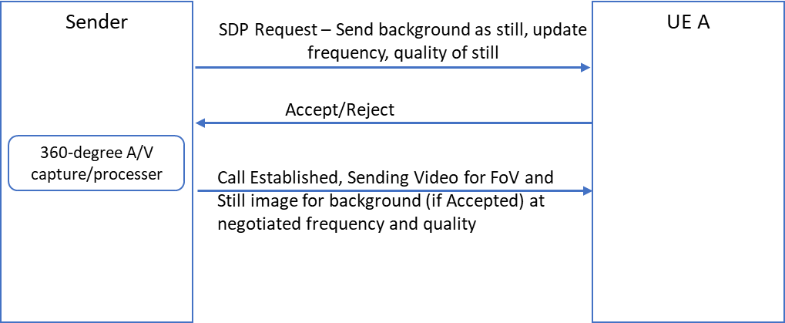

Figure 1: Signalling to allow sending background as a still image with chosen quality and update interval.]

6.5 Potential Solutions for Network-based Stitching
MPEG Network-based Media Processing (NBMP) in ISO/IEC 23090-8 [11] may be used to establish media processing tasks for network-based stitching at MRF/MCU sink to be performed on received media components from the MTSI sender(s). In particular, the NBMP Workflow Description Document for the 360 stitching workflow may be provided to the MRF/MCU, which would then use the information during negotiation of the media streams to be used in the session and subsequent media plane processing, e.g., as per the example workflow provided in clause 8.2. In addition to 360 stitching, NBMP can also be used for initiating other media processing workflows in MRF/MCU such as guided transcoding, overlaying on image or video backgrounds or view-dependent content customization.

6.6 SDP Signalling of 360-degree Video

6.6.1 Design Principles

This section describes the principles we followed to design the SDP signaling for ITT4RT 360-degree video:
- Identifying the type of stream
The SDP attributes 3gpp_360video, 3gpp_overlay, 3gpp_360bg are used to indicate respectively a 360-degree video stream, a spherical overlay and a 360-degree background image (or series of images or video). These are explained more clearly later.
- Offering 360-degree video in multiple versions
The media with attribute a=3gpp_360video may not be a full 360-degree video, but a partial sphere. The following fields define the 360-degree video.
  - cfov (Capture FoV) may be used to express the extent (range) of the source with respect to the unit sphere. The range is expressed in unit of degrees with an x parameter for azimuth range and a y parameter for elevation range. In the absence of cfov, the default value of x and y are 360 and 180 degrees, respectively.
  - pfov. The receiver may respond with a Preferred FoV, where pfov <= cfov in one of both the x and y dimensions. The pfov range is expressed in unit of degrees with an x parameter for azimuth range and a y parameter for elevation range. In the absence of pfov, it should be assumed to be the same as cfov.
  - cfov_center and pfov_center attributes may be used to define the center respectively of the Capture FoV and the Preferred FoV with respect to the global coordinates. The range in pfov and cfov pass through the defined center. In the absence of a cfov_center or pfov_center value, the global (0,0) coordinates will be assumed as the center of azimuth and elevation range in cfov and/or pfov. These two parameters are expressed in units of degrees with an x parameter for azimuth range and a y parameter for elevation range.
During a VR conference call, a 360-degree video sender may offer an overlay and a 2D version of the ominidirectional video for receivers that are not viewing the content immersively. For example, in the case of multiple 360-degree sender, receivers in of sender A for instance can receive the stream for sender B as an overlay. The SDP offer is similar to the way MTSI offers multiple encoding options, so each receiver would choose only one of these proposed formats.

- Viewport control definition
The viewport control parameter as defined in 9.10 is added as part of the 3gpp_360video as follows:
- viewport-ctrl: The source of viewport control for viewport dependent delivery, e.g., device-signalled, presenter-viewport, device-not-signalled.
[- margin: margin sizes to be used with the viewport]

- Resolution of 360-degree content
The imageattr attribute indicates the resolution of the delivered content based on the cfov and pfov options.
a=imageattr:100 send [x=1920,y=1080]

- Background area
A background stream may be offered for a 360-degree video as a separate stream using the parameter 3gpp_360bg. For now, the ITT4RT use cases only propose using a still background image. However, the same parameter can be used for a background video.
Note: Additional information may be needed to define the background stream that is FFS, e.g., sphere-locking, transparency.

- Grouping of media
Grouping of certain overlays or background media with a particular omnidirectional video may be done using mid and itt4rt_group attribute. If a new media stream becomes available, an updated itt4rt_group line using previously shared mids can be added in the new offer with the new stream.

- Overlays definition
The following aspects are considered for SDP signalling when sending an overlay:
- A media level attribute a=3gpp_overlay indicates the presence of an overlay. The attribute further defines aspects of the overlay including flags and position.
- flags: set of eight flags related to overlay positioning, moveability, on/off behavior and resizing is included for overlay media streams.
- position: position of the overlay on the spherical region if it is to be defined. The fields for position are defined in section 6.3 of PD. Depending on the values within position, a spherical and 2D overlay can be differentiated.

Bit Position | Flag and Value
0 | 0 = Viewport Relative, 1=Sphere relative
1 | Change_position_flag
2 | Switch_on_off_flag
3 | Resize_flag
4 | Rotation_flag
5 | Opacity_flag
6 | Timeline_change_flag
7 | Reserved

The different usages of the parameters required for the SDP signalling of ITT4RT 360 fisheye video are described as follows:

- Identifying the 360 fisheye video stream
Currently three main SDP attributes, 3gpp_360video, 3gpp_overlay, 3gpp_360bg are defined, indicating respectively a 360-degree video stream, a spherical overlay and a 360-degree background image.
We propose to add an additional 3gpp_fisheye attribute that is used to indicate a 360 fisheye video stream.

- Fisheye video SDP attribute parameters
Session level parameters, such as the number of circular fisheye images, can be newly defined as attributes to SDP signalling in order to aid session establishment between the sender and receiver for fisheye video.

- Fisheye video information parameters
Fisheye video information which are required for the stitching or and/or rendering of 360 fisheye video, and which are not necessarily required for the SDP offer and answer (session establishment) negotiation can either be carried inside the SDP signalling, if static for the session, or by some other means if dynamic.
Session static parameters (such as those describing the bitstream characteristics) which are already defined in ISO/IEC 23008-2 as SEI messages may use the ‘sprop-sei’ parameter as specified in clause 6.1 of the PD, but further recommendations in terms of the parameter’s use in conjunction with embedded bitstream metadata should be clarified.
Examples given in IETF RFC 7798 on the usage of the ‘sprop-sei’ parameter imply that certain applications may choose to carry and send SEI messages in sprop-sei rather than in the bitstream itself, saving bits and allowing one to configure the renderer only once. For other applications, on the other hand, the SEI messages may be sent both in sprop-sei and also inside the bitstream, depending on the parameter and application characteristics.

6.6.2 Example syntax for session description of 360-degree video

The following example consists of an SDP offer for video content as (i). 360-degree video, (ii). Spherical overlay and (iii). 2D flat video. The 360-degree video has an azimuth range of 270 degrees. A background image is provided with the video.

Note: The margin attribute in the SDP fields is for FFS.

SDP offer
a=itt4rt_group: A B /*create group between 360-degree video and background image*/

m=video 49154 RTP/AVP 98 100 99
a=tcap:1 RTP/AVPF
a=pcfg:1 t=1
b=AS:950
b=RS:0
b=RR:5000

/*360-degree video of sender A*/
a=rtpmap:100 H265/90000
a=3gpp_360video:100 cap=VDP; sm=Mono; cfov=[x=270,y=180] proj=ERP viewport-ctrl=[device-signalled,presenter-viewport,device-not-signalled]; /*VD delivery with limited sphere capture and ERP projection*/
a=imageattr:100 send [x=7680,y=4320] recv [x=1280,y=720]
a=mid :A

/*overlay video of sender A (spherical)*/
a=rtpmap:99 H265/90000
a=3gpp_overlay:99 flags=0x03 position:[] /*position/size of the overlay as defined in PD*/
a=imageattr:99 send [x=1280,y=720] [x=640,y=480]

/*flat video of sender A*/
a=rtpmap:98 H265/90000
a=3gpp_overlay:99 flags=0x03 position=[] /*position/size of the overlay as defined in PD*/
a=imageattr:98 send [x=1280,y=720] [x=640,y=480]

/*background image*/
m=image 49174 sctp /* SCTP is used only as example*/
a=3gpp_360bg:cfov:[x=90, y=180] cfov_center:[180,0] /*background image*/
a=mid:B

a=rtcp-fb:* trr-int 5000
a=rtcp-fb:* nack
a=rtcp-fb:* nack pli
a=rtcp-fb:* ccm fir
a=rtcp-fb:* ccm tmmbr

Note: The above example consists of only an SDP offer. An SDP answer can be added to this for completeness in a later contribution.

Editor’s Note: The specific parameters signaled as part of the three main SDP attributes are FFS. The purpose is to have a starting point for SDP signaling in ITT4RT and come to a comprehensive solution.

Working Assumptions

TBD]

8 Example Signaling Flows and Media Processing Procedures

8.1 Immersive Teleconferencing with In-Camera Stitching

For in-camera stitching, stitched immersive video is sent from the conferencing room to the conferencing server (e.g., MSMTSI MRF) or directly to the remote participant (e.g., one-to-one conversation) in one or more RTP streams (e.g., established via SDP). Multiple RTP streams may be used in case tile or sub-picture based delivery optimization is in use. We consider a point to point communications scenario in this example so there is no conferencing server in between. An example signaling flow is depicted in Figure 8.1.1.

Figure 8.1.1 – Example Signaling flow for immersive conferencing with in-camera stitching

1- The Remote Participant UE sends an SDP offer to the Conference Room Terminal indicating immersive media capabilities including 360 video support, e.g., based on the potential solution described in clause 6.1. Optionally, the Remote Participant UE may also include viewport-dependent processing capability in the SDP offer, e.g., based on the potential solution described in clauses 6.1 and 9. Two or more RTP streams may be included in the SDP offer in case viewport-dependent processing is offered, e.g. one RTP stream for the base 360 video and another viewport-optimized RTP stream, with the high quality 360 video corresponding to the desired viewport.

2- The Conference Room Terminal responds to the Remote Participant UE with an SDP answer confirming immersive media capabilities including 360 video support. Optionally, the Conference Room Terminal may also accept viewport-dependent processing capability in the SDP answer. In case viewport-dependent processing is accepted, the SDP answer from the Conference Room Terminal may include multiple RTP streams.

3- The Conference Room Terminal streams the RTP media flow with immersive media including 360 video to the Remote Participant UE. 360 video transmission could be based on the RTP payload formats for HEVC that carry SEI messages describing immersive media metadata as described in clause 6.1.

4- (Optional) The Remote Participant UE signals the desired Viewport Information to the Conference Room Terminal using a dedicated RTCP feedback message, e.g., based on the potential solution described in clauses 6.1 and 9.

5- (Optional) The Conference Room Terminal streams the viewport-optimized RTP media flow with immersive media including 360 video to the Remote Participant UE. Information on the actually transmitted viewport may also be included in the RTP media flow, e.g., based on the potential solution described in clauses 6.1 and 9. In case two RTP streams are negotiated, then the viewport-optimized RTP stream containing the high quality 360 video may contain this information.

EDITOR’S NOTE: Further details on SDP examples are to be provided.

8.2 Immersive Teleconferencing with Network-Based Stitching

For network-based stitching, multiple RTP streams are established (e.g., via SDP, using MSMTSI) between the conferencing server and conference room, each of which carries a particular 2D capture. These RTP streams are then sent from the conference room to the conferencing server and the conferencing server performs decoding, stitching, and re-encoding to produce one or more RTP streams containing the immersive video, which are then distributed to the remote participants (e.g., again via MSMTSI). Multiple RTP streams may be used for the immersive video in case tile or sub-picture based delivery optimization is in use. An example signaling flow is depicted in Figure 8.2.1.

Figure 8.2.1 – Example Signaling flow for immersive conferencing with network-based stitching

1- The Remote Participant UE sends an SDP offer to the Conferencing Server (e.g., MSMTSI MRF) indicating immersive media capabilities including 360 video support, e.g., based on the potential solution described in clause 6.1. Optionally, the Remote Participant UE may also include viewport-dependent processing capability in the SDP offer, e.g., based on the potential solution described in clauses 6.1 and 9. Two or more RTP streams may be included in the SDP offer in case viewport-dependent processing is offered, e.g. one RTP stream for the base 360 video and another viewport-optimized RTP stream, with the high quality 360 video corresponding to the desired viewport.

2- The Conferencing Server forwards the SDP offer to the Conference Room Terminal to see it is capable of supporting immersive media. The SDP offer also indicates 2D video capabilities as a fallback in case the Conference Room Terminal is not capable of immersive media support. Multiple RTP streams may be included in the SDP offer.

3- The offered media is rejected by the Conference Room Terminal indicating that it has no support for immersive media. Instead, the Conference Room Terminal sends an SDP answer to the Conferencing Server indicating its 2D video capabilities. Multiple RTP streams may be included in the SDP answer depending on the capture capabilities of the conference room.

4- The Conferencing Server responds to the Remote Participant UE with an SDP answer confirming immersive media capabilities including 360 video support. Optionally, the Conference Room Terminal may also accept viewport-dependent processing capability in the SDP answer. In case viewport-dependent processing is accepted, the SDP answer from the Conference Room Terminal may include multiple RTP streams.

5- The Conference Room Terminal streams multiple RTP media flows carrying 2D video to the Conferencing Server.

6- The Conferencing Server stitches the received 2D videos to generate immersive media including 360 video and streams it to the Remote Participant UE. 360 video transmission could be based on the RTP payload formats for HEVC that carry SEI messages describing immersive media metadata as described in clause 6.1.

7- (Optional) The Remote Participant UE signals the desired Viewport Information to the Conferencing Server using a dedicated RTCP feedback message, e.g., based on the potential solution described in clauses 6.1 and 9.

8- (Optional) The Conferencing Server streams the viewport-optimized RTP media flow with immersive media including 360 video to the Remote Participant UE. Information on the actually transmitted viewport may also be included in the RTP media flow, e.g., based on the potential solution described in clauses 6.1 and 9. In case two RTP streams are negotiated, then the viewport-optimized RTP stream containing the high quality 360 video may contain this information.

EDITOR’S NOTE: Further details on SDP examples are to be provided.

9 Further Considerations for Potential Solution for Viewport-Dependent Processing

9.1 High-Level Functionality Description

The following RTP/RTCP signalling may be defined to enable support for viewport-dependent processing:

1) A new RTCP feedback (FB) message type to carry desired or requested viewport information during the RTP transmission of media (signalled from the MTSI receiver to the MTSI sender).
2) A new SDP parameter on the RTCP-based ability to signal desired or requested viewport information during the IMS/SIP based capability negotiations.
3) A new RTCP feedback (FB) message type to carry desired region of interest (ROI) during the RTP transmission of media (signalled from the MTSI receiver to the MTSI sender).
4) A new SDP parameter on the RTCP-based ability to signal desired ROI during the IMS/SIP based capability negotiations.
5) [A new RTP header extension type to carry actually transmitted viewport information during the RTP transmission of media (signalled from the MTSI sender to the MTSI receiver). Editor’s Note: more work is needed to justify the need for this by explaining how the media receiver could use this viewport information]
6) [A new SDP parameter on the RTP-based ability to signal actually transmitted viewport information during the IMS/SIP based capability negotiations. ]
To realize these capabilities, an extension of the existing “Video Region of Interest (ROI)” feature defined in clauses 6.2.3.4 and 7.3.7 of TS 26.114 may be considered. The Video ROI feature of MTSI consists of signalling the currently requested region-of-interest (ROI) of the video on the receiver side to the sender for appropriate encoding and transmission. This MTSI feature may be extended with the definition of the following additional modes, based on new formats that provide Viewport indications using the spherical coordinate system:

- ‘Viewport’, in which the MTSI receiver determines a specific region on the sphere (i.e. desired viewport) and signals its spherical coordinates to the MTSI sender.
[Additionally, a ‘Sent Viewport’ mode is defined in order for the MTSI sender to communicate the actually transmitted viewport information to the MTSI receiver as part of the sent RTP stream.]
The fundamental difference of the proposed viewport signaling modes is the use of the spherical coordinate system to describe the desired / sent viewport relevant in the case of immersive 360 video delivery over MTSI, instead of the 2D coordinates currently used as part of the current Video ROI feature in TS 26.114 which would be relevant in case of 2D video delivery over MTSI.

9.2 RTCP-based Signaling of Desired Viewport Information

The signalling of ‘Viewport’ requests may use RTCP feedback messages as specified in IETF 4585. The RTCP feedback message is identified by PT (payload type) = PSFB (206) which refers to payload-specific feedback message. FMT (feedback message type) may be set to the value ‘9’ for ROI feedback messages. The IANA registration information for the FMT value for ROI is provided in Annex R.1 of TS 26.114. The RTCP feedback method may involve signalling of viewport information in both of the immediate feedback and early RTCP modes.

The FCI (feedback control information) format for Viewport may be as follows. The FCI may contain exactly one viewport. The signalled desired viewport information in the RTCP feedback message for ‘Viewport’ is composed of the following parameters (as aligned with OMAF):

- Viewport_azimuth: Specifies the azimuth of the centre point of the sphere region corresponding to the desired viewport in units of 2⁻¹⁶ degrees relative to the global coordinate axes.
- Viewport_elevation: Specifies the elevation of the centre point of the sphere region corresponding to the desired viewport in units of 2⁻¹⁶ degrees relative to the global coordinate axes.
- Viewport_tilt: Specifies the tilt angle of the sphere region corresponding to the desired viewport, in units of 2⁻¹⁶ degrees, relative to the global coordinate axes.
- Viewport_azimuth_range: Specifies the azimuth range of the sphere region corresponding to the desired viewport through the centre point of the sphere region in units of 2⁻¹⁶ degrees.
- Viewport_elevation_range: Specifies the elevation range of the sphere region corresponding to the desired viewport through the centre point of the sphere region in units of 2⁻¹⁶ degrees.
- [Viewport_stereoscopic: Included if the desired viewport is indicated for stereoscopic video. Value 0 indicates monoscopic content, value 1 indicates that the sphere region is on the left view of a stereoscopic content, value 2 indicates the sphere region is on the right view of a stereoscopic content, and value 3 indicates that the sphere region is on both the left and right views.]
Editor’s note: Stereoscopic content support is agreeable, but syntax should be aligned with OMAF
The appropriate low-delay operation to timely delivery of the changes in viewport orientation from the remote participants is critical for high quality VR experience.

RTCP usually operates at the order of seconds. For example, the minimum transmission interval of RTCP is five seconds as stated in IETF RFC 3550 [9]. Although such constraints may be later removed, there is no real number to illustrate the minimum transmission interval. It is not clear if RTCP can achieve the timely delivery of the changes in viewport orientation from the remote participants. In general there is 5% rule for bandwidth usage for RTCP feedback. If there is no sufficient bandwidth for ITT4RT system operation, then RTCP feedback could be sent less frequently.

RTCP has fast modes such as immediate feedback and early RTCP feedback mode. However, the RTCP interval depends on the group size or number of remote participants. If the group size or number of remote participants increases, the RTCP interval could also increase to maintain the 5% of total bandwidth usage. When the group size or number of remote participants is small, immediate feedback can be used. When the group size or number of remote participants increases, early RTCP feedback mode can be used. As the group size or number of remote participants is large, the regular RTCP feedback mode should be used. Therefore, the interval of RTCP could be large when the number of remote participants is large. This could result in additional delay or latency.

Moreover, RTCP shares the same QoS characteristics as the RTP traffic, while QoS requirements associated with viewport information signalling may potentially necessitate a more reliable channel.

Another potential RTCP-FB drawback is the unreliable and out-of-order transmission due to its delivery over UDP. Instead, reliable and in-sequence transport of viewport information messages may be of vital importance for high quality VR experiences, either over TCP or UDP, e.g., via the SCTP protocol, and this motivates the search for alternative approaches.

Reliable and low-latency transport of RTCP feedback messages carrying viewport information is desirable. How to ensure this in MTSI is FFS, e.g., via potential QoS handling mechanisms or other means. Furthermore, certain restrictions on RTCP feedback message frequency may be imposed in order to control network overhead and server computational load, this is also FFS.

9.3 RTCP-based Signaling of Desired ROI

The parameters defined in section 9.2 are also applicable to RTCP feedback signalling for spherical ‘Arbitrary ROI’ for 360-degree video.
In case of spherical ‘Predefined ROI’, the MTSI receiver selects one of the offered ROIs pre-determined by the MTSI sender and signals the index of this ROI to the MTSI sender. In this mode, the MTSI receiver obtains the set of spherical coordinates for the pre-defined ROIs from the MTSI sender during the SDP capability negotiation as described in clause 9.6. The signalled desired ROI information in the RTCP feedback message for ‘Pre-defined ROI’ is composed of the following parameter:
- ROI_ID – identifies the pre-defined ROI selected by the MTSI receiver. The value of ROI_ID can be acquired from the "a=predefined_roi_spherical" attributes that are indicated in the SDP offer-answer negotiation (see clause 9.4 below for the related SDP-based procedures).
The semantics of the proposed RTCP feedback messages is independent of the payload type.
Unlike ‘Arbitrary ROI’ and ‘Pre-defined ROI’ modes currently defined in MTSI which may be supported bi-directionally or uni-directionally depending on how clients negotiate to support the feature during SDP capability negotiations, the consideration for spherical ‘Pre-defined ROI’ and ‘Arbitrary ROI’ is constrained to be supported only uni-directionally based on the current 360 video delivery considerations over MTSI.

Spherical ‘Arbitrary ROI’ and ‘Pre-defined ROI’ may be supported at the same time. It is the MTSI receiver’s decision to request an arbitrary ROI or one of the pre-defined ROIs at a given time. When pre-defined ROIs are offered by the MTSI sender, it is also the responsibility of the MTSI sender to detect and track any movements of these ROIs, e.g., the ROI could be a moving object, or moving person, etc., and refine the content encoding accordingly.

[9.4 RTP-based Signaling of Actually Transmitted Viewport Information

‘Sent Viewport’ involves signalling from the MTSI sender to the MTSI receiver and this helps the MTSI receiver to know the actually sent viewport corresponding to the 360 video transmitted by the MTSI sender, i.e., which may or may not agree with the viewport requested by the MTSI receiver. In some settings, the actually transmitted viewport could be smaller than the desired viewport, e.g., due to network bandwidth limitations which may force the sender to only send a limited region in higher quality. In other scenarios, the actually transmitted viewport could be larger than the desired viewport, e.g., when the sender is able to predict the future viewports to be desired by the remote terminal.

If the sent viewport corresponds to an arbitrary viewport (indicated via the URN urn:3gpp:viewport-sent-arbitrary in the SDP negotiation, see clause 9.4), the signalling can use RTP header extensions as specified in IETF 5285 and can carry the Viewport_azimuth, Viewport_elevation, Viewport_tilt, Viewport_azimuth_range, and Viewport_elevation_range parameters corresponding to the actually sent viewport.

If the sent viewport corresponds to one of the pre-defined viewports (indicated via the URN urn:3gpp:viewport-sent-predefined in the SDP negotiation, see clause 9.4), then the signalling can again use the RTP header extensions and can carry the Viewport_ID parameter corresponding to the actually sent pre-defined viewport. ]

9.5 Example SDP Capability Negotiation Procedures for ‘Viewport’

An MTSI client supporting ‘Viewport’ mode may offer ‘Viewport’ in SDP for all media streams containing 360 video, where ‘Viewport’ and associated viewport-dependent processing capabilities are desired. ‘Viewport’ may be offered by including the a=rtcp-fb attribute with the ‘Viewport’ type under the relevant media line scope. The ‘Viewport’ type in conjunction with the RTCP feedback method can be expressed with the following parameter: 3gpp-viewport. A wildcard payload type ("*") may be used to indicate that the RTCP feedback attribute for ‘Viewport’ signaling applies to all payload types. If several types of viewport signaling are supported and/or the same ‘Viewport’ may be specified for a subset of the payload types, several "a=rtcp-fb" lines can be used. Here is an example usage of this attribute to signal ‘Viewport’ relative to a media line based on the RTCP feedback method:

a=rtcp-fb:* 3gpp-viewport

An MTSI client supporting ‘Viewport’ can also offer ‘Sent Viewport’ in SDP for all media streams containing 360 video. An MTSI sender accepting ‘Viewport’ can also accept an accompanying ‘Sent Viewport’ offer. ‘Sent Viewport’ can be offered by including the a=extmap attribute indicating the ‘Sent Viewport’ URN under the relevant media line scope. The ‘Sent Viewport’ URN can be: urn:3gpp:viewport-sent. Here is an example usage of this URN to signal ‘Sent Viewport’ relative to a media line:

a=extmap:7 urn:3gpp:viewport-sent

The number 7 in the example may be replaced with any number in the range 1-14.

NOTE: The above SDP offer-answer procedures are just described as examples, and more compact SDP-based capability negotiation procedures may instead be defined outside of the ‘Video ROI’ feature to specifically negotiate viewport dependent processing during MTSI-based delivery of 360 video, as described in Section 6. Nevertheless, the RTP/RTCP-based formats described in clauses 9.2, 9.3 and 9.4 to signal desired / actual viewport information based on extensions of the current Video ROI signalling formats in TS 26.114 based on spherical coordinate representations can still be relevant as part of these more compact SDP negotiation procedures.

9.6 Example SDP Capability Negotiation Procedures for ROI

An MTSI client supporting spherical ‘Arbitrary ROI’ mode may offer ‘Arbitrary ROI’ in SDP for all media streams containing 360 video, where ‘Arbitrary ROI’ and associated ROI-dependent processing capabilities are desired. ‘Arbitrary ROI’ may be offered by including the a=rtcp-fb attribute with the ‘Arbitrary ROI’ type under the relevant media line scope. The ‘Arbitrary ROI’ type in conjunction with the RTCP feedback method can be expressed with the following parameter: 3gpp-roi-arbitrary-spherical. A wildcard payload type ("*") may be used to indicate that the RTCP feedback attribute for ‘Arbitrary ROI’ signaling applies to all payload types. If several types of arbitrary ROI signaling are supported and/or the same ‘Arbitrary ROI’ may be specified for a subset of the payload types, several "a=rtcp-fb" lines can be used. Here is an example usage of this attribute to signal ‘Arbitrary ROI’ relative to a media line based on the RTCP feedback method:

a=rtcp-fb:* 3gpp-roi-arbitrary-spherical

An MTSI client supporting spherical ‘Pre-defined ROI mode may offer ‘Pre-defined ROI’ in SDP for all media streams containing 360 video, where ‘Pre-defined ROI’ and associated ROI-dependent processing capabilities are desired. ‘Pre-defined ROI’ may be offered by including the a=rtcp-fb attribute with the ‘Pre-defined ROI’ type under the relevant media line scope. The ‘Pre-defined ROI’ type in conjunction with the RTCP feedback method can be expressed with the following parameter: 3gpp-roi-predefined-spherical. A wildcard payload type ("*") may be used to indicate that the RTCP feedback attribute for ‘Pre-defined ROI’ signaling applies to all payload types. If several types of ROI signaling are supported and/or the same ‘Pre-defined ROI’ can be specified for a subset of the payload types, several "a=rtcp-fb" lines can be used. Here is an example usage of this attribute to signal ‘Pre-defined ROI’ relative to a media line based on the RTCP feedback method:

a=rtcp-fb:* 3gpp-roi-predefined-spherical

The ABNF for rtcp-fb-val corresponding to the feedback types "3gpp-roi-arbitrary-spherical"and "3gpp-roi-predefined-spherical" is given as follows:

rtcp-fb-val =/ "3gpp-roi-arbitrary-spherical"
rtcp-fb-val =/ "3gpp- roi-predefined-spherical"

An MTSI sender supporting the spherical ‘Pre-defined ROI feature can offer detailed pre-defined ROI information in the initial offer-answer negotiation by carrying it in SDP. Pre-defined ROI can be offered by including the "a=predefined_roi_spherical" attribute under the relevant media line. The following parameters can be provided in the attribute for each pre-defined ROI:

- ROI_ID – identifies the offered pre-defined ROI
- ROI_azimuth: Specifies the azimuth of the centre point of the sphere region corresponding to the offered pre-defined ROI in units of 2⁻¹⁶ degrees relative to the global coordinate axes.
- ROI_elevation: Specifies the elevation of the centre point of the sphere region corresponding to the offered pre-defined ROI in units of 2⁻¹⁶ degrees relative to the global coordinate axes.
- ROI_tilt: Specifies the tilt angle of the sphere region corresponding to the offered pre-defined ROI, in units of 2⁻¹⁶ degrees, relative to the global coordinate axes.
- ROI_azimuth_range: Specifies the azimuth range of the sphere region corresponding to the offered pre-defined ROI through the centre point of the sphere region in units of 2⁻¹⁶ degrees.
- ROI_elevation_range: Specifies the elevation range of the sphere region corresponding to the offered pre-defined ROI through the centre point of the sphere region in units of 2⁻¹⁶ degrees.
- Name- specifies the name of the offered pre-defined ROI.
In response to the SDP offer with the set of offered pre-defined ROI provided using the "a=predefined_roi_spherical" line(s), an MTSI client accepting ‘Pre-defined ROI’ can provide an SDP answer using the "a=predefined_roi_spherical" line(s) containing the accepted set of pre-defined ROIs. Such an SDP answer can also contain the "a=rtcp-fb:* 3gpp-roi-predefined-spherical" line. The accepted set of pre-defined ROI would be a subset of the offered set of pre-defined ROIs. Following the successful negotiation of ‘Pre-defined ROI’, the MTSI receiver uses the RTCP feedback method to request from the accepted set of pre-defined ROI [and MTSI sender encodes the sent 360 video accordingly to provide the requested pre-defined ROI.

A new SDP offer-answer negotiation can be performed to modify the set of pre-defined ROI. The MTSI sender may update all the content of pre-defined ROIs, including the total number of pre-defined ROIs, and the spherical coordinates and name of each of the pre-defined ROIs.

9.7 Viewport Margin Area

9.7.1 Introduction

In order to minimize the M2HQdelay and consequently enhance the user experience, a receiver should be able to request additional margins at a higher quality around the viewport when the network conditions allow. Figure 9.7.1 shows the viewport and margin areas in an equirectangular projected picture. The margin area may also be used for stabilizing the viewport when the receiving user is following the viewport orientation of another user, or when the receiving user is performing small head motion perturbations. The role of margins in the context of ITT4RT is two-folds:

- Provide a better user experience for the receiver by reducing the M2HQ delay and the percentage of low quality viewport seen by the user.
- Reduce the need for viewport updates due to small head motion. When the receiver knows the amount of margin, it may be possible to reduce the frequency of the RTCP viewport feedback (or not trigger the immediate RTCP viewport feedback mode) because the knowledge of the extra margin gives the receiver extra intelligence to manage the RTCP viewport feedback and its timing. Not knowing the margin extent would prevent the receiver from such a behaviour and trigger RTCP viewport feedback unnecessarily while the head moves through a high quality area.

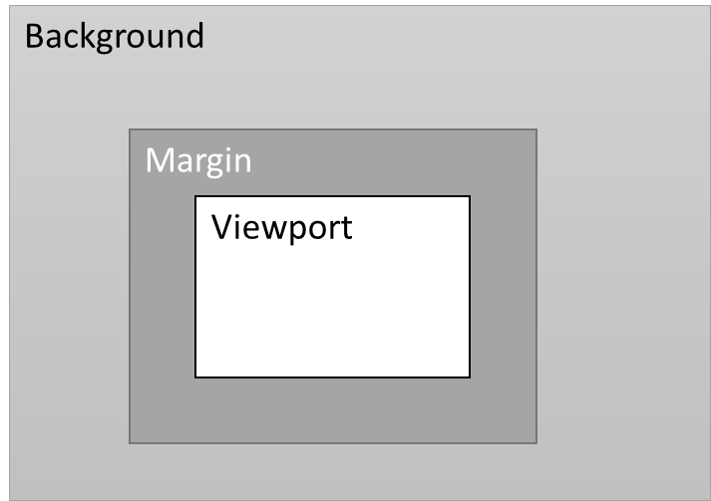
Figure 9.7.1: An equirectangular projected picture with viewport, margin and background areas.

- It should be possible to signal the extent of this margin area (as a minimum and maximum). The signaling may be done using SDP at the beginning of the session or during the session.
- It may be possible for the sender to change the width of these margins during the session without receiver involvement. However, the margin area should not exceed the maximum or be less than the minimum value set for it.
- The margin area may be extended equally on all sides of the viewport or unevenly.

9.7.2 Role of the Sender and Receiver and Margin Control

It is important to have a clear responsibility split between sender and receiver during the adaptation operations. As mentioned above, the margin control is fully sender controlled. So, we envision the following responsibilities for sender and receiver:

SENDER:
- The extension of the viewport in the form of margins around it is controlled by the sender.
- The sender alone is responsible for optimizing the use of the margins during the session based on the signalled parameters and the receiver feedback (e.g., viewport orientation, etc.).
- The sender signals its capabilities in the use of margins in the initial SDP signaling.

- The sender relies on the information signaled from the receiver including RTCP feedback (e.g., viewport orientation, timing information etc.).

RECEIVER:

- The receiver should not request a larger viewport area during a session to ensure better operation.

- While the receiver may influence the parameters to be used for margins, it is not involved in the actual adaptation operations.

9.7.3 Uses and Examples

Margin areas around the viewport can be used by a 360-degree sender to optimize the user experience of the receiver. Margins may be extended around the viewport evenly or unevenly. Some example scenarios where margins may be used to improve safe playback are listed below:
- Equally extended margins (symmetric) around the viewport in all directions may be used when the network allows to decrease the motion to high-quality delay for a receiver. The margins may be gradually extended farther by probing the network and reduced when the network is congested. In this scenario, the use of margins is akin to sending a larger viewport.
- Margins may be unevenly extended around the viewport (directional) with larger margins in the direction the user’s head is turning. In the absence of head motion, the margins may return to being equally extended all around the viewport. In this case, RTCP viewport orientation feedback is used to decide the distribution of margins. See Figure 1.
- Margins may be unevenly extended around the viewport with larger margins in the direction of the predicted head motion, e.g., based on audio input, motion tracking or other application level functions.
- A sender may optimize the use of margins based on network characteristics. For instance, a larger margin may be used when the motion to high-quality delay is high. Alternatively, a low motion to high-quality delay would indicate that the sender should use the available bandwidth for higher quality viewport instead of larger margins.
- In case of multiple receivers, margins are specifically signaled for each of the receivers.

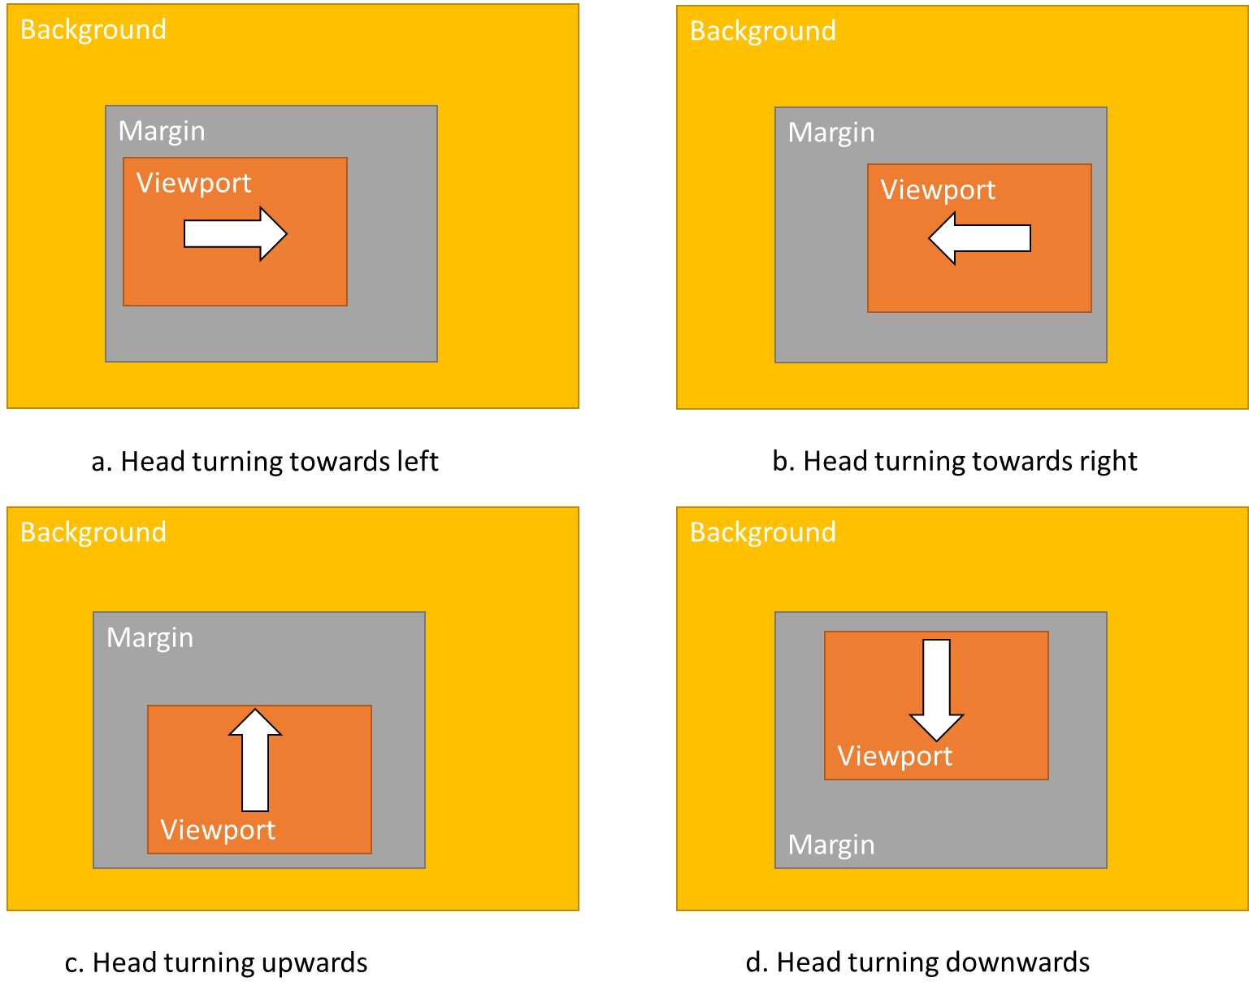
Figure 9.7.3.1: Uneven extension of margins based on the user head motion. Similar uneven extensions may be used based on other application-level parameters.

Example 1: Directional Margins

It is noted that margins in ITT4RT should be implemented such that they provide some level of flexibility to the sender in their implementation. For instance, directional margins may be used by the sender in anticipation of motion, as previously discussed. The benefit of such a scheme is illustrated here with an example. Consider a receiver with a 90 degree horizontal viewport. A 20% margin is used around the viewport. A viewport information message is sent at a rate equal to the frame rate, 30fps, i.e. approximately every 33ms. We simulated a head motion in the right direction going from 0 to 90 degrees at varying speeds from 5 to 360 degress per second (dps).Figure 1 shows the M2HQ delay and the percentage of the viewport at low quality (averaged). In this figure , the M2HQ is calculated from the first frame in which the device viewport is at least partially outside the high-quality region sent by the sender up to the last frame after which the device viewport remains within the high-quality region.

Two cases are shown 1) symmetric margins, and 2) directional margins. In the former case, the extent of margins is equal on each side for the entire duration of motion. In the latter, the symmetry of the margin changes with the speed of the head. For speeds
- <50dps, the margin is the same on each side;
- >=50dps, the full margin is in the direction of motion.

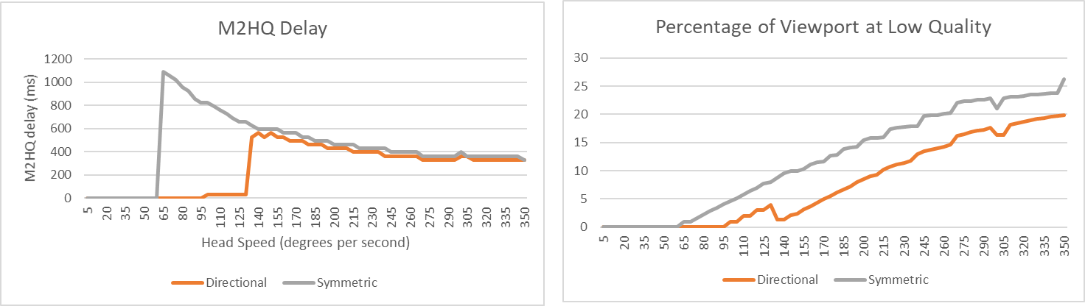
Figure 9.7.3.2: Effect of using Symmetric and Directional margins based on head motion
In the graph, a spike in M2HQ delay is seen when the speed of the head is fast enough for the viewport of the device to exceed the margin area before the server is able to update the high-quality region. Specifically, for the directional margins, since the margin in the direction of motion is wider, it takes higher speeds for the viewport to extend beyond it. The M2HQ values decrease at higher speeds because the motion from 0 to 90 degrees ends faster. However, the percentage of viewport at low-quality is higher as the device viewport moves much farther beyond the margin before an update is received. At speeds over 125dps, M2HQ values converge for both schemes. However, the percentage of viewport at low-quality is lower for directional margin.

The above example, while simplistic, illustrates that the sender can manipulate margins to provide better quality to the user, and that the margins are not necessarily the same as a larger viewport. Results show also the improved benefits of using directional margins. The margin area in degrees or percentage once negotiated can remain the same even if the viewport size changes.

9.7.3 Signalling and Operation

[Editor’s Note:
- clarify that signaling margins is optional, but if supported, consider proposing to require the following four attributes.
- clarify ranges of values to avoid conflicts and specify default values.
- clarify that height and width are equivalent to OMAF elevation and azimuth range.]
In order to indicate margins, a 360-degree video sender may include in its SDP offer the attribute margins with the following parameters:
- Max_T+B: defines the maximum sum of the top and bottom viewport margins. The value is provided as a percentage of the viewport height.
- Max_L+R: defines the maximum sum of the left and right viewport margins. The value is provided as a percentage of the viewport width.
- Min_T: defines the minimum margin that will be present above the viewport region. The value is provided as a percentage of the viewport height.
- Min_L: defines the minimum margin that will be present left of the viewport region. The value is provided as a percentage of the viewport width.
- Min_B: defines the minimum margin that will be present below the viewport region. The value is provided as a percentage of the viewport height. If this value is not signalled, it is assumed to be the same as Min_T.
- Min_R: defines the minimum margin that will be present right of the viewport region. The value is provided as a percentage of the viewport width. If this value is not signalled, it is assumed to be the same as Min_L.

The sender may, during operation, adjust margins between the minimum and maximum around the viewport based on the viewport feedback and RTCP reporting. However, it would not extend the margins beyond the maximum and will not shrink them below the minimum in any direction as indicated in the SDP.

The receiver can use margin extent and the RTCP feedback interval to evaluate when to prioritise sending an immediate feedback to the sender containing viewport information. The receiver knows that at any time the minimum margin is guaranteed and the maximum margin represents a safety threshold above which HQ video is not expected. The receiver application may adjust its behavior based on how aggressively it wants to address viewport orientation feedback. The receiver awareness of the margins used by the sender allows the former to have a look-ahead mechanism while the head is in motion at a given velocity towards the maximum margin and have an early predict-and-react policy that improves the viewport dependent operations.

EXAMPLES:

Directional Margins Usage: If the Max_L+R margin is 30% and the Min_L (and Min_R) is 5%. Then, in the case of directional margin described above, during head motion in the right direction, the viewport can have a maximum margin of 25% on the right side (the difference of Max_L+R and the Min_L) and a minimum margin of 5% on the left side of the viewport. The same happens when the head moves to the left direction.

Fixed Symmetric Margins Usage: If the Max_L+R margin is 30% and both Min_L and Min_R are 15%, then the margin on each side will always be symmetric, i.e. 15% on either side.

In addition to the extent of the margin, the sender may offer the receiver an option to choose the type of margin operation. Using the same network bandwidth, a sender may be able to deliver

1) HQ: a high-quality viewport with limited margin,
2) CQ: consistent quality using a larger margin and, if needed, a relatively lower-quality viewport.

The two modes define whether higher quality viewport is prioritized over a consistent viewport quality (one that minimizes the amount and duration of low-quality content at background quality in the viewport region in case of head motion) in case of restricted allowed bandwidth. A sender can in its SDP offer include these options, for example, using the format 3gpp_360video = "a=3gpp_video:" [cap=”VDP" SP "HQ/CQ" ], where HQ stands for High-Quality and CQ stands for consistent quality . The receiver can respond with the type of operation it prefers. The sender will try to achieve the highest quality with at least the minimum margin in case of HQ, and the highest quality possible with the maximum margin in case of CQ. Note that CQ in the SDP offer does not represent a quality level, but expresses the idea of a common visual quality between viewport and margin that (may be typically lower than HQ) allows a larger overall display area to user towards reducing MTHQ delay. Also, that “HQ” in the MTHQ term does not imply a specific level of quality but rather a consistent quality between the viewport and margin regions.

9.8 Enhancing RTCP Feedback with High Level Metrics

9.8.1 Introduction

ITT4RT streams will have more stringent bandwidth and latency requirements than traditional RTP streams. Since, RTP transmission is a sender-driven operation, the 360-degree video sender (either the 360-degree source or the MRF/MCU) should have the capability to adapt the stream to varying network conditions.

9.8.2 Bandwidth Adaptation and Reporting

The sender bandwidth adaptation steps may include:

- Viewport-dependent delivery to concentrate bandwidth usage on currently visible content.
- Using viewport margins or larger viewports to mitigate the effects of slow networks on viewport updates.
- Use of background still images.
- Reducing/increasing stream quality based on network conditions.
Bandwidth adaptation decisions at the sender should be taken on the basis of RTCP reporting from the receiver. Relevant RTCP report fields already present in MTSI/Telepresence include low-level metrics included in RTCP RR and RTCP XR reports, e.g., jitter, RTT, packet losses and discards. In addition to these, RTP receivers for 360-degree video also must provide RTCP feedback for head orientation that senders use for viewport-dependent delivery.

9.8.3 Motion to High Quality Delay

DASH adaptation techniques have shown that high-level metrics provide better insight and are more valuable in rate adaptation techniques [16]. The RTP sender is aware of the delivered quality and quality changes already. In addition, we propose that RTP receivers of 360-degree video report the Motion to High-Quality (MTHQ) Delay to the sender. The MTHQ Delay is defined as the time elapsed between the start of the head motion to an orientation not covered by the current viewport and the time the receiver (i.e., the client HMD) renders the high-quality video stream corresponding to the new viewport in the new head orientation.

The usage of the MTHQ Delay metric is beneficial in several ways:
- It may be used for real-time bandwidth adaptation, e.g., delivering wider margins when the MTHQ delay is high.
- It may be used for session monitoring in live conferences.
- It provides important information collected at a single point (RTP sender) to application engineers to optimize systems a posteriori.

CALCULATION

A possible method for calculating the MTHQ Delay is described here. Consider a receiver device with current viewport V_{i}. The user moves their head resulting in a change in viewport to V_{i+1}. This change in viewport is large enough (i.e., above a given threshold of degrees) for the receiver to send a feedback message to the sender to update the current viewport orientation.

The RTP timestamp of any of the packets belonging to the last rendered video frame on the V_{i} is V_{i}_Highest_TS. The sender continues to send viewport-dependent content based on V_{i} until it receives the receiver’s feedback message with the new viewport orientation V_{i+1}. The sender now updates the viewport-dependent streams to use the new viewport orientation V_{i+1}. The RTP Timestamp of any of the packets belonging to the first successfully rendered video frame using viewport-dependent delivery with the new viewport is V_{i+1}_Lowest_TS. The MTHQ delay, Motion_to_HQ, can now be calculated as:

Motion_to_HQ = V_{i+1}_Lowest_TS - V_{i}_Highest_TS

This results in a parameter expressed in RTP Timestamps units, which can be sent to the sender. It should be investigated further what level of aggregations should be used for the above value.

9.8.4 RTT Is not Enough

Motion to High-Quality Delay is not the same as RTT as depicted in the figure below. Furthermore, RTCP and RTP traffic may be treated differently in the network, and viewport updates use both types of messages. Hence, RTT values calculated using RTCP reports only can be misleading.

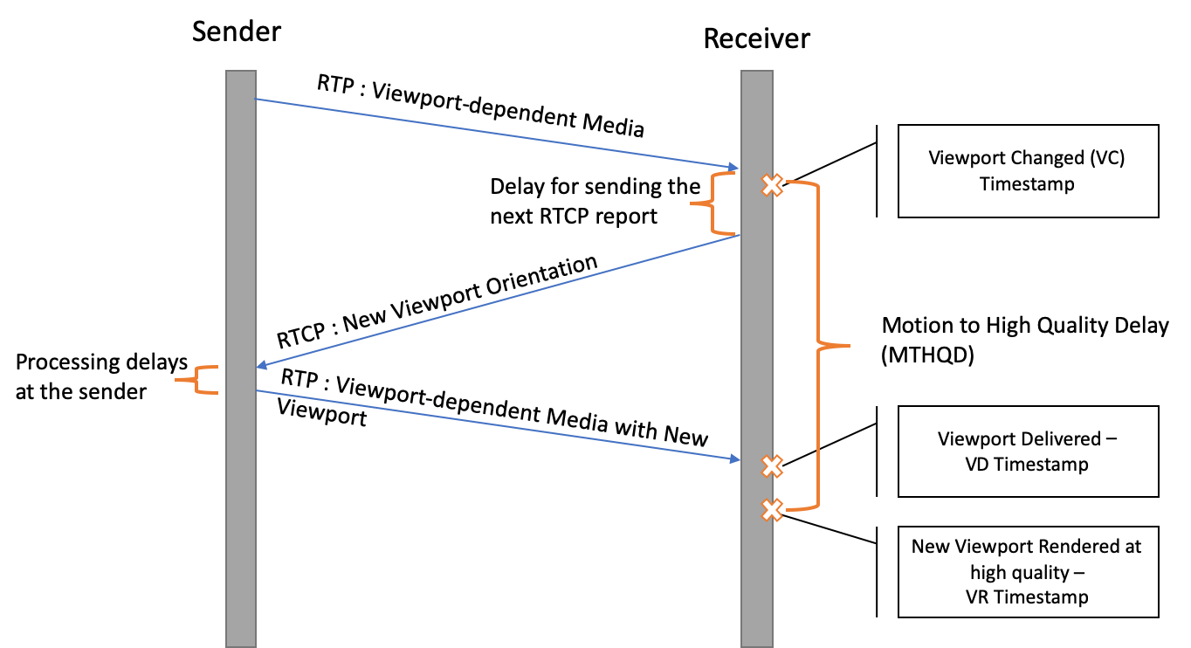
Figure 9.8.4.1: timing chart showing the events associated with viewport change and update

9.9 Signaling of Viewport Information using WebRTC Data Channel

Viewport information signalling based on the use of the WebRTC data channel [15]. The support for WebRTC data channel (as an optional feature for the MTSI client) is currently present for both MTSI in TS 26.114 and IMS-based Telepresence in TS 26.223. It runs over the “SCTP over DTLS” (Stream Control Transmission Protocol / Datagram Transport Layer Security) [13]-[14] protocol and is negotiated over the SDP [12]. The use of SCTP ensures the reliable and in-sequence delivery of the messages carrying viewport information.

[I-D.ietf-mmusic-sctp-sdp] defines how to set the values of an "m=" line describing an SCTP over DTLS association, with the following SDP ‘proto’ field values:
+-----------------+---------------+----------------------------+------------------------------+
| media | port | proto | fmt |
+-----------------+---------------+----------------------------+------------------------------+
| "application" | UDP port | "UDP/DTLS/SCTP" | "webrtc-datachannel" |
| | value | | |
| "application" | TCP port | "TCP/DTLS/SCTP" | "webrtc-datachannel" |
| | value | | |

While both of the above configurations are allowed in [I-D.ietf-mmusic-sctp-sdp], it is expected that UDP/DTLS/SCTP will be used.

The SDP dcmap attribute associated with the "m=" line describing the SCTP over DTLS association used to realize the WebRTC data channel, with the values set as following:

+-----------+-------------+--------------+-----------+------------+-------------+
| stream- | sub- | label | ordered | max-retr | max-time |
| id | protocol | | | | |
+-----------+-------------+--------------+-----------+------------+-------------+
| Value of | "View-" | Appli- | "true" | N/A | N/A |
| SCTP | “port” | cation | | | |
| stream | | specific | | | |
| used to | | | | | |
| realize | | | | | |
| the | | | | | |
| viewport | | | | | |
| channel | | | | | |
+-----------+-------------+-------------+-----------+--------------+------------+

A new sub-protocol attribute “Viewport” is defined to indicate the use of the WebRTC data channel for the purpose of viewport information signalling. The ‘ordered’ parameter is set as true to ensure in-sequence delivery of the messages over the WebRTC data channel carrying viewport information.

Here’s an example use of the SDP to negotiate the signalling of viewport information using the WebRTC data channel:
m=application 54111 UDP/DTLS/SCTP webrtc-datachannel
a=sctp-port: 5000
a=dcmap:2 subprotocol="Viewport";ordered=true

Accordingly, the new WebRTC data channel Protocol Value for Viewport (VP) information signalling may be registered with IANA as follows:

Subprotocol Identifier: Viewport
Subprotocol Common Name: Viewport
Subprotocol Definition: 3GPP TS 26.114
Reference: 3GPP TS 26.114

Viewport information messages may be formatted using structures such as XML or JSON. Accordingly, an XML schema or JSON schema may be defined carrying the following information, as aligned with the RTCP-FB message structure in clause 9.2 of the ITT4RT permanent document:

- Viewport_azimuth: Specifies the azimuth of the centre point of the sphere region corresponding to the desired viewport in units of 2⁻¹⁶ degrees relative to the global coordinate axes.
- Viewport_elevation: Specifies the elevation of the centre point of the sphere region corresponding to the desired viewport in units of 2⁻¹⁶ degrees relative to the global coordinate axes.
- Viewport_tilt: Specifies the tilt angle of the sphere region corresponding to the desired viewport, in units of 2⁻¹⁶ degrees, relative to the global coordinate axes.
- Viewport_azimuth_range: Specifies the azimuth range of the sphere region corresponding to the desired viewport through the centre point of the sphere region in units of 2⁻¹⁶ degrees.
- Viewport_elevation_range: Specifies the elevation range of the sphere region corresponding to the desired viewport through the centre point of the sphere region in units of 2⁻¹⁶ degrees.
- Timestamp: Specifies the timestamp of the last received RTP packet, toward associate the viewport information to the RTP media timeline
Editor’s Note: Definition of the packet format is still to be defined.
An example XML structure for a message carrying viewport information is shown below:
<xs:complexType name="viewportMessageType" abstract="true">
<xs:sequence>
<xs:element name="sequenceNr" type="xs:positiveInteger"/>
<xs:element name="azimuth" type="xs:positiveInteger"/>
<xs:element name="elevation" type="xs:positiveInteger"/>
<xs:element name="tilt" type="xs:positiveInteger"/>
<xs:element name="azimuthRange" type="xs:positiveInteger"/>
<xs:element name="elevationRange" type="xs:positiveInteger"/>
<xs:element name="timestamp" type="xs:unsignedInteger"/>
</xs:sequence>
<xs:attribute name="protocol" type="xs:string" fixed="Viewport"
use="required"/>
</xs:complexType>

The sender may increment the sequence numbers by one for each new message sent, the receiver may remember the most recent sequence number received and send back an error message if it receives a message with an unexpected sequence number.
The potential response message may be defined the following example XML structure:
<xs:complexType name="viewportResponseType">
<xs:sequence>
<xs:element name="responseCode" type="responseCodeType"/>
<xs:element name="reasonString" type="xs:string" minOccurs="0"/>
</xs:sequence>
</xs:complexType>

Editor’s Note: Efficiencies of RTCP and SCTP for carriage of viewport information should be studied and compared.

9.10 Proposed Solution for Viewport Sharing/Following

9.10.1 Description

Users with Head Mounted Displays are prone to motion-sickness and should not enable viewport-following on their devices.

However, users with 2D display devices that are not fully immersed in the experience may miss some audio/visual cues. Therefore, such users may want to follow the viewport of another user (e.g., a presenter). Viewport following requires a receiver to give up viewport orientation signalling and a sender to be capable of using another source for it. The following additional signalling is identified to enable this scenario:

A sender can include the list of viewport-control options it supports in the SDP offer during session establishment. The receiver would respond with the viewport-control option it wishes to use. Possible options may include:
- device-signalled: The receiver signals the viewport orientation information to the sender, which controls the viewport in the delivered stream(s).
- presenter-viewport: The receiver follows the viewport of another user.
- device-not-signalled: The viewport orientation information is not signaled. A viewport-independent stream is delivered by the sender due to sender limitations or receiver’s preference (e.g., based on device limitations or privacy reasons).
All senders must at least offer “viewport-ctrl: device-not-signalled” to the receiver devices. A sender may limit the quality of viewport-independent streams for the sake of network fairness.

A sender that offers “presenter-viewport”, should have the capability to receive requests for viewport-following from remote UEs wishing to follow another user’s viewport, and send requests to receiver(s) to request permission for sharing their viewport orientation, if needed.

9.10.2 Signaling Chart

One possible example scenario is illustrated below. Figure 9.10.2.1 shows the signalling flow for a conference call with an MRF/MCU with two remote participants UE B (HMD) and UE C (2D Display). The steps are explained below.

1a/b : The MRF/MCU sends a SIP Invite with the list of viewport control options supported by it.

2a: UE B (HMD) accepts the request with the following options 1) Allow viewport following (VF) requests from other devices 2) Send viewport-dependent stream based on device signalling. After this, an RTP/RTCP session is established for UE B, where viewport-orientation is sent to the MRF/MCU via RTCP feedback messages.

2b. UE C (2D Display) accepts the request with the following options 1) Disallow VF requests from other devices 2) Send viewport-dependent stream in VF-presenter mode with UE B as the VF-Source.

3. MRF/MCU requests permission for VF from UE B.

4. UE B grants permission to share viewport-orientation and allow VF. The MRF/MCU starts an RTP/RTCP session with UE C.
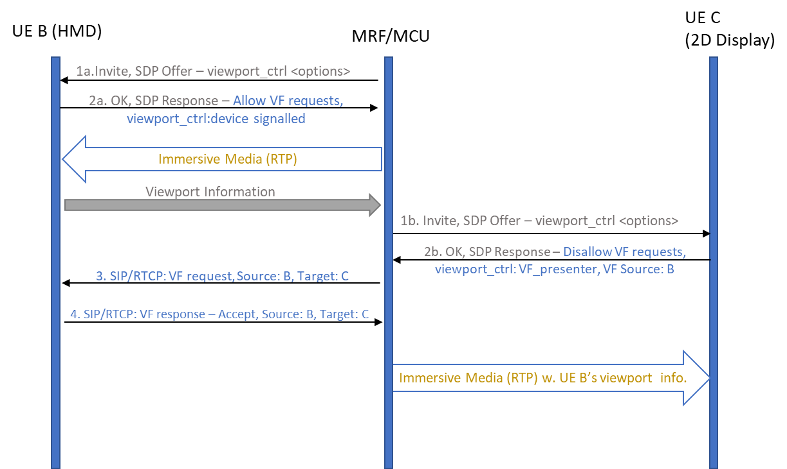

Figure 9.10.2.1 shows a signalling flow where a UE with 2D Display, C, chooses to enable VF-other with UE B (HMD) as the source.

9.11 Evaluation of RTCP as a Feedback Mechanism for Viewport Information

This section provides initial information about typical RTCP traffic for ITT4RT in MTSI. The idea is to start discussion and evaluate RTCP as feedback mechanism for real-time 360-degree video transmission.

Two simple example cases will be presented, with simplification of the scenarios to estimate the volume of RTCP traffic for immersive video.

CASE 1 – Constant RTCP feedback rate
In this case we suppose there is no head motion or that the head motion does not trigger additional feedback traffic. For instance, the RTCP feedback in this case is sent at a constant rate. The feedback may also include the transmission of viewport orientation information from the receiver to the sender, in addition to ordinary RTCP reports.

The analysis will here consider only the video stream of a multimedia immersive session. At a later stage we will conduct a similar analysis considering also the connected audio stream. We are interested in having an understanding of how much RTCP feedback a 360-degree video receiver is able to transmit for different video session bandwidths.

With the hypothesis of receiving a video stream of 5/10/15/20/30 Mbps and considering the standard 5% bandwidth allocated for RTCP traffic (without the 5 seconds minimum RTCP transmission interval, as allowed by RTP/AVPF profile), we can easily calculate the RTCP bandwidth for these cases. Considering RTCP packets of 96 bytes, it is possible to estimate how frequently can RTCP feedback packets be sent back to the sender. This feedback includes also viewport orientation information. So, these results give an important performance indicator for viewport-dependent operations in ITT4RT.

Table 9.11.1 shows that the standard 5% bandwidth for RTCP feedback is more than sufficient in order to dimension a VR system with a sub-second feedback capability.

Video bit rate (Mbps) | RTCP feedback bit rate (Mbps) | RTCP feedback frequency
5 | 0.25 | 3ms
10 | 0.5 | 1.54ms
15 | 0.75 | <1ms
20 | 1 | <1ms
30 | 1.5 | <1ms
Table 9.11.1. RTCP feedback bit rate requirements and feedback frequency

The Motion to High-Quality (MTHQ) Delay is larger than the network Round Trip Time (RTT), since there are processing delays at the sender and receiver to take into account. Let’s suppose an ITT4RT system aims at a MTHQ Delay of 100ms with constant rate RTCP feedback. Let’s also assume the one-way network delay be 30ms and sender+receiver processing delays are 10ms. Then 30ms x 2 + 10ms = 70ms are absorbed by network and processing delays. The receiver should set its constant feedback frequency to no more than every 30ms (i.e., the “delay for sending the next RTCP report” in Figure 1) in order to be within the 100ms MTHQ Delay budget.

Figure 9.11.1. Motion to High Quality Delay

Sending RTCP feedback every 30ms with the given RTCP packet size as defined above would mean to send 33.33 RTCP packets per second and requires 25.6 kbps, which is just 0.5% of the video stream bandwidth at 5 Mbps, or 0.08% of the video stream bandwidth at 30 Mbps.

Note that 30ms is the constant RTCP reporting frequency. However, a random head turn may occur at any time between two RTCP reports. So, on average it may occur after about 15ms from the sending of the previous RTCP report. In case the reports are transmitted at a constanr rate, the impact of a lost or delayed feedback report is smaller, since there will be another one already transmitted after e.g. 30ms. This makes the system well dimensioned and within the MTHQ Delay budget for the average case and also for the worst case.

Conclusion: the results shown give an idea of the bandwidth required for the RTCP feedback and for a competitive MTHQ Delay. The RTCP feedback requirements seem feasible, under the condition that the feedback is conveyed at a constant rate, regardless of the head motion and its speed.

Editor’s Note 1: Above analysis applies to point to point scenario and impact of multiple participants in the same RTP session also needs to be analyzed.

Editor’s Note 2: The above analysis does not consider the impact of jitter when sending RTCP-FB messages. Jitter may have significant impact on the delay calculations.

CASE 2 – Event-driven RTCP feedback with HMD motion
In this case we suppose that the RTCP feedback of the viewport orientation is given immediately upon the event of head turn (ordinary RTCP feedback may be sent at a higher or lower frequency). We also assume that the RTCP frequency increases with the HMD speed.

We consider HMD motion at speeds from 6 up to 180 degrees per second, with the assumption that there exist a feedback trigger, which is the minimum fixed distance that the head must move for a feedback to be sent. We assume this trigger to be 0.1, 0.5, 1 and 2 degrees in our simulation. We assume that the creation of the RTCP report is immediate. Figure 2 shows the RTCP feedback bit rate for different head speeds and trigger values. The required RTCP feedback rates are within the required 5% bandwidth of a 5Mbps video (0.25Mbps) in Table 1 for feedback triggers of 0.5 degrees and more. For a feedback trigger as short as 0.1 degrees, however, the required bandwidth values exceed RTCP bandwidth limitations for even a 20Mbps video when head speeds are over 125 degrees per second.
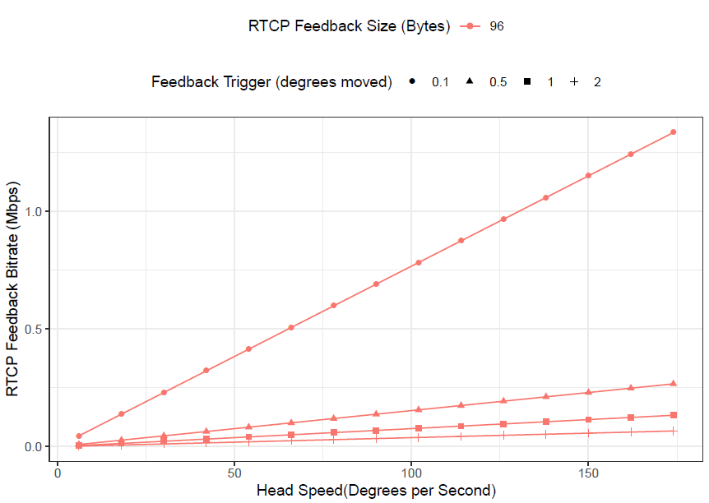
Figure 9.11.2. Required bit rate for event-based RTCP feedback at different head speeds

The time it takes for an event-based RTCP feedback to be sent depends on the feedback trigger and speed of the head. For instance, at a head speed of 6 degrees per second and 2 degree trigger, it would take about 333ms for the first feedback to be sent. This is reduced to 60ms when the trigger used is 0.1 degrees. Adding the previously assumed 70ms of network and processing latency, the value is over 100ms. It can be rightly assumed that a large trigger is set only when the viewport-dependent scheme allows this level of movement without needing an updated stream and the user will not experience this calculated latency in its entirety. However, the large change in latency based on the trigger value is an indicator that designing event based RTCP feedback requires careful thought and engineering to work efficiently. Initial implementations may benefit from using a fixed interval feedback.

As per RFC 4585, the receiver can send event-based immediate feedback as long as:
Events per interval <= RTCP allocated bandwidth / Avg RTCP packet size
where,
Events per interval= Avg no of events reported/ Time interval
For an immersive video, the event-based feedback interval can be calculated by:
Events per interval =HMD Speed/Trigger Angle
Therefore, to respect the 5% bandwidth allocated for the RTCP traffic allowed by the standard, it is recommended that the receiver does not trigger event-based immediate feedbacks for trigger angle smaller than TA_{min}, and

TA_{min} => Avg RTCP packet size / RTCP allocated bandwidth * HMD speed

With a changing trigger angle, receivers continue to operate within immediate feedback mode, where a feedback is sent as soon as an event is detected, however, the receiver redefines the event, which is the minimum trigger angle, based on current head speed.

Alternatively, receivers may evaluate an average time interval, T, between RTCP feedback messages based on the allocated RTCP bandwidth. The value T can be used by the receiver to limit RTCP viewport feedbacks from exceeding the allocated bandwidth in case of high motion, as done for the early RTCP feedback mode in RFC 4585. Using the interval, it is possible to use a combination of regular and event-based feedback messages.

9.12 Informative Discussion on Various VDP Solutions

There may be different ways in which a sender chooses to deliver viewport-dependent 360-degree video to the receiver(s). We discuss below four of these, which are described later in more detail:

- 360-degree video optimized for the current viewport
- Tiled video with multiple (at least two) quality levels
- High-quality viewport-only delivery
- High-quality viewport + low-quality background 360-degree video.
Note that the term 360-degree video is used for omnidirectional content within the Captured (or Preferred) Field of View range, and may not necessarily always be full 360 degrees. The figures show Equirectangular Projection (ERP) examples to illustrate the quality in different parts of the image for simplicity. While viewport margins are not shown in any of the solutions, they can be used unless indicated otherwise.

360-degree video optimized for the current viewport
In this case, the full 360-degree video which has been optimized for the current viewport is delivered to the receiver, so that the viewport is at a higher quality as shown in Figure 9.12.1. For the sake of scalability, an MRF/MCU delivering content to multiple end users may receive viewport independent 360-video from the content source, and encode multiple versions of the content optimized for different viewing orientations, and deliver the version most suitable to the current viewport of each user.

The bitrate savings are limited when the full 360-degree video is delivered. However, a delay in viewport update does not cause disruption in the viewing experience in terms of content flow, but just a temporary lowered quality of the visible content.

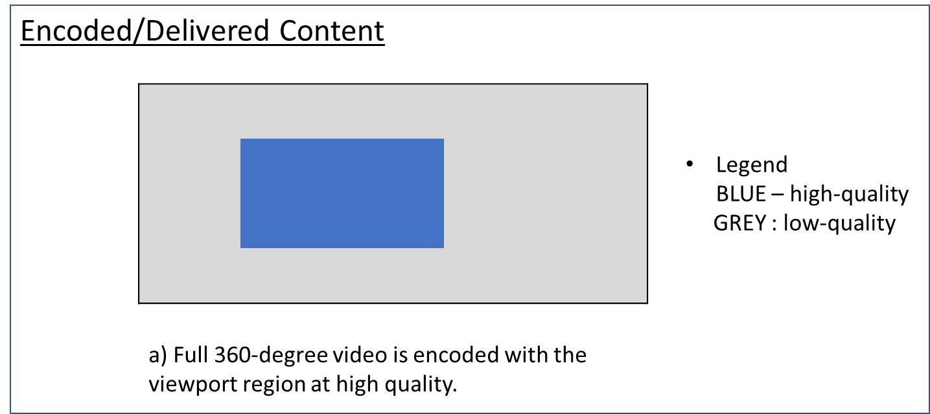
Figure 9.12.1: Full 360-degree video is encoded, optimized and delivered for the current viewport region.

Signalling and Delivery

The full 360-degree video can be delivered as a single RTP stream and the media stream will have the SDP attribute

a=3gpp_360video:100<sp>cap=VDP

where cap indicates the capability and VDP means Viewport-Dependent Processing. The receiver does not require any additional signalling from the sender to decode and render the stream. The resolution in the attribute “imageattr” corresponds to the 360-degree video and not just the viewport region.

Full Pipeline
We present here the pipeline for a point-to-point case (see Figure 9.12.2). The sender receives an image from a capture device and stitched if not pre-stitched. It then determines the viewport of the receiver based on RTCP viewport feedback. Once the viewport has been determined, the video is encoded with higher quality in the viewport region, packetized and delivered to the receiver. The receiver decodes and renders the received video. No additional signalling is needed.

Note: Region-wise packing may be used in this case as well, with additional signalling or information carried in SEI messages.
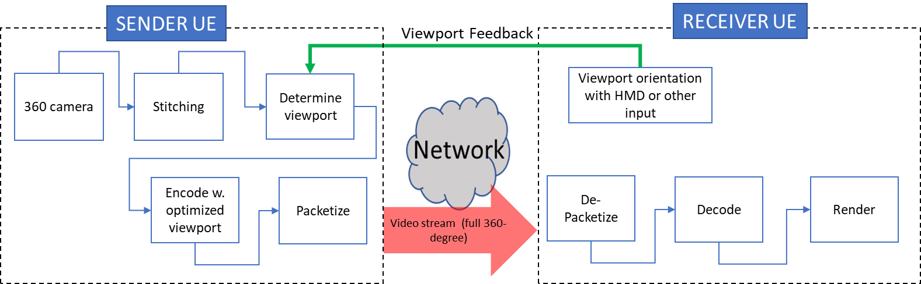
Figure 9.12.2 : Pipeline for 360-degree video with optimized viewport solution.

Tiled Video with multiple quality levels
In this case, tiled encoding, e.g., HEVC motion-constrained tiling, is used to create a tiled low-quality version of the 360-degree video and a tiled high-quality version of the 360-degree video (note that more than two quality levels for the encodings may be created). The delivered stream consists of high-quality tiles for the viewport region and low-quality tiles for the non-viewport region. When the low-quality and high-quality tiles are encoded using low fidelity and high fidelity, we refer to this as the mixed-quality tiled encoding approach. Whereas if the low-quality and high-quality tiles are created using lower resolution and higher resolution respectively, we refer to this as the mixed-resolution tiled encoding approach. Figure 3 illustrates the concept.

Mixed-resolution has been found to have a lower subjective quality in comparison to the mixed-quality approach [20] but may be used to increase the effective viewport resolution of viewport for devices with limited decoding capability [23] (e.g., effective 6K viewport resolution with 4K viewport resolution). The mixed-resolution and mixed-quality client operation implementation is described in [21]. The slice header and other bitstream rewriting required to create a conformant HEVC bitstream which can be decoded by a single decoder is described in OMAF 2nd edition draft (MPEG N19274), clause 4.6.4.2 and 10.1.5.4 [22].

The main advantage of tiled encoding is scalability; the MRF/MCU does not have to produce content for each receiver individually, but the operations are limited to picking the right high quality tiles and low-quality tiles from the two versions of the video, and “assemble it” for each receiver based on the receiver’s head orientation. However, tiled video has lower coding efficiency as inter-picture prediction is limited to each tile. Furthermore, the storage and processing requirements for encoding tiled video at multiple qualities may be unsuitable for smaller conference sizes.

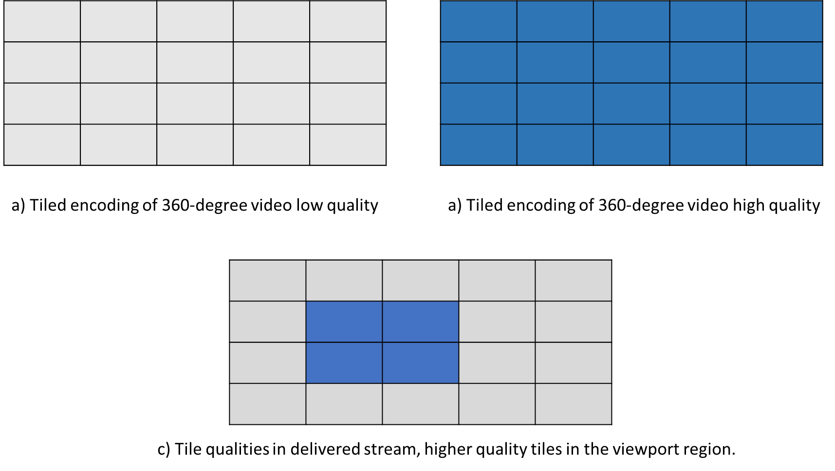
Figure 9.12.3: Tiled encoding is used to generate two versions of the full 360-degree video. The delivered stream consists of high-quality tiles in the viewport region and low-quality tiles in the non-viewport regions.

Note: Multiple streams and multiple decoders may be used for the tiled case but may increase complexity.

Signalling and Delivery
All tiles can be packaged and delivered in a single RTP stream and can be decoded using a single decoder when all tiles are decoded together. In case of mixed-resolution, packing information needs to be signaled to the receiver, which uses it for rendering after decoding. The SEI messages for region-wise packing (RWP) can be used to carry the information about packed picture mapping to assist the receiver in the understanding of the high-quality and low-quality areas, or be sent as an RTP header extension.

In the SDP, in addition to indicating VDP, an additional SDP parameter may be used to indicate the packed picture mapping (PPM). For example,

a=3gpp_360video:100<sp>cap=VDP<sp>PPM=1/2

where “PPM” (i.e., packed picture mapping) may carry the value 1 for mixed quality packing or 2 for mixed-resolution packing.

The resolution in imageattr corresponds to the 360-degree video.

Full Pipeline
The full pipeline is shown in Figure 9.12.4. In this case, the encoding process is the same regardless of the viewport orientation of the receiver. Once encoding is done, the sender can determine the viewport and select the tile qualities based on the viewport region. The tiles are packed and delivered to the receiver which decodes and renders. The stream must carry information about RWP to assist the receiver in unpacking. The unpacking is part of the rendering process and may require upsampling tiles and arranging the upsampled tiles into the projected format in the mixed-resolution case. The packing/unpacking step and signalling packed picture information in the stream is not needed for the mixed-quality case.

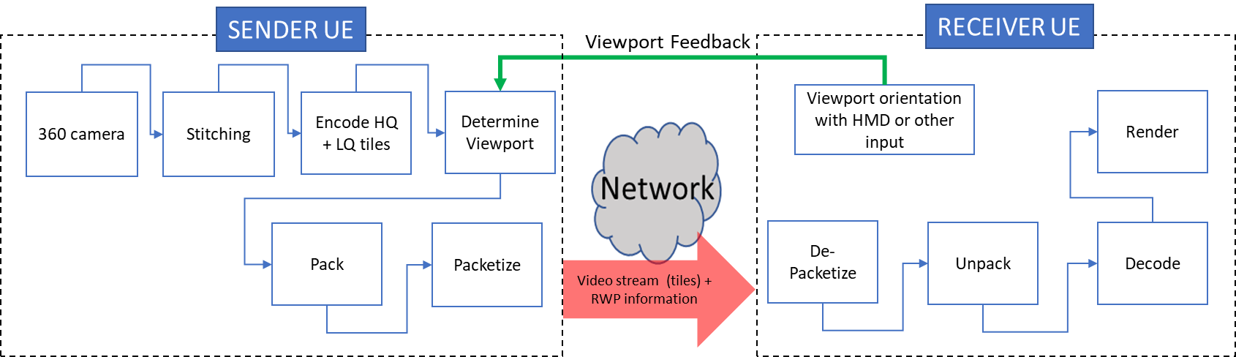
Figure 9.12.4: Pipeline for 360-degree video with tiled encoding. Packing and RWP information may not be needed in cased of mixed-quality.

HQ viewport-only delivery
For maximim bandwidth savings, the sender may send only an extracted high-quality region corresponding to the viewing orientation. In this case, only the extracted viewport (with or without a margin) from the 360-degree video is encoded and delivered to the receiver. If the viewport is extracted from a projected picture (e.g., ERP), the resolution would change depending on where the viewport is located on the picture. To prevent changing resolution, the sender must rotate the sphere to re-orient the selected viewport to the center of the projected picture. Figure 5 illustrates the rotated and centered viewport extracted from the 360-degree video.
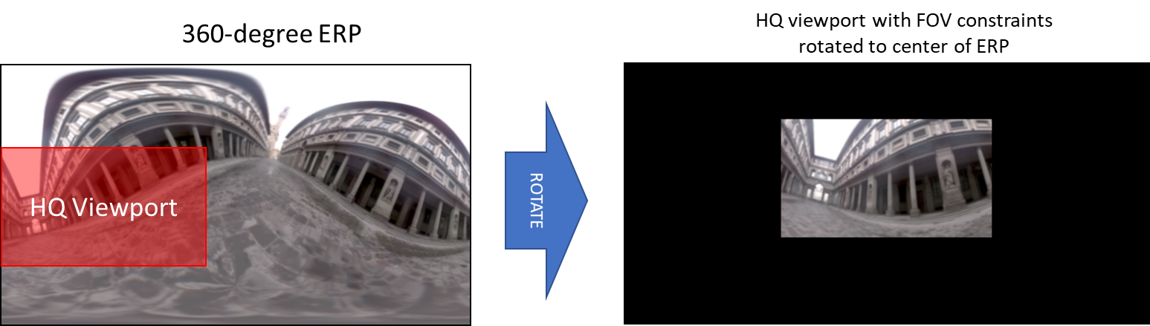
Figure 9.12.5: The 360-degree video is rotated with respect to the original capture orientation to bring the viewport to the center of the ERP in order to ensure the same resolution for the viewport region.

The required steps for this method on the sender side are :
- The images are captured with a 360-degree camera.
- The images are stitched if in-camera stitching is not provided.
- The viewport is selected based on the viewport size and the last known viewport orientation (based on RTCP viewport feedback).
- The viewport is rotated to the center of the projected picture; this ensures consistent resolution for viewport-dependent encoded picture resolution of a projected picture (as shown in Figure 9.12.5).
- Encode the content and deliver it to the receiver.
For the receiver to be able to display the received viewport correctly in reference to the capture orientation, the sender must signal the rotation information to the receiver. This can be done using the rotation SEI messages or using an RTP payload header extension carrying the orientation of the delivered viewport in reference to the capture orientation.

Signalling and Delivery

The video is delivered as a single stream. The SDP signalling consists of

a=3gpp_360video:100<sp>cap=VDP

An RTP header extension to carry the selected viewport information (azimuth, elevation and tilt) of the delivered stream may be used as previously discussed in sections 6.1 and 9.4 of the Permanent document when SEI messaging is not used. The resolution in the imageattr corresponds to the resolution of the delivered viewport region.

Full Pipeline
The full process based on the steps mentioned above is illustrated in Figure 9.12.6. The receiver always receives a constant sized, constant resolution image for the viewport region. The sender must include information about the selected viewport with the stream so that the receiver is able to reverse the rotation applied by the sender in Step 4 above.

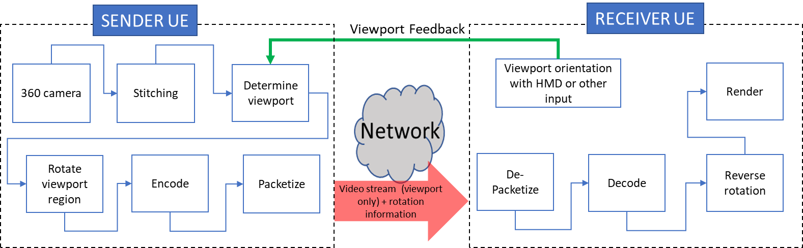
Figure 9.12.6: A high-quality viewport-only solution

Viewport-Locked Mode
The viewport only solution is especially useful for viewport followers that are following the viewport orientation of another user. In this case, the received viewport does not need to be mapped to the original capture orientation, i.e., there is no need to reverse the rotation. Instead, the receiver can render the received video as viewport-locked, i.e., centered at the center of the viewport/display. The modified pipeline for this case is shown in Figure 9.12.7. The SDP parameter to use would be:

a=3gpp_360video:100<sp>cap=VDP-VL

The solution may be useful for other 2D display devices even if they are not follower UEs, as a delayed viewport update (at least 1 RTT) does not significantly lowers the user experience. In case of ultra low-latency networks, the solution can be used for HMDs, but may cause motion sickness if latency increases and, hence, must be used carefully.
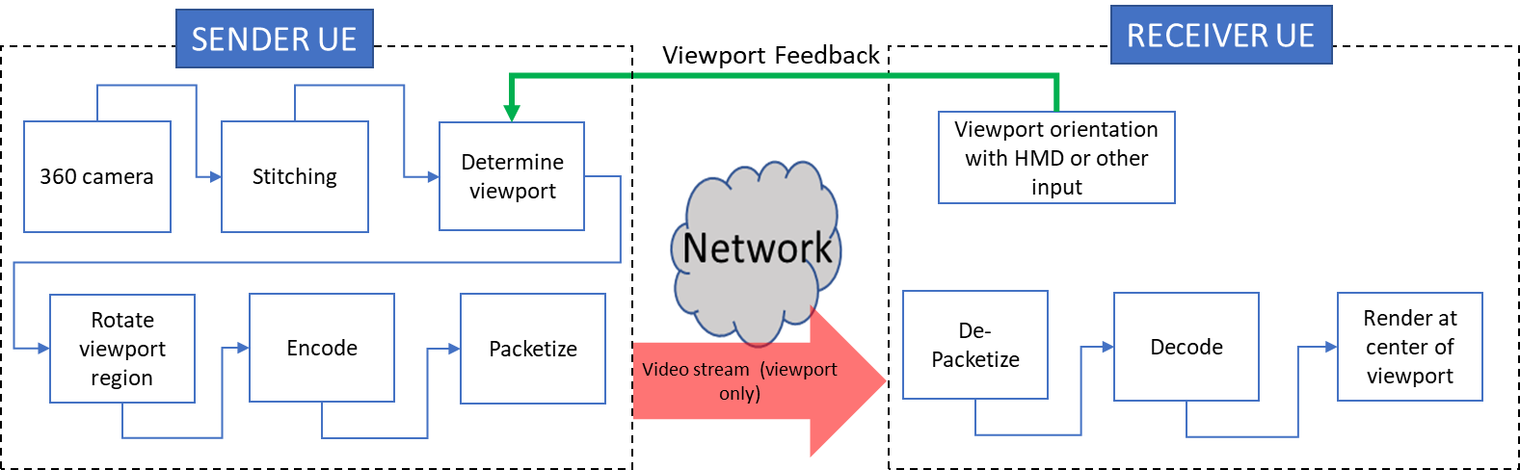
Figure 9.12.7: A high-quality viewport only, viewport-locked (VL) solution. The viewport feedback may be received from a different UE in case of follower UEs.

HQ Viewport + LQ background delivery
The HQ viewport-only solution can be combined with a low-quality (LQ) viewport-independent 360-degree video to deliver a more continuous viewing experience in case of head motion. This LQ background may be delivered as a separate 360_bg stream, however, this requires the use of two decoders and the two streams require synchronization. The HQ viewport stream may be an upgrade stream sent only when network conditions allow and paused in case of network issues.

In an alternate case, the LQ viewport-independent 360-degree video can be frame packed with the HQ viewport and delivered as a single stream, as shown in Figure 9.12.8. This method would require packing information to be delivered to the receiver. Since the size and shape of the pictures remains same, this information can be signaled only once using SDP, using the Packed Picture Mapping (PPM) attribute. Further details on the signalling and pipeline of a single stream case follow.

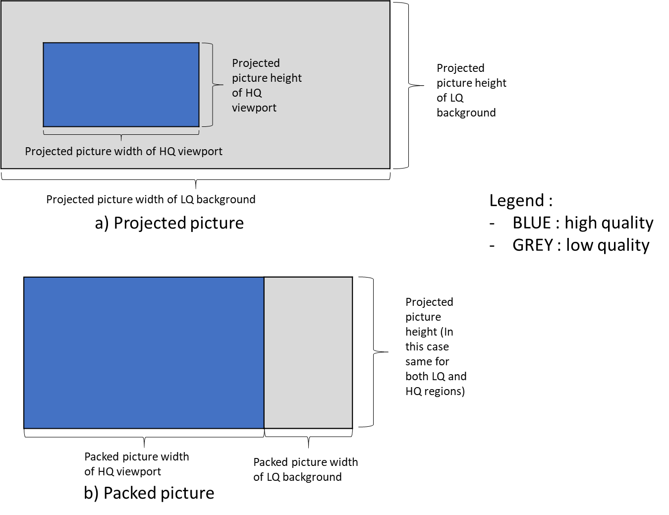
Figure 9.12.8: A high-quality viewport and low-quality background packed in a single stream.

Signalling and Delivery:
When the video is delivered as a single stream, the SDP signalling consists of
a=3gpp_360video:100<sp>cap=VDP<sp>PPM:[packing information]

The packing information consists of:
- Packed_picture_width of the high-quality region
- Packed_picture_height of the high-quality region
- Packed_picture_width of the low-quality region
- Packed_picture_height of the low-quality region
- Transform operations applied on the high-quality region.
- Transform operations applied on the low-quality region
Transform operations may be any of the following:
1. no transorm
2. mirrored horizontally
3. Rotation clockwise by 90 degrees
4. Rotation clockwise by 180 degrees
5. Rotation clockwise by 270 degrees
6. Rotation anti-clockwise by 90 degrees
7. Rotation anti-clockwise by 180 degrees
8. Rotation anti-clockwise by 270 degrees.

An RTP header extension to carry the selected viewport information (azimuth, elevation and tilt) of the delivered stream may be used as previously discussed in sections 6.1 and 9.4 of the Permanent document when SEI messaging is not used for carrying rotation information for the HQ viewport. The resolution in the imageattr corresponds to the resolution of the encoded picture. The resolution of the viewport may be higher than the background.

Full Pipeline
The full pipeline is shown in Figure 9.12.9. A high-quality viewport is encoded in the same way as described in part c for HQ viewport-only delivery. In addition, a LQ 360-degree viewport-independent version of the video is encoded. Both streams are packed together, packetized and delivered to the receiver. The receiver unpacks, decodes, reverse rotates the HQ viewport to the right coordinates and finally renders. 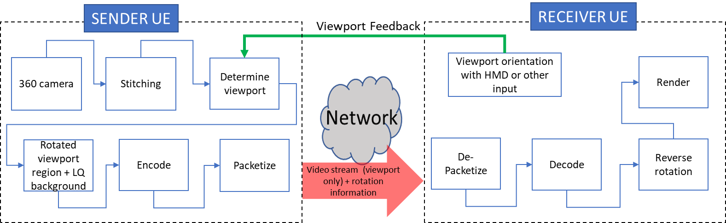

Figure 9.12.9: A high-quality viewport and low-quality background using a single stream.

Comparisons of the Proposed Solutions

We present here a short discussion on the advantages and disadvantages of each of the proposed solutions. The purpose is to formulate a clear recommendation for ITT4RT applications on what type of VDP solution to use.

- 360-degree video with optimized viewport is delivered entirely as a single stream and does not require any complex unpacking process at the receiver. It can be made scalable if multiple versions with different viewport orientations are encoded.
- Tiled media is scalable to a large number of receivers with different viewport sizes. The tiles are independently decodeable, and hence only the required tiles can be delivered (e.g., only the viewport with or without a margin) but decoding the tiles independently requires either multiple decoders or serializing the decoding process (introducing latency). Decoding all tiles within the frame is more suited to a single decoder solution. This way the receiver also maintains media availability in case of head motion. However, this comes at the expense of bit rate savings. Finally, since tiled encoding at multiple qualities has higher storage and processing requirements it is, therefore, less suited to smaller conference sizes and may work better in the presence of an MRF/MCU. It should be investigated further if there is a recommended minimum conference size for which such a scheme is more suitable.
- A HQ viewport-only solution is able to maximize bandwidth savings but limits the availability of media in case of head motion. Margins can be used to extend the viewport for better experience. The frames maintain shape and resolution despite projection. The content is delivered as a single stream and a single decoder is required making it suitable for simpler receivers. However, additional selected viewport information needs to be signaled from the sender to receiver with the video stream either as SEI or RTP header extension. The special viewport-locked case omits this signalling and provides a simplistic solution for follower UEs and limited FoV ITT4RT clients. It can be paired with a background LQ 360-degree video for a fuller viewing experience. When packed in a single stream, the LQ background + HQ viewport solution does not require updating the packing information with a changing viewport. The packing information can be signaled once in the beginning using SDP.
Finally Table 9.12.1 shows a comparison of the different solutions.
 | 360-degree video optimized for the current viewport | Tiled Video with multiple quality levels | HQ Viewport-only | HQ Viewport + LQ background
Required number of decoders | 1 | 1 | 1 | 1
Number of RTP streams | 1 | 1 | 1 | 1
Synchronization needed | No | No | No | Required in case of multiple streams
Efficiency in terms of bit rate | Low | Variable⁺ | High | Low
Intracoding prediction efficiency |  | ∝ 1/N⁺⁺
Scalability (for multiple receivers and MCU usage) | Low** | High | Low* | Low*
Freedom of movement | Full | Variable⁺ | Limited | Full
SDP signaling (cap) | VDP | VDP | VDP / VDP-VL | VDP
RTP header extensions | No | Packing information (may be sent in SEI) (Not required for Mixed-quality) | Delivered Viewport (unless VL is used)  (may be sent in SEI) | Delivered viewport  (may be sent in SEI)
Encoding complexity | FFS | High | Low | Low
Required receiver complexity | Low | Variable⁺ | Low | FFS
Additional SDP signaling | None | PPM: To indicate mixed-quality or mixed-resolution tiles | None | PPM:  Packing information in case of single stream***
* Scalability can be improved by encoding multiple versions of HQ viewport for different viewport orientations and deliver the version most suited to each receiver’s orientation.
** Scalability can be improved by encoding multiple versions of the content optimized for different viewing orientations and deliver the version most suited to each receiver’s orientation.
*** The packing information does not need to be updated regularly as the size and orientation of both frames remains the same. It can be shared once in the beginning in SDP.
+ Depends on whether all tiles (for full 360-degree) are delivered and decoded or only a subset.
++ N is the number of tiles
Table 9.12.1: Comparison of different Viewport-Dependent Delivery schemes for ITT4RT.

Recommendations:
[Note: From the discussed options, one or more recommended solutions should be selected based on conference size, device capabilities and network topology.]

9.13 QoE Metrics for ITT4RT

9.13.1 Introduction
This section documents a VR QoE metrics collection and reporting framework for ITT4RT, by reusing (i) existing metrics developed for DASH-based VR Streaming in TS 26.118 [5] and (ii) existing QoE metric configuration and reporting techniques for MTSI in TS 26.114 [1]. The VR QoE metrics may be collected by service providers and used to enhance the immersive media quality and experiences as part of ITT4RT. A client reference model is also provided with observation and measurement points for collection of the metrics.

9.13.2 Client Reference Model
The client reference architecture for VR metrics, shown below in Figure 9.13.2.1, is based on the receiver architecture in Figure 6.1. It also contains a number of observation points where specific metric-related information can be made available to the Metrics Collection and Computation (MCC) function. The MCC can use and combine information from the different observation points to calculate more complex metrics.

Note that these observation points are only defined conceptually, and might not always directly interface to the MCC. For instance, an implementation might relay information from the actual observation points to the MCC via the VR application. It is also possible that the MCC is not separately implemented, but simply included as an integral part of the VR application.
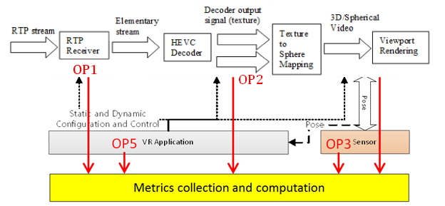
Figure 9.13.2.1: Client reference architecture for VR metrics

Observation Point 1
Based on one or more received RTP media streams, the UE parses, possibly decrypts and feeds the elementary stream to the HEVC decoder.

The interface from the RTP receiver towards MCC is referred to as observation point 1 (OP1) and is defined to monitor:

- The reception time for each received RTP packet as well as packet losses and interarrival times of the RTP packets.
- Relevant RTCP packet information including RTCP sender and receiver reports containing packet statistics, as well as related RTCP feedback messages for rate adaptation as well as for viewport information signalling.

Observation Point 2
The HEVC decoder receives the elementary bitstream and obtains the decoder output signal, referred to as the "texture", as well as the decoder metadata. The Decoder Metadata contains the Supplemental Information Enhancement (SEI) messages, i.e., information carried in the omnidirectional video specific SEI messages, to be used in the rendering phase.

The interface from the HEVC decoder towards MCC is referred to as observation point 2 (OP2) and is defined to monitor:

- Media resolution
- Media codec
- Media frame rate
- Media projection, such as region wise packing, region wise quality ranking, content coverage
- Mono vs. stereo 360 video
- Media decoding time

Observation Point 3
The sensor extracts the current pose according to the user's head and/or eye movement and provides it to the renderer for viewport generation. The current pose may also be used by the VR application to control the RTP receiver to signal for instance viewport information to the RTP sender using RTCP feedback messages.

The interface from the sensor towards MCC is referred to as observation point 3 (OP3) and is defined to monitor:

- Head pose
- Gaze direction
- Pose timestamp
- Depth

Observation Point 4
The output signal, i.e., the decoded picture or "texture", is then rendered using the Decoder Metadata information contained in relevant SEI messages contained in the video elementary streams. The Decoder Metadata is used when performing rendering operations such as region-wise unpacking, projection de-mapping and rotation toward creating spherical content for each eye. The VR Renderer uses the decoded signals and rendering metadata, together with the pose and the knowledge of the horizontal/vertical field of view, to determine a viewport and render the appropriate part of the video and audio signals.

The interface from the media presentation towards MCC is referred to as observation point 4 (OP4) and is defined to monitor:

- The media type
- The media sample presentation timestamp
- Wall clock counter
- Actual presentation viewport
- Actual presentation time
- Actual playout frame rate
- Audio-to-video synchronization
- Video-to-motion latency
- Audio-to-motion latency

Observation Point 5
The VR application manages the complete device, and controls the RTP receiver, the HEVC decoder and the rendering based on media control information, the dynamic user pose, and the display and device capabilities.

The interface from the VR application towards MCC is referred to as observation point 5 (OP5) and is defined to monitor:

- Display resolution
- Max display refresh rate
- Field of view, horizontal and vertical
- Eye to screen distance
- Lens separation distance
- OS support, e.g. OS type, OS version

9.13.3 Metrics Definitions
Based on the client reference model described in clause 9.13.2, the VR QoE metrics described in TS 26.118 may be reused as potential metrics candidates for ITT4RT metrics collection and reporting, namely:

- Comparable quality viewport switching latency, as described in clause 9.2 and Annex D.1 of TS 26.118
- Rendered viewports, as described in clause 9.3 and Annex D.2 of TS 26.118
- VR device information, as described in clause 9.4 of TS 26.118

Comparable quality viewport switching latency
The comparable quality viewport switching latency metric reports the latency and the quality-related factors when viewport movement causes quality degradations, such as when low-quality background content is briefly shown before the normal higher-quality is restored. Note that this metric is only relevant in case of viewport dependent processing, i.e., when VPD capability is negotiated.

Editor’s Note: Detailed syntax and measurement process for this metric are TBD.

The observation points needed to calculate the metrics are:

- OP2 HEVC Decoder: QR information
- OP3 Sensor: Gaze information
- OP4 VR Renderer: Start of switch event detection
- OP5 VR Application: Field-of-view information of the device

Rendered viewports
The rendered viewports metric reports a list of viewports that have been rendered during the media presentation.

Editor’s Note: Detailed syntax and measurement process for this metric are TBD.

The observation points needed to calculate the metrics are:

- OP3 Sensor: Gaze information
- OP5 VR Application: Field-of-view information of the device

VR Device information
This metric contains information about the device, and is logged at the start of each session and whenever changed (for instance if the rendered field-of-view for the device is adjusted).

Editor’s Note: Detailed syntax and measurement process for this metric are TBD.

The observation point needed to report the metrics is:

- OP5 VR Application: Device information

9.13.4 Metrics Configuration and Reporting

Configuration
Metrics configuration is done according to MTSI in TS 26.114, but can also include any metrics above defined for ITT4RT. Both OMA-DM and QMC approaches described in clauses 16.3 and 16.5 of TS 26.114 may be used to configure the QoE metrics for ITT4RT.

Reporting
Metrics reporting can be done according to MTSI, with the type QoeReportType extended to handle the additional VR-specific metrics according the XML schema in clause 16.4.1 of TS 26.114.

[

10 Another Potential Solution for Overlays based on Scene Description

10.1 Introduction

Clause 6.3 introduced a potential solution for overlays. This clause provides another potential solution based on scene description.

10.2 Overview

A scene graph is a directed acyclic graph, usually just a plain tree-structure, that represents an object-based hierarchy of the geometry of a scene. The leaf nodes of the graph represent geometric primitives such as polygons. Each node in the graph holds pointers to its children. The child nodes can among others be a group of other nodes, a geometry element, a transformation matrix, etc.

Spatial transformations are attached to nodes of the graph and represented by a transformation matrix.

This structure of scene graphs has the advantage of reduced processing complexity, e.g. while traversing the graph for rendering. An example operation that is simplified by the graph representation is the culling operation, where branches of the graph are dropped from processing, if deemed that the parent node’s space is not visible or relevant (level of detail culling) to the rendering of the current view frustum.

10.3 glTF 2.0

glTF 2.0 is a new standard that was developed by Khronos [17] to enable Physically Based Rendering. glTF 2.0 offers a compact and low-level representation of a scene graph. glTF 2.0 offers a flat hierarchy of the scene graph representation to simplify the processing. glTF 2.0 scene graphs are represented in JSON to ease the integration in web environments. The glTF 2.0 specification is designed to elimate redundancy in the representation and to offer efficient indexing of the different objects in the scene graph.

The structure of a glTF 2.0 scene graph document is arranged as follows:

The scene graph itself has the following structure:

MPEG is working on extensions to glTF 2.0 to add support for real-time media, scene updates, and other features. [19]

10.4 Scene Description-based Composition and Overlays

10.4.1 General

Scene Graphs make it very simple to compose scenes for an immersive presentation. The composition may be performed at an MRF or MCU. Alternatively, a designated party in the conference is responsible for creating the initial scene description and sharing it with all other parties in the call. This party may be the one that creates the main VR content, for instance, the party that is in the conference room with a VR capture.

Each party may contribute one or more nodes to the Scene Graph. Each nodes comes with its associated transformation (in form of a matrix, or individual translation and rotation operations), to place that node appropriately in the scene.

10.4.2 SDP Signaling

In this section, 2 different alternatives are offered for the signaling of the scene description for the ITT4RT session.

In the first alternative, a dedicated websocket channel may be used [18]. By using WebSockets, the reliable transmission and exchange of the scene description and its updates is guaranteed. Each party of the conference call may offer to send and receive a scene description through the following session-level attribute given in ABNF syntax:

Session-Description = “a=scene-description:” SP mime-type [SP uri] [SP sent-nodes] CRLF
mime-type = “mime-type:” byte-string
sent-nodes = “nodes-owned=1*(byte-string “;”)
uri = “websocket-uri:”URI

The uri parameter shall be a WebSocket URI for a data channel over which the scene description will be shared and updated.

Alternatively, a WebRTC data channel based on SCTP/DTLS/UDP is used [12]-[15]. This alternative leverages the data channel definition in 26.114 for MTSI sessions. An application media session is used with the protocol identifier UDP/DTLS/SCTP with the subprotocol being “sd” for scene description information.

An example is shown below:
m=application 52718 UDP/DTLS/SCTP webrtc-datachannel
a=sctp-port:5000
a=fingerprint:SHA-1 4A:AD:B9:B1:3F:82:18:3B:54:02:12:DF:3E:5D:49:6B:19:E5:7C:AB
a=tls-id: abc3de65cddef001be82
a=dcmap:0 subprotocol="sd"
a=setup:passive
a=connection:new
a=mime-type:model/gltf+json
a=nodes-owned: node12,node13,node14

10.4.3 Referencing Media Streams

The scene description references media streams from the conferencing session that are used as components of nodes in the scene. An example could be a video stream of a conference participant that is to be displayed in a rectangular region in the 3D scene. The following URI format shall be used for this purpose:

url=”rtp://” fqdn_or_ip “/” call_id “/” ssrc “/” mid

where fqdn_or_ip represent the domain name or ip address of the MRF or SIP proxy that manages the call. If none is used, it represents the domain name or ip address of the SIP address of the host of the call. call_id provides a unique identifier for the current call or conference. ssrc represents the synchronization source of the owner/sending participant of the media stream. Finally, mid represents media session identifier as provided in the SDP.
Other forms of addressing may be defined, e.g. as URNs.

10.4.4 Processing

Parties of an ITT4RT conference may establish direct peer-to-peer WebSocket channels with each other or a connection may be offered by an MRF to all parties. The WebSocket channel shall use the text frame format.

In a scene, node names shall be unique and shall be declared in the SDP to ensure there are no naming conflicts in nodes provided by different parties in a call. Nodes in the scene description may reference external media streams, such as other media streams that are declared in the SDP.
A receiver may mask nodes from certain parties in the rendering process, e.g. based on user input.
The MRF is by default the owner of the master scene graph, i.e. the one that sets the coordinate system and in which all other nodes are composited. It is also the one that defines the main camera in the scene.

In the absence of a centralized MRF, the parties in the call may select one party to provide the main scene description, for example by selecting the one that provides the VR content or the organizer of the call.

Overlays can be 2D or 3D objects that are placed within the scene. The geometry of the overlay and its texture are defined by the node that corresponds to that overlay object. A simple example is a set of slides that are played in a rectangular area that is shown inside the VR scene. In this case, the geometry will be a rectangle and the texture might be coming from a video media stream. The rectangle is placed in the scene. For viewport-dependent overlay, the position of the rectangle is locked to the camera direction.

Editor’s Note: Initial specification for overlays will only be focused on the SDP-based solution for which potential solutions are provided in clause 6.3. A scene description based solution may be specified at a later stage after MPEG delivers the FDIS of the related specification ISO/IEC 23090-14 [19].

10.4.5 SD Data Channel Specification

It is proposed to use a WebRTC data channel for the exchange of the scene description and updates between the ITT4RT session participants.

The following restrictions may apply:

- the channel may use the reliable message transmission mode of SCTP
- the channel may use the in-order message delivery mode of SCTP
- The channel label may be set to ‘sd’ for a complete scene description message or ‘sd-update’ for a scene description update message
- The payload protocol may be set to ‘3gpp-sd’
- The priority field may be set to 1024 for highest priority
The message payload may be a JSON formatted string in UTF-8 format that carries either the scene description document in glTF 2.0 format or the update commands.

10.4.6 Scene Updates

Scene updates are required to signal changes to the scene and share them among all participants. Each participant is only allowed to modify scene graph nodes that it has ownership of (and their child nodes). This implies that the call host has ownership of the full scene and may modify all nodes of the scene as it owns the root node.

Participants may join and leave the call at will and they may also decide to share or un-share overlay content during the lifetime of the ITT4RT session. These operations are supported through the ability of the participants to create new scene graph nodes and to remove scene graph nodes.
The JSON Patch protocol as specified in [1] shall be used for signaling scene graph updates. Each update operation shall consist of a JSON Patch document, where all update operations are considered as a single timed transaction. All update operations of a transaction shall be executed successfully for an update operation to be considered successful.

After successfully performing an update operation, the resulting scene graph shall be consistent, valid, and all references shall be correct. Since glTF 2.0 uses the order of elements for referencing, particular care should be used with update operations that change the order of elements in the graph, such as move and remove operations. The client shall update all references after every successful update operation.

Scene Update documents are carried using the scene description data channel and they are identified by using the label ‘sd-update’.

]

11 References

[1] 3GPP TS 26.114: "IP Multimedia Subsystem (IMS); Multimedia telephony; Media handling and interaction".
[2] 3GPP TS 26.223: "Telepresence using the IP Multimedia Subsystem (IMS); Media handling and interaction".
[3] ISO/IEC 23008-2: "Information technology -- High efficiency coding and media delivery in heterogeneous environments -- Part 2: High efficiency video coding".
[4] ISO/IEC 23090-2: " Information technology -- Coded representation of immersive media -- Part 2: Omnidirectional media format".
[5] 3GPP TS 26.118: "3GPP Virtual reality profiles for streaming applications".
[6] IETF RFC 7798 (2016): "RTP Payload Format for High Efficiency Video Coding (HEVC)", Y.-K. Wang, Y. Sanchez, T. Schierl, S. Wenger, M. M. Hannuksela.
[7] IETF RFC 7728 (2016): "RTP Stream Pause and Resume".
[8] ISO/IEC 14496-10: "Information technology – Coding of audio-visual objects – Part 10: Advanced Video Coding".
[9] IETF RFC 3550, “RTP: A Transport Protocol for Real-Time Applications,” 2003
[10] Peter Fasogbon, Emre Aksu, “Calibration of fisheye camera using entrance pupil”, http://arxiv.org/abs/1907.01759, IEEE International Conference on Image Processing (ICIP), 2019.
[11] ISO/IEC 23090-8: " Information technology -- Coded representation of immersive media -- Part 8: Network-based media processing".
[12] IETF Internet Draft, draft-ietf-mmusic-data-channel-sdpneg-28 (2019): "SDP-based Data Channel Negotiation" (WORK IN PROGRESS)
[13] IETF RFC 4960 (2007): "Stream Control Transmission Protocol"
[14] IETF RFC 8261 (2017): "Datagram Transport Layer Security (DTLS) Encapsulation of SCTP Packets"
[15] IETF Internet Draft, draft-ietf-rtcweb-data-channel-13 (2015): "WebRTC Data Channels" (WORK IN PROGRESS)
[16] Bentaleb, A., Taani, B., Begen, A. C., Timmerer, C., & Zimmermann, R. (2018). A survey on bitrate adaptation schemes for streaming media over HTTP. IEEE Communications Surveys & Tutorials, 21(1), 562-585.[17] Khronos Group, The GL Transmission Format (glTF) 2.0, https://github.com/KhronosGroup/glTF/tree/master/specification/2.0
[18] IETF RFC 8124, The Session Description Protocol (SDP) WebSocket Connection URI Attribute
[19] ISO/IEC 23090-14: Scene Description for MPEG Media
[20] Igor D.D. Curcio, H. Toukomaa, D. Naik, Bandwidth Reduction of Omnidirectional Viewport-Dependent Video Streaming via Subjective Quality Assessment, ACM International Workshop on Multimedia Alternate Realities at ACM Multimedia Conference, 27 October 2017, Mountain View, CA, U.S.A.
[21] M. M. Hannuksela, Y.-K. Wang, and A. Hourunranta, “An overview of the OMAF standard for 360° video,” Data Compression Conference, Mar. 2019.
[22] N19274, Potential improvement of OMAF, MPEG 130, April 2020.
[23] Alireza Zare, Alireza Aminlou, and Miska M. Hannuksela. 2018. 6K Effective Resolution with 4K HEVC Decoding Capability for OMAF-compliant 360° Video Streaming. In Proceedings of the 23rd Packet Video Workshop (PV ’18). Association for Computing Machinery, New York, NY, USA, 72–77. DOI:https://doi.org/10.1145/3210424.3210425

INCLUDEPICTURE "cid:image001.jpg@01D57F7D.A02B75E0" \* MERGEFORMATINET

The system supports transmission of full 360 video. However, the use cases may restrict the field of view to enhance user experience.

