3GPP TSG SA WG4#110-e meeting S4-201089
19th – 28th August 2020

Agenda item: 22
Source: Qualcomm Incorporated
Title: Gitlab for document tracking?
Document for Consideration

Introduction
After SA4#108-e there was SA4#109-e and now there is SA4#110-e. Realistically, there will be SA4#111-e and SA4#112-e. And there may be SA4#113-e. And there will be telcos over telcos. Rel-17 will be a primarily online Release. We are getting used to it, but can we get better, and maybe even get used it after COVID-19. Good tools may help on this and we started to integrate several of those into our 3GPP and in particular SA4 workflow. Primarily this includes:
- GotoMeeting for online meeting
- Tohru Handraising Tool
- 3GPP FTP and Document Server
- Minutes taking through shared google docs
- E-mail for discussion of document
While 1 – 4 prove to be very useful and will not longer be discussed, there may be two obvious further needs, namely
- An online collaboration tool for joint document editing such as onedrive, nextcloud, etc.
- An improved handling of document discussion.
We believe that the first topic can be handled in a case-by-case manner, depending on interested parties. This document addresses the latter, improved document discussoin, based on some experiences in MPEG.
The use of gitlab turned out to be useful and effective compared to e-mail discussion.

MPEG Approach
In MPEG Systems, and in this case for MPEG-I Scene description, the following process is conducted.
- All gitlab information is here: http://mpegx.int-evry.fr/software/MPEG/Systems/SceneDescription/MPEG-Contributions
- All gitlab issues are here: http://mpegx.int-evry.fr/software/MPEG/Systems/SceneDescription/MPEG-Contributions/issues
- Recommended asynchronous review process of contributions
  - Subgroup chair or BoG chair creates an issue for a registered contribution under the relevant project for asynchronous discussion.
  - When the contribution is uploaded then the entry will be added with the label DocAvailable for starting discussions
  - As async discussions develop, try to drive towards consensus. If someone believe that consensus has been reached, he/she can add a comment about what the consensus is (in a comment) and add the label ProbableAgreement. If someone disagree with that, he/she removes the label and add a comment why.
  - During the formal BoG meeting, the potential agreements about the document will be confirmed.
  - If a BoG decide on a disposition of a document, then the minutes are updated with the decision and a summary of the discussion, and appropriate label will be added to the issue then closed.
- Labels

Additional Labels in Scene Description:
- http://mpegx.int-evry.fr/software/MPEG/Systems/SceneDescription/MPEG-Contributions/labels

A few additional functionalities are used:
- Members must sign up for gitlab and need to be added to the project
- When starting a session, the issues can be filtered according to labels and/or milestones
- In the heading the document number is added with the title
- In the description, the document number, title, source and agenda item is added as well as a link to the document.
- Assignee: A single person is assigned to be owning the document, typically the submitter of the document
- Milestones are created for every milestone and document editing deadline. As an example, if the document is discussed in a BoG session #1 and requires comments by then, it is added this milestone.
- Every individual member can add comments or can generally just add a thumbs-up or down for the document. Thumbs-down should be supported with a comment.
- Every indivual member can also switch on and off notifications for the document.
- For tracking comments, people can use the login of the member discussing the issue. This links a person directly to the issue tracking

Potential Adjustments for 3GPP meeting
In order to use this tool for a 3GPP meeting (in this case of video), the above is rewritten with some adjustments. An example was created.
- All gitlab information is here: https://gitlab.com/3GPP_SA4/video
- All gitlab issues are here: https://gitlab.com/3GPP_SA4/video/-/issues
- Recommended asynchronous review process of contributions
  - Chair or SWG chair creates an issue for a registered contribution under the relevant project for asynchronous discussion and assigns person.
  - When the contribution is uploaded the assigned person adds a label Doc-Available.
  - When the contribution is due to for review, the chair/SWG chair changes the label to Doc-Under-Review and adds a milestone.
  - Once the review deadline is completed, the chair looks through the documents and
    - Changes Doc-Under-Review to Review-Completed.
    - assigns one of the following labels: Agreed Merged Needs-Discussion NeedsRevision Noted Rejected
  - Asynchronuously documents may be Revised or Withdrawn. If revised, the link to the new document is added in the description.
  - During the formal SWG or WG meeting, the document needing discussions are treated and handled. This can be done by applying a filter https://gitlab.com/3GPP_SA4/video/-/issues?scope=all&utf8=%E2%9C%93&state=opened&milestone_title=Video%20SWG%20%231&label_name[]=Needs-Discussion. The discussion is tracked in the system and one of the above labels may be assigned.
  - Revisions of documents are tracked in the same issue tracker
  - The minutes only refer to the gitlab discussion issue tracker and take over the final decisions.
- Proposed Labels
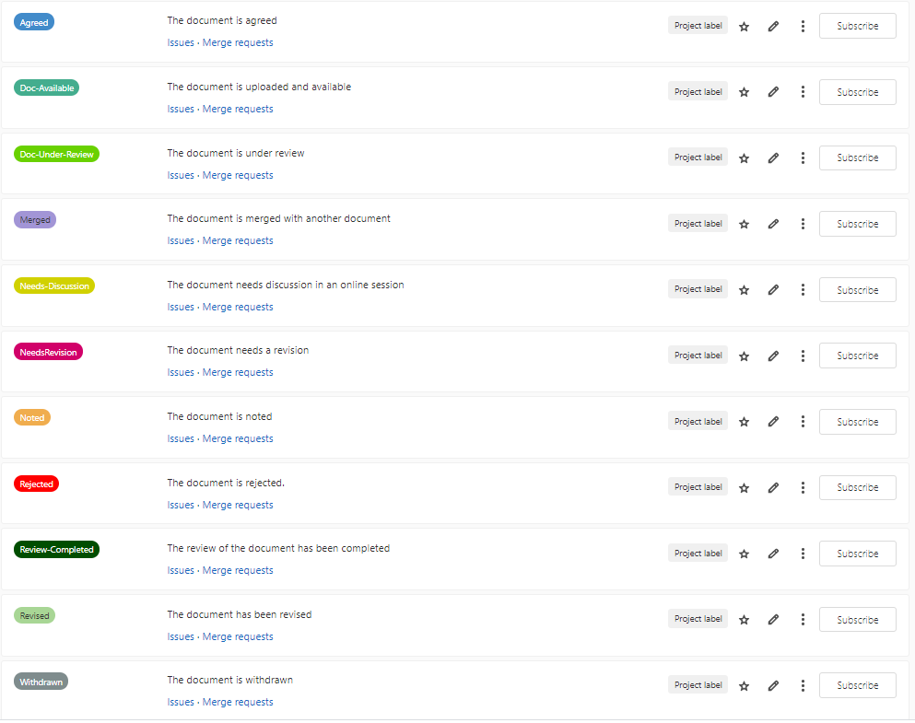

Example
As an example, one document has been created here: https://gitlab.com/3GPP_SA4/video/-/issues/1. This is the cockpit for this issue is below and explains a few of the topics.
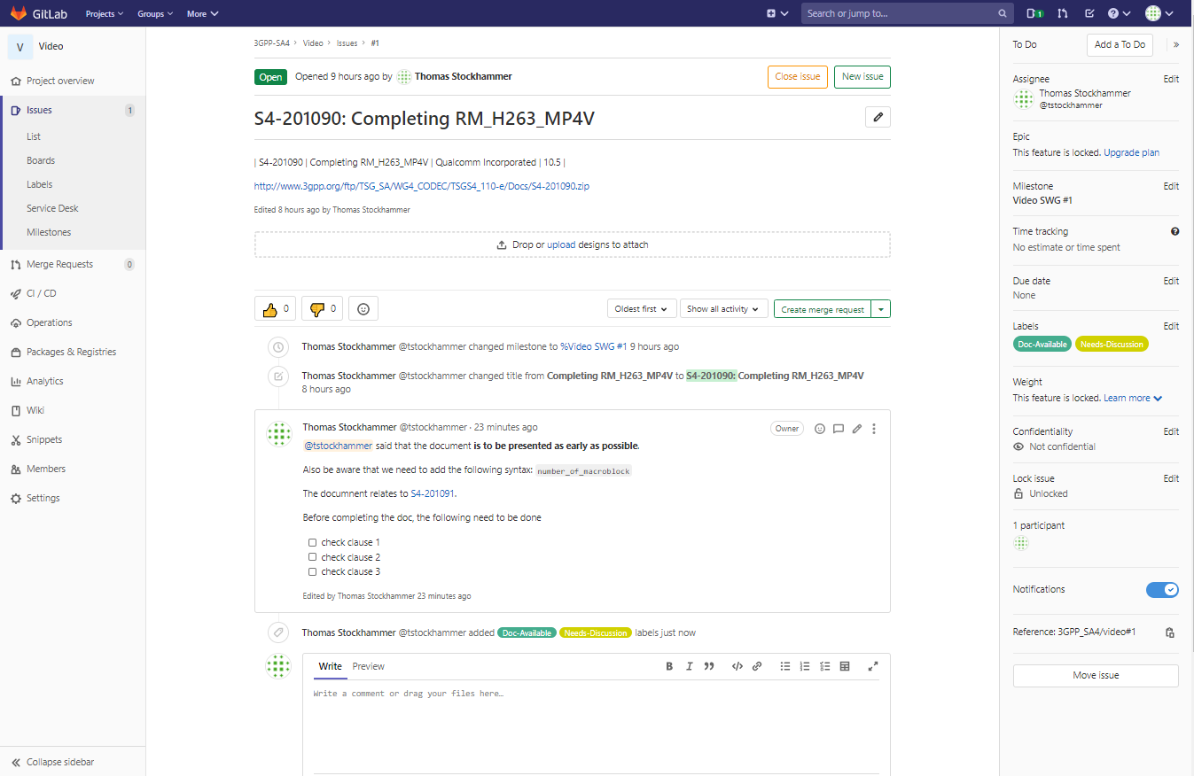

Test Signup
If you want to test sign up, please just sign up here https://gitlab.com/3GPP_SA4/video/-/project_members and I will provide you the ability to play around.
Obvious Issues
Before using such a tool, there are obvious issues:
- Does it comply with 3GPP rules?
- Who manages the gitlab access?
- What is the work load?
- Are we just adding another set of workload?
- Is it really needed?
- What are the costs, if any?
And and and.

Updates from the week
During the week, this document had been discussed here: https://gitlab.com/3GPP_SA4/video/-/issues/2. Thanks to Jayeeta, Thorsten, Richard, Stefan, SR, or as they are called in their gitlab world @ThorstenL, @Jayeeta_S, @Hoich, @sungryeul1 and @rjb1000.
The main points from the week are summarized:
- I am very open for using a better tool than email for document discussion and issue tracking. The tool should be hosted by 3GPP in the long run. A trial is good to know, what to request from ETSI / 3GPP.
- SA3, SA5 and CT groups are using Gitlab environment hosted by ETSI/3GPP for much longer duration than SA4, but the issue tracker is not used.
- Using an issue tracker would also be good for specs to simply collect all those things not worth filling out the CR form.
- You can create templates create using markdown files with extension .md - E.g., /.gitlab/issue_templates/contrib.md Then when you click new issues, you can select contrib. We can have many templates indeed.
- A suggestion: perhaps we could also tag each issue with the relevant Work Item short code [FS_5GVideo], etc.
- ETSI seems to have the "Enterprise" version, which supports the full featureset of Gitlab, way beyond the free Gitlab here. It's probably more a question whether ETSI is willing to give Maintainer rights to maintainers of a project.

Updated Considerations
We may consider
- To create a team to improve the above features during the AHG period and before SA4#111-e.
- To start the initial approach in a free gitlab for video SWG study items for FS_5GVideo and FS_XRTraffic on a trial basis. The rapporteur of the work item commits to fill in the submitted documents into the gitlab tracker following the procedures from clause 4 with some adaptation to AHG to announced.

- We learn as we walk – let’s give it a try.
- To report back on experiences, possibly improved processes and so on for the upcoming SA4#111-e meeting

