**3GPP TSG-S4 Meeting #110e**

**, Everywhere, – 28. August 2020**

|  |  |  |  |  |  |  |  |  |
| --- | --- | --- | --- | --- | --- | --- | --- | --- |
| *CR-Form-v12.0* | | | | | | | | |
| **Pseudo CHANGE REQUEST** | | | | | | | | |
|  | | | | | | | | |
|  |  | **CR** |  | **rev** |  | **Current version:** |  |  |
|  | | | | | | | | |
| *For* [***HE******LP***](http://www.3gpp.org/3G_Specs/CRs.htm#_blank)*on using this form: comprehensive instructions can be found at* [*http://www.3gpp.org/Change-Requests*](http://www.3gpp.org/Change-Requests)*.* | | | | | | | | |
|  | | | | | | | | |

|  |  |  |  |  |  |  |  |  |
| --- | --- | --- | --- | --- | --- | --- | --- | --- |
| ***Proposed change affects:*** | UICC apps |  | ME |  | Radio Access Network |  | Core Network |  |

|  |  |  |  |  |  |  |  |  |  |  |
| --- | --- | --- | --- | --- | --- | --- | --- | --- | --- | --- |
|  | | | | | | | | | | |
| ***Title:*** | Informative Annex on Parameter Population | | | | | | | | | |
|  |  | | | | | | | | | |
| ***Source to WG:*** |  | | | | | | | | | |
| ***Source to TSG:*** | S4 | | | | | | | | | |
|  |  | | | | | | | | | |
| ***Work item code:*** |  | | | | |  | ***Date:*** | | |  |
|  |  | | | |  | |  | | |  |
| ***Category:*** |  |  | | | | | ***Release:*** | | |  |
|  | *Use one of the following categories:* ***F*** *(correction)* ***A*** *(mirror corresponding to a change in an earlier release)* ***B*** *(addition of feature),* ***C*** *(functional modification of feature)* ***D*** *(editorial modification)*  Detailed explanations of the above categories can be found in 3GPP [TR 21.900](http://www.3gpp.org/ftp/Specs/html-info/21900.htm). | | | | | | | | *Use one of the following releases: Rel-8 (Release 8) Rel-9 (Release 9) Rel-10 (Release 10) Rel-11 (Release 11) Rel-12 (Release 12)* *Rel-13 (Release 13) Rel-14 (Release 14) Rel-15 (Release 15) Rel-16 (Release 16)* | |
|  |  | | | | | | | | | |
| ***Reason for change:*** | | This document is a followup of S4-AHIA43, which was discussed during last SA4 adhoc.  This version incorporates the suggested changes from Richard (BBC), thanks for the contribution.  This version uses a new figure, inspired by Thomas’ really good figure. | | | | | | | | |
|  | |  | | | | | | | | |
| ***Summary of change:*** | |  | | | | | | | | |
|  | |  | | | | | | | | |
| ***Consequences if not approved:*** | |  | | | | | | | | |
|  | |  | | | | | | | | |
| ***Clauses affected:*** | |  | | | | | | | | |
|  | |  | | | | | | | | |
|  | | **Y** | **N** |  | | | |  | | |
| ***Other specs*** | |  |  | Other core specifications | | | | TS/TR ... CR ... | | |
| ***affected:*** | |  |  | Test specifications | | | | TS/TR ... CR ... | | |
| ***(show related CRs)*** | |  |  | O&M Specifications | | | | TS/TR ... CR ... | | |
|  | |  | | | | | | | | |
| ***Other comments:*** | |  | | | | | | | | |
|  | |  | | | | | | | | |
| ***This CR's revision history:*** | |  | | | | | | | | |

**** First Change ****

# Annex X Dynamic policy parameter propagation (informative)

## X.1 End-to-end model

Figure X.1‑1 below depicts an end-to-end model for the propagation of dynamic policy parameters. The arrows indicate the main information flow. The interfaces specified in TS 26.501 [2] are used throughout. However, there are additional interfaces (i.e. P1 or U1), which are not in the 5GMS Architecture.

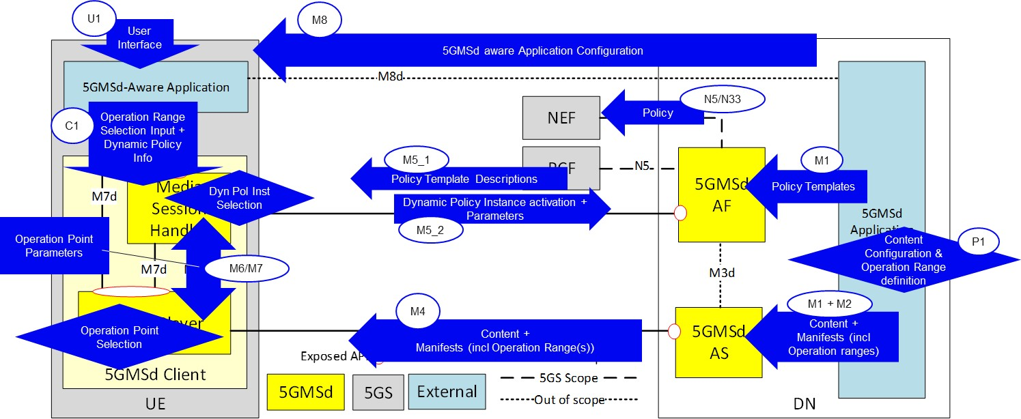

Figure X.1‑1: End-to-end model for dynamic policy parameter propagation

The interfaces involved and their roles in this feature are as follows:

* M1: Provisioning interface between the 5GMS Application Provider and the 5GMS AF.
* P1: The 5GMS Application Provider provisions the DASH MPD generator, e.g. by annotating the MPD with Service Descriptors.
* U1: User Interface to the 5GMS-Aware Application.

NOTE: The 5GMS Application Provider controls the application, i.e. controls the GUI choices.

* M8: Non-standardized input from the 5GMS Application Provider to the 5GMS-Aware Application, such as country-specific application behaviours (languages, on-demand catalogue, etc).

- Input on subscriptions (e.g. 4K subscription versus SD subscription).

- Device-specific content selection rules (e.g. SmartPhone versus Smart TV).

- Additional service offering features (e.g. background download possible).

* C1 (one of M6 or M7): Information from the 5GMS-Aware Application to the 5GMS Client, e.g. user content selections.
* M6: Information flow from the DASH Player to the Media Session Handler.
* M7: Information flow from the Media Session Handler to the DASH Player.
* M5_1: Information flow into the Media Session Handler for parameter provisioning (Policy Descriptions, which originate from 5GMS AF and 5GMS Application Provider). The Policy Descriptions contain or reference the detailed Service Access Information, i.e. URLs to activate a certain policy.
* M5_2: Information flow from the Media Session Handler to the 5GMS AF. This includes:

- input to create the Service Data Flow Templates (see TS 23.503 [X]) for identifying the application data flows within a PDU Session,

- an identifier for the Dynamic Policy instance (e.g. QoS, Conditional Zero-rating, charging, etc) and

- optionally, Network Assistance information, e.g. bit rate recommendations.

In its Annex K, the DASH standard [Y] specifies so-called “Service Descriptors”. The purpose of Service Descriptors is to provide additional information to a DASH player to influence its “Selection Logic”, e.g. a DASH player should prefer a certain set of representations within an adaptation set. It is assumed in the following that the DASH MPD can be annotated using Service Descriptors to give hints for subscription models and different device types.

The 5G System specifies a number of different means to detect application flows. When activating a Dynamic Policy, the Media Session Handler provides a Service Data Flow Template to the 5GMS System, which identifyies the application flow(s) of interest. It is assumed here that multiple applications are executing simultaneously on a given UE and that each application may independently access the network. Therefore, the Media Session Handler needs to provide (and update) these Service Data Flow Templates in order that the application traffic can be treated according to the corresponding Dynamic Policy.

In the following clauses, the parameter propagation for a number of different use cases is described.

## X.2 Premium QoS dynamic policy

### X.2.1 General

To realise a Premium QoS service offering, the 5GMS Client should activate a QoS Flow with characteristics matching the service needs. It is assumed that the DASH content is prepared for different subscription levels, e.g. 4K, HDR or SD, and for different target device types, e.g. SmartPhone or SmartTV. When commencing playback of a DASH presentation according to a particular subscription level (e.g. 4K), the 5GMS Client needs to activate a QoS Flow with a matching bit rate setting.

NOTE: The 5GMS Client may choose to activate a QoS Flow with a lower bit rate than the maximum supported by the 5G System, e.g. a small screen SmartPhone may select different QoS settings from a large screen device.

The per-title quality and the subscription levels of an example on-demand catalogue are illustrated in the figure below. The subscription levels in this example are 4K, FullHD, HD, SD and 480p. Only devices entitled to activate a 4K quality should actually select the according representations from the MPDs. In this example, all titles are available in SD and HD quality. Often, not all titles are available in 4K quality. Thus, a device with a 4K subscription can only activate reqception of the HD or SD representations.

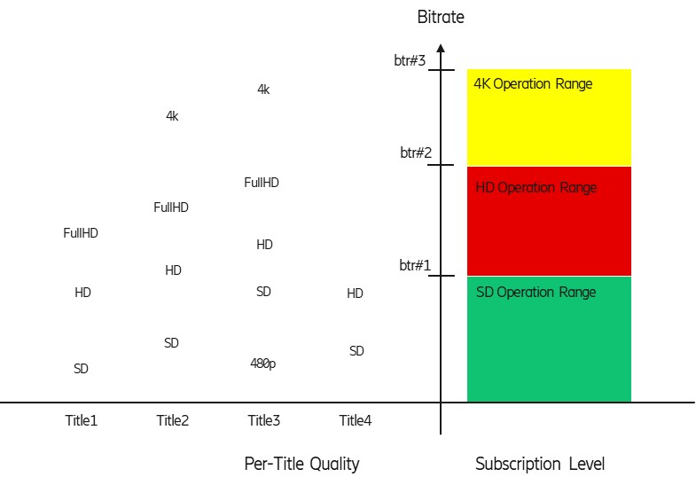

Figure X.2.1‑1: Subscription Levels for Premium QoS

The bit rate required to sustain a certain quality varies from title to title. In the figure, the bit rate needed for Title4 in HD is in the same range as SD quality of Title3.

The various consumer-facing Network Subscription Levels define a set of bounded Operation Ranges, as illustrated on the right side of the figure. Each such Operation Range is conveniently modelled in the 5GMS architecture as a Policy Template. The Policy Template for SD subscription level (SD Operation Range) is authorized to activate a maximal bit rate of btr#1. The Policy Template for 4K subscription level is authorized to activate between any low bit rate and a maximal bit rate of btr#3.

When activating a Dynamic Policy instance, the 5GMSd Client provides a desired bit rate for the selected title. The desired bit rate can be smaller than the maximal bit rate allowed by the Policy Template. The 5GMSd Client always activates a Dynamic Policy instance from its assigned Network Subscription Level, even when the desired bit rate justifies a different Policy Template.

When activating a QoS Flow for a certain subscription level and title, the 5GMSd Client should preferably select a desired bit rate matching the quality needed. For example, a device with an HD Operation Range subscription needs a higher desired bit rate when consuming Title3 in HD quality and a lower desired bit rate when consuming Title4 in HD quality.

In some cases, the system rejects a requested QoS Flow or drops an established QoS Flow due to insufficient available network resource. The 5GMSd Client can then try to activate a different QoS Flow with a lower desired bit rate.

### X.2.2 Procedure

The procedure for activating a Premium Qos dynamic policy is illustrated in figure X.2.2‑1 below.



Figure X.2.2-1: Procedure for activating Premium QoS dynamic policy

Steps:

1. The 5GMS Application Provider interacts with the 5GMS AF to set up one or more Policy Templates (using M1). Each Policy Template is identified by a Policy Template identifier and contains information about how to activate the corresponding policy within the 5G System (e.g. N5 URLs and parameters).

2. The 5GMS Application Provider interacts with its DASH content generation function (e.g. an MPD provider) to annotate the DASH MPD with Service Descriptors (using P1). The Service Descriptors define the Operational Ranges within the Media Player should operate. The DASH MPD and the DASH Media Segments are then ingested by the 5GMS AS.

3. The 5GMS-Aware Application is configured via M8 (step 3) with information about the available content catalogue (e.g. resolving MPD URLs), the available subscription identifiers (e.g. the user has a 4K subscription or the user has an SD subscription), device type identifiers and network policy identifiers. Each Policy Template is identified by a Policy Template identifier and contains information about how to activate the according policy within the 5G System (e.g. N5 URLs and parameters).

The subscription identifiers and the device type identifiers are collectively referred to as Service Description Filters in the following.

NOTE 1: It is for further study whether network policy identifiers are embedded in the MPD Service Descriptors or derived from the Service Descriptors.

NOTE 2: The network policy identifier can be equal to a Policy Template identifier when the 5GMS-Aware Application is aware about its usage (e.g. for QoS streaming or background download). It is assumed here, that a unique Network Policy identifier is assigned to each subscription level.

4. When the user selects an item via the User Interface (U1), the 5GMS-Aware Application translates the input to the needed 5GMSd API calls.

5. The 5GMS-Aware Application provides input (via C1) on the selected presentation entry (i.e. MPD URL) together with a Network Policy Identifier (the value indicates here a “HD Premium QoS” policy (alternative Network Policy Identifiers can refer to e.g. 4K quality), i.e. make the Media Session Handler request a QoS Flow) and Service Description Filters. The Service Description Filter is used by the Media Player to identify the usable Service Descriptors from the MPD. The Network Policy Identifier is used by the Media Session Handler to find the according Policy Description containing information on the Dynamic Policy instantiation method (i.e. procedure and parameters such as Policy Template identifier).

6. The DASH player fetches the MPD.

7. The Media Player selects the Service Descriptor and applies the Service Descriptor Filter.

8 The DASH player indicates to the Media Session Handler (M6) that a “HD Premium QoS” network service should be activated (value of the Network Policy Identifier). The DASH player provides input on bit rate ranges (which may depend on the device type and the title quality). The Media Session Handler has received one ore more Policy Descriptions together with matching Service Access Information (via M5_1). When the Media Session Handler has received the policy indication, the Media Session Handler uses the Network Policy Identifier to find the procedure and the parameters to activate the Dynamic Policy instance (i.e. find the matching Policy Description). The Media Session Handler activates a Dynamic Policy instance in the 5GMS AF, providing Service Data Flow Templates identifying the DASH media flows (audio, video, etc) and to provide the desired bit rate of the video.

9. The Media Session Handler activates a Dynamic Policy instance with the 5GMS AF. The 5GMS AF uses the Policy Template identifier to look up the matching Policy Template in order to create the PCF or NEF API invocation. As result, the Media Session Handler receives the enforcement bit rate in the 5GMS AF response. The 5GMS Client should not exceed this bit rate threshold.

The Service Access Information (via M5_1) includes a list of recommended traffic detection methods. The Media Session Handler selects a Service Data Flow description method (e.g. 5-Tuples). When the Media Session Handler selects:

- 5-Tuples: For each new TCP connection, the Media Session Handler updates the Dynamic Policy instances and adds a new 5-Tuple. For each closed TCP connection, the Media Session Handler updates the Dynamic Policy instances and removes the 5-Tuple of the closed TCP connection.

- TOS or Traffic Class: The Media Session Handler sets the TOS or Traffic Class for each new TCP connection.

- domain name: The Media Session Handler provides the domain name with the Dynamic Policy Instance.

### X.2.3 Example parameters

Table X.2.3‑1: M5_1 parameters for Policy Descriptions (used by the Media Session Handler)

|  |  |  |  |
| --- | --- | --- | --- |
| Parameter | Type | Purpose | Example Values |
| Policy Description | Object |  |  |
| Network Policy Idenfitier | String | Identifies the Policy Description. | “4K Premium QoS”,  “HD Premium QoS”. |
| Service Access Information URL | URL | References the associated Service Access Information. |  |

Table X.2.3‑2: M5_1 parameters for Service Access Information

|  |  |  |  |
| --- | --- | --- | --- |
| Parameter | Type | Purpose |  |
| Service Access Information | Object |  |  |
| Policy Template identifier | String | Identifies the Policy Template. | “HD QoS”. |
| 5GMS AF URL | URL | Used to invoke the 5GMS AF. |  |
| Mandatory Request M5 information | List | Desired bit rate, which should be provided by the network for the application. | Policy Template identifier,  Desired Bit Rate,  Packet Detection Filters. |
| M5 Response information | List | Information to the Media Session Handler on the response parameters. | OK (requested bit rate is accepted),  Proposed Lower Bit rate (requested bit rate cannot be provided). |
| sdfMethod | [String] | Indicates which Service Data Flow Description methods are recommended to be used by the Media Session Handler. | “5-Tuple”,  “domainName”,  “TOS=xx”, etc. |

## X.3 (Conditional) Zero Rating dynamic policy

### X.3.1 General

In the case of (Conditional) Zero Rating, the quality of a video streaming service must not exceed a certain bit rate threshold (called the policy threshold). This can be realized by deploying a traffic shaper in the network (e.g. a policing function in the UPF) or by instructing the DASH Player not to exceed a certain policy threshold bit rate. The policy threshold may be network-specific, i.e. depending on the 5G System. The following realization assumes the latter, i.e. the DASH Player is not exceeding the bit rate policy and the UPF is just monitoring the compliance of the application flows (one or more TCP and/or UDP flows). The MPD is annotated using DASH Service Descriptors in such a way that the DASH Player can identify which maximal representation bit rates still comply with the policy threshold.

Figure X.3.1‑1 below illustrates the per-title quality and the policy threshold. For Titles1 and Title2, the 5GMSd Client can activate the SD and HD representations. For Title3, the 5GMSd Client can activate the 480p and the SD representations. For Title4, the 5GMSd Client can activate all available representations (i.e. SD and HD).

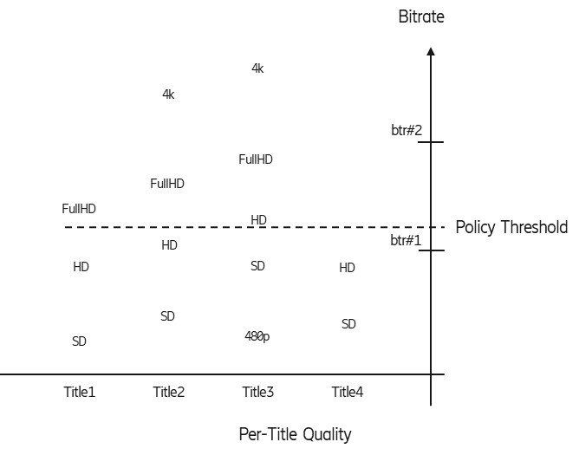

Figure X.3.1‑1: Policy threshold versus quality

When the 5GMSd Client receives the bit rate of the policy threshold from the network, the 5GMSd Client filters the MPD for policy-compliant representations (i.e. those that lie at or below the policy threshold).

### X.3.2 Procedure

The procedure for activating a (Conditional) Zero Rating dynamic policy is illustrated in figure X.3.2‑1 below.

Figure X.3.2‑1: Procedure for activating (Conditional) Zero Rating dynamic policy

Steps:

1. The 5GMS Application Provider interacts with the 5GMS AF to set up one or more Policy Templates. Each Policy Template is identified by a Policy Template identifier and contains information about how to activate the corresponding policy within the 5G System (e.g. N5 URLs and parameters).

2. The 5GMS Application Provider interacts with its DASH content generation function (e.g. an MPD provider) to annotate the DASH MPD with Service Descriptors (step 2). The intention of the Service Descriptors here is that the DASH Player can identify those representation combinations which do not exceed the bit rate requirement.

3. The 5GMSAware Application is configured via M8 with information about the available content catalogue (e.g. resolving MPD URLs), the available subscription identifiers (e.g. the user has a 4K content subscription or the user has an SD subscription), device type identifiers. Each Policy Template is identified by a Policy Template identifier and contains information, how to activate the according policy within the 5G System (e.g. N5 URLs and parameters).

The 5GMSd-Aware Application is configured via M8 about the available (Conditional) Zero Rating policy. This includes the Network Policy Ids.

4. When a user selects an item via the User Interface (U1), the 5GMS-Aware Application translates the input to the needed 5GMSd API calls.

5. The 5GMS Aware Application provides input (via C1) on the selected presentation entry (i.e. MPD URL) and also on the Network Policy Id (the value in this case indicates a (Conditional) Zero-Rating policy, i.e. make the Media Session Handler request the policy threshold parameter from the network).

NOTE: C1 is an abstract interface and indicates that the 5GMS-Aware Application may either first use M6 or M7 for the interactions with the 5GMS Client.

6. The Media Session Handler uses the Network Policy Identifier to find the procedure and the parameters to activate the Dynamic Policy Instance (here a (Conditional) Zero Rating policy). The Media Session Handler has received one ore more Policy Descriptions together with matching Service Access Information (via M5_1). The Media Session Handler uses the Network Policy Identifier as a key to find the correct Policy Description. Here, the Network Policy Identifier indicates a (Conditional) Zero Rating policy. The Media Session Handler should activate a dynamic policy in the 5GMS AF, providing Service Data Flow Template information about the DASH media flows (audio, video, etc.) and retriving the bit rate threshold, which cannot be exceeded to comply with the policy. The Media Session Handler receives (as result of the Dynamic Policy activation) some information on the policy enforcement (enforcementMethod and/or enforcementBitrate), so that the representation selection logic (bit rate adaptation function) in the DASH Player can consider the effects of the enforcement scheme.

7. The Media Session Handler activates the Dynamic Policy instance on M5, providing a Policy Template identifier. Upon positive response, the Media Session Handler notifies the DASH Player, providing Service Descriptor Filters. The Media Session Handler may receive these Service Descriptor Filters with the response, or it may look up the Service Descriptor Filter values by a response value. Alternatively, the Media Session Handler receives a maximum bit rate with the response and the Media Session Handler derives the Service Descriptor Filter. The Media Session Handler may also receive information about Policy Enforcement, e.g. what type of traffic shaper will throttle the bit rate.

The Media Session Handler may need to update the Dynamic Policy instance, depending on the selected traffic detection method. For example, when the Media Session Handler uses 5-Tuples, the Media Session Handler needs to update the Dynamic Policy instance with every newly opened and every closed TCP connection.

8. The DASH Player fetches the MPD of the selected content.

9. : The Service Descriptor Filter is used by the DASH Player to filter policy-compliant Service Descriptors from the MPD. The DASH Access Engine or Selection Logic (see ISO/IEC 23009-1 [Y] figure K.1) selects only adaptation sets and representations according to the filter. Here, the DASH Player fetches the MPD after the notification from the Media Session Handler.

### X.3.3 Example parameters

Table X.3.3‑1: M5_1 parameters for Policy Descriptions (used by the Media Session Handler)

|  |  |  |  |
| --- | --- | --- | --- |
| Parameter | Type | Purpose | Example Values |
| Policy Description | Object |  |  |
| Network Policy Id | String | Identifies the Policy Description. | “(Conditional) Zero Rating”. |
| Service Access Information URL | URL | References the associated Service Access Information. |  |

Table X.3.3.‑2: M5_1 parameters for Service Access Information

|  |  |  |  |
| --- | --- | --- | --- |
| Parameter | Type | Purpose |  |
| Service Access Information | Object |  |  |
| Policy Template Id | String | Identifies the Policy Template. | “not exceed bit rate” |
| 5GMS AF URL | URL | Used to invoke the 5GMS AF. |  |
| sdfMethods | [String] | Indicates which Service Data Flow Description methods are recommended for use by the Media Session Handler. | “5-Tuple”,  “domainName”,  “TOS=xx”, etc. |
| Mandatory M5 Request information | List |  | Policy Template identifier,  Service Data Flow Template. |
| M5 Response information | List | Information to the Media Session Handler on the response parameters. | Bit rate Policy Threshold (upper bit rate bound, which should not be exceeded). |

## X.4 Background Download

### X.4.1 General

In the case of Background Download, the asset is acquired in the background, prior to viewing. Many application services offer the capability of acquring a VoD item for later consumption. The 5GMS-Aware Application triggers the Media Session Handler to acquire the item, providing a background download network policy id.

NOTE: Here, the DASH Player is handling the acquisition, since the DASH Player contains the MPD processing and the DASH Access engine parts. Other realizations would use a separate background download agent, which is not even try to decode and render the video.

Figure X.4.1‑1 below illustrates the representation marking for background download. The MPD may be annotated with Service Descriptors clearly identifying representations intended for download. Here, Title1 should be downloaded in Full HD quality and all other titles in regular HD quality.

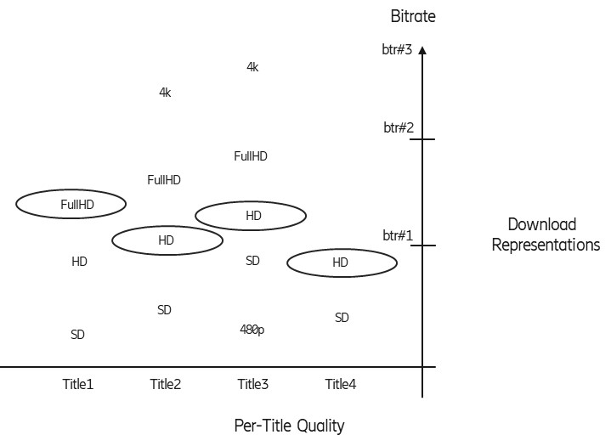

Figure X.4.1‑1: Background Download Representations

### X.4.2 Procedure

The procedure for activating a Background Download dynamic policy is illustrated in figure X.3.2‑1 below.



Figure X.3.2‑1: Procedure for activating Background Download dynamic policy

Steps

1. The 5GMS Application Provider interacts with the 5GMS AF to set up one or more Policy Templates (M1). Each Policy Template is identified by a Policy Template identifier and contains information about how to activate the according policy within the 5G System (e.g. N5 URLs and parameters).

2. The 5GMS Application Provider also interacts with its DASH content generation function (e.g. an MPD provider) to annotate the DASH MPD with Service Descriptors, e.g. to identify, which representation is intended for background download.

3. The 5GMS-Aware Application is configured via M8 with information about the available content catalogue (e.g. resolving MPD URLs), the available subscription identifiers (e.g. the user has a 4K subscription or the user has an SD subscription), device type identifiers. Each Policy Template is identified by a Policy Template identfier and contains information about how to activate the corresponding policy within the 5G System (e.g. N5 URLs and parameters).

The 5GMSd-Aware Application is configured via M8 about the available background download policy. This includes the Network Policy Id which hints a background download policy.

4. When a user selects an item via the User Interface (U1), the 5GMS-Aware Application translates the input to the needed 5GMSd API calls.

4. When a user selects an item via the User Interface (U1) for Background Download the 5GMS-Aware Application translates the input to the needed 5GMSd API calls.

5. The 5GMS-Aware Application provides input (via C1) on the selected presentation entry (i.e. MPD URL) and also on the Network Policy Identifier (indicating a background download policy, i.e. make the Media Session Handler request a bearer suitable for Background Download).

NOTE: C1 is an abstract interface and indicates that the 5GMS-Aware Application may either first use M6 or M7 for the interactions with the 5GMS Client.

6. The Media Session Handler uses the Network Policy Identifier to find the procedure and the parameters to activate the Dynamic Policy Instance (here a Background Download policy). The Media Session Handler has received one or more Policy Descriptions together with matching Service Access Information (via M5_1). The Media Session Handler uses the Network Policy Identifier as a key to find the correct Policy Description. The Media Session Handler should activate a Dynamic Policy in the 5GMS AF, providing Service Data Flow Template information of the media flows (audio, video, etc). The Media Session Handler can also receive information on a bit rate policing (enforcementMethod and/or enforcementBitrate), e.g. that the bit rate is actively limited.

7. The Media Session Handler activates the Dynamic Policy instance on M5, providing the Policy Template identifier and additional parameters. Upon positive response, the Media Session handler notifies the DASH Player to start the Background Download. The notification contains a Service Descriptor Filters, which is used by the DASH Player to filter policy-compliant Service Descriptors from the MPD. The Media Session Handler may receive the Service Descriptor Filters with the response or may look up the Service Descriptor Filter values by a response value (e.g. derived from a maximum bit rate indication).

The Media Session Handler may need to update the Dynamic Policy instance, depending on the selected traffic detection method. For example, when the Media Session Handler uses 5-Tuples, it needs to update the Dynamic Policy instance with every newly opened and every closed TCP connection.

8. The DASH Player fetches the MPD of the selected content.

9. The DASH Access Engine / Selection Logic (see ISO 23009-1 [Y] figure K.1) selects only adaptation sets and representations according to the filter (i.e. suitable for Background Download). Here, the DASH Player fetches the MPD after the notification from the Media Session Handler.

### X.4.3 Example parameters

Table X.4.3‑1: M5_1 Parameters for Policy Descriptions (used by the Media Session Handler)

|  |  |  |  |
| --- | --- | --- | --- |
| Parameter | Type | Purpose | Example Values |
| Policy Description | Object |  |  |
| Network Policy Id | String | Identifies the Policy Description. | “Background Download”. |
| Service Access Information URL | URL | References the associated Service Access Information. |  |

Table X.4.3‑2: M5_1 Parameters for Service Access Information

|  |  |  |  |
| --- | --- | --- | --- |
| Parameter | Type |  |  |
| Service Access Information | Object |  |  |
| Policy Template Id | String | Identifies the Policy Template. | “backgrounddata”. |
| 5GMS AF URL | URL | Used to invoke the 5GMS AF. |  |
| sdfMethods | [String] | Indication, which Service Data Flow Description methods are recommended to use by the media session handler. | “5-Tuple”, “domainName”, “TOS=xx”, etc. |
| Mandatory M5 Request information | List | Desired bit rate, to be provided by the network for the application. | Policy Template Id,  Average Bit rate,  Service Data Flow Template. |
| M5 Response information | List | Information to the Media Session Handler on the response parameters. |  |

**** Last Change ****