Source: Intel, Nokia Corporation (ITT4RT Co-Rapporteurs)
Title: ITT4RT Permanent Document – Requirements, Working Assumptions and Potential Solutions
Version: 0.6.2
Document for: Agreement
Agenda Item: 11.7

Introduction

A new work item on “Support of Immersive Teleconferencing and Telepresence for Remote Terminals” (ITT4RT) as defined in SP-180985 was approved during SA#82 in Dec. 2018.

The objective of this Work Item is to specify VR support in MTSI in TS 26.114 [1] and IMS-based Telepresence in TS 26.223 [2] to enable support of an immersive experience for remote terminals joining teleconferencing and telepresence sessions. For MTSI, the work is expected to enable scenarios with two-way audio and one-way immersive video, e.g., a remote single user wearing an HMD participates to a conference will send audio and optionally 2D video (e.g., of a presentation, screen sharing and/or a capture of the user itself), but receives stereo or immersive voice/audio and immersive video captured by an omnidirectional camera in a conference room connected to a fixed network.

More specifically, this work item aims to conduct normative work in TS 26.114 and also in TS 26.223, toward specifying the following aspects for immersive video and immersive voice/audio support:

- Recommendations of audio and video codec configurations (e.g., profile, level, and encoding constraints of IVAS, EVS, HEVC, AVC as applicable) to deliver high quality VR experiences
- Constraints on media elementary streams and RTP encapsulation formats
- Recommendations of SDP configurations for negotiating of immersive video and voice/audio capabilities. For immersive voice and audio considerations using IVAS, this is dependent on specification of the IVAS RTP payload format to be developed as part of the IVAS WI
- An appropriate signalling mechanism, e.g., RTP/RTCP-based, for indication of viewport information to enable viewport-dependent media processing and delivery
The RTP payload format and SDP parameters to be developed under the IVAS WI will be considered to support use of the IVAS codec for immersive voice and audio. The RTP payload format and SDP parameters for HEVC will be considered to support immersive video.

For video codec(s), use of omnidirectional video specific Supplemental Enhancement Information (SEI) messages for carriage of metadata required for rendering of the omnidirectional video will be considered. Suitable video codec configurations for omnidirectional video specified in TS 26.118 as part of the VRStream Rel-15 work item will also be considered, subject to their applicability to the conversational service environment.

In case the IVAS codec cannot be finalized in the time frame of this work item, this work will provide only limited support for immersive voice/audio using the EVS codec based on multi-mono EVS coding, and in that case, full support for immersive voice/audio will be added subsequently when the IVAS codec is available as a separate work item.

Note that it is envisioned that work outside this work item will address suitable acoustic requirements in sending and receiving, considering stereo/immersive audio is not supported by current acoustic tests in TS 26.131 and TS 26.132, and taking into account objective requirements defined in TS 26.260.

This permanent document addresses the requirements, working assumptions and potential solution aspects for this Work Item.

Main Use Case

A group of colleagues is having a meeting in conference room A (see Figure 1). The room consists of a conference table (for physically present participants), a 360-degree camera, and a view screen. Two of their colleagues, Bonnie (B) and Clyde (C) are travelling and join the meeting through a conference call.

- Participants in conference room A use the screen to display a shared presentation and/or video streams coming from Bonnie and Clyde.
- Bonnie joins the conference from her home using a Head Mounted Display (HMD) and a camera that captures her video. She has a 360-degree view of the conference room.
- Clyde joins the conference from the airport using his mobile phone. He also has a 360-degree view of the conference room on his mobile screen and uses his mobile camera for capturing his own video.
Both Bonnie and Clyde can see the screen in the conference room as part of the 360-degree video. They also have the option to bring into focus any of the incoming video streams (a presentation or the other remote participant’s camera feed) using their own display devices. The manner in which this focused stream is displayed is a function of their display device and is not covered in this use case.

Within the 3GPP MTSI TS 26.114 [1] and Telepresence TS 26.223 [2] specifications, the above use case can be realized in two possible configurations, which are explained below. The participants are referred to as A, B and C from here onwards.

In the first scenario, shown in Figure 2.1, the call is set up without the support of any media-aware network elements. Both remote participants, B and C, send information about their viewport orientation to A, which in turn sends them a viewport-dependent video stream from the omnidirectional camera.

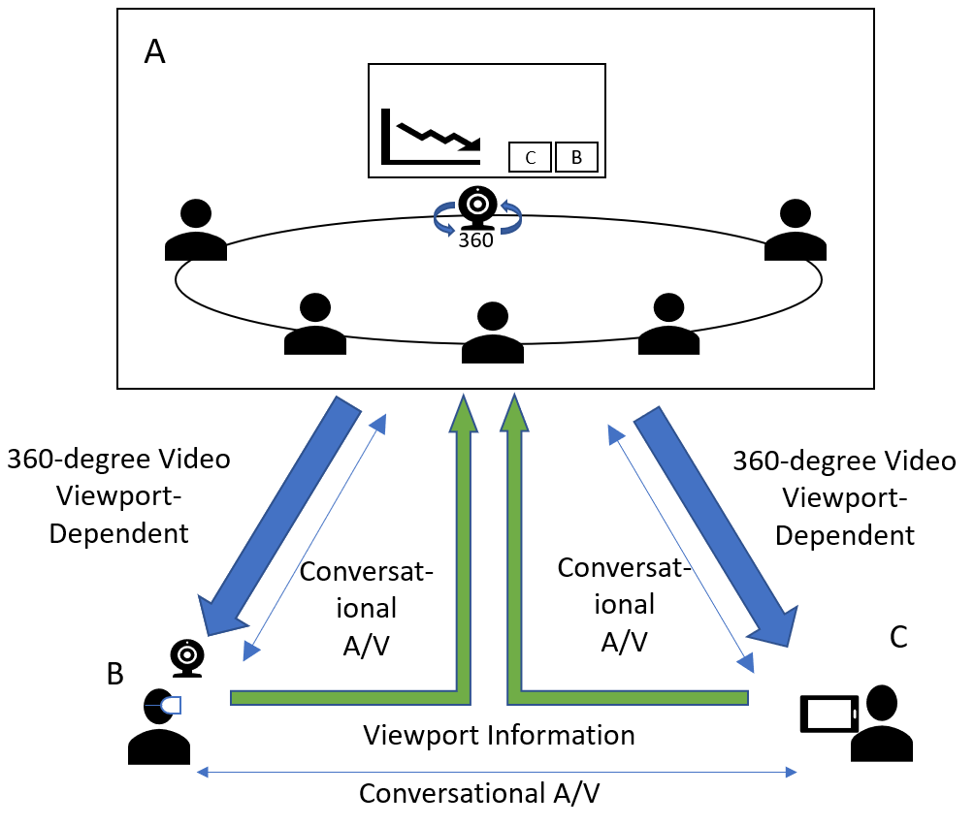
Figure 2.1 - 360-degree conference call
In the second scenario, the call is setup using a network function, which may be performed by either a Media Resource Function (MRF) [1] or a Media Control Unit (MCU) [2]. In this case, the MRF/MCU receives a viewport-independent stream from A. Both B and C, send viewport orientation information to the MRF/MCU and receive viewport-dependent streams from it. Figure 2.2 illustrates the scenario. The A/V channel for conversational non-immersive content also flows through the MRF/MCU in the figure.

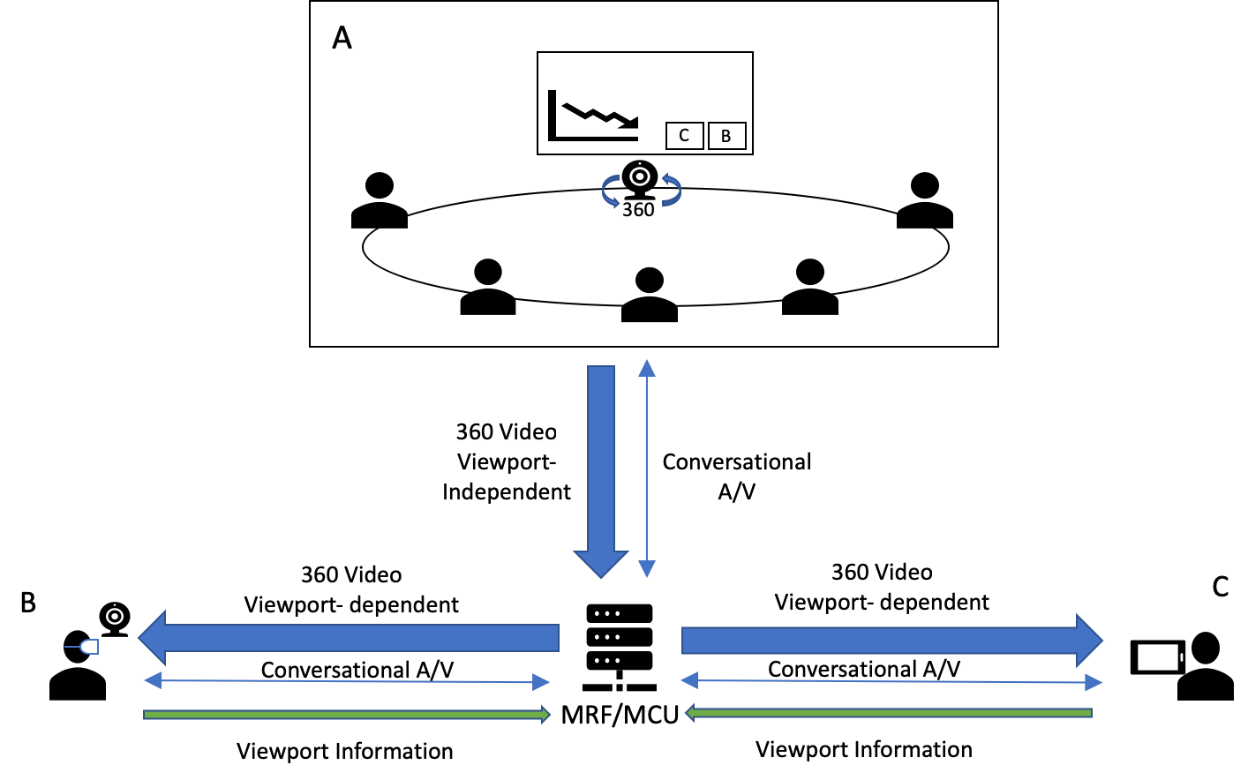
Figure 2.2 - A 360-degree conference call via MRF/MCU

The use case aims to enable immersive experience for remote terminals joining teleconferencing and telepresence sessions, with two-way audio and one-way immersive video, e.g., a remote single user wearing an HMD participates to a conference will send audio and optionally 2D video (e.g., of a presentation, screen sharing and/or a capture of the user itself), but receives stereo or immersive voice/audio and immersive video captured by an omnidirectional camera in a conference room connected to a fixed network.
Private side communication is also expected to be enabled as part of this use case. For instance, two users attending the conference may wish to talk privately and do not want to be heard by others. In this case, the audio information exchanged between these two users should not be transmitted to others, and the content of their conversation should be protected and only be fully rendered on their devices. Others may know that these users are interacting but would not be able to hear the specific content.

A special variation of this use case is when the 360 camera capture occurs not in a conference room but on a user device. [Requirements associated with this variation are TBD. Unless users in the conference room wear HMDs, is this feasible? For example, how would the viewing orientation of the conference room be determined for the 360 video captured by the user device of a remote participant? This seems only possible if there is only one user in the meeting room, and the display in the meeting room has a camera for tracking the position of the single user in the conference room.]

In the third scenario, multiple conference rooms are sending 360-degree video to an MRF/MCU. The rooms may choose to receive 2D video streams from other participants including one of the other rooms, which is displayed on the screen in the room. A pictorial representation is shown in Figure 2.3.

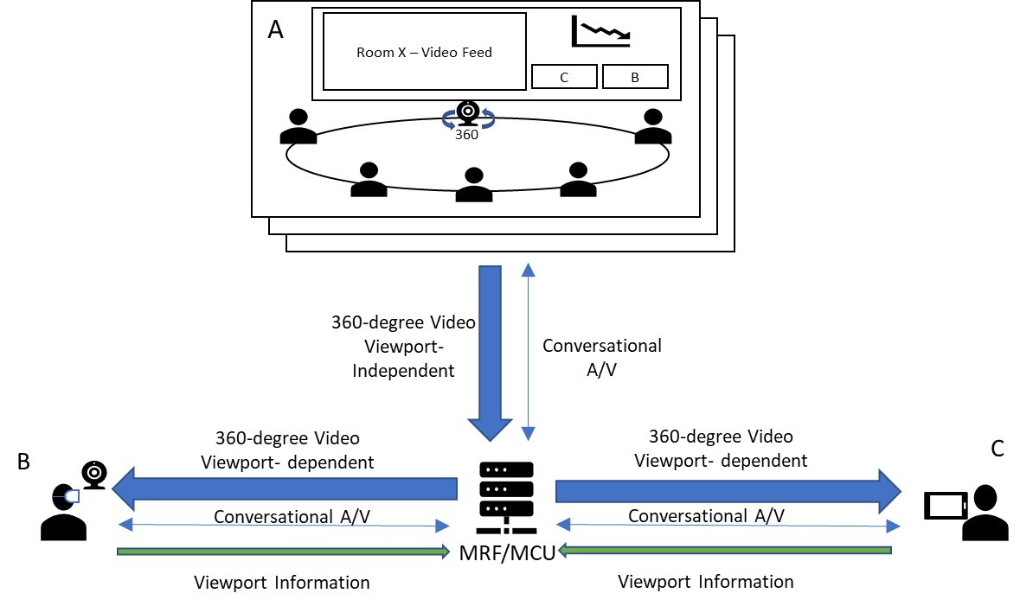
X
Figure 2.3: Multiple rooms with 360-degree video

Furthermore,
- The remote (single) users can choose to view any one or none (e.g., when only viewing the screenshare) of the available 360-degree videos from the multiple rooms. Switching from one room to another may be triggered manually, or using other mechanisms, such as, viewing direction or dominant speaker. However, for the case of the dominant speaker, it is important to consider effects of motion sickness while switching from one video to another as the user may not be sufficiently prepared for the switch.
- The MRF/MCU may signal to pause the receiving 360-degree video from any of the rooms that do not currently have any active viewers. The streams can be resumed if and when there are viewers [7].
- The presentation/screenshare stream is distributed to the single users and the rooms as a separate stream and can be identified using an explicit “a=content:slides” SDP field [1]. The single users may view the stream as an overlay on top of the 360-degree video.
- If the area of interest in the 360-degree video is limited (the preferred FoV is defined and negotiated between the participants) or the motion outside the FoV is limited, the background area (outside the viewport) can be transmitted as a still image to maintain continuity in the 360-degree view. The still-image may be updated at regular intervals or as needed.
- A still-image background area can also be used for placing overlays and avoiding unnecessary bandwidth utilization. In the scenario in the figure, this background area would be the wall with the screen and the presentation overlay may be placed on top of the screen for a better visual experience.
- Overlays may also be used for other 2D streams. These include videos from the single users and 2D video streams from the other rooms. Spatial audio should be associated with overlays when placed in the 360-degree view, i.e., the sound should appear to originate from the placement of the overlay, not necessarily associated with the elements within the video.
- MRF/MCU based media processing may be used for creating 360-degree views combining multiple input sources, e.g., 360-degree video with limited FoV, still image for background, overlays of screenshare and other 2D videos, etc., when the device capabilities are limited.

Use Case Extensions

Viewport sharing among remote participants
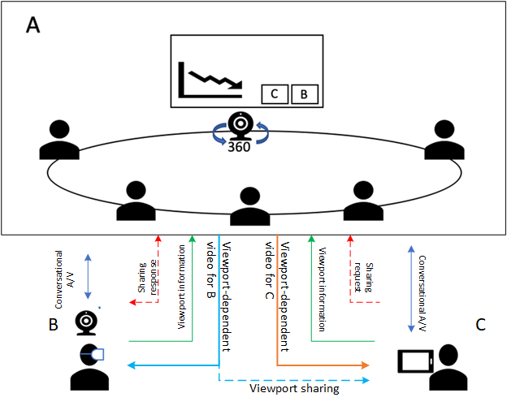
Figure 3.1.1 Viewport sharing between remote participants w/o MRF/MCU
Figure 3.1.1 illustrates viewport sharing capability added to the above use case. When B is presenting to the conference or B is communicating with C, C may be interested in B’s focus or her 360-degree viewport, especially when B is interacting with anything or anyone in room A. In such case, C would request to follow B’s viewport. Upon permission from B, C may follow B’s viewport on his own display device regardless of C’s orientation. In this scenario, room A may multicast (i.e., send the same information using unicast to different receivers as in usual MTSI/Telepresence) viewport dependent stream with embeddedB’s viewport metadata to both B and C. C’s device will follow embedded viewport metadata and playback the same viewport presented to B.
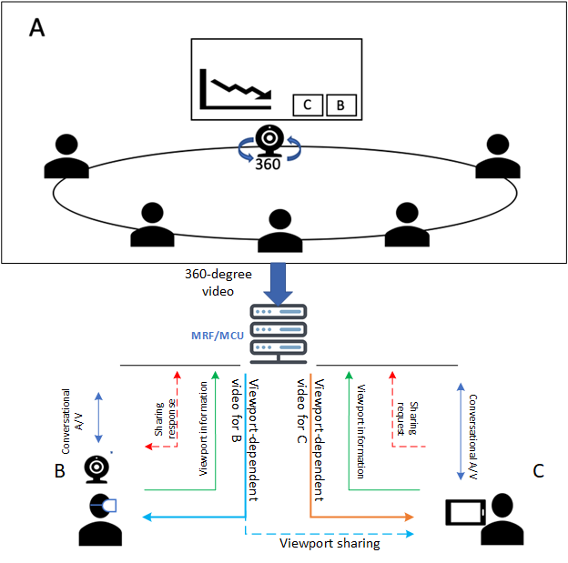
Figure 3.1.2 Viewport sharing between remote participants w/ MRF/MCU
Figure 3.1.2 shows the second scenario where the call is setup using a MRF or MCU. The MRF/MCU may receive C’s viewport sharing request and check B’s permission for such request. Once B’s permission is confirmed, MRF/MCU may forward the viewport dependent stream with B’s viewport metadata embedded to C. C’s device will follow embedded viewport metadata and playback the same viewport presented to B.

Viewport sharing feature may require capability of party A or MRF/MCU to forward B’s viewport-dependent video stream to C after request/response signalling exchange, and embed B’s viewport metadata into the stream.

EDITOR’S NOTE: Impact of motion sickness from viewport sharing is to be investigated

Viewport-dependent stream for display device
Participants in conference room A may have their own display device (HMD, AR glass or mobile phone) to receive a 360-degree video stream (viewport independent or dependent stream) from room A, or conversational video from remote participant B or C. For a large conferencing room, some participants may not sit close to the view screen or other participants he or she would like to communicate, a display device may offer high quality view of room A regardless where the participant sits. A viewport-independent or viewport dependent 360-video stream may send to participant’s display device.
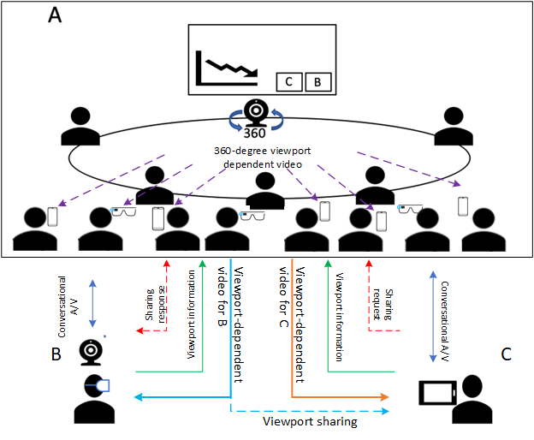
Figure 3.1.3 Proposed viewport sharing use case w/o MRF/MCU
Figure 3.1.3 shows the first scenario, the call is setup without the support of a MRF or MCU. B and C send viewing orientation information to A and receive corresponding viewport-dependent streams from the omnidirectional camera. For the participants with their own display device, the display device may receive 360-degree viewport-independent video from omnidirectional camera, or viewport-dependent video stream by sending orientation information to A.

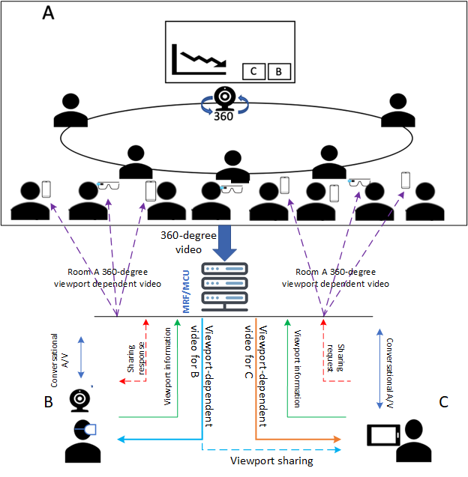
Figure 3.1.4 Proposed viewport sharing use case via MRF/MCU
Figure 3.1.4 shows a second scenario, the call is setup using a MEF or MCU. In this case, the viewport dependent streaming may be handled by MRF or MCU. For the participants with their own display device, the display device may receive 360-degree viewport-independent video from omnidirectional camera, or viewport-dependent video by sending orientation information to MRF/MCU.

Viewport sharing for second display device
When a remote participant B or C is presenting or communicate to the room A, participants in room A with their own display device may be interested in B or C’s focus or interaction on specific viewport of 360-degree video captured by omnidirectional camera, these participants may request to follow B or C’s viewport and receive the same viewport-dependent stream sending to B or C.
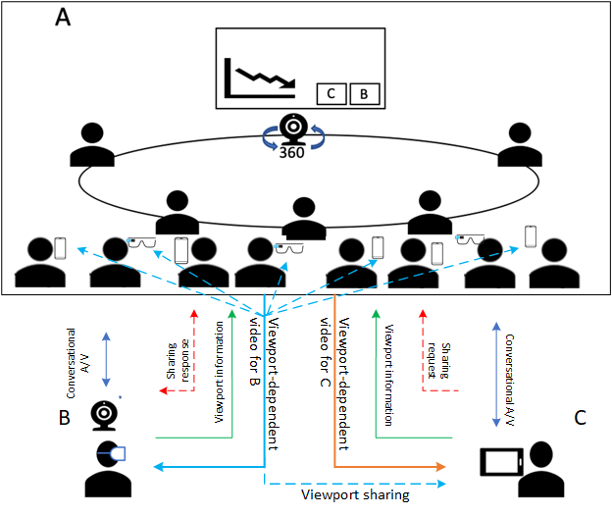
Figure 3.3.1 Viewport sharing to second display w/o MRF/MCU
Figure 3.3.1 shows the first scenario, the call is setup without MEF or MCU. Participants in room A with their own display device may like to follow B’s viewport, participant sends the request to B and is authorized by B. The viewport-dependent video for B is then played back on authorized participant display device with embedded viewport information, the display device would follow embedded viewport information to render the viewport regardless participant’s orientation.
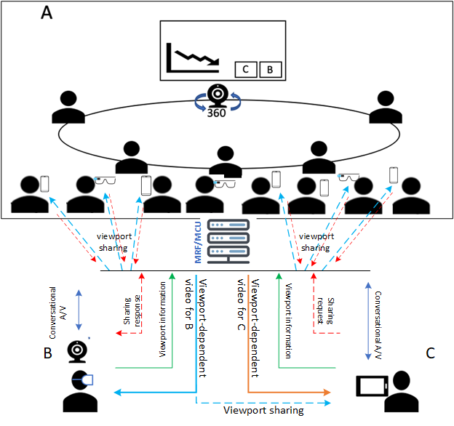
Figure 3.3.2 Proposed viewport sharing use case via MRF/MCU
Figure 3.3.2 shows a second scenario, the call is setup using a MEF or MCU. In this case, the viewport sharing request may be handled by MRF or MCU, MRF or MCU receive the request from participants and confirm the authorization from B. MRF or MCU then sends viewport-dependent video streams with embedded B’s viewport metadata to B and her followers in room A.

3.4 Separate stream for presentation content

John (a participant in conference room A) shares his current computer screen to present his work. This presentation audio/video stream is displayed in the conference room A, but also broadcasted (i.e., sending the same information using unicast to different receivers as in usual MTSI/Telepresence, same for the two instances of "broadcasted" below in this subclause and in subclause 3.5) to all other remote participants (in other conference rooms and for the VR users). While john is still presenting Alice (who is also in the conference room A) adds her screen to be shared with supportive materials for John’s presentation, resulting into two streams being displayed in the room and broadcasted to all other remote participants.

[3.4.1 Comments and questions
Sharing the presentation as a separate stream seems logical as it aligns to current video conferencing paradigms. The main question here is can this follow the conventional MTSI/Telepresence communications architecture or are additions necessary. E.g. is it envisioned that this stream is overlaid in the 360-degree image or displayed in parallel.]

[3.5 Room to room connection
Another conference room B joins the session. While both rooms and remote users are connected users can freely communicate and follow a common presentation (broadcasted by John). Each room displays the other room on a dedicated screen (either as a full 360 video, or a cut-out based on the current speaker or manual viewport selection.

3.5.1 Comments and questions
Does a room to room connection follow the same principle as a VR user? Is there more functionality needed in the network for audio and video orchestration (e.g. spatial mapping) or is it simply a problem of transferring the streams and rendering into an end device / room dependent layout?]

[3.6 End device limitations of multiple streams
More participants join the conference call (conference room B, User C, User D), resulting into a total conference of two rooms, 4 remote users and two presentation streams. Clyde who joined the conference from his mobile phone from the airport now gets a prerendered video of the conference with the most relevant visual information. This is a network function which transcodes and merges different streams according the requirements of the end device (e.g. manual selection of streams, dominant speaker paradigm or viewing direction).

3.6.1 Comments and questions
After a certain number of streams even a modern phone might struggle in the encoding and rendering of multiple video streams. This is simply forwarding all streams of all users, room (as full or viewport adapted streams) and presentations and only leaving it for the client to decode and render to a suitable layout might not be enough to fulfil the limitations and restrictions of a given mobile device. Thus, we can envision network-based media processing (e.g. NBMP) e.g. in the MRF/MCU to assist such mobile end devices and reduce the processing load on end-device, in order to cope with its limitations and in order to increase battery life. However how such a network-based processing should be addressed in 3GPP requires more discussion, particularly in terms of metadata necessary.]
3.7 Applications to 3GPP FLUS
MTSI-based FLUS as defined in TS 26.238 [ADD_REF] relies on the use of RTP/RTCP-based protocols as defined in TS 26.114. Immersive video and immersive audio/speech may be delivered uplink using MTSI-based FLUS. Thus, even though FLUS is outside the scope of the current ITT4RT work item, the normative specification resulting from the ITT4RT work item could be (and are not required to be) reused in providing the immersive video and immersive audio/speech support for MTSI-based FLUS including (i) recommendations of audio and video codec configurations to deliver high quality VR experiences, (ii) constraints on media elementary streams and RTP encapsulation formats, (iii) recommendations of SDP configurations for negotiating of immersive video and voice/audio capabilities and (iv) RTP/RTCP-based signalling for indication of viewport information to enable viewport-dependent media processing and delivery. In that regard, potential solutions described in clauses 6 and 9 could also be applicable for live uplink streaming scenarios using MTSI-based FLUS.
For immersive video support over MTSI-based FLUS, both in-camera stitching and network-based stitching can be considered. In case of camera stitching, stitched immersive video is sent from the FLUS source (i.e., MTSI sender) to the FLUS sink (e.g., MTSI receiver, which is either in the UE, e.g., as a remote viewer, or in the network, e.g., as a media gateway). This is where immersive video gets delivered uplink using MTSI-based FLUS, and the normative specification output of ITT4RT becomes relevant. In case of network-based stitching, different 2D captures are sent from the FLUS sources (MTSI senders) to the FLUS sink (MTSI receiver as a media gateway) in the network and the media gateway server performs decoding, stitching, and re-encoding to produce the immersive video, which is then distributed to the remote viewers using MTSI or other means. In this case, only 2D video gets delivered using MTSI-based FLUS and immersive video is only delivered in the non-FLUS portion of the link, i.e. downlink. If MTSI-based means are used to deliver the immersive video to the remote viewers, only then the normative specification output of ITT4RT could be applicable.
Editor’s Note: There could also be certain FLUS features re-usable in ITT4RT, this is TBD.

Requirements

- Multiple single-user participants are supported.
- Communications between the single users can be conventional MTSI/Telepresence communications. MSMTSI could be used, and if that is used, then media data can be transmitted in separate media streams, and the layout of different participants is up to the client application/implementation.
- One 360 camera per location in multi-party conference scenarios involving multiple physical locations are allowed.
- Both in-camera stitching and network-based stitching are supported.
  - In case of camera stitching, stitched immersive video is sent from the conference room to the conferencing server (e.g., MSMTSI MRF or any other media gateway) and then from the conferencing server to the remote participants. If this is a one-to-one conversational session between the conferencing room and the remote participant, a media gateway in the middle may not be necessary.
  - In case of network-based stitching, different 2D captures are sent from the conference room to the conferencing server and the conferencing server performs decoding, stitching, and re-encoding to produce the immersive video, which is then distributed to the remote participants.
- It is recommended that MTSI and IMS Telepresence endpoints support codec, protocol and transport capabilities relevant for encoding, delivery and consumption of immersive speech/audio and immersive video.

- Capability for the party that sends 360-degree video to send viewport-dependent and/or viewport-independent streams.
- Timely delivery of the changes in viewport orientation from the remote participants, and appropriate low-delay actions to update the viewport-dependent streams. Any changes in viewport orientation should not lead to latency-prone signalling, such as SIP renegotiations.
- Capability to create viewport-dependent streams for individual UEs including an larger area of the original viewport for safe playback in the UE.
- A suitable coordinate system to be used as the standard way of communicating the orientation of the viewport.
- Given possible end device limitations as well as potential constraints on the conference room equipment, network-based processing should be considered for media workloads involving both conference room and remote participants, e.g., stitching of captured streams from the conference room, media composition, transcoding and prerendering for the remote participant, etc.
- The following parameters need to be signalled in the SDP during call setup in addition to normal MTSI call signaling [1].
  - Initial viewport orientation. It is the default orientation from which to start the view at the receivers’ side.
  - Decoding/Rendering metadata, e.g., region-wise packing information, projection mapping information, frame packing information, etc. It is subject of discussion whether this information is signaled via SDP and/or within SEI messages with the media stream.
  - Capture Field-of-View (CFoV): as discussed during the definition of the use case, the system supports transmission of 360-degree video. However, the range of the FoV may be restricted in order to enhance user experience. The negotiation requires signaling the capture FoV of the capture device, and a response carrying the receiver’s preferred FoV (PFoV) depending on the remote UE, where the preferred FoV will be less than or equal to the captured FoV.
  - Codec negotiation
The high level signaling flows are depicted in Figure 4.1. The user C is not represented here for simplicity, but this is not a restriction for our reasoning. In this example MRF/MCU is not used.

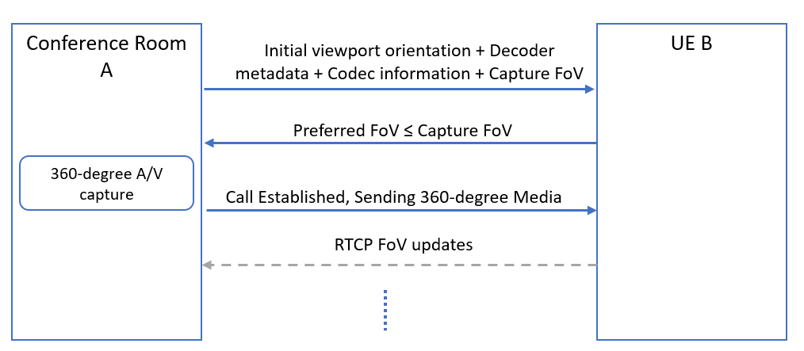
Figure 4.1 Signalling flow for a 360-degree conference call with unidirectional 360- degree video from A to B.

- Once the call has been established, remote parties (B or C) can send viewport orientation information using RTCP reports with yaw, pitch and roll data. These may be sent at fixed intervals or event-based, triggered by changes in viewport orientation. The most efficient RTCP reporting scheme for viewport orientation information is for further study.
- Capability to support the interaction where all media types will be presented to certain users and a subset of the media types are presented to the others.
- Capability for the participant in room A with his or her own display device to receive a viewport independent or viewport dependent video from omnidirectional camera in room A.
- Capability for the remote party to share a viewport dependent video stream with embedded viewport metadata to another remote participant.
- Capability for the participant in room A with his or her own display device to follow remote participant viewport presentation.
- The capability to place overlays in the 360-degree video either within the device or pre-rendered through a network element.
- Transmission from sender to receiver of the coordinates of the location of the overlay (e.g. a presentation): this is a necessary and basic requirement that will give flexibility in the overlay placement at the receiver’s side. By sender/receiver it is meant either one of the parties or the MRF/MCU.
- Avoid that the overlaid background content is transmitted unnecessarily at high quality within the user viewport: this is a basic issue that overlays cause to viewport-dependent streaming. The content in the viewport is always streamed at higher quality. However, when an overlay with different content is sticked on top of (part of) the viewport, the content behind the overlay does not need to be sent ay higher quality. This allows saving bandwidth or increase the quality in the viewport for the non overlaid parts.
- Enable some form of interaction with the overlay (e.g., moving or rotating the overlay, resizing it, switching it on/off, etc.): these are basic and simple ways to interact with the overlay, to increase flexibility and utility of an overlay.
- Capability for users to receive an incoming interaction message (e.g., SMS, chat message, voice call or audio-visual call) from other users as an overlay: this is a good way to allow integration of other 3GPP services and applications into ITT4RT/MTSI applications in order to increase the value of the first VR applications for 3GPP.
- [Signalling to establish the format of the background area, especially if a limited “captured” FoV is used for immersive video content. For example, a still background image.]
- To facilitate network-based stitching, it is possible to signal camera calibration parameters for each 2D video capture (i.e., each camera lens) transported from the conference room to the conferencing server at the beginning of each session. Relevant intrinsic and extrinsic camera parameters can include lens numbers, layouts, positions, angles, radius, distortion, entrance pupil and resolutions.
- [Signalling for setting, unsetting or negotiating a margin area that extends on any or all of the sides of the viewport. ]
- [The maximum extent of the margins: a sender may indicate the maximum extent of the margins and a receiver may want to limit the maximum extent of the margin area to indicate a preference for high quality viewport.]
- An RTP receiver should be able to signal higher-level metrics such as Motion to High-Quality Delay to the sender to assist in bandwidth adaptation and monitoring.
- [Signalling to] allow still background images to be used when network conditions do not permit transmitting a video stream for the area outside the viewport.
- Capability to identify the location of the presentation and where to insert an overlay of the alternative presentation into the omnidirectional content:
- [while stitching the different camera images together in the sending client]
- while stitching the different camera images together in the network
- after the stitching of the camera images into the omnidirectional video (e.g. by reencoding the omnidirectional video in the network)
- after receiving the stitched omnidirectional video and the overlay by the receiving client

Architecture

The current MTSI service architecture depicted in Figure 4.1 of TS 26.114 is applicable for immersive teleconferencing. No further architectural gaps are identified.

In terms of the reuse of existing MTSI functionality, the following may be observed:

- For in-camera stitching, stitched immersive video is sent from the conferencing room to the conferencing server (e.g., MSMTSI MRF) or directly to the remote participant (e.g., one-to-one conversation) in one or more RTP streams (e.g., established via SDP). Multiple RTP streams may be used in case tile or sub-picture based delivery optimization is in use.
- For network-based stitching, multiple RTP streams are established (e.g., via SDP, using MSMTSI) between the conferencing server and conference room, each of which carries a particular 2D capture. These RTP streams are then sent from the conference room to the conferencing server and the conferencing server performs decoding, stitching, and re-encoding to produce one or more RTP streams containing the immersive video, which are then distributed to the remote participants (e.g., again via MSMTSI). Multiple RTP streams may be used for the immersive video in case tile or sub-picture based delivery optimization is in use.

Potential Solutions

6.1 Potential Solutions for Immersive Video

Figure 6.1 provides an overview of a possible receiver architecture that reconstructs the spherical video in an MTSI or IMS Telepresence UE. Note that this figure does not represent an actual implementation, but a logical set of receiver functions. Based on one or more received RTP media streams, the UE parses, possibly decrypts and feeds the elementary stream to the HEVC decoder. The HEVC decoder obtains the decoder output signal, referred to as the "texture", as well as the decoder metadata. The Decoder Metadata contains the Supplemental Information Enhancement (SEI) messages, i.e., information carried in the omnidirectional video specific SEI messages, to be used in the rendering phase. In particular, the Decoder Metadata may be used by the Texture-to-Sphere Mapping function to generate a spherical video (or part thereof) based on the decoded output signal, i.e., the texture. The viewport is then generated from the spherical video signal (or part thereof) by taking into account the viewport position information from sensors, display characteristics as well as possibly other metadata such as initial viewport information. A similar receiver architecture can also be supported for the AVC codec.
Figure 6.1 - Potential receiver architecture for VR support over MTSI and IMS Telepresence

For 360 degree video, the potential solutions can consider the following principles:

- The RTP stream would contain an HEVC or an AVC bitstream with omnidirectional video specific SEI messages. In particular, the omnidirectional video specific SEI messages as defined in ISO/IEC 23008-2 [3] and ISO/IEC 14496-10 [8] may be present.
- The video elementary stream(s) may be encoded following the requirements in the Omnidirectional Media Format (OMAF) specification ISO/IEC 23090-2 [4], clause 10.1.2.2.
Relevant SEI messages contained in the elementary stream(s) with decoder rendering metadata may include the following information as per ISO/IEC 23008-2 [3] and ISO/IEC 14496-10 [8]:

- Region-wise packing information, e.g., carrying region-wise packing format indication and also any coverage restrictions
- Projection mapping information, indicating the projection format in use, e.g., Equi-rectangular projection (ERP) or Cubemap projection (CMP)
- Padding, indicating whether there is padding or guard band in the packed picture
- Frame packing arrangement, indicating the frame packing format for stereoscopic content
- Content pre-rotation information, indicating the amount of sphere rotation, if any, applied to the sphere signal before projection and region-wise packing at the encoder side
The output signal, i.e., the decoded picture or "texture", is then rendered using the Decoder Metadata information contained in relevant SEI messages contained in the video elementary streams. The Decoder Metadata is used when performing rendering operations such as region-wise unpacking, projection de-mapping and rotation toward creating spherical content for each eye.

Viewport-dependent processing could be supported for both point-to-point conversational sessions and multiparty conferencing scenarios and be achieved by sending from the MTSI receiver RTCP feedback or RTP header extension messages with the desired viewport information and then encoding and sending the corresponding viewport by the MTSI sender or by the media gateway, e.g., MRF. This is expected to deliver resolutions higher than the viewport independent approach for the desired viewport. The transmitted RTP stream from the MTSI sender or media gateway may also include the actual viewport or coverage information, e.g., in an RTP header extension message, as the 360 degree video generated, encoded and streamed by the sender may cover a larger area than the desired viewport. The media formats for tiling and sub-picture coding as described in the viewport-dependent profile of OMAF in ISO/IEC 23090-2 [4] etc. are not relevant for the 5G conversational setting. Instead, viewport-dependent processing based on tiling and sub-picture coding could be realized via RTP/RTCP based protocols that are supported by MTSI and IMS-based telepresence.

OMAF video profiles specified in ISO/IEC 23090-2 [4] are based on HEVC Main 10 Profile, Main Tier, Level 5.1 in order to deliver high quality VR experiences. In the meantime, MTSI in TS 26.114 [1] mandates H.265 (HEVC) Main Profile, Main Tier, Level 3.1 for video, and IMS telepresence in TS 26.223 [2] mandates H.265 (HEVC) Main Profile, Main Tier, Level 4.1 for video.

For achieving video quality required by VR services, it may be recommended that the video codecs for VR support in MTSI and IMS telepresence are aligned with OMAF and/or TS 26.118 [5], e.g., HEVC Main 10 Profile, Main Tier, Level 5.1 may be recommended for MTSI and IMS telepresence in TS 26.114 and TS 26.223 to ensure a high-quality VR experience. It is expected that both MTSI client and MTSI gateway codec requirements are aligned with these recommended video codec requirements for VR support. It is not expected that the mechanisms for session setup and negotiation would be different because of this changed requirement on video codecs.

With regards to the negotiation of SEI messages for carriage of decoder rendering metadata, procedures specified in IETF RFC 7798 [6] on the RTP payload format for HEVC may be reused. In particular, RFC 7798 can allow exposing SEI messages related to decoder rendering metadata for omnidirectional media in the SDP using the 'sprop-sei' parameter, which allows to convey one or more SEI messages that describe bitstream characteristics. When present, a decoder can rely on the bitstream characteristics that are described in the SEI messages for the entire duration of the session. Intentionally, RFC 7798 does not list an applicable or inapplicable SEI messages to be listed as part of this parameter, so the newly defined SEI messages for omnidirectional media in ISO/IEC 23008-2 can be signalled. It is expected that both MTSI clients and MTSI gateways support RTP payload formats for VR support.

For most one-to-one video telephony and multi-party video conferencing scenarios, it is expected that support of the following omnidirectional video specific SEI messages would be sufficient:

- the equirectangular projection SEI message,
- the cubemap projection SEI message,
- the sphere rotation SEI message, and
- the region-wise packing SEI message.
For stereoscopic video support, in either one-to-one video telephony scenarios or multi-party video conferencing scenarios, support of a subset of the frame packing arrangement SEI message as in ISO/IEC 23090-2 [4] is also needed.

Based on the above, an SDP framework for immersive video exchange needs to be developed to negotiate codec support, SEI messages for decoder rendering metadata, as well as RTP/RTCP signaling necessary for viewport dependent processing. These capabilities may be individually negotiated, but to simplify the SDP exchange and avoid fragmentation of capabilities it would be more preferable to specify one or more MTSI client profiles and develop the SDP framework based on these profiles. Such an example compact SDP negotiation framework is described below.
A new SDP attribute 3gpp_360video may be defined with the following ABNF:

3gpp_360video = "a=3gpp_video:" [SP "VDP" SP "Stereo"]

A potential specification for the semantics of the above attribute and parameter is provided below. Unsupported parameters of the 3gpp_360video attribute may be ignored.

An MTSI terminal supporting the 360 video feature without using viewport-dependent processing (VDP) or stereoscopic video for video may support the following procedures:

- when sending an SDP offer, the MTSI client includes the 3gpp_360video attribute in the media description for video in the SDP offer
- when sending an SDP answer, the MTSI client includes the 3gpp_360video attribute in the media description for video in the SDP answer if the 3gpp_360video attribute was received in an SDP offer
- after successful negotiation of the 3gpp_360video attribute in the SDP, for the video streams based on the HEVC codec, the MTSI clients exchange an RTP-based video stream containing an HEVC bitstream with omnidirectional video specific SEI messages as defined in ISO/IEC 23008-2 [3] with the following characteristics:
  - OMAF video profiles specified in ISO/IEC 23090-2 [4] are based on HEVC Main 10 Profile, Main Tier, Level 5.1 are supported.
  - exchange of the following SEI messages are supported: (i) the equirectangular projection SEI message, (ii) the cubemap projection SEI message, (iii) the sphere rotation SEI message, and (iv) the region-wise packing SEI message.
- after successful negotiation of the 3gpp_360video attribute in the SDP, for the video streams based on the AVC codec, the MTSI clients exchange an RTP-based video stream containing an AVC bitstream with omnidirectional video specific SEI messages as defined in ISO/IEC 14496-10 [8] with the following characteristics:
  - OMAF video profiles specified in ISO/IEC 23090-2 [4] are based on AVC Progressive High Profile, Main Tier, Level 5.1 are supported.
  - exchange of the following SEI messages are supported: (i) the equirectangular projection SEI message, (ii) the cubemap projection SEI message, (iii) the sphere rotation SEI message, and (iv) the region-wise packing SEI message.

An MTSI terminal supporting the 360 video feature supporting use of viewport-dependent processing (VDP) would include the VDP parameter in the SDP offer and answer. Depending on the value indicated by the VDP parameter, the MTSI terminal would further support the following procedures:

- the RTCP feedback (FB) message described in clause 9.2 type to carry desired or requested viewport information during the RTP streaming of media (signalled from the MTSI receiver to the MTSI sender).
- the RTCP feedback (FB) message described in clause 9.3 type to carry desired ROI (arbitrary or pre-defined) information during the RTP streaming of media (signalled from the MTSI receiver to the MTSI sender).
- [the new RTP header extension type described in clause 9.4 to carry actually transmitted viewport information during the RTP streaming of media (signalled from the MTSI sender to the MTSI receiver).]
An MTSI terminal supporting the 360 video feature with stereoscopic video would include the Stereo parameter and additionally support frame packing arrangement SEI message as in ISO/IEC 23090-2 [4] for HEVC and ISO/IEC 14496-10 [8].

6.2 Potential Solutions for Signalling of Camera Calibration Parameters

Alignment of the ITT4RT solution to be defined and what is in the FLUS spec is desirable.
Clause 4.5 of the FLUS specification in TS 26.238 describes the FLUS source system. Accordingly the MTSI instantiation of FLUS supports SDP-based description of the relationships among multiple streams in a FLUS source system identified using the SDP attribute a=3gpp-flus-system:<urn>. A vendor-specific source system may be identified by a unique vendor-specific urn identifier such as urn:[com]:[vendor_x]:[system_y]. Alternatively, a 3GPP-specific source system description may be specified using a 3GPP-specific urn identifier such as urn:org:3gpp:itt4rt:default:2020 which would provide interoperable means to signal source system description, including parameters for camera calibration. Further details can be found in Table 4.5-1 of TS 26.238.

One potential solution can be to adopt the FLUS signaling framework to provide the relationships among the 2D video captures to be used for network-based stitching in ITT4RT and amend the SDP-based signaling in Table 4.5-1 to also include the camera calibration parameters. The existing SDP syntax in Table 4.5-1 may be reused (e.g., a=3gpp-flus-configuration: which provides source system-specific configuration parameters for the source system at the session level or a=3gpp-flus-media-configuration: which provides media stream configuration parameters for the source system at the media level) or a dedicated new SDP attribute (e.g., a= a=3gpp-flus-camera-configuration:) may be defined to explicitly signal the camera calibration parameters.

The set of camera calibration parameters to be signaled can include lens numbers, layouts, positions, angles, radius and resolutions.

As a possible solution, the SDP syntax for a=3gpp-flus-media-configuration may be defined with the following ABNF:

3gpp-flus-media-configuration = "a=3gpp-flus-media-configuration:" [SP "Param 1" SP "Param 2" SP ……. SP "Param K"]

where “Param 1”, …. , “Param K” may be the set of intrinsic and extrinsic camera parameters.

3GPP-specific source system description conveyed using the urn identifier such as urn:org:3gpp:itt4rt:default:2020 may imply such an SDP syntax to communicate camera calibration parameters. If the set of parameters to be conveyed is found to considerably increase the SDP size, another alternative may be considered where the camera calibration parameters may be described by a JSON document embedded in the SDP.

For each 2D video capture to be used for network-based stitching, the SDP attribute 3gpp-flus-media-configuration may be included under the m= line to signal the camera calibration parameters associated with that particular media stream. Session-level camera configuration parameters may be signalled using 3gpp-flus-configuration.

The set of camera calibration parameters to be signaled can include lens numbers, layouts, positions, angles, radius and resolutions. More specifically the following parameters may be signaled:

- Number of cameras
- Layout of the cameras
- General intrinsic parameters: resolution, Focal length (focal_x, focal_y) in pixel unit (int), Principal point (center of projection), Lens distortion (deviation from ideal perspective or fisheye) of each camera. These are expressed in Figure 6b below by intrinsic parameters represented by image_height, image_width, center_x, center_y, radius in pixel unit (int) and camera field of view (fov_h, fov_v) in angle or radian degree unit (float)
- Extrinsic camera parameters for each camera represented in the above figure by translation (x, y, z coordinates) and orientation (yaw, pitch, roll) values of each camera to accommodate various rig geometries. These are depicted in Figure 6a below.
- Entrance pupil (EP), with 4 floating-point EP coefficients. EP coefficients provide a more precise model of various lens characteristics and improve the conversion from a sample location of an active area in a lens decoded picture to sphere coordinates relative to the global coordinate axes. Please note that the formulation of the distortion correction and the EP coefficients for any lens can be derived using the calibration provided in [10]. The EP coefficients are formulated using a polynomial, and added seamlessly on whatever lens projection type specified. The use of EP coefficients is especially encouraged for wide lens cameras, e.g., for fisheye omnidirectional video.
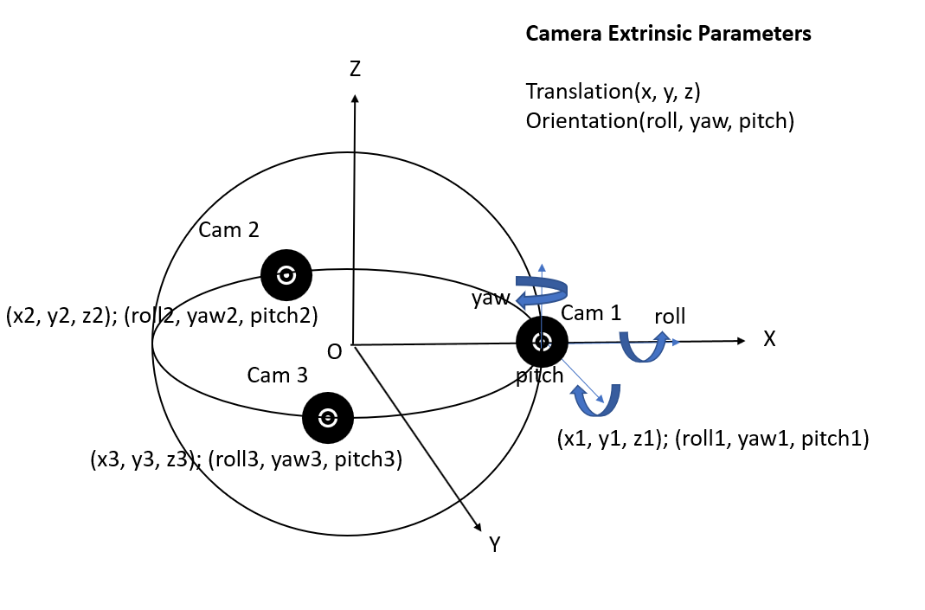
Figure 6a – Extrinsic camera calibration parameters.

Figure 6b – Intrinsic camera calibration parameters.

6.3 Potential Solutions for Overlays

Editor’s Note: Include definition of overlay from OMAF spec

The SDP signaling semantics in Section 9.6 currently defined as a potential solution for predefined region signaling will have the following applicability:

- Allow adding real-time overlay on the top of a pre-defined region. Client devices may use the pre-defined regions as hints for personalized overlay operations. Compared to handling overlays for all audience on the server side, a client device may utilize its own computing power to generate overlays on pre-defined regions.
- Content to be overlaid on the predefined region may be encoded and transported separately with higher quality.
An MTSI sender supporting the ‘Overlay’ feature can allow adding real-time overlay on top of a 360 background and offer this capability in the SDP as part of the the initial offer-answer negotiation. Regions for overlays can be offered by including the "a=overlay" attribute under the relevant media line corresponding to the related 360 video and overlay images. The following parameters can be provided in the attribute for each overlay:

Editor’s Note: The parameters below are aligned with “Sphere-relative two-dimensional overlay” specification in OMAF.

- Overlay_ID – identifies the offered region for overlay
- Overlay_azimuth: Specifies the azimuth angle of the centre of the offered overlay region on the unit sphere in units of 2⁻¹⁶ degrees relative to the global coordinate axes.
- Overlay_elevation: Specifies the elevation angle of the centre of the offered overlay region on the unit sphere in units of 2⁻¹⁶ degrees relative to the global coordinate axes.
- Overlay_tilt: Specifies the tilt angle of the offered overlay region, in units of 2⁻¹⁶ degrees, relative to the global coordinate axes.
- Overlay_azimuth_range: Specifies the azimuth range of the offered region corresponding to the 2D plane on which the overlay is rendered through the centre point of the overlay region in units of 2⁻¹⁶ degrees.
- Overlay_elevation_range: Specifies the elevation range of the offered region corresponding to to the 2D plane on which the overlay is rendered through the centre point of the overlay region in units of 2⁻¹⁶ degrees.
- Overlay_rot_yaw, Overlay_rot_pitch, and Overlay_rot_roll specify the rotation of the 2D plane on which the overlay is rendered. Prior to rendering the 2D plane, it may be rotated as specified by overlay_rot_yaw, overlay_rot_pitch and overlay_rot_yaw and placed on a certain distance as specified by region_depth_minus1. The rotations are applied starting from overlay_rot_yaw, followed by overlay_rot_pitch, and ending with overlay_rot_roll.
- region_depth_minus1 - indicates the depth (z-value) of the region on which the overlay is to be rendered. The depth value is the norm of the normal vector of the overlay region. region_depth_minus1 + 1 specifies the depth value relative to a unit sphere in units of 2⁻¹⁶.
- timeline_change_flag equal to 1 specifies that the overlay content playback shall pause if the overlay is not in the user's current viewport, and when the overlay is back in the user's viewport the overlay content playback shall resume with the global presentation timeline of the content. The content in the intermediate interval is skipped. timeline_change_flag equal to 0 specifies that the overlay content playback shall pause if the overlay is not in the user's current viewport, and when the overlay is back in the user's viewport the overlay content playback resumes from the paused sample. This prevents loss of any content due to the overlay being away from the user's current viewport.
- Name- specifies the name of the offered region for overlay.

Editor’s Note: The parameters below are aligned with “Viewport-relative overlay” specification in OMAF.

- Overlay_ID – identifies the offered region for overlay
- Overlay_rect_left_percent: Specifies the x-coordinate of the top-left corner of the rectangular region of the overlay to be rendered on the viewport in per cents relative to the width and height of the viewport. The values are indicated in units of 2⁻¹⁶ in the range of 0 (indicating 0%), inclusive, up to but excluding 65536 (that indicates 100%).
- Overlay_rect_top_percent: Specifies the y-coordinate of the top-left corner of the rectangular region of the overlay to be rendered on the viewport in per cents relative to the width and height of the viewport. The values are indicated in units of 2⁻¹⁶ in the range of 0 (indicating 0%), inclusive, up to but excluding 65536 (that indicates 100%).
- Overlay_rect_width_percent: Specifies the width of the top-left corner of the rectangular region of the overlay to be rendered on the viewport in per cents relative to the width and height of the viewport. The values are indicated in units of 2⁻¹⁶ in the range of 0 (indicating 0%), inclusive, up to but excluding 65536 (that indicates 100%).
- Overlay_rect_height_percent: Specifies the height of the top-left corner of the rectangular region of the overlay to be rendered on the viewport in per cents relative to the width and height of the viewport. The values are indicated in units of 2⁻¹⁶ in the range of 0 (indicating 0%), inclusive, up to but excluding 65536 (that indicates 100%).
NOTE: The size of overlay region over the viewport changes according to the viewport resolution and aspect ratio. However, the aspect ratio of the overlaid media is not intended to be changed.
- Disparity_in_percent: Specifies the disparity, in units of 2⁻¹⁶, as a fraction of the width of the display window for one view. The value may be negative, in which case the displacement direction is reversed. This value is used to displace the region to the left on the left eye view and to the right on the right eye view.
- Name- specifies the name of the offered pre-defined region for overlay.
Editor’s Note: Other overlay definitions in OMAF are not excluded from ITT4RT. Which overlay definition(s) from OMAF are adopted for overlays in ITT4RT is currently TBD.

Editor’s Note: For both of the above overlay types from OMAF, incorporate from the spec further details about the order of operations for overlay rendering.

For the negotiated 360 video, a=overlay" attribute is expected to contain all of the above parameters for overlays under the m= line, each overlay image is expected to only contain the corresponding Overlay_ID parameter as part of a=overlay" attribute.

In response to the SDP offer with the set of offered regions provided using the "a=overlay" line(s), an MTSI client accepting ‘Overlay’ can provide an SDP answer using the "a=overlay" line(s) containing the accepted set of regions. The accepted set of regions for overlays would be a subset of the offered set of overlay regions.

A new SDP offer-answer negotiation can be performed to modify the set of regions for overlays. The MTSI sender may update all the content of overlayregions, including the total number of overlay regions, and the spherical coordinates and name of each of the overlay regions.

6.4 Potential Solutions for Still Background for Omnidirectional Video

A still background may be used when

- The captured FoV of the sender’s cameras is less than 360-degrees.
In this case, the sender may use a background image (or a series) that was (were) captured previously and distribute it to the receivers. The area will be viewed as a still image even when it is within the viewport.

- The captured FoV of the camera is 360-degrees but the (preferred) FoV of the receiver is less than 360-degrees.
The receiver may signal a desire to receive the content outside the preferred FoV as a still image, to improve bandwidth efficiency. It may further request an updated image of the background at a later stage. The area will be viewed as a still image even when it is within the viewport.

- The network is unable to support a full 360-degree video stream.
If the network is unable to support the full 360-degree video stream, the sender/receiver may choose to deliver the content outside the viewport as a still image in order to save bandwidth. Only the content outside the viewport region is transmitted as a still image; the content within the viewport is transmitted as a video stream.

It is possible for the sender and receiver to negotiate this behavior at the beginning or during the session using SDP. An appropriate quality and update interval may be fixed for background images. If the background image is used for adaptation to network conditions, it is possible that the update frequency and quality is lowered by the sender or the receiver when needed. One possible example realization is by having two RTP streams: one which carries the still image(s) background content, and another one which carries the viewport content.

[The following Figure 1 shows a signaling diagram of one of the above scenarios.

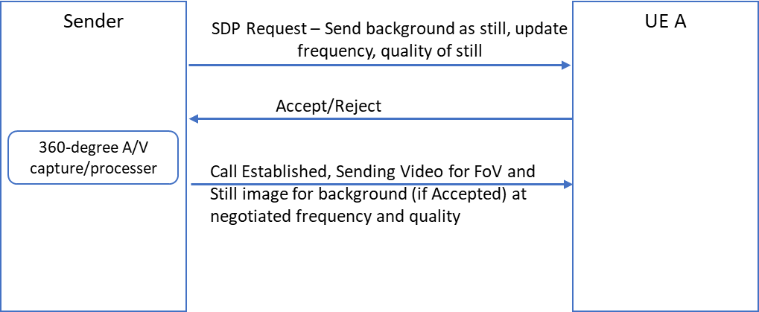
Figure 1: Signalling to allow sending background as a still image with chosen quality and update interval.]

6.5 Potential Solutions for Network-based Stitching
MPEG Network-based Media Processing (NBMP) in ISO/IEC 23090-8 [11] may be used to establish media processing tasks for network-based stitching at MRF/MCU sink to be performed on received media components from the MTSI sender(s). In particular, the NBMP Workflow Description Document for the 360 stitching workflow may be provided to the MRF/MCU, which would then use the information during negotiation of the media streams to be used in the session and subsequent media plane processing, e.g., as per the example workflow provided in clause 8.2. In addition to 360 stitching, NBMP can also be used for initiating other media processing workflows in MRF/MCU such as guided transcoding, overlaying on image or video backgrounds or view-dependent content customization.

Working Assumptions

TBD]

8 Example Signaling Flows and Media Processing Procedures

8.1 Immersive Teleconferencing with In-Camera Stitching

For in-camera stitching, stitched immersive video is sent from the conferencing room to the conferencing server (e.g., MSMTSI MRF) or directly to the remote participant (e.g., one-to-one conversation) in one or more RTP streams (e.g., established via SDP). Multiple RTP streams may be used in case tile or sub-picture based delivery optimization is in use. We consider a point to point communications scenario in this example so there is no conferencing server in between. An example signaling flow is depicted in Figure 8.1.1.

Figure 8.1.1 – Example Signaling flow for immersive conferencing with in-camera stitching

1- The Remote Participant UE sends an SDP offer to the Conference Room Terminal indicating immersive media capabilities including 360 video support, e.g., based on the potential solution described in clause 6.1. Optionally, the Remote Participant UE may also include viewport-dependent processing capability in the SDP offer, e.g., based on the potential solution described in clauses 6.1 and 9. Two or more RTP streams may be included in the SDP offer in case viewport-dependent processing is offered, e.g. one RTP stream for the base 360 video and another viewport-optimized RTP stream, with the high quality 360 video corresponding to the desired viewport.

2- The Conference Room Terminal responds to the Remote Participant UE with an SDP answer confirming immersive media capabilities including 360 video support. Optionally, the Conference Room Terminal may also accept viewport-dependent processing capability in the SDP answer. In case viewport-dependent processing is accepted, the SDP answer from the Conference Room Terminal may include multiple RTP streams.

3- The Conference Room Terminal streams the RTP media flow with immersive media including 360 video to the Remote Participant UE. 360 video transmission could be based on the RTP payload formats for HEVC that carry SEI messages describing immersive media metadata as described in clause 6.1.

4- (Optional) The Remote Participant UE signals the desired Viewport Information to the Conference Room Terminal using a dedicated RTCP feedback message, e.g., based on the potential solution described in clauses 6.1 and 9.

5- (Optional) The Conference Room Terminal streams the viewport-optimized RTP media flow with immersive media including 360 video to the Remote Participant UE. Information on the actually transmitted viewport may also be included in the RTP media flow, e.g., based on the potential solution described in clauses 6.1 and 9. In case two RTP streams are negotiated, then the viewport-optimized RTP stream containing the high quality 360 video may contain this information.

EDITOR’S NOTE: Further details on SDP examples are to be provided.

8.2 Immersive Teleconferencing with Network-Based Stitching

For network-based stitching, multiple RTP streams are established (e.g., via SDP, using MSMTSI) between the conferencing server and conference room, each of which carries a particular 2D capture. These RTP streams are then sent from the conference room to the conferencing server and the conferencing server performs decoding, stitching, and re-encoding to produce one or more RTP streams containing the immersive video, which are then distributed to the remote participants (e.g., again via MSMTSI). Multiple RTP streams may be used for the immersive video in case tile or sub-picture based delivery optimization is in use. An example signaling flow is depicted in Figure 8.2.1.

Figure 8.2.1 – Example Signaling flow for immersive conferencing with network-based stitching

1- The Remote Participant UE sends an SDP offer to the Conferencing Server (e.g., MSMTSI MRF) indicating immersive media capabilities including 360 video support, e.g., based on the potential solution described in clause 6.1. Optionally, the Remote Participant UE may also include viewport-dependent processing capability in the SDP offer, e.g., based on the potential solution described in clauses 6.1 and 9. Two or more RTP streams may be included in the SDP offer in case viewport-dependent processing is offered, e.g. one RTP stream for the base 360 video and another viewport-optimized RTP stream, with the high quality 360 video corresponding to the desired viewport.

2- The Conferencing Server forwards the SDP offer to the Conference Room Terminal to see it is capable of supporting immersive media. The SDP offer also indicates 2D video capabilities as a fallback in case the Conference Room Terminal is not capable of immersive media support. Multiple RTP streams may be included in the SDP offer.

3- The offered media is rejected by the Conference Room Terminal indicating that it has no support for immersive media. Instead, the Conference Room Terminal sends an SDP answer to the Conferencing Server indicating its 2D video capabilities. Multiple RTP streams may be included in the SDP answer depending on the capture capabilities of the conference room.

4- The Conferencing Server responds to the Remote Participant UE with an SDP answer confirming immersive media capabilities including 360 video support. Optionally, the Conference Room Terminal may also accept viewport-dependent processing capability in the SDP answer. In case viewport-dependent processing is accepted, the SDP answer from the Conference Room Terminal may include multiple RTP streams.

5- The Conference Room Terminal streams multiple RTP media flows carrying 2D video to the Conferencing Server.

6- The Conferencing Server stitches the received 2D videos to generate immersive media including 360 video and streams it to the Remote Participant UE. 360 video transmission could be based on the RTP payload formats for HEVC that carry SEI messages describing immersive media metadata as described in clause 6.1.

7- (Optional) The Remote Participant UE signals the desired Viewport Information to the Conferencing Server using a dedicated RTCP feedback message, e.g., based on the potential solution described in clauses 6.1 and 9.

8- (Optional) The Conferencing Server streams the viewport-optimized RTP media flow with immersive media including 360 video to the Remote Participant UE. Information on the actually transmitted viewport may also be included in the RTP media flow, e.g., based on the potential solution described in clauses 6.1 and 9. In case two RTP streams are negotiated, then the viewport-optimized RTP stream containing the high quality 360 video may contain this information.

EDITOR’S NOTE: Further details on SDP examples are to be provided.

9 Further Considerations for Potential Solution for Viewport-Dependent Processing

9.1 High-Level Functionality Description

The following RTP/RTCP signalling may be defined to enable support for viewport-dependent processing:

1) A new RTCP feedback (FB) message type to carry desired or requested viewport information during the RTP transmission of media (signalled from the MTSI receiver to the MTSI sender).
2) A new SDP parameter on the RTCP-based ability to signal desired or requested viewport information during the IMS/SIP based capability negotiations.
3) A new RTCP feedback (FB) message type to carry desired region of interest (ROI) during the RTP transmission of media (signalled from the MTSI receiver to the MTSI sender).
4) A new SDP parameter on the RTCP-based ability to signal desired ROI during the IMS/SIP based capability negotiations.
5) [A new RTP header extension type to carry actually transmitted viewport information during the RTP transmission of media (signalled from the MTSI sender to the MTSI receiver). Editor’s Note: more work is needed to justify the need for this by explaining how the media receiver could use this viewport information]
6) [A new SDP parameter on the RTP-based ability to signal actually transmitted viewport information during the IMS/SIP based capability negotiations. ]
To realize these capabilities, an extension of the existing “Video Region of Interest (ROI)” feature defined in clauses 6.2.3.4 and 7.3.7 of TS 26.114 may be considered. The Video ROI feature of MTSI consists of signalling the currently requested region-of-interest (ROI) of the video on the receiver side to the sender for appropriate encoding and transmission. This MTSI feature may be extended with the definition of the following additional modes, based on new formats that provide Viewport indications using the spherical coordinate system:

- ‘Viewport’, in which the MTSI receiver determines a specific region on the sphere (i.e. desired viewport) and signals its spherical coordinates to the MTSI sender.
[Additionally, a ‘Sent Viewport’ mode is defined in order for the MTSI sender to communicate the actually transmitted viewport information to the MTSI receiver as part of the sent RTP stream.]
The fundamental difference of the proposed viewport signaling modes is the use of the spherical coordinate system to describe the desired / sent viewport relevant in the case of immersive 360 video delivery over MTSI, instead of the 2D coordinates currently used as part of the current Video ROI feature in TS 26.114 which would be relevant in case of 2D video delivery over MTSI.

9.2 RTCP-based Signaling of Desired Viewport Information

The signalling of ‘Viewport’ requests may use RTCP feedback messages as specified in IETF 4585. The RTCP feedback message is identified by PT (payload type) = PSFB (206) which refers to payload-specific feedback message. FMT (feedback message type) may be set to the value ‘9’ for ROI feedback messages. The IANA registration information for the FMT value for ROI is provided in Annex R.1 of TS 26.114. The RTCP feedback method may involve signalling of viewport information in both of the immediate feedback and early RTCP modes.

The FCI (feedback control information) format for Viewport may be as follows. The FCI may contain exactly one viewport. The signalled desired viewport information in the RTCP feedback message for ‘Viewport’ is composed of the following parameters (as aligned with OMAF):

- Viewport_azimuth: Specifies the azimuth of the centre point of the sphere region corresponding to the desired viewport in units of 2⁻¹⁶ degrees relative to the global coordinate axes.
- Viewport_elevation: Specifies the elevation of the centre point of the sphere region corresponding to the desired viewport in units of 2⁻¹⁶ degrees relative to the global coordinate axes.
- Viewport_tilt: Specifies the tilt angle of the sphere region corresponding to the desired viewport, in units of 2⁻¹⁶ degrees, relative to the global coordinate axes.
- Viewport_azimuth_range: Specifies the azimuth range of the sphere region corresponding to the desired viewport through the centre point of the sphere region in units of 2⁻¹⁶ degrees.
- Viewport_elevation_range: Specifies the elevation range of the sphere region corresponding to the desired viewport through the centre point of the sphere region in units of 2⁻¹⁶ degrees.
- [Viewport_stereoscopic: Included if the desired viewport is indicated for stereoscopic video. Value 0 indicates monoscopic content, value 1 indicates that the sphere region is on the left view of a stereoscopic content, value 2 indicates the sphere region is on the right view of a stereoscopic content, and value 3 indicates that the sphere region is on both the left and right views.]
Editor’s note: Stereoscopic content support is agreeable, but syntax should be aligned with OMAF
The appropriate low-delay operation to timely delivery of the changes in viewport orientation from the remote participants is critical for high quality VR experience.

RTCP usually operates at the order of seconds. For example, the minimum transmission interval of RTCP is five seconds as stated in IETF RFC 3550 [9]. Although such constraints may be later removed, there is no real number to illustrate the minimum transmission interval. It is not clear if RTCP can achieve the timely delivery of the changes in viewport orientation from the remote participants. In general there is 5% rule for bandwidth usage for RTCP feedback. If there is no sufficient bandwidth for ITT4RT system operation, then RTCP feedback could be sent less frequently.

RTCP has fast modes such as immediate feedback and early RTCP feedback mode. However, the RTCP interval depends on the group size or number of remote participants. If the group size or number of remote participants increases, the RTCP interval could also increase to maintain the 5% of total bandwidth usage. When the group size or number of remote participants is small, immediate feedback can be used. When the group size or number of remote participants increases, early RTCP feedback mode can be used. As the group size or number of remote participants is large, the regular RTCP feedback mode should be used. Therefore, the interval of RTCP could be large when the number of remote participants is large. This could result in additional delay or latency.

Moreover, RTCP shares the same QoS characteristics as the RTP traffic, while QoS requirements associated with viewport information signalling may potentially necessitate a more reliable channel.

Another potential RTCP-FB drawback is the unreliable and out-of-order transmission due to its delivery over UDP. Instead, reliable and in-sequence transport of viewport information messages may be of vital importance for high quality VR experiences, either over TCP or UDP, e.g., via the SCTP protocol, and this motivates the search for alternative approaches.

Reliable and low-latency transport of RTCP feedback messages carrying viewport information is desirable. How to ensure this in MTSI is FFS, e.g., via potential QoS handling mechanisms or other means. Furthermore, certain restrictions on RTCP feedback message frequency may be imposed in order to control network overhead and server computational load, this is also FFS.

9.3 RTCP-based Signaling of Desired ROI

The parameters defined in section 9.2 are also applicable to RTCP feedback signalling for spherical ‘Arbitrary ROI’ for 360-degree video.
In case of spherical ‘Predefined ROI’, the MTSI receiver selects one of the offered ROIs pre-determined by the MTSI sender and signals the index of this ROI to the MTSI sender. In this mode, the MTSI receiver obtains the set of spherical coordinates for the pre-defined ROIs from the MTSI sender during the SDP capability negotiation as described in clause 9.6. The signalled desired ROI information in the RTCP feedback message for ‘Pre-defined ROI’ is composed of the following parameter:
- ROI_ID – identifies the pre-defined ROI selected by the MTSI receiver. The value of ROI_ID can be acquired from the "a=predefined_roi_spherical" attributes that are indicated in the SDP offer-answer negotiation (see clause 9.4 below for the related SDP-based procedures).
The semantics of the proposed RTCP feedback messages is independent of the payload type.
Unlike ‘Arbitrary ROI’ and ‘Pre-defined ROI’ modes currently defined in MTSI which may be supported bi-directionally or uni-directionally depending on how clients negotiate to support the feature during SDP capability negotiations, the consideration for spherical ‘Pre-defined ROI’ and ‘Arbitrary ROI’ is constrained to be supported only uni-directionally based on the current 360 video delivery considerations over MTSI.

Spherical ‘Arbitrary ROI’ and ‘Pre-defined ROI’ may be supported at the same time. It is the MTSI receiver’s decision to request an arbitrary ROI or one of the pre-defined ROIs at a given time. When pre-defined ROIs are offered by the MTSI sender, it is also the responsibility of the MTSI sender to detect and track any movements of these ROIs, e.g., the ROI could be a moving object, or moving person, etc., and refine the content encoding accordingly.

[9.4 RTP-based Signaling of Actually Transmitted Viewport Information

‘Sent Viewport’ involves signalling from the MTSI sender to the MTSI receiver and this helps the MTSI receiver to know the actually sent viewport corresponding to the 360 video transmitted by the MTSI sender, i.e., which may or may not agree with the viewport requested by the MTSI receiver. In some settings, the actually transmitted viewport could be smaller than the desired viewport, e.g., due to network bandwidth limitations which may force the sender to only send a limited region in higher quality. In other scenarios, the actually transmitted viewport could be larger than the desired viewport, e.g., when the sender is able to predict the future viewports to be desired by the remote terminal.

If the sent viewport corresponds to an arbitrary viewport (indicated via the URN urn:3gpp:viewport-sent-arbitrary in the SDP negotiation, see clause 9.4), the signalling can use RTP header extensions as specified in IETF 5285 and can carry the Viewport_azimuth, Viewport_elevation, Viewport_tilt, Viewport_azimuth_range, and Viewport_elevation_range parameters corresponding to the actually sent viewport.

If the sent viewport corresponds to one of the pre-defined viewports (indicated via the URN urn:3gpp:viewport-sent-predefined in the SDP negotiation, see clause 9.4), then the signalling can again use the RTP header extensions and can carry the Viewport_ID parameter corresponding to the actually sent pre-defined viewport. ]

9.5 Example SDP Capability Negotiation Procedures for ‘Viewport’

An MTSI client supporting ‘Viewport’ mode may offer ‘Viewport’ in SDP for all media streams containing 360 video, where ‘Viewport’ and associated viewport-dependent processing capabilities are desired. ‘Viewport’ may be offered by including the a=rtcp-fb attribute with the ‘Viewport’ type under the relevant media line scope. The ‘Viewport’ type in conjunction with the RTCP feedback method can be expressed with the following parameter: 3gpp-viewport. A wildcard payload type ("*") may be used to indicate that the RTCP feedback attribute for ‘Viewport’ signaling applies to all payload types. If several types of viewport signaling are supported and/or the same ‘Viewport’ may be specified for a subset of the payload types, several "a=rtcp-fb" lines can be used. Here is an example usage of this attribute to signal ‘Viewport’ relative to a media line based on the RTCP feedback method:

a=rtcp-fb:* 3gpp-viewport

An MTSI client supporting ‘Viewport’ can also offer ‘Sent Viewport’ in SDP for all media streams containing 360 video. An MTSI sender accepting ‘Viewport’ can also accept an accompanying ‘Sent Viewport’ offer. ‘Sent Viewport’ can be offered by including the a=extmap attribute indicating the ‘Sent Viewport’ URN under the relevant media line scope. The ‘Sent Viewport’ URN can be: urn:3gpp:viewport-sent. Here is an example usage of this URN to signal ‘Sent Viewport’ relative to a media line:

a=extmap:7 urn:3gpp:viewport-sent

The number 7 in the example may be replaced with any number in the range 1-14.

NOTE: The above SDP offer-answer procedures are just described as examples, and more compact SDP-based capability negotiation procedures may instead be defined outside of the ‘Video ROI’ feature to specifically negotiate viewport dependent processing during MTSI-based delivery of 360 video, as described in Section 6. Nevertheless, the RTP/RTCP-based formats described in clauses 9.2, 9.3 and 9.4 to signal desired / actual viewport information based on extensions of the current Video ROI signalling formats in TS 26.114 based on spherical coordinate representations can still be relevant as part of these more compact SDP negotiation procedures.

9.6 Example SDP Capability Negotiation Procedures for ROI

An MTSI client supporting spherical ‘Arbitrary ROI’ mode may offer ‘Arbitrary ROI’ in SDP for all media streams containing 360 video, where ‘Arbitrary ROI’ and associated ROI-dependent processing capabilities are desired. ‘Arbitrary ROI’ may be offered by including the a=rtcp-fb attribute with the ‘Arbitrary ROI’ type under the relevant media line scope. The ‘Arbitrary ROI’ type in conjunction with the RTCP feedback method can be expressed with the following parameter: 3gpp-roi-arbitrary-spherical. A wildcard payload type ("*") may be used to indicate that the RTCP feedback attribute for ‘Arbitrary ROI’ signaling applies to all payload types. If several types of arbitrary ROI signaling are supported and/or the same ‘Arbitrary ROI’ may be specified for a subset of the payload types, several "a=rtcp-fb" lines can be used. Here is an example usage of this attribute to signal ‘Arbitrary ROI’ relative to a media line based on the RTCP feedback method:

a=rtcp-fb:* 3gpp-roi-arbitrary-spherical

An MTSI client supporting spherical ‘Pre-defined ROI mode may offer ‘Pre-defined ROI’ in SDP for all media streams containing 360 video, where ‘Pre-defined ROI’ and associated ROI-dependent processing capabilities are desired. ‘Pre-defined ROI’ may be offered by including the a=rtcp-fb attribute with the ‘Pre-defined ROI’ type under the relevant media line scope. The ‘Pre-defined ROI’ type in conjunction with the RTCP feedback method can be expressed with the following parameter: 3gpp-roi-predefined-spherical. A wildcard payload type ("*") may be used to indicate that the RTCP feedback attribute for ‘Pre-defined ROI’ signaling applies to all payload types. If several types of ROI signaling are supported and/or the same ‘Pre-defined ROI’ can be specified for a subset of the payload types, several "a=rtcp-fb" lines can be used. Here is an example usage of this attribute to signal ‘Pre-defined ROI’ relative to a media line based on the RTCP feedback method:

a=rtcp-fb:* 3gpp-roi-predefined-spherical

The ABNF for rtcp-fb-val corresponding to the feedback types "3gpp-roi-arbitrary-spherical"and "3gpp-roi-predefined-spherical" is given as follows:

rtcp-fb-val =/ "3gpp-roi-arbitrary-spherical"
rtcp-fb-val =/ "3gpp- roi-predefined-spherical"

An MTSI sender supporting the spherical ‘Pre-defined ROI feature can offer detailed pre-defined ROI information in the initial offer-answer negotiation by carrying it in SDP. Pre-defined ROI can be offered by including the "a=predefined_roi_spherical" attribute under the relevant media line. The following parameters can be provided in the attribute for each pre-defined ROI:

- ROI_ID – identifies the offered pre-defined ROI
- ROI_azimuth: Specifies the azimuth of the centre point of the sphere region corresponding to the offered pre-defined ROI in units of 2⁻¹⁶ degrees relative to the global coordinate axes.
- ROI_elevation: Specifies the elevation of the centre point of the sphere region corresponding to the offered pre-defined ROI in units of 2⁻¹⁶ degrees relative to the global coordinate axes.
- ROI_tilt: Specifies the tilt angle of the sphere region corresponding to the offered pre-defined ROI, in units of 2⁻¹⁶ degrees, relative to the global coordinate axes.
- ROI_azimuth_range: Specifies the azimuth range of the sphere region corresponding to the offered pre-defined ROI through the centre point of the sphere region in units of 2⁻¹⁶ degrees.
- ROI_elevation_range: Specifies the elevation range of the sphere region corresponding to the offered pre-defined ROI through the centre point of the sphere region in units of 2⁻¹⁶ degrees.
- Name- specifies the name of the offered pre-defined ROI.
In response to the SDP offer with the set of offered pre-defined ROI provided using the "a=predefined_roi_spherical" line(s), an MTSI client accepting ‘Pre-defined ROI’ can provide an SDP answer using the "a=predefined_roi_spherical" line(s) containing the accepted set of pre-defined ROIs. Such an SDP answer can also contain the "a=rtcp-fb:* 3gpp-roi-predefined-spherical" line. The accepted set of pre-defined ROI would be a subset of the offered set of pre-defined ROIs. Following the successful negotiation of ‘Pre-defined ROI’, the MTSI receiver uses the RTCP feedback method to request from the accepted set of pre-defined ROI [and MTSI sender encodes the sent 360 video accordingly to provide the requested pre-defined ROI.

A new SDP offer-answer negotiation can be performed to modify the set of pre-defined ROI. The MTSI sender may update all the content of pre-defined ROIs, including the total number of pre-defined ROIs, and the spherical coordinates and name of each of the pre-defined ROIs.

[9.7 Viewport Margin Area

9.7.1 Introduction

In order to minimize the M2HQdelay and consequently enhance the user experience, a receiver should be able to request additional margins at a higher quality around the viewport when the network conditions allow. Figure 1 shows the viewport and margin areas in an equirectangular projected picture. The margin area may also be used for stabilizing the viewport when the receiving user is following the viewport orientation of another user, or when the receiving user is performing small head motion perturbations.

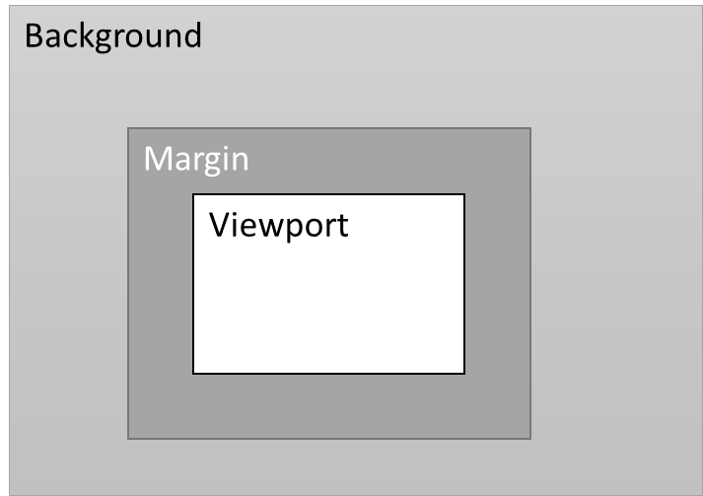
Figure 1: An equirectangular projected picture with viewport, margin and background areas.

- It should be possible to signal the extent of this margin area exactly (or as a minimum or maximum). The signaling may be done using SDP at the beginning of the session or during the session.
- It may be possible for the sender to change the width of these margins during the session without receiver involvement, e.g., based on the quality of the network. However, the margin area should not exceed the maximum or be less than the minimum value set for it.
- The margin area may be extended equally on all sides of the viewport or unevenly depending on i) general user behavior as determined through watching patterns ii) recent head motion signals or iii) nature of the content (e.g., room layout).
]

9.7.2 Role of the Sender and Receiver and Margin Control

It is important to have a clear responsibility split between sender and receiver during the adaptation operations. As mentioned above, the manring control is fully sender controlled. So, we envision the following responsibilities for sender and receiver:

SENDER:
- The extension of the viewport in the form of margins around it is controlled by the sender.
- The sender alone is responsible for optimizing the use of the margins during the session based on the suggested parameters and the receiver feedback (e.g., viewport orientation, etc.).
- The sender signals its capabilities in the use of margins in the initial SDP signaling.
- The sender signals changes in the margin dimention during the session using RTCP.
- The sender relies on the information signaled from the receiver including RTCP feedback (e.g., viewport orientation, timing information etc.).

RECEIVER:
- The receiver may indicate the preference of margins during the initial SDP signalling.
- The receiver should not request a larger viewport area during a session to ensure better operation.
- The receiver may suggests the sender the extent to which the margins may be used via RTCP feedback.
- While the receiver may influence the parameters to be used for margins, it is not involved in the actual adaptation operations.

9.7.3 Uses

Margin areas around the viewport can be used by a 360-degree sender to optimize the user experience of the receiver. Margins may be extended around the viewport evenly or unevenly. Some example scenarios where margins may be used to improve safe playback are listed below:
- Equally extended margins around the viewport in all directions may be used when the network allows to decrease the motion to high-quality delay for a receiver. The margins may be gradually extended farther by probing the network and reduced when the network is congested. In this scenario, the use of margins is akin to sending a larger viewport.
- Margins may be unevenly extended around the viewport with larger margins in the direction the user’s head is turning. In the absence of head motion, the margins may return to being equally extended all around the viewport. In this case, RTCP viewport orientation feedback is used to decide the distribution of margins. See Figure 1.
- Margins may be unevenly extended around the viewport with larger margins in the direction of the predicted head motion, e.g., based on audio input, motion tracking or other application level functions.
- A sender may optimize the use of margins based on network characteristics. For instance, a larger margin may be used when the motion to high-quality delay is high. Alternatively, a low motion to high-quality delay would indicate that the sender should use the available bandwidth for higher quality viewport instead of larger margins.
- In case of multiple receivers, margins are specifically signaled for each of the receivers.

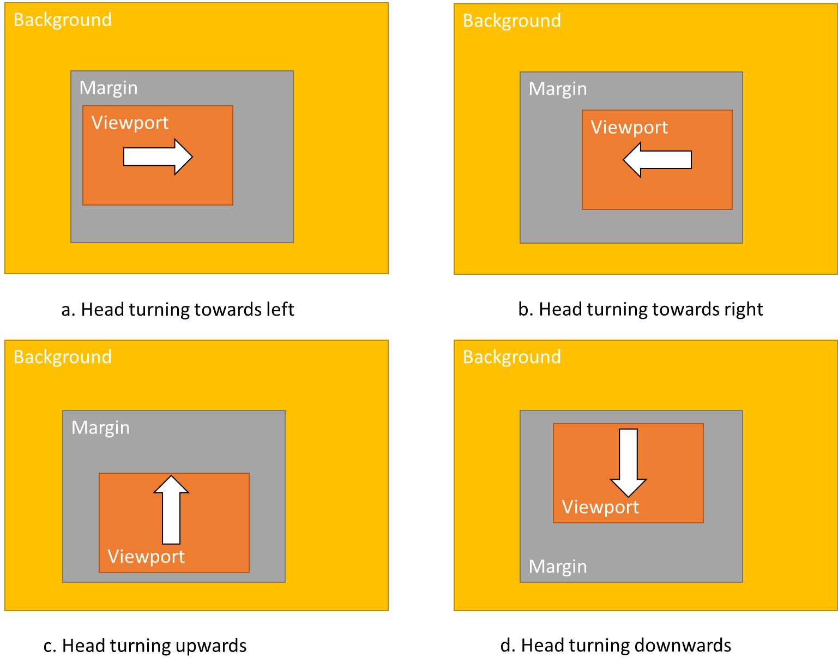
Figure 9.7.3.1: Uneven extension of margins based on the user head motion. Similar uneven extensions may be used based on other application-level parameters.

Editor’s Note: This feature is still under study/analysis for the pros and cons.

8 Eani9.8 Enhancing RTCP Feedback with High Level Metrics

9.8.1 Introduction

ITT4RT streams will have more stringent bandwidth and latency requirements than traditional RTP streams. Since, RTP transmission is a sender-driven operation, the 360-degree video sender (either the 360-degree source or the MRF/MCU) should have the capability to adapt the stream to varying network conditions.

9.8.2 Bandwidth Adaptation and Reporting

The sender bandwidth adaptation steps may include:

- Viewport-dependent delivery to concentrate bandwidth usage on currently visible content.
- Using viewport margins or larger viewports to mitigate the effects of slow networks on viewport updates.
- Use of background still images.
- Reducing/increasing stream quality based on network conditions.
Bandwidth adaptation decisions at the sender should be taken on the basis of RTCP reporting from the receiver. Relevant RTCP report fields already present in MTSI/Telepresence include low-level metrics included in RTCP RR and RTCP XR reports, e.g., jitter, RTT, packet losses and discards. In addition to these, RTP receivers for 360-degree video also must provide RTCP feedback for head orientation that senders use for viewport-dependent delivery.

9.8.3 Motion to High Quality Delay

DASH adaptation techniques have shown that high-level metrics provide better insight and are more valuable in rate adaptation techniques [16]. The RTP sender is aware of the delivered quality and quality changes already. In addition, we propose that RTP receivers of 360-degree video report the Motion to High-Quality (MTHQ) Delay to the sender. The MTHQ Delay is defined as the time elapsed between the start of the head motion to an orientation not covered by the current viewport and the time the receiver (i.e., the client HMD) renders the high-quality video stream corresponding to the new viewport in the new head orientation.

The usage of the MTHQ Delay metric is beneficial in several ways:
- It may be used for real-time bandwidth adaptation, e.g., delivering wider margins when the MTHQ delay is high.
- It may be used for session monitoring in live conferences.
- It provides important information collected at a single point (RTP sender) to application engineers to optimize systems a posteriori.

CALCULATION

A possible method for calculating the MTHQ Delay is described here. Consider a receiver device with current viewport V_{i}. The user moves their head resulting in a change in viewport to V_{i+1}. This change in viewport is large enough (i.e., above a given threshold of degrees) for the receiver to send a feedback message to the sender to update the current viewport orientation.

The RTP timestamp of any of the packets belonging to the last rendered video frame on the V_{i} is V_{i}_Highest_TS. The sender continues to send viewport-dependent content based on V_{i} until it receives the receiver’s feedback message with the new viewport orientation V_{i+1}. The sender now updates the viewport-dependent streams to use the new viewport orientation V_{i+1}. The RTP Timestamp of any of the packets belonging to the first successfully rendered video frame using viewport-dependent delivery with the new viewport is V_{i+1}_Lowest_TS. The MTHQ delay, Motion_to_HQ, can now be calculated as:

Motion_to_HQ = V_{i+1}_Lowest_TS - V_{i}_Highest_TS

This results in a parameter expressed in RTP Timestamps units, which can be sent to the sender. It should be investigated further what level of aggregations should be used for the above value.

9.8.4 RTT Is not Enough

Motion to High-Quality Delay is not the same as RTT as depicted in the figure below. Furthermore, RTCP and RTP traffic may be treated differently in the network, and viewport updates use both types of messages. Hence, RTT values calculated using RTCP reports only can be misleading.

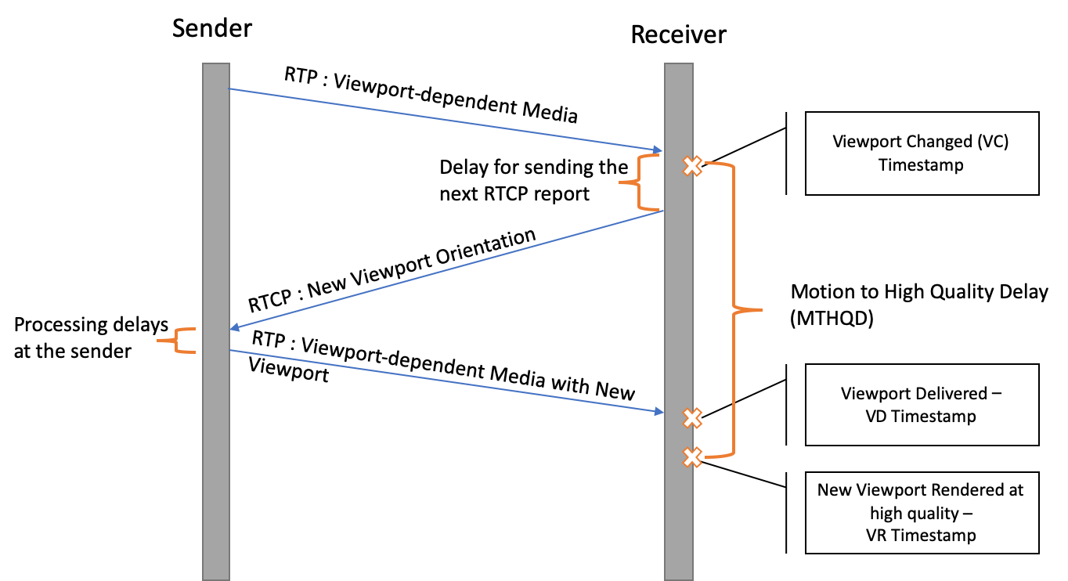
Figure 9.8.4.1: timing chart showing the events associated with viewport change and update

9.9 Signaling of Viewport Information using WebRTC Data Channel

Viewport information signalling based on the use of the WebRTC data channel [15]. The support for WebRTC data channel (as an optional feature for the MTSI client) is currently present for both MTSI in TS 26.114 and IMS-based Telepresence in TS 26.223. It runs over the “SCTP over DTLS” (Stream Control Transmission Protocol / Datagram Transport Layer Security) [13]-[14] protocol and is negotiated over the SDP [12]. The use of SCTP ensures the reliable and in-sequence delivery of the messages carrying viewport information.

[I-D.ietf-mmusic-sctp-sdp] defines how to set the values of an "m=" line describing an SCTP over DTLS association, with the following SDP ‘proto’ field values:
+-----------------+---------------+----------------------------+------------------------------+
| media | port | proto | fmt |
+-----------------+---------------+----------------------------+------------------------------+
| "application" | UDP port | "UDP/DTLS/SCTP" | "webrtc-datachannel" |
| | value | | |
| "application" | TCP port | "TCP/DTLS/SCTP" | "webrtc-datachannel" |
| | value | | |

While both of the above configurations are allowed in [I-D.ietf-mmusic-sctp-sdp], it is expected that UDP/DTLS/SCTP will be used.

The SDP dcmap attribute associated with the "m=" line describing the SCTP over DTLS association used to realize the WebRTC data channel, with the values set as following:

+-----------+-------------+--------------+-----------+------------+-------------+
| stream- | sub- | label | ordered | max-retr | max-time |
| id | protocol | | | | |
+-----------+-------------+--------------+-----------+------------+-------------+
| Value of | "View-" | Appli- | "true" | N/A | N/A |
| SCTP | “port” | cation | | | |
| stream | | specific | | | |
| used to | | | | | |
| realize | | | | | |
| the | | | | | |
| viewport | | | | | |
| channel | | | | | |
+-----------+-------------+-------------+-----------+--------------+------------+

A new sub-protocol attribute “Viewport” is defined to indicate the use of the WebRTC data channel for the purpose of viewport information signalling. The ‘ordered’ parameter is set as true to ensure in-sequence delivery of the messages over the WebRTC data channel carrying viewport information.

Here’s an example use of the SDP to negotiate the signalling of viewport information using the WebRTC data channel:
m=application 54111 UDP/DTLS/SCTP webrtc-datachannel
a=sctp-port: 5000
a=dcmap:2 subprotocol="Viewport";ordered=true

Accordingly, the new WebRTC data channel Protocol Value for Viewport (VP) information signalling may be registered with IANA as follows:

Subprotocol Identifier: Viewport
Subprotocol Common Name: Viewport
Subprotocol Definition: 3GPP TS 26.114
Reference: 3GPP TS 26.114

Viewport information messages may be formatted using structures such as XML or JSON. Accordingly, an XML schema or JSON schema may be defined carrying the following information, as aligned with the RTCP-FB message structure in clause 9.2 of the ITT4RT permanent document:

- Viewport_azimuth: Specifies the azimuth of the centre point of the sphere region corresponding to the desired viewport in units of 2⁻¹⁶ degrees relative to the global coordinate axes.
- Viewport_elevation: Specifies the elevation of the centre point of the sphere region corresponding to the desired viewport in units of 2⁻¹⁶ degrees relative to the global coordinate axes.
- Viewport_tilt: Specifies the tilt angle of the sphere region corresponding to the desired viewport, in units of 2⁻¹⁶ degrees, relative to the global coordinate axes.
- Viewport_azimuth_range: Specifies the azimuth range of the sphere region corresponding to the desired viewport through the centre point of the sphere region in units of 2⁻¹⁶ degrees.
- Viewport_elevation_range: Specifies the elevation range of the sphere region corresponding to the desired viewport through the centre point of the sphere region in units of 2⁻¹⁶ degrees.
- Timestamp: Specifies the timestamp of the last received RTP packet, toward associate the viewport information to the RTP media timeline
Editor’s Note: Definition of the packet format is still to be defined.
An example XML structure for a message carrying viewport information is shown below:
<xs:complexType name="viewportMessageType" abstract="true">
<xs:sequence>
<xs:element name="sequenceNr" type="xs:positiveInteger"/>
<xs:element name="azimuth" type="xs:positiveInteger"/>
<xs:element name="elevation" type="xs:positiveInteger"/>
<xs:element name="tilt" type="xs:positiveInteger"/>
<xs:element name="azimuthRange" type="xs:positiveInteger"/>
<xs:element name="elevationRange" type="xs:positiveInteger"/>
<xs:element name="timestamp" type="xs:unsignedInteger"/>
</xs:sequence>
<xs:attribute name="protocol" type="xs:string" fixed="Viewport"
use="required"/>
</xs:complexType>

The sender may increment the sequence numbers by one for each new message sent, the receiver may remember the most recent sequence number received and send back an error message if it receives a message with an unexpected sequence number.
The potential response message may be defined the following example XML structure:
<xs:complexType name="viewportResponseType">
<xs:sequence>
<xs:element name="responseCode" type="responseCodeType"/>
<xs:element name="reasonString" type="xs:string" minOccurs="0"/>
</xs:sequence>
</xs:complexType>

Editor’s Note: Efficiencies of RTCP and SCTP for carriage of viewport information should be studied and compared.

9.10 Proposed Solution for Viewport Sharing/Following

9.10.1 Description

Users with Head Mounted Displays are prone to motion-sickness and should not enable viewport-following on their devices.

However, users with 2D display devices that are not fully immersed in the experience may miss some audio/visual cues. Therefore, such users may want to follow the viewport of another user (e.g., a presenter). Viewport following requires a receiver to give up viewport orientation signalling and a sender to be capable of using another source for it. The following additional signalling is identified to enable this scenario:

- A sender can include the list of viewport-control options it supports in the SDP offer during session establishment. The receiver would respond with the viewport-control option it wishes to use. Possible options may include:
- device-signalled: The receiver signals the viewport orientation information to the sender, which controls the viewport in the delivered stream(s).
- presenter-viewport: The receiver follows the viewport of another user.
- device-not-signalled: The viewport orientation information is not signaled. A viewport-independent stream is delivered by the sender due to sender limitations or receiver’s preference (e.g., based on device limitations or privacy reasons).
All senders must at least offer “viewport-ctrl: device-not-signalled” to the receiver devices. A sender may limit the quality of viewport-independent streams for the sake of network fairness.

A sender that offers “presenter-viewport”, should have the capability to receive requests for viewport-following from remote UEs wishing to follow another user’s viewport, and send requests to receiver(s) to request permission for sharing their viewport orientation, if needed.

9.10.2 Signaling Chart

One possible example scenario is illustrated below. Figure 9.10.2.1 shows the signalling flow for a conference call with an MRF/MCU with two remote participants UE B (HMD) and UE C (2D Display). The steps are explained below.

1a/b : The MRF/MCU sends a SIP Invite with the list of viewport control options supported by it.

2a: UE B (HMD) accepts the request with the following options 1) Allow viewport following (VF) requests from other devices 2) Send viewport-dependent stream based on device signalling. After this, an RTP/RTCP session is established for UE B, where viewport-orientation is sent to the MRF/MCU via RTCP feedback messages.

2b. UE C (2D Display) accepts the request with the following options 1) Disallow VF requests from other devices 2) Send viewport-dependent stream in VF-presenter mode with UE B as the VF-Source.

3. MRF/MCU requests permission for VF from UE B.

4. UE B grants permission to share viewport-orientation and allow VF. The MRF/MCU starts an RTP/RTCP session with UE C.
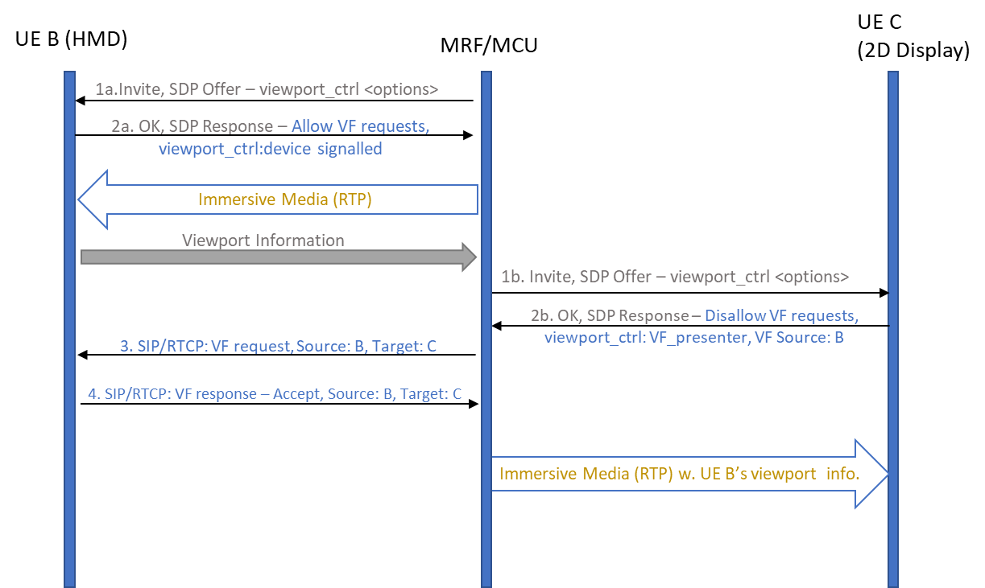

Figure 9.10.2.1 shows a signalling flow where a UE with 2D Display, C, chooses to enable VF-other with UE B (HMD) as the source.

9.11 Evaluation of RTCP as a Feedback Mechanism for Viewport Information

This section provides initial information about typical RTCP traffic for ITT4RT in MTSI. The idea is to start discussion and evaluate RTCP as feedback mechanism for real-time 360-degree video transmission.

Two simple example cases will be presented, with simplification of the scenarios to estimate the volume of RTCP traffic for immersive video.

CASE 1 – Constant RTCP feedback rate
In this case we suppose there is no head motion or that the head motion does not trigger additional feedback traffic. For instance, the RTCP feedback in this case is sent at a constant rate. The feedback may also include the transmission of viewport orientation information from the receiver to the sender, in addition to ordinary RTCP reports.

The analysis will here consider only the video stream of a multimedia immersive session. At a later stage we will conduct a similar analysis considering also the connected audio stream. We are interested in having an understanding of how much RTCP feedback a 360-degree video receiver is able to transmit for different video session bandwidths.

With the hypothesis of receiving a video stream of 5/10/15/20/30 Mbps and considering the standard 5% bandwidth allocated for RTCP traffic (without the 5 seconds minimum RTCP transmission interval, as allowed by RTP/AVPF profile), we can easily calculate the RTCP bandwidth for these cases. Considering RTCP packets of 96 bytes, it is possible to estimate how frequently can RTCP feedback packets be sent back to the sender. This feedback includes also viewport orientation information. So, these results give an important performance indicator for viewport-dependent operations in ITT4RT.

Table 9.11.1 shows that the standard 5% bandwidth for RTCP feedback is more than sufficient in order to dimension a VR system with a sub-second feedback capability.

Video bit rate (Mbps) | RTCP feedback bit rate (Mbps) | RTCP feedback frequency
5 | 0.25 | 3ms
10 | 0.5 | 1.54ms
15 | 0.75 | <1ms
20 | 1 | <1ms
30 | 1.5 | <1ms
Table 9.11.1. RTCP feedback bit rate requirements and feedback frequency

The Motion to High-Quality (MTHQ) Delay is larger than the network Round Trip Time (RTT), since there are processing delays at the sender and receiver to take into account. Let’s suppose an ITT4RT system aims at a MTHQ Delay of 100ms with constant rate RTCP feedback. Let’s also assume the one-way network delay be 30ms and sender+receiver processing delays are 10ms. Then 30ms x 2 + 10ms = 70ms are absorbed by network and processing delays. The receiver should set its constant feedback frequency to no more than every 30ms (i.e., the “delay for sending the next RTCP report” in Figure 1) in order to be within the 100ms MTHQ Delay budget.

Figure 9.11.1. Motion to High Quality Delay

Sending RTCP feedback every 30ms with the given RTCP packet size as defined above would mean to send 33.33 RTCP packets per second and requires 25.6 kbps, which is just 0.5% of the video stream bandwidth at 5 Mbps, or 0.08% of the video stream bandwidth at 30 Mbps.

Note that 30ms is the constant RTCP reporting frequency. However, a random head turn may occur at any time between two RTCP reports. So, on average it may occur after about 15ms from the sending of the previous RTCP report. In case the reports are transmitted at a constanr rate, the impact of a lost or delayed feedback report is smaller, since there will be another one already transmitted after e.g. 30ms. This makes the system well dimensioned and within the MTHQ Delay budget for the average case and also for the worst case.

Conclusion: the results shown give an idea of the bandwidth required for the RTCP feedback and for a competitive MTHQ Delay. The RTCP feedback requirements seem feasible, under the condition that the feedback is conveyed at a constant rate, regardless of the head motion and its speed.

Editor’s Note 1: Above analysis applies to point to point scenario and impact of multiple participants in the same RTP session also needs to be analyzed.

Editor’s Note 2: The above analysis does not consider the impact of jitter when sending RTCP-FB messages. Jitter may have significant impact on the delay calculations.

CASE 2 – Event-driven RTCP feedback with HMD motion
In this case we suppose that the RTCP feedback of the viewport orientation is given immediately upon the event of head turn (ordinary RTCP feedback may be sent at a higher or lower frequency). We also assume that the RTCP frequency increases with the HMD speed.

We consider HMD motion at speeds from 6 up to 180 degrees per second, with the assumption that there exist a feedback trigger, which is the minimum fixed distance that the head must move for a feedback to be sent. We assume this trigger to be 0.1, 0.5, 1 and 2 degrees in our simulation. We assume that the creation of the RTCP report is immediate. Figure 2 shows the RTCP feedback bit rate for different head speeds and trigger values. The required RTCP feedback rates are within the required 5% bandwidth of a 5Mbps video (0.25Mbps) in Table 1 for feedback triggers of 0.5 degrees and more. For a feedback trigger as short as 0.1 degrees, however, the required bandwidth values exceed RTCP bandwidth limitations for even a 20Mbps video when head speeds are over 125 degrees per second.
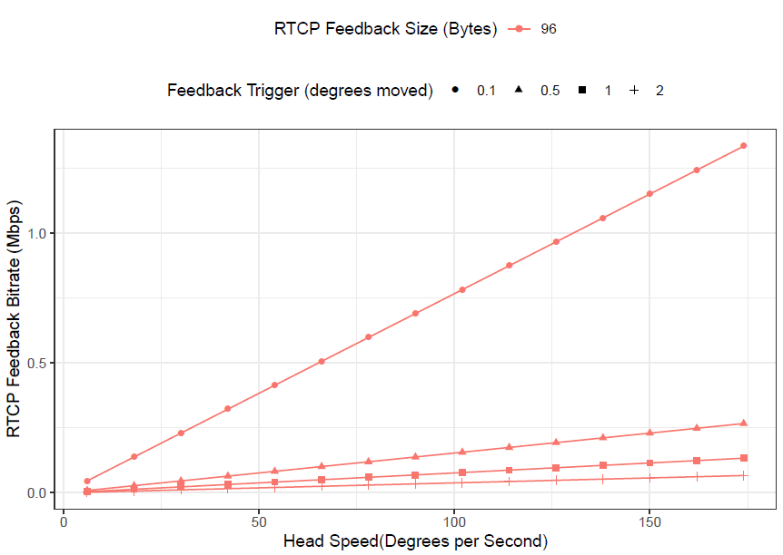
Figure 9.11.2. Required bit rate for event-based RTCP feedback at different head speeds

The time it takes for an event-based RTCP feedback to be sent depends on the feedback trigger and speed of the head. For instance, at a head speed of 6 degrees per second and 2 degree trigger, it would take about 333ms for the first feedback to be sent. This is reduced to 60ms when the trigger used is 0.1 degrees. Adding the previously assumed 70ms of network and processing latency, the value is over 100ms. It can be rightly assumed that a large trigger is set only when the viewport-dependent scheme allows this level of movement without needing an updated stream and the user will not experience this calculated latency in its entirety. However, the large change in latency based on the trigger value is an indicator that designing event based RTCP feedback requires careful thought and engineering to work efficiently. Initial implementations may benefit from using a fixed interval feedback.

10 Another Potential Solution for Overlays based on Scene Description

10.1 Introduction

Clause 6.3 introduced a potential solution for overlays. This clause provides another potential solution based on scene description.

10.2 Overview

A scene graph is a directed acyclic graph, usually just a plain tree-structure, that represents an object-based hierarchy of the geometry of a scene. The leaf nodes of the graph represent geometric primitives such as polygons. Each node in the graph holds pointers to its children. The child nodes can among others be a group of other nodes, a geometry element, a transformation matrix, etc.

Spatial transformations are attached to nodes of the graph and represented by a transformation matrix.

This structure of scene graphs has the advantage of reduced processing complexity, e.g. while traversing the graph for rendering. An example operation that is simplified by the graph representation is the culling operation, where branches of the graph are dropped from processing, if deemed that the parent node’s space is not visible or relevant (level of detail culling) to the rendering of the current view frustum.

10.3 glTF 2.0

glTF 2.0 is a new standard that was developed by Khronos [17] to enable Physically Based Rendering. glTF 2.0 offers a compact and low-level representation of a scene graph. glTF 2.0 offers a flat hierarchy of the scene graph representation to simplify the processing. glTF 2.0 scene graphs are represented in JSON to ease the integration in web environments. The glTF 2.0 specification is designed to elimate redundancy in the representation and to offer efficient indexing of the different objects in the scene graph.

The structure of a glTF 2.0 scene graph document is arranged as follows:

The scene graph itself has the following structure:

MPEG is working on extensions to glTF 2.0 to add support for real-time media, scene updates, and other features. [19]

10.4 Scene Description-based Composition and Overlays

10.4.1 General

Scene Graphs make it very simple to compose scenes for an immersive presentation. The composition may be performed at an MRF or MCU. Alternatively, a designated party in the conference is responsible for creating the initial scene description and sharing it with all other parties in the call. This party may be the one that creates the main VR content, for instance, the party that is in the conference room with a VR capture.

Each party may contribute one or more nodes to the Scene Graph. Each nodes comes with its associated transformation (in form of a matrix, or individual translation and rotation operations), to place that node appropriately in the scene.

10.4.2 SDP Signaling

In this section, 2 different alternatives are offered for the signaling of the scene description for the ITT4RT session.

In the first alternative, a dedicated websocket channel may be used [18]. By using WebSockets, the reliable transmission and exchange of the scene description and its updates is guaranteed. Each party of the conference call may offer to send and receive a scene description through the following session-level attribute given in ABNF syntax:

Session-Description = “a=scene-description:” SP mime-type [SP uri] [SP sent-nodes] CRLF
mime-type = “mime-type:” byte-string
sent-nodes = “nodes-owned=1*(byte-string “;”)
uri = “websocket-uri:”URI

The uri parameter shall be a WebSocket URI for a data channel over which the scene description will be shared and updated.

Alternatively, a WebRTC data channel based on SCTP/DTLS/UDP is used [12]-[15]. This alternative leverages the data channel definition in 26.114 for MTSI sessions. An application media session is used with the protocol identifier UDP/DTLS/SCTP with the subprotocol being “sd” for scene description information.

An example is shown below:
m=application 52718 UDP/DTLS/SCTP webrtc-datachannel
a=sctp-port:5000
a=fingerprint:SHA-1 4A:AD:B9:B1:3F:82:18:3B:54:02:12:DF:3E:5D:49:6B:19:E5:7C:AB
a=tls-id: abc3de65cddef001be82
a=dcmap:0 subprotocol="sd"
a=setup:passive
a=connection:new
a=mime-type:model/gltf+json
a=nodes-owned: node12,node13,node14

10.4.3 Referencing Media Streams

The scene description references media streams from the conferencing session that are used as components of nodes in the scene. An example could be a video stream of a conference participant that is to be displayed in a rectangular region in the 3D scene. The following URI format shall be used for this purpose:

url=”rtp://” fqdn_or_ip “/” call_id “/” ssrc “/” mid

where fqdn_or_ip represent the domain name or ip address of the MRF or SIP proxy that manages the call. If none is used, it represents the domain name or ip address of the SIP address of the host of the call. call_id provides a unique identifier for the current call or conference. ssrc represents the synchronization source of the owner/sending participant of the media stream. Finally, mid represents media session identifier as provided in the SDP.
Other forms of addressing may be defined, e.g. as URNs.

10.4.4 Processing

Parties of an ITT4RT conference may establish direct peer-to-peer WebSocket channels with each other or a connection may be offered by an MRF to all parties. The WebSocket channel shall use the text frame format.

In a scene, node names shall be unique and shall be declared in the SDP to ensure there are no naming conflicts in nodes provided by different parties in a call. Nodes in the scene description may reference external media streams, such as other media streams that are declared in the SDP.
A receiver may mask nodes from certain parties in the rendering process, e.g. based on user input.
The MRF is by default the owner of the master scene graph, i.e. the one that sets the coordinate system and in which all other nodes are composited. It is also the one that defines the main camera in the scene.

In the absence of a centralized MRF, the parties in the call may select one party to provide the main scene description, for example by selecting the one that provides the VR content or the organizer of the call.

Overlays can be 2D or 3D objects that are placed within the scene. The geometry of the overlay and its texture are defined by the node that corresponds to that overlay object. A simple example is a set of slides that are played in a rectangular area that is shown inside the VR scene. In this case, the geometry will be a rectangle and the texture might be coming from a video media stream. The rectangle is placed in the scene. For viewport-dependent overlay, the position of the rectangle is locked to the camera direction.

Editor’s Note: Initial specification for overlays will only be focused on the SDP-based solution for which potential solutions are provided in clause 6.3. A scene description based solution may be specified at a later stage once MPEG delivers the related specification ISO/IEC 23090-14 [19].

11 References

[1] 3GPP TS 26.114: "IP Multimedia Subsystem (IMS); Multimedia telephony; Media handling and interaction".
[2] 3GPP TS 26.223: "Telepresence using the IP Multimedia Subsystem (IMS); Media handling and interaction".
[3] ISO/IEC 23008-2: "Information technology -- High efficiency coding and media delivery in heterogeneous environments -- Part 2: High efficiency video coding".
[4] ISO/IEC 23090-2: " Information technology -- Coded representation of immersive media -- Part 2: Omnidirectional media format".
[5] 3GPP TS 26.118: "3GPP Virtual reality profiles for streaming applications".
[6] IETF RFC 7798 (2016): "RTP Payload Format for High Efficiency Video Coding (HEVC)", Y.-K. Wang, Y. Sanchez, T. Schierl, S. Wenger, M. M. Hannuksela.
[7] IETF RFC 7728 (2016): "RTP Stream Pause and Resume".
[8] ISO/IEC 14496-10: "Information technology – Coding of audio-visual objects – Part 10: Advanced Video Coding".
[9] IETF RFC 3550, “RTP: A Transport Protocol for Real-Time Applications,” 2003
[10] Peter Fasogbon, Emre Aksu, “Calibration of fisheye camera using entrance pupil”, http://arxiv.org/abs/1907.01759, IEEE International Conference on Image Processing (ICIP), 2019.
[11] ISO/IEC 23090-8: " Information technology -- Coded representation of immersive media -- Part 8: Network-based media processing".
[12] IETF Internet Draft, draft-ietf-mmusic-data-channel-sdpneg-28 (2019): "SDP-based Data Channel Negotiation" (WORK IN PROGRESS)
[13] IETF RFC 4960 (2007): "Stream Control Transmission Protocol"
[14] IETF RFC 8261 (2017): "Datagram Transport Layer Security (DTLS) Encapsulation of SCTP Packets"
[15] IETF Internet Draft, draft-ietf-rtcweb-data-channel-13 (2015): "WebRTC Data Channels" (WORK IN PROGRESS)
[16] Bentaleb, A., Taani, B., Begen, A. C., Timmerer, C., & Zimmermann, R. (2018). A survey on bitrate adaptation schemes for streaming media over HTTP. IEEE Communications Surveys & Tutorials, 21(1), 562-585.[17] Khronos Group, The GL Transmission Format (glTF) 2.0, https://github.com/KhronosGroup/glTF/tree/master/specification/2.0
[18] IETF RFC 8124, The Session Description Protocol (SDP) WebSocket Connection URI Attribute
[19] ISO/IEC 23090-14: Scene Description for MPEG Media
INCLUDEPICTURE "cid:image001.jpg@01D57F7D.A02B75E0" \* MERGEFORMATINET

The system supports transmission of full 360 video. However, the use cases may restrict the field of view to enhance user experience.

