**3GPP SA3LI#94 *s3i240502***

**9-12 July 2024, Amsterdam (The Netherlands)**

**Title: Reply LS on LI considerations for TR 33.757**

**Response to: s3i240502**

**Release: Rel-19**

**Work Item: LI19**

**Source: SA3-LI**

**To: SA3**

**Cc: SA2**

**Contact person: Mark Canterbury**

**markc@tencastle.com**

**Send any reply LS to: 3GPP Liaisons Coordinator,** [**mailto:3GPPLiaison@etsi.org**](mailto:3GPPLiaison@etsi.org)

**Attachments:**

# Overall description

SA3-LI kindly thanks SA3 for their LS, and for adding LI considerations to TR 33.757.

Regarding TR 33.757 Key Issue #3 (SUPI privacy), SA3-LI is grateful for SA3’s clarifications (in particular that for the purposes of this study it is assumed that both the hosting PLMN and the hosted NPN belong to the same regulatory domain) and for undertaking to ensure that either SUPI-based LI is supported or that the feature is optional to deploy.

Regarding TR 33.757 Key Issue #1 (Security for dedicated UPF interacting with PLMN through N4 interface), SA3-LI notes following question:

**Question 1:** SA3 would like to ask SA3-LI to clarify what the detailed issues and specific impacts the proxy related mechanisms may bring for the LI_T2/LI_T3 interfaces.

SA3-LI is pleased to attempt to provide the necessary clarifications below.

LI_T2 and LI_T3 are known as “triggering” interfaces. In this context, they are found between the LI function in the SMF (the “IRI-TF”) and the LI function in the UPF (the “CC-POI”). The triggering interfaces serve a similar purpose to N4 and operate in parallel to it, in that they enable the IRI-TF in the SMF to manage interception within the CC-POI in the UPF. A more complete view of the architecture can be found in TS 33.127 clause 6.2.3, while a description of the protocols involved can be found in TS 33.128 clause 6.2.3.

For convenience, the relevant architectural view from TS 33.127 is reproduced below.

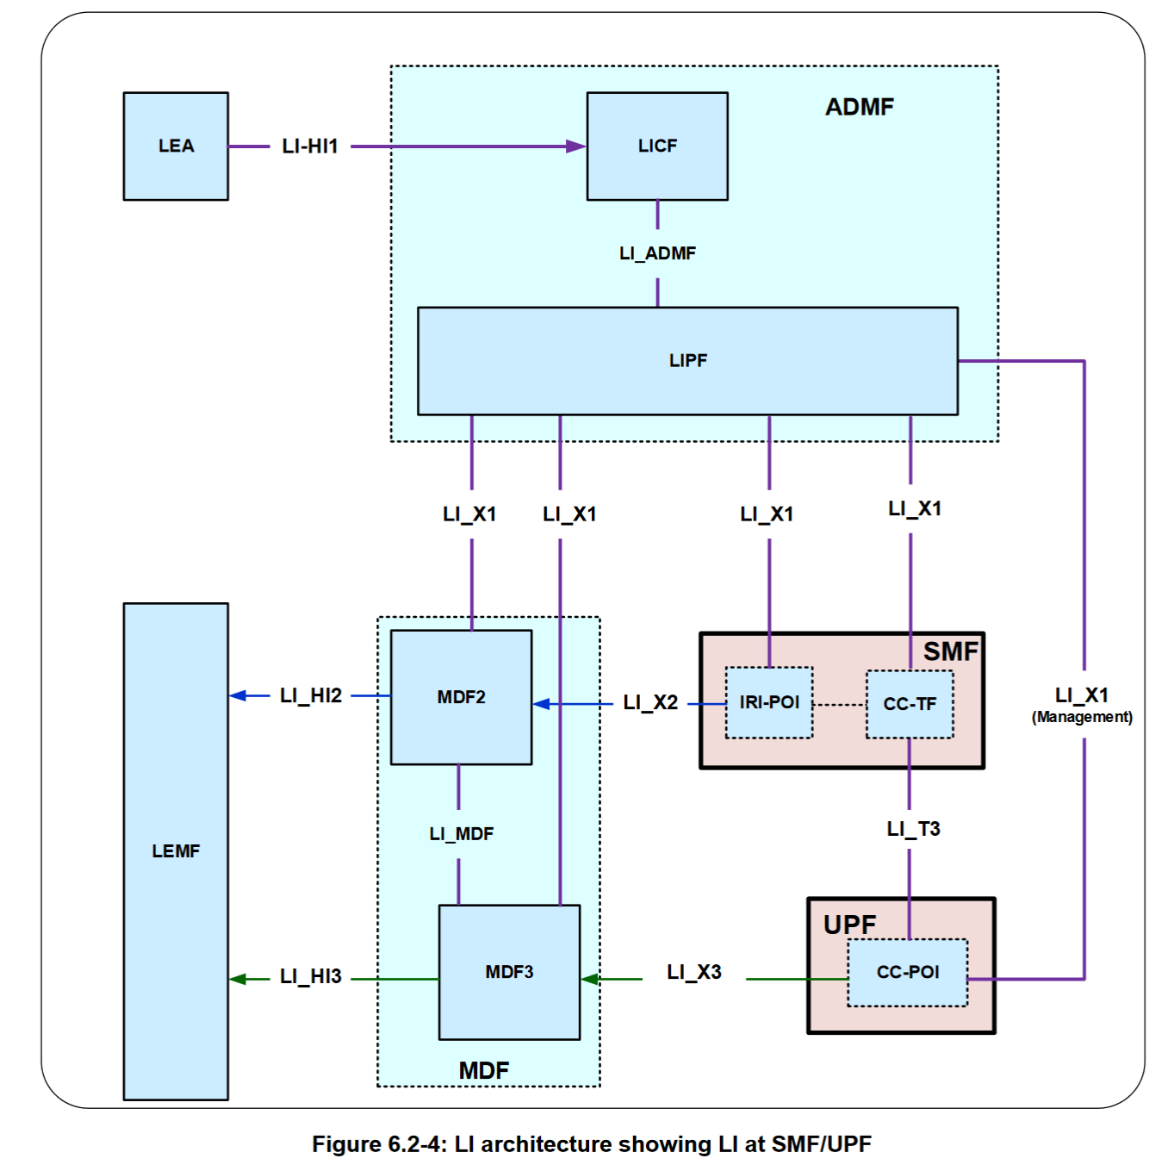

Concretely, this approach means that the IRI-TF in the SMF needs to be able to send and receive HTTPS messages to the CC-POI in the UPF, secured by mutual TLS authentication. SA3-LI’s understanding is that TR 33.757 is considering placing proxies or gateways between the SMF and UPF in order to perform topology hiding in one or both directions. SA3-LI is concerned that this may impact on the IRI-TF’s ability to discover, establish trust with and exchange messages with the CC-POI.

However, SA3-LI observes that presumably a similar set of challenges exist on N4 itself. It also observes that the proposed solutions to Key Issue #1 in TR 33.757 all appear to involve the introduction of one or more dedicated gateway functions. Assuming that the behaviour and interfaces of these functions are defined in 3GPP (as opposed to being left to implementation), then SA3-LI’s view is that it is likely that it will be possible to place an LI function within this gateway which has parallel responsibilities for proxying LI_T2/LI_T3. The definition of this function would then be for SA3-LI to define.

SA3-LI kindly asks SA3 to confirm if SA3-LI’s understand of the above is correct, and if any further clarifications are required to allow SA3 to continue their work.

# Actions

**To SA3:**

**ACTION:** SA3-LI kindly asks SA3 to clarify if SA3-LI’s understanding of the likely solutions to Key Issue #1 is correct, and to inform SA3-LI if any further clarifications are required to enable SA3’s work to progress.

# 3 Dates of next SA3-LI meetings

SA3#95-LI 29 October – 1 November 2024 Las Vegas, NV (US)

SA3#96-LI 28 – 31 January 2025 Sophia Antipolis, France