**3GPP TSG-SA3 Meeting #83-LI-e-b *s3i210820r1***

**Online, , 1st Nov 2021 - 5th Nov 2021**

|  |  |  |  |  |  |  |  |  |
| --- | --- | --- | --- | --- | --- | --- | --- | --- |
| *CR-Form-v12.1* | | | | | | | | |
| **CHANGE REQUEST** | | | | | | | | |
|  | | | | | | | | |
|  | **33.127** | **CR** | **0153** | **rev** | **1** | **Current version:** | **17.2.0** |  |
|  | | | | | | | | |
| *For* [***HE******LP***](http://www.3gpp.org/3G_Specs/CRs.htm#_blank)*on using this form: comprehensive instructions can be found at* [*http://www.3gpp.org/Change-Requests*](http://www.3gpp.org/Change-Requests)*.* | | | | | | | | |
|  | | | | | | | | |

|  |  |  |  |  |  |  |  |  |
| --- | --- | --- | --- | --- | --- | --- | --- | --- |
| ***Proposed change affects:*** | UICC apps |  | ME |  | Radio Access Network |  | Core Network | **x** |

|  |  |  |  |  |  |  |  |  |  |  |
| --- | --- | --- | --- | --- | --- | --- | --- | --- | --- | --- |
|  | | | | | | | | | | |
| ***Title:*** | LI for EPC-5GC Interworking Stage 2 | | | | | | | | | |
|  |  | | | | | | | | | |
| ***Source to WG:*** | SA3-LI (OTD) | | | | | | | | | |
| ***Source to TSG:*** | SA3 | | | | | | | | | |
|  |  | | | | | | | | | |
| ***Work item code:*** | LI17 | | | | |  | ***Date:*** | | | 2021-11-03 |
|  |  | | | |  | |  | | |  |
| ***Category:*** | **B** |  | | | | | ***Release:*** | | | Rel-17 |
|  | *Use one of the following categories:* ***F*** *(correction)* ***A*** *(mirror corresponding to a change in an earlier release)* ***B*** *(addition of feature),* ***C*** *(functional modification of feature)* ***D*** *(editorial modification)*  Detailed explanations of the above categories can be found in 3GPP [TR 21.900](http://www.3gpp.org/ftp/Specs/html-info/21900.htm). | | | | | | | | *Use one of the following releases: Rel-8 (Release 8) Rel-9 (Release 9) Rel-10 (Release 10) Rel-11 (Release 11) … Rel-15 (Release 15) Rel-16 (Release 16) Rel-17 (Release 17) Rel-18 (Release 18)* | |
|  |  | | | | | | | | | |
| ***Reason for change:*** | | SA3-LI has previously agreed Stage 3 LI reporting of EPC-5GC interworking scenarios. This contribution aligns agreed Stage 3 to Stage 2 for SMF+PGW-C and UPF+PGW-U LI reporting. | | | | | | | | |
|  | |  | | | | | | | | |
| ***Summary of change:*** | | Addition of NOTE to clause 6.3.3.1.3, modification of clause 6.3.3.2, 6.3.3.3, 6.3.3.4, and adds new clause 6.3.3.X. | | | | | | | | |
|  | |  | | | | | | | | |
| ***Consequences if not approved:*** | | Continued Stage 2 and Stage 3 misalignment. CSPs may not be able to fully meet LI obligations. | | | | | | | | |
|  | |  | | | | | | | | |
| ***Clauses affected:*** | | 6.3.3.1.3, 6.3.3.2, 6.3.3.3, 6.3.3.4, 6.3.3.X | | | | | | | | |
|  | |  | | | | | | | | |
|  | | **Y** | **N** |  | | | |  | | |
| ***Other specs*** | |  | **x** | Other core specifications | | | | TS/TR ... CR ... | | |
| ***affected:*** | |  | **x** | Test specifications | | | | TS/TR ... CR ... | | |
| ***(show related CRs)*** | |  | **x** | O&M Specifications | | | | TS/TR ... CR ... | | |
|  | |  | | | | | | | | |
| ***Other comments:*** | |  | | | | | | | | |
|  | |  | | | | | | | | |
| ***This CR's revision history:*** | | S3i210820 | | | | | | | | |

***START OF CHANGES***

***START OF FIRST CHANGE***

##### 6.3.3.1.3 EPS CUPS Architecture

Figure 6.3-3 shows the LI architecture for EPS CUPS SGW/PGW based interception.

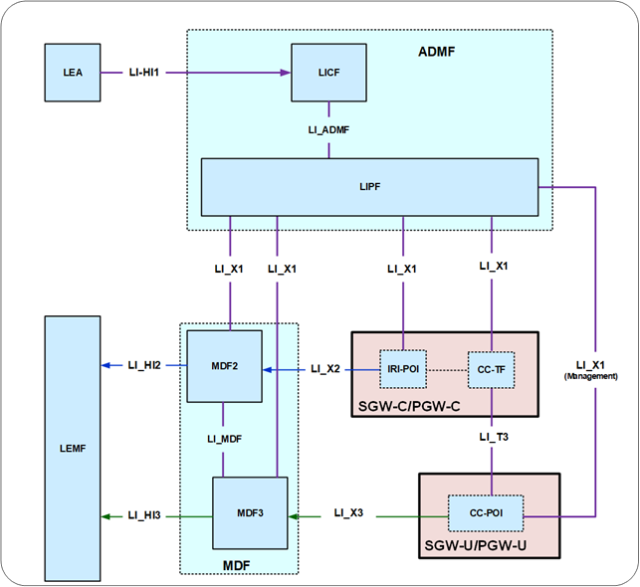

Figure 6.3-3: LI architecture for LI at EPS CUPS SGW/PGW

The LICF present in the ADMF receives the warrant from an LEA, derives the intercept information from the warrant and provides the same to the LIPF.

The LIPF present in the ADMF provisions IRI-POI present in the SGW-C/PGW-C and the MDF2 over the LI_X1 interfaces. To enable the interception of the target's user plane packets (e.g. when the warrant requires the interception of communication contents), the CC-TF present in the SGW-C/PGW-C is also provisioned with the intercept data.

NOTE 1: The IRI-POI and CC-TF represented in figure 6.3-3 are logical functions and require correlation information be shared between them; they may be handled by the same process within the SGW-C/PGW-C.

When PGW-C and PGW-U (represented in figure 6.3-3) are part of combined SMF+PGW-C and UPF+PGW-U respectively in the EPC-5GC interworking architectures as shown in clause A.2.2, figure A.2-1 of the present document, the PGW-C and PGW-U shall exhibit the LI functions as described in clause 6.3.3.3.1.

The IRI-POI present in the SGW-C/PGW-C detects the target UE's bearer activation, modification and deactivation and generates and delivers the xIRI to the MDF2 over LI_X2. The MDF2 delivers the IRI messages to the LEMF over LI_HI2.

The CC-TF present in the SGW-C/PGW-C detects the target UE's bearer activation, modification and deactivation and provisions the CC-POI in the SGW-U/PGW-U.

The CC-POI present in the SGW-U/PGW-U generates the xCC from the user plane packets and delivers the xCC (that includes the correlation number and the target identity) to the MDF3. The MDF3 delivers the CC to the LEMF over LI_HI3.

A warrant that does not require the interception of communication contents, may require IRI messages that have to be derived from the user plane packets. To support the generation of related xIRI (i.e. that requires access to the user plane packets), the present document supports two implementation approaches described in clause 7.12.2.

***END OF FIRST CHANGE***

***START OF SECOND CHANGE***

#### 6.3.3.2 Target identities

The target identities which the LIPF provisions to the IRI-POI and CC-POI present in the SGW/PGW include the following:

- IMSI.

- MSISDN.

- ME (Mobile Equipment) Identity.

Interception performed on the above three identities are mutually independent, even though, an xIRI may contain the information about the other identities when available.

In the case of EPC-5GC interworking via combined SMF+PGW-C and UPF+PGW-U, the LIPF also provisions the following target identities to the IRI-POI present in the SMF+PGW-C:

- SUPI.

- PEI.

- GPSI.

Interception performed on the above three identities are mutually independent, even though, an xIRI may contain information about the other identities when available.

***END OF SECOND CHANGE***

***START OF THIRD CHANGE***

#### 6.3.3.3 IRI events

##### 6.3.3.3.1 Option A

When Option A described in clause 6.3.1 is used, xIRI provided by the IRI-POI in the PGW based on the events specified in TS 33.107 [11] may not be generated; the IRI-POI in the PGW shall generate xIRI when it detects the following specific events or information specified in TS 33.128 [15]:

- PDU session establishment.

- PDU session modification.

- PDU session release.

- Start of interception with an established PDU session.

- SMF unsuccessful procedure.

The PDU session establishment xIRI is generated when the IRI-POI present in the SMF+PGW-C detects that a PDU session with mapped EBIs has been established for the target UE.

The PDU session modification xIRI is generated when the IRI-POI present in the SMF+PGW-C detects that a PDU session or EBIs are modified for the target UE or when a PDN connection from EPC is migrated to the 5GS.

The PDU session release xIRI is generated when the IRI-POI present in the SMF+PGW-C detects that a PDU session or EBI is released for the target UE.

The start of interception with an established PDU session xIRI is generated when the IRI-POI present in a SMF+PGW-C detects that interception is activated on the target UE that has an already established PDU session in the 5GS. When a target UE has multiple PDU sessions mapped to multiple PDN connections in EPC, this xIRI shall be sent for each PDU session with a different value of correlation information.

When additional warrants are activated on a target UE, MDF2 shall be able to generate and deliver the start of interception with an established PDU session related IRI messages to the LEMF associated with the warrants without receiving the corresponding start of interception with an established PDU session xIRI.

When the warrant requires the packet header information reporting, the following xIRI shall be generated:

- Packet header information report (see clause 7.12.2).

The generation of packet header information reporting can be done by either the IRI-POI present in the UPF+PGW-U or the MDF2.

##### 6.3.3.3.2 Option B

The IRI-POI present in the SGW/PGW shall generate xIRI, when it detects the applicable events specified in TS 33.107 [11].

***END OF THID CHANGE***

***START OF FOURTH CHANGE***

#### 6.3.3.4 Common IRI parameters

The list of xIRI parameters are specified in TS 33.128 [15]. All xIRI shall include the following:

- Target identity.

- Time stamp.

- Correlation information.

- Location information.

- Session related information.

***END OF FOURTH CHANGE***

***START OF FIFTH CHANGE***

#### 6.3.3.X EPC-5GC Interworking via SMF+PGW-C and UPF+PGW-U

In the case of interworking between EPC and 5GC via combined nodes (e.g. SMF+PGW-C, UPF+PGW-U) as defined in TS 23.501 [2] clause 5.17, all of the requirements found in clause 6.2.3 (LI for SMF/UPF) and clause 6.3.3 (LI at the SGW/PGW) of the present document apply with the following modifications:

- PDN Connection context information present in the combined SMF+PGW-C shall be reported via the mechanisms defined in clause 6.2.3 of TS 33.128 [15].

- User identifiers that are EPC specific but known in the combined SMF+PGW-C are reported as supplemental user IDs per clause 6.2.3 of TS 33.128 [15].

***END OF FIFTH CHANGE***

***START OF CHANGES***