3GPP TSG-SA3LI, SA3#46LI SA3LI12_075
17-19 July 2012, Quebec City, Canada

Source: Rogers Wireless
Title: Scope of work on LI solutions for Mobile Cloud Services
Document for: Discussion and decision
Agenda Item:
Work Item / Release: LI Rel-12
Contact Information: George Babut, george.babut@rci.rogers.com;
Ed O’Leary (ed.oleary@rci.rogers.com)

Introduction
This contribution proposes text for the Background on Mobile Cloud Service section of the living document on LI solutions for Mobile Cloud Services.

Proposal

***********************First addition******************************

4 Background on Mobile Cloud Services

4.1 General

“Cloud computing, including distributed virtual services, is an evolving paradigm that is fundamentally and rapidly changing communication services and infrastructure.
The diversity of these services and the underlying infrastructure has itself produced different perspectives.
In general, most of the many forums dealing with cloud computing have found common ground in the following description (Special Publication 800-145, The NIST Definition of Cloud Computing, Sept 2011 [x])”
( ETSI DTR 101 567 V0.0.5 Lawful Interception (LI);Cloud/Virtual Services (CLI) [y].

Definition of “Cloud Computing”
According to NIST:
“Cloud Computing is a model for enabling ubiquitous, convenient, on-demand network access to a shared pool of configurable computing resources (e.g., networks, servers, storage, applications, and services) that can be rapidly provisioned and released with minimal management effort or service provider interaction. This cloud model promotes availability and is composed of five essential characteristics, three service models, and four deployment models.”
Cloud Essential Characteristics
- On-demand self-service.
A consumer can unilaterally provision computing capabilities, such as server time and network storage, as needed automatically without requiring human interaction with each service’s provider.
- Broad network access.
Capabilities are available over the network and accessed through standard mechanisms that promote use by heterogeneous thin or thick client platforms (e.g., mobile phones, laptops, and PDAs).
- Resource pooling.
The provider’s computing resources are pooled to serve multiple consumers using a multi-tenant model, with different physical and virtual resources dynamically assigned and reassigned according to consumer demand. There is a sense of location independence in that the customer generally has no control or knowledge over the exact location of the provided resources but may be able to specify location at a higher level of abstraction (e.g., country, state, or datacenter). Examples of resources include storage, processing, memory, network bandwidth, and virtual machines.
- Rapid elasticity.
Capabilities can be rapidly and elastically provisioned, in some cases automatically, to quickly scale out, and rapidly released to quickly scale in. To the consumer, the capabilities available for provisioning often appear to be unlimited and can be purchased in any quantity at any time.
- Measured Service.
Cloud systems automatically control and optimize resource use by leveraging a metering capability1 at some level of abstraction appropriate to the type of service (e.g., storage, processing, bandwidth, and active user accounts). Resource usage can be monitored, controlled, and reported, providing transparency for both the provider and consumer of the utilized service.

Service Models
- Software as a Service (SaaS)
The capability provided to the consumer is to use the provider’s applications running on a cloud infrastructure. The applications are accessible from various client devices through a thin client interface such as a web browser (e.g., web-based email) or a program interface. The consumer does not manage or control the underlying cloud infrastructure including network, servers, operating systems, storage, or even individual application capabilities, with the possible exception of limited user-specific application configuration settings.

- Platform as a Service (PaaS)
The capability provided to the consumer is to deploy onto the cloud infrastructure consumer-created or acquired applications created using programming languages and tools supported by the provider. The consumer does not manage or control the underlying cloud infrastructure including network, servers, operating systems, or storage, but has control over the deployed applications and possibly application hosting environment configurations.

- Infrastructure as a Service (IaaS)
The capability provided to the consumer is to provision processing, storage, networks, and other fundamental computing resources where the consumer is able to deploy and run arbitrary software, which can include operating systems and applications. The consumer does not manage or control the underlying cloud infrastructure but has control over operating systems, storage, deployed applications, and possibly limited control of select networking components (e.g., host firewalls).

Deployment Models
- Private cloud.
The cloud infrastructure is provisioned for exclusive use by a single organization comprising multiple consumers (e.g., business units). It may be owned, managed, and operated by the organization, a third party, or some combination of them, and it may exist on or off premises.
- Community cloud.
The cloud infrastructure is provisioned for exclusive use by a single organization comprising multiple consumers (e.g., business units). It may be owned, managed, and operated by the organization, a third party, or some combination of them, and it may exist on or off premises.
- Public cloud.
The cloud infrastructure is provisioned for open use by the general public. It may be owned, managed, and operated by a business, academic, or government organization, or some combination of them. It exists on the premises of the cloud provider.
- Hybrid cloud.
The cloud infrastructure is provisioned for open use by the general public. It may be owned, managed, and operated by a business, academic, or government organization, or some combination of them. It exists on the premises of the cloud provider.

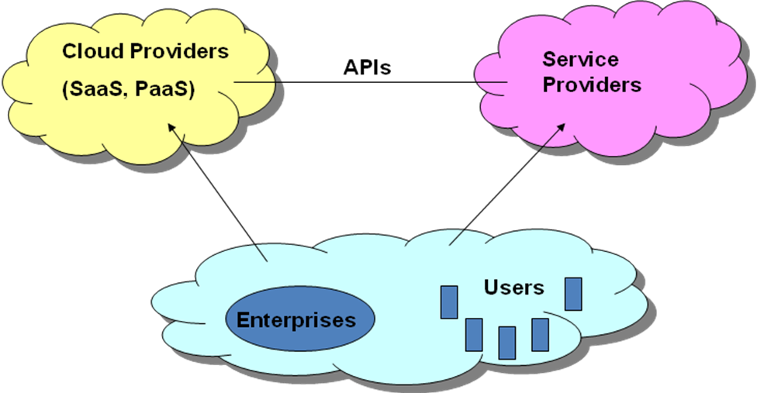

4.2 Enabling Mobile Cloud

The cloud ecosystem is already taking shape and a number of players from IT, as well as OTT (Over-The-Top) players already offer agility and scalability through their service offerings.
The fixed and mobile telecom operators have deployed an extensive infrastructure (distributed data centres, broadband access, application servers, etc) that are ripe for virtualization, allowing these operators to better monetize these resources.
The telecom operators have some important advantages, especially through their existing, strong customer relationship, billing expertise and customer services, which are important for companies wanting to deploy cloud services.
As such, the operators are in a unique position, especially the mobile operators, to offer a wide variety of bundling of cloud and network services for customers that practically maintain and expand their business with their existing service provider.
The Mobile Cloud enables existing and new cloud services to be ubiquitously available across multiple, separate mobile network operator domains.
The Mobile Cloud Providers (MCP) are the “intermediaries” facilitating the implementation of a Mobile Cloud through agreements with individual network operators (based upon wholesale models).
By using a MCP the Service Providers (SPs) can have a single interface and single business relationship, but interwork with multiple network operators.
From a user's service perspective, we can look at the cloud environment as an on-demand environment where various services controlled by other organizations can be leveraged and composed for the use of a user, so that the services that are outside of an organization's own boundaries, operated and controlled by other organizations can become part of the aggregated portfolio of services of that organization. (eg file storage and backup) A Mobile Clouds examples relevant to 3GPP is GSMA’s OneAPI’s objective is to provide a cross-operator domains framework for Mobile Cloud Computing. Based upon OneAPI, the GSMA is acting as a Mobile Cloud Provider/Aggregator, providing SPs access to network resources and charging capabilities (NaaS type of cloud) of multiple mobile operators

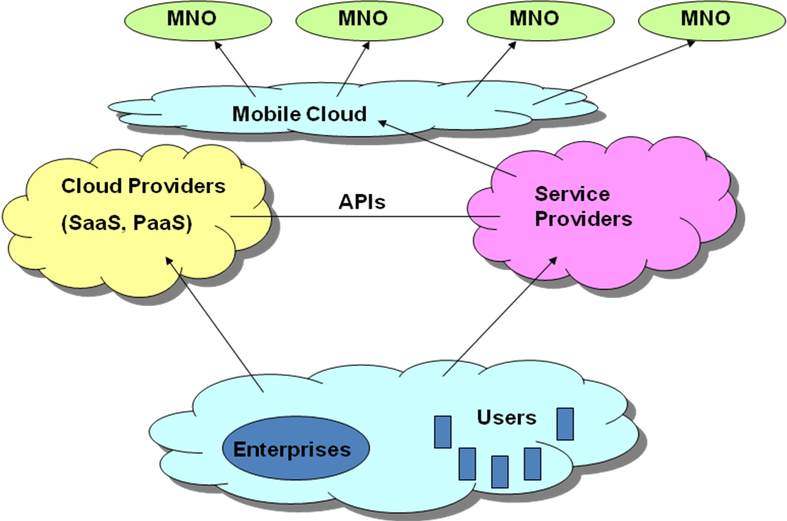

4.3 Lawful Interception security considerations

In regards to the cloud legal aspects, it is to be expected that many cloud computing scenarios will span the laws of multiple jurisdictions, i.e. the laws at the users’ location, at the location of the cloud provider, etc, may all potentially apply.
The same data may be stored in multiple jurisdictions at the same time and the actual location of a user’s data may be difficult to determine.
The “combinatorial” character of the mobile cloud services, across multiple resource domains, infrastructure domains, security domains and jurisdictions domains, makes the task of developing LI solutions for cloud services particularly challenging.
The market opportunities of the mobile cloud services might be impeded, for the 3GPP mobile operators, by some conditions of their operating licenses, like the regulatory requirements for LI, that are an intrinsic part of any operational license.
Even if not specifically spelled out for cloud services cases, as the mobile operator domain is a “component” of the whole “combination” of domains contributing to the feasibility and delivery of the cloud services, the LI requirements are most likely to be implicitly extended by the regulators to cloud services.

The working document will address:
- Types of MNO Mobile Cloud deployment scenarios using the wide diversity of cloud architectures, loosely defined by others than 3GPP, but integrating segments of them into a 3GPP mobile communication system
- Relevant Mobile Cloud Use Cases for purposes of examining LI impacts and deficiency
- Deployment scenarios that are likely to address MNO LI requirement

***************************End of first addition**********************************

Recommendation
Discuss and adopt the proposed background for Section 4 of the cloud services living document.

